DEPARTMENT OF VETERANS AFFAIRS

**Veterans Benefits Administration**

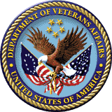

**Instructions for Accessing**

**School Certifying Officials (SCOs)**

**Online Training Modules**

**August 1, 2019**

Veterans Benefits Administration

 

Top

To access the training, click the hyperlink for the [New or Existing School Certifying Officials (SCOs) Courses](https://vba-tpss.vbatraining.org/Assess2/trkSignIn?refid=XSCO)

Click **“New User Account**” on the Live Assessments page to register for the training

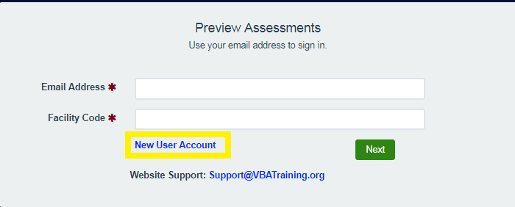

Enter the following information in the New User Account Field:

* User’s e-mail address, (enter e-mail address twice to confirm accuracy)
* User’s first and last name
* Select the applicable role from the drop-down menu
* New SCO
* Existing SCO
* SAA
* Read Only SCO
* VACO Employee
* Other
* Enter **your** facility code (enter the facility code twice to confirm accuracy).
* Click **“Next”.**

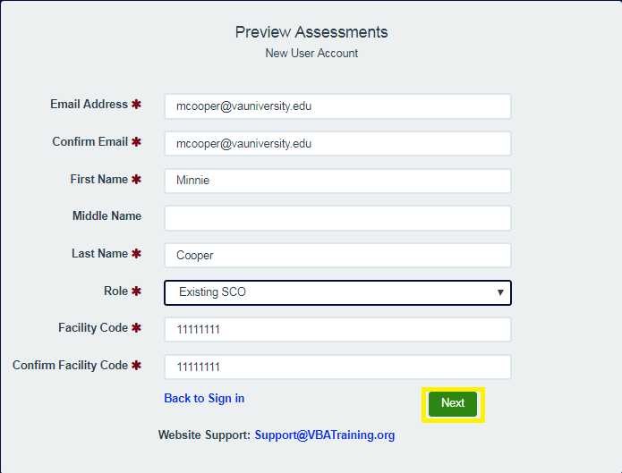

After you successfully complete the registration process, the Department of Veterans Affairs School Certifying Official Training 2019 home page will appear as shown below.

* Click on “Welcome” to review Getting Started and Instructions regarding the training
* Your Profile will be displayed in the bottom right corner of the page.
* If needed; make adjustments then click save changes

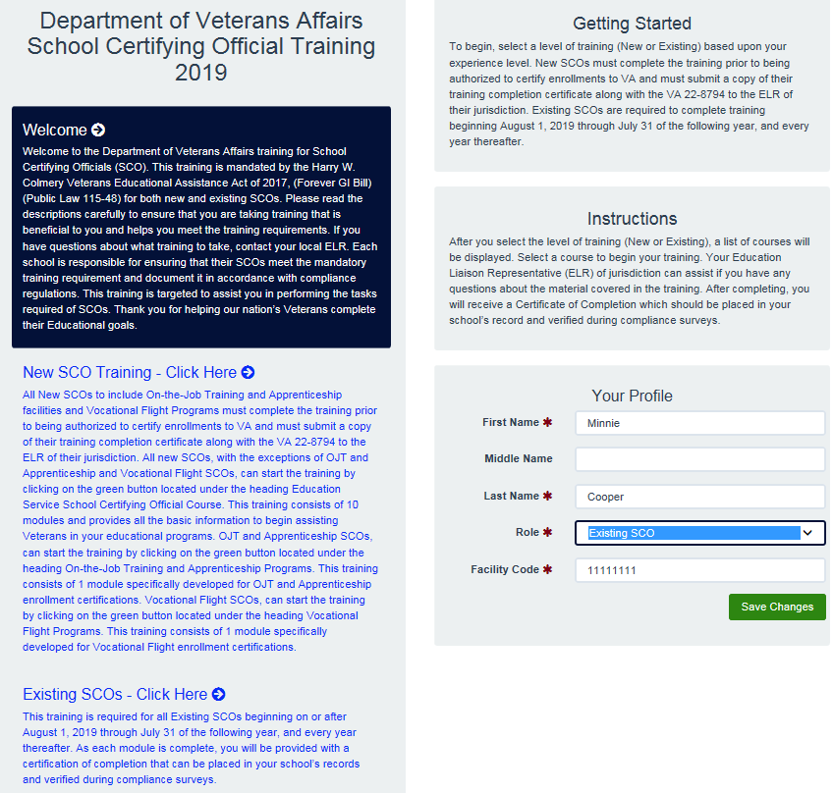

**New SCOs –** All New SCO, **except** for OJT/Apprentice and Vocational Flight Facilities, are required to take the training under the heading **Education Service School Certifying Official Course**.

**OJT/Apprentice and Vocational Flight Facilities** are required to take the training under their corresponding heading.

To start the training, click the green button labeled “Begin” under the applicable heading.

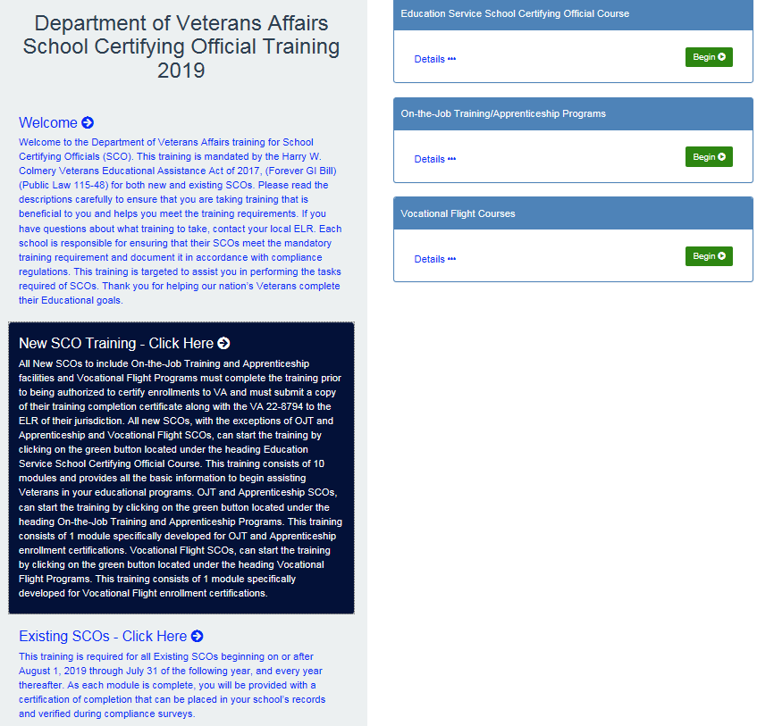

**Existing SCOs** – Existing SCOs are required to take the training under the heading that corresponds with their facility type. Additionally, the Compliance Surveys and the applicable VA-ONCE Modules should be taken to help you meet the 5-hour annual training requirement. To start the training click the green button labeled “Begin”.

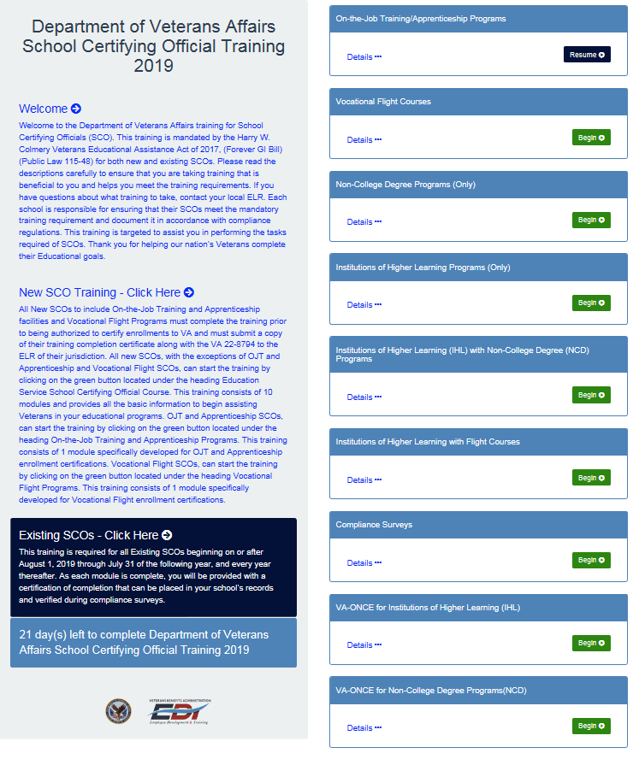

After clicking “Begin”, you will be directed to the corresponding welcome page. The page shown below is the welcome page for the Education Service School Certifying Official Course.

**Click Continue**

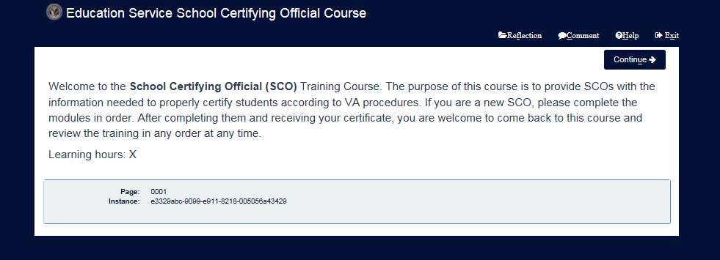

After clicking continue, you will be taken to the Demographic Survey Page; Complete the Demographic Survey and **Click Submit**

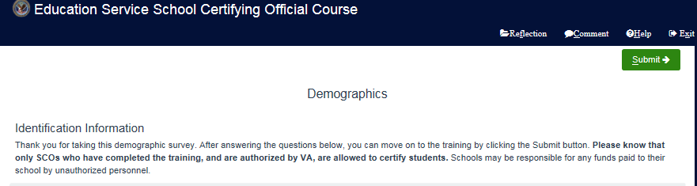

After completing the demographic survey, you will be taken back to the Welcome Page **Click Continue**

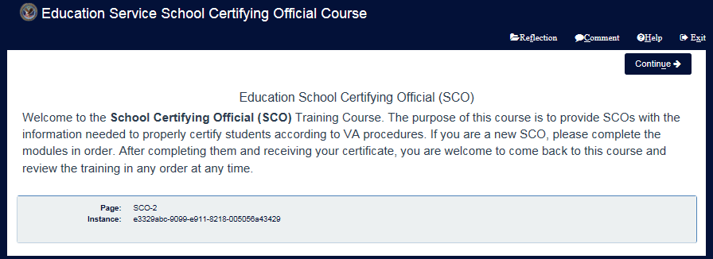

**Note: After clicking continue, you will be directed to the Course Menu if you are taking the Education Service School Certifying Official Courses. For all other training modules, you will be directed to the Start Screen for the applicable training module.**

The Course Menu listed below will be displayed for the Education Service School Certifying Official Courses only. Although you can take the modules in any order, it is recommended that you take the training in numerical order. You must complete all 10 modules to access the Post-Course Review. Upon completion of the Post-Course Review you will receive your certification of completion.

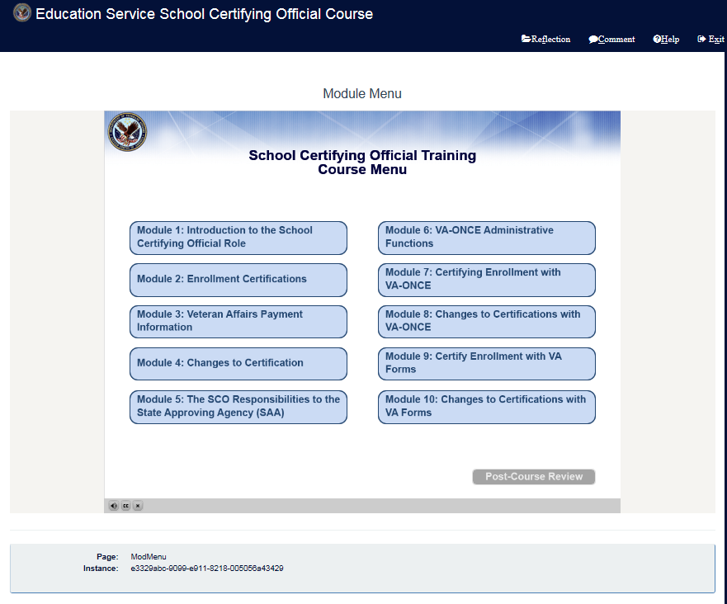

**If you are taking any other training module, you will be taken to a start screen as shown below for the OJT/Apprenticeship Training Module listed below.**

**Click Start**

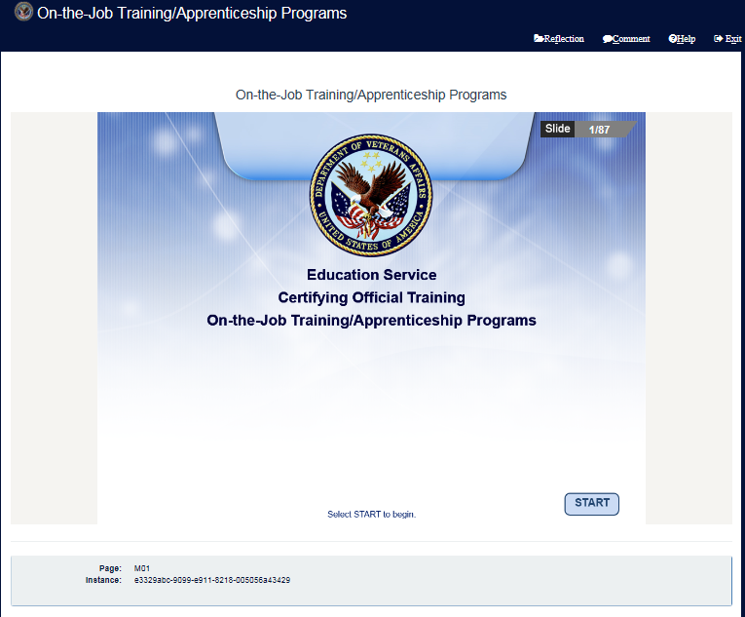

Upon completion of the training, you will receive a certificate of completions. If you have any questions or need additional assistance, please contact your [ELR of jurisdiction.](https://www.benefits.va.gov/GIBILL/resources/education_resources/school_certifying_officials/elr.asp)