**Procedural Advisory: School Certifying Official (SCO) Guidance for Certifying Chapter 33 Graduate Training – INTERIM Guidance**

July 11, 2019

**Background:** In accordance with 38 CFR 21.9750, VA will calculate an individual’s rate of pursuit. Under chapter 33, a School Certifying Official (SCO) must report the minimum number of credit hours their academic regulations require to be considered full-time, to ensure proper entitlement is charged and appropriate payments are released for any rate of pursuit. (38 CFR 21.9640 and 21.9560, Authority 38 USC 3313) Presently, every school does not have published or defined in their catalog the number of credits required to be considered full-time while enrolled in non-standard length terms. Until all schools have included full-time requirements for non-standard length terms, guidance and procedures applicable will vary. In some scenarios, equivalent credit hours need to be calculated and used in determining Rate of Pursuit (RoP). In other scenarios, VA will divide the number of credit hours certified by the number of credit hours required to be considered full-time to determine rate of pursuit.

**Issue:** The Long Term Solution (LTS) automatically performs credit hour equivalent calculations for all non-standard terms. These automatic adjustments alter the expected rate of training for students enrolled less than full-time in terms with individually defined fulltime modifiers, and under values training for terms longer than standard length.

**Procedures:** Until the LTS is reprogrammed, Compliance and Liaison will advise the SCO to add the VBA Standard Remarks; “*Graduate non-standard term*”:

* For any non-standard term that is longer (regardless of whether there is an individually defined FT modifier)
* For short non-standard terms, that have an individually defined FT modifier

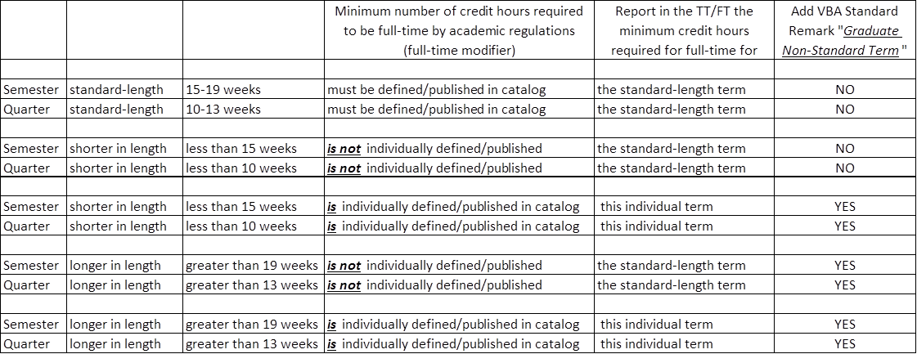

When VBA Standard Remarks; “*Graduate non-standard term*” are included on the enrollment, Veterans Claims Examiners (VCE) will apply workaround procedures as follows:

• Change the hour type to “clock-standard”

• Enter the SCO reported full-time measurement in both “full-time” fields

• Enter all other enrollment information as reported, and

• Enter “Graduate Non-Standard Work Around” in the Work Product comments section

**NOTE:** The number for full-time hours certified by the SCO on each enrollment will be used for processing chapter 33 claims. Do not substitute a “Graduate Full-time” number populated in the Web Enabled Approval Management System (WEAMS).

Standard Term: Standard quarters are 10 to 13 weeks in length and standard semesters are 15 to 19 weeks in length. Enrollment periods, longer or shorter in length are non-standard terms.

See attached Frequently Asked Questions (FAQs) for additional information.

**When Entitlement Exhausts:**

**Issue:** Under normal circumstances, the LTS will automatically extend entitlement, when entitlement exhausts during a term, to the end of the quarter or semester for eligible individuals. However, the LTS is programmed with different rules for clock hour enrollments. When entitlement exhausts prior to the middle of a term entered as clock hours in the LTS, system rules do not extend benefits.

Additionally, to receive extended benefits, a claimant must not be using transferred entitlement and must not have exhausted 48 months or 81 months of entitlement; when combined with Chapter 35, under two or more programs in accordance with 38 USC 3695. Whenever system rules are inadequate or disrupted by a workaround, a VCE must manually apply the proper payment rules.

**Procedures:** Review the date when entitlement exhausts. In addition to reviewing if a chapter 30 refund is due, verify if the claim has been properly extended. If payments are not extended to the end of the term and an extension is due, manually issue payments to the end of the term for graduate students enrolled in credit hours.

**Questions:** Questions about these procedures should be submitted to the [National Training Team - Processing](mailto:225A.VBACO@va.gov?subject=Procedural%20Advisory%20-%20CH33%20Graduate%20Training%20(Interim%20Guidance)).

V/R

National Training Team - Processing

Education Service