**Training Reminder – M22-4 Part 4, Chapter 11 Enrollment Adjustments, subchapter 5 section 11.20 Entitlement Restoration**

**February 2017**

* **Reference:** [**M22-4 Part 4, Ch 11 Enrollment Adjustments**](http://vbaw.vba.va.gov/bl/22/ref/m22-4/Part%20IV/ch11.htm)

**Subchapter 2 Section 11.20 Entitlement Restoration**

Restoration of Entitlement is authorized when a claimant had to discontinue the course or courses as a result of being ordered to:

* + Active duty service under 10 U.S.C. 688, 12301 (a), 12301 (d), 12301 (g), 12302, or 12304; or
* **AND**
  + Did not receive credit or lost training time for any portion of the period of enrollment in the course or courses

**Chapter 33 Restoration of Entitlement**

* Find the term needing to be amended due to the activation and select "Add Amendment". The VCE must enter in the effective date of the withdrawal and check "Restore Entitlement for Enrollment Period“ and **send to authorization**. The VCE must send the claimant the AWD-15 Letter whenever processing the restoration of entitlement
* If the term was previously adjusted, the VCE must find the term and amendment previously adjusted where the claimant was terminated due to the activation and select the "Correction". The VCE must edit the amendment by checking the "Restore Entitlement for Enrollment Period" box and unchecking all other boxes, click "Save" and have the Work Product authorized
  + If the 6 credit exclusion was previously used, the VCE should send the claimant the MC-5, Restore Exclusion letter along with the LTS generated letter. **The MC-5 letter applies to all benefits**

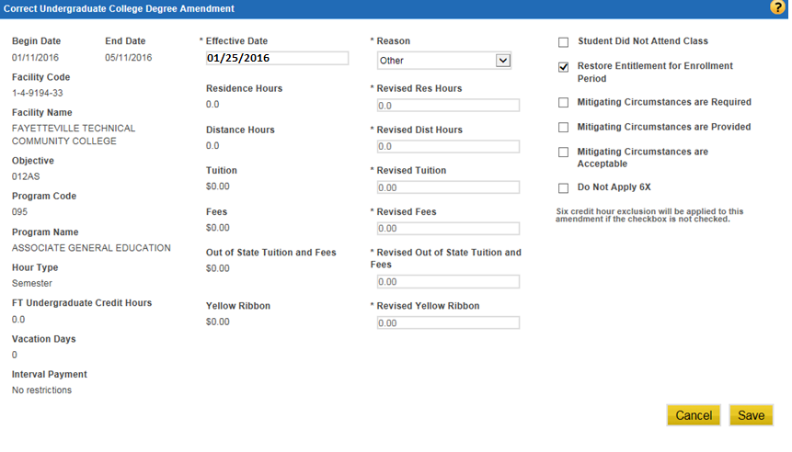

Non-Chapter 33 Restoration of Entitlement

**For Non-Chapter 33 Adjustments.** To restore entitlement for a claimant, the VCE must repeat the restoration period dates in BDN on the 312 screen. The VCE must use "X" for type hours instead of Semester, Quarter, etc. BDN will recognize this as a restoration of entitlement claim and will calculate the correct adjustment.

To restore entitlement for a Chapter 1606 claimant, the VCE must update the 310 screen with a mobilization (MOB) period in order to use the "X" type hours.

**"X" Type Hours.** The code "X" in type hours is an acceptable entry on the award screens for Chapters 30, 32, 35, and 1606. By amending a previous award period to "X" type hours, entitlement will be restored. "X" type hours will not charge entitlement for the period in which it is used.

"X" type hours will not "roll down" to the next award line. If a multiple line award is affected, enter "X" type hours on each award line. "X" type hours cannot be entered in the future. If the award period to be adjusted is for a different type of training than the most recent award period, stop/reentrance processing is required.