**Training Reminder - Date of Claim**

*February 2, 2017*

**References:**

* [CFR 21.1029 Definitions](http://www.benefits.va.gov/warms/docs/regs/38cfr/bookg/part21/s21_1029.doc)
* [M22-4, Part 3, 1.22b](http://vbaw.vba.va.gov/bl/22/ref/m22-4/Part%20III/ch01.htm#122)
* [M22-4, Part 3, 3.02A-E](http://vbaw.vba.va.gov/bl/22/ref/m22-4/Part%20III/ch03.htm#302)

**Date of Claim:** The date of claim will be the earliest date on which a valid claims document was received by a Regional Office (RO), VA facility, eBenefits, or scanning vender site. If multiple documents are received on one claim, use the earliest date of receipt as the date of claim. The doc date in TIMS is not necessarily the date of claim.

**Date Stamp:** When a claims document is received, the RO will stamp the document verifying the date it was received in the RO. Claims received via email, from scanning vendors, or other electronic means will not have a traditional date stamp, the date of receipt will be used as the date of claim. See examples below:

**VARO Date Stamp**

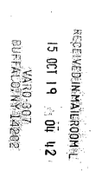 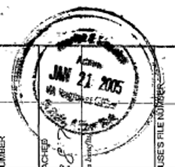

**Date Stamp from Scanning Vendor**



**Date Stamp from VONAPP Reprint**

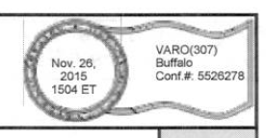

**Processing Note:** If you have a Date of Claim that is over 60 days old; please confer with your Coach before authorization.

**Scenarios:**

Please review the scenarios; in each example assume the documents listed are in the same claim token and require adjudication.

Example 1: Original Claim with 1999

* 22-1990, received on 11/15/2015 in RPO 307 (date stamp from RPO 331 reflecting 11/4/15 is on document)
* 22-1999; received on 11/28/2015

*What is the correct Date of claim?* **November 4, 2015**; we must use the earliest date in which a valid claim was received by an RO.

Example 2: Supplemental Claim with a 1995, 1999 & 1999B on file

* 22-1995, received on 12/1/2015
* 22-1999; received on 12/13/2015
* 22-1999B; received 12/18/2015

*What is the correct Date of claim?* **December 1, 2015,** if an EP was established by AUTO LTS or ECAP with an incorrect date; it must be PCAN’d and re-established with the appropriate date of claim.

Example 3: Supplemental Claim; 1999 & 1995 received at the same time

* 22-1999; received 1/13/16
* 22-1995; received 1/23/16

*What is the correct Date of claim?* If change of program is an issue, the date of receipt of the 22-1995 would be the correct date of claim, however if change of program is not an issue the 22-1999 would be the correct date of claim

Example 4: Original Claim with 1999

* 22-1999; received on 11/15/15
* 22-1990: received on 12/2/15

*What is the correct Date of claim?* **December 2, 2015** is the correct date of claim; a 22-1999 is not considered a formal claim until the applicant files for benefits using the prescribed form.

Example 5: Claim previously denied; program is now approved

* 22-1999; received on 11/21/13
* Claimant was denied under Ch33 for course not approved; 11/23/13
* 119 received stating program was approved; 1/15/2014

*What is the correct Date of claim?* The correct date of claim is **January 15, 2014,** the 119 created a valid claim; action was previously taken on the prior documents.

Example 6: Document received; token was not created or closed

* 22-1999 received on 11/1/2015; processed on 11/14/2015
* 22-1999b received on 11/13/2015; token was not created/ closed
* 119 asking about the increase; received on 12/12/15

*What is the correct Date of claim?* The correct dated of claim is **November 13, 2015** as action was not taken on the document; the 1999b this is the earliest date in which a valid claims document was received.

Example 7: Email/ Correspondence received

* 22-1999 received 11/27/2015; processed on 12/1/2015
* Email received from POC confirming claimant has kicker; received 12/15/2015
* Copy of kicker contract; received 12/16/2015

*What is the correct Date of claim?* The correct dated of claim is **December 15, 2015,** if an email is received required processing action the date of claim is the date the email is received by the VA; the email must be capture into TIMS.