This job aid provides training managers and VBA TMS administrators* with instructions on adding employees to (and removing them from) classes in TMS.

**\* In order to edit national classes, TMS Admins must obtain OMGT domain access by contacting the VBA Domain Manager at** [**VBATMSHelp@VBAVACO@va.gov**](mailto:VBATMSHelp@VBAVACO@va.gov)

1. Select **Learning** from the TMS Admin home screen.
2. Select **Classes** from the left-hand menu.
3. Input the desired Class ID in the **Class ID** field and select **Search.**
4. Once the initial class record appears in the search results, select the **Edit** icon.
5. 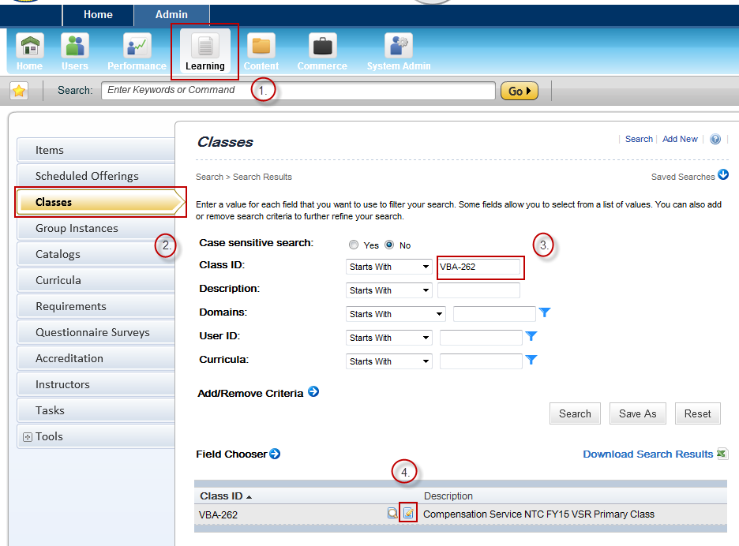Within the main class record, select **Users** from the left-hand menu.
6. To add an employee to the class, input the employee’s TMS User ID and select **Add**. To add multiple employees, select ‘add one or more from list’.
7. To remove an employee from the class, mark the ‘Remove’ check box next to the employee’s TMS User ID and select **Apply Changes**.

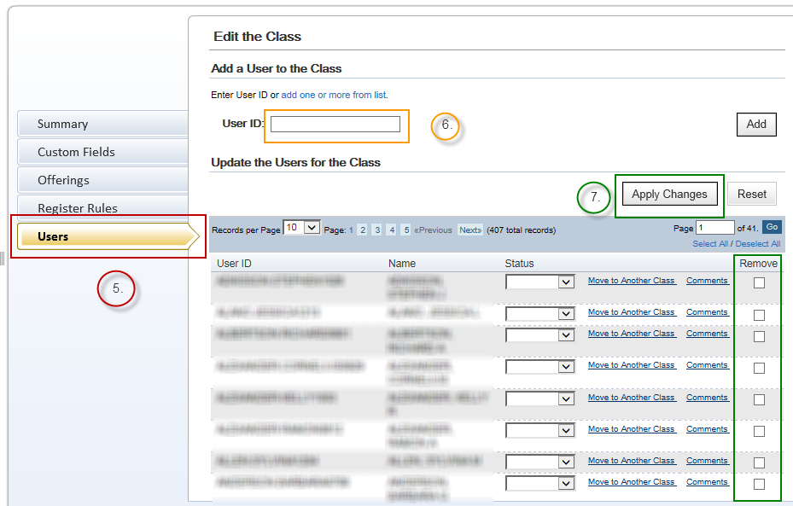

**For questions regarding this job aid, please contact the VBA Curriculum Support Team at** [**VBATMSHelp@VBAVACO@va.gov**](mailto:VBATMSHelp@VBAVACO@va.gov)