**TMS Learning History Report Job Aid**

To submit CRC CEU for processing, please run and export your TMS *Learning History* report and submit to your designated local CRC CE Coordinator (if applicable), or directly to the [VRE CEU Mailbox](mailto:VAVBAWAS/CO/VRECEU%20%3cVRECEU.VBACO@va.gov%3e). Please use your local CRC CE Coordinator, if your station has designated one to avoid duplication of requests.

For additional information on CRCs and the submission process, please refer to the [CRC Information](http://vretraining.vba.va.gov/CRC.htm) page on our [VR&E Service Training](http://vretraining.vba.va.gov/Index.htm) homepage.

To run and export your TMS *Learning History* report, please follow these steps:

1. Log into your TMS account

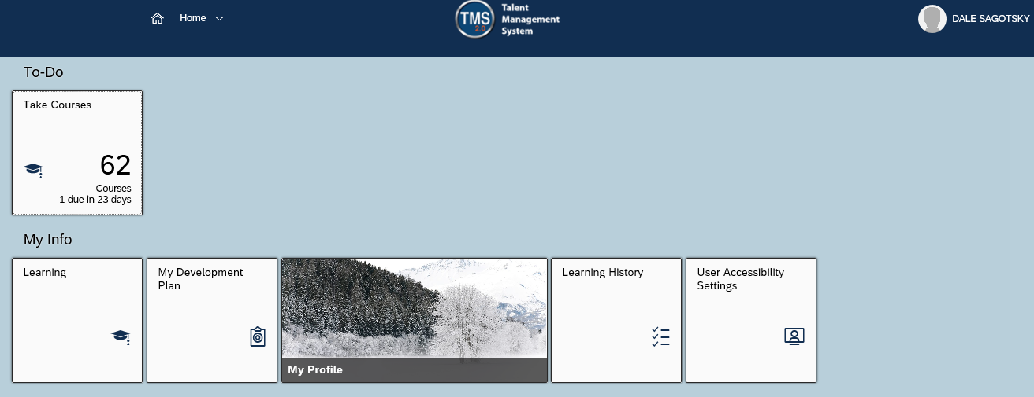

1. On the homepage, Choose *Learning* from the Drop-Down menu to display your My Learning

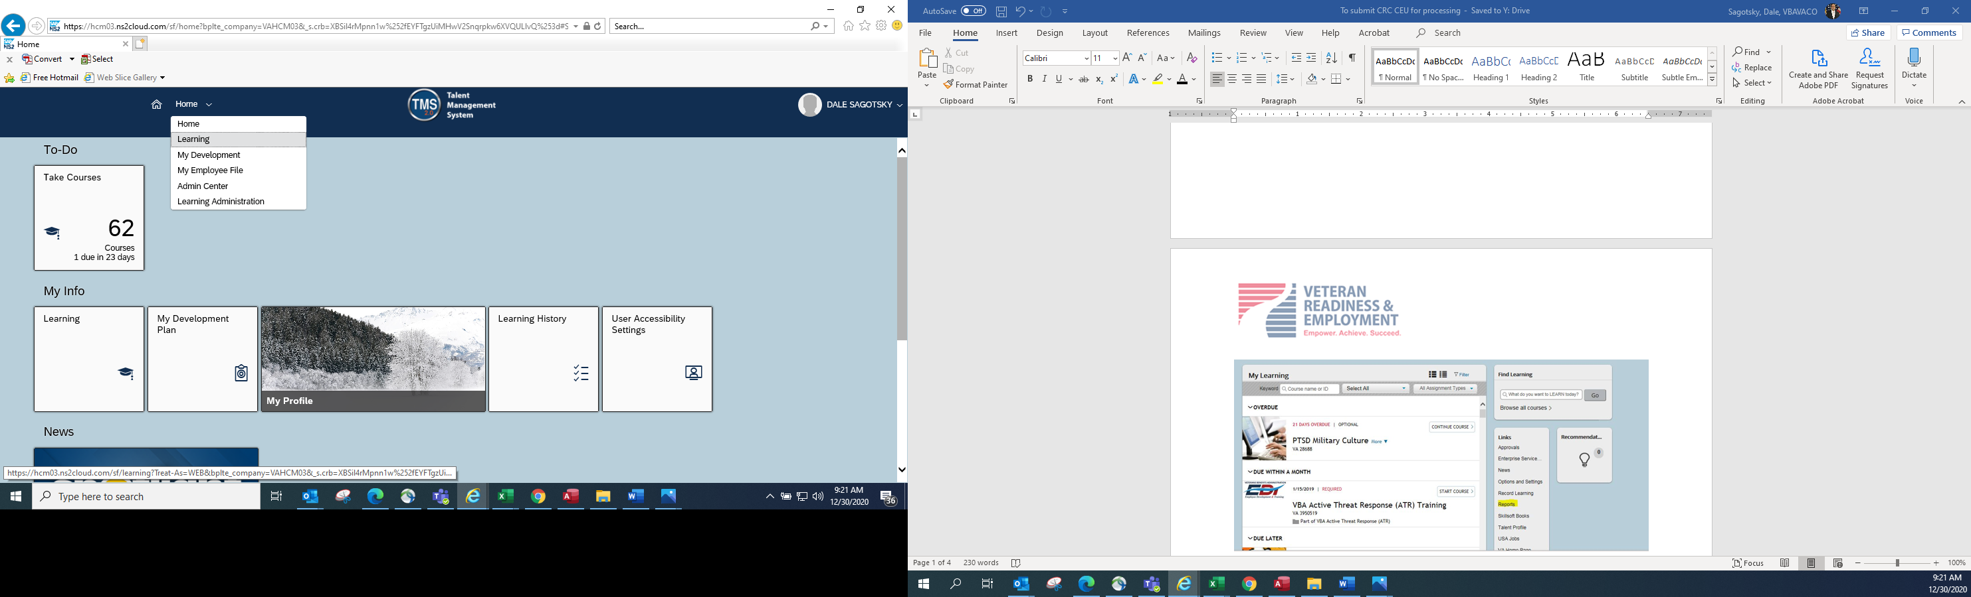

1. Click on *Reports* from the Links Section

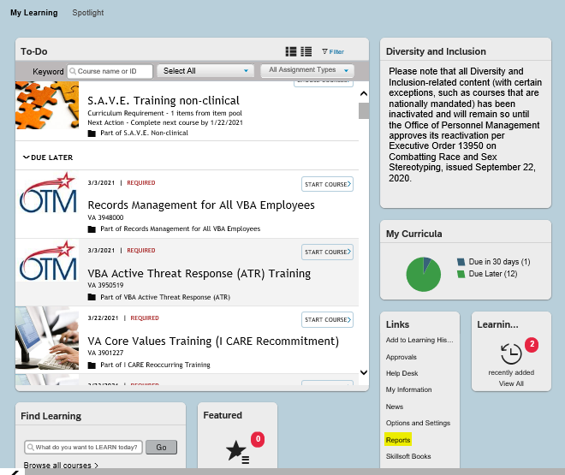

1. Click on *Learning History and select Learning History (CSV)*

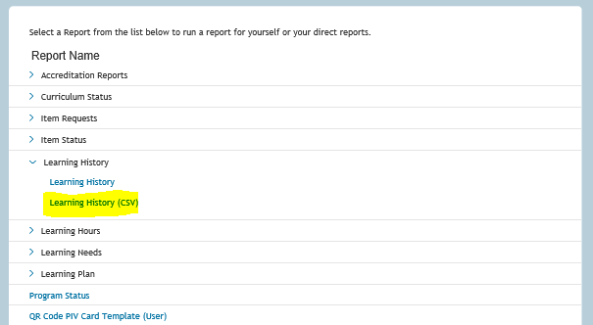

1. Ensure the following selections are made:

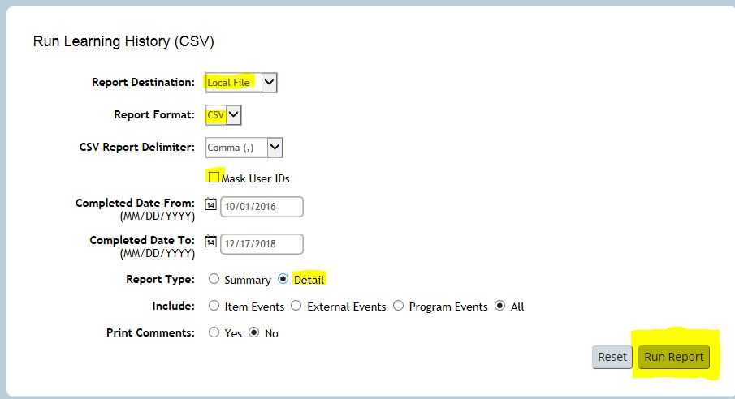

* Report Destination: Local File (default)
* Report Format: CSV
* Uncheck Mask User IDs checkbox
* Select date range: From - To
* Report Type: Detail
* Click on *Run Report*

1. You will see the report waiting in queue as it loads, then an option to save or open the report will appear at the bottom of the screen. Open file or save the file to the desktop or a folder

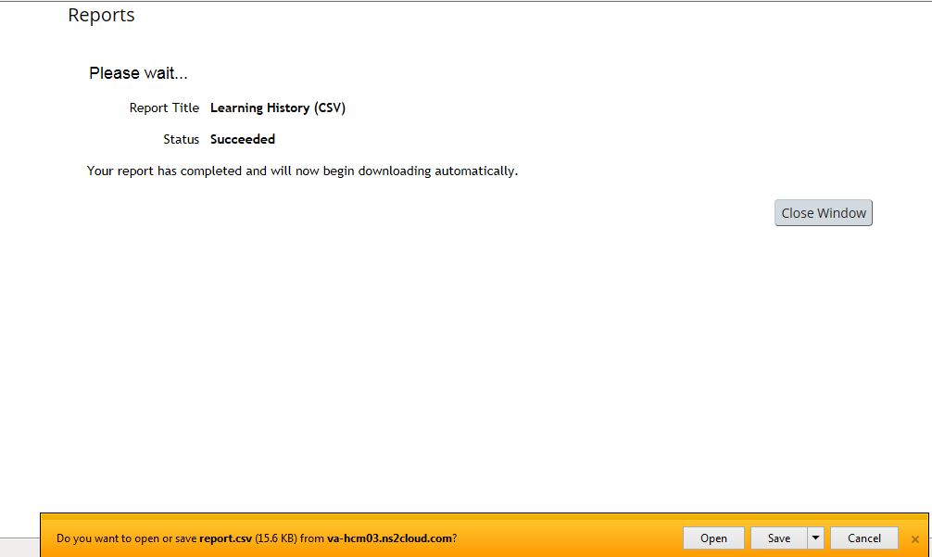

1. Once the report downloads, highlight the trainings you would like to receive CEs, ensure that you save the spreadsheet to a Microsoft Excel Workbook (.xlsx) file type and email it to your TMS Coordinator or directly to the [VRE CEU Mailbox](mailto:VAVBAWAS/CO/VRECEU%20%3cVRECEU.VBACO@va.gov%3e).

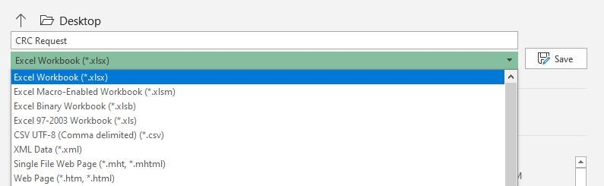

Note: You will only receive credit one time within a five-year renewal period per item.