Section 1 of this job aid provides training managers and VBA TMS administrators* with instructions on adding employees to (and removing them from) PMC classes in TMS. Section 2 lists the proper actions to take when employees change job positions.

### * In order obtain access to edit Pension classes, TMS Admins must ask their RO Training Manager to contact the VBA Domain Manager at VBATMSHELP.VBAVACO@va.gov.

# Section I: Adding and Removing Employees to/from a PMC Class

1. Select **Learning** from the TMS Admin home screen.
2. Select **Classes** from the left-hand menu.
3. Input the desired Class ID in the **Class ID** field and select **Search.**
   * **VBA-293** for PMC VSRs
   * **VBA-294** for PMC RVSRs/DROs
4. 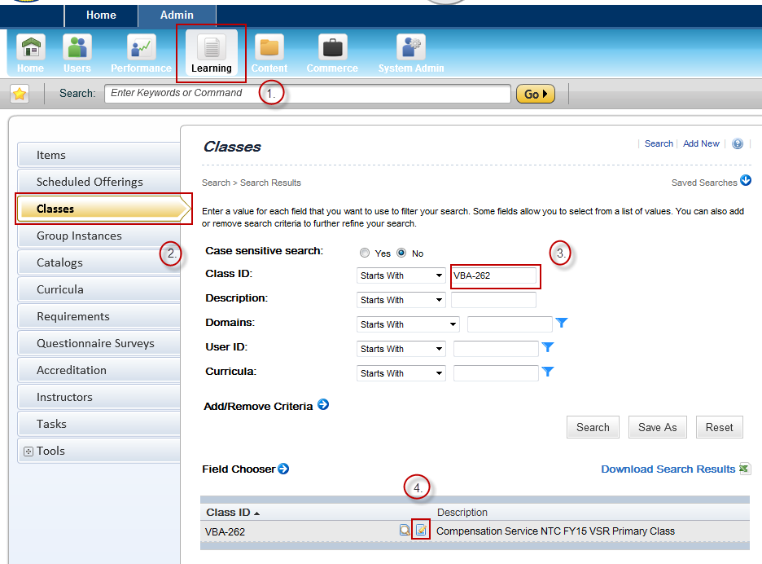Once the initial class record appears in the search results, select the **Edit** icon.
5. Within the main class record, select **Users** from the left-hand menu
6. To add an employee to the class, input the employee’s TMS User ID and select **Add**. To add multiple employees, select ‘add one or more from list’
7. To remove an employee from the class, mark the ‘Remove’ check box next to the employee’s TMS User ID and select **Apply Changes**

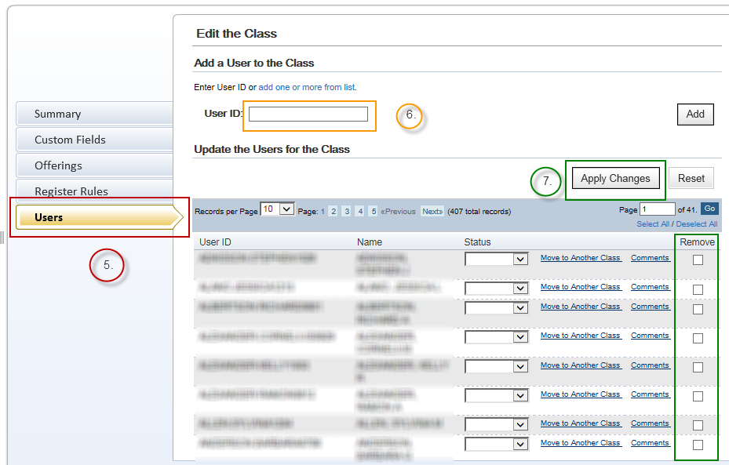

# Section 2: Class Change Scenarios

Scenario 1: **A PMC VSR employee becomes a PMC RVSR**. In this situation, the TMS Admin will need to remove the employee from the PMC VSR Primary class (VBA-293).

Scenario 2: **A PMC VSR or PMC RVSR moves to a supervisory position and is no longer a production employee.**  This situation requires the TMS Admin to remove the employee from the PMC VSR or PMC RVSR Primary class (VBA-293 or VBA-294 respectively), as non-production employees are not part of the target audience for the Pension Service NTC. The Training Manager should ensure the appropriate supervisory curricula, such as the ‘New Supervisors Soft Skills Training’ curriculum, are added to the employee’s learning plan.

Scenario 3: **A Pension Service employee accepts a VA position outside of Pension Service.** In this circumstance, the employee should be removed from all Pension Service NTC classes. The employee’s new required training curricula should be added.

**For questions regarding this job aid, please contact the VBA Curriculum Support Team at** [**VBATMSHELP.VBAVACO@va.gov**](mailto:VBATMSHELP.VBAVACO@va.gov)**. For policy-related questions, contact the Pension Training Staff at** [**PENSIONTRNGQUAL.VBACO@va.gov**](mailto:PENSIONTRNGQUAL.VBACO@va.gov)**.**