Introduction

This job aid instructs TMs and TCs on gathering the necessary data in TMS and converting it to the required format for use with the NTC Reporting Application. Although the RPOs are not required to submit quarterly NTC reports to Education Service, TMs and TCs may run the reports as needed throughout the fiscal year to check their employees’ progress.

*Note: Before you begin, ensure that you have added each employee that you are tracking to* ***only one of the following cohorts****, based on the employee’s job position.*

|  |  |
| --- | --- |
| ACL Cohorts | Cohort ID |
| ECSS (NTC) | VBA-393 |
| ELR (NTC) | VBA-395 |
| MA (NTC) | VBA-550 |
| Manager (CELOs & Supervisors) (NTC) | VBA-664 |
| Program Support Assistant (PSA) (NTC) | VBA-606 |
| QTS (NTC) | VBA-661 |

|  |  |
| --- | --- |
| VACO Cohorts | Cohort ID |
| Management Analyst (MA) Cohort (NTC) | VBA-708 |
| Training Specialist (Series 1712) Cohort (NTC) | VBA-748 |
| Supervisory Management Analyst (MA) Cohort (NTC) | VBA-750 |
| Public Affairs Specialist (Series 1035) Cohort (NTC) | VBA-752 |
| Statistician (Series 1530) Cohort (NTC) | VBA-754 |

|  |  |
| --- | --- |
| Processing Cohorts | Cohort ID |
| ECCT (NTC) | VBA-396 |
| ECM (NTC) | VBA-524 |
| EQTS (NTC) | VBA-660 |
| Lead SVCE (NTC) | VBA-659 |
| Management Analyst (MA) (NTC) | VBA-399 |
| Supervisory VCE (NTC) | VBA-744 |
| SVCE (NTC) | VBA-658 |
| VCE (NTC) | VBA-392 |

Part 1: Running the TMS Report

Run the **Custom User Item Status (CSV)** report in TMS using the following parameters:

1. Uncheck the **Mask User IDs** box.
2. Click the filter icon next to the **User** field.
3. Within the **Users Filter** pop-up:
   1. Enter your Station ID into the **Security Domains** field.
   2. Enter the NTC Cohort ID (from the above tables) in the **Cohorts** field.
   3. Select **Submit Criteria**.

1. Leave the **Item** and **Completion Status** fields blank.
2. Enter **first day of the FY** in the **Completed Date From** field.
3. Leave the **Completed Date To** field blank OR select a specific date if the preferred date is in the past.
4. Select Schedule Job.
5. Open the report and save as a CSV (Comma delimited) file.

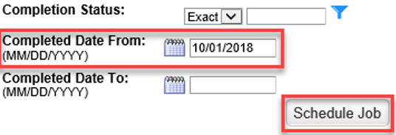

Part 2: Using the NTC Reporting Application

Note: As of FY20, the NTC Reporting Application had to be limited to 6 users at a time. Each of the below links allows access to one user at a time. Training Managers should use the link that matches their district alignment. The two non-district links should be reserved for service lines to run central reports. If the application is in use by another TM, you will receive a notification indicating that the application is locked. You will also see that a timer has been implemented to ensure that users to not accidentally leave the application open if they are not using it. Additionally, there is now a new ‘Reset’ button:

This button must be used when exiting the application and when you are ready to upload another report for a different position. If you do not click this button, you will lock yourself and all other TMs out of that link for the application until the server resets, which can take around 20 minutes. If that happens, please send a VA Teams message to Dawn Dorsch, Kathy Poole, Jennifer Martin, or Charissa Morris to request that they reset the application for you. You will need to let them know which link you were using.

|  |  |
| --- | --- |
| Districts | NTC Link |
| Northeast District | <https://vba-tpi.vbatraining.org/NTCProgressReportNE/> |
| Southeast District | <https://vba-tpi.vbatraining.org/NTCProgressReportSE/> |
| Continental District | <https://vba-tpi.vbatraining.org/NTCProgressReportCONT/> |
| Pacific District | <https://vba-tpi.vbatraining.org/NTCProgressReportPAC/> |
| Non-District | <https://vba-tpi.vbatraining.org/ntcprogressreport> |
| Non-District | <https://vba-tpi.vbatraining.org/NTCProgressReport2> |

1. Select the **Service** for which you would like to calculate progress.

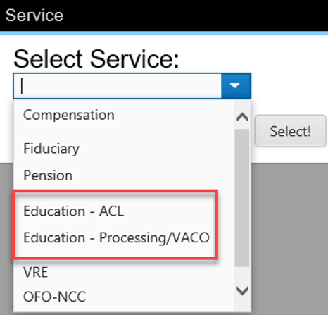

1. Select the **position** for which you would like to calculate progress.

1. Next, select the **Browse** button to locate your locally saved Custom User Item Status report.

1. Once the report is located, select the **Submit** button to calculate progress toward the FY Education Service NTC requirements.



1. You will then see the initial results for each employee.

*Note: The number shown in the ‘Mandated Hours’ column is the number of FY mandated hours plus the number of ETA hours that the employee has completed.*

1. If you need to adjust tenure for any employees, you may make all adjustments at once, using the dropdowns to select the number of months the employee is responsible for. Once all modifications have been made, select the **Submit Tenure** button. All adjustments will then be calculated at the same time. If no tenure adjustments are needed, proceed to the next step.

*Note: Tenure adjustments only modify the employees’ station-selected requirement. It does not modify the mandated requirements.*

1. To download an Excel version of your RPO’s results, select the **Download** button at the top of the screen.

1. After you have downloaded your report and completed all desired activities for a position, click the **Reset** button to start over with a new position. Once you are finished with all reports, please ensure that you close the browser tab or window in order to close out your session in the application.

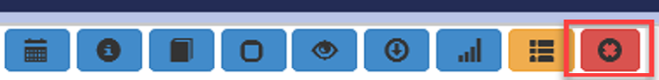

Interpreting the NTC Application Report Columns

An explanation of each report column is listed below:

* **Tenure (in months):** This drop-down menu allows TMs to adjust how the program tracks progress for employees who have been on approved leaves of absence or whose trainee status ended during the current FY. To change an employee’s tenure, select the number of months the employee is responsible for training during the FY. Do this for each employee that requires a tenure adjustment. Once all adjustments have been made, click the ‘Submit Tenure’ button and the program will track the progress accordingly.

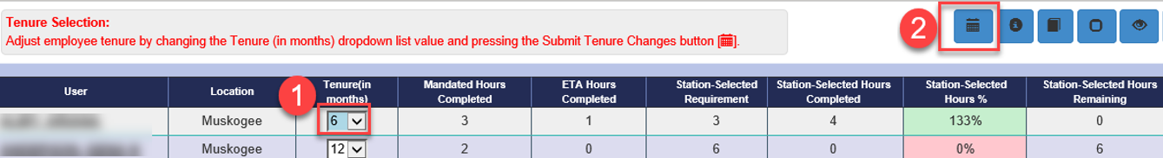

* **Mandated Hours Completed:** Indicates the total number of Education Service mandated hours an employee has completed in the FY. This total includes both FY mandated item and ETA item completions.

**Please Note:** Some employees may have less mandated hours completed due to passing a course’s pre-test or substitute items.

The mandated hours are highlighted in green for employees who have completed all centrally assigned FY mandated items to date. Those who have not completed all assigned FY mandated items will not be highlighted. This color scheme was designed for visual representation purposes only and does not reflect categories established in the Education Service NTC SOP.

**Note:** If any FY mandated items have a pre-test or approved substitute item with different learning hours, it is possible that some employees may have more or less mandated hours but still be highlighted green.

* **ETA Hours Completed:** Indicates the total number of Error Trend Analysis (ETA) training hours employees have completed. If applicable, ETA requirements for positions should be listed in the service's FY NTC SOP. Any completed ETA hours over the FY requirement will count as station-selected hours.
* **Station-Selected Requirement:** Indicates the total number of station-selected hours the employee is required to complete by the end of the FY. This number takes proration levels into account.
* **Station-Selected Hours Completed:** Indicates the total number of station-selected hours an employee has completed in the FY.
* **Station-Selected Hours %:** Reports the percentage of required station-selected hours an employee has completed in the FY. These percentages take proration levels into account. It is expected that progress toward satisfaction of requirements will be evenly distributed across the year. For example, when one quarter of the year has passed, it is expected that an employee will have satisfied 25% of his or her station-selected requirements.

The station-selected hours are highlighted in green for employees who are meeting this requirement. Employees who are at least 10% behind expected progress are highlighted in yellow. Employees who are at least 20% behind expected progress are highlighted in red. This color scheme was designed for visual representation purposes only and does not reflect categories established in the Education Service NTC SOP.

* **Station-Selected Hours Remaining:** Indicates the number of station-selected hours the employee has left to complete in the FY.

Additional Data Available in the NTC Reporting Application

Select the **User ID** of an employee to display the following:

1. List of incomplete mandated courses: Displays mandated courses the employee still needs to complete to satisfy his or her FY mandated requirement. Mandated courses will be added to the application as they are released throughout the fiscal year.
2. All courses the employee has completed during the fiscal year. Items listed with ‘0’ learning hours do not count toward the NTC (e.g., local items).

1. All Error Trend Analysis (ETA) credit items an employee has been granted.

* To view a chart of your RPO’s overall progress, select **View Chart**.
* To view an exportable list of incomplete mandated courses for all employees, select **View Deficiency Report**.

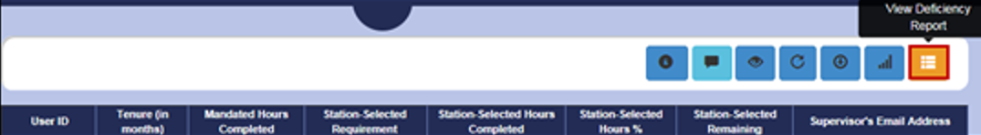

For questions regarding this job aid, contact [**VBATMSHELP.VBAVACO@va.gov**](mailto:VBATMSHELP.VBAVACO@va.gov)**.**