Introduction

This job aid provides VBA TMS Administrators**\*** with instructions on adding employees to (and removing them from) Education Service cohorts in TMS. In TMS, a ‘cohort’ contains a group of users. Education Service has created the cohorts in the following tables for the purpose of assigning training by job position. Section 1 of this job aid provides cohort IDs and TMS instructions. Section 2 lists the proper actions to take when employees change job positions.

*\*In order to obtain access to edit Education Service cohorts, TMS Admins must ask their RO Training Manager to contact the VBA Domain Manager at* [***VBATMSHELP.VBAVACO@va.gov***](mailto:VBATMSHELP.VBAVACO@va.gov)*.*

Part 1: Adding and Removing Employees to/from an Education Service Cohort

1. Select **People** from the TMS Admin Home screen.
2. Select **Cohorts** from the drop-down menu.

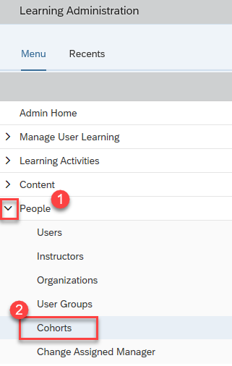

|  |  |
| --- | --- |
| ACL Cohorts | Cohort ID |
| ECSS Cohort (NTC) | VBA-393 |
| ELR Cohort (NTC) | VBA-395 |
| MA Cohort (NTC) | VBA-550 |
| Manager Cohort (CELOs & Supervisors) (NTC) | VBA-664 |
| Program Support Assistant (PSA) Cohort (NTC) | VBA-606 |
| QTS Cohort (NTC) | VBA-661 |
| O&A Compliance Contractors Cohort | VBA-968 |
| State Approving Agency (SAA) Training Cohort | VBA-1029 |

|  |  |
| --- | --- |
| VACO Cohorts | Cohort ID |
| Management Analyst (MA) Cohort (NTC) | VBA-708 |
| Training Specialist (Series 1712) Cohort (NTC) | VBA-748 |
| Supervisory Management Analyst (MA) Cohort (NTC) | VBA-750 |
| Public Affairs Specialist (Series 1035) Cohort (NTC) | VBA-752 |
| Statistician (Series 1530) Cohort (NTC) | VBA-754 |
| Quality Cohort (NTC) | VBA-1042 |

| Processing Cohorts | Cohort ID |
| --- | --- |
| ECCT Cohort (NTC) | VBA-396 |
| ECM Cohort (NTC) | VBA-524 |
| EQTS Cohort (NTC) | VBA-660 |
| Lead SVCE Cohort (NTC) | VBA-659 |
| Management Analyst (MA) Cohort (NTC) | VBA-399 |
| Supervisory VCE Cohort (NTC) | VBA-744 |
| SVCE Cohort (NTC) | VBA-658 |
| VCE Cohort (NTC) | VBA-392 |
| Administrative Support Assistant (ASA) Cohort | VBA-394 |
| Call Center Manager Cohort | VBA-663 |
| Manager Cohort | VBA-551 |
| Program Specialist (PS) Cohort | VBA-401 |
| Program Specialist (PS/Clerical) Cohort | VBA-607 |
| Program Specialist (PS/Work-Study) Cohort | VBA-549 |
| Program Support Assistant (PSA/Clerical) Cohort | VBA-547 |
| Program Support Assistant (PSA/Upstream/TIMS) Cohort | VBA-548 |
| Trainee Administrative Support Assistant (ASA) | VBA-671 |
| Trainee Call Center Manager Cohort | VBA-669 |
| Trainee ECCT Cohort | VBA-402 |
| Trainee ECM Cohort | VBA-400 |
| Trainee EQTS Cohort | VBA-667 |
| Trainee Lead SVCE Cohort | VBA-666 |
| Trainee Management Analyst (MA) Cohort | VBA-574 |
| Trainee Manager Cohort | VBA-668 |
| Trainee Program Specialist (PS) Cohort | VBA-608 |
| Trainee Program Specialist (PS/Clerical) Cohort | VBA-609 |
| Trainee Program Specialist (PS/Work-Study) Cohort | VBA-572 |
| Trainee Program Support Assistant (PSA/Clerical) Cohort | VBA-570 |
| Trainee Program Support Assistant (PSA/Upstream/TIMS) Cohort | VBA-571 |
| Trainee Supervisory VCE Cohort | VBA-745 |
| Trainee SVCE Cohort | VBA-665 |
| Trainee VCE Cohort | VBA-398 |

1. Input the desired cohort ID in the **Cohort ID** field and select **Search**.
2. Once the initial cohort record appears in the search results, select the **Edit** icon.

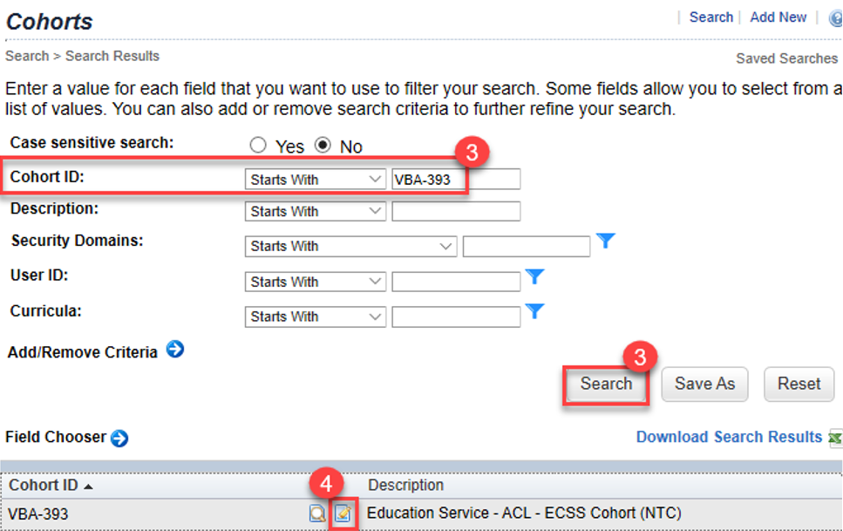

1. Within the main cohort record, select **Users** from the top menu.
2. To add an employee to the cohort, input the employee’s TMS User ID and select **Add**. To add multiple employees or to search for employees, select ‘add one or more from list’.
3. To remove an employee from the cohort, mark the ‘Remove’ check box next to the employee’s TMS User ID and select **Apply Changes**. Employees will then automatically receive any associated curricula assignments the following day.

Tip: You can press **CTRL + F** to use the search function to find names within the list on this page.

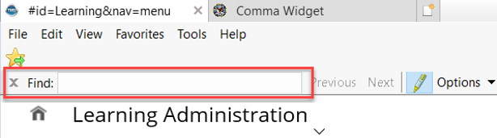

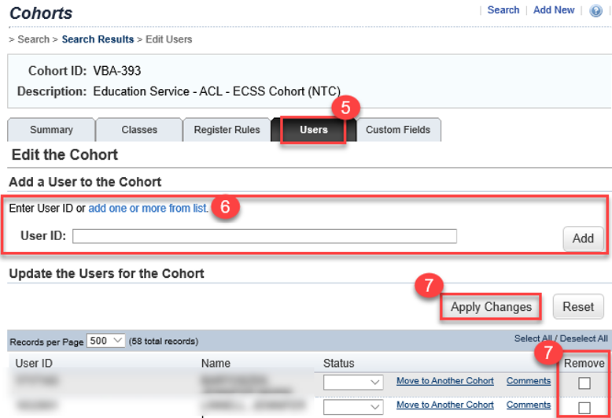

Part 2: Cohort Change Scenarios

**Scenario 1: E**mployee Completes 12-Month Trainee Status.

This situation requires the local TMS Admin to remove the employee from the trainee cohort and add them to the appropriate ‘non-trainee’ cohort for their position.

**Scenario 2:** Education Service Employee Accepts VA Position Outside of Education Service.

In this circumstance, the employee should be removed from all Education Service cohorts. The employee’s cohort and curricula assignments should be updated according to the requirements for their new position.

For questions regarding this job aid, please contact the VBA Curriculum Support Team at [**VBATMSHELP.VBAVACO@va.gov**](mailto:VBATMSHELP.VBAVACO@va.gov).

For policy-related questions, contact the following Education Service teams:

* ACL**:** [**eduopermgmt.vbavaco@va.gov**](mailto:eduopermgmt.vbavaco@va.gov)
* Processing & VACO:[**EDUTRAINING.VBACO@va.gov**](mailto:EDUTRAINING.VBACO@va.gov)