This Job Aid is designed to instruct TMs on running reports to track Compensation Service One-Time Mandated Item completions.
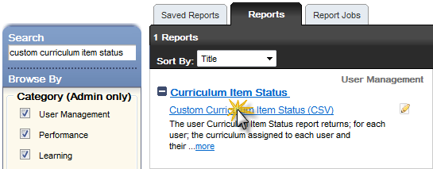
Part 1: Run the Custom Curriculum Item Status (CSV) report in TMS using the following parameters:

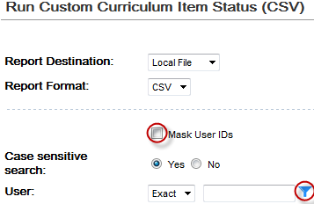
  - Uncheck the Mask User IDs box.
  - Click the filter icon next to the User field.

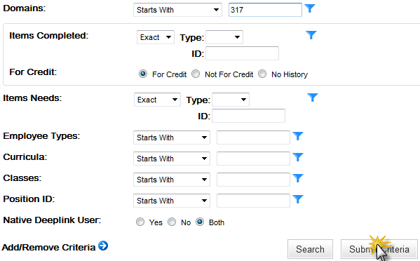
  - Within the Users Filter pop-up:

a. Enter your Station ID into the Domain field.
b. Select Submit Criteria

  - Enter the Curriculum ID in the Curricula field: (we suggest running separate reports for VSRs and RVSRs)
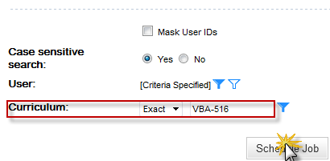
a. VBA-516 for VSRs
b. VBA-517 for RVSRs

Part 2: Making the report easier to view (optional)
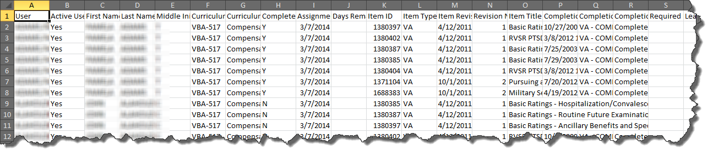
(The reports you receive from TMS will be raw and unedited. As you see above)
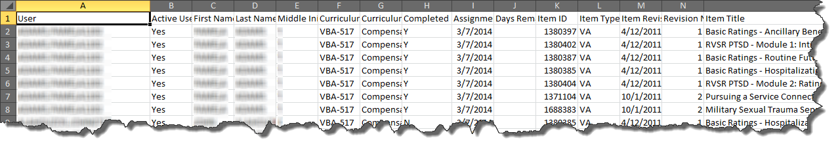
- First we suggest expanding some of the more important Columns like A(user), H(Completed), O(Item Title), P(Completion Date), Q(Completion Status ID), and R(Completion Status) to make them easier to read.

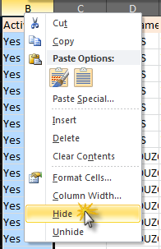
- Optional Step A: depending on preference, we suggest hiding any columns you feel you don’t need. To hide a column, Right click on the Column Letter and select Hide.

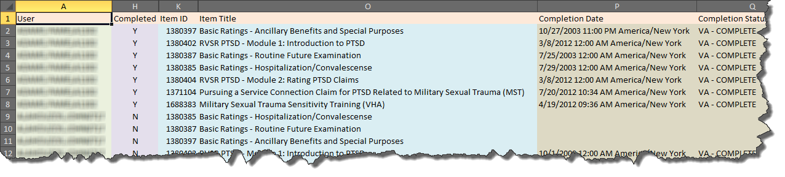
- Optional Step B: adding column highlights (fill color) can also make it easier to read as you can see below.
Part 3: Understanding the data.
- The data in column H lets you know if an employee has completed ALL of the items within the curriculum.
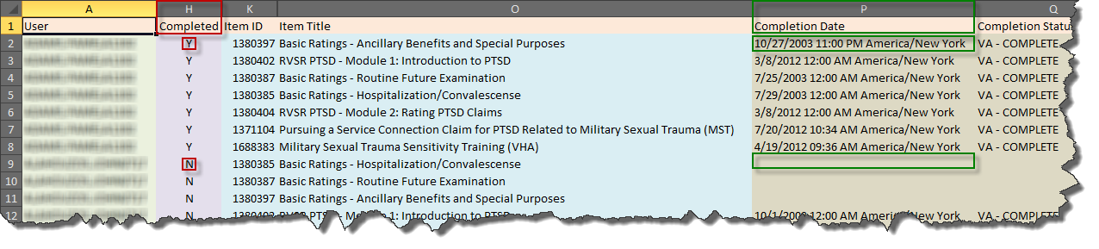
- Column P tells you the completion date of each individual item. If the cell in Column P is blank, this means the employee has not yet completed the item.
For questions regarding this job aid, please contact VBACurriculumSupport@Camber.com.

