Comma-separated lists enable TMS Administrators to quickly and easily submit multi-item and multi-user reports in TMS. Semicolon-separated lists are useful in certain applications, including creating email distribution lists. This job aid instructs VBA employees on how to convert lists of usernames, email addresses, etc., into comma- or semicolon-separated lists using the “Comma Widget” tool.
Step 1:
Select the desired delimiter from the delimiter selection drop-down box.
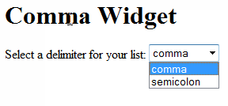
Step 2:
Select the desired item IDs or usernames within your document (e.g., Word document, Excel spreadsheet, etc.).
Press CTRL+C to copy the data.
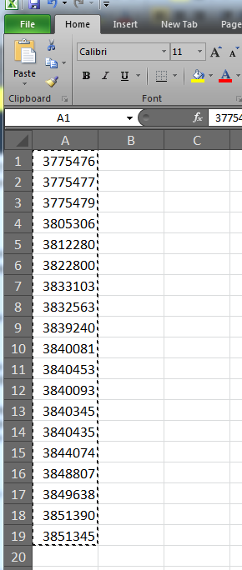

Step 3:
- Place your cursor in the first text box and press CTRL+V to paste your copied data into the field.
- Select the Make List button. The comma- or semicolon-separated list will appear in the box below. You may select the Clear All Data button if you wish to paste in a new list of items.
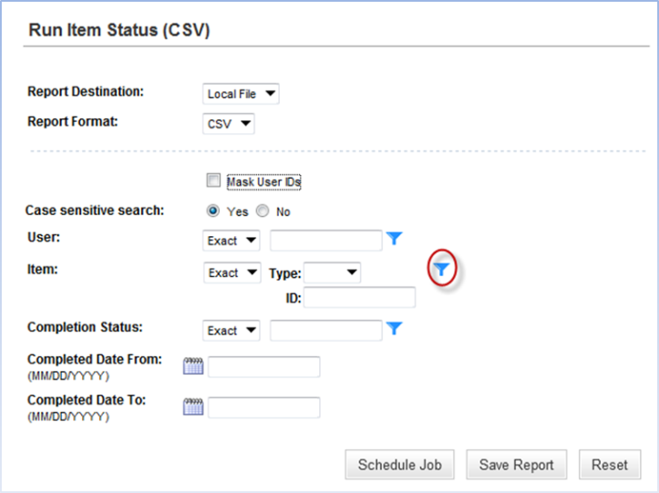
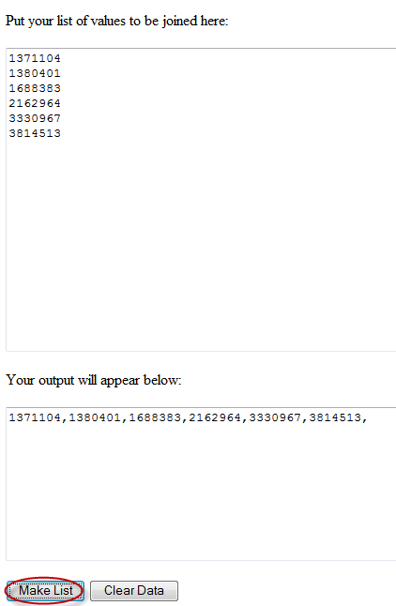
Step 4:
Paste the comma- or semicolon-separated list into the desired application. In the example to the right, we pasted a comma-separated list into a TMS Item Status (CSV) report.
From the Reports tab in TMS, select the report you wish to run.
Select the Filter icon next to the Item field.
When the Item Filter For Item Status (CSV) pop-up screen appears (see screenshot below), select Any next to the Item ID field.
Press CTRL+V to paste your comma-separated list into the neighboring field.
Select the Submit Criteria button.
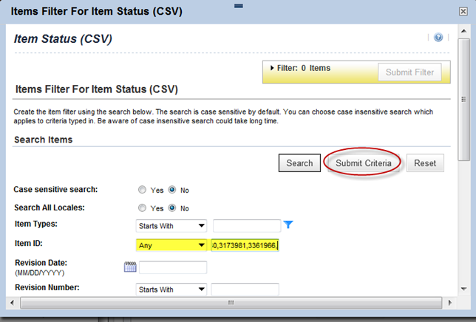
When you return to the main screen of the Item Status Report, you will notice the text (Criteria Specified) appears next to the Item field, and you are ready to run your report.
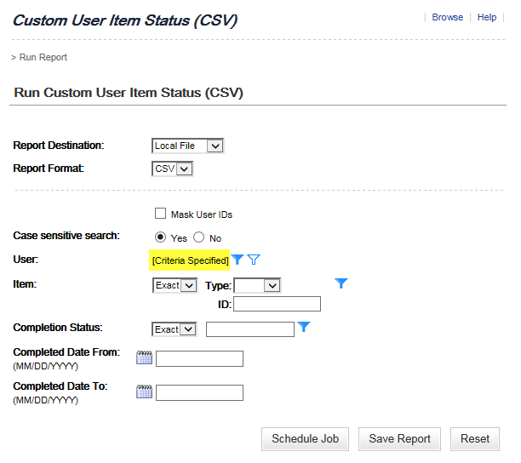

For questions regarding this job aid, please contact VBACurriculumSupport@Camber.com

