VETSNET/VOR END PrOduct 689 Reporting

Student Guide
PREREQUISITE TRAINING | Prior to this training, the trainees must be familiar with procedural directives for Integrated Disability Evaluation System (IDES), MAP-D and COVERS.
PURPOSE OF LESSON | The purpose of this lesson is to instruct the trainees on how to access critical data and workload information from VETSNET Operation Reports (VOR) and to utilize the data to track EP 689.  Provided with the appropriate manual and regulatory references, handouts, and access to VOR, the trainee will be able to:  - Accurately identify the steps needed to control a claim in the Integrated Disability Evaluation System (IDES) as well as the different applications (COVERS, SHARE, & MAP-D)  - Demonstrate accessing the VOR intranet-accessible workload management tool
Time Required | 50 min lecture to include VOR demonstration; 10 min practical exercise
Materials/ Training Aids | - VETSNET/VOR Reporting Power Point Presentation  - VETSNET/VOR Reporting Trainee Handout

References

- M21-4, Chapter 2, Workflow Management
- VOR Desk Reference Guide
- PA&I Online website
- ASPEN Guide

Disability Evaluation System (DES) Pilot Paperless Delivery of Veterans Benefits April 2009
- Disability Evaluation System (DES) Pilot Program Implementation Guide October 2009

Table of Contents

References | 2
Definitions | 4
Commonly used acronyms | 5
Control of Claims in the IDES Pilot Program | 6
Accessing VETSNET Operations Reports (VOR) | 7
VETSNET Operations Reports Screens | 12
Primary Parameters (Filters) | 16
VETSNET Operations Reports Screens | 19
Example of Microsoft Excel | 22
VETSNET Suspense Functionality-Inquiry | 23
Practical Exercise | 25

Definitions

IDES Claim – A claim initiated by Department of Defense (DoD) where the service member is assessed to determine if he/she meets medical retention standards. The Department of Veterans Affairs (VA) partners with DoD to expedite the delivery of benefits to service members who are discharged for physical disability(ies) related to service.

Paperless Claims Processing (PLCP) – The process of incorporating imaging technology into the traditional claims process to adjudicate claims in an electronic environment.

IDES Rating Activity Site (DRAS) - The Baltimore Regional Office will be the DRAS for the Paperless IDES in the National Capital Region. The DES Rating Activity Site (DRAS) has primary responsibility for rating, award, and notification actions on original and reopened claims received as part of the IDES paperless pilot. Working in cooperation with the Military Service Coordinator (MSC) and Physical Evaluation Board Liaison Officer (PEBLO), the DRAS facilitates expeditious handling of IDES claims.

Military Service Coordinator (MSC) – The MSC is assigned by the Department of Veterans Affairs (VA), and is a key participant in the IDES process, acting as a liaison for the service member, assisting the member in the VA claims process, developing the package, and notifying the member of all process findings.

Physical Evaluation Board Liaison Officer (PEBLO) – The PEBLO is the service member’s link to the service member’s commander and the disability evaluation system. The PEBLO will inform and notify the service member of the Medical Evaluation Board (MEB) process, medication retention, and Physical Evaluation Board (PEB) results and ratings. The PEBLO will also coordinate with the VA assigned MSC.

Medical Evaluation Board (MEB) – Designed to evaluate the Active Duty, National Guard or Reserve Component member’s medical condition(s) to determine if they do or do not meet the medical retention standards, documents a member’s medical status and duty limitations, and refers soldiers to the Physical Evaluation Board (PEB), if necessary.

Physical Evaluation Board (PEB) - The PEB makes the fitness determination as to whether the soldier should remain in service, should medically retire (permanently or temporarily), or should be separated (with or without benefits). PEB sites are as follows: Army (Walter Reed Army Medical Center, D.C.; Brooke Army Medical Center, Ft. Sam Houston, TX; Madigan Army Medical Center, Ft. Lewis, WA), Navy/USMC (Washington Naval Yard, D.C.), and USAF (Lackland Air Force Base, TX). Members may appeal PEB final decisions to their respective Service Secretaries.

St. Paul Scanning Facility – The scanning facility in St. Paul is responsible for the prepping, scanning, indexing of claims folders (c-folders) for the IDES paperless pilot, and for subsequent mail received as part of the Benefits Delivery at Discharge (BDD) paperless initiative. St. Paul is also responsible for completing the quality assurance process to ensure that all images committed to the Virtual VA repository are legible and retrievable by the end user community.

Imaging - The process of converting paper documents into an electronic format that can be easily accessed and manipulated through the use of computer software.

Commonly Used Acronyms

ADP | Average Days Pending
ADC | Average Days to Complete
TD | Terminal Digit
CM | Current Month
EP | End Product
DOC | Date of Claim
POA | Power of Attorney
ASD | All Suspense Dates
CSD | Claim Suspense Date
FSD | First Suspense Date
MTD | Month-to-Date
ADTC MTD | Average Days to Complete Month-to-Date

Control of Claim in IDES

- VA Form 21-0819, VA/DoD Joint Disability Evaluation Board Claim
- CEST of claim in Share with EP689 – Disability Evaluation System Claim Label
- Control development action in MAP-D
- Update location of claims folder(s) in COVERS
- Establishment and maintenance of claims folder with green IDES flash on cover
- Disability Evaluation System (PEB Pilot) Corporate Flash (remains indefinitely)
- Utilize MAP-D notes

Accessing VETSNET Operation Reports (VOR)

VETSNET Operational Reports draw data from the Corporate Record. These reports enable us to better manage the workload by providing a cycle time analysis at every stage of processing of claims, and for tracking progress on individual claims. It is necessary for these reports to be reviewed frequently and systematically to identify bottlenecks and adjust workload accordingly. The VOR reports have replaced IMS for workload management purposes.

The VOR are a suite of workload reports designed to replace the BDN, WIPP, PIF and IMS reports. These full-featured reports contain all of the functionality of existing reports.

To access the reports, you must be registered as a VOR user. Your access is linked to your LAN account. You must fill out the local VARO LAN Network Access form, which can be obtained from your local ISO. If you are still having issues with access, contact your local IT Administrator. If you are unable to resolve access issues with your ISO or IT Administrator, you or your supervisor should contact VAVBAWAS/CO/VOR.

VOR is accessible from the PA&I D&IS Intranet site at:
http://vbaw.vba.va.gov/bl/20/opai/pai/wkld/2010/files/dis.htm/

Post Initial Interview Actions

- For the EP689, add one tracked item for the requested examination(s) and update the claim level suspense in MAP-D to Special Project Team Claim, Awaiting: VAE. EP689 will remain pending throughout the entire IDES process until the member is returned to duty or is found unfit for continued service. Once the servicemember is found unfit, the EP689 shall be PCLRd before the final IDES rating is pulled into RBA2000.
- Set a 30-calendar day claim level suspense in MAP-D to follow-up on an examination request (the examination phase goal is 45 days, however follow-up is necessary to ensure the goal is met).
- Perform any additional development (processing 4142’s, etc.). Encourage the servicemember to contact the providers VA is requesting the records from to ensure the requested party responds quickly. Mail any generated MAP-D letters to the servicemember and file one copy in the c-folder. It is not necessary to generate, file, and send a letter in MAP-D for the servicemember’s examination appointment, however the tracked item for the exam is necessary.
- Use COVERS to temporarily transfer the VA claims folder to the examination site (if available). All examinations completed by VHA or VA contractor will require claims folder review. Attach a green cover sheet identifying the claim as “IDES.”
- Ensure CAPRI/VERIS print completed examination reports daily.
- Notify (via e-mail) the D-RAS that the examination(s) is complete, and should be reviewed for adequacy and completeness without the claims folder. If any examination is determined to be inadequate/incomplete, the MSC informs the PEBLO that the D-RAS has determined that the examination is inadequate/incomplete, with instructions to notify the MEB. The D-RAS has 3 calendar days to review the examinations and return them for correction to the designated facility. Hold further action pending notice from the PEBLO. Update VTA.

When All Exams are Complete

Use COVERS to permanently transfer (PTO) the VA claims folder(s) to the designated D-RAS. Attach a green cover sheet to outside of claims folder to identify as “IDES” and the point of contact for delivery.
- Send the claim folder(s) overnight to the designated D-RAS via FedEx.
- MSC shall update the MAP-D Claim Level Suspense to File Permanently Transferred to: D-RAS {313 or 346, choose appropriate DRAS] for 5 days.
- Utilize MAP-D notes.

Post MEB Actions

If the MEB determines the servicemember does not meet retention standards, and the case is referred to the PEB, the PEBLO will notify the MSC.
- MSC notifies the designated D-RAS to update the MAP-D Claim Level Suspense to Special Project Team Claim, Awaiting: IDES IPEB for 120 days.
- If the servicemember is found fit for duty at any stage of the IDES process, the PEBLO will inform the MSC. The MSC will schedule an exit interview with the servicemember. After the exit interview (see below), the MSC shall notify the D-RAS the servicemember is found fit for duty. The DRAS shall send the VA claims folder to VA Records Management Center (RMC) to the attention of the RMC Director. Ensure “IDES” green paper flash is attached to the front of the claims folder.

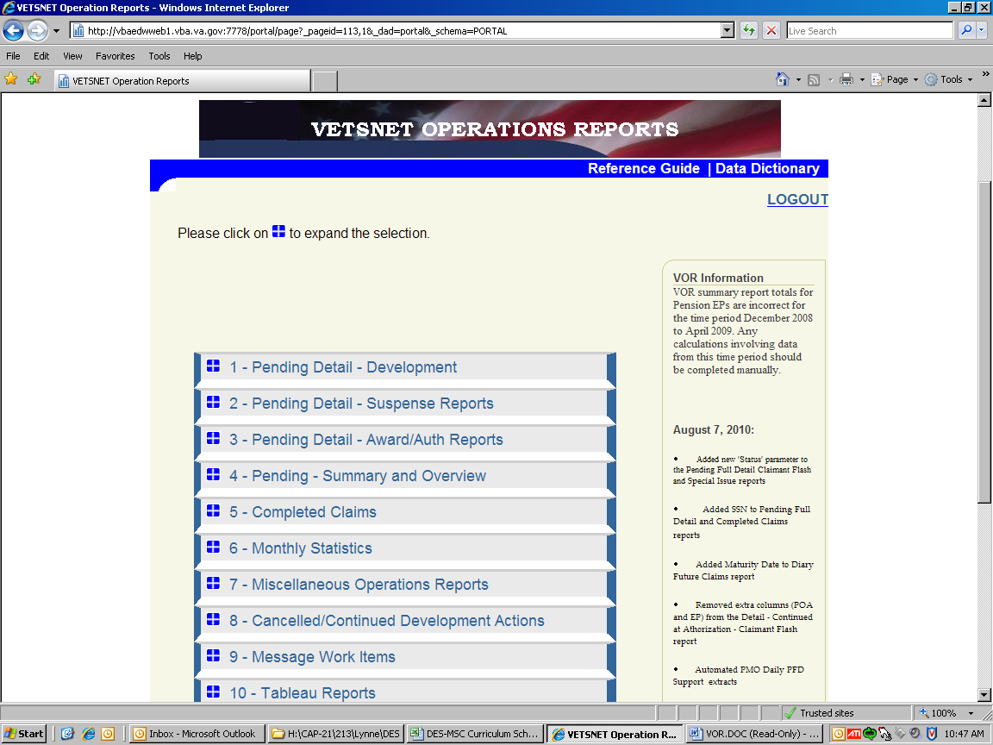
Hyperlink to VOR Data Dictionary
News / Updates

First screen after log-on
Choose: 1 – Pending Detail - Development

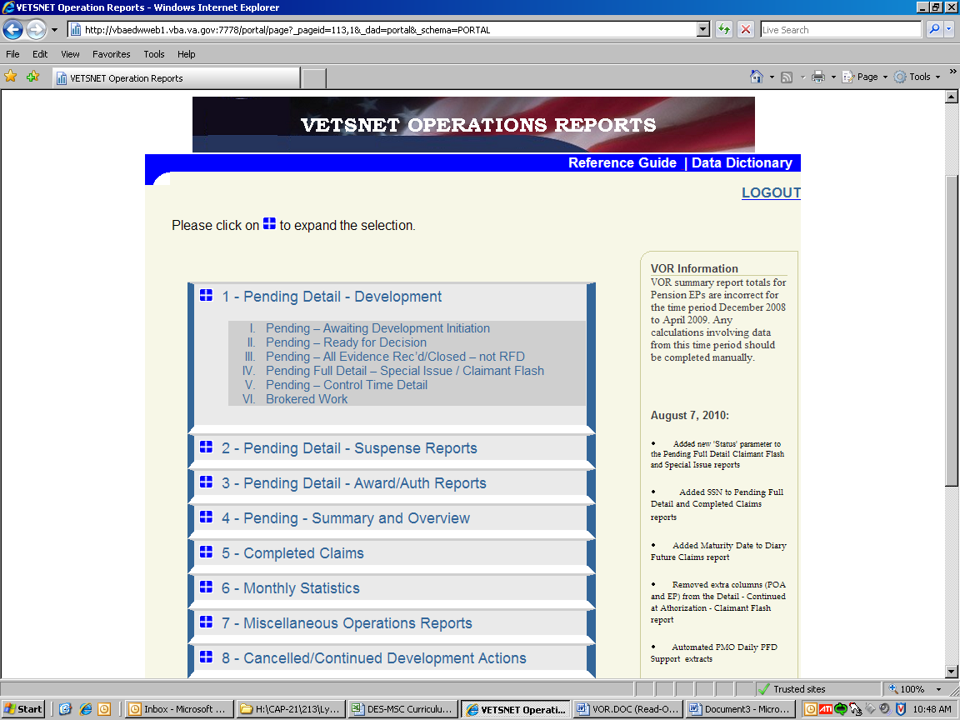

1 is expanded to 6 Categories
Choose:
IV. Pending Full Detail – Special Issue/Claimant Flash

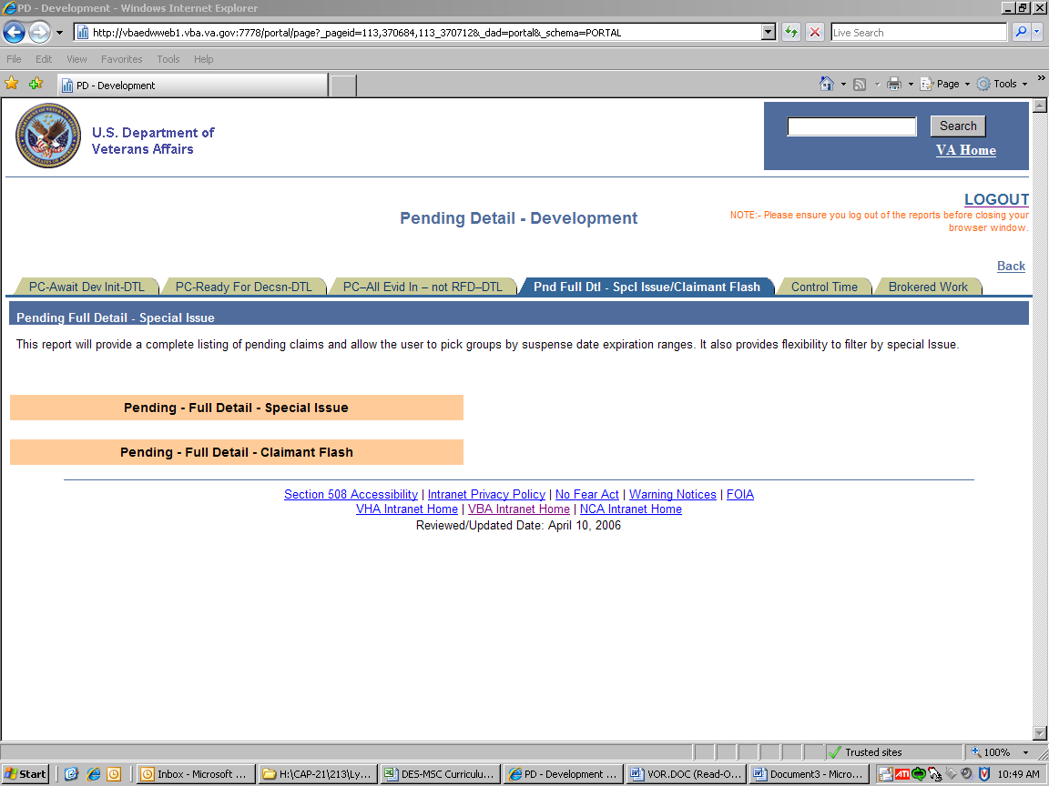

Pending – Full Detail – Claimant Flash

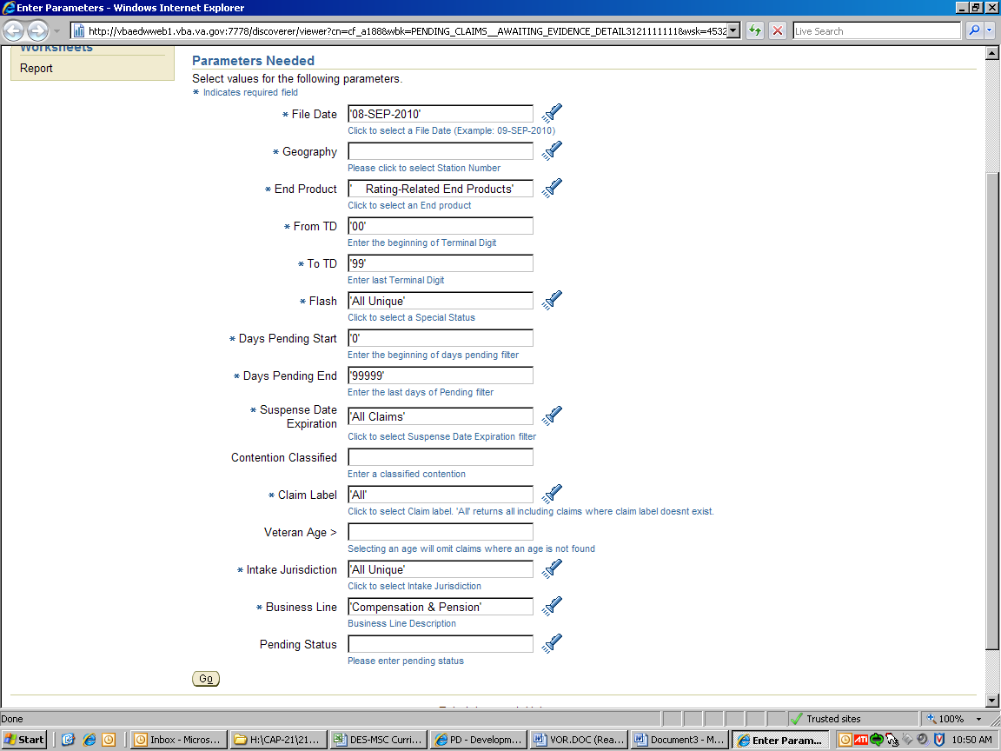

Click on the flashlight to enter the parameters for Geography

Primary Parameters (Filters)

The following filters are shown in various detail reports:

Filter | Purpose | Broadest Value – to get the most claims
File date | This is the date of the data | Choose the most recent date – this is COB prior business day
Geography | Station or stations where you want the data from | Choose your own RO for maximum efficiency
TD | Allows user to specify the terminal digit range | Select as appropriate
Special issues | This keys on the special issues in MAP-D established in contentions. A special issue exists only for the lifecycle of the claim. | The default value is “all unique claims” which returns every claim regardless of any special issue. Will only show one line per veteran – if multiple special issues exist only the first alphabetically will appear.
Flash | This keys on the VETSNET flash. A flash will appear on all claims established for the Veteran until removed. | The default value is “all unique” which returns every claim irrespective of any flash. Will only show one line per Veteran – if multiple flashes exist, the report will always show any G-WOT flash first, and then default to the first alphabetically if no G-WOT flash exists.
Days pending range | Allows user to specify the days pending range | Set low value to “1” and high value to “9999” or greater.
Suspense date | Allows user to enter parameters for the suspense date | All claims. The addition of MAP-D suspense functionality, once available in VOR, will display the MAP-D suspense information first. If no information exists, the default will be the Share PIF suspense date and reason.
Days Awaiting Development | Allows user to enter parameters for how long a claim has been pending with no development | Select “all” to see all claims awaiting development. Otherwise, choose a parameter in line with the time it is taking to initiate development in your office.
Days awaiting award | Allows user to enter parameters for how soon after a rating has been completed but not yet proposed (GAP’d) | All returns all claims awaiting award. Choose a parameter that reflects the length of time from when a rating is complete until it arrives in the Post-Determination Team for award input.

Filter | Purpose | Broadest Value – to get the most claims
Days awaiting authorization | Allows user to enter parameters for how long claims have been pending authorization | “All” shows all claims pending authorization regardless of how long pending
Contention Classified | Allows user to search for a specific Contention Classification as entered in MAP-D | No entry is required. Users can enter a standard contention classification to perform a search.
Claim Label | Allows user to search for a specific claim label | “All” provides information on all claim labels. For a complete list of claim labels, go to http://vbaw.vba.va.gov/bl/21/Systems/share.htm. Insert the “Claim Label” into the field in VOR.
Veteran Age | Allows user to search for a particular minimum Veteran age | No entry is required. Entering 70 will bring back all Veterans 70 years and older, provided there is a correct date of birth in BIRLS.
Jurisdiction Station | On brokered work reports, this parameter allows the user to specify the temporary station of jurisdiction | Choose a particular station of temporary jurisdiction, i.e., station that brokers in work, for maximum efficiency.
Jurisdiction | On brokered work reports, this mutually exclusive parameter determines whether VOR returns only brokered in work, or all work assigned to the station specified in the “Jurisdiction Station” parameter | Choose “Brokered Work Only” to view only work brokered in to the station of temporary jurisdiction, or “All Brokered and Permanent” to view both brokered and non-brokered work.
Business Line | This mutually exclusive parameter allows the user to specify claims for a particular business line. | Options available are “Compensation and Pension,” “Education,” and “Vocational Rehabilitation and Employment” for current fiscal year data. Note: To retrieve any VOR data for previous fiscal years, be sure to select “History Data Fiscal Date < Current Date” under the “Business Line” parameter.
Intake Jurisdiction | This mutually exclusive parameter is intended for use by Benefits Delivery at Discharge (BDD) and similar units | Choose “All Unique” for maximum efficiency.
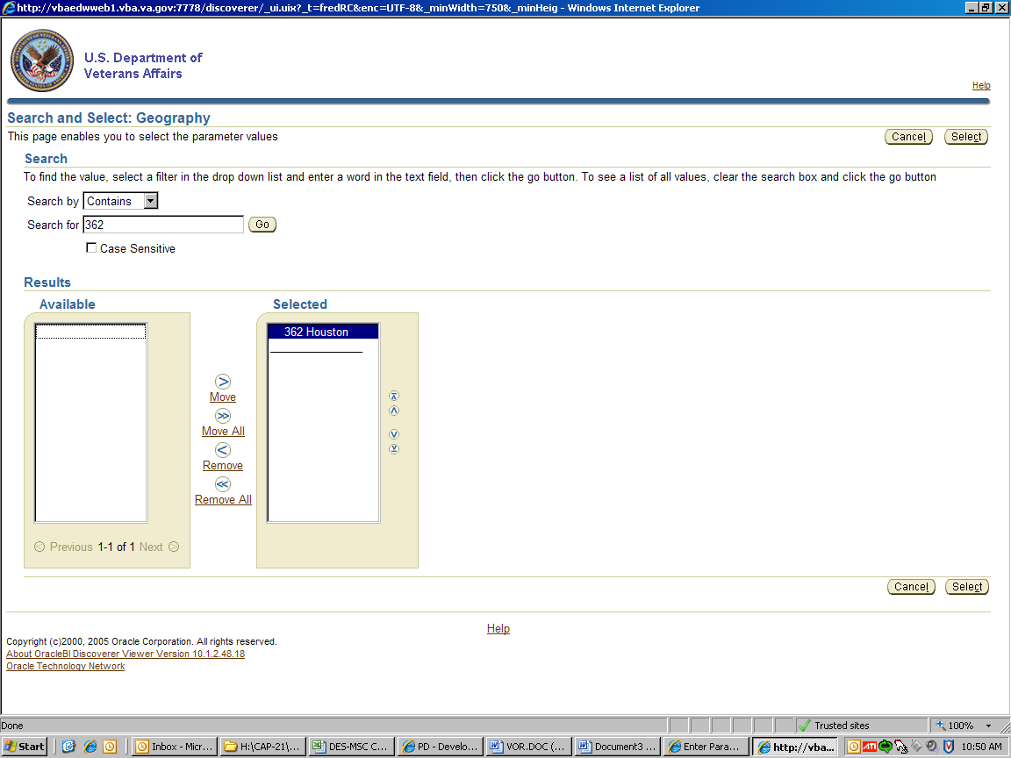

Type in your station number and click go
The station number will appear in the Available box, move to the Selected box.
Click on the select button

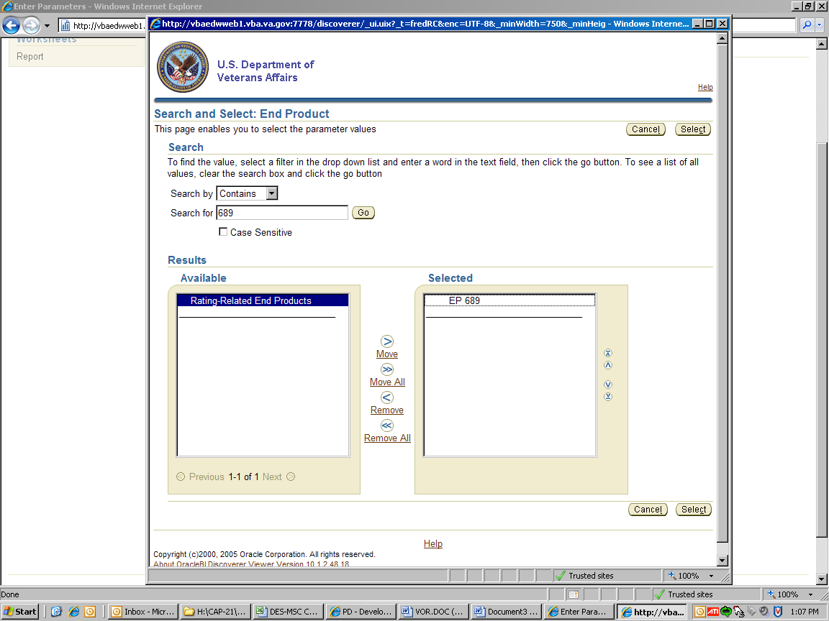

Choose the parameters for the EP 689 in the same manner.
This time REMOVE the Rating-Related End Products from the selected box.

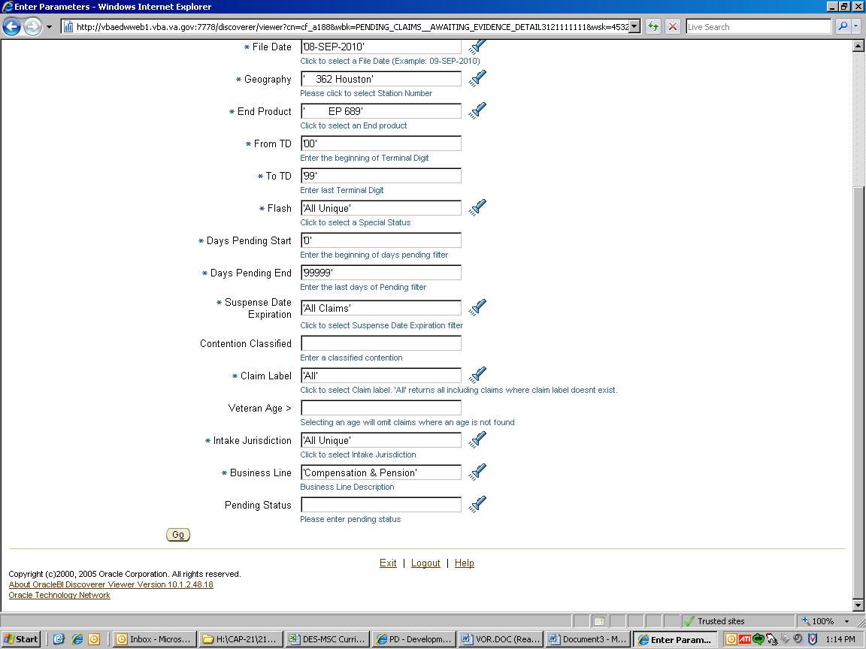

The Geography and End Product parameters have been selected.
Click on Go.
Note: You may select more parameters if needed.

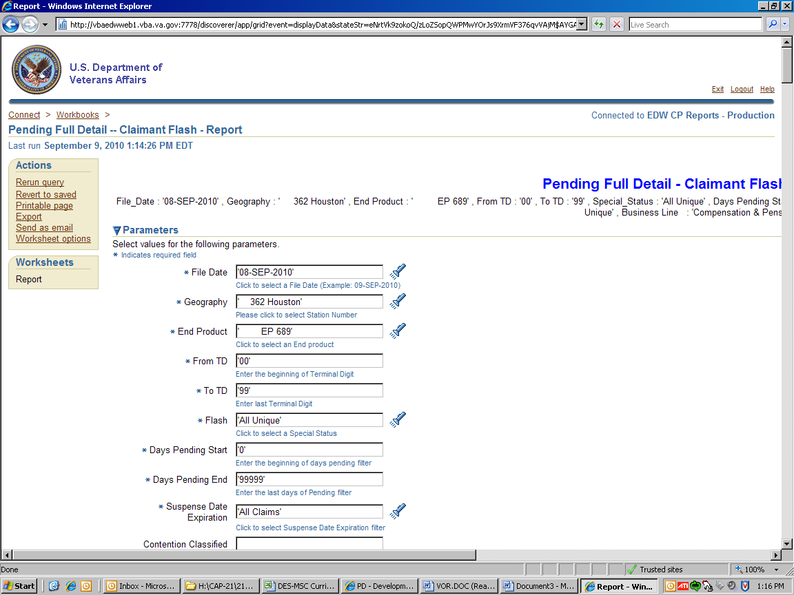

Export

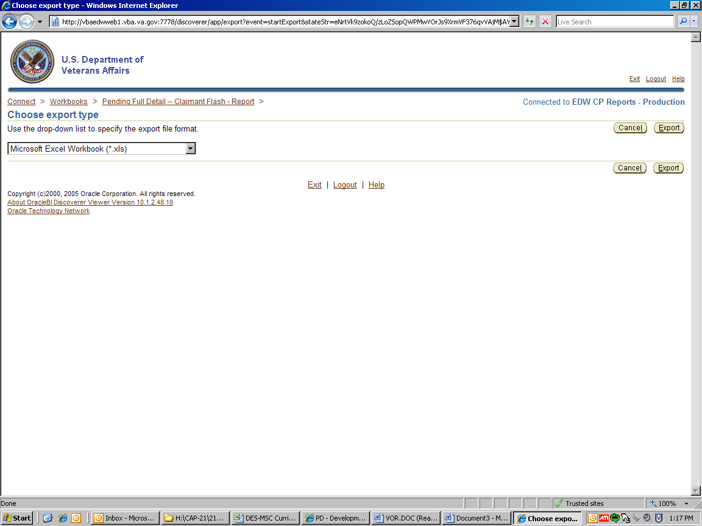

Export again!
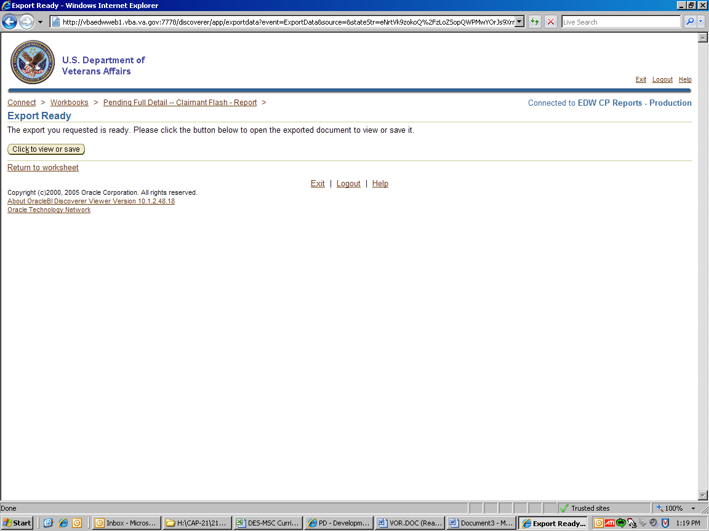

Click to view or save
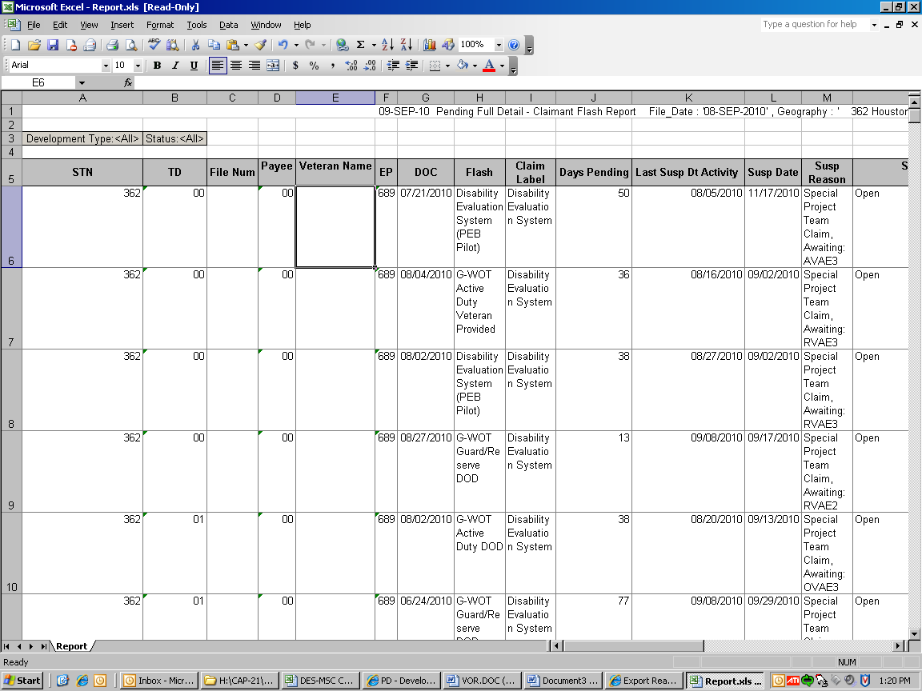
Examples of VETSNET suspense
Date of user action – when suspense was set
Organize your spreadsheet!

VETSNET Suspense Functionality – Inquiry

A claim established in Share creates an end product (EP) in BDN, known as the Pending Issue File (PIF), and a matching record in VETSNET, which contains the same EP and date of claim.

VETSNET suspense – This new functionality will include two methods for a regional office to control the suspense. The claim level suspense is similar to the PIF suspense in that it is entirely user input. The difference is that it provides more information and introduces a level of consistency not found in the four-character PIF suspense. The other method will use a development-tracked item (related to evidence requested) to automatically populate the date of the suspense, changing that date as evidence is received.

With either method, the suspense date and reason are viewable in MAP-D and Share, on the corporate inquiry screen.

MAP-D Customer Service Screen
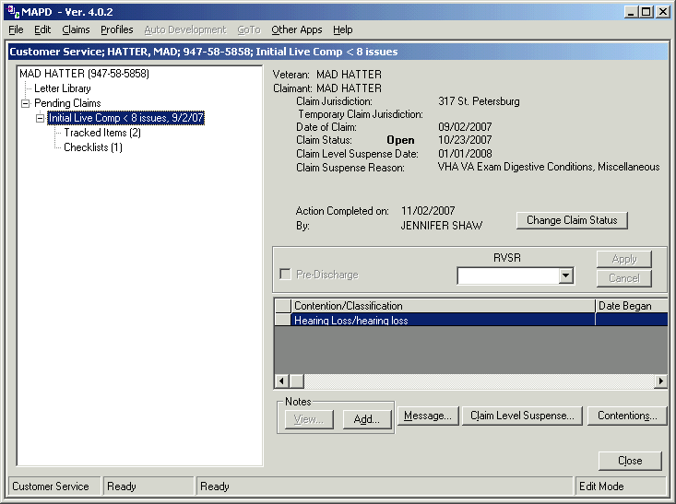

MAP-D view of the VETSNET suspense

Share Corporate Inquiry - Claims/Denials View
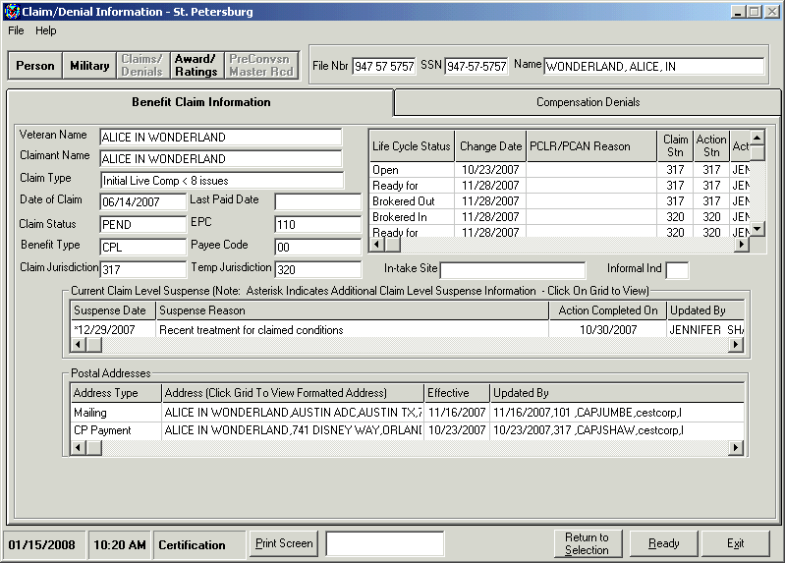

Share view of the VETSNET suspense

Suspense Dates in VOR

This information will roll-up to the suspense date fields in the VETSNET Operations Reports (VOR) when it exists on a claim, otherwise, if a suspense date has not been input in MAP-D, the reports will show the PIF suspense.

IMPORTANT: Once the MAP-D suspense has been used on a claim, it must continue to be used on that claim. Any updates to the PIF suspense will not be viewable in VOR.

For update purposes, claims processing personnel are not required to update the PIF suspense if they have properly input information for the VETSNET suspense.

For inquiry purposes, system users should also view the Share corporate inquiry (claims) for a current VETSNET suspense date. If one exists, it should be considered the true active suspense date.

Practical Exercise

What is the process of converting paper documents into an electronic format?

The VETSNET Operations Report (VOR) is designed to replace what computer applications?

3. Please match the correct purpose to the filter.

Filters |  | Purpose
Example: Business Line |  | Allows the user to specify claims for a particular business line
1.Suspense Date |  | a.) Exclusive parameter used for BDD
2. Flash |  | b.) Allows user to specify the terminal digit range
3. Intake Jurisdiction |  | c.) This is the date of the data
4. Geography |  | d.) Will appear on all claims established for the Veterans
5. TD |  | e.) Allows users to specify the days pending range
6. File date |  | f.) Allows user to enter parameters for the suspense date
7. Days pending range |  | g.) Station(s) where you want the data from

