ADC 103-
Review of service treatment records &
post service Treatment Records
Handout

PREREQUISITE TRAINING | Prior to this training, you should have demonstrated proficiency in basic development skills or should have completed the VSR Curriculum Training for the Pre-Determination Team at http://cptraining.vba.va.gov/C&P_Training/vsr/VSR_curriculum.htm.  You should also have completed the following 100 level courses:  - ADC 100—Fundamentals of Legal Requirements  - ADC 101—Medical Terminology  - ADC 102—Introduction to Medical EPSS and the Body Systems
PURPOSE OF LESSON | The purpose of this lesson is to teach you how to efficiently review Service Treatment Records (STRs) and Post Service Treatment Records (PSTRs) to find information needed to develop a claim. This lesson will allow you to practice your skills on actual STRs/PSTRs. STR review will focus primarily on the newer type of STRs and not the type used during WWII through the 1950s.  This lesson will present the following material:  - Basic organization of STRs  - Identification of entrance and separation physical examinations  - Explanation of the SOAP format (used in STRs and PSTRs)  - Review of general location of information found in STRs  - Review of general location of information found in PSTRs  - Tips on how to efficiently review records
Time Required | 2.5 hours
Instructional Method | Lecture, participatory discussion, and practical exercise.
Materials/ Training Aids | - Note pad and writing utensil  - Access to reference material  - Advanced Development Curriculum Student Handbook and Student Guide  - Tabbing aides
Topic Objectives | At the end of this lesson, the trainee will be able to:  - Explain the organization of the STRs.  - Identify different types of information may be found most efficiently.  - Review STRs and PSTRs efficiently.
REFERENCES | M21-1-MR III.iii.2.A.1

Basic Organization of STRs

Generally, the newer type of STRs used by the services starting in the late 1970s or early 1980s are separated into four parts. If the STRs are still in their original jackets, these parts can be opened like a book. The left inside is page 1, the left side of the middle page is page 2 (to the right of page 1), the right side of the middle page is page 3 (to the left of page 4) and the right inside page is page 4.
Each service uses a slightly different format for filing down evidence and forms and this format has also changed somewhat over time. Information found in STRs is generally in chronological order, new information is filed on top during the veteran’s active service. Records from the 1960’s and early 1970’s only have two sides, page 1 and 2.
STRs in their original jackets are organized as follows:
- Page 1 (four-sided STRs): Back-filed on this page, or in the newer type of STRs included as a cardboard attachment, is a treatment summary (often titled Preventative and Chronic Care Flow Sheet). These forms may have different names but are generally completed by the treatment provider and give a good history of surgeries, chronic conditions, allergies and other information that treatment providers want to highlight. Below this summary, you will often find physical profile reports, audiology reports and other specialized types of reports that depending on the veteran’s occupation.
- Page 1 (two-sided STRs): These records may or may not have a back-filed treatment summary. Often you will find physical exams filed on this side as well as some specialty tests and physical profile reports.
- Page 2 (four-sided STRs): This is where you will find treatment notes. Treatment notes are records of clinic visits and emergency room visits. You will also find referrals to specialty providers (often titled Requests for Consultation), and abbreviated mental health notes. Most military mental health clinics keep separate mental health files but cross reference visits in the STRs; these cross-referenced entries often do not show the diagnosis or reason for visit to the Mental Health Clinic.
- Page 2 (two-sided STRs): Radiology reports, laboratory reports and some other specialty tests are filed on the bottom and treatment notes are filed chronologically on the top. Sometimes, you will find the entrance examination and other physical exam reports on the bottom or inter-filed amongst the treatment reports.
- Page 3: This is where you will find entrance and separation physicals, periodic physicals and some tests associated with the physicals.
- Page 4: Here you will find radiology reports (x-ray reports), laboratory test results/reports, and biopsy results.

Please keep in mind that the basic organization of records may vary by military service and time.

Additionally, if the STRs are removed from their original jackets, they should maintain a similar order in the STRs envelopes.

How to Identify the Entrance and Separation Physical Exam

To identify the entrance and separation physical exams in the STRs, you will need to know the dates the veteran entered and separated from service.
When reviewing the STRs, the entrance and separation physical exams can be noted by the status of the veteran. Often the status of the veteran or type of exam is noted as “Civilian” on the entrance examination or “Separation Exam” for a separation physical exam.
You may find it helpful to tab these two records for future reference.

SOAP Format

The SOAP format found in treatment records came into use by the military in the late 1970’s and early 1980’s. Generally, you would only look at the S and the A parts and not read the full note. You will also notice that many treatment records will use different abbreviation to signify each section. Some of these variations are included below:

S or H Subjective summary or history of the patient’s reason for seeking medical advice/help or symptoms experienced
O Objective finding by the treatment provider during the examination
A, I(Imp) or Dx Assessment (the diagnosis, or in some cases the provisional diagnosis pending further tests)
P Plan for treatment or medication prescribed

See below for an example of a treatment record in SOAP format.
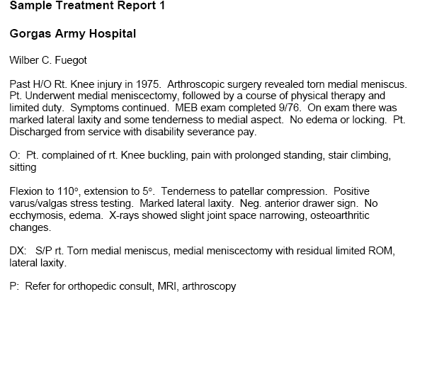

General Information Found in STRs

The following is a basic list of information found in the STRs:

- Entrance and Separation Physical Exams: Each document consists of two parts: a self-report by the veteran regarding medical history and problems experienced and a body system review part completed by the physician.
- Medical Evaluation Board (MEB) and Physical Evaluation Board (PEB): These reports are generally very comprehensive and provide a lot of background information.
- Preventative and Chronic Care Flow Sheets (or equivalents): These are found on page 1 of the STRs in the original jackets. They often provide excellent summaries of chronic medical conditions, surgeries, and injuries.
- Hearing Conservation Data (DD Form 2216E or equivalent): These are periodic audiological examinations.
- Physical Therapy and X-ray Reports: They provide information regarding orthopedic conditions and injuries. Refer to the Crib Notes found in the Student Handbook for more information.
- Emergency treatment reports (SF 558 or equivalent): These provide information regarding injuries and acute conditions. They list assessment/diagnosis on the middle of the left side of the page.

General Information Found in PSTRs

Generally, post service treatment records utilize the SOAP format and review and tabbing should be limited to finding one instance where the claimed condition was noted.

How to Efficiently Review Records

In order to review Service Treatment Records and Private Treatment Records efficiently you should:
- Limit your review as much as possible.
- Locate and tab the entrance and separation physical exams in the STRs.
- Review the body of the STRs only if the claimed condition(s) are not listed on the separation examination or one or more are listed on the entrance examination.
- Tab where a claimed condition is located if it is not mentioned on the separation physical exam.
- Take brief notes on the development checklist.
- Tab post service records only to show the claimed condition exists.
- Refer to the Service Treatment Record and Post Service Treatment Record Crib Notes for additional tips and strategies.

