Due Process
tRAINEE handout

PREREQUISITE TRAINING | Prior to this training, the trainees must have completed the following training:  - VA Terminology  - Reference Materials (WARMS & Manual Training)  - Tour of the C&P Website  - TPSS Module 1, Original Claim for Compensation Introduction, Lesson 1 through 4.  - Introduction to MAP-D  - Dependency for Compensation  - Introduction to VETSNET  - Introduction to SHARE  - Introduction to PCGL  - Is This Case Ready to Promulgate; to include VA Form 21-526/VCAA Duty to Assist  - Claims Recognition/Records Management
PURPOSE OF LESSON | The purpose of this lesson is to teach students the rules and regulatory requirements for adverse actions involving VA benefits.  At the end of this lesson, the student will be able to:  - define due process as it pertains to VA benefits  - differentiate between predetermination and contemporaneous notice  - identify the situations when predetermination is required versus situations when contemporaneous notice is appropriate  - list the necessary components of pre-determination, post-determination and contemporaneous notices
Time Required | 1 hour lecture, 1 hour practical hands on
Instructional Method | Interactive lecture  Classroom discussion  Review exercises
Materials/ Training Aids | - Due Process Trainee Handouts  - Due Process PowerPoint Presentation
Table of Contents

Due Process Trainee Handout……………………………………………………1
Table of Contents………………………………………………………………...2
References………………………………………………………………………..3
Definition of Due Process……..…………………………………………………4
Notification Letters………………………………………………………………5-6
Proposal Rating.………………………………………………………………….7-8
VBA Ready Screen…………………………..…………………………………..9-10
MAPD Contention Screen……………………………………………………….11-13
Predetermination Notice……………………..…………………………………..14-15
Review Exercise………………………………………………………………….16-17
Pre Determination Notice Sent……………………………………………………18

REFERENCES

- 38 CFR 3.103, Procedural due process and appellate rights
- 38 CFR 3.105(e)(i), Reduction in evaluation-compensation, Predetermination hearings
- 38 CFR 3.110, Computation of time limit
- 38 CFR 3.217, Submission of statements or information affecting entitlement to benefits
- 38 CFR 20.304, Filing additional evidence does not extend time limit for appeal
- 42 U.S.C. 659(a)
- M21-1MR, Part I, Chapter 2, Due Process
- M21-1MR, Part IV, Subpart ii, Chapter 3, Section B, Failure to Report for Review of Examination
- M21-1MR, Part III, Subpart v, Chapter 1, Administrative Decisions
- M21-1MR, Part III.iv.8.B.6.c, Providing a Due Process Period
- M21-1MR, Part III.iv.8.E, Other Due Process Concerns
Definition of Due Process

US Constitution:

Fifth Amendment to the US Constitution

No person shall be held to answer for a capital, or otherwise infamous crime, unless on a presentment or indictment of a grand jury, except in cases arising in the land or naval forces, or in the militia, when in actual service in time of war or public danger; nor shall any person be subject for the same offense to be twice put in jeopardy of life or limb; nor shall be compelled in any criminal case to be a witness against himself, nor be deprived of life, liberty, or property, without due process of law; nor shall private property be taken for public use, without just compensation.

Fourteenth Amendment to the US Constitution

“No state shall make or enforce any law which shall abridge the privileges or immunities of citizens of the United States; nor shall any state deprive any person of life, liberty or property without due process of law; nor deny to any person within its jurisdiction the equal protection under the law.”

The reference in the 5th Amendment applies only to the federal government and its courts and agencies. The reference in the 14th Amendment extends protection of due process to all state governments, agencies, and courts.

How Due Process Applies to VA Benefits

- Due process is a legal concept embodied in the United States Constitution.

- Due process is essentially advising a claimant of our action or proposed action, and of their right to provide additional evidence or have a personal hearing before the decision makers.

- In most cases due process is to be considered when we reduce or discontinue a benefit. In some cases, such as a character of discharge determination, due process is for consideration before we make a determination of eligibility for VA benefits.

NOTIFICATION LETTERS

THREE TYPES:

- Predetermination notice:
  - tells the beneficiary of a proposed adverse action
  - no action is taken to adjust the award for 65 days

- Contemporaneous notice:
  - informs beneficiary of an adverse action that has been taken
  - No advance notice is provided

- Post-determination notice:
  - tells the beneficiary that a final action has been taken
  - only sent after the expiration of the predetermination period

Components of a Predetermination Letter
M21-1MR, Part I.2.B.5.a
Every notice of proposed adverse action (predetermination notice) must include the following elements:
- a statement of the proposed decision, including old rates paid and proposed new rates of payment
- the proposed effective date of the decision
- information of the possible creation of an overpayment
- detailed reason for the proposed decision, and
- the rights to:
  - present evidence,
  - request a personal hearing,
  - have representation.

Components of a Post-determination Letter
M21-1MR, Part I.2.C.12.b
Every post-determination notice must be sent to the beneficiary and representative (if applicable) and include:
- a statement of the decision (including new rates, if applicable)
- a statement of the effective dates
- detailed reasons for the decision
- overpayment information, and
- appeal rights.

Components of a Contemporaneous Notice Letters
M21-1MR, Part I.2.D.15.b

Notification requirements for contemporaneous notice are the same as for post-determination notices, but no advance notice (notice of proposed action) was given prior to the decision:
- a statement of the decision (including new rates, if applicable)
- a statement of the effective dates
- detailed reasons for the decision
- overpayment information, and
- appeal rights

DEPARTMENT OF VETERANS AFFAIRS
Lincoln Regional Office
5631 S 48th ST
Lincoln NE 68516

VA File Number

Represented by:
AMERICAN LEGION

Rating Decision
April 20, 2007

INTRODUCTION

The records reflect that you are a veteran of the Vietnam Era. You served in the Navy from March 31, 1966 to April 7, 1968. We have received a copy of your recent VA examination dated April 12, 2007. Based on a review of the evidence listed below, we have made the following decision(s) on your claim.

DECISION

Evaluation of prostate cancer; status post radical retro pubic prostatectomy, which is currently 100 percent disabling, is proposed to be decreased to 0 percent.

EVIDENCE

- VA examination, VA Nebraska-Western Iowa Health Care System, dated April 12, 2007
- Addendum to VA examination dated April 19, 2007
- Treatment reports, VA Nebraska-Western Iowa Health Care System, from November 7, 2006 through February 20, 2007.

REASONS FOR DECISION

Evaluation of prostate cancer; status post-radical retro pubic prostatectomy currently evaluated as 100 percent disabling.

The evaluation of prostate cancer; status post radical retro pubic prostatectomy is proposed to be decreased to 0 percent disabling.

The VA examiner indicated that your last antineoplastic treatment was in late 2006. You have no recurrent urinary tract infections, obstructed voiding, renal dysfunction or renal failure. You continue to dribble and leak urine on a daily basis. You denied incontinence. You use no protective garments, pads, or devices. You denied any other residuals of prostate cancer or treatment.

A noncompensable evaluation is assigned unless there are disabling dysfunctions of the genitourinary system.

If proposal to reduce is implemented your overall combined evaluation will be reduced from 100 percent to 50 percent. You will continue to be entitled to special monthly compensation on account of loss of use of a creative organ.

REFERENCES:

Title 38 of the Code of Federal Regulations, Pensions, Bonuses and Veterans' Relief contains the regulations of the Department of Veterans Affairs, which govern entitlement to all veteran benefits. For additional information regarding applicable laws and regulations, please consult your local library, or visit us at our web site, www.va.gov.

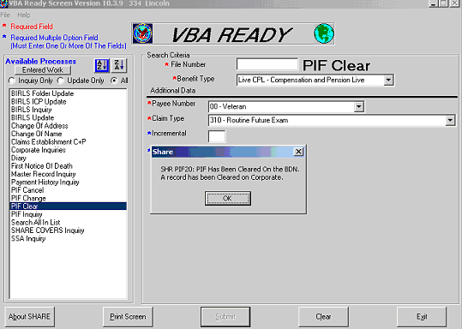

Upon receipt of the rating PCLR the pending EP 310.
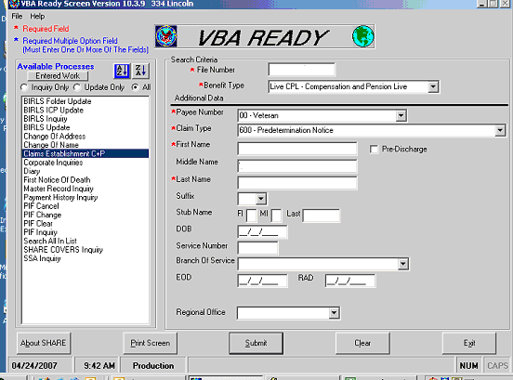

CEST an EP 600 for control of due process period.

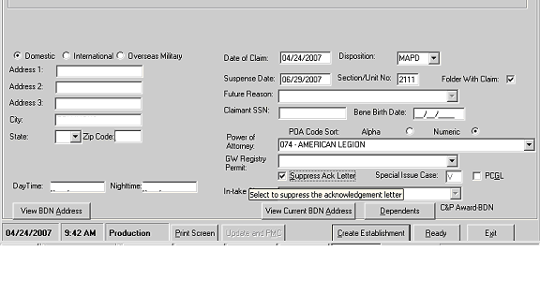

Use today’s date as the date of claim and set your suspense date at 65 days from the date of claim.

Suppress the acknowledgement letter. Once the issue is established, continue to MAPD.

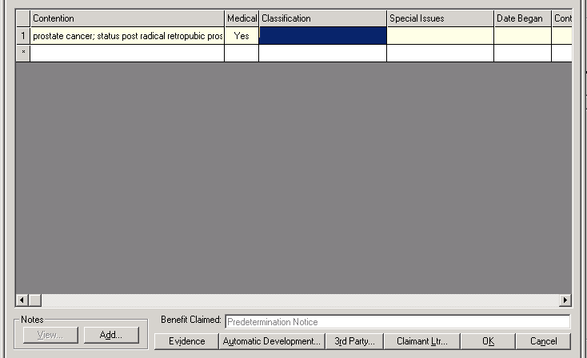

In the contentions screen you should type out the condition exactly as it is written on the front sheet of the rating decision because you will be using this contention later on as a fill-in for your letter.

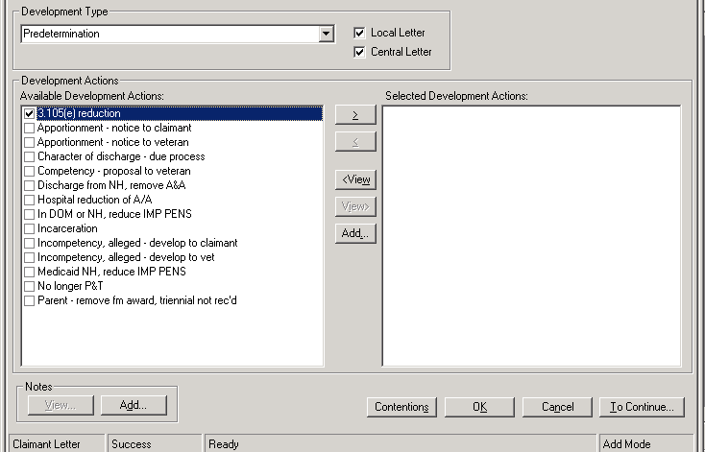

Under the Predetermination heading, you will select the 3.105(e) reduction letter.
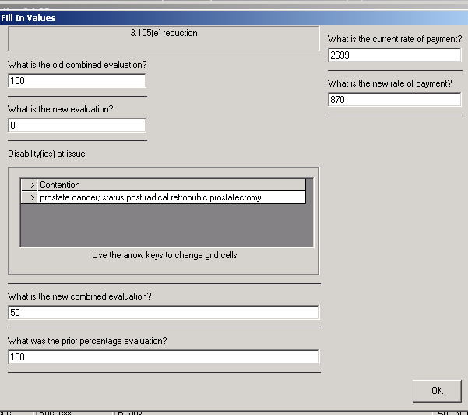

You will complete the pop-up screen as indicated above.

To obtain the new rate of payment, you can go into the C&P Rate Tables, so that you have the correct amount listed in your letter.

For VETSNET AWARDS, you will need to familiarize yourself with reading the Disability Compensation rate tables.

If your rates and dates are incorrect in your letter, you may have to do another letter, which extends the due process period 65 days.
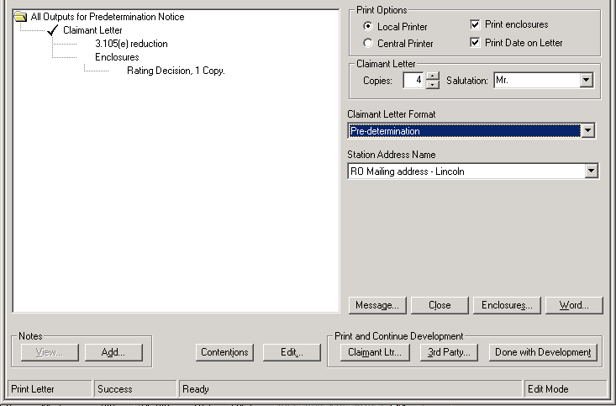

The claimant letter format should be the Pre-determination selection.

You’ll notice that MAPD lists the Rating Decision as an attachment for you.

In Reply Refer To:
334/211/jnr
CSS

IMPORTANT — reply needed

Dear Mr. Veteran:

We have reviewed medical records concerning your service-connected conditions and noted some improvement in your prostate cancer; status post radical retro pubic prostatectomy.

We propose to reduce the prior evaluation of its disabling effect from 100% to 0%. The combined evaluation for all of your service-connected disabilities will drop from 100% to 50%. This will not affect your entitlement to special monthly compensation on account of loss of use of a creative organ.

This proposed action does not affect your entitlement to treatment for service-connected conditions. We propose to reduce your monthly rate of compensation from $2,699.00 to $870.00.

How Did We Make Our Decision?
We have enclosed a copy of our Rating Decision for your review. It provides a detailed explanation about our proposed decision.

What Evidence Can You Submit?
You may submit medical or other evidence to show that we should not make this change. You may submit this evidence in person, through the mail or through your accredited representative. The best type of evidence to submit is a statement from a physician who recently treated or examined you. It should include detailed findings about the condition(s). If we do not receive additional evidence from you within 60 days, we will reduce your evaluation. Reduced payments will begin the first day of the third month following our notice to you of the final decision.

How to Obtain a Personal Hearing
If you desire a personal hearing to present evidence or argument on any point in your claim, notify this office and we will arrange a time and place for the hearing. If you want, you may bring witnesses and their testimony will be entered in the record. VA will furnish the hearing room and provide hearing officials. VA cannot pay for any other expenses of the hearing since a personal hearing is held only on your request.

If, within 30 days from the date of this notice, VA receives your hearing request, we will continue payments at the present rate until we have held the hearing and reviewed the testimony. Continuing to receive the current rate of payment until a hearing is conducted could result in the creation of an overpayment, which you must repay. If you request a hearing but wish to minimize any overpayment which could result, you should submit a statement asking that we reduce or suspend your benefits beginning with your next check.

You may request a hearing after 30 days; however, we may continue with our proposed action.

How to Obtain Representation
An accredited representative of a veterans' organization or other service organization recognized by the Secretary of Veterans Affairs may represent you, without charge. An accredited agent or attorney may also represent you. However, under 38 U.S.C. 5904(c), an accredited agent or attorney may only charge you for services performed after the date you file a notice of disagreement. If you desire representation, let us know and we will send you the necessary forms. If you have already designated a representative, no further action is required on your part.

Please see the enclosed VA Form 21-0789, “Your Rights to Representation and a Hearing”, for more information regarding your due process rights.

How Can You Contact Us?
If you are looking for general information about benefits and eligibility, you should visit our website at http://www.va.gov. Otherwise, you can contact us in several ways. Please give us your VA file number, XXX XX XXXX, when you do contact us.

- Call us at 1-800-827-1000. If you use a Telecommunications Device for the Deaf (TDD), the number is 1-800-829-4833.
- On the Internet at https://iris.va.gov.
- Write to us at the address at the top of this letter.

Sincerely yours,

M.E. Bunde
Veterans Service Center Manager

Enclosures: Rating Decision
VA Form 21-0789

Review Exercise
[Use the 38 CFR and Manuals to answer the following questions.]

- What is the regulation that governs due process procedures for VA benefits?

- Who must be sent advance notification of adverse action?

- A veteran calls in to report that his spouse passed away on January 23, 2006. The VSR confirmed the veteran’s identity and properly completed a VA form 119 “Report of Contact” documenting this. What action do you take? What type of notification is sent to the veteran?

- VA received an anonymous telephone call that a veteran’s spouse died in November of 2003. There is no evidence in the file to show the spouse is currently alive. Attempts to reach the veteran by telephone have been unsuccessful. What action do you take? What internal controls are established?

- A veteran sends in a signed statement indicating that his son is no longer attending college and that he left school on March 10, 2006. What action do you take? What type of notification is sent to the veteran?

- VA sent a veteran notification on May 23, 2006 that his benefits would be reduced based on evidence that his knee disability had improved. A written request for a hearing was received on June 11, 2006. What action do you take?

- VA sent a veteran notification on April 3, 2006 that his benefits would be reduced because his daughter (school child) was no longer attending an approved facility. He sends in a request for a hearing which was received by the office on May 25, 2006. What action do you take?
PRE-DETERMINATION NOTICE SENT
Establish 600 EP, 65-day control PCLR non due process EP if in order, or establish/continue until issue is resolved

NO RESPONSE

OR NO CHANGE IN DECISION
Final action taken after 65 days **. EP’s cleared.

RESPONSE & DEVELOPMENT
NOW REQUIRED
Develop
Payments
Continue *. Extend control period 30 to 60 days.

HEARING REQUESTED
WITHIN 30 Days Priority Scheduling. Payment continue *. Extend control for 30 to 60 days.

HEARING REQUESTED
After 30 Days regular scheduling. Proposed action taken after 65 days unless development action is pending.

FINAL DECISION MADE
Award action, as necessary.
EP’s cleared

