Dependency for compensation
TRAINEE Handouts
PREREQUISITE TRAINING | Prior to this training, you must have completed the Original Compensation Claims lesson.
PURPOSE OF LESSON | The purpose of this lesson is to teach you the evidentiary requirements and rules for establishing dependents and adding them to disability compensation awards. You will also learn the evidentiary requirements and rules for removing dependents.  At the end of this lesson, you will understand the:  - Different types of dependents for which additional disability compensation can be paid  - Rules for establishing dependents for disability compensation purposes  - Rules for removing dependents for disability compensation purposes
Time Required | 3 hours
Instructional Method | Interactive lecture, Classroom discussion, and Review Exercises
Materials/ Training Aids | Dependency for Compensation Trainee Handouts  Dependency for Compensation PowerPoint Presentation

Dependency for compensation
Trainee Handouts

Table of Contents

References.…………………………………………………………………………….……. 3
Who is a Dependent? Handout..……………………………………………………….……... 4
Review Exercise 1.…………………………………………………………………….……… 5
Review Exercise 2.…………………………………………………………………….…… 6
Review Exercise 3.…………………………………………………………………….…… 7-8
Dependency – Add Spouse.………………………………………………………….……… 9-11
Dependency – Add a minor Child.…………………………………………………….……12-15
Dependency – Change minor Child to School Child.………………………………….……16-18
Dependency – Add a School Child.…………………………………………………….……19-21
Dependency – Add a Helpless Child……………………………………………………..…..22-24
Dependency – Helpless Child attends school.…………………………………………….….25-28
Dependency – Add Spouse aid & attendance.………………………………………….…….29-31
Dependency – Remove a dependent.………………………………………………….…………32

REFERENCES

- 38 CFR 3.1(j), Definitions, Marriage
- 38 CFR 3.4(b)(2), An additional amount of compensation
- 38 CFR 3.50, Spouse and surviving spouse
- 38 CFR 3.57, Child

- 38 CFR 3.204, Evidence of dependents and age
- 38 CFR 3.210, Child's relationship
- 38 CFR 3.315 (a), Child over 18 years
- 38 CFR 3.401(b), Veterans, Additional compensation or pension for dependent

- M21-1MR III.iii.5, F & G, Relationship and Dependency

- M21-1MR III.iii.5.F.35.c, Subsequent Disability Rating of at Least 30 Percent
- M21-1MR III.iii.6, School Attendance
- M21-1MR III.iii.7, A Child’s Permanent Incapacity for Self-Support
- M21-1MR V.i.3.E.17.a, General Information on Development for SSNs
- M21-1MR III.v.2, Award and Denial Authorization & Notification

- Fast Letter 10-39, Adding a dependent without claims folder review

Who is a Dependent?
(For VA Compensation benefits)

Remember, a veteran must have at least a 30% combined evaluation due to service-connected disabilities before dependency becomes an issue.
Each time any rating decision grants a Veteran a combined disability evaluation of a least 30 percent..
If the Veteran subsequently responds to evidence/information requested about his/her dependent(s) within one year, grant entitlement to additional compensation from the later of the following dates:
- Effective date of the evaluation granted in the rating decision, or
- Date dependency arose

Important: This policy applies even if the rating activity previously determined the Veteran was at least 30 percent disablied and is now:

- Increasing the evaluation of an existing disability or establishing service connection for a new disability (regardless of whether or not the combined evaluation changes)
- Granting entitlement to a total disability rating based on individual unemployability
- Granted entitlement to special monthly compensation, and/or
- Establishing an earlier effective date for a combined disability evaluation of 30 percent or greater

NOTE: If, during routine review of a claims folder, it is discovered that a rating decision completed on or after October 15, 2009, entitles a Veteran to additional compensation for (a) dependent(s) from an earlier effective date based on Sharp v. Shinseki, take action to correct the Veteran’s award.

Exception: The policy stemming from Sharp v. Shinseki does not apply to:

- Pension awards, and
- Subsequent rating decisions that only
- Confirm and continue (a) currently disability evaluation(s), or
- Deny service connection

Spouse of Veteran (Dependency assumed)

38 CFR 3.50(a), 38 CFR 3.1(j)

Children of Veteran (Dependency assumed)

General: 38 CFR 3.57, Legitimate vs. Illegitimate 38 CFR 3.210

- Biological child 38 CFR 3.57(a)
- Stepchild 38 CFR 3.57(b)
- Adopted child 38 CFR 3.57(c)

Additional subcategories
- Helpless children 38 CFR 3.57(a)(1)(ii)
- School children 38 CFR 3.667

Parents of Veteran (Actual dependency must be shown)*

General: 38 CFR 3.59
38 CFR 3.250
M21-1MR III.iii.5.I

- Biological parent
- Adoptive parent
- Foster parent

*We will not be discussing dependency of parents in this lesson.

Examples of those who cannot be considered dependents:

- Foster children of veteran
- Grandchildren of veteran
- Ex-spouses of veteran
- Parents of veteran who cannot establish financial dependency

Review Exercise 1

- Under what circumstances may a veteran be paid additional compensation for dependents?

- What are the three types of dependents for which additional compensation may be paid?

- Which regulation provides the general description of a child?

- What type of evidence is normally sufficient to establish a dependent for VA benefits purposes?

- What are the two types of formal decisions that are sometimes required to establish a dependent for VA benefits purposes?

- Which section of the Manual provides general information regarding relationship and dependency?

Review Exercise 2

- What should the veteran’s statement of marriage contain at a minimum?

- When is documentary evidence of marriage required?

- What are the age requirements for a child to be considered a dependent child of a veteran?

- In order for a stepchild to be considered a dependent, what additional requirement must be met?

- What form is used to file a claim for a school child?

- In reference to school children, what is meant by non-duplication of benefits?

Review Exercise 3

- How long does a veteran have from the date of his/her initial notification of entitlement to qualifying compensation to file a claim for dependents?

- What regulation describes the effective date for adding dependents?

- What regulation must you apply to effective dates when determining payment dates?

- What is the compensation rate payable for a veteran who is rated as 60% disabled, with a spouse and a child as of February 1, 2007?

- A veteran has a running award of compensation at the 40% level. You received a VA Form 21-686c on March 23, 2006 on which the veteran claims the birth of a child on November 8, 2005. (Assume all information was provided on the form.) What is the effective date to add the child to the award? What is the payment date?

- A veteran is in receipt of compensation and is receiving additional dependency benefits. On August 10, 2005, he provides a properly completed VA Form stating that his child is still in high school and would not graduate until June 2006. The child’s date of birth is April 3, 1987. Answer the following questions:
- What date is the child’s status changed to school child?

- What VA form is used to add or change the status of a child to school child?

- What is the effective date to change dependency status from child to a school child?

- What is the effective date to remove the child from the veteran’s award?

- Give the manual reference for adding and removing a child.

- What is the effective date to remove a spouse of a veteran who died on October 3, 2006?

- You receive a clipping from a newspaper along with an unsigned note indicating that the spouse of a veteran has passed. What action do you take?

Dependency - Add spouse

As with every dependency action, you will need to add the reported family member first in Share via the PIF Change (or CEST) function before attempting to pay for the dependent in the Awards application.

In this example, the veteran is rated 30% effective 02/15/2006, with a pay date (award effective date) of 03/01/2006.

Select the Dependency button in the row of decision screen buttons to open the Dependency decision screen.

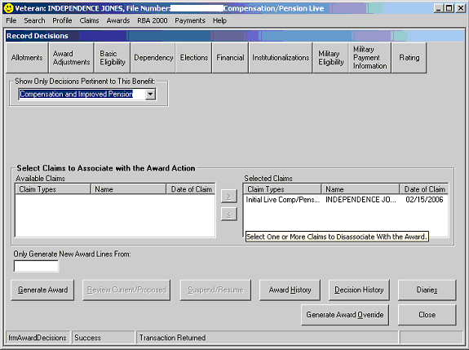

- Select the Add button.

- Select the Person for whom a dependency decision will be made.

The system will list all dependents that have been previously established as family members during the Share CEST or PIF Change process. In this case, Martha Jones is the spouse.

The Relationship Type, Date of Birth, and SSN information will be automatically populated based on the information entered in Share during the CEST or PIF Change process.

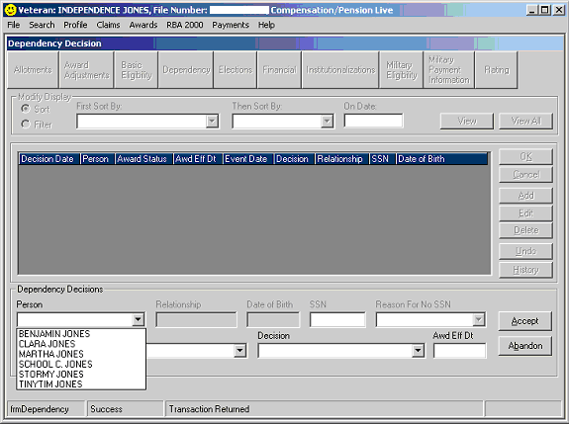
1
23

- If the person does not have a SSN assigned or is a foreign national, select the reason that no SSN exists.

- Enter the Event Date. In this case we are working on an original award and will use the effective date of the rating, 02/15/2006.

- Select the Award Status of Spouse.

- Select the Decision of Dependency Established.

- Once the Decision is selected, the system will automatically record the Award Effective Date. This field can be modified if needed.

- Select the Accept button to update the grid.

- Select the OK button to save the decision and close the screen.

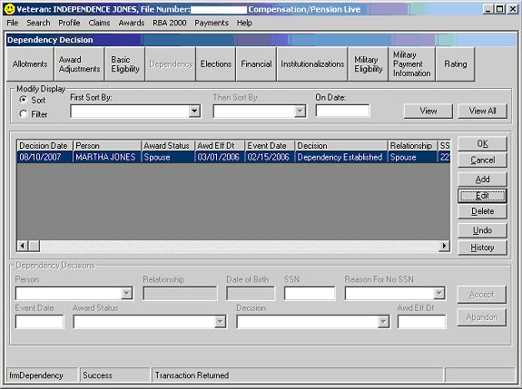
3
4
5
6
7
8

Dependency - Add a minor child

As with every dependency action, you will need to add the reported family member first in Share via the PIF Change (or during CEST) function before attempting to pay for the dependent in the Awards application.

In this example, the veteran is rated 30% effective 02/15/2006, with a pay date (award effective date) of 03/01/2006.

Select the Dependency button in the row of decision screen buttons to open the Dependency decision screen.

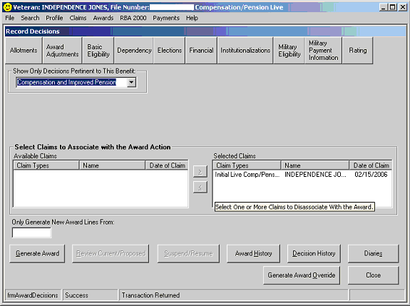

- Select the Add button.

- Select the Person for whom a dependency decision will be made.

The system will list all dependents that have been previously established as family members during the Share CEST or PIF Change process. In this case, Clara is the minor child.

The Relationship Type, Date of Birth, and SSN information will be automatically populated based on the information entered in Share during the CEST or PIF Change process.

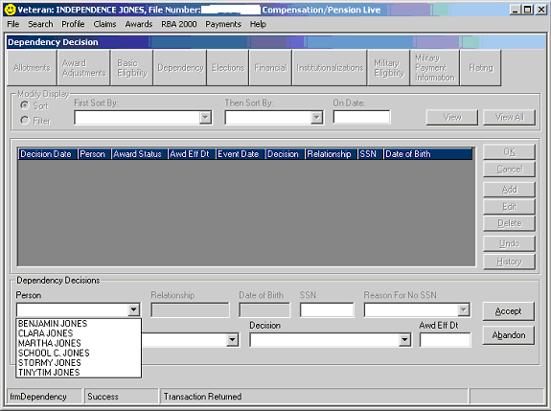
1
2

- Enter the Event Date. In this case we are working on an original award and will use the effective date of the rating, 02/15/2006.

- Select the Award Status of Minor Child.

- Select the Decision of Eligible Minor Child.

- Once the Decision is selected, the system will automatically record the Award Effective Date. This field can be modified if needed.

- Select the Accept button to update the grid.

- Select the OK button to save the decision and close the screen.

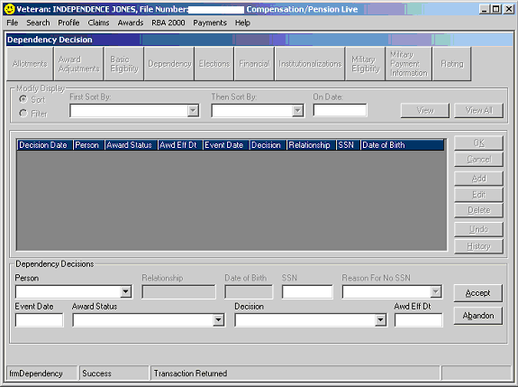
7
8

4
5
6
3

Note that the system will automatically add the decision to remove the child on the 18th birthday.

See the screen below for the expected display.

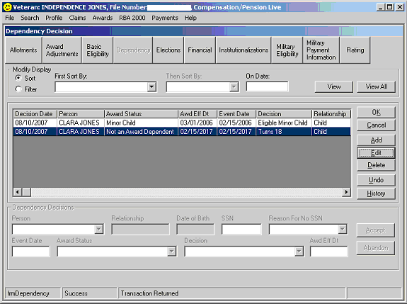

Dependency – Change minor child to school child

For a situation where a minor child was already an award dependent through the 18th birthday and is now attending college, it may be necessary to pay the additional minor child benefit through the end of the month in which the child turned 18.

Select the Dependency button in the row of decision screen buttons to open the Dependency decision screen.

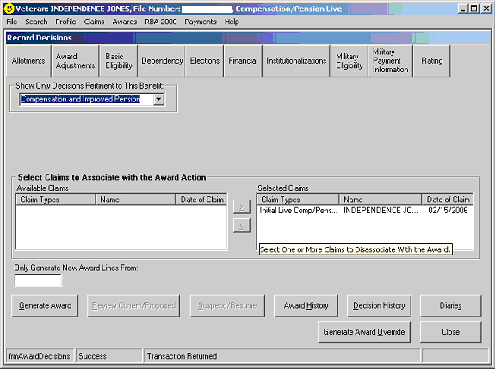

The Dependency Decision screen will be displayed.

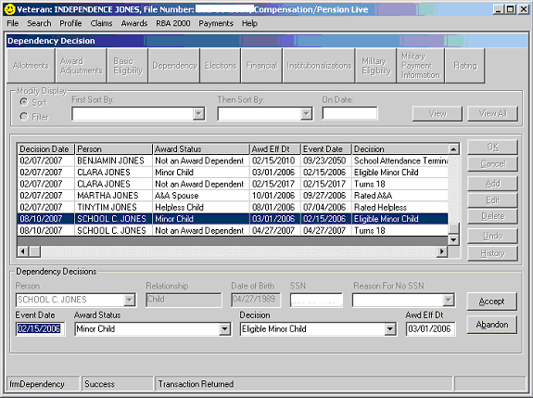
1
2
4 – Change to School Child
5 – Change to School Attendance Begins
6 – Change to first of the month following the month school begins
7

- Select the row indicating that the child was removed for turning 18.
- Select the Edit button.
- The information for that row will be displayed in the Dependency Decisions grid.
- Change the Award Status to School Child.
- Change the Decision to School Attendance Begins. The system will automatically set the Event Date and the Award Effective Date to the 18th birthday.
- Change the Award Effective date to the first of month following the month school begins.
- Select the Accept button.

A message will display requesting that the date school attendance ends be recorded.

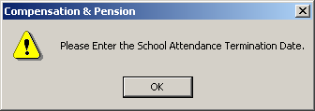
8

- Select OK and enter the date the child is expected to graduate in the Event Date field. The system will automatically put the first day of the following month into the Award Effective Date field or the 23rd birthday, whichever comes first.
- Select Accept to update the grid as shown below.

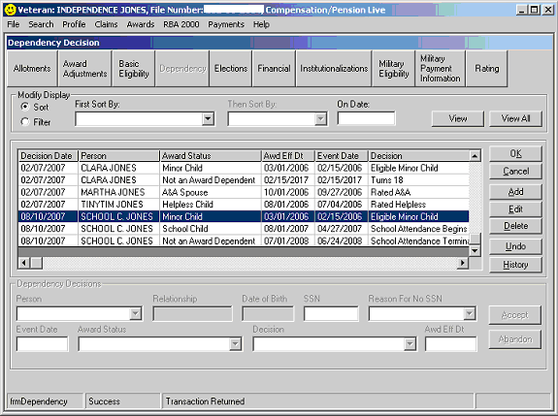
9
10
11

- Note there are three lines for School C. Jones now. One for the add date, one for the status change, and one for the removal.
- Select OK to save the decisions and close the screen.

Dependency - Add a school child

As with every dependency action, you will need to add the reported family member first in Share via the PIF Change (or during CEST) function before attempting to pay for the dependent in the Awards application.

In this example, the veteran is rated 30% effective 02/15/2006, with a pay date (award effective date) of 03/01/2006.

Select the Dependency button in the row of decision screen buttons to open the Dependency decision screen.

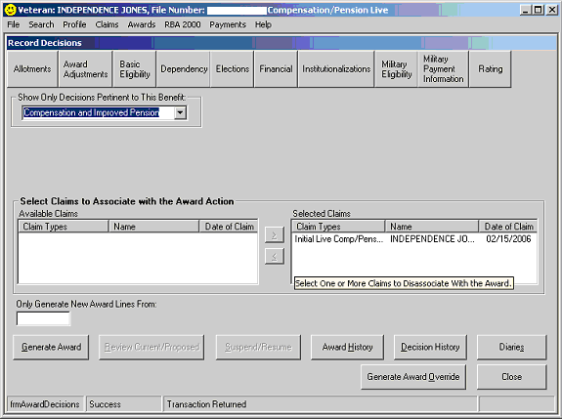

- Select the Add button.

- Select the Person for whom a dependency decision will be made.

- The system will list all dependents that have been previously established as family members during the Share CEST or PIF Change process. In this case, Benjamin is the school child.

- The Relationship Type, Date of Birth, and SSN information will be automatically populated based on the information entered in Share during the CEST or PIF Change process.

- Enter the Event Date. In this case we are working an original award and will use the effective date of the rating, 02/15/2006.

- Select the Award Status of School Child.

- Select the Decision of School Attendance Begins.

- Once the Decision is selected, the system will automatically record the Award Effective Date. This field can be modified if needed.

- Select the Accept button to update the grid.

- A prompt will display to notify that the school termination date must be entered.

- Select OK.

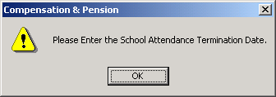

Enter the date the child is expected to graduate in the Event Date field.

The system will automatically input the first of the following month as the Award Effective Date.

Note: if the school attendance continues beyond the child’s 23rd birthday, the system would automatically input the 23rd birthday.

- Select the OK button to save the decision and close the screen.

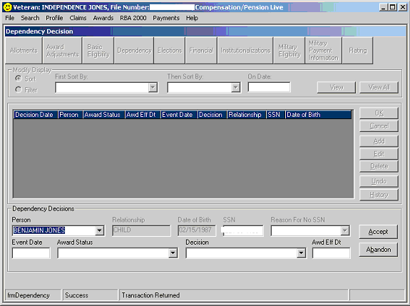
2
1
3
4
5
6
7
8

Dependency - Add a helpless child

- Before adding a helpless child through the dependency screen, first check to make sure that there is a rating decision to support the payment.

- Select the Rating button on the Record Decisions screen.

- View the Family Member Ratings tab.

- A helpless child decision should display as shown below.
1
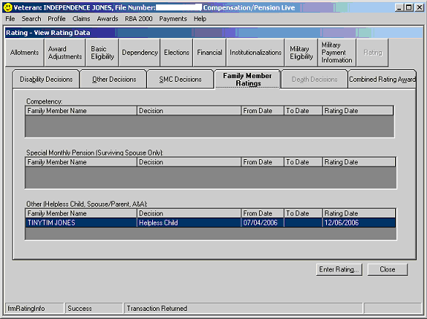
2

Select the Dependency button in the row of decision screen buttons to open the Dependency decision screen.

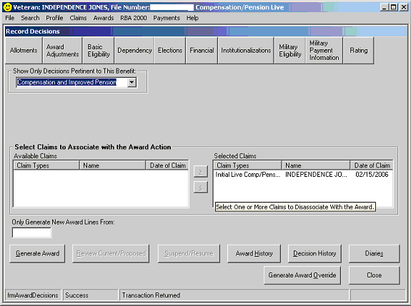

- Select the Add button.

- Select the Person for whom the dependency decision will be made.

The system will list all dependents that have been previously established as family members during the Share CEST or PIF Change process.

The Relationship Type, Date of Birth, and SSN information will be automatically populated based on the information entered in Share during the CEST or PIF Change process.

- Enter the Event Date. In this case we are working a helpless child rating and will use the effective date of the rating, 07/04/2006.

- Select the Award Status of Helpless Child.

- Select the Decision of Rated Helpless.

- Once the Decision is selected, the system will automatically record the Award Effective Date. This field can be modified if needed.

- Select the Accept button to update the grid.

- Select the OK button to save the decision and close the screen.

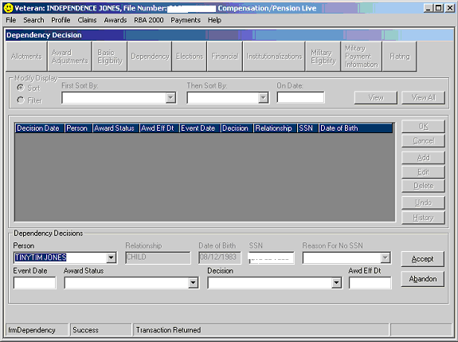
1
2
3
4
5
7
8
6

Dependency - Helpless child attends school

For compensation, a greater rate is payable if a helpless child attends an approved school. To pay the additional benefit while the child is in school, complete the following steps on the Dependency decision screen.

- Select the Add button.

- Select the helpless child (in this example Tiny Tim), under Person.

- Enter the Event Date equal to the first day of school attendance.

- Select the Award Status of School Child.

- Select the Decision of School Attendance Begins.

- Once the Decision is selected, the system will automatically record the Award Effective Date. This field can be modified if needed.

- Select the Accept button.

A prompt will display to notify that the school termination date must be entered.

- Select OK.

8

- Enter the date the child is expected to graduate in the Event Date field

- The system will automatically input the first of the following month as the Award Effective Date.

Note: if the school attendance continued beyond the child’s 23rd birthday, the system would automatically input the 23rd birthday.

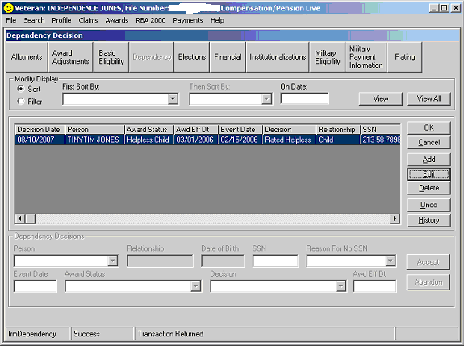
1
3 and 9
4
5
7
6 and 10
2

Unfortunately, if you were to stop here, the system would stop paying for the child entirely as of 08/12/2006 – this child’s 23rd birthday as shown below.

To continue paying for the child at the helpless rate:

- Select the data line for Tiny Tim indicating he is no longer an award dependent.

- Select the Edit button.

- Change the Award Status to Helpless Child.

- Change the Decision to Rated Helpless.

- Change the Awd Eff Dt to the 23rd birthday (or date school attendance terminates if the child is under age 23.

- Select Accept to update the grid.

- Select OK to save the decision and close the screen.

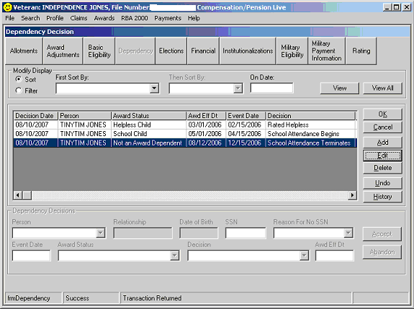
11
12
13
14
16
17
15
The system will pay for Tiny Tim for the entire award, but pay the increased rate for a school child from the time he began attending school until his 23rd birthday.

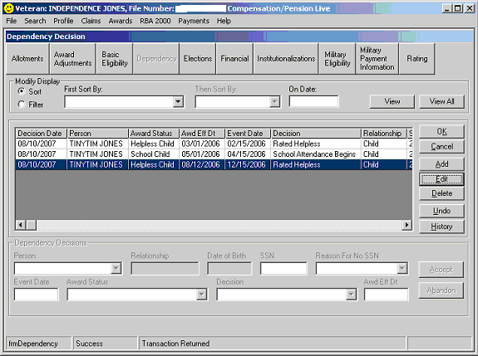

Dependency - Add Aid & Attendance for a spouse

Before paying the additional amount for Aid and Attendance for a spouse, first check to make sure that there is a rating decision to support the payment.

- Select the Rating button.

- View the Family Member Ratings tab.

An Aid & Attendance decision should appear as shown below.
1
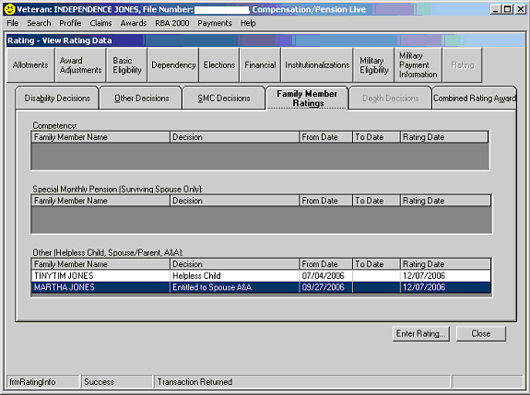
2

In this example, the spouse was previously added as an award dependent effective 02/15/2006.

The rating decision does not establish entitlement to A&A until 09/27/2006. Therefore, another dependency decision must be added.

On the Dependency screen:

- Select the Add button.

- Select the spouse from the Person drop down menu.

- Enter the Event Date which should be equal to the effective date of A&A per the rating decision.

- Select the Status of AA Spouse.

- Select the Decision of Rated A&A.

- Once the Decision is selected, the system will automatically record the Award Effective Date. This field can be modified if needed.

- Select the Accept button to update the grid.

- Select the OK button to save the decision and close the screen.

1
2
3
4
5
7
8
6

The screen is shown below after adding the Aid and Attendance decision.

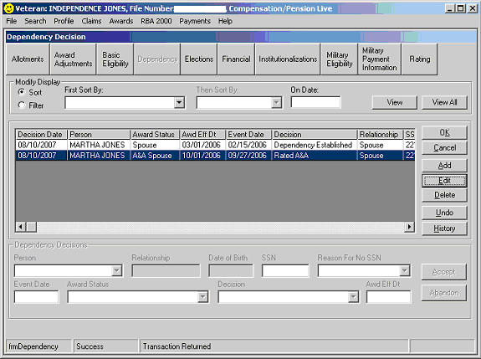

Variation:

If A&A had been granted back to the date the spouse was added to the award (in this case the original date of claim), it would be necessary to select the line establishing the spouse followed by the Edit button to change the Award Status to A&A spouse and the Decision to Rated A&A.

Dependency - Remove a dependent

Remove any dependent from the initial eligibility date:

To remove a dependent effective the date you were initially added to the award, use the following steps on the Dependency screen:

- Select the line in the grid that initially established the dependent
- Select the Delete button.
- Select the Accept button.
- Select Yes to the prompt displayed to confirm the decision to delete the decision.
- Select OK to save the decision and close the screen.

Remove spouse or helpless child dependent after the initial eligibility date:

- To remove a dependent spouse after the initial eligibility date for the dependency:

- Select the Add button.
- Select the spouse or helpless child from the Person drop-down menu.
- Select the Award Status of Not an Award Dependent.
- Select the Decision that supports removing the dependent.
- Enter the Award Effective Date that the dependent is to be removed from the award.
- Select Accept to update the grid.
- Select OK to save the decision and close the screen.

Remove minor child or school child dependent after the initial eligibility date:

To remove a dependent child after the initial eligibility date for the dependent but prior to the established end date (age 18, end of school attendance):

- Select the line in the grid that removes the award dependent.
- Select the Edit button.
- Record the Event Date.
- Update the Award Status.
- Select the Decision that supports removing the dependent.
- Record the Award Effective Date.
- Select Accept to update the grid
- Select OK to save the decision and close the screen.

