SELECTING THE CORRECT worksheet
for VA Examinations:
claims for increase
TRAINEE HANDOUT

PREREQUISITE TRAINING |  | Prior to this training you should have completed  - AMIE/CAPRI  - Medical terminology TPSS  - Introduction to Medical EPSS and the Body Systems  - Duty to Assist  - Review of Service Treatment Records and private treatment records  - Selecting the Correct Worksheet for VA Examination: Original Claims within 1 Year of Discharge
PURPOSE OF LESSON | This lesson will teach you how to select the correct worksheets for VA examinations for claims for increase.  This lesson will present the following material:  - Overview of VA’s duty to assist and why an examination is necessary for most claims for increase  - What needs an ‘exam’ and what needs an ‘opinion’  - How to select the correct examination worksheet for a disability.  - How to avoid common mistakes on examination requests  While this guide will provide basic information to you as a new VSR, it is not intended to make or supercede policy from Compensation and Pension Service. Use your manuals for guidance. Policies, procedures and applications change frequently. Stay current by checking the C&P daily calendar page on our website, attending staff meetings, and seeking clarification from your coach or mentor when you have a question.
references | - 38 CFR 3.159  - 38 CFR 3.326  - M21-1MR.I.1.C.7  - M21-1MR.III.iv.3.A  - M21-1MR.III.iv.3.D  - CAPRI Users’ Guide at http://vbaw.vba.va.gov/bl/21/systems/index.htm  - CPEP C&P Exam Request Quality Indicators, version 3.0. and Disability Examination Worksheets at http://vbaw.vba.va.gov/bl/21/rating/index.htm  - VERIS users’ guide at http://vbaw.vba.va.gov/bl/21/publicat/Users/Veris/VERIS_USER_Guide.zip
Objective: | Review of Medical EPSS  You will:  Demonstrate aptitude with the Medical EPSS  In this exercise, you will gain expertise using the Medical EPSS. The website is http://epss.vba.va.gov/MEPSS. You may wish to copy this shortcut to your desktop for quick reference.
 | Review of Veterans’ Claims Assistance Act (VCAA)
References | - 38 CFR 3.159 (c)(4)  - M21-1MR.I.1.C.7  - M21-1MR.III.iv.3.A
OBJECTIVE | At the end of this section, you will be able to explain how VA’s duty to assist relates to the medical examination process.
What Does The Law Say? | Recall that 38 CFR 3.159 directs us that…  A medical opinion or examination is necessary when, after the development of all other relevant evidence, including the statement of the claimant, the file  - contains competent evidence that the claimant has a current disability, or persistent or recurrent symptoms of disability  - shows an in-service event, injury or disease, and  - indicates the claimant’s disability may be associated with service  - does not contain enough competent medical evidence to let VBA decide the case without an examination.  These are the main points of VA’s duty to assist, introduced in the Original Claims lesson plan. If they are met, then we must obtain an exam and/or opinion in order to decide the claim.
Do I Need An Exam Or Opinion? | As a new VSR, you will not request medical opinions. This responsibility is taught in the Advanced Development series. An RVSR must review and approve any opinion request written by a VSR. (M21-1MR III.iv.3.A.9.a)  Recall that an ‘examination’…  - Diagnoses a claimed condition  - Shows the extent of a current disability  Example: A veteran claims to have had “breathing problems” in service and is diagnosed with asthma at VA examination. Another veteran claims her service-connected knee condition is worse and undergoes a joints examination.  Whereas a medical opinion…  - Reconciles multiple diagnoses  - Determines the relationship between conditions  - Gives a nexus between a condition in service and a current diagnosis  Example: A veteran claims that he has developed a back problem because his service-connected knee condition alters his gait. A medical opinion is required with review of submitted evidence.  If you’re not sure whether you need an exam or an opinion, check with the RVSR on your pre-determination team.
 | Selecting a VA exam WORKSHEET
OBJECTIVE  VA Examinations | Given a claim for increase of a service-connected condition, you will be able to correctly select the required exam worksheet.  A VA examination gives a complete picture of the level of disability for rating purposes. The examination can be performed at a VA clinic or by a contractor selected by VBA. The medical center clerk uses CAPRI to generate standardized worksheets for examiners to use, based on your request. VERIS fulfills the same task for contract examiners.  - The worksheets guide the examiner to assess for specific signs and symptoms as described in the rating criteria.  - A rating based upon an incomplete examination report may underevaluate the veteran’s condition. The presence or absence of even one sign or symptom could make the difference between two levels of disability evaluation.
What Do I Order? | VBA has over 55 examination worksheets from which to choose. A complete list is on Rating Job Aids at http://vbaw.vba.va.gov/bl/21/rating/Medical/exams/index  Recall the lesson on original claims for veterans within one year of discharge. Those veterans receive a General Medical exam with any needed specialist exams. For claims for increase, your request will be based on the veteran’s disabilities. When the veteran requests an increase in a service-connected condition, look at the codesheet of the last rating decision for a diagnostic code for that condition.  Check the “Other Job Aids” page and the Disability Examination Worksheets listing on Rating Job Aids. The Medical EPSS will also help with diagnoses and diagnostic codes.
Same body system, different exams! | Just looking at the Disability Examinations listing shows that there are multiple exams for the same body system. What’s going on?  - Audio or Ear disease: The audio exam covers hearing loss and tinnitus and is performed by an audiologist. Ear Disease is performed by a physician and assesses diseases of the middle and inner ear. Use your reference materials to find a disease the Ear disease worksheet would cover.  - Bones or Joints or Spine: The Bones exam is for residuals of fractures and bone diseases. Joints exam covers all joints except the temporomandibular joint (covered by Dental) and arthritis of the spine, which obviously has its own worksheet. The Spine exam also covers other spinal disabilities. Give an example of a bone disease and a spinal condition.  - Brain and spinal cord or Spine: The Spine exam focuses on disabilities affecting range of motion, such as spinal arthritis. It overlaps a good deal with the Brain/ spinal cord exam, which assesses diseases such as stroke and tumors.  - Neurological disorders or Peripheral nerves: Neurological examines diseases such as migraine. Peripheral nerves looks at sensory and motor impairment of the limbs.  - Heart or Arrhythmias or Arteries, Veins, Miscellaneous: Look at these worksheets and give a diagnosis assessed by each.  - Initial PTSD or Review Exam for PTSD: A veteran typically receives the ‘initial’ PTSD exam, before service connection is established. Exams after the grant of service connection for PTSD – whether for claims for increase or routine future examinations – are ‘review’ exams.  - Intestines or Digestive Conditions or Stomach, Duodenum and Adhesions or Esophagus and Hiatal Hernia: Look at these worksheets and give a diagnosis assessed by each. Gastritis would be covered by the Stomach exam, but GERD by Esophagus.  - Respiratory (Obstructive, Restrictive and Interstitial), or Respiratory, Miscellaneous or Pulmonary Tuberculosis: Asthma, asbestosis and COPD are examined with Obstructive, Restrictive, and Interstitial diseases. Lung cancer is ‘Miscellaneous.’ Tuberculosis, although rare now, has its own worksheet.  - Protocol exams: There are comprehensive exams for veterans with unique medical needs. These include Gulf War Guidelines, Prisoner of War Protocol Examination, Cold Injury Protocol and Social and Industrial Survey.  - Special exams: A commonly ordered exam is Aid and Attendance or Housebound. This exam is requested for veterans who need help with bathing, dressing, eating and other daily activities due to their service-connected conditions.  The best way to select a worksheet is to be familiar with its contents. If you’re not sure, take a minute to look it up and avoid a cancelled exam for your veteran.
Exam Selection Tools | You can use the Exams Reference Listing or CAPRI’s exam selection tool for guidance. Below is an example of finding an exam in CAPRI. Let’s say we want to examine a veteran for hyperthyroidism. Select ‘find exam by body system’. Clicking ‘endocrine’ gets…  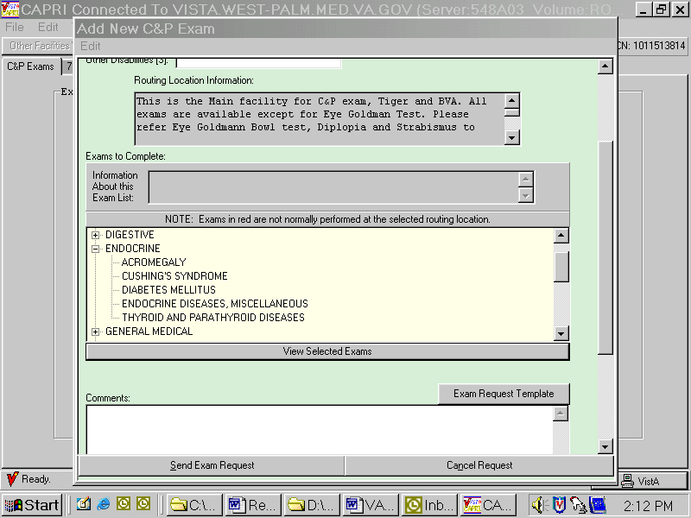
Then select ‘thyroid’…
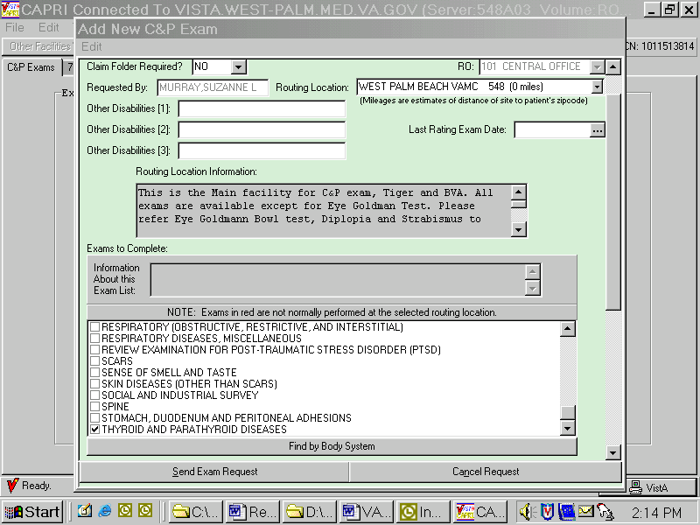
…which will give the request for thyroid disease exam worksheet.
There is more information about CAPRI at http://vbaw.vba.va.gov/bl/21/systems/index.htm
Remember: Do not confuse a ‘specialty exam’ with a ‘specialist.’
A ‘specialist’ is trained and board certified in a medical discipline. Typically, requesting an exam by a specialist is a function of the Board of Veterans’ Appeals.
A ‘specialty’ exam is more correctly called a ‘body system’ or ‘focused’ exam and what we need for most claims for increase.
Exercise 1 | Exercise 1:  The veteran is a 47 year old man who has filed a claim for increase in the following service-connected conditions:  Left knee bursitis  Lumbar arthritis  Residuals, right wrist fracture  Right hip bursitis  Sinusitis  Hemorrhoids  Take ten minutes to select the worksheet(s).
General Remarks Field | The general remarks field is your way to communicate directly with the examiner and the VAMC staff.  - State the disability you would like the examiner to evaluate. Avoid “condition” if you have a diagnosis. Keep it simple. Many requests include detail such as “veteran is claiming increased evaluation of service-connected arthritis of the right knee, currently evaluated as 0 percent disabling.” Just indicate the diagnosis (with ‘left’ or ‘right’ as applicable) and ask: “Please examine arthritis, right knee.”  - You do not need to ask for the same information that worksheets require, such as lab tests or procedures.  - Do not indicate what type of examiner (specialist) is to perform the examination, unless directed by remand.  - Include a contact name and telephone number in case the clinic has questions.  - Check your work before sending it out. Make sure the clinic clerk will be able to understand your request. Don’t use VBA abbreviations or acronyms such as “SC”, “NSC” or “A&A/HB”.  - Make sure the exams requested and the comments section ‘match.’ You should have an exam selected for each disability in the comments section, and a comment for each exam selected.  - Be sensitive as to what you include in these comments.  Think of the total examination request as providing the examiner two pieces of information per disability. The first piece of information is the disability to be examined; the second is the correct worksheet for the examiner to use to evaluate that disability.
Common errors on VA exam requests | CPEP (Compensation and Pension Examination Program) assesses the quality of each station’s examination requests. More information is contained in FL 04-15. The most common errors on VA exams are:  - Ordering the incorrect exam (such as Joints exam for spinal arthritis)  - Failure to correctly identify the disability to be examined (indicate left or right as needed)  - Using VBA jargon in the exam request (such as SC, NSC or A&A/HB)  - Failure to provide the claims folder when required. Remember to send the claims file for all psychiatric exams and opinion requests.  - Requesting unnecessary opinions on service connection
Insufficient Exams | When an exam is ‘insufficient for rating purposes’, the RVSR cannot use the examination report to make a decision on the claim because it lacks essential information. We must return the report to the examining facility for correction. Your coach will tell you if this is part of your responsibilities.  There are four main reasons an exam is insufficient for rating:  - The examination report did not address all disabilities for which an examination was requested  - The same disability is diagnosed differently by different examiners  - Conclusions or findings have been expressed in ambiguous or equivocal terms, and/or  - The examiner has not discussed the impact of musculoskeletal pain on the functional loss of an affected joint. (M21-1MR III.iv.3.D.19.e)
 | REVIEW EXERCISES
Exercise 1
Using your reference materials, identify four conditions that can result from cold injury.

Exercise 2
A veteran writes: “I need an increase in my left leg condition. I have to take medicine every day and wear a brace. It’s a lot worse than it was when I was last rated.” His codesheet shows the following:
DC 6843 Residuals, left spontaneous pneumothorax
DC 8714 Neuralgia, left radial nerve
DC 5257 Recurrent subluxation, left patella
DC 6022 Lagophthalmos, left
Which disability is he claiming and which worksheet do you order?
Please write the general remarks for this request.

Exercise 3
Match the diagnosis with the worksheet. Some choices may be used more than once.
- hepatitis C Digestive
- gastritis Esophagus and Hiatal Hernia
- ventral hernia Stomach
- pancreatitis Intestines
- postgastrectomy syndrome Liver, Gall Bladder and Pancreas
- ulcerative colitis Stomach
- gastroesophageal reflux disease Digestive

Exercise 4
Indicate the correct exam to request.
- Degenerative joint disease, lumbar spine.
              - Joints
              - Spine
              - Bones
- Emphysema
              - Respiratory, miscellaneous
              - Respiratory, obstructive, restrictive
              - Pulmonary tuberculosis
- Chronic maxillary sinusitis
              - Respiratory, miscellaneous
              - Sense of smell and taste
              - Nose, sinus, larynx, pharynx
- Coronary artery disease
              - Arrhythmias
              - Hemic disorders

c. Heart

CPEP’s C&P Exam Request Indicators For Quality Scoring

Key Indicator | Reviewer Instructions

QUALITY PERFORMANCE INDICATORS
General Requests Section
- For each selected exam, does request identify a specific condition (or conditions)? | Do not use NA.  Answer YES if a specific condition (or conditions) is (are) identified, in the General Remarks section for each exam requested. [NOTE 1: If a condition is identified for each exam but the requested exam is incorrect, answer YES and proceed.]  Otherwise, answer NO.
- For the condition(s) identified in Remarks, is (are) appropriate exam(s) selected? | Answer NA if you answered NO to Indicator 1 AND no condition was identified in the General Remarks.  Answer YES if the appropriate exam is selected for each specific claimed condition identified in the General Remarks section, including appropriate use of General Medical exam. [NOTE: If a general medical exam was requested the request must be supported by the remarks or other information in the exam request (for example, recently discharged veteran)].  Otherwise, answer NO.
- Remarks identify specific joint(s) or part(s) to be examined including left/right, if applicable? | Answer NA if the issue does not call for further specification (for example heart attack). Answer YES if the remarks adequately specify the issue(s) to be examined (for example, left ankle, right shoulder, left eye, thoracic spine, etc.).  Otherwise, answer NO.

