Non-Original Compensation Claims
Trainee Handout
Table of Contents
Objectives 2
References 2
Topic 1: Non-Original New Claims 3
Topic 2: Previously Denied Claim and Reopened Claim 3
Topic 3: Claims For Increase 8
Topic 4: Claims For Secondary Service Connection 10
Attachment A: Practical Exercise – Non-Original New Claims 11
Attachment B: Practical Exercise Previously Denied Claim and Reopened Claim/Check Comprehension 12
Attachment C: Practical Exercise – Previously Denied Claim and Reopened Claim 13
Attachment D: Practical Exercise – Claims For Secondary Service Connection 14
Attachment E1: Sample Traditional Notification Letter Date 15
Attachment E2: Sample Rating Decision 16
Attachment E3: Sample ADL Notification Letter Date 19
Attachment F: Table – Actions for Reopened Claims 26

Objectives
- Given 38 U.S.C. 5103(a), 38CFR 3.150, and M21-1MR, differentiate the development actions for a Non-Original New Claim, with 85% accuracy.
- Given 38 U.S.C. 5103(a), 38CFR 3.150, and M21-1MR, differentiate development actions when a claim for a previously denied condition is received with or without new and material evidence, with 85% accuracy.
- Given 38 U.S.C. 5103(a), 38CFR 3.150 and M21-1MR, differentiate the development actions for a claim for increase, with 85% accuracy.
- Given 38 U.S.C. 5103(a), 38CFR 3.150, and M21-1MR, differentiate the development actions for claims for secondary conditions, with 85% accuracy.

References
- 38 U.S.C. 5103(a) Notice to claimants of required information and evidence
- 38CFR 3.150: Forms to be furnished
- 38CFR 3.151(a): Claims for disability benefits, general
- 38CFR 3.156(a): New and material evidence
- 38CFR 3.160(e): Reopened claims
- 38CFR 3.160(f): Claim for increase
- 38CFR 3.310(a): Claims for secondary service connection
- 38CFR 3.159 Department of Veterans Affairs assistance in developing claims
- M21-1MR I.1.A: Duty to Assist
- M21-1MR I.1.B: Handling Claims under Veteran’s Claims Assistance Act
- M21-1MR III.ii.2.E: Reopened Claims
- M21-1MR III.ii.2.F: Claims for Increase
- M21-1MR III.iv.2.B: Reviewing for New and Material Evidence
- M21-1MR IV.ii.2.B.6: Determining Secondary Service Connection, Including by Aggravation
- Fast Letter 06-04: Notification requirements of the Veterans Claims Assistance Act of 2000 (VCAA)
- Allen v. Brown, 7 Vet. App. 439 (1995)
Topic 1: Non-Original New Claims

Non-Original New Claim Definition

A Veteran’s claim for a new condition after the Veteran has filed an original claim and VA has not taken adjudicative actions on the new claimed condition.

Development Actions for a Non-Original New Claim (Within One Year of Discharge Date)

When the Non-Original New Claim is filed within one year of the Veteran’s discharge date:
- Complete the appropriate Section 5103 Notice (formerly VCAA Letter)
- Request a VA exam for the new condition

Development Actions for a Non-Original New Claim (After One Year of Discharge Date)

When the Non-Original New Claim is filed after one year of the Veteran’s discharge date, development of the claim is identical to an original claim for service connection.
- Review the Service Treatment Records (STRs) and all evidence of record to determine if the new condition can be established as:
  - A chronic condition in service
  - A presumptive condition
- Complete the appropriate Section 5103 Notice
- Make a decision whether or not the evidence of record is sufficient to request an exam or medical opinion (Does the evidence of record provide continuity or a chronic condition in service?).

Topic 2: Previously Denied Claim and Reopened Claim

Definition – Reopened Claim

M21-1MR III.ii.2.E.19.b defines a Reopened Claim as:
- A reopened claim is any claim for service connection, received after a finally denied claim, which VA must reconsider because the evidence it presents, is _____ and ________________.
- A finally denied claim means that at least ____ ____________ has elapsed since the letter was sent notifying the claimant of the decision to deny the benefit sought.

Notes: The term "reopened" does not apply to pension, increased ratings, or individual unemployability. Those claims involve the review of new evidence based on new applications, rather than reconsideration of prior decisions. For this reason, they are "new" claims.
Emphasize the point of previously denied issue is found on the rating decision and the notification letter date is over one year.

New and Material Evidence

M21-1MR III.iv.2.B.5(a) and (e) provides the following requirements when ‘Reopening Denied Claims:

(a) Once a claim has been finally denied, it cannot be reopened unless _______ and ______________ evidence is received.

(e) A previously denied claim is not considered __________ unless the evidence submitted is both new and material.

New and material evidence is required before the Department of Veterans Affairs (VA) will reconsider a finally denied claim for service connection for a particular disability.

Definition of New and Material Evidence

New Evidence is information:

- That is not previously of __________, and
- That is neither _________ nor _________.

Material Evidence is infomration:

- That is __________ and relates to an unestablished fact necessary to substantiate the claim,
- Has a legitimate _______ or bearing on the decision in the case, and
- That is neither cumulative nor redundant.

Notes: If the claimant has submitted new and material evidence to reopen, you should proceed to adjudicate the claim on the merits.

Claim received without New and Material Evidence

A claim for a previously denied condition must provide new and material evidence to be successfully reopened.

If the claimant has not submitted new and material evidence to reopen then advise the Veteran through a locally generated letter, that service connection for the claimed condition was previously denied. Ensure the letter includes the following:

- The date of the letter which advised the Veteran of the denial.
- The reason for which the claim was denied.
- The evidence (new and material) needed to reopen the claim.
- The time limit for submission of this evidence

38 U.S.C. 5103(a)

Under 38 U.S.C. 5103(a), the VA is required to notify a claimant of what constitutes new and material evidence, generally, and in the context of his or her particular claim to reopen.

Therefore, the VA’s letter should include:
- Language above from 38 CFR 3.156(a).
- Information specific to the claimant’s lack of new and material evidence.
- Date of the letter which advised the Veteran of the denial
- Reason for which the claim was denied
- Evidence (new and material) needed to reopen
- Time limit for submission of this evidence

Private Treatment without Medical Release Forms

If a claim for a previously denied condition is received with an indication of private treatment without medical release forms (VAF 21-4142s) then bsend out the necessary number of release forms in the Section 5103 Notice.

When signed release forms are returned to the VA:

1. Send generated letters to the doctor(s) or hospital(s) that provided treatment, and
2. Inform the Veteran of the third party development and advise him/her of the consequences of non-receipt of the evidence.

Example

The information provided in the New & Material Evidence paragraph:

“You were previously denied service connection for (condition). You were notified of the decision on (date of previous denial). The appeal period for that decision has expired and the decision is now final. In order for us to reopen your claim, we need new and material evidence. Your claim was previously denied because (reason for previous denial). Therefore, the evidence you submit must be new and relate to this fact”.

Anatomy of a Rating Decision

The rating consists of the “Narrative” and “Coded Conclusion” sections.

The Narrative

The Narrative section contains the Introduction, Decision, Evidence, Reasons for Decision, and References. It may be copied and sent to the claimant as part of the notification of the decision.

The following elements are a part of the narrative:

- _____________ – Provides an overview of Veteran’s service, including branch and period of service. Mention type of claim filed, issues being claimed, and date claim was received.

- ______________ – Clear and concise statement of the decision made on each issue or inferred issue considered in the rating. If there is more than one decision, list the decisions by number that corresponds to the numbered issues.

- ______________ – Clear and concise inventory of all evidence considered in arriving at the decision. Include with each piece the applicable dates of treatment reports, hospitalization, the dates covered by service treatment records (identifying at least the month and year), and the names of VA and private medical facilities, private physicians and other information sources. The Evidence section should also describe items of evidence requested but not received. Further reference to evidence not received will not be required in the Reasons for Decision.

- _____________ – Narrative explaining reasons and bases for decision reached by Rating Veterans Services Representative (RVSR). If more than one issue, the issues will be numbered and arranged according to the “Decision” formatting.

- ______________ – Concise statement of regulations and laws used by the RVSR to reach his/her decision on the issue(s).

The Coded Conclusion

The Coded Conclusion is intended for internal processing and will not be sent to the claimant and has the following four parts:

- ________ _________ – Information included on the data table reflects periods of active duty service, branch of service and character of discharge found in the “Introduction” of the narrative.

- _____________ – Under "Jurisdiction," identify the type of claim and date it was received.

- _________ __________ – A coded conclusion will be prepared in accordance with Part I, Appendix A, and the provisions of this chapter. On subsequent ratings, bring forward the coding for all disabilities previously rated whenever coding directly affecting compensation or pension entitlement is added or changed.

- __________________- Except as specifically provided for overprint ratings the signed file copy of ratings must be printed on blue paper. One or two RVSRs will sign the completed rating at the bottom of the last page. Ratings may be printed on both sides of the paper (duplex printing) provided that the reverse side is printed head to foot ("short edge" as opposed to "long edge").

Diagnostic Codes

Four digit numbers from the rating schedule and each number are assigned to a different disability/disease as follows:

- Analogous Codes – When evaluating by analogy any disability not listed in the Rating Schedule, use a built-up diagnostic code consisting of two diagnostic codes separated by a hyphen. The first two digits of the first diagnostic code should be applicable to the body system involved and the second two digits would end with "99." The second diagnostic code is to be taken from the Rating Schedule and identifies the diagnostic criteria used to evaluate the claimed disability. For example, use 6599-6516 for postoperative tonsillectomy if the condition was evaluated under the criteria for chronic laryngitis.
- Residual Conditions – Hyphenated codes do not necessarily denote analogous ratings. Two diagnostic codes may be used to identify the source of a disability or a residual from disease. For example, ankylosis of the spine from rheumatoid arthritis would be rated as 5002-5240.

Listing Disabilities

Disabilities are listed in the following order:

- ___________ Service-Connection - Under code 1, SC and show in descending order by current percentage evaluation.

- _____________ Service-Connection - Code 8 Disabilities – List disabilities held not SC under code 8. Next to code 8, parenthetically show the periods of service considered and the following reasons for denial in parentheses: constitutional or developmental abnormality, willful misconduct or vicious habits, not line of duty.

- ____________ Ratings – Following code 8, use rating code 2 showing Veteran "PT from [date]" or code 9 showing Veteran "Not PT." Identify the disabilities by diagnostic code in order of percentage evaluation.

- __________ Codes – If applicable, then show combined degree(s), effective date(s), bilateral factor and all other coded entitlements indicated in M21-1, Part I, Appendix A.

Notification Date

The notification date required in the Section 5103 Notice is on the Award Notification Letter in the c-file. The Award Notification Letter was sent to the Veteran and a copy of the Rating was attached. The letter notified the Veteran of the rating deicision, payment information and appeal periods. Use the date on the first page of the letter. Refer to Attachement E1 as an example of the Notification Letter date.

Claim Received With New and Material Evidence

If a claim for a previously denied condition is received with new and material evidence the claim becomes a reopened claim.

Send the appropriate Section 5103 Notice and route the case directly to the Rating Veterans Service Representative (RVSR).

If a reopened claim was received with an indication of VA treatment, then upload the VA records via CAPRI into Virtual VA.

The RVSR has the authority to determine if evidence received is new and material to reopen a previously denied claim.

Topic 3: Claims For Increase

Definition of Claim for Increase

M21-1MR III.ii.2.F.23 Identification of Claims for Increase per 38 CFR § 3.160(f) is a:

  - Claim related to a case in which a running compensation or pension award is already in existence, or
  - Claim for a resumption of payments previously discontinued.

Types of Claims for Increase:

- For an increased evaluation of a disability
- For special monthly pension (SMP)
- For special monthly compensation (SMC)
- To add a dependent, or
- To show either a reduction of, or a deduction from, income.

Example of a Claim for Increase – A claim for increased disability in a compensation claim that was previously denied because all service-connected (SC) disabilities were considered noncompensable is a "claim for increase."

Notes: The VA cannot grant service connection for a presumptive condition unless it meets the compensable rate (10% or higher).

Example: Hypertension is a presumptive condition within one year of discharge at the compensable rate only. The Veteran would have to meet the 10% rate within the one year of discharge date.

Development Actions for Claims for Increase

If you have determined that the Veteran is already service-connected for the disability which he or she is currently claiming, then you have determined that the current claim is a claim for increase.

Non-original SC disability compensation claims do not have to be submitted on any particular form. The following are all acceptable ways of receiving non-original claims:

- Statement from the claimant that the disability has worsened
- Doctor’s statement detailing the Veteran’s current evaluation for his/her service-connected condition
- VA Form 0820 – Report of Contact

Claim for Increase is Received without Medical Evidence

If a claim for increase is received without medical evidence, an indication of recent treatment, or the medical evidence of record is too old or otherwise insufficient to determine the current level of the disability, then a VA examination (VAE) is to be scheduled at the Veteran’s nearest VA Medical Center (VAMC).

If a claim for increased evaluation is received with:
- An indication of private treatment without medical release forms (VAF 21-4142s)
  - Send the Veteran the necessary number of 4142s with his/her Section 5103 Notice.
  - Schedule a VAE.
- Medical release forms
  - Send the forms letter to the doctor or hospital that provided treatment.
  - Simultaneously inform the Veteran that we are requesting the third party evidence and advice him/her of the consequences of non-receipt of the evidence.
  - Schedule a VAE.
- An indication of VAMC treatment
  - Obtain medical records via CAPRI
  - Review claim for possible Ready to Rate (RTR) status
  - If not RTR, then send Section 5103 Notice and schedule a VAE

Notes: Conditions that have met the maximum schedular will not need a VA Exam with the exception of claims for individual Unemployability (IU), which is covered in a separate lesson. Use an example of a claim for increase for tinnitus in which the Veteran is service-connected at the maximum schedular of 10%. Remind the trainees to consult with a RVSR when in doubt about rating issues related to requesting exams.

Topic 4: Claims For Secondary Service Connection

Provisions for Claims for Secondary Conditions

M21-1MR IV.ii.2.B.6.a Provisions for Service Connection under 38 CFR 3.310(a) and (b).
Grant service connection for the following:
- Disabilities that are proximately due to, or the result of, a SC condition, or
- The increase in severity of a nonservice-connected (NSC) disability that is attributable to aggravation by an SC disability, and not to the natural progress of the NSC disability.

Notes: For more information on service connection for aggravation of NSC disabilities by SC disabilities, see 38 CFR 3.310(b), and Allen v. Brown, 7 Vet. App. 439 (1995).

Development Actions for Secondary Claimed Conditions

If it is determined that the Veteran is already service-connected for a disability(ies) and now the Veteran wants to claim a new condition based on the service-connected disability(ies), then you have determined that the current claim is a claim for secondary service connection.

If a claim for secondary service connection is received, then develop the claim by following all necessary development guidelines pertaining to the claimed condition. When reviewing these types of claims, focus should be on:
- Pertinent back ground information (i.e. service-connected disabilities).
- The Veteran’s contentions.
- The evidence showing a current disability or symptom(s) does/does not exist.
- The evidence showing a possible relationship between the claimed disability/symptoms and the service-connected condition.

Medical Opinions for Secondary Conditions

Do not request a VA Exam for secondary conditions. Follow the development procedures for the claim and forward to the rating activity to determine if a medical opinion is warranted to determine the relationship between the service-connected condition and the claimed secondary condition.

Notes: There is an additional lesson plan for medical opinions for secondary issues.

Attachment A: Practical Exercise – Non-Original New Claims
A Veteran files a claim for lumbar degenerative joint disease (DJD) and hearing loss. He provides private medical records with radiology reports that have a diagnosis of lumbar DJD with his claim. The private medical records show that the Veteran has received continuous treatment since the date of his discharge, three years ago. A review of the claims folder reveals one rating decision of record and it granted hearing loss and denied right shoulder strain. The STRs show the Veteran had 3 events of lumbar strains during parachute jumps while on active duty. His exit exam reveals he has lumbar DJD.

- Which claimed condition is the new claim?

- What development actions are needed for the new claimed condition?

Attachment B: Practical Exercise Previously Denied Claim and Reopened Claim/Check Comprehension
Instructions: Match the situation on the left with the correct action(s) on the right.
Situation | Action
- The claimant has not submitted new and material evidence.  - VA is required to notify a claimant of what constitutes new and material evidence.  - A claim for a previously denied condition is received with new and material evidence.  - A reopened claim was received with an indication of VA treatment. | - The claim has not been successfully reopened.  - The claim becomes a reopened claim.  - Provide information specific to the claimant’s lack of new and material evidence in the Section 5103 Notice (formerly VCAA letter).  - Print the VA records from CAPRI.

The claimant has not submitted new and material evidence
VA is required to notify a claimant of what constitutes new and material evidence.
A claim for a previously denied condition is received with new and material evidence.
A reopened claim was received with an indication of VA treatment.
Attachment C: Practical Exercise – Previously Denied Claim and Reopened Claim
Read the provided scenarios and answer the questions.

Scenario: A Veteran files a claim for hearing loss on April 1, 2010 on a VA Form 21-4128 and does not provide any other information. Review of the claims folder reveals a Rating Decision dated January 30, 2005 denied service connection for hearing loss due to lack of evidence to provide a current diagnosis of hearing loss. VA notified the Veteran of the rating decision and provided appellate rights information in a letter dated February 15, 2005.

- Is this a reopened claim?
____________________________________________________________________________________________________________________________________________________________________________________________________________________________________________________________________________________________________________
- Why or why not?
____________________________________________________________________________________________________________________________________________________________________________________________________________________________________________________________________________________________________________
Part 2
Review the paragraph shown below.
“You were previously denied service connection for (condition). You were notified of the decision on (date of previous denial). The appeal period for that decision has expired and the decision is now final. In order for us to reopen your claim, we need new and material evidence. Your claim was previously denied because (reason for previous denial). Therefore, the evidence you submit must be new and relate to this fact.”
To complete the paragraph above, where would you locate the bold information?
Fill in the blank with one of the following options:
- Rating Code Sheet
- Notification Letter
- Rating Narrative
Condition - _______________________
Date of Previous Denial - ________________________
Reason for Previous Denial -______________________
Attachment D: Practical Exercise – Claims For Secondary Service Connection

Read the provided scenarios and answer the questions.
Scenario: A Veteran claims his service-connected lumbar DDD has caused a right hip degenerative joint disease of his right hip due to walking with an altered gait and placing more pressure on his right hip due to an adjusted sitting posture.
- Is this a claim for a secondary condition?
________________________________________________________________________________________________________________________________________________________________________________________________________________________________________________________________________________________________________________________
- What development actions are required for the above scenario?
________________________________________________________________________________________________________________________________________________________________________________________________________________________________________________________________________________________________________________________
Attachment E1: Sample Traditional Notification Letter Date

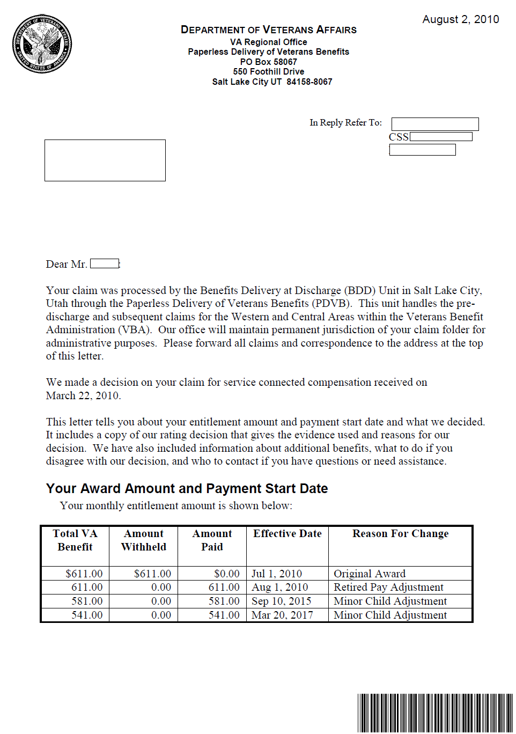
This is the Notification date used in the New and Material paragraph

Attachment E2: Sample Rating Decision

DEPARTMENT OF VETERANS AFFAIRS
Any Regional Office
Any Town
Any State XXXXX

VA File Number
XXX-XX-XXXX

Represented by:
Any Power of Attorney
This is not the date of claim; it is the date the rating was written. In most cases this will not be the date of notification.

Rating Decision
MM/DD/YYYY

INTRODUCTION

The records reflect that you are a Veteran of the World War II. You served in the Army from January 25, 1941 to December 10, 1945. You filed an original disability claim that was received on January 15, 2008. Based on a review of the evidence listed below, we have made the following decision(s) on your claim.
DECISION
1. Service connection for instability of the right knee (claimed as right knee condition) is granted with an evaluation of 10 percent effective January 15, 2008.
2. Service connection is not established for depression.
EVIDENCE
- Veteran's claim, VA Form 21-526, was received January 15, 2008.
- Duty to Assist letter dated XXXXX
- USA service treatment records for January 25, 1941 to December 10, 1945.
- VAMC General Medical Exam, dated XXXX
- Treatment notes from Dr. Elvis Presley that were received on XXXX.

REASONS FOR DECISION
1. Service connection for instability of the right knee (claimed as right knee condition.)
Service connection for instability of the right knee (claimed as right knee condition) has been established as directly related to military service.
Your service treatment records document a history of treatment for a right knee condition while you were in the military. The records show that you sustained a twisting injury to the right knee and subsequent reports noted that you received ongoing treatment for this condition up until your discharge from the military. Treatment notes from Dr. Presley noted continuous treatment for this condition since your discharge from the military. They also showed that you received cortisone injections on the right knee every six months.
On your recent VA examination the VA examiner noted that you have some crepitus with movement of the knee. The VA examiner noted that you do not use any assistive devices and that there is evidence of the knee giving away, but that there is no evidence of the knee locking. The VA examiner also noted that your forward flexion was to 90 degrees and that your extension was to 0. The examiner also noted that you have mild instability of the knee joint on objective testing. X-ray of the knee noted no remarkable findings. The examiner’s assessment was instability of the right knee.
Based on the evidence of record to include the objective findings from your recent VA examination a 10 percent evaluation is assigned as there is clinical evidence of a recurrent subluxation or lateral instability of the right knee which is considered to be mild. To be entitled to a higher evaluation you need to provide clinical evidence of a recurrent subluxation or lateral instability which is considered to be moderate in severity.
2. Service connection for depression.
A review of your service medical records is completely negative for treatment for or a diagnosis of a depression while you were in the military. The VA afforded you an opportunity to furnish clinical evidence to support your contention that you should be service-connected for this condition and though as of the date of this determination no clinical evidence has been submitted which shows that you have a diagnosis of depression. Therefore, in the absence of clinical evidence which shows that you have depression and that it is related to your military service which ended in 1945, your claim for service connection is denied.
REFERENCES:
Title 38 of the Code of Federal Regulations, Pensions, Bonuses, and Veterans' Relief contains the regulations of the Department of Veterans Affairs which govern entitlement to all Veteran benefits. For additional information regarding applicable laws and regulations, please consult your local library, or visit us at our web site, www.va.gov.

Rating Code Sheet

ACTIVE DUTY
EOD | RAD | BRANCH | CHARACTER OF DISCHARGE
01/24/1941 | 12/10/1945 | Army | Honorable

LEGACY CODES
ADD’L SVC  CODE | COMBAT  CODE | SPECIAL  PROV CDE | FUTURE EXAM  DATE
 | 1 |  | None

JURISDICTION: Original Received 1/15/2008
ASSOCIATED CLAIM(s): 110; original claim; 1/15/08

SUBJECT TO COMPENSATION (1. SC)

5257 | Instability of the right knee  Service-Connected, WWII, Incurred  10% from 01/15/2008

NOT SUBJECT TO COMPENSATION (8. NSC)

9434 | Depression  Not Service-Connected, WWII, Not Incurred
COMBINED EVALUATION FOR COMPENSATION:
10% from 1/15/2008

______________________________________
XXX, RVSR

Attachment E3: Sample ADL Notification Letter Date

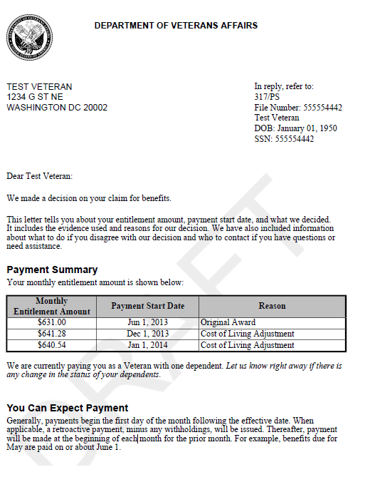
02 October 2014
This is the date in the Notification letter in the New and Material paragraphs.
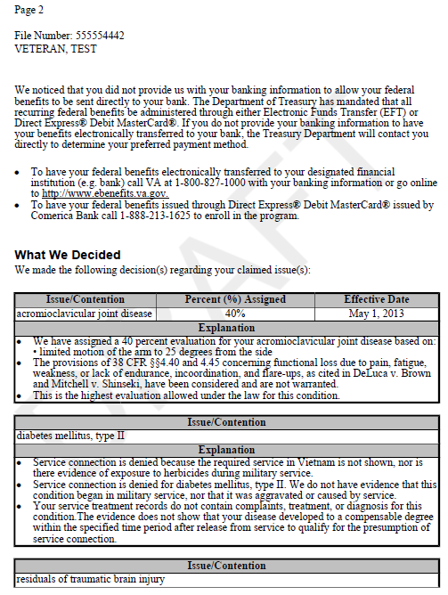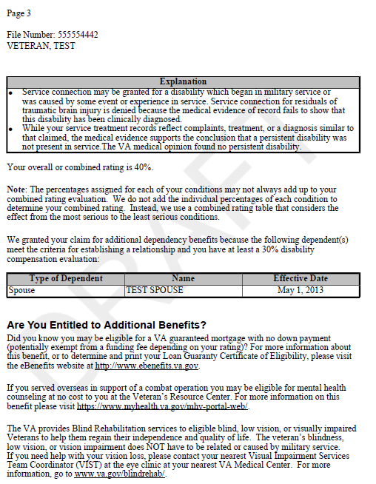
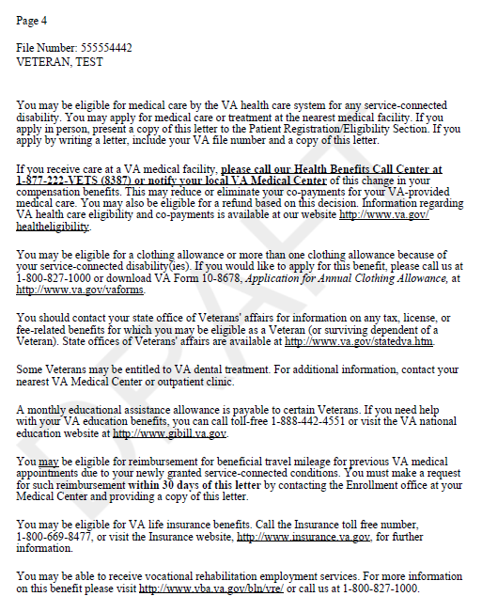
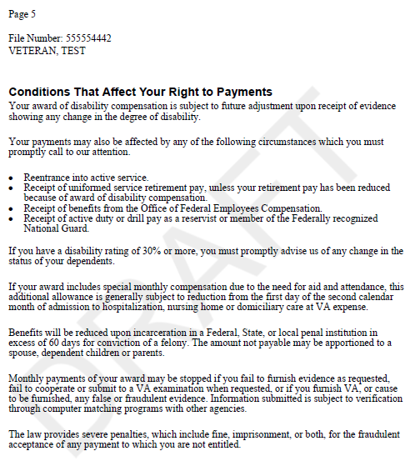
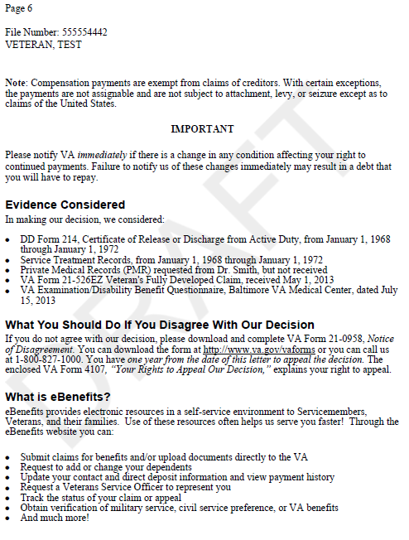
Attachment F: Excerpt from 38 CFR Part 4.71
(Rating Schedule for Disabilities of the Knee and Leg)

 |  | Rating
5256 | Knee, ankylosis of:
 | Extremely unfavorable, in flexion at an angle of 45° or more………..…………… | 60
 | In flexion between 20° and 45°………………………………………….………… | 50
 | In flexion between 10° and 20°……………………………………………………. | 40
 | Favorable angle in full extension, or slight flexion between 0° and 10°….………. | 30
5257 | Knee, other impairment of:
 | Recurrent subluxation or lateral instability:
 | Severe………………………………………………………………………… | 30
 | Moderate……………………………………………………………………… | 20
 | Slight………………………………………………………………………… | 10
5258 | Cartilage, semilunar, dislocated, with frequent episodes of
 | “locking,” pain, and effusion into the joint……………………………………… | 20
5259 | Cartilage, semilunar, removal of, symptomatic…………………………..……… | 10
5260 | Leg, limitation of flexion of:
 | Flexion limited to 15°…………………………………………………………… | 30
 | Flexion limited to 30°…………………………………………………………… | 20
 | Flexion limited to 45°…………………………………………………………… | 10
 | Flexion limited to 60°…………………………………………………………… | 0
5261 | Leg, limitation of extension of:
 | Extension limited to 45°………………………………………………………… | 50
 | Extension limited to 30°………………………………………………………… | 40
 | Extension limited to 20°………………………………………………………… | 30
 | Extension limited to 15°………………………………………………………… | 20
 | Extension limited to 10°………………………………………………………… | 10
 | Extension limited to 5°……………………………………………………………. | 0
5262 | Tibia and fibula, impairment of:
 | Nonunion of, with loose motion, requiring brace………………………………… | 40
 | Malunion of:
 | With marked nee or able disability…………………………………………… | 30
 | With moderate knee or ankle disability………………………………………… | 20
 | With slight knee or ankle disability…………………………………………….. | 10
5263 | Genu recurvatum (acquired, traumatic, with weakness and insecurity in weight bearing objectively demonstrated…………………………….. | 10

Attachment F: Table – Actions for Reopened Claims
The table below includes actions after the Section 5103 Notice has requested new and material evidence and all development actions have been completed. Actions in the table are required for RVSRs (rating activity) and Post Determination VSRs (authorization activity). The table is a demonstration to familiarize the trainees of all actions for reopened claims.
M21-1MR III.iv.2.B.5.f Handling Cases in Which VA has Requested New and Material Evidence
If… | Then…
The evidence submitted is new and material | The rating activity will:  - Reopen the claim, and  - Review all the evidence of record before making another rating decision.
The evidence submitted is new, but not material | The rating activity will prepare a rating decision that  - Confirms the previous decision, and  - Indicates that the claim is not considered to have been successfully reopened.  Important: The rating decision must explain the reason for the continued denial and why the submitted evidence is considered to be new, but not material.
The evidence submitted is not new, because it is clearly duplicate | The authorization activity will  - Deny the claim administratively without a rating decision, and  - Advise the claimant why the claim is not considered to have been successfully reopened.
No evidence has been submitted in response to the request for new and material evidence | The authorization activity will  - Deny the claim administratively, and  - Advise the claimant why the claim is not considered to have been successfully reopened.

