DPRIS Web
(defense personnel records information retrieval system)
tRAINEE HANDOUT

PREREQUISITE TRAINING | Prior to this training you must have completed the Records Management and PIES lessons.
objectives  PP #2 | The purpose of this lesson is to assist users of the DPRIS website in requesting digital copies of OMPF (Official Military Personnel File) documents or reports to which access is authorized, as well as navigating through the website itself. This lesson also explains the functionality and capabilities the user will encounter while requesting and viewing images or reports through the system.  Given the instructor’s lecture, class discussions, and practical exercises, you will:  - Understand what records are available through DPRIS Web, and what records must continue to be ordered through PIES  - Understand your role and responsibilities as a DPRIS Web User  - Become familiar with the DPRIS Website.
 | 1.0 hours
Instructional Method | Interactive lecture, Classroom discussion, Review exercise
Materials/ Training Aids | Classroom or private area where a discussion may be held. Chairs and writing surfaces are required. DPRIS Web trainee handouts, and DPRIS Web Power Point presentation.
REFERENCES | DPRIS Website User Guide

Table of Contents

DPRIS Web & Its Advantages...………..………………………………………………… | 3
VA-Services Interface…………………………………………………………………..… | 3
Standard Indexing Scheme……………………………………………………………….. | 4
Personnel Records Available Through DPRIS Web……………………………………... | 5
Roles & Responsibilities………………………………………………………………….. | 6
Using DPRIS Web………………………………………………………………………... | 7
Submitting OMPF & JSRRC Requests…………………………………………………... | 10
Account Management………………………………………………………………….…. | 15
DPRIS Web Information...……………………………………………………………….. | 18
DPRIS Web Help...……………………………………………………………….………. | 19
Review Exercise………………………………………………………………………….. | 21

DPRIS WEB & ITS ADVANTAGES

The Defense Personnel Records Information Retrieval System (DPRIS) Website provides authorized users with access to digital electronic images to Official Military Personnel Files (OMPF). DPRIS Web is now the primary Internet portal supporting external electronic access by authorized government agencies to any of the military services’ digital OMPF repositories, except Coast Guard. In the past, information from these records was typically provided via hardcopy, with requests for information and responses to such requests mailed through the U.S. Postal Service. Regardless of the form in which the information is obtained, all users are required by law to safeguard the information contained in the OMPF, as directed by the Privacy Act of 1974 and HIPPA. Some advantages of DPRIS Web over other systems include:

- Through a single secure internet sign-on, allows access to OMPF images contained in the military services’ repositories,

- On average, images are received in less than 48 hrs,

- Many images are received within minutes,

- Provides a standard index of all images contained in each of the Services’ OMPF systems, and

- Includes a Follow-up Message capability. This enables the user to gain additional information directly from the Services’ action officer (except Army).

VA SERVICES INTERFACE
Without DPRIS Web, submitting a request to a service’s image repository would be much more cumbersome. If you needed images from the Army’s image repository, for example, you would have to log into the repository, submit the request, and then log out. At some point later on, you would have to go back to see if the request for images has been processed, and if so, then download the images. You would have to do this for each military service’s repository (Army, Navy, Air Force, or Marines). Therefore, you would have to maintain several separate log-ons.
In addition, if one of the Services needed to change some of the programming for its record system, VA would possibly need to change its programming to ensure users would have continued access. VA would have to do this every time a military service changed the programming in its personnel records system. This would result in delays in retrieving images from these repositories, which is not an efficient way to conduct business. This is why the Office of the Under Secretary of Defense, Personnel and Readiness Management, sponsored the creation of DPRIS Web.
By having DPRIS Web, you will only need to maintain one login in order to submit requests. When you submit the request, DPRIS Web will route the request to the correct image repository. When the image is available for viewing, DPRIS Web will advise you via e-mail.
dpris WEB standard indexing scheme
Each of the military services manages its OMPF digital records systems differently. Rather than requiring users to learn each indexing system, DPRIS Web has developed a standard index. Each document within the four military services’ OMPF systems has been mapped to the DPRIS Web standard indexing scheme. The complete DPRIS Web Standard OMPF Document Indexing Scheme is depicted below. It shows the four major functional document groupings.
DPRIS Web Standard OMPF Document Indexing Scheme
The Consolidated OMPF Document Mapping Report published July 24, 1998, assigned each of the individual document types contained in the military services’ digital OMPF systems to one or more of the DPRIS Web Standard Index subgroups. Building on this, DPRIS Web can support standard requests and retrieval of OMPF document images from any of the four OMPF systems, by another military service or authorized agency, using a single functional methodology.
PERSONNEL RECORDS AVAILABLE THROUGH DPRIS WEB
Not every veteran’s OMPF is available through DPRIS Web. There are specific dates associated with each branch of service as to when each branch of service began retaining veterans’ OMPFs into the imaging system.
The veteran’s OMPF should be available through DPRIS Web if his/her service obligation ended on or after the following dates:

Army | July 1, 2002
Navy | December 31, 1996
Marine Corps: | December 31, 1997
Air Force | October 1, 2004

There are no Coast Guard records currently available in DPRIS Web.
National Guard and Reserves Service
When determining if the OMPF records are available through DPRIS Web, you must take Reserves and National Guard duty into consideration as well. The easiest way to think about this is the word obligation. It does not matter if the person served on Active Duty, Reserves, National Guard, or in all three. It is when there is no further obligation that matters. That is the date that you need to consider in your inquiry.
Two Periods of Active Duty Service (before and after DPRIS dates)
Example: The veteran served in the Marine Corps from 1980 to 1988. The veteran had no other obligated service after 1988. However, the veteran reenlisted in 2001 and served on active duty until 2005. Would the veteran’s OMPF be available through DPRIS Web?
Answer: You would begin your search for the OMPF records by first going to DPRIS Web. The 2001 through 2005 records will be available through DPRIS Web. Also, there may be OMPF images from the 1980 through 1988 period because the veteran served after December 31, 1997. However, if the records from the first period of service were not part of the imaged OMPF (in this case, the 1980 to 1988 period), then you need to try alternate sources for those particular records.
Note: If the OMPF records for this veteran’s first period of service were not available through DPRIS Web, then a request for OMPF records should be sent to the National Personnel Records Center (NPRC) through the Personnel Information Exchange System (PIES) application for the first period of service. If the veteran only served from 1980 to1988, and had no service obligation after December 30, 1997, then a request for OMPF records should be submitted to NPRC, through the PIES application, and not through DPRIS Web.
ROLES & RESPONSIBILITIES
As a DPRIS Web user, there are several roles and responsibilities associated with this assigned duty:
- Communicate with local managers, DPRIS Web staff via User Assistance Forms, and Central Office to solve problems.
- Initiate DPRIS Web requests for military personnel records information.
- Initiate requests for approved DPRIS Web Standard Reports.
- Initiate secure DPRIS Web follow-up messages.
- Manage own personal DPRIS Web user account information.
- Access DPRIS Web Information, Help Website Modules, and submit automated User Assistance Forms.

USING DPRIS WEB

Log-in using your User ID and Password. This is the first screen you see once you have successfully logged into DPRIS Web.

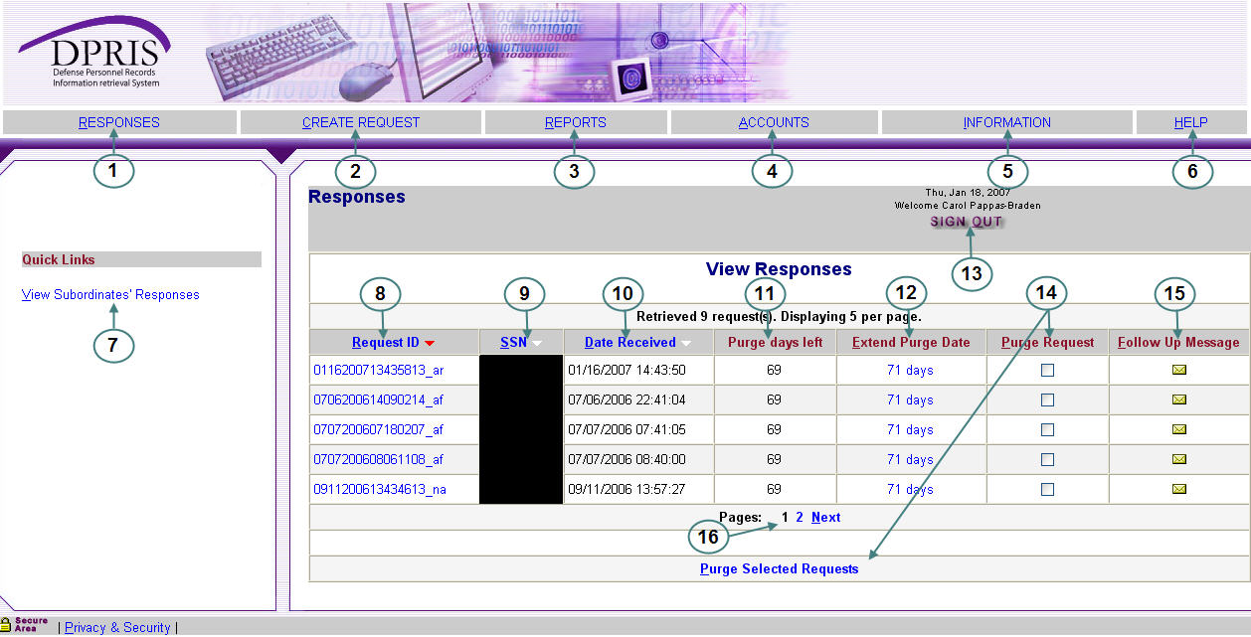

DPRIS Web Response Page
- Responses (Item 1): Link to the Responses via a list of your requests for which responses have been received from one or more of the military service OMPF systems or from the Joint Services Records Research Center (JSRRC). This is the default page that opens after a successful user login. It is often useful to return to this screen from other pages within the secure area of the Website via this link.
- Create Request (Item 2): Link to the Create Request Form, where you can create a new query for information from a digital OMPF record maintained by one of the military services or submit a request to JSRRC.
- Reports (Item 3): Link to a page where a variety of DPRIS Web reports can be requested. The reports available to you are determined by your access level within DPRIS Web.
- Accounts (Item 4): Link to a page that allows you to modify your profile or change your password.
- Information (Item 5): Link to a page with background information about the DPRIS Web initiative and the DPRIS Web Standard Indexing Scheme.
- Help (Item 6): Link to the DPRIS Web Assistance Form, which allows you to submit suggestions or feedback, or request assistance for using DPRIS Web.
- View Subordinate’s Responses (Item 7): This link is only available for Level 1 – Super Users and Level 2 - Managers
- Request ID (Item 8): This column lists Request IDs that have received a response from an OMPF repository or JSRRC. If multiple requests are displayed, they are initially sorted by the Request ID. However, multiple requests can be sorted in a different order by clicking on the arrow in either the Social Security Number (SSN) or Date column headings.
- SSN (Item 9): Lists the SSNs associated with each of your active requests.
- Date Received (Item 10): This column lists the date and time each set of images was received by DPRIS Web from the OMPF repository, or information was received from JSRRC.
- Purge Days Left (Item 11): This column displays the number of days remaining before the responses will be purged from the DPRIS Web system. After a requested response is purged, non-image data pertaining to the request remains available via the Reports option, but the response is no longer displayed on the Responses page.
- Extend Purge Date (Item 12): This link allows you to extend the purge date for a request.
- Sign Out (Item 13): This link allows you to log out of the DPRIS Web application.
- Purge Requests (Item 14): This column and link allows you to purge requests prior to the purge date. You check one or more checkboxes associated with the requests to be purged, then click the Purge Selected Requests link. A popup message will be displayed, requiring you to confirm the purge process. If you click the OK button on the confirmation message, all selected requests will be permanently removed from your list of active requests. If you click the Cancel button on the confirmation message, the selected requests will not be purged and will remain in the user’s list until the purge date has expired.
- Follow-Up Message (Item 15): Links to a page from which a secure follow-up message can be generated to a Military Service Action Officer, with regard to the related request. Once created, the message is stored in the DPRIS Web database and the Action Officer for the appropriate military service branch is notified of the message. You will be able to submit follow-up messages for review by the Action Officer, as well as review the secure electronic responses from the Action Officer. When the Action Officer has responded to a follow-up message, you will receive an e-mail notification that a response is available for review.
- Navigation (Item 16): If you have more than one page of returned requests, navigational links will be visible to enable you to go from page to page.

Viewing Responses to Request

Clicking on the Request ID brings up a list of documents available for viewing. Select the images to be viewed by clicking the box. Then, click Display Selected Files.
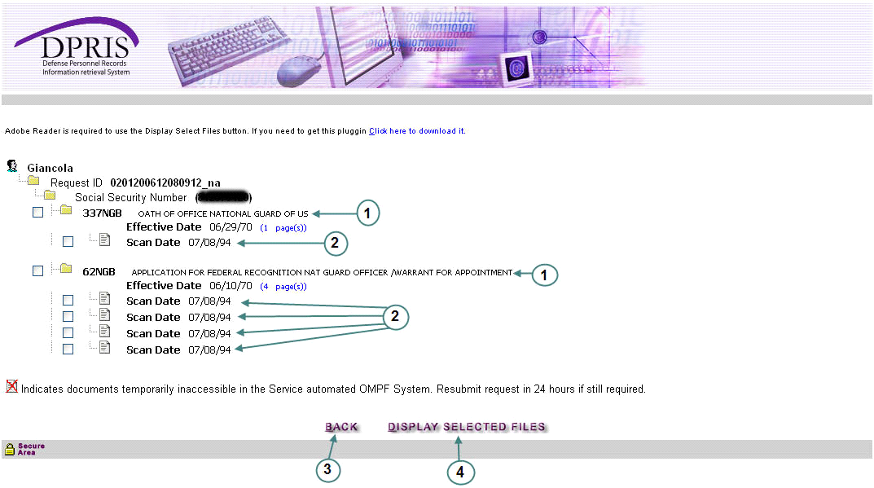

SUBMITTING OMPF AND JSRRC REQUEST

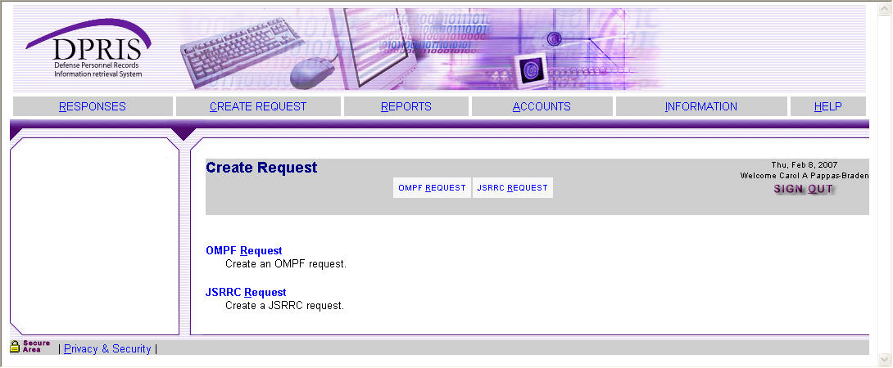

Figure 3-8. Create Request Page
When the “Create Request”, link is selected, the page shown above (Figure 3-8) is displayed. When the OMPF Request link on this page is selected, the OMPF Request Form is displayed as shown in Figure 3-9 on the following page. The OMPF repositories that are displayed in Item 1 in Figure 3-9 will vary, based upon the authorization approved for the agency. For example, if an agency is only authorized to submit requests to the Navy and Army repositories, only the checkboxes for the Navy and Army would be displayed on this form. The Air Force and Marine Corps checkboxes would not be visible on the form. The Document Index codes that are displayed in Item 2 in Figure 3-9 will also vary, based upon the access level approved for the user. To create an OMPF request, you need to complete the form and click the Submit button.
Your authorization level is pre-established by the your manager during the registration process. This process determines the types of documents (i.e., groups and subgroups of the DPRIS Web Standard Index) that will be visible to you on the OMPF Request Form and that can be used in a request to the military service OMPF repositories. For example, a user viewing the screen in Figure 3-9 is only authorized to request document images associated with the DPRIS Web Service Computation Group and some of the subgroups from the DPRIS Web Professional History Group, Item 2.

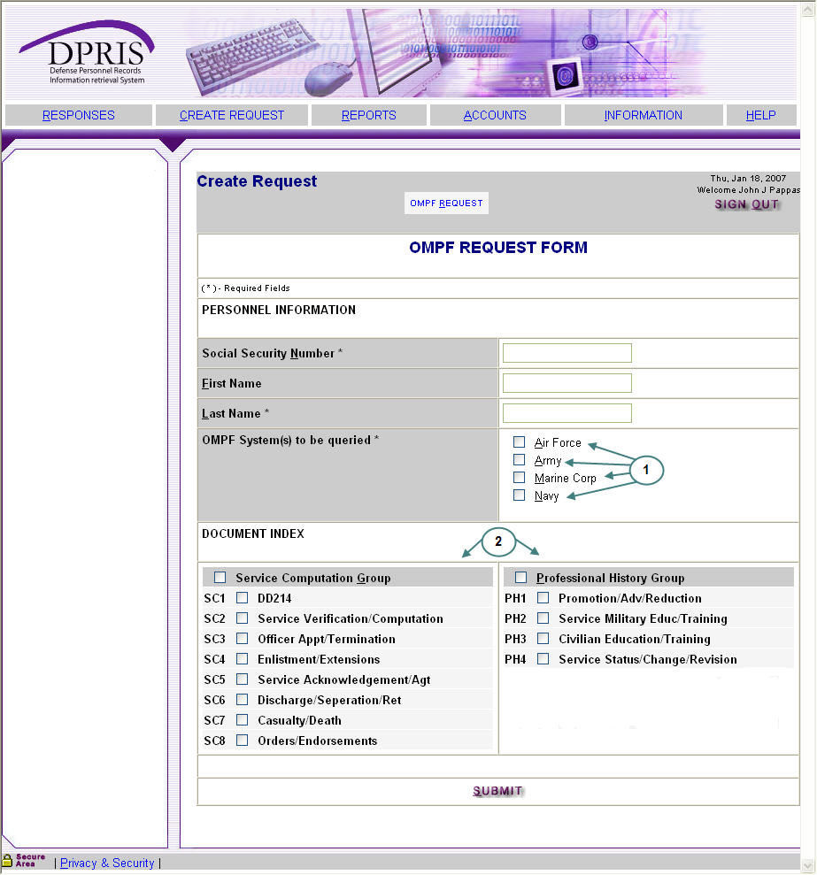

Figure 3-9. OMPF Request Form

Submitting JSRRC Request
When the JSRRC Request link on the Create Request page is selected, the main JSRRC Request Form is displayed as shown in Figure 3-10. To create a JSRRC request, the user first enters the mandatory information in the Personnel Information section (Item 1 in Figure 3-10).

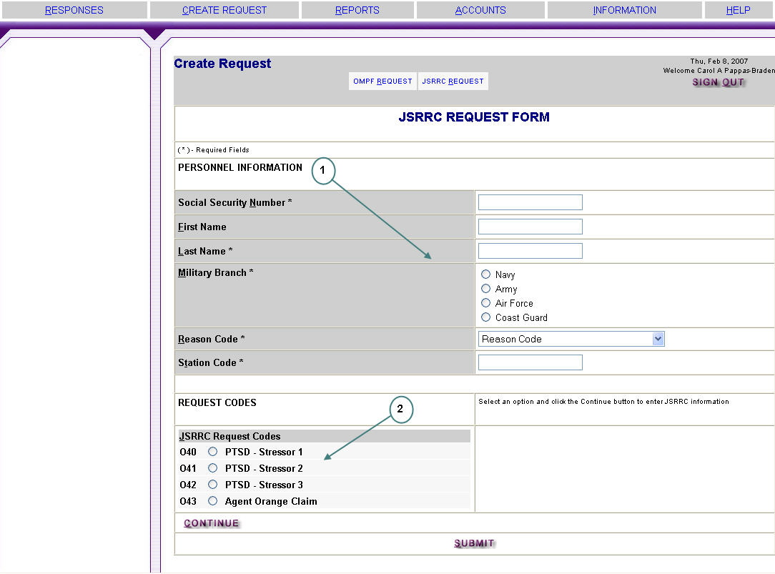

Figure 3-10. JSRRC Request Form

Figure 3-10. JSRRC Request Form

PTSD JSRRC REQUESTS

A JSRRC request must contain the information for at least one of the Post Traumatic Stress Disorder (PTSD) Stressor codes or the Agent Orange code. It can contain up to four codes if needed. To enter the request code information, you must select one of the request code radio buttons (Item 2 in Figure 3-10) and then click the Continue button. If one of the PTSD Stressor codes was selected, the PTSD Stressor form will be displayed as shown in Figure 3-11 on the following page. You would enter the mandatory information on this form and click the Continue button to return to the main JSRRC Request Form.

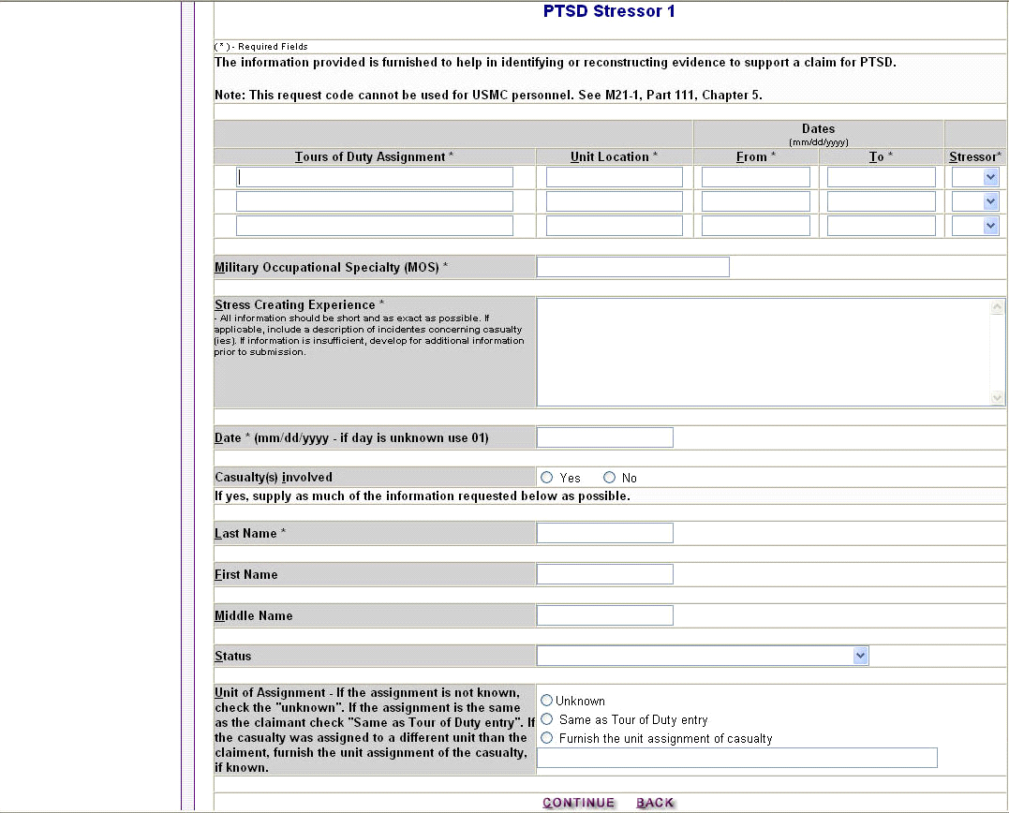

Figure 3-11. PTSD Stressor Form

AGENT ORANGE JSRRC REQUESTS

If the Agent Orange code was selected, the Agent Orange Claim form will be displayed as shown in Figure 3-12 below. You would enter Ship From and Ship To dates for up to five shipments. Each shipment can have up to 25 pairs of dates. To add another date to a shipment (i.e., Unit assignment), you must click the Add Date button for the shipment. Once all shipment information is entered, you would click the Continue button to return to the main JSRRC Request Form.

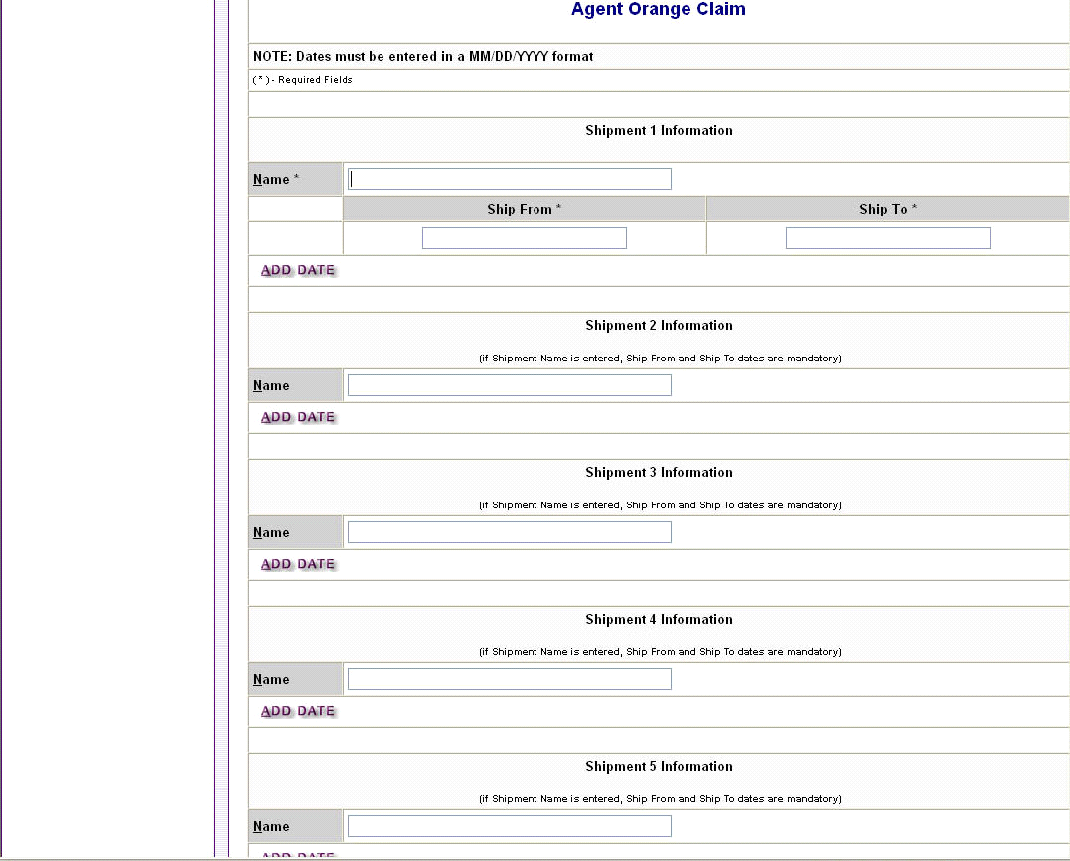

Figure 3-12. Agent Orange Claim Form

ACCOUNT MANAGEMENT

The DPRIS Web Responses page, which appears for all users immediately following successful login, displays an Accounts option on the bar near the top. This is a link to the Account Management page shown in Figure 3-16 below. From the Account Management page, you can access links to modify your profile or change your password, depending on your login method.
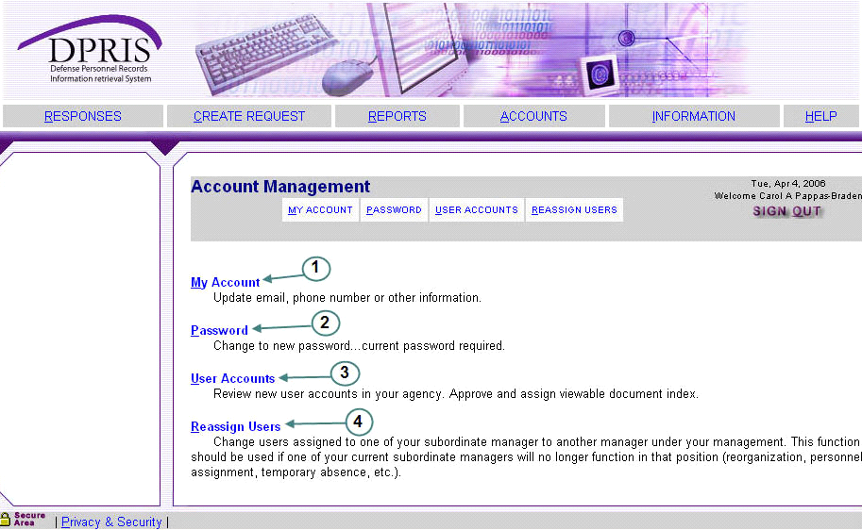

Figure 3-16. Account Management Options

My Account Option

Item 1 of Figure 3-16 is the My Account option. It provides a link to the page that allows you to update or change your personal account information, as shown in Figure 3-17 below. The fields and options in this form are fairly intuitive and self-explanatory.
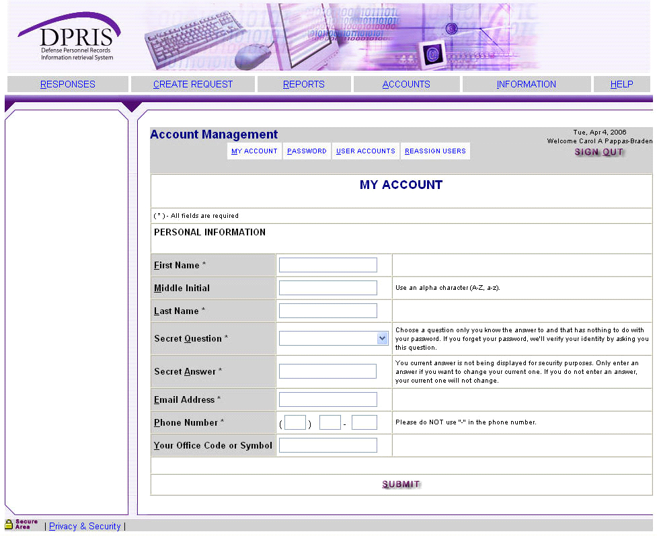

Figure 3-17. My Account Option

Password Option

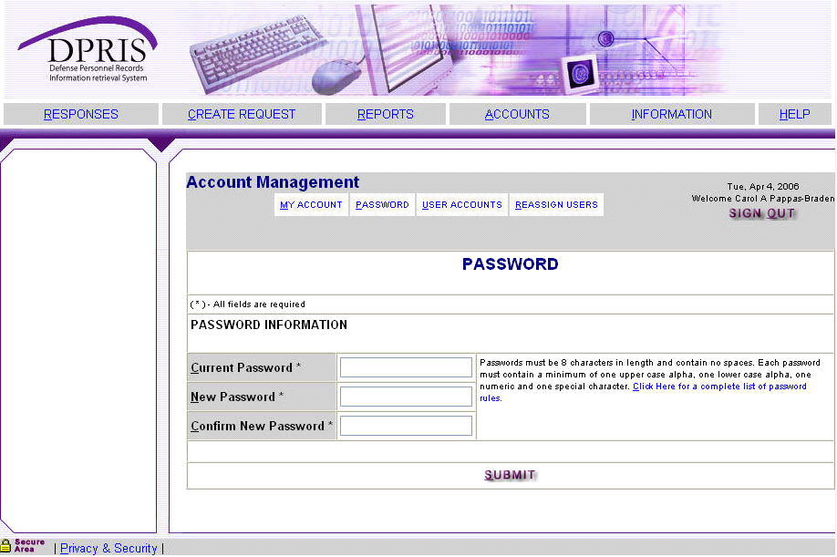
Item 2 of Figure 3-16 permits you to change your personal password. Clicking on item 2 of Figure 3-16 will bring you to the page shown in Figure 3-18 below.
Item 2 of Figure 3-16 permits you to change your personal password. It links the page shown in Figure 3-18 below.

Figure 3-18. Password Option

DPRIS WEB INFORMATION

The Information page (shown below) provides historical and background information on DPRIS Web and the OMPF Environment.
DPRIS WEB HELP

The DPRIS Web Help Desk can be contacted from most of the DPRIS Web pages by clicking on the Help link located on the bar near the top of each page. After clicking the link, you are taken to the Help area of the Website. Figure 3-14 shows the links provided at the secure area Help link.

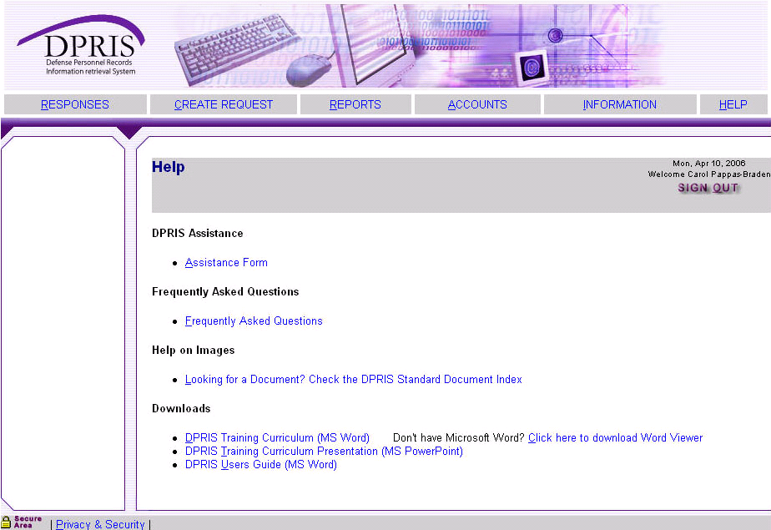
Figure 3-14. DPRIS Web Secure Area Help Options

The Assistance Form link will take you to the DPRIS Web Assistance Form (Figure 3-15 on the following page). The Frequently Asked Questions link will provide you with regularly asked questions and answers concerning DPRIS Web. The Help On Images link provides you with information concerning documents available in the Services’ OMPF systems. The Downloads links give you the capability to download the most recent versions of the DPRIS Website Users Guide, DPRIS Training Curriculum, and the MS PowerPoint slides used in conjunction with the training curriculum.

VBA CENTRAL OFFICE CONTACT

If any other issues arise with DPRIS Web that does not fall into any of the previous categories, please contact the VBA Central Office for assistance at the following e-mail address: VAVBAWAS/CO/PIES.

Review Exercise

- List two advantages of DPRIS Web over other systems.

- What are the four major functional document groupings in the DPRIS Web Standard Indexing Scheme?

- If a veteran served in the Navy from August 16, 1992, to September 23, 1995, will his Official Military Personnel File (OMPF) be available through DPRIS Web?

- When submitting a JSRRC request, what information is mandatory for a proper request to be sent?

- What should the DPRIS Web Help Desk using the Assistance Form be used for?
  - To submit suggestions to improve the DPRIS Web user interface and functional design.
  - To report deficiencies and problems encountered with the performance of DPRIS Web.
  - To request technical or operational assistance.
  - All of the above.

