Character of Discharge (COD)

Trainee Handout

**Table of Contents**

Objectives 2

References 3

Topic 1: Character of Discharge Explained 4

Topic 2: Development Requirements for COD 7

Topic 3: Making a COD Decision 12

Topic 4: Promulgation of COD Decision 18

38 CFR Character of Discharge Quick Reference 22

COD Flow Chart 23

Example of a Decision 24

Example of a Decision Notice Letter 27

Practical Exercise 30

Objectives

* Identify which type of discharge and character of service are binding on VA and which require an administrative decision
* Understand the advance notice requirements for a pending COD determination
* Recognize when a conditional service period exists and its impact on a claim for VA benefits
* Understand how to evaluate evidence for a COD administrative decision
* Identify whether insanity is placed at issue
* Comprehend preparation of a COD administrative decision
* Understand promulgation of a COD administrative decision

References

* [Public Law 95-126](https://www.gpo.gov/fdsys/pkg/STATUTE-91/pdf/STATUTE-91-Pg1106.pdf)
* [38 U.S.C. Chapter 17, Section 1710, Eligibility for hospital, nursing home, and domiciliary care](https://www.law.cornell.edu/uscode/text/38/part-II/chapter-17)
* [38 U.S.C. 5303(a)](http://www.law.cornell.edu/uscode/html/uscode38/usc_sec_38_00005303----000-.html), Certain bars to benefits
* [38 CFR 3.12, Character of discharge](http://www.ecfr.gov/cgi-bin/text-idx?SID=1e3b7d37f5d486813321c75b1d285ca9&node=se38.1.3_112&rgn=div8)
* [38 CFR 3.13(c), Conditional discharge](http://www.ecfr.gov/cgi-bin/retrieveECFR?gp=&SID=197b972b5ec49a0558f6511c3620c8a5&mc=true&n=pt38.1.3&r=PART&ty=HTML#se38.1.3_113)
* [38 CFR 3.102, Reasonable doubt](http://www.ecfr.gov/cgi-bin/retrieveECFR?gp=&SID=197b972b5ec49a0558f6511c3620c8a5&mc=true&n=pt38.1.3&r=PART&ty=HTML#se38.1.3_1102)
* [38 CFR 3.103, Procedural due process and appellate rights](http://www.ecfr.gov/cgi-bin/retrieveECFR?gp=&SID=197b972b5ec49a0558f6511c3620c8a5&mc=true&n=pt38.1.3&r=PART&ty=HTML#se38.1.3_1103)
* [38 CFR 3.360, Service connected health care eligibility of certain persons administratively discharged under other than honorable condition](http://www.ecfr.gov/cgi-bin/retrieveECFR?gp=&SID=197b972b5ec49a0558f6511c3620c8a5&mc=true&n=pt38.1.3&r=PART&ty=HTML#se38.1.3_1360)
* M21-1 Part III, Subpart v, Chapter 1, Section A, General Information on Administrative Decisions
* M21-1 Part III, Subpart v, Chapter 1, Section B, Statutory Bar to Benefits and Character of Discharge (COD)
* M21-1 Part III, Subpart v, Chapter 1, Section E, Determinations of Insanity
* M21-1 Part III, Subpart v, Chapter 7, Section A, Eligibility for Hospital, Nursing Home, Domiciliary, and Medical Care
* M21-1 Part IX, Subpart ii, Chapter 2, Rating for Medical Care

All M21-1 references are found in the [Live Manual Website](https://vaww.compensation.pension.km.va.gov/).

Topic 1: Character of Discharge Explained

**COD Requirement for Benefit Eligibility**

A Veteran’s COD must be under other than dishonorable conditions to establish eligibility for Department of Veterans Affairs (VA) benefits based on that individual’s military service.

A dishonorable discharge or statutory bar pertaining to a period of service deprives a claimant of all VA benefits for any claim based on that period of service. However,service members who are determined to have been discharged under the bars described in 38 CFR 3.12(d) are eligible for health care.

The type of separation and character of service a service member receives is located on his/her DD Form 214, Certificate of Release or Discharge from Active Duty.

**When is a COD Initiated**

A service member’s character of discharge is put at issue when

* a claim for VA benefits is received from a service member or other eligible party
* a request for a COD determination has been received from another VA department, a different Federal agency, or a state agency

***Example:***

The Veterans Health Administration (VHA) submits a VA Form 10-7131, Exchange of Beneficiary Information and Request for Administrative and Adjudicative Action, requesting that a character of discharge determination be made to establish if a service member is eligible for VA health care benefits.

**When COD is Binding on VA**

An individual is entitled to full rights and benefits of programs administered by VA unless there is a bar to benefits under 38 U.S.C. 5303(a). Normally, the military’s characterization of service is binding on VA if the discharge is

* honorable
* under honorable conditions (UHC), or
* general.

***Exception*:** For a general COD, the type of separation will need to be considered. The narrative reason for the separation will determine whether the COD is binding on the VA or not. For example, a general discharge with a narrative reason “bad conduct” requires an administrative decision to determine eligibility to VA benefits.

**Formal Findings Required for OTH Discharges**

A formal COD determination is required when the discharge is one of the following

* an undesirable discharge
* an OTH discharge, or
* a bad conduct discharge.

**When it is Not Necessary to Make a COD Determination**

It is not necessary to make a COD determination for VA claim purposes

* before the claimant applies to the Veterans Benefits Administration (VBA) and places the matter at issue, or
* if there is a separate period of honorable service, which qualifies the person for the benefits claimed

***Exception***: If the individual is subsequently convicted of a “subversive activity” as provided in [38 U.S.C. 6105](http://www.law.cornell.edu/uscode/html/uscode38/usc_sec_38_00006105----000-.html) the determination is necessary.

**Uncharacterized Separations**

For cases in which enlisted personnel are administratively separated from service on the basis of proceedings initiated on or after October 1, 1982, the separation may be classified as one of the following three categories of administrative separation

* entry level separation
* void enlistment or induction, and
* dropped from the rolls.

***Note***: Entry level separation can include separation reasons such as:

* failure to meet procurement medical fitness standards
* failure to meet retention standards due to a preexisting medical condition
* completion of a period of Active Duty for Training (ADT)
* hardship discharge, or
* dependency discharge.

***Important***: The service department does not need to provide a characterization of service for the aforementioned three categories of separation.

**Action to Take for Uncharacterized Separations**

Use the table below to determine which action to take for the three categories of uncharacterized administrative separations.

|  |  |
| --- | --- |
| **Type of Separation** | **Action** |
| Entry level separation | * Consider uncharacterized separations of this type to be under conditions other than dishonorable. * No administrative decision is required.   ***Reference***: For information on the effect of an entry-level separation based upon fraudulent enlistment on the status as a Veteran, see [VAOPGCPREC 16-99](http://www.va.gov/ogc/docs/1999/prc16-99.doc). |
| Void Enlistment or induction | * Review uncharacterized separations of this type based on facts and circumstances of separation, with reference to the provisions of [38 CFR 3.14](http://www.ecfr.gov/cgi-bin/text-idx?SID=a2e4f4d9b06648de90de7379be695705&node=se38.1.3_114&rgn=div8) to determine whether separation was under conditions other than dishonorable. * Prepare an administrative decision. |
| Dropped from the rolls | * Review uncharacterized administrative separations of this type based on facts and circumstances of separation to determine whether separation was under conditions other than dishonorable. * Prepare an administrative decision. |

**Upgraded Discharges**

A discharge may be upgraded by a discharge review board. Depending on the type of upgrade and the authority under which the discharge was upgraded, the decision may be binding on VA.

For more information on identifying upgraded discharges and how they effect a service member’s entitlement to VA benefits, see [38 CFR 3.12(e-h)](http://www.ecfr.gov/cgi-bin/retrieveECFR?gp=&SID=197b972b5ec49a0558f6511c3620c8a5&mc=true&n=pt38.1.3&r=PART&ty=HTML#se38.1.3_112) and M21-1, Part III, Subpart v, Chapter 1, Section B, 6-7

Topic 2: Development Requirements for COD

**Was a Previous COD Decision Made**

Before beginning development, make sure to review the file for any previous COD determinations.

If no previous decision(s) has been made, then proceed to develop.

If a previous decision(s) has been made, then

* review to make sure that no clear and unmistakable error was made or that no change(s) in laws or regulations has been made since the decision that would warrant reexamination of the previous decision,
* decide if new and material evidence has been provided to reopen and reexamine the previous decision, and
* decide if an additional decision is needed for entitlement to health care benefits under Chapter 17, 38 U.S.C. 1710 and 38 CFR 3.360(a).

If at least one of the above applies, then undergo any additional development that may be necessary.

If a previous decision has been made and none of the above applies, then proceed to deny the claim in accordance with denying a claim when no new and material evidence is provided per M21-1, Part III, Subpart ii, Chapter 2, D.4.b.

**Responsibility for COD Development and Determinations**

The development activity (VSR) is responsible for development of all necessary evidence and preparation of a COD administrative decision. The VSR is also responsible for determining if an OTH discharge was granted under honorable conditions (UHC) for VA purposes (HVA) for eligibility to all VA benefits.

Follow the steps in the table below when a COD determination is needed.

|  |  |
| --- | --- |
| **Step** | **Action** |
| 1 | If the discharge at issue is not specifically honorable, UHC, or general; or if there is evidence that the discharge was upgraded, send a request to the service department for all available records, including active duty medical records, personnel records, and records of proceedings pertaining to the discharge. |
| 2 | Make a formal determination |
| 3 | Prepare the formal determination for the approval of the Veterans Service Center Manager (VSCM) or designee. |

**Required Records for a COD Determination**

It is always necessary to request all active duty military and personnel records, to include the facts and circumstances surrounding the service member’s discharge, prior to making a formal decision.

Request records relating to the facts and circumstances of discharge using Personnel Information Exchange System (PIES) or Defense Personnel Records Information Retrieval System (DPRIS), as appropriate.

In all cases full and complete development of information pertaining to the discharge, including but not limited to service treatment records (STRs) and the complete military personnel file, is needed.

***Note:*** Occasionally the service department will provide only limited records. Make a determination using all the evidence in VA’s possession and resolve any reasonable doubt in favor of the claimant.

**Requirement for Advance Notice**

In any situation that requires a character of discharge determination, including dishonorable discharges

* notify the service member in advance of the need for a determination
* provide information concerning the service member’s legal and procedural rights, and
* solicit a completed application for benefits (typically a VA EZ Form) covering the disabilities for which a determination is needed, if one has not already been received.

***Note***: Veterans barred from payment of VA benefits under [38 CFR 3.12(d)](http://www.ecfr.gov/cgi-bin/text-idx?SID=200d57890017c0820930c4c6446bd9c4&mc=true&node=se38.1.3_112&rgn=div8) have tentative eligibility to receive VHA health care only for service connected (SC) conditions. In all cases in which VHA has not requested adjudication for specific medical conditions, VBA must request a completed VA Form 21-526EZ, *Application for Disability Compensation and Related Compensation Benefits,* from the claimant.

***Explanation***: In many cases the need for a COD determination may be prompted by a claim. However in some situations, such as in VHA referrals for determinations of service connection for treatment purposes, there may not be a claim of record at the time a need for a COD determination is discovered.

The table below

* lists the specific elements the advance notice ***must*** contain, and
* provides the purpose and a description of each element.

|  |  |
| --- | --- |
| **Element** | **Purpose and description** |
| Reason for the Decision | Explains the reason why a COD determination is necessary.  ***Note***: Basic eligibility for VA benefits is contingent upon a discharge under conditions other than dishonorable. |
| Criteria Used to Make the Decision | * Explains the criteria VA will use to make the decision. * Explains and cites the applicable VA regulations. |
| Right of Representation | Informs the claimant of the right to be represented, without charge, by an accredited representative of a recognized Veteran’s service organization.  Explains the following to the claimant:   * he/she may employ an attorney to assist in prosecuting the claim, and * the attorney may appear with the claimant if a personal hearing is requested. |
| Review of military records | Explains that VA will review all military records to include STRs, facts and circumstances, and all other available personnel records. |
| Claimant’s Right to Submit Evidence | Explains the claimant’s right to submit any evidence, contention, or argument bearing on the issue. |
| Claimant’s Right to a Hearing | Explains the claimant’s right to request a personal hearing before a decision is made. |
| 60-Day Time Limit | Explains that if the claimant does not reply within 60 days, VA will   * assume he/she * has no additional evidence to submit, and * does not desire additional time for presentation of his/her case, and * make a decision based on the evidence available. |
| Effect of the Decision | Fully explains that an unfavorable decision might preclude entitlement to   * the benefit claimed, and * all other gratuitous VA benefits. |
| Statement of Policy | Explains that   * the established policy of VA is to assist claimants in developing facts pertinent to a claim, and * VA will make a decision that grants the claimant every benefit that can be supported in law, while protecting the interest of the Federal Government. |

You may draft an advance notice letter using the Veterans Benefits Management System (VBMS) or a Personal Computer Generated Letter (PCGL).

**Conditional Discharge**

[38 U.S.C. 101(18)](http://www.law.cornell.edu/uscode/html/uscode38/usc_sec_38_00000101----000-.html) provides that an individual who enlisted or reenlisted before completion of a period of active service can establish eligibility to VA benefits if he/she satisfactorily completed the period of active service for which he/she was obligated at the time of entry. The satisfactory completion of one contracted period of enlistment while serving on a subsequent contracted period of service under a new enlistment is considered a conditional discharge.

The provisions of [38 U.S.C. 101(18)](http://www.law.cornell.edu/uscode/html/uscode38/usc_sec_38_00000101----000-.html) apply even if

* the subsequent discharge was under dishonorable or OTH conditions, or
* a statutory bar exists for entitlement to benefits for the later period of service.

**When to Develop for a Possible Conditional Discharge**

A *DD Form 214* may show that an individual served one continuous period of service. However, enlistment contracts generally range from three to six years. Therefore development for a conditional discharge must be undertaken, if

* the service was over three years, especially if the discharge dates do not line up to an exact number of years or months, or
* if there is any question about how many periods of service the Veteran enlisted for, or
* the *DD Form 214* shows that prior active service exists.

To develop for a possible conditional discharge, request all available STRs and personnel records from all periods of service.

**Identifying the Need for a Conditional Discharge COD Determination**

Once development is complete and evidence is received, use the table below to identify the need for a conditional discharge COD determination.

|  |  |
| --- | --- |
| **If…** | **Then…** |
| Development discloses a prior and separate period of honorable service which would qualify the claimant for the benefit requested | * Adjudicate the claim on that basis, if the claimed conditions fall under the good period of service, or * Complete a COD determination if the claimed conditions fall under the questionable period of service.   ***Note***: If it is unclear which period of service the claimed conditions fall under, complete a COD determination. |
| Development does not disclose a prior and separate period of honorable service which would qualify the claimant for the benefit requested | * Proceed with a COD determination * Consider whether the former service member had faithful and meritorious service through the period of active duty for which he/she was obligated at the time of induction or enlistment, and * Discuss the issue of conditional discharge in the decision. |

**Determining the Dates of Service for a Conditional Discharge**

When determining the dates of service for a conditional discharge it is necessary to know the length of each enlistment contract the service member signed. Dates of faithful and meritorious service are calculated by

* adding the full length of the first enlistment contract to the service member’s entry into service date, thus calculating the date the individual ***would*** have completed his/her first period of obligation and would have been discharged, then
* adding the full length of the next enlistment contract to the date determined above, thus calculating the next date that the individual would have completed his/her period of obligation and would have been discharged, then
* continuing to add the full length of each enlistment contract to the date determined above, until no more enlistment contract periods remain.

For examples, please see to M21-1 Part III, Subpart v, Chapter 1, B.5.g-h.

Topic 3: Making a COD Decision

**Statutory Bars Established by 38 CFR 3.12(c)**

Per [38 CFR 3.12 (c)](http://www.ecfr.gov/cgi-bin/text-idx?SID=514aa275325137ed149956ccc8beb291&node=se38.1.3_112&rgn=div8), benefits are not payable where the former service member was discharged or released under one of the following conditions:

* conscientious objector who refused to perform military duty, wear the uniform, or obey orders
* discharged by sentence of a General Court-Martial (GCM)
* resignation by an officer for the good of the service
* an alien during a period of hostilities
* absence without official leave (AWOL) for continuous period of at least 180 days, and
* desertion.

***Note:*** Cases in which the facts indicate the service member was sentenced by a GCM are considered to be a statutory bar to benefits.

**Regulatory Bars Established by 38 CFR 3.12(d)**

Per [38 CFR 3.12 (d)](http://www.ecfr.gov/cgi-bin/text-idx?SID=514aa275325137ed149956ccc8beb291&node=se38.1.3_112&rgn=div8), benefits are not payable where the former service member was discharged or released under one of the following conditions:

* Acceptance of an undesirable discharge to escape trial by GCM
* mutiny or spying,
* an offense involving moral turpitude,
* willful and persistent misconduct, and
* sexual acts involving aggressive circumstances

**Additional Information on Discharge by Sentence of a GCM**

Cases in which the facts indicate the service member was sentenced by a GCM or agreed to accept an undesirable discharge (often seen on the DD Form 214 as OTH), in order to escape trial by GCM, are a bar to benefits.

***Note:*** The evidence must show that the service member was sentenced by a GCM or accepted the undesirable discharge to escape a GCM, not a summary court-martial or a special court-martial.

**Additional Information on Discharge Alienage**

If there was a discharge during a period of hostilities that was not changed to honorable prior to January 7, 1957, determine if the records show that the Veteran requested the discharge. If the record

* ***shows*** that the Veteran requested the discharge, it is a bar,
* does ***not*** show that the Veteran requested the discharge, make a specific request to the service department for this information.

**Additional Information on Discharge for UA or AWOL**

Follow the steps in the table below to determine the action to take if a discharge was issued under OTH conditions, and there was a continuous period of 180 or more days of either an unauthorized absence (UA) or AWOL

|  |  |
| --- | --- |
| **Step** | **Action** |
| 1 | As with all COD determination, send the claimant a due process letter and request all active duty personnel and medical records via PIES or DPRIS, as appropriate. |
| 2 | Review the information collected to confirm that it includes the exact dates and nature of the lost time. |
| 3 | If the service department confirms a continuous period of 180 or more days of UA or AWOL (exclusive of periods of imprisonment or confinement) which led to the OTH discharge, and the claimant didn’t provide compelling reasons for the absence, then deny benefits. |
| 4 | If the claimant provided compelling reasons for the absence but our decision is ultimately unfavorable, make the issue in the formal decision “Statutory Bar Under [38 U.S.C. 5303(a)](http://www.law.cornell.edu/uscode/text/38/5303)” rather than “Character of Discharge,” and use the following as the Conclusion: “The discharge for the period [date] to [date] is a bar to VA benefits under the provisions of 38 CFR 3.12(c)(6) and 38 U.S.C. 5303(a).” |

**Additional Information on Discharge for Moral Turpitude**

Cases in which the facts indicate the discharge was for moral turpitude, generally including conviction of a felony, are a bar to benefits.

Moral turpitude does not have to be a felony conviction; it can be a single incident, or a series of events.

Note: VBA must apply a liberal standard when determining whether an offense is related to moral turpitude. Claims personnel must consider the context and any mitigating circumstances, including whether a service connected mental or physical condition caused, aggravated, or resulted in the offense.

**Additional Information on Discharge for Willful and Persistent Misconduct**

A discharge, including other OTH conditions, for behavior constituting willful and persistent misconduct is considered to have been issued under dishonorable conditions and is a bar to benefits.

***Exceptions:***

* A minor offense is not considered willful and persistent misconduct if service was otherwise honest, faithful, and meritorious.
* Insanity is a defense to willfulness of misconduct.

**Making a Decision**

A VSR of any salary grade may prepare any administrative decision as part of assigned duties.

The term “evidence” signifies all of the means by which an alleged matter of fact may be established or disproved. For decision-making purposes in Department of Veterans Affairs (VA), the term generally refers to

* testimony (including statements in support of a claim)
* various kinds of documentary proof, and
* medical or field examination reports.

Evidence may be

* “positive,” meaning it supports a claimant’s position, or
* “negative,” meaning it disproves the claimant’s position.

When there is an approximate balance between positive and negative evidence regarding any issue, the evidence is said to be “in equipoise.”

**Evaluating the Evidence**

According to the Federal Circuit Court in [*Maxson v. Gober*](http://vbaw.vba.va.gov/bl/21/advisory/CAVCDAD.htm#bmm), 230 F.3d 1330 (Fed. Cir. 2000) the ***absence*** of evidence that supports a claimant’s position is considered negative evidence that must be weighed when making a decision.

When deciding an issue, decision-makers must first determine the “weight” of each piece of evidence, based on its probative value.

After collecting all of the available evidence that is relevant to a pending issue,

* Weigh the positive and negative evidence as a whole, and
* Determine if the weight of the positive evidence is greater than, less than, or equal to the weight of the negative evidence.

|  |  |
| --- | --- |
| **If…** | **Then…** |
| A majority of the evidence is positive | Decide in the claimant’s favor. |
| A majority of the evidence is negative | Decide against the claimant. |
| The evidence for and against the claimant’s position is in equipoise | Resolve reasonable doubt in the claimant’s favor. |

**Health Care Benefits for COD Decisions**

Consider any claim which requires a COD determination as a claim for health care benefits.

*Important*: Individuals who are barred from receiving payment for *SC compensation* because of a discharge under other than honorable conditionscan still receive medical care benefits for a disability incurred or aggravated in the line of duty during active military naval or air service as provided by [38 CFR 3.360](http://www.ecfr.gov/cgi-bin/text-idx?SID=1264aa8161836a86d3513e78f421a208&mc=true&node=se38.1.3_1360&rgn=div8).

Effective October 8, 1977, under Public Law (PL) 95-126, eligibility to health care benefits for any disability incurred or aggravated in the line of duty during active service is extended to any former military personnel with an OTH discharge, regardless of the date of that discharge. Even service members who are determined to have been discharged under the bars described in 38 CFR 3.12(d), are eligible for health care.

Eligibility for health care is ***not*** extended to persons discharged

* By reason of a bad conduct discharge (BCD),
* Under one of the statutory bars described in 38 CFR 3.12(c), or
* Persons subsequently convicted of a “subversive activity” under 38 U.S.C. 6105 any time after discharge.

Use the table below to determine which action to take for health care benefits when determining a COD decision.

|  |  |
| --- | --- |
| **If the claimant has an OTH discharge and there is…** | **Then…** |
| A determination that the discharge was   * Due to a statutory bar under 38 CFR 3.12(c), or * A BCD | * In conclusion of the administrative decision include the following eligibility statement: “*The individual is not entitled to health care under Chapter 17 of Title 38, U.S.C. for any disabilities incurred in service.”* |
| A determination that discharge was due to a condition listed in 38 CFR 3.12(d), but not due to a   * Statutory bar, or * BCD | * In conclusion of the administrative decision include the following eligibility statement: “*The individual is entitled to health care under Chapter 17 of Title 38, U.S.C. for any disabilities incurred in service.”*   ***Note:*** A rating decision addressing SC for treatment purposes is required after a claim has been received. After the administrative decision, forward to the rating activity for a rating decision on whether the claimed condition is service connected or not. |

***Important:*** In all cases in which a bar to payments under 38 CFR 3.12(d) exists and claimed conditions are available, a rating decision is required addressing service connection under 38 U.S.C. Chapter 17 for treatment purposes for all conditions claimed on the application. This means that after a COD decision deems the service member’s service honorable for VA purposes or entitles the service member to health care benefits, the claim must be sent to the rating activity for a rating decision of whether the claimed condition is service connected.

**Format for Administrative Decision**

Every administrative decision must communicate clearly the precise basis for the decision.

For the COD template, see M21-1, Part III, Subpart v, Chapter 1, B.k. Please see the attached COD administrative decision example.

***Notes:***

* The entire CFR reference does not need to be included in the administrative decision. Only the part of the CFR that applies needs to be included.
* In any COD determination, there ***must***be, minimally, a finding that the issue of the Veteran’s sanity is ***not*** involved.
* If the Veteran had more than one period of consecutive service, include information covering the periods of satisfactory as well as unsatisfactory service in the determination.

**Approval of Administrative Decisions**

All administrative decisions must be approved by a Veterans Service Center Manager (VSCM) designee including, but not limited to, a Coach.

Furthermore, VSRs below grade 11 who prepare administrative decisions affecting permanent entitlement to benefits (such as decisions on character of discharge or willful misconduct) must obtain signed concurrence from a VSR grade 11 or higher prior to approval review.

For the process for electronically signing an administrative decision in VBMS, see the table in M21-1, Part III, Subpart v, Chapter 1, A.3.b.

**Effect of Insanity on VA Benefits**

If a service member was determined to be insane at the time of the commission of the act or acts that would otherwise result in an adverse character of discharge, hold that the service member

* was without fault, and
* is not precluded from any VA benefits.

**Placing Insanity at Issue**

Insanity is placed at issue in the following ways:

* by specific allegation by the Veteran or an authorized representative
* by the VA employee if the evidence indicates the possibility of insanity, or
* if suicidal death occurs in service.

**Developing Cases in Which Insanity is an Issue**

If insanity is at issue, develop the case completely before making a determination.

Obtain the following information when developing:

* all service and post-service treatment records that are in any way relevant, and
* complete transcripts of any court martial or board proceedings that may be relevant.

***Note*:**State specifically in a PIES request that the reason for the request is that “*insanity is at issue*.”

**Rating Decision on Insanity Issue**

After completing development, refer the case to the rating activity to resolve the issue of insanity. Only the Rating VSR (RVSR) is qualified to resolve the issue of insanity.

When a rating decision is received, whether or not insanity is established, a formal decision of character of discharge (COD), line of duty (LOD), or willful misconduct determinations is still required.

Topic 4: Promulgation of COD Decision

**Generation of an Award After Making a Decision**

By signing off on an administrative decision regarding the character of a Veteran’s discharge, the signing official implicitly authorizes corresponding updates to the corporate record.

After making a COD decision, a record-purpose award must be generated and authorized.

Remind the audience that the functionality of VBMS-A and VETSNET C&P Awards mirrors each other. Walk the audience throught the screen shots in the handout.

Select the military eligibility tab.

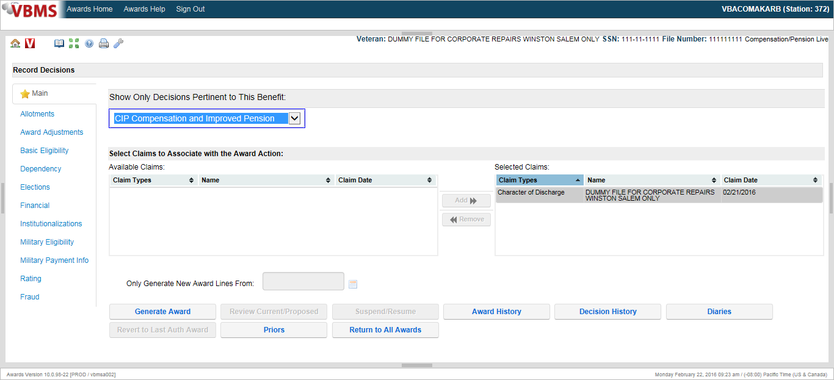

Select the “Add” option.

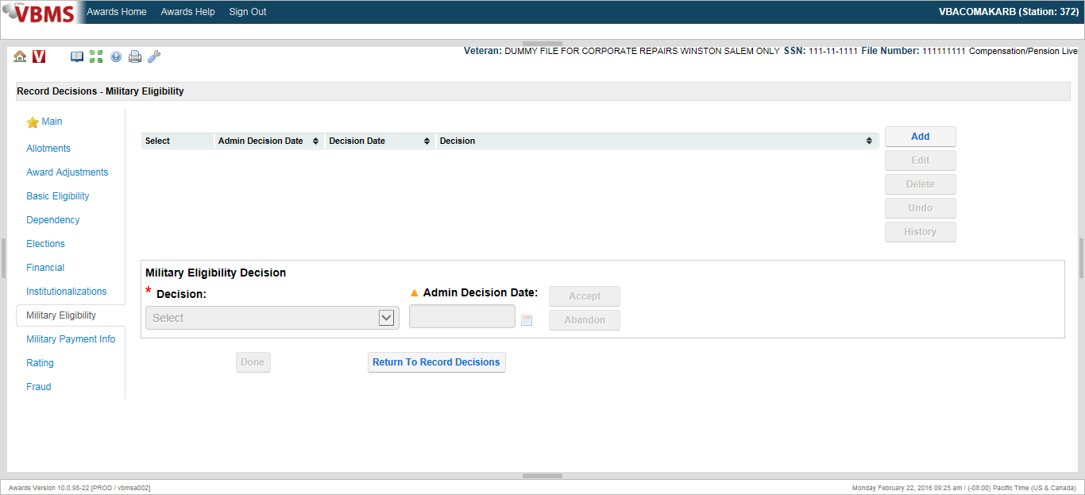

Under the decision drop down, one of the following three options must be selected:

* Dishonorable for VA purposes – Chapter 17 eligible,
* Dishonorable for VA purposes – Chapter 17 ineligible, or
* Honorable for VA purposes.

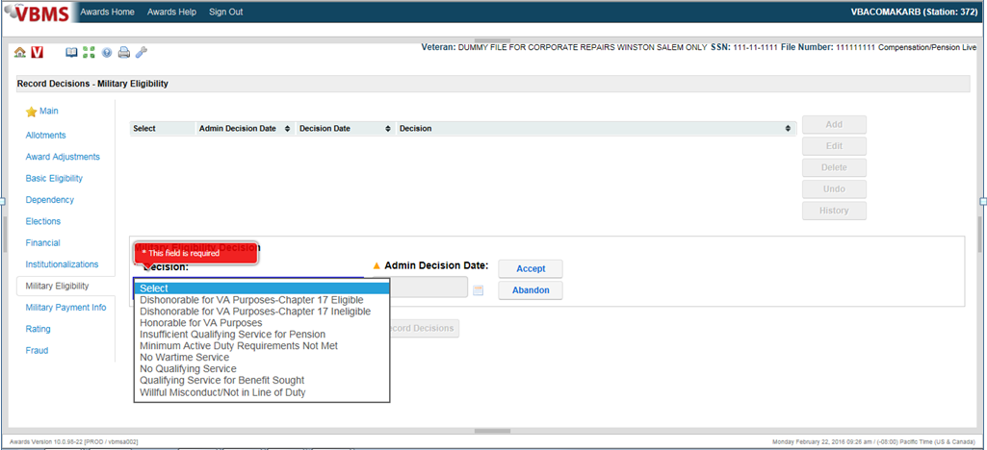

Inform the audience that the admin decision date is the date the COD decision was approved. Finally, instruct the audience to select Accept.

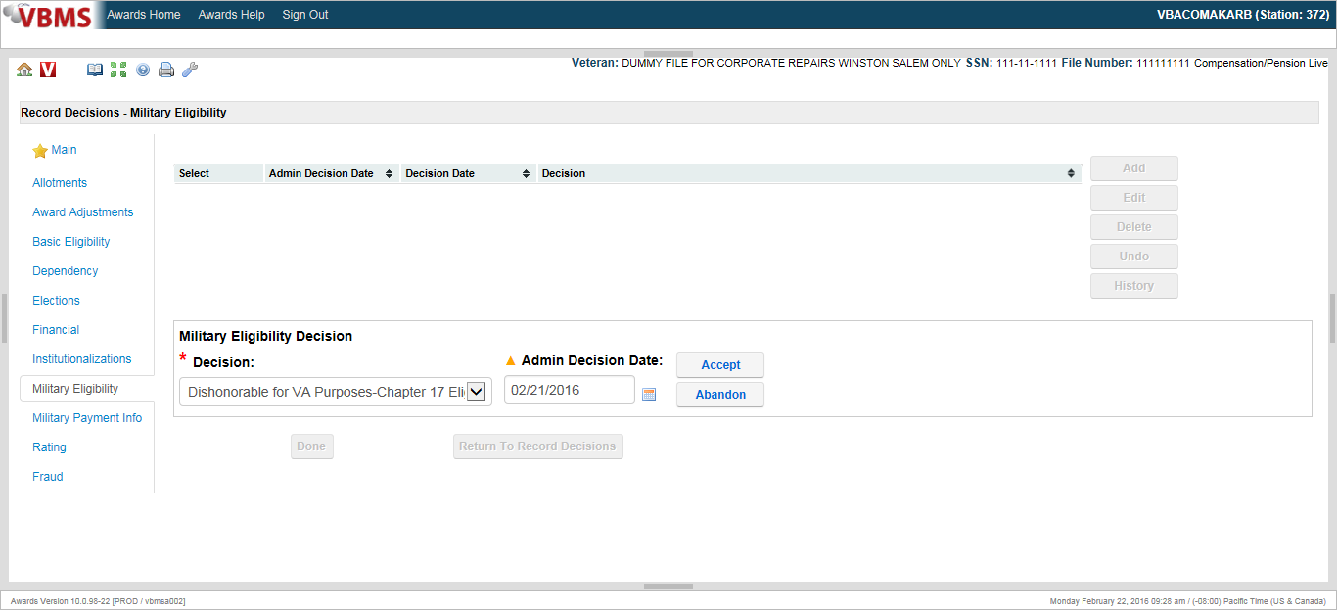

***Key:*** For a Dishonorable for VA purposes – Chapter 17 ineligible (DVA) decision, the end product (EP) associated with the administrative decision must be cleared. For a chapter 17 eligible or Honorable for VA purposes decision, the EP associated with the administrative decision must be kept pending until a final decision on service connection is determined.

**Updating the Corporate Record After Making a Decision**

By signing off on an administrative decision regarding the character of a Veteran’s discharge, the signing official implicitly authorizes corresponding updates to the corporate record.

Authorization activity is responsible for updating the corporate record. This is accomplished by making entries in the Beneficiary Identification and Records Locator Subsystem (BIRLS).

Unless current entries are accurate, authorization activity must update the VETERAN IDENTIFICATION DATA tab on the BIRLS VETERAN IDENTIFICATION screen to reflect the Veteran’s

* period(s) of service
* type(s) of discharge, and
* separation reason(s).

***Note***: All data entries are made on the VETERAN IDENTIFICATION DATA tab of the BIRLS VETERAN IDENTIFICATION screen.

**Procedures for Updating BIRLS**

Follow the instructions in the table below when updating BIRLS to reflect the outcome of an administrative decision regarding the character of a Veteran’s discharge.

|  |  |
| --- | --- |
| **If the administrative decision indicates…** | **Then identify the column containing service data for the period at issue and enter…** |
| * The entire period of service at issue was *dishonorable* for VA purposes, or * A statutory bar to benefits exists for the entire period of service under [38 CFR 3.12(b)](http://www.ecfr.gov/cgi-bin/text-idx?SID=1e3b7d37f5d486813321c75b1d285ca9&node=se38.1.3_112&rgn=div8) | * *DVA* (**d**ishonorable for **VA** purposes) in the CHAR SVC (**char**acter of **s**er**v**i**c**e) field, and * *ADM* (**adm**inistrative decision) in the SEP REAS (**sep**aration **reas**on) field. |
| the entire period of service at issue was *other than dishonorable* for VA purposes | * *HVA* (**h**onorable for **VA** purposes) in the CHAR SVC field, and * *ADM* in the SEP REAS field. |
| * the Veteran was discharged under dishonorable conditions for VA purposes (or a statutory bar to benefits exists under 38 CFR 3.12(b)), but * the Veteran was eligible for complete separation at an earlier date | * the date the Veteran was eligible for complete separation in the RAD (**r**eleased from **a**ctive **d**uty) field * *HVA* in the CHAR SVC field * the beginning and ending dates of the remainder of the Veteran’s period of service in the EOD (**e**ntry **o**n **d**uty) and RAD fields, respectively, of the ***next*** column of service data * *DVA* in the CHAR SVC field of the next column of service data, and * *ADM* in the SEP REAS field of ***both*** columns of service data. |

**Notification of Final Decision**

After making a final decision and having it approved, promptly provide notice to the claimant as provided in M21-1, Part III, Subpart v, 2.B.1.b.

If the decision held is “honorable for VA purposes” or “Dishonorable for VA purposes – chapter 17 eligible” follow the notification elements indicatied above to include

* notifying the claimant of the COD decision,
* entitlement to health care is established, and
* explanation that, although conditions surrounding his/her discharge generally preclude payment of VA benefits, there may be eligibility to VA medical care for any disabilities incurred or aggravated during active service, and that he or she should apply for VA medical care at the nearest VA medical center

If the decision is unfavorable, also advise the claimant of the

* decision’s effect on his/her entitlement to VA benefits,
* entitlement to health care is not established, and
* procedure for asking the service department that declared his/her character of discharge to review it.

Please see the attached example of a decision notification letter.

**Notifying VA and Non-VA Entities of a Decision**

After making a character-of-discharge determination at the request of a VA or non-VA entity,

* notify the entity of the outcome of the determination, and
* follow the instructions in M21-1, Part III, Subpart v, 1.A.4.b.

***Important***: If a VA medical unit made the request, provide the results of the decision expeditiously, as entitlement to medical treatment may be at issue.

38 CFR Character of Discharge Quick Reference

|  |  |
| --- | --- |
| **38 CFR 3.12(c)**  **Benefits are not payable where the former service member was discharged or released under one of the following conditions:** | |
| (1) Conscientious objector who refused to perform military duty, wear the uniform or obey orders. | |
| (2) Discharged by sentence of a General Court Martial | |
| (3) Resignation by an officer for the good of the service. | |
| (4) Deserter | |
| (5) As an alien during a period of hostilities at their request | |
| (6) An OTH discharge because of an AWOL period of at least 180 consecutive days  BUT see 3.12(c)(6) for exceptions | |
| **38 CFR 3.12(d)**  **A discharge or release because of one of the offenses listed is considered to have been issued under dishonorable conditions:** | |
| (1) Acceptance of an Undesirable Discharge to escape trial by General Court Martial. | |
| (2) Mutiny or spying | |
| (3) An offense involving moral turpitude, including conviction of a felony | |
| (4) Willful and persistent misconduct | |
| (5) Homosexual acts involving aggressive circumstances | |
| **38 CFR 3.12e-g Upgraded Discharges** |  |
| (e) An honorable or UHC discharge granted by a board for corrections of discharges under authority of 10 USC 1552 is binding on VA | (g) An honorable or general discharge, on or after October 8, 1977, by a discharge review board established under 10 USC 1553 sets aside any bar to benefits under 3.12(d) when certain conditions are met. See 38 CFR 3.12(g) |
| 1. An honorable or general discharge issued prior to October 8, 1977 by a discharge review board established under 10 USC 1553, but not under   authority of the Presidents directive of 1-19-77; DOD’s special discharge review program; or any discharge review program implemented after 4-5-77 that didn’t apply to everyone discharged or released with an OTH conditions, sets aside any bar to benefits under 3.12(c) or (d) but not (c)(2) | (h) An honorable or general discharge issued by reason of the President’s directive of 1-19-77, the DOD special discharge review program effective 4-5-77, or any discharge review program implemented after 4-5-77 and not made applicable to all persons discharged or released from service with an OTH discharge does NOT set aside any bar imposed by 3.12(c) or (d). There is an exception. See 3.12(h) |

|  |
| --- |
| **38 CFR 3.12(k)**  **Uncharacterized Separations**  **After 10-1-82** |
| (1) **Entry level** - Consider uncharacterized separations of this type to be under conditions other than dishonorable. No administrative decision is required. Considered by VA to be under honorable conditions |
| (2) **Void enlistment or induction** -Review uncharacterized separations of this type based on facts and circumstances surrounding separation, with reference to the provisions of to determine whether separation was under conditions other than dishonorable. Prepare an administrative decision. |
| (3) **Dropped from rolls** - Review uncharacterized administrative separations of this type based on facts and circumstances surrounding separation to determine whether separation was under conditions other than dishonorable. Prepare an administrative decision. |

COD Flow Chart

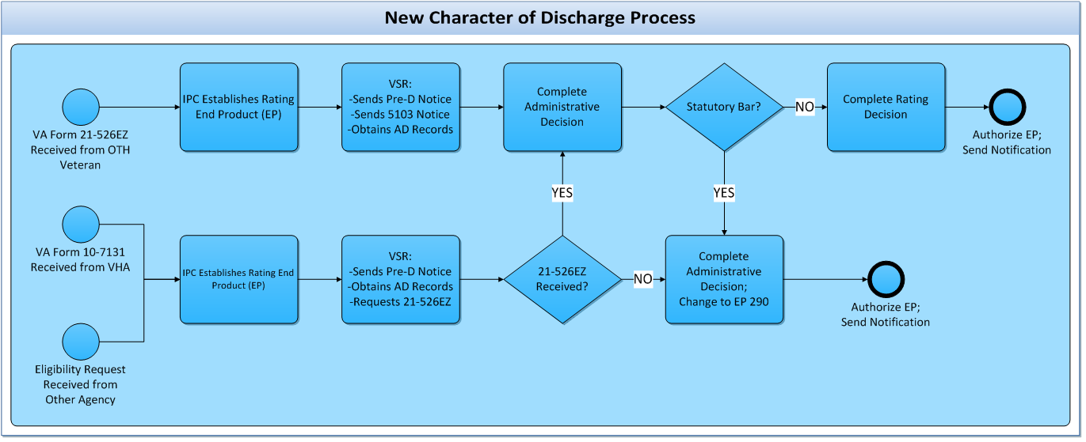

Example of a Decision

**DEPARTMENT OF VETERAN AFFAIRS CSS: XXX XX XXXX**

**REGIONAL OFFICE VETERAN, JOE Q**

**ANYWHERE USA**

**ADMINISTRATIVE DECISION**

**State the issue:** Either a Statutory Bar Determination if the reasons for discharge are found under 38 CFR 3.12(c), or a Regulatory Bar Determination if the reasons for the discharge are found under 38 CFR 3.12(d)

**ISSUE**: Character of Discharge Determination

**EVIDENCE**:

1. Veteran’s VA Form 21-526, Application for compensation benefits received Oct. 30, 2004.

List all the evidence used in the decision.

1. Pre-determination (or due process) letter to veteran dated November 9th, 2004.
2. Facts and circumstances of discharge and DD 214 received from the National Personnel Records Center on November 25th, 2004.
3. Response from veteran regarding pre-determination (or due process) letter, received on January 2, 2005.

**State the decision**: What is the veteran’s character of service for VA purposes? Also is the veteran entitled to healthcare benefit? (Remember: discharge reasons under 38 CFR 3.12(c), or a bad conduct discharge (BCD) = no healthcare; discharged under 38 CFR 3.12(d) = entitled to healthcare, unless it’s a BCD.)

**DECISION**:

Joe Q. Veteran’s United States Army service from January 11th, 1976 to November 27th, 1977 is ***dishonorable*** and is ***a bar*** to VA benefits under the provisions of 38 CFR 3.12(d)(4).

Mr. Veteran ***is entitled*** to health care benefits under Chapter 17, Title 38 U.S.C. and 38 CFR 3.360(a) for any disability determined to be *service connected*.

**Provide the regulations used in the determination.** Be sure to use only the 38 CFR and the USC, NOT the manuals for your reasons and bases. Commonly used 38 CFR references: 3.12(c) or 3.12(d), depending on the reasons for discharge; 3.13 **IF** a conditional discharge is at issue; 3.360 is always needed due to our need to determine entitlement to Chapter 17 healthcare.

**REASONS AND BASES**:

If the former service member did not die in service, pension, compensation, or dependency and indemnity compensation is not payable unless the period of service on which the claim is based was terminated by discharge or release under conditions other than dishonorable. (38 U.S.C. 101(2)). A discharge under honorable conditions is binding on the Department of Veterans Affairs as to character of discharge. (38 CFR 3.12)

A discharge or release from service under one of the conditions specified in this section is a bar to the payment of benefits unless it is found that the person was insane at the time of committing the offense causing such discharge or release or unless otherwise specifically provided (38 U.S.C. 5303(b)). (38 CFR 3.12)

A discharge or release because of one of the offenses specified in this paragraph is considered to have been issued under dishonorable conditions.

(1) Acceptance of an undesirable discharge to escape trial by general court-martial.

Don’t need to include all. Just those that are applicable.

(2) Mutiny or spying.

(3) An offense involving moral turpitude. This includes, generally, conviction of a felony.

**(4) Willful and persistent misconduct.** This includes a discharge under other than honorable conditions, if it is determined that it was issued because of willful and persistent misconduct. A discharge because of a minor offense will not, however, be considered willful and persistent misconduct if service was otherwise honest, faithful and meritorious

(5) sexual acts involving aggravating circumstances or other factors affecting the performance of duty. Examples of sexual acts involving aggravating circumstances or other factors affecting the performance of duty include child molestation, homosexual prostitution, sexual acts or conduct accompanied by assault or coercion, and homosexual acts or conduct taking place between service members of disparate rank, grade, or status when a service member has taken advantage of his or her superior rank, grade, or status. (38 CFR 3.12)

The health-care and related benefits authorized by chapter 17 of title 38, United States Code shall be provided to certain former service persons with administrative discharges under other than honorable conditions for any disability incurred or aggravated during active military, naval, or air service in line of duty.

With certain exceptions such benefits shall be furnished for any disability incurred or aggravated during a period of service terminated by a discharge under other than honorable conditions. Specifically, they may not be furnished for any disability incurred or aggravated during a period of service terminated by a bad conduct discharge or when one of the bars listed in 38 CFR §3.12(c) applies. (38 CFR 3.360)

**Provide a brief summary of the evidence considered.**

Joe Q. Veteran enlisted in the United States Army on January 11, 1976 and served 1 year, 7 months and 15 days of creditable service. On November 27th, 1977, Mr. Veteran was recommended for discharge for the good of the service under the provisions of Chapter 10, AR 635-200 with an other than honorable discharge in lieu of trial by special court-martial. Mr. Veteran’s violation of the UCMJ occurred before he was eligible for complete separation from his first period of service. In the summary of military offenses listed in a copy of his Official Military Personnel File, Mr. Veteran was charged with being absent without leave (AWOL) for a period of 66 days. In addition, the personnel file shows that Mr. Veteran was reprimanded on June 6, 1977, October 1, 1977, and October 13, 1977 for failure to report to the designated location for duty.

The record shows that Mr. Veteran did reply to our request for evidence, however, he did not address the issues surrounding his discharge.

**Relate the regulations to the evidence.** State how the evidence indicates the actions leading to the discharge either do or do not conform to the regulations, thereby constituting the claimant’s service to be either honorable or dishonorable for VA purposes.

Mr. Veteran’s repeated offenses during his United States Army service from January 11, 1976 to November 27, 1977 constitute willful and persistent misconduct under the provisions of 38 CFR 3.12(d)(4). Mr. Veteran’s charge of AWOL without the presence of any mitigating circumstances to offset the contentions of the US Army is deemed appropriate. His violations of the UCMJ displayed a disregard for authority and military regulations.

**Address the issue of sanity.** If sanity *has* been placed at issue, you will need to discuss it here.

Sanity is not an issue.

Due to the afore mentioned reasons, Mr. Veteran’s United States Army service from January 11, 1976 to November 27, 1977 is deemed *dishonorable* for VA purposes and is *a bar* to VA benefits under the provisions of 38 CFR 3.12(d)(4).

Mr. Veteran ***is entitled*** to health care benefits under Chapter 17, Title 38 U.S.C. and 38 CFR 3.360(a) for any disability determined to be *service connected*.

***SUBMITTED:_____________________________ DATE__________________***

***CONCURRED:_____________________________ DATE__________________***

***APPROVED:_____________________________ DATE__________________***

If prepared by a SVSR (GS 11 or higher), no need for concurrence, only approval by a VSCM designee such as a coach. If prepared by a VSR below grade 11, then concurence must be obtained from a VSR grade 11 or higher and approval by a VSCM designee such as a coach.

Example of a Decision Notice Letter

In Reply Refer To:

000/000/00

CSS XXX XX XXXX

JOE VETERAN

1 VETERAN WAY

WASHINGTON DC 00001

Dear Mr. Veteran:

We made a decision regarding your discharge from military service. Every effort was made to see that your claim received complete consideration.

This letter tells you what we decided, how we reached our decision and what evidence we used to reach our decision. We have also included information on what you can do if you don't agree with our decision, and who to contact if you have questions or need assistance.

**What Did We Decide?**

We decided that your military service for the period September 15, 2003 to November 16, 2004 is dishonorable for VA purposes. You and your dependents aren't eligible for any VA benefits for this period of military service. Only veterans with honorable service are eligible for VA benefits.

You *may* be eligible for treatment at a VA hospital for any condition determined to be related to your military service. You should apply for treatment at the nearest VA Medical Center or Outpatient Treatment Clinic. If you apply in person, please bring this letter. If you apply by letter, include your VA file number on your letter.

**How Did We Make Our Decision?**

The record shows we received a response from you on March 30, 2005 addressing the issues surrounding your discharge. You offered no mitigating factors which would have resulted in a positive urinalysis, which led to your other than honorable discharge.

**What Evidence Did We Use To Decide Your Claim?**

In making our decision, we used the following evidence:

* DD Form 214, US Navy
* Fact and Circumstances received April 20, 2005
* Due Process Letter to you dated March 3, 2005
* Your response to our letter, received March 30, 2005

**What You Should Do If You Disagree With Our Decision**

If you do not agree with our decision, you must complete and return to us the enclosed VA Form21-0958, *Notice of Disagreement*, in order to initiate your appeal. You have *one year from the date of this letter to appeal the decision*. The enclosed VA Form 4107, “*Your Rights to Appeal Our Decision,*” explains your right to appeal.

You can also ask the Service Department to change the character of discharge or you can apply for a correction of military records. To request a change, use the enclosed DD Form 293, Application for the Review of Discharge or Dismissal from the Armed Forces of the United States. To apply for correction, use the enclosed DD Form 149, Application for Correction of Military Record under the Provisions of Title 10, U.S. Code, and Section 1552. Send the completed form to the proper address on the back of the form.

**Do You Have Questions Or Need Assistance?**

If you have any questions, you may contact us by telephone, e-mail, or letter.

|  |  |
| --- | --- |
| **If you** | **Here is what to do.** |
| Telephone | Call us at 1‑800‑827‑1000. If you use a Telecommunications Device for the Deaf (TDD), the number is 711. |
| Use the Internet | Send electronic inquiries through the Internet at https://iris.va.gov. |
| Write | VA now uses a centralized mail system. For all writtencommunications, put your full name and VA file number on the letter.Please mail or fax all written correspondence to the appropriate addresslisted on the attached *Where to Send Your Written Correspondence*chart, below. |

In all cases, be sure to refer to your VA file number XXX XX XXXX.

If you are looking for general information about benefits and eligibility, you should visit our website at https://www.va.gov, or search the Frequently Asked Questions (FAQs) at https://iris.va.gov.

**What Is eBenefits?**

eBenefits provides electronic self-service resources to Servicemembers, Veterans, and theirfamilies. Use of these resources often helps us serve you faster! Through the eBenefits websiteyou can:

● Submit claims for benefits and/or upload documents directly to VA

● Request to add or change your dependents

● Update your contact and direct deposit information and view payment history

● Request a Veterans Service Officer to represent you

● Track the status of your claim or appeal

● Obtain verification of military service, civil service preference, or VA benefits

● And much more!

Enrolling in eBenefits is easy. Just visit www.eBenefits.va.gov for more information. If yousubmit a claim in the future, consider filing through eBenefits. Filing electronically, especially ifyou participate in our fully developed claim program, may result in a faster decision than if yousubmit your claim through the mail.

We have no record of you appointing a service organization or representative to assist you with your claim. You can contact us for a listing of the recognized veterans' service organizations and/or representatives. Veterans' service organizations, which are recognized or approved to provide services to the veteran community, can also help you with any questions.

Sincerely yours,

VA Director

Enclosure(s): VA Form 4107

DD Form 149

DD Form 293

Where to Send Your Written Correspondence

Practical Exercise

Mr. Joe Veteran served in the US Navy from July 31, 2001 to February 18, 2005. He received an Under Other Than Honorable Conditions *(OTH)* discharge.

Claimant’s DD-214 reflects that he received the National Defense Service Medal, and Global War on Terrorism Service Medal.

1. What Evidence should be developed for?

**Scenario:**

Mr. Veteran enlisted in the United States Navy on July 31, 2001. On December 8, 2004, USS Little Wing was noted that the urinalysis test Mr. Veteran took was positive for Tetrahydrocannabinol (THC). Review of the records showed that there is no evidence of insanity.

On September 13, 2015, we received VA Form 21-526EZ, *Application for Disability Compensation and Related Compensation Benefits*. We sent Mr. Veteran a development letter on September 26, 2015, and began requesting the facts and circumstances surrounding his discharge. On November 17, 2015, we retrieved the facts and circumstances from the U.S. Navy.

**Violation:**

On or about December 8, 2004, Aircraft Mechanic (E1) AMAR, Joe Veteran, US Navy, USS LITTLE WING (CVN-00), on active duty, did wrongfully use marijuana.

1. Prepare a brief administrative decision indicating the following:
   1. If the discharge is dishonorable/honorable, what regulation serves as the grounds for your decision?
   2. Is the discharge honorable or dishonorable for VA purposes? Please show your reasoning.
   3. What information must be included in the administrative decision?
   4. If the discharge is dishonorable for VA purposes, is the veteran eligible for Chapter 17 health care benefits?