Quality Management System (QMS)

# **Salesforce Lightning View**

**In Lightning View**

The user will know they’re in the **Salesforce Lightning** view when the 9-dot pattern (waffle) is displayed on the far top left side and will see a little hoodie avatar on the far top right side.

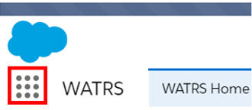

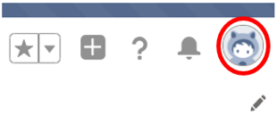

**Switch from Classic to Lightning view**

When a user first logs into Salesforce it may open to the Lightning view or to the Classic view. This will be determined based on being in Lightning or Classic when they logged out of QMS. If in the Classic view, the user will need to switch from Classic to the Lightning View. This is accomplished by using the “Switch to Lightning Experience” button, found at the top and in the middle of the screen. See the below screenshot



**Change Display Density “Comfy” to “Compact”**

When the user first logs into Lightning, they need to validate the view density they are in, is “Compact”. Click the hoodie person to open the view menu and scan down to “DISPLAY DENSITY”. The current checked density is either “Comfy” or “Compact”. If the checkmark is beside “Compact”, no action is needed. See below:

: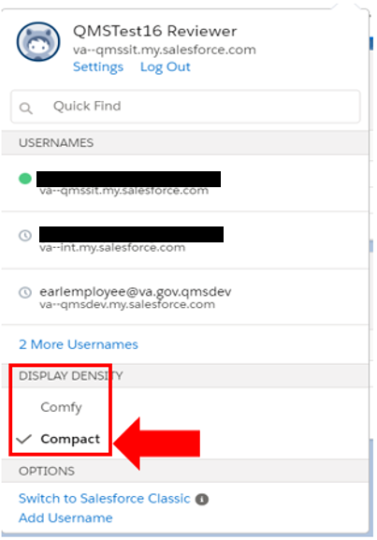

**Note**: “Compact” is the correct Display Density

If the checkmark is beside “Comfy”, click “Compact”. A popup message will identify a change to the density and the page needs to be refreshed. Select the “Refresh Now” button on the message and the user will be returned to the prior tab. See the screenshots below for clarity.

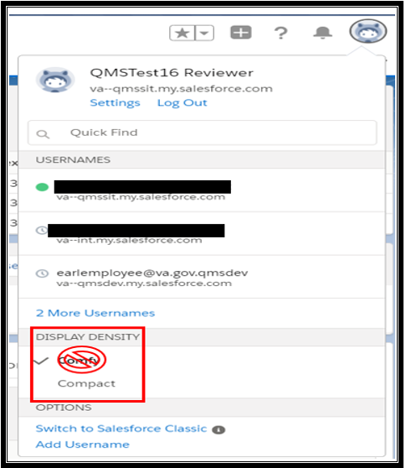

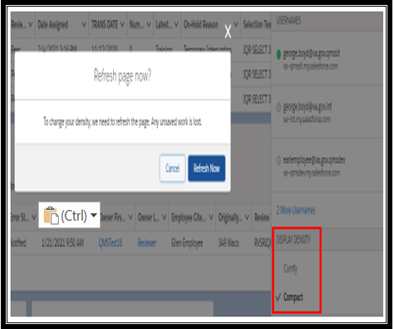

**Access to QMS**

If “QMS” is not shown to the right of the 9-dot pattern, the user is not in the QMS app. Click the 9-dot pattern to open the App Launcher menu to find the QMS application. Type “QMS” in the search box and QMS will appear as a selection. Click “QMS” to open the application and connect to QMS.

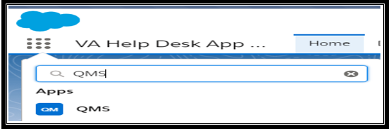

Next, “QMS” will appear next to the 9-dot pattern along with the pre-established tab set.

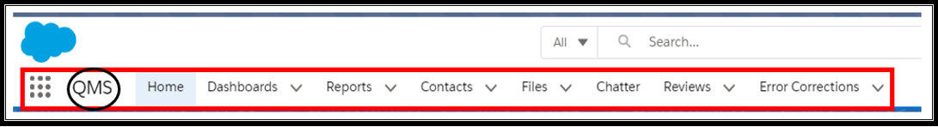

**“Home” Tab**

The new “Home” screen display provides the user a view of any reviews in their review queue and Error Correction (EC) records in their queue. On the “Home” tab the user has the option to access a pending review or error correction in their view queue. They can also request a new review using the “Request a New Review” button.

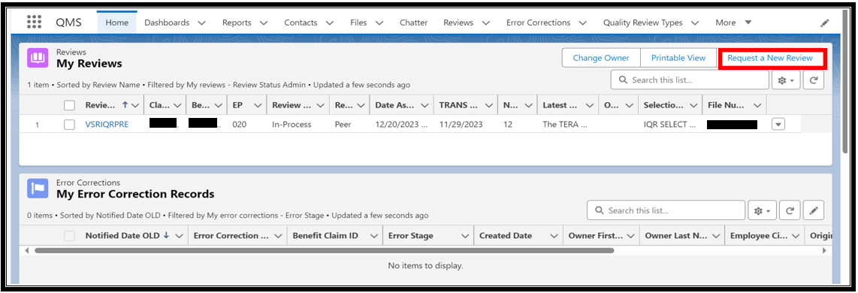

**“Reviews” Tab**

The user has the option to use the “Home” tab or select the “Reviews” tab to access their pending reviews. Once the “Reviews” tab is selected, a menu is opened with options of prior view selections. See the below screenshot.

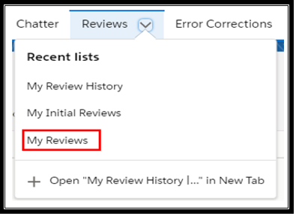

**“My Reviews” View list**

The “My Reviews” view is a list of Quality Review Specialist (QRS) reviews in a pending status. An example is “On-Hold”, “Assigned” or “In-process” in their queue.

The drop-down menu above, under the heading “Reviews Tab” indicates no reviews in the user’s queue. The menu indicates “My Review History”, “My Initial Reviews”, and “My Reviews” view lists are available. Select “My Reviews” to open this view list.

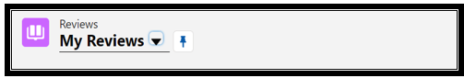

**Always open to “My Reviews” list view**

The user can “Pin” the “My Review” list view to always open when the “Reviews” tab is selected. The user will need to click the pin icon next to the “My Review” drop-down.

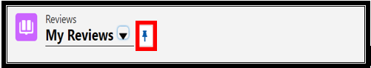

The pin icon will change position  and a message will be received confirming the view “was pinned”. This list view is now locked. Refer to the screen example below:

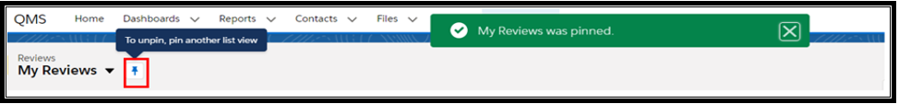

**Select a New Review**

The User will select the “Request a New Review” link and the below screen and message is displayed which confirms success “Review assigned successfully” and the “Back to Reviews” button to return to access the new review. This process has not changed from the original Classic view.

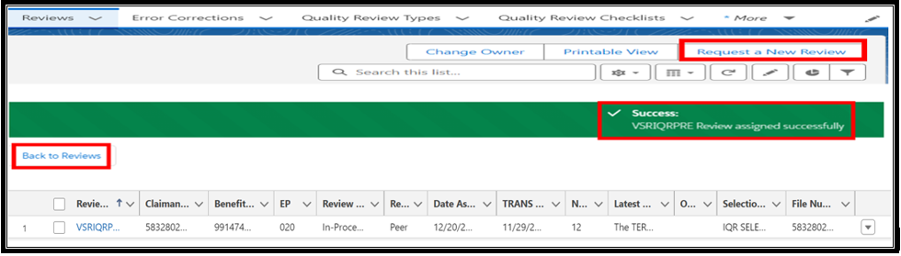

**Open a Review**

As in Classic, select the “Review Name” hyperlink and the “Details” page will open. Review the “Review Name, BCID, and C file” (e.g., VSRIQRPRE B#123456 F#876543210). See below.

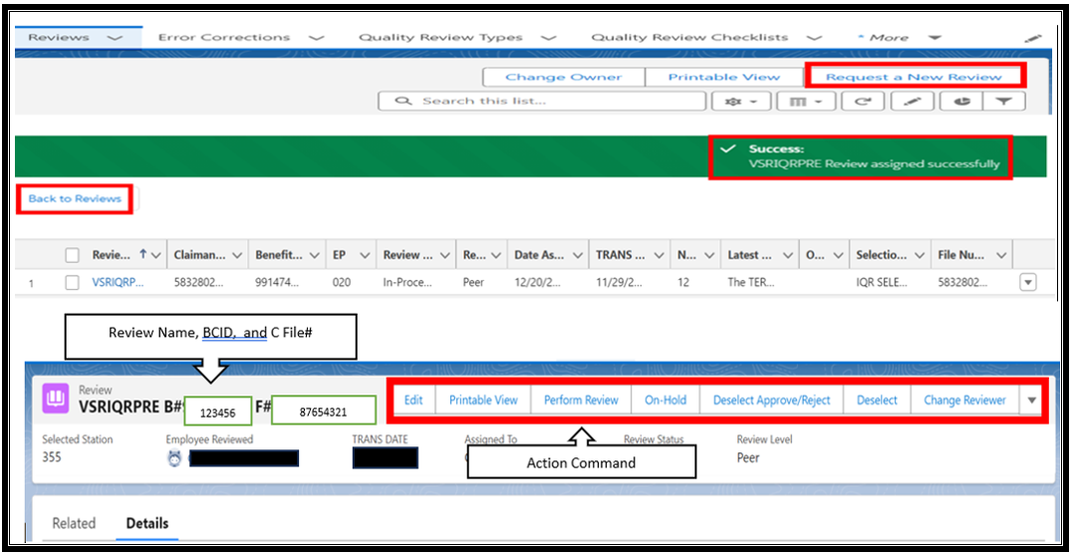

When opening a review, in the “Lighting Experience” the next screen displays:

1. The “My Reviews” view list remains displayed and accessible.
2. The Review Title heading displayed on the “Details” page includes the Review Name, Benefit Claim ID, and C-File number.
3. The details of the review are easier to scan.

Compare to the “Lighting Experience” view, when opening a review, in Salesforce Classic, the view slightly differs. In the “Salesforce Classic” view, the next screen displays:

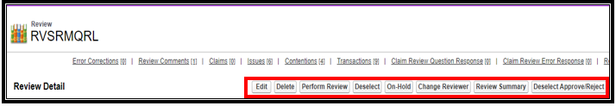

**Note:** The Action Command buttons, navigating in the Details page, are displayed the same in as Classic.

**Important:** After submitting a review, the question responses on the Details page, may not be displayed and the user will need to refresh the page.

**Error Corrections**

**Note:** The Error Correction Detail page has changed. There is a new column named “Notified Date OLD”. The Notified Date column allows the users to sort their error corrections.

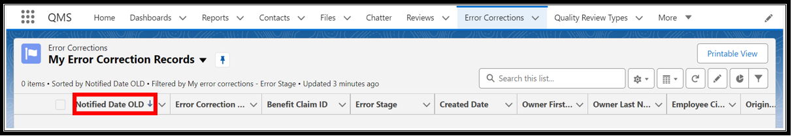

# **Index of QMS Lightning Pre-established Tabs**

**Important**: The QMS Tabs are locked and preset for all QMS users, Reviewers, Coaches, and Management. Some tabs may not be accessible based on position. The user does have the option to add Tabs and delete the Tabs they added, using the pencil icon  to customize.

**“Home” Tab (All Users)**

Description: Provides the user a view of any reviews in their “My Reviews” queue and Error Correction (EC) records in their “My Error Correction Records” queue.

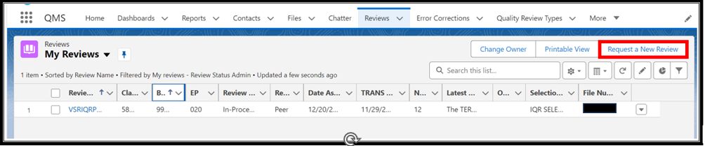

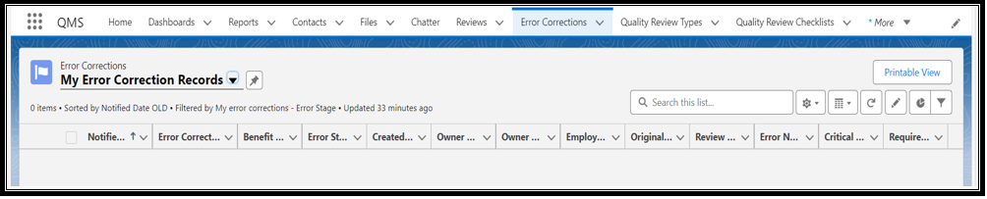

**“Dashboard” Tab (Coaches and Management)**

Description: Dashboards help visually understand changing business conditions so management can make decisions based on the real-time data they have gathered with reports. Use dashboards to help identify trends, sort out quantities, and measure the impact of their activities. Before building, reading, and sharing dashboards, review these dashboard basics.

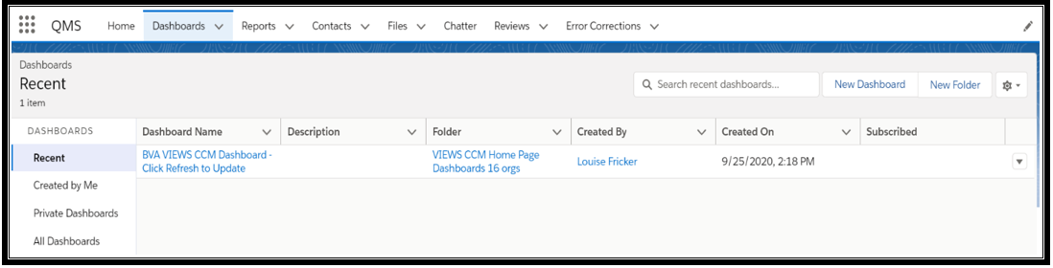

**“Reports” Tab (Coaches and Management)**

Reports give a user access to their Salesforce data. They can examine their Salesforce data in almost infinite combinations, display it in easy-to-understand formats, and share the resulting insights with others. Before building, reading, and sharing reports, review these reporting basics.

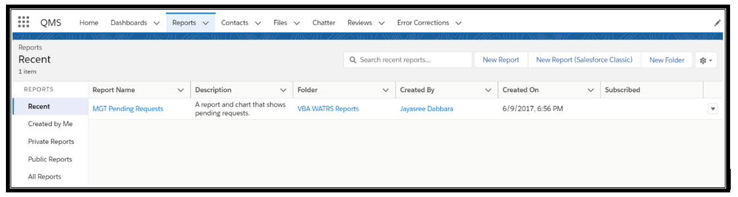

**“Contacts” Tab (All Users)**

Access to the user’s QMS Contact Detail page for changes to Review Levels and Review Types.

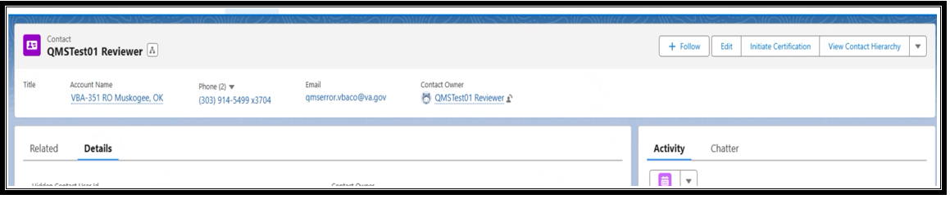

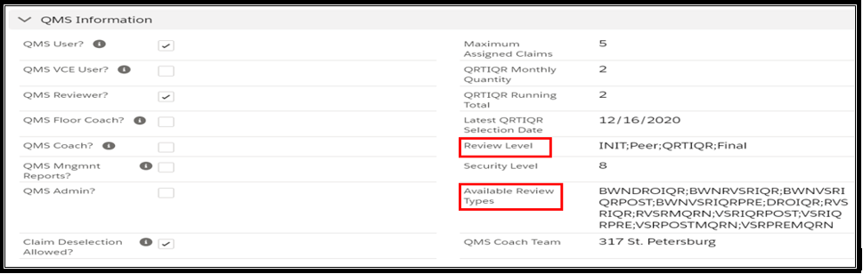

**“Files” Tab (All Users)**

Use Salesforce Files to share and collaborate on files, store files privately, manage version updates, and follow files that are important. Use Files Connect to connect to external file systems right from Salesforce.

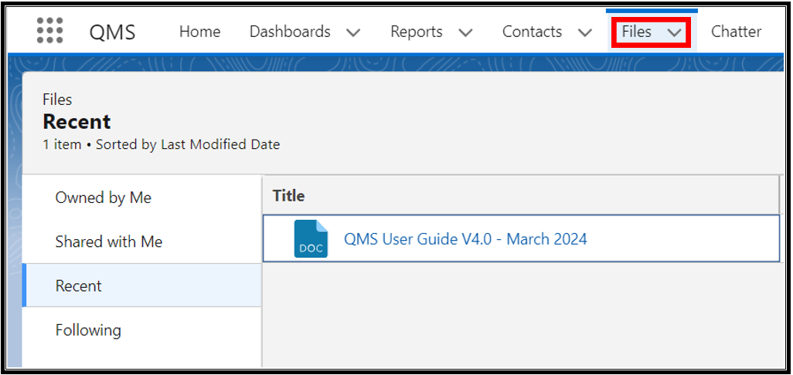

**“Chatter” Tab (All Users)**

Allows for collaboration with selected QMS groups with other QMS users.

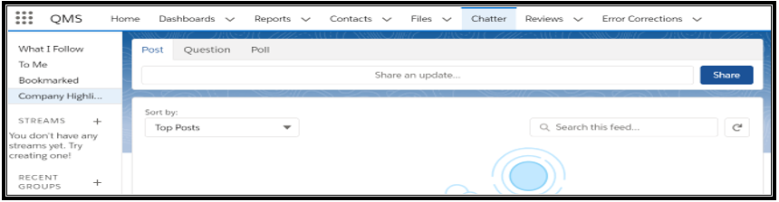

**“Reviews” Tab (All Users)**

Gives the option to access a user’s pending reviews, with options of viewing prior review selections.

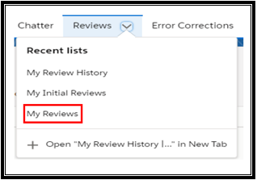

**“Error Correction” Tab (All Users)**

Gives the option to access the user’s pending “Error Correction” records, with options of viewing prior “Error Correction” selections.

