(VSR VIP POST-D)

Recoupment of Separation Benefits

Trainee Handout

**Table of Contents**

Objectives 2

References 3

Topic 1: Separation Benefits Overview 4

Topic 2: Confirming Payment and Amount to Recoup 6

Topic 3: Principles Specific to Disability Severance Pay 13

Topic 4: Award Action and Notification 17

Attachment A: Recoupment of Separation Benefits – General Process Overview 21

Practical Exercise 22

Objectives

After this lesson, you will be able to:

* Name the three most common types of separation benefits and explain the general process of recoupment
* Recognize receipt of separation benefits and amounts
* Examine whether recoupment of separation benefits is required or has already been completed
* Implement procedures specific to the recoupment of disability severance pay (DSP)
* Generate awards and decision notices that incorporate the recoupment of separation benefits

References

* [10 U.S.C. 1174](https://www.law.cornell.edu/uscode/text/10/1174), Separation pay upon involuntary discharge or release for active duty
* [10 U.S.C. 1174a](https://www.law.cornell.edu/uscode/text/10/1174a), Special Separation Benefit (SSB)
* [10 U.S.C. 1175a](https://www.law.cornell.edu/uscode/text/10/1175a), Voluntary Separation Pay (VSP)
* [10 U.S.C. 1212](https://www.law.cornell.edu/uscode/text/10/1212), Disability severance pay
* [38 U.S.C. 5304](https://www.law.cornell.edu/uscode/text/38/5304), Prohibition against duplication of benefits
* [38 CFR 3.700](https://www.ecfr.gov/cgi-bin/text-idx?SID=e5c2b791510e5a04ce5b6f6bc562cbe2&mc=true&node=se38.1.3_1700&rgn=div8), Concurrent Benefits and Elections (General)
* [M21-1, Part III, Subpart v, 4.B](https://vaww.vrm.km.va.gov/system/templates/selfservice/va_kanew/help/agent/locale/en-US/portal/554400000001034/content/554400000014245/M21-1-Part-III-Subpart-v-Chapter-4-Section-B-Recoupment-of-Separation-Benefits), Recoupment of Separation Benefits
* [AskDFAS](https://corpweb1.dfas.mil/askDFAS/custCategories.action?tsm=1485548562128&pgModId=5243)
* [AskDFAS User Guide](http://vbaw.vba.va.gov/bl/21/Products/docs/askDFAS%20user%20guide.docx)
* [Disability Rating Calculator](http://cptraining.vba.va.gov/c&p_training/Job_Aids/Documents/Combinator.docm) (often referred to as the Combinator) (or find via: Compensation Service Intranet Homepage/Miscellaneous/Job Aids/Combinator)
* [Separation Program Designator (SPD) Codes](http://vbaw.vba.va.gov/bl/21/Products/docs/spd_codes.pdf)
* [Veterans Compensation Benefits Rate Tables](https://www.va.gov/disability/compensation-rates/veteran-rates/) (or find via: Compensation Service Intranet Homepage/Publications/Rate Tables/Veterans Compensation Benefits Current Rates)

Topic 1: Separation Benefits Overview

**General Information**

Separation benefits are, generally, a lump-sum payment for voluntary or involuntary separation. The three most common types of separation benefits, which will be the focus of this lesson, are:

* separation pay (replaced *readjustment pay*, on September 15, 1981)
* special separation benefit (SSB)
* disability severance pay (DSP)

*Note:* For situational awareness, separation pay under *10 U.S.C. 1174* should not be confused with voluntary separation pay (VSP) under *10. U.S.C. 1175a*. VSP is beyond the scope of this lesson; however, you should be aware of this benefit due to exceptions for withholding. If you receive a claim involving VSP, see *M21-1, Part III, Subpart v, 4.B.1.o*.

For information on all types of separation benefits, see *M21-1, Part III, Subpart v, 4.B.1*.

**Prohibition Against Duplication of Benefits**

*38 CFR 3.700* prohibits VA from paying compensation to a Veteran who also received certain separation benefits (to include those mentioned above) from the Department of Defense (DoD) or Department of Homeland Security (DHS) (for Coast Guard Veterans). Therefore, VA must withhold compensation to offset the amount of the separation benefit the Veteran already received.

**Process Overview**

Generally, recoupment of separation benefits is initiated during award processing of a rating decision (most often on the initial award paying benefits). Similar to how retired pay withholding is processed, the VSR must check for receipt of separation benefits while conducting his/her review of the rated claim for award processing. The steps of the process that have not been discussed in prior lessons will be covered in detail; however, the following are the general processing steps:

1. Review the assigned claim, to include a review for indication of payment of separation benefits

1. If indicated, determine whether VA has already recouped separation benefits
2. Confirm the *type* of benefit paid, the gross and net *amounts*, and the *date* the benefit was paid (*usually* date of discharge)
   1. You must obtain the *verified amounts* for the benefit. The amounts provided on the corporate record in Share, the Beneficiary Identification and Records Locator System (BIRLS) Miscellaneous Information screen, the *DD Form 214*, and the Veteran’s application, are *not* considered verified. Use the following:
      * VIS
      * AskDFAS (Defense Finance and Accounting Service)
      * Compensation Service Military Pay Staff
      * Call Coast Guard
   2. For DSP, ensure you have identified the severance-pay disabilities and that they are properly identified on the rating decision codesheet
      * Severance-pay disabilities are found on the Physical Evaluation Board (PEB) report (usually found in the Veteran’s personnel records, or sometimes his/her service treatment records (STRs))
      * The rating activity is responsible for identifying the severance-pay disabilities on the codesheet, and entering the initial compensable evaluation for them in the Veterans Benefits Management System – Rating (VBMS-R)
3. Ensure that the *BIRLS Miscellaneous Information* screen reflects the verified gross amount; update if necessary (update BIRLS before entering data in VBMS-Awards (VBMS-A))
4. Based on the type of benefit and the date it was paid, determine if you need to withhold the gross (pre-tax) or net (post-tax/after-tax) amount
   1. Always withhold the net amount of SSB a Veteran received
   2. Determine whether to withhold the gross or net amount of separation pay or DSP a Veteran received based on the date the benefit was paid
      * September 30, 1996 *and earlier* – withhold the gross amount
      * October 1, 1996 *and later* – withhold the net amount
5. Enter information into VBMS-A for award processing, updating any other necessary *Record Decisions* screens (e.g. *Dependency*, *Basic Eligibility*, etc.)
   1. *Military Payment Info screen (*enter the information on this screen first)
   2. *Award Adjustments screen*
6. Generate the award and notify the Veteran using the RADL functionality in VBMS-A (if RADL fails or is incorrect, revert to PCGL for the decision notice)

**\*See Attachment A: Recoupment of Separation Benefits – General Process Overview**

Topic 2: Confirming Payment and Amount to Recoup

**General Rules for Withholding**

After VA determines recoupment of separation benefits is necessary, and the amount that is subject to recoupment, it must withhold some, or all, of the Veteran’s monthly compensation until recoupment is complete.

If a Veteran is already receiving compensation when VA learns recoupment of his/her separation benefits is necessary, give the Veteran notice of proposed adverse action (due process), *before* initiating recoupment.

The amount VA withholds each month includes any of the following to which the Veteran is entitled:

* additional compensation for dependents, and
* special monthly compensation (SMC)

*Exception:* If the separation benefit is DSP, and VA has awarded service connection (SC) for both severance- and non-severance-pay disabilities, VA may ***not*** withhold an amount greater than that to which the Veteran is entitled based on the non-severance pay disabilities. This includes the additional amount of compensation payable for:

* dependents (if the non-severance-pay disabilities *alone* have a combined rating of at least 30%), and/or
* SMC (if the SMC is based on non-severance-pay disabilities *alone)*

See *M21-1, Part III, Subpart v, 4.B.2.a,* *General Information About Recouping Separation Benefits*, for additional general exceptions involved in recoupment of separation benefits.

**Receipt of Separation Benefits** *(Step 1)*

A review of the following will typically reveal whether a Veteran received separation benefits:

* Application for VA compensation (*VA Form 21-526EZ*)
* *DD Form 214, Certificate of Release or Discharge from Active Duty*
* Documentation in the Veteran’s claims folder, such as:
  + Responses to requests for information/records submitted through:
    - The Personal Information Exchange System (PIES) or
    - AskDFAS, and or
    - Letters from:
    - The Coast Guard
    - DFAS Retired and Annuity, and/or
    - DFAS Military Pay Operations
* The MISCELLANEOUS INFO tab on the VETERANS IDENTIFICATION screen in BIRLS (located within the Share program)
* The DISCHARGE PAY tab on the MILITARY PAYMENT INFO screen in the Veterans Service Network (VETSNET) Awards, or VBMS-A
* The MILITARY PAYMENTS tab on the MILITARY INFORMATION screen in Share
* VIS – Non-Recurring Pay at Separation Information on the DFAS/CG Payments tab

*Important:* The above will only indicate that some sort of separation benefit was paid. It *does not* verify the amount paid, even if an amount is provided. *Exceptions:* VIS, responses from PIES, and responses from AskDFAS will confirm the type of payment *and* the amounts.

*Notes:*

* The presence of an amount in the SEPARATION PAY field on the MILITARY PAYMENTS tab in Share is only an indicator the Veteran received some type of separation benefit. It is not a reliable indicator of whether this benefit is “regular” separation pay.
* Use the spreadsheet titled Separation Program Designator (SPD) Codes to determine whether – based on the SPD code that appears in Block 26 of the Veteran’s *DD Form 214* – the Veteran was eligible for any of the separation benefits named on the spreadsheet.  If eligibility did not exist, it is safe to conclude the Veteran was not awarded any of them.

**Determining if VA has Already Recouped** *(Step 2)*

Before establishing a withholding to recoup a Veteran’s separation benefit, you must first determine if the recoupment has already been initiated and/or completed. Such a determination:

* is not generally needed on awards involving an initial payment of benefits
* is needed when reviewing a claim with a running award, or a claim in which VA was previously paying benefits but stopped for a period of time and is now re-starting the payments. For example: VA stopped paying benefits when a Veteran returned to active duty; VA resumed the payment of benefits following the Veteran’s discharge.

To make this determination, perform the *Corporate Inquiry* command in Share or perform a *Search All in List* command and choose *Corporate* from the list, then:

1. Navigate to the *Military* screen
2. Click on the *Military Payments* tab
3. Review the information under the appropriate separation benefit to determine if VA has already recouped it
4. When done, click **Ready** to return to the main *Ready* screen

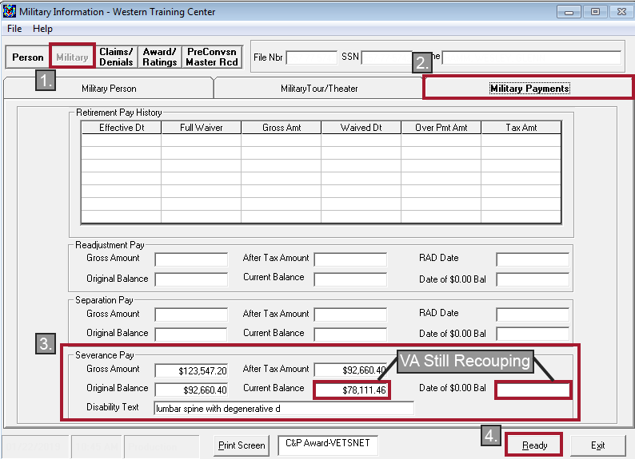



If the corporate record shows recoupment is complete, claims processors must ensure the amount of benefits VA recouped matches the amount of the separation benefit the Veteran received. If they do not match, treat the separation benefit currently at issue as unrecouped.

*Exception:* If the recoupment was *started* in the Benefits Delivery Network (BDN) before conversion into VETSNET Awards, the *completion* of recoupment will *not* be evident in Share. Use the PRECONVSN MASTER RCD button in Share, along with BDN award prints and decision notices in the claims folder, to determine if recoupment has been *completed*.



If a determination cannot be made, ask the local finance activity to perform a financial audit to assist in making the determination.

**Verifying Separation Benefit Amounts** *(Step 3)*

Use the following to verify the gross and net amounts of separation benefits paid:

1. VIS – Non-Recurring Pay at Separation Information on the DFAS/CG Payments tab
2. AskDFAS – submit a request through the portal if not already completed
3. Compensation Service Military Pay Staff – send an encrypted email

Use the sources in the order listed for best results. VIS is instantaneous if the information has been loaded into that program. For step-by-step instructions on obtaining amounts from these sources and when to use them, see *M21-1, Part III, Subpart v, 4.B.2.b.*

*Note:* For DSP, the severance-pay disabilities must be identified. This will be discussed in greater detail in Topic 3.

**Reviewing/Updating BIRLS** *(Step 4)*

To review or update separation benefit information in BIRLS:

Execute the *BIRLS Inquiry* or *BIRLS Update* command through Share (depending on the action needed), then:

1. Click on the *Miscellaneous Info* tab, and
2. Review and, if necessary, edit the amount displayed on the bottom middle of the screen in the following fields:
   * Disability Severance Pay
   * Lump Sum Readjustment Pay, and
   * Separation Pay (this block is also used for SSB payments)
3. Click **Ready** to return to the main *Ready screen* (if only reviewing the info), or click **Update** (the Update button will only be available when you use the BIRLS Update command) to update the information and return to the main Ready screen

*Note:* Completing a BIRLS update will update some of the information in VBMS-A. Therefore, if an update to the information is needed, it is important to complete this update prior to entering information into VBMS-A.

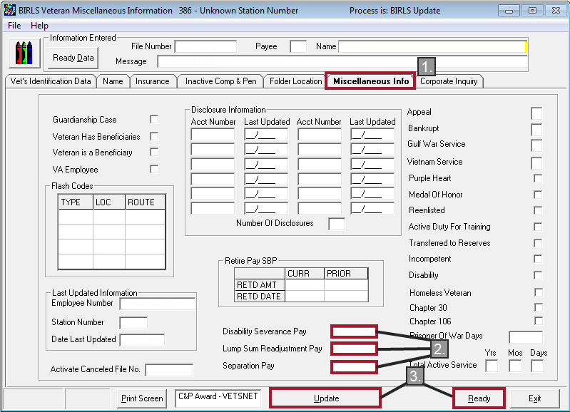

*Note:* If Department of Veterans Affairs (VA) systems show the type of benefits paid as *readjustment pay*, and the date of discharge for which that benefit was paid was after September 15, 1981, it is coded incorrectly (see *Exception*). The separation benefit should be listed as separation pay or SSB, and the VSR will need to update all VA systems to reflect the correct type of separation benefit as well as the withholding. The *DD Form 214* and Veterans Information Solution (VIS) will indicate the correct *type*. The Leave and Earnings Statement is not a reliable source for the type of separation benefit as it will often show readjustment pay, despite the Veteran enlisting well after September 15, 1981, due to use of an old template.

*Exception:* Although readjustment pay was replaced by separation pay (payable under *10 U.S.C. 1174*) effective September 15, 1981, there are instances in which it was still paid at discharge after that date. Always verify the separation benefit *type* on the *DD Form 214*.

**Determining Amount to Recoup** *(Step 5)*

The following factors determine whether and how much of a Veteran’s separation benefits VA must recoup from his/her disability compensation:

* Type of separation benefit
* Date of entitlement to VA compensation, and
* Date of receipt of the separation benefit

*Note:* Date of receipt of the separation benefit *not* needed for SSB.

For separation pay and DSP, use the following to determine whether to recoup the pre-tax vs. post-tax amount: If the separation benefit was paid:

* September 30, 1996, and earlier, recoup the *pre-tax* amount
* October 1, 1996, and later, recoup the *post-tax* amount

For *SSB,* **always recoup the post-tax amount**.

For a table on recouping different types of separation benefits and when to recoup the pre-tax vs. post-tax amount, see *M21-1, Part III, Subpart v, 4.B.2.d*.

**Calculating the After-Tax Amount** *(Step 5)*

Service departments **always** withhold Federal income tax from SSB, and separation pay (not DSP). Often, though, DoD’s database does not contain the amount of Federal income tax service departments withheld from these types of separation benefits. In these cases, VIS will show $0.00 as the Federal income tax withholding. In this situation, see the table below.

Also see the table below any time VA has verified the gross amount of a separation benefit, but has not yet verified the amount of Federal income tax the service department withheld.

*Important:* For DSP, where the service department did not withhold Federal income tax or withheld the tax but later refunded it, recoup the pre-tax/gross amount.

*See* Topic 3: Principles Specific to Disability Severance Pay*, for guidance in determining the amount of DSP to recoup.*

Once the gross amount is calculated, the table below can then be used to determine which flat-tax rate was in effect on the date the Veteran received the separation benefit:

* Multiply the gross amount of the separation benefit by the appropriate flat-tax rate, and
* Subtract the product from the gross amount of the separation benefit

|  |  |
| --- | --- |
| **Effective Date** | **Flat-Tax Rate** |
| December 31, 1993, and earlier | 20% |
| January 1, 1994 | 28% |
| August 7, 2001 | 27.5% |
| January 1, 2002 | 27% |
| May 28, 2003 | 25% |
| January 1, 2018 | 22% |

*Note:* There is no need to make these calculations when the Federal income tax amounts are available in VIS or are otherwise verified.

**Veterans with Multiple Periods of Service** *(Step 5)*

Separation pay and SSB (not DSP) are not paid for a particular period of service, but for all periods of service that *preceded* the separation for which the benefit was paid.

If the Veteran’s disabilities were incurred during a period of service:

* *Before* the separation for which the Veteran received separation pay or SSB, then:
* *Establish* a withholding for recoupment
* *After* the separation for which the Veteran received separation pay or SSB, then:
* *Do not establish* a withholding for recoupment

Occasionally, a Veteran will have disabilities incurred prior to the receipt of separation pay or SSB, and some incurred after. In such instances, a partial withholding is required for the disabilities incurred prior to receipt of separation pay or SSB. See example scenario within *M21-1 III.v.4.B.2.k*.

Topic 3: Principles Specific to Disability Severance Pay

*(Step 5 cont. (entire topic))*

**Identifying Severance-Pay Disabilities**

Before recouping DSP, it is necessary to identify the disabilities for which the Veteran received this benefit. The best source for this information is the Veteran’s Physical Evaluation Board (PEB) report, which is normally included in his/her STRs.

If the PEB report is not included in the Veteran’s STRs, it might be in his/her service personnel records. Use the table below to determine how to submit a request for the PEB report. (*M21-1, Part III, Subpart v, 4.B.3.a*)

|  |  |
| --- | --- |
| **If the Veteran separated from the...** | **Then submit a request through...** |
| * Coast Guard * Army prior to October 1, 1994 * Navy prior to January 1, 1995 * Air Force prior to October 1, 2004, or * Marine Corp prior to January 1, 1999 | PIES, using request code *O50* (if not already of record).  ***Exception***: For claims not being processed in VBMS, request the records from PIES using the request code *O11*. |
| * Army on or after October 1, 1994 * Navy on or after January 1, 1995 * Air Force on or after October 1, 2004, or * Marine Corp on or after January 1, 1999 | the Defense Personnel Records Image Retrieval System (DPRIS), using request code *AG5* |

**General Policies on Recouping DSP**

DSP is handled a little differently than separation pay and SSB. For separation pay and SSB, VA withholds all the Veteran’s compensation until the full amount of the benefit is recouped.

Generally, if a Veteran received DSP, VA must withhold from his/her monthly compensation up to an amount equal to the monthly compensation payable for the disabilities for which the Veteran received DSP. VA continues to withhold this amount until it has recouped the amount of DSP the Veteran was paid.

The monthly withholding may never exceed the monthly amount of compensation payable based on the *initial compensable evaluation* that VA assigns the severance-pay disability.

*Exception:* If VA ***initially*** assigns a severance-pay disability a temporary 100% evaluation under *38 CFR 4.28, 4.29,* or *4.30*:

* VA must withhold compensation until entitlement to the temporary 100% rating ends, and
* monthly withholdings thereafter may never exceed the monthly amount of compensation payable based on the disability rating VA assigns the severance-pay disabilities *immediately after* entitlement to the temporary 100% rating ends.

If VA has awarded SC for both severance and non-severance-pay disabilities, VA may *not* withhold an amount greater than that to which the Veteran is entitled based on the non-severance-pay disabilities.

*Scenario:* VA grants SC for the following based on an *original claim* for benefits:

* A severance-pay disability at a temporary 100% disabling, and
* A non-severance-pay disability rated at 50% disabling

*Result:* VA must pay the Veteran at least as much as the amount payable for the non-severance-pay disability (50% disabling) and withhold the rest. **VBMS-A will calculate the proper withholding in such situations. Manual calculation on the VSR’s part is not necessary.**

*How DSP Withholding is Calculated* ***(For situational awareness only):***

There will be times when the withholding in VBMS-A does not equal the combined disability evaluation for all severance-pay disabilities. When the Veteran has both severance-pay and non-severance-pay disabilities, he/she must receive an amount that is at least equal to the total amount of benefits payable for the non-severance-pay disabilities.

The Disability Rating Calculator (or Combinator) will assist in determining the combined evaluation of all non-severance-pay disabilities, allowing you to see if the withholding was calculated correctly.

The calculations below are for situational awareness only, as ***VBMS-A will do the calculations for you*** to pay the Veteran the most advantageous amount.

|  |  |
| --- | --- |
|  | **Method 1** |
| $1,232.00 | Start with the rate payable for a combined disability rating of {XX} percent. |
| - 781.00 | Withhold the amount payable for the **severance-pay** disability. |
| 451.00 | Pay the remaining amount to the Veteran. |
|  |  |

|  |  |
| --- | --- |
|  | **Method 2** |
| $1,232.00 | Start with the rate payable for a combined disability rating of {XX} percent |
| - 556.00 | Pay the Veteran the amount payable for the **non-severance-pay** disability. |
| 676.00 | Withhold the difference between the two rates. |

*Note:* The greater amount (payable to the Veteran) determines the method used.

**Changes in the Evaluation of Severance-Pay Disabilities**

*Increase*: If the evaluation of a severance-pay disability increases after the initial evaluation, VA will still withhold at the rate for the *initial compensable evaluation*.

*Decrease*: If the evaluation of a severance-pay disability decreases after the initial evaluation, *decrease the withholding* to match the rate of the decreased evaluation. If the evaluation subsequently increases to the initial, or higher rate, increase the withholding back to the *initial* compensable evaluation.

For Veterans with multiple service-connected severance-pay disabilities, the determination will be made according to whether the combined evaluation of all severance-pay disabilities changes.

**No Withholding for DSP**

* Do not withhold compensation to recoup DSP if the evaluation assigned to the severance-pay disability has no impact on the combined evaluation of all service-connected (SC) disabilities. For example, the combined evaluation of the ***non-severance-pay disabilities*** is equal to the combined evaluation of ***all*** service-connected disabilities.

*Example: Vet is SC for the following:*

*Non-severance-pay disabilities: Diabetes Mellitus Type II – 20%*

*Right knee condition – 10%*

*Right shoulder condition – 10% 40%*

*Hypertension – 0% 40%*

*Severance-pay disability: Left knee condition – 10%*

***\*VBMS-A will make this calculation for you.***

* Do not withhold compensation for any severance-pay disabilities that are rated 0% disabling. Only begin withholding when the evaluation becomes *compensable* (other than a temporary 100% evaluation).

If the *initial* evaluation of a severance-pay disability is 0%, then VA subsequently assigns that disability a temporary 100% evaluation, do not withhold compensation to recoup DSP until a permanent, compensable evaluation is assigned. (As noted previously, if the ***initial*** evaluation of a severance-pay disability is a temporary 100% evaluation, withholding *is* required.)

* Do not withhold compensation to recoup DSP if the Veteran separated from service *on or after January 28, 2008* ***and*** *incurred the disability* for which he/she received DSP *in the line of duty in a combat zone or during combat-related operations*. This information can be found:
* in Block 28 of the *DD Form 214*
* on the PEB report

Important: The content of the CMBT RELATED CD field on the DFAS/CG PAYMENTS screen in VIS is not a reliable indicator of whether a Veteran incurred a disability in the line of duty in a combat zone or during combat-related operations.

* Do not withhold compensation to recoup DSP if the Veteran’s only entitlement is a 10% evaluation based on multiple disabilities, each evaluated as 0% disabling. (*38 CFR 3.324*)
* Do not withhold compensation to recoup DSP if the combined evaluation of the non-severance-pay disabilities is 100% (not factoring in the severance-pay disabilities).

Scenario: In a decision on a Veteran’s original claim for benefits, VA awards SC for

* a severance-pay disability rated 50% disabling, and
* a non-severance-pay disability rated 100% disabling

Result: VA may not withhold any compensation to recoup the Veteran’s DSP while the non-severance-pay disability is rated 100% disabling.

Note: The result in this example is the same, regardless of whether VA assigned the 100% rating on a temporary basis under *38 CFR 4.28, 4.29,* or *4.30*.

Topic 4: Award Action and Notification

**Effective Date to Commence Recoupment** *(Step 6)*

*Initial or subsequent award (not claim)* – effective date of compensation award (payment start date).

*Running award* – date in the Last Paid Date field on the *Award Information* tab of the *corporate record* in *Share*.

**Entering Information into VBMS-A** *(Step 6)*

*Military Payment Info screen*

Before inputting the actual withholding amount on the *Award Adjustments* screen, you must first enter information on this screen, or you will get an error message when trying to enter the withholding.

Open the Veteran’s file in VBMS-A and navigate to the *Record Decisions* screen.

1. Click on **Military Payment Info**
2. Click on the **Discharge Pay** tab
3. The *Discharge Pay* type (Separation Pay, Disability Severance Pay) and *Gross Amount* should auto-populate based on the information on the *BIRLS Miscellaneous Info* screen. Add or update if necessary
4. Enter the *After-Tax Amt*
5. Enter the *RAD Date* (for separation pay) or the *Discharge Disabilities*, by name (*not* diagnostic code) (for DSP)
6. Check the *Verified* box (if amount is verified)
7. Click **Done**

**Note:** If the gross amount of the separation benefit doesn’t auto-populate per step 3, you can do so by clicking *Retrieve BIRLS Data*, as long as the separation benefit information was correctly entered into BIRLS (see page 10).

Separation Pay

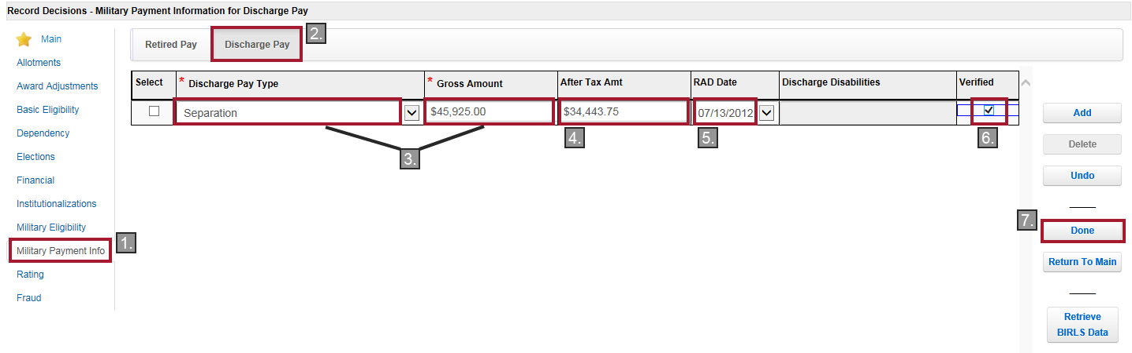

Disability severance pay

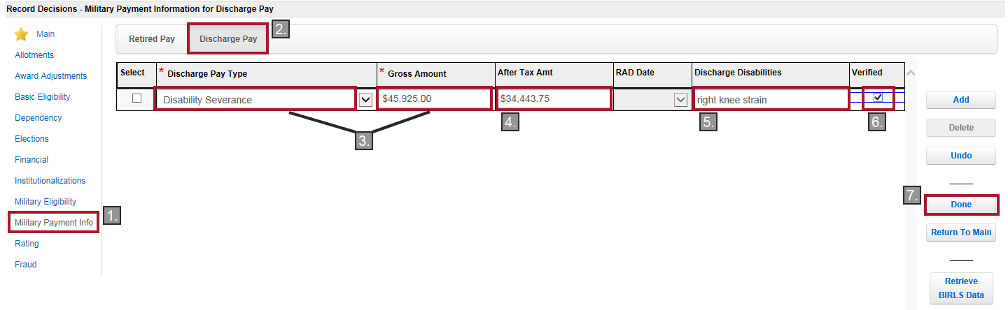

*Award Adjustments screen*

After clicking **Done** on the *Military Payment Info* screen, you will be back on the *Record Decisions* screen.

1. Click on **Award Adjustments**
2. Click on the **Separation Pay** or **Disability Pay** (DSP) tab, whichever is applicable
3. The *Separation Pay Type* or *Payment Type* (DSP) and *Original Balance* should be populated based on the information entered on the *Military Payment Info* screen
4. Enter the *Award Effective Date* (Payment Start Date)
5. Click **Done**

Separation Pay

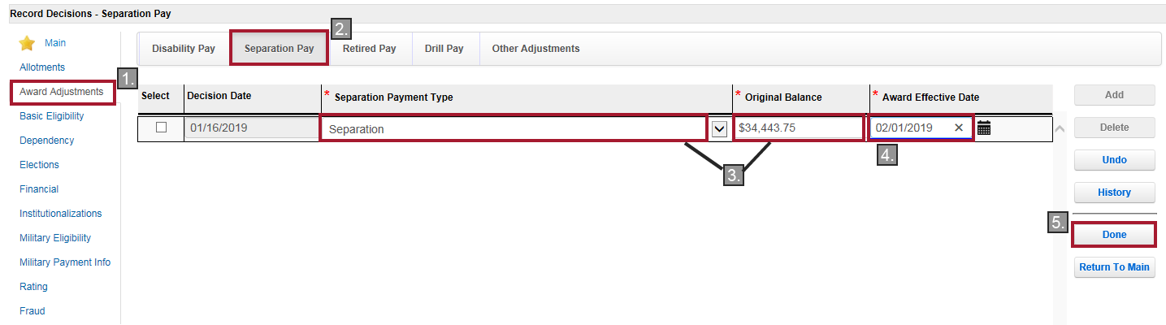

Disability severance pay

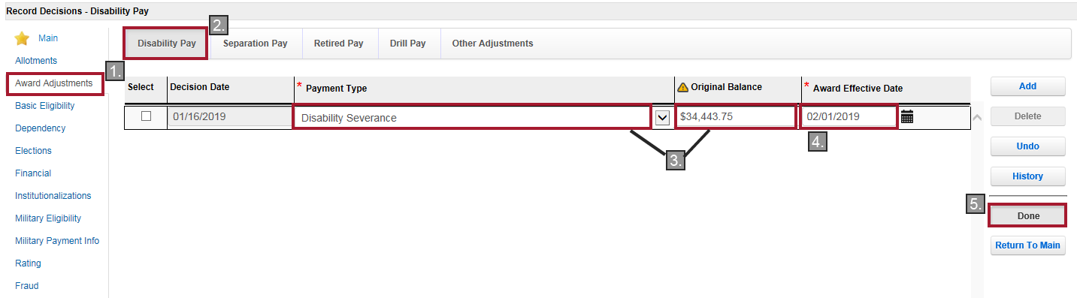

**Generate Award and Notify** *(Step 7)*

*Award*

On the *Record Decisions* screen, click **Generate Award.**

*Notification*

The decision notice is sent to a Veteran after recoupment begins (usually in conjunction with the first compensable rating). The notice should be generated using the RADL function in VBMS-A. Only use PCGL if RADL fails or is incorrect (apart from minor free text). In addition to requirements outlined in *M21-1, Part III, Subpart v, 2.B*, VA must inform the Veteran of:

* The pre-tax amount of his/her separation benefits
* The gross amount of his/her monthly award of compensation
* The amount of compensation VA is withholding for recoupment of separation benefits
* The net amount of his/her monthly award of compensation, if any, and
* The fact that VA will continue withholding compensation until recoupment is complete

The notification information above is automatically generated in RADL based on the information in VBMS-A. If PCGL must be used, the information referenced in the preceding bullets will be inserted into the decision notice upon following the prompts after the *Is there a withholding?* prompt in PCGL.

Additionally, if VA is withholding all a Veteran’s compensation to recoup separation benefits, the decision notice *must* inform the Veteran that he/she must notify VA of any changes in his/her address and that failure to do so could result in:

* A reduction or discontinuation of benefits, and/or
* Delayed or undeliverable future payments of compensation

Users must insert the information in the preceding paragraph into the decision notice as free text, regardless of the system used for its generation. Neither RADL nor PCGL automatically insert this information. See *M21-1, Part III, Subpart v, 4.B.5.c*.

Suggested language:

*VA is withholding all your compensation to recoup separation benefits you received from the service department; however, you must still notify VA of any changes in your address. Failure to do so could result in:*

* *A reduction or discontinuance of benefits, and/or*
* *Delayed or undeliverable future payments of compensation*

Attachment A: Recoupment of Separation Benefits – General Process Overview

Practical Exercise

1. What information is needed to determine whether, and how much of, a Veteran’s separation benefits VA must recoup from his/her disability compensation?
2. Veteran, John Smith, was discharged from the U.S. Army on March 17, 1993. Looking at block 18, Remarks, of his *DD Form 214*, you see that Mr. Smith received special separation benefit (SSB) in the amount of $25,250.00. You review the file and see that there is an AskDFAS response in the record showing Mr. Smith received an after-tax amount of $20,200.00. VA is granting an initial award with an overall combined evaluation (compensation) at 60%, effective January 31, 2018.
3. How much will VA recoup from John Smith?
4. When will the withholding start?
5. On which two decision screens in VBMS-A do you enter the separation benefit amount?
6. Under what conditions do we *not* withhold for DSP?
7. Which system and screens can you use to determine if the recoupment of the separation benefit has been *completed*, and was not previously processed in BDN?
8. A Veteran entered service on October 3, 2011 and was discharged on October 3, 2015. You review all systems and it shows an amount under readjustment pay. What should you do?
9. Where is the best place to identify the disabilities for which the Veteran received DSP?
10. What are the three resources used to verify the amount of separation benefits paid to the Veteran?