(VSR VIP Pre-D)

Individual Unemployability Development

Trainee Handout

**Table of Contents**

[Objectives 2](#_Toc11052867)

[References 2](#_Toc11052868)

[Topic 1: IU Benefits, Eligibility Criteria, and VA Forms 3](#_Toc11052869)

[Topic 2: Development for SSA and VR&E Records 8](#_Toc11052870)

[Topic 3: Development for Veteran’s Employment History 13](#_Toc11052871)

[Topic 4: Exam, Subsequent Development, and Ready To Rate Considerations for IU Claims 15](#_Toc11052872)

[Practical Exercise 17](#_Toc11052873)

Objectives

* Identify individual unemployability (IU) benefits, eligibility criteria, and VA Forms
* Identify and recall the procedure for obtaining relevant Social Security Administration (SSA) and Veteran Readiness and Employment (VR&E) records
* Assess when and how to obtain a Veteran’s employment history
* Recall examination, subsequent development, and ready to rate considerations

References

* [38 CFR 4.16, Total disability ratings for compensation based on unemployability of the individual](https://www.ecfr.gov/cgi-bin/text-idx?SID=37e2fff4241ce89e1e26eb66338d1d4d&mc=true&node=pt38.1.4&rgn=div5" \l "se38.1.4_116)
* [M21-1, Part I, Chapter 1.B.1, Notification Requirements for Claims Not Previously Denied](https://vaww.vrm.km.va.gov/system/templates/selfservice/va_kanew/help/agent/locale/en-US/portal/554400000001034/content/554400000014065/M21-1-Part-I-Chapter-1-Section-B-Duty-to-Notify-Under-38-USC-5102-and-5103)
* [M21-1, Part III, Subpart ii.2.B.1, Applications for Disability Compensation and/or Pension](https://vaww.vrm.km.va.gov/system/templates/selfservice/va_kanew/help/agent/locale/en-US/portal/554400000001034/content/554400000014119/M21-1-Part-III-Subpart-ii-Chapter-2-Section-B-Claims-for-Disability-Compensation-and-or-Pension-and-Claims-for-Survivors-Benefits)
* [M21-1, Part III, Subpart iii.1.C, Requesting Evidence From Federal Record Custodians](https://vaww.vrm.km.va.gov/system/templates/selfservice/va_kanew/help/agent/locale/en-US/portal/554400000001034/content/554400000014156/M21-1-Part-III-Subpart-iii-Chapter-1-Section-C-Requesting-Evidence-From-Federal-Record-Custodians)
* [M21-1, Part III. Subpart iii. 3.A.2, VA Request for Disability Records From SSA](https://vaww.vrm.km.va.gov/system/templates/selfservice/va_kanew/help/agent/locale/en-US/portal/554400000001034/content/554400000014166/M21-1-Part-III-Subpart-iii-Chapter-3-Section-A-Department-of-Veterans-Affairs-VA-Requests-for-Information-From-the-Social-Security-Administration-SSA#2)
* [M21-1, Part III, Subpart iv.3.A, Examination Requests Overview](https://vaww.vrm.km.va.gov/system/templates/selfservice/va_kanew/help/agent/locale/en-US/portal/554400000001034/content/554400000015809/M21-1-Part-III-Subpart-iv-Chapter-3-Section-A-Examination-Requests-Overview)
* [M21-1, Part IV, Subpart ii.2.F, Compensation Based on Individual Unemployability (IU)](https://vaww.vrm.km.va.gov/system/templates/selfservice/va_kanew/help/agent/locale/en-US/portal/554400000001034/content/554400000014564/M21-1-Part-IV-Subpart-ii-Chapter-2-Section-F-Compensation-Based-on-Individual-Unemployability-IU)

Topic 1: IU Benefits, Eligibility Criteria, and VA Forms

Total Disability Based on Individual Unemployability (TDIU) or IU for short is a benefit awarded to a Veteran who is determined to be unemployable by reason of service connected disability(ies).

Granting IU results in payment at the 100 percent (total) rate, even though their combined service connected (SC) percentage is less than 100%. It may also result in other benefits, such as Chapter 35, or possibly SMCs.

Substantially gainful employment is defined as employment at which non-disabled individuals earn their livelihood with earnings comparable to the particular occupation in the community where the Veteran resides. It suggests a living wage.

Substantially gainful employment is defined as:

* Competitive (not protected) employment, and
* Earnings exceeding the amount established by the U.S. Department of Commerce, U.S. Census Bureau, as the poverty threshold for one person.

**Establishing Entitlement to IU**

The Veteran must meet **one** of the criteria below for a grant of IU:

* one service-connected disability at 60%
* two or more service-connected disabilities combined at 70% or more, with at least one rated at 40 % or more
* have an extra-schedular evaluation approved by Compensation Service

You should not screen or determine eligibility, but simply gather evidence concerning the Veteran’s current employment status, past employment history, and functional impairment arising from SC disabilities through examinations, medical record development, and information about the impact of SC disabilities upon employability. Rating activity will make a decision on eligibility.

IU is not necessarily a permanent benefit and the VA will monitor earned income information via the yearly Social Security Administration wage data match. A new matching process will identify Veterans who are in receipt of earned income over the poverty threshold who are also in receipt of IU. Earned income can be an indicator that the Veteran could sustain gainful employment in the previous calendar year.

A Veteran in receipt of IU benefits who is identified as having verified earned income above the poverty threshold will be sent a due process letter and VA Form 21-4140, Employment Questionnaire. The Veteran is required to explain the earned income by returning a completed VA Form 21-4140.

**Unemployed v. Unemployable**

There is a difference between being unemployed and being unemployable, which the RVSR will have to distinguish.

A Veteran can be unemployed, but not be unemployable. Being unemployable as defined in M21-1 means being incapable of holding substantially gainful employment.

Being unemployed can be due to factors such as the state of the economy, work performance issues, retirement, or other reasons not related to the Veteran’s service connected disabilities.

A Veteran might also be unemployed from one job due to an SC disability, but still be capable of securing another substantially gainful occupation.

**VA Forms Specific to IU Claims**

A VA Form 21-8940, Veteran’s Application for Increased Compensation Based on Unemployability, is the required form to award IU. However, any communication indicating a Veteran is unable to work because of SC disabilities or listing IU/TDIU on a VA Form 21-526EZ should trigger the VA to request a VA Form 21-8940 (if not submitted) unless the veteran does not meetschedular requirments as noted below.

When written communication or other evidence indicates the Veteran cannot work because of SC disabilities and a standard application for benefits with a specific claim for IU has not been received, but the criteria to consider the information a reasonably raised claim has *not* been met due to the Veteran’s disabilities not meeting the schedular criteria specified under [38 CFR 4.16(a)](https://www.ecfr.gov/cgi-bin/text-idx?SID=7b203119b682d477d005f9a07b386114&mc=true&node=se38.1.4_116&rgn=div8), follow the request for application procedures at M21-1, Part III, Subpart ii, 2.C.6

Realize that a recent rating decision might have solicited a VA Form 21-8940, which might be the only evidence needed to make a determination. Always review prior decisions as this may save you from unnecessary development.

A VA Form 21-4192, Request for Employment Information in Connection with Claim for Disability Benefits, is used to obtain employment information from the Veteran’s former employer(s) when necessary. If the Veteran’s former employer is a Federal agency development will be processed per guidelines for requesting federal records.

**Initial Development Overview**

Initial development can include the simultaneous, but not all claims will require these actions:

* Review of the claim folder for IU related forms, medical evidence, and prior development.
* Review and development for a substantially complete VA Form 21-8940.
* Sending required 5103 notification, letters for the development of private or federal treatment records, and/or employment information from prior employers.
* Requesting DBQs for SC disability(ies) the Veteran alleges to be causing unemployability*.*

**Important:** a recent rating might have solicited a VAF 21-8940, so the Veteran could be responding to that. A relatively recently submitted VA Form 21-526EZ may satisfy 5103 notification requirements. The previous rating might have even had enough information to grant IU but relies on a VA Form 21-8940 to certify status of employment. Sometimes the submission of a VA Form 21-8940 can be made ready for decision.

**Fully Developed Claims (FDC) and IU**

When an IU claim is received on a VA Form 21-526EZ, you should review submitted evidence and determine if the claim meets Fully Developed Claims requirements or necessitates an exclusion

* Common exclusions for FDC are not submitting a VA Form 21-8940, necessary VA Form 21-4192, or private medical records.
* Do not automatically exclude if the claim requires a phone call to clarify information (like addresses, dates, or contention clarification on a VA Form 21-8940).
* Do not exclude for the development of National Guard and Reserve records and other federal records (Vet Center, Social Security Administration (SSA), Veteran Readiness and Employment (VR&E), VA Medical Centers (VAMC), and Mil Treatment Facility (MTF).

**Review of the VA Form 21-8940**

The VA Form 21-8940 provides critical information for the decision of an IU claim and guides most of the development. Review the VA Form 21-8940 and consider all of these questions to aid your development and solicit any missing information you can obtain through a phone call.

* IMPORTANT: Do we have the Veteran’s signature? (Section IV)
  1. Veteran’s electronic or physical signature MUST be present
  2. Power of Attorneys or other 3rd parties CANNOT sign this form
  3. Develop as an incomplete application to obtain the signature if needed and discontinue further development for IU
* What SC disability(ies) are claimed to cause unemployability? (Section II, block 8)
  1. Develop disability(ies) alleged to cause IU as claim(s) for increase
  2. Do not list any new/supplemental/secondary claims from this block unless they are submitted on a VA Form 21-526EZ.
  3. The Veteran is required to specify at least one SC disability that they believe causes their unemployability. The Veteran should list these in block 8, but additional conditions might be listed in the remarks section if there isn’t enough room to list all disabilities.
  4. If the Veteran doesn’t specify a disability and the Veteran only has one SC disability, you can presume that it’s the sole disability and continue with your review and development.
  5. If the Veteran doesn’t specify a disability and has multiple SC conditions, make reasonable efforts to contact them by phone. If you cannot obtain this via phone, then request this information using a subsequent development letter with custom language.
* Did the Veteran list non-service connected (NSC) disability(ies) but did not submit a claim for the NSC disability(ies)? (Section II)

1. If the NSC disability was not previously denied SC and there is no legacy appeal pending follow the request for application procedures in M21-1, Part III, Subpart ii to address the NSC disability.
2. If the NSC disability listed on the form is on legacy appeal

* proceed with development of the IU claim without further development of the legacy appeal issue, and
* notify the claimant that the issue(s) is on legacy appeal.
* Did the Veteran mention private or federal treatment that requires development? (Section II)
  1. Review blocks 9-13 for mention of private or federal treatment that might require development.
  2. Realize that VAMC or DoD records are likely accessible through CAPRI or JLV respectively.
* Do we need to request VA Form 21-4142, Authorization to Disclose Information to the Department of Veterans Affairs, and VA Form 21-4142a, General Release for Medical Provider Information to the Department of Veterans Affairs? (Section II)
  1. If the noted evidence of Vet Center or private medical treatment was not included, request VA Form 21-4142, Authorization to Disclose Information to the Department of Veterans Affairs, and VA Form 21-4142a
  2. **IMPORTANT**: Be careful to research the names of doctors or addresses of unfamiliar facilities. You don’t want to request VA Form 21-4142s for VAMCs or MTFs from the Veteran when they are not required.
* Is the work history information complete? (Section III)
  1. This should list the employment history of the last five years the Veteran worked (not to be confused with just the last five years of work from application)
  2. Take note of National Guard and Reserve service, self-employment, or
* Do we need addresses of former employers for VA Form 21-4192 development?
  1. Make sure you can obtain the address of employers for the last year of employment if VA Form 21-4192 development needs to be done.
* Is there any information that requires clarification from the Veteran?
  1. Common examples of issues needing clarification include but is not limited to SC conditions which cause unemployability, approximate dates of work history, and employer addresses.

**Updating Contentions in VBMS Core**

If a VA Form 21-526EZ is submitted, list all contentions as appropriate.

Additionally, list Individual Unemployability as a contention with the classification as Unemployability. Medical Field should be updated for yes. There are no IU specific special issues.

Review blocks 8 and 26 on the VA Form 21-8940 to determine what service connected disabilities are claimed to cause unemployability and list these as claims for increase.

Since the VA Form 21-8940 is only a prescribed form for the benefit of IU, this form cannot establish a claim for service connection. The SC disabilities listed must be considered in a claim for IU, so we consider them claims for increase.

Any claim for SC must be on a prescribed form.

Topic 2: Development for SSA and VR&E Records

**When to Obtain SSA Reports**

If the Veteran is claiming Individual Unemployability and has been examined or awarded disability benefits by SSA, request complete copies of all SSA decisions and any supporting medical records.

You can use the SSA Inquiry function within VBMS Core to help you identify if a Veteran has applied for disability benefits. The inquiry does provide information about disability and/or retirement benefits and decisions, but we will instruct you on how to focus on disability benefit decisions.

**How to Identify SSA Reports**

First, select the SSA Inquiry button in the VBMS Core claim development screen



Next, fill out the appropriate fields in the SSA Inquiry

* Inquiry for: select the Veteran’s name
* Inquiry reason: select Verify Benefits
* Select the Submit Inquiry button

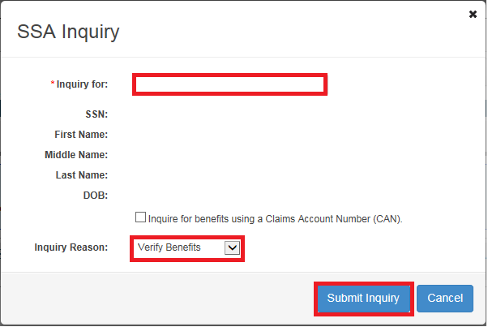

**No Social Security Retirement or Disability Data**

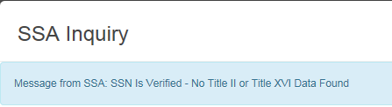

SSA has no record of the Veteran applying for retirement or disability benefits, so no further development is required.

**Action:** Upload a screenshot of these findings in VBMS Core.

Document type: SSA Profile and Benefit Data

Subject: No SSA disability decision

**Social Security Number Unverified**

****

The Veteran’s date of birth is likely incorrectly entered into VA systems

**Action:** Review documents and update SSA and/or DOB and retry an SSA Inquiry.

**Social Security Administration Inquiry Profile Beneficiary Identification Code (BIC)**

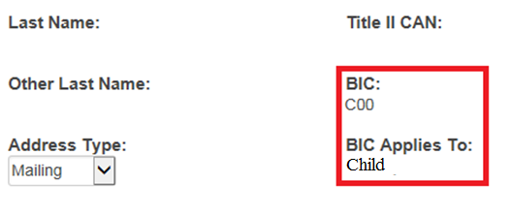

**Important:** If the BIC begins with “C”, the beneficiary is a child of the Veteran and you do not have to obtain SSA reports as these do not pertain to the Veteran.

**Action:** Upload a screenshot of these findings to VBMS Core.

Document type: SSA Profile and Benefit Data

Subject: No SSA disability decision

**No Social Security Disability Determination**

**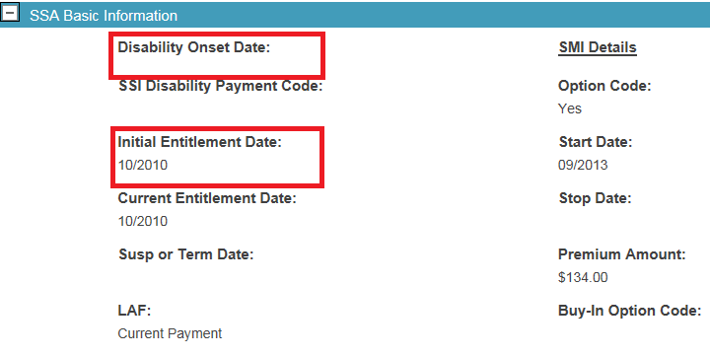**

If the disability onset date is blank, account for the Veteran’s age. If the entitlement date is on or after their 62nd birthday, they are likely receiving SS retirement pay. In this scenario, no record development is needed.

**Action:** Select the *Save to eFolder* button and change the document subject to *No SSA disability decision*

**Social Security Disability Denied**

**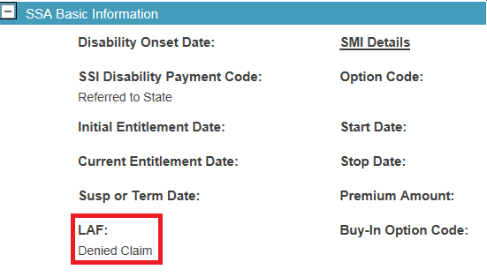**

The Ledger Account File (LAF) reflects the current payment status of the particular record. Commonly, you might see the LAF state denied claim, which means a decision was made and records may exist. You should request complete copies of the SSA denial and supporting medical records.

**Action**: Select the Save to eFolder button and request SSA records.

**Social Security Disability Granted**

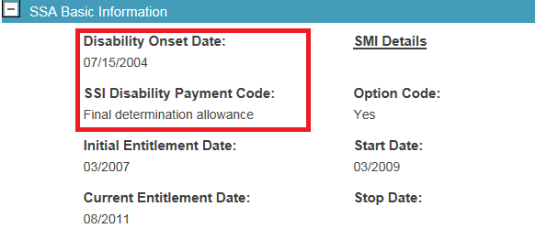

If there is a disability onset date shown on the SSA inquiry, request complete copies of the SSA award and supporting medical records.

**Action**: Select the Save to eFolder button and request SSA records.

**How to Obtain SSA Records**

Social Security Disability determination records must be requested and obtained using the Social Security Administration-Government Services Online (SSA-GSO) website. Make sure to talk to your supervisor for local policy and procedures for ensuring these requests are made.

**When to Obtain Veteran Readiness and Employment Records (VR&E)**

VR&E records may document the Veteran’s participation in a training program or show that the training was not feasible or was unsuccessful.

If there is an indication that the Veteran applying for IU has participated in the VA’s VR&E consultation, additional development is needed to obtain VR&E records.

**Important:** You are not required to request VR&E records when a Veteran fails to return the VA Form 21-8940.

The following are indications that the Veteran has participated in VR&E:

* A statement of the Veteran’s participation in VR&E
* VA Form 28-1900, Application for Vocational Rehabilitation for Claimants with Service-Connected Disabilites, included in the claims folder
* Chapter 31 payments shown in SHARE
* VR&E (CER) folder type shown in BIRLS, as seen below:

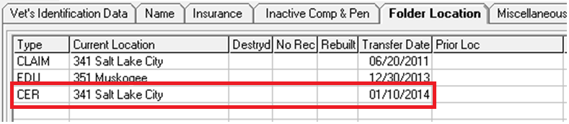

**How to Obtain VR&E Records**

The entire Counseling/Evaluation/Rehabilitation (CER) folder is not necessary to adjudicate IU claims that are processed at the Regional Office. M21-1 III.iii.1.C.2.j. RO Procedure for Requesting VA Form 28-1902b, Counseling Record – Narrative Report and VA Form 28-1902f Feasibility Determination – Narrative Report from VR&E outlines the procedure and the VR&E Office Directory to obtain emails for the request.

* Check to see if VA Form 28-1902b and VA Form 28-1902f are in the claim folder already.
* Use the [VR&E Office Directory](https://vbaw.vba.va.gov/vocrehab/directory.asp) and select the CER Folder Request link of the RO housing the CER folder to create an encrypted email. Change the automated subject of CER Folder Request to *VA Form 28-1902b and VA Form 28-1902f Request*. In the body of the email, include the Veteran’s name and SSN for identification.
* Upload the email request in the VBMS Core eFolder and add the VR&E Records Required tracked item under the COMPMGT category.
* Follow up on requests as you would Federal records with subsequent emails and timelines.
* Upload the VA Form 28-1902b and VA Form 28-1902f into the eFolder with document properties indicated below and close tracked item when received:

| **In the document field …** | **Enter …** |
| --- | --- |
| SUBJECT | Vocational Rehabilitation & Employment Documents. |
| CATEGORY – TYPE | Education General – VA Form 28-1902b. |
| SOURCE | VBMS. |
| DATE OF RECEIPT | the date the completed form was received. |
|  |  |
| **In the document field …** | **Enter …** |
| SUBJECT | Vocational Rehabilitation & Employment Documents. |
| CATEGORY – TYPE | Education General – VA Form 28-1902f. |
| SOURCE | VBMS. |
| DATE OF RECEIPT | the date the completed form was received. |

If the VR&E records do not exist or further efforts to obtain the VA Form 28-1902b and VA Form 28 – 1902f would be futile, follow the procedures of M21-1 III.iii.1.C.2.m. Preparing a Final Notification Letter for VAMC or VR&E Records.

ROs are not required to request VR&E records when a Veteran fails to return the VA Form 21-8940.

Topic 3: Development for Veteran’s Employment History

**Reviewing Employment History Information**

* Section III of the VA 21-8940 asks for the Veteran to fill out an employment statement, to include information about dates, places, and details about their employment history.
* The Veteran should list all employment, including self-employment for the last five years they worked, including military duty. This is not to be confused with any work they’ve done in just the past five years from the time of submitting the application.
* **Example:** If the Veteran last worked in December 2012, they should list all employment from December 2007 to December 2012.
* Attempt to obtain any missing work history, to include addresses of former employers, via telephone before sending a letter requesting they provide the information within 30 days.

**Requesting Employment Information**

Use the information in Section III (block 18) of the VA Form 21-8940 to request VA Form(s) 21-4192, Request for Employment Information in Connection with Claim for Disability Benefits, for the Veteran’s last year of employment even if the Veteran has not worked for five years or more. **Important:** You should request VA Form 21-4192 from all employers that fall within the last year of employment.

**Creating a VBMS Core Letter to Employer(s)**

* Ensure that IU is listed as a contention with unemployability as a classification.
* Select “Initial Private 3rd Party Employer Letter, 21-4192” and update the quantity desired.
* Selecting this will also create a subsequent development letter to the Veteran.
* Enter the employer name and address, including requests for the employer to identify the nature of the disability for which the Veteran was retired (if needed).
* Select Save & Next to continue to the next employer OR the letter to the Veteran.

**Creating a VBMS Core Letter to the Veteran**

The notification letter to the Veteran should automatically be created.

* Verify that the “Employment info needed – 21-4192 to veteran” and “Notice – VA is contacting provider for med rcds” paragraphs are included
* Add notification of any private or federal record requests
* If FDC, add exclusion paragraph and update special issues
* Verify the correct number of VA Form 21-4192(s) are included as standard enclosures
* Preview all 3rd party and Veteran letters to verify accuracy
* Finalize any letters and ensure package manager printing

**Creating a Follow-up Letter**

Creating a follow-up letter just takes a few simple steps.

* When reviewing the letter tab in VBMS Core, select the follow-up button beside the Initial Private 3rd Party Employer Letter.
* This will generate a letter to the employer as well as notification to the Veteran with a 15-day suspense.
* Preview all 3rd party and Veteran letters to verify accuracy.
* Finalize any letters and ensure package manager printing.

**Self-Employment Development**

If the Veteran states self-employment, send a subsequent letter requesting the Veteran furnish a statement regarding the types of work performed, number of hours worked per week, and the amount of time lost in the previous 12 months due to SC disabilities.

Create a subsequent VBMS Core letter using the paragraph titled *Unemployability – self-employed.*

**IU Claims for National Guard and Reservists**

Review the folder, the VA Form 21-8940, and VIS to identify if the Veteran had/has National Guard and or Reserve service. If service is found, review all evidence of record to determine in f a medical professional has indicated the Veteran is/was unable to perform their military duties due to SC disabilities. Examples of evidence can include C&P examinations previously conducted, STRs and medical evidence from JLV, and a personnel file from DPRIS.

Ensure you’ve obtained the address of the unit prior requesting a VA Form 21-4192. To ensure that the request is routed to the unit commander, include “ATTN Unit Commander” in the *Employer Name* section following the unit designation.

**Reviewing Received VA Form 21-4192**

If the returned info on a VA Form 21-4192 only states they retired, then request additional information as to whether the Veteran’s retirement was by reason of disability and to identify the nature of the disability for which the Veteran was retired.

Do not send the VA Form 21-4192 to a previous employer if the Veteran states that the employer is no longer in business or other evidence indicates the business is closed.

Topic 4: Exam, Subsequent Development, and Ready To Rate Considerations for IU Claims

**Examination Requests for IU**

It is normally sufficient to request condition-specific Disability Benefit Questionnaires (DBQs) for the conditions alleged to cause unemployability listed on the VA Form 21-8940.

Request condition-specific DBQs for the SC conditions listed (for example, Joints, Mental, and Peripheral Nerves DBQs). In the exam, request that the examiner comment on the Veteran’s ability to function in an occupational environment and describe the functional impairment caused solely by the service connected disabilities. When an examination is indicated, it is normally sufficient to request condition-specific [disability benefits questionnaires](http://www.benefits.va.gov/compensation/dbq_ListByDBQFormName.asp) (DBQs) for the conditions alleged to cause unemployability on the [VA Form 21-8940](http://vbaw.vba.va.gov/bl/20/cio/20s5/forms/VBA-21-8940-ARE.pdf) (for example, Joints, Mental, and Peripheral Nerves DBQs).

Do not ask the examiner to opine as to whether or not the Veteran is “unemployable” due to his or her SC disabilities. A determination that a Veteran is unemployable is a legal determination that rests solely with the rating activity.  Instead, request that the examiner comment on the Veteran's ability to function in an occupational environment, and describe functional impairment caused solely by the SC disabilities.

You can make this request by selecting “Employment Impact Assessment Requested?” during the process of requesting an examination using Exam Management System in VBMS Core.

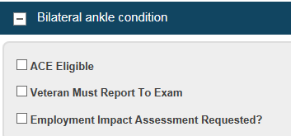

**Unnecessary Examinations**

A medical examination is not automatically required in every IU claim.

When TDIU is inferred and deferred on a decision by rating activity, the evidence in most cases is sufficient to award TDIU pending receipt of just the VA 21-8940 to certify their employment status and understanding to notify the VA if employment changes.

**Subsequent Development and Ready for Decision Considerations**

When assigned an IU claim that has been previously worked, consider the following questions and methods to guide your next step in development. Review the complete folder, notes, and tracked items, evidence and consider the following questions. Claims may be ready for decision after the review of prior development shows accuracy and completion.

Did the VSR performing the initial development process the claim correctly?

Have we received a response from the Veteran? Is further action needed?

Have we received a VA Form 21-8940 or VA Form 21-4192? Is further action needed?

Have we received requested private or federal records?

Have we requested and/or received the correct DBQs with physician IU comments?

Update any tracked items as needed.

Practical Exercise

***Match Column A to the statement in Column B. Write the correct number in the “Response” column.***

|  |  |  |
| --- | --- | --- |
| Response | Column A | Column B |
|  | VA Form 21-8940 | 1. Statement in support of claim |
|  | VA Form 21-4192 | 1. VR&E Counseling Record – Narrative Report |
|  | SSA-GSO | 1. Application for increased compensation based on unemployability |
|  | VA Form 28-1902b | 1. VR&E Feasibility Determination – Narrative Report |
|  | VA Form 21-4138 | 1. Request for employment information in connection with claim for disability benefits |
|  | VA Form 28-1902f | 1. Web based portal to request SSA disability records |

Review a VA Form 21-8940 and match Column A to the statement in Column B. Write the correct number in the “Response” column.

|  |  |  |
| --- | --- | --- |
| Response | Column A | Column B |
|  | Section II | 1. Where to send correspondence |
|  | Section III | 1. List of employment information for the last five years worked |
|  | Section IV | 1. Service connected disabilities claimed to prevent employability and medical care |
|  | Section V | 1. Schooling and training and remarks section |

1. The Veteran should list employment history for the last \_\_\_\_\_ years of employment on a VA Form 21-8940.
   1. One
   2. Three
   3. Five
   4. N/A – the Veteran only needs to list employment from the last five years from the date of
2. Which station should you contact via email to obtain VA Form 28-1902b and VA Form 28-1902f? See the below BIRLS Folder Location screenshot.

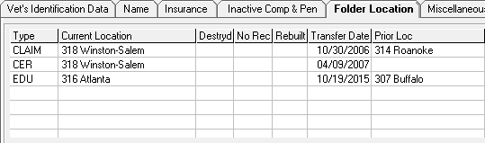

1. 318 Winston-Salem
2. 316 Atlanta
3. 314 Roanoke
4. 307 Buffalo
5. True or False: The VA Form 21-8940 is substantially complete if it is signed by the legal power of attorney.

**CASE STUDY – Review the following evidence and questions to indicate what initial actions you can take on the individual unemployability claim.**

**VBMS Core File:** all STRs, service verification, and prior rating decisions are of record and developed properly.

**VBMS Core SSA Inquiry:**



**BIRLS Folder Location Inquiry:**

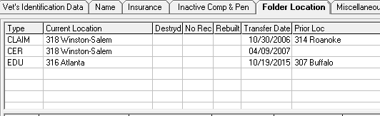

**Last rating decision** **(dated over two years ago):**

* posttraumatic stress disorder 30%
* diabetes mellitus 20%
* peripheral neuropathy of right lower extremity 20%
* peripheral neuropathy of left lower extremity 20%
* peripheral neuropathy of the right upper extremity 10%
* peripheral neuropathy of the left upper extremity 10%
* no previous denials
* no previous decision on individual unemployability

Combined overall evaluation of 70%

**Current Claim (received ten days ago):**

* VA Form 21-526EZ signed by the Veteran listing the issues of individual unemployability and diabetes mellitus. No private or non-Federal treatment is listed and the Veteran has elected FDC processing.
* No medical evidence or other VA Forms are submitted.
* A complete VA Form 21-8940, Veterans Application for Increased Compensation Based on Unemployability, signed by the Veteran. All sections are completed and sections II and III are shown below.

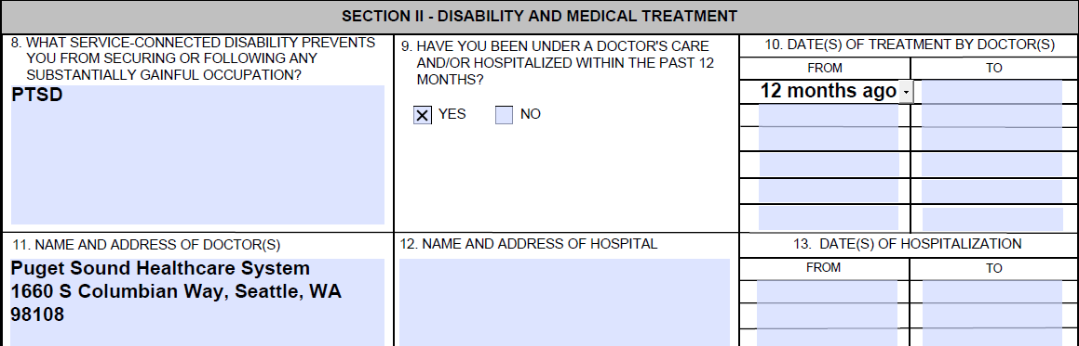

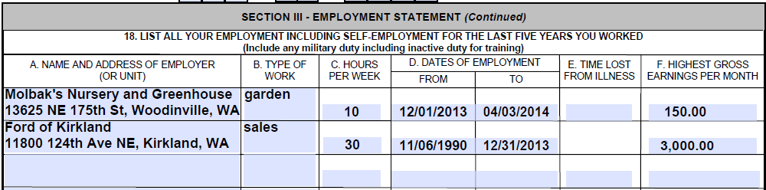

***What developmental actions are necessary? (Select all that apply.)***

Send a standard 5103 Notice.

Notify the Veteran of an Fully Developed Claim exclusion.

Notify the Veteran to complete and submit a VA Form 21-8940.

Notify the Veteran of the VA’s request to obtain, but also submit a VA Form 21-4192 from Molbak’s Nursery and Greenhouse.

Notify the Veteran of the VA’s request to obtain, but also submit a VA Form 21-4192 from Ford of Kirkland.

Send a 3rd party letter to Molbak’s Nursery and Greenhouse requesting a VA Form 21-4192.

Send a 3rd party letter to Ford of Kirkland requesting a VA Form 21-4192.

Request a VA Form 21-4142 from the Veteran for Puget Sound Healthcare System from the Veteran.

Upload relevant Puget Sound Healthcare System records from CAPRI into VBMS Core.

Order DBQ General Medical Compensation.

Order DBQ PSYCH PTSD Review.

Order DBQ ENDO Diabetes Mellitus.

Order DBQ NEURO Diabetic sensory-motor peripheral neuropathy.

Request the examiner comment on the Veteran’s ability to function in an occupational environment and the functional impairment caused solely by the PTSD.

Request the examiner comment on the Veteran’s ability to function in an occupational environment and the functional impairment caused solely by the Diabetes Mellitus.

Follow local guidance to request SSA records through the SSA-GSO website.

Upload the results of the SSA Inquiry into VBMS Core.

Send encrypted email to Veteran Readiness and Employment Service (VR&E) requesting a VA Form 28-1902b and VA Form 28-1902f and add the appropriate tracked items.