(VSR VIP Post-D) School Child Dependency

Trainee Handout

**Table of Contents**

Objectives 2

References 3

Topic 1: Basic Eligibility and Claims for a School Child 4

Topic 2: Courses of Instruction and Schools 6

Topic 3: School Child Effective and Payment Dates 9

Topic 4: Miscellaneous Award Actions Involving School Attendance 12

Topic 5: The Effect of DEA and the Fry Scholarship 14

Topic 6: Generating the Award and Decision Notice 15

Practical Exercise 21

Objectives

* Define a school child for VA purposes
* Identify the evidentiary and developmental requirements to establish a school child
* Describe guidelines for school attendance and school accreditation
* Determine the proper effective and payment dates for establishing a school child
* Discuss the prohibition against the concurrent payment of VA compensation and certain education benefits
* Implement the procedures for processing awards and notification on claims for school children
* Discuss favorable findings as they relate to the denial of additional benefits for school children

References

* [Public Law 115-55 Veterans Appeals Improvement and Modernization Act 2017](https://www.congress.gov/bill/115th-congress/house-bill/2288/text/pl?overview=closed)
* [38 CFR 3.31](https://www.ecfr.gov/cgi-bin/retrieveECFR?gp=&SID=f6705942a5e7d072865e8573713116b3&mc=true&r=SECTION&n=se38.1.3_131), Commencement of the period of payment
* [38 CFR 3.667](https://www.ecfr.gov/cgi-bin/retrieveECFR?gp=&SID=cdd688d342494ff4bb7d90fd5a8c95cd&mc=true&r=SECTION&n=se38.1.3_1667), School Attendance
* [M21-1, Part III, Subpart iii, 5.A](https://vaww.vrm.km.va.gov/system/templates/selfservice/va_kanew/help/agent/locale/en-US/portal/554400000001034/content/554400000015798/M21-1-Part-III-Subpart-iii-Chapter-5-Section-A-General-Information-on-Relationship-and-Dependency), General Information on Relationship and Dependency
* [M21-1, Part III, Subpart iii, 5.L](https://vaww.vrm.km.va.gov/system/templates/selfservice/va_kanew/help/agent/locale/en-US/portal/554400000001034/content/554400000032212/M21-1-Part-III-Subpart-iii-Chapter-5-Section-L-Adjusting-Awards-for-Dependents), Adjusting Awards for Dependents
* [M21-1, Part III, Subpart iii, 6.A](https://vaww.vrm.km.va.gov/system/templates/selfservice/va_kanew/help/agent/locale/en-US/portal/554400000001034/content/554400000014180/M21-1-Part-III-Subpart-iii-Chapter-6-Section-A-Notification-of-Potential-Entitlement-and-School-Attendance-Policies), Notification of Potential Entitlement and School Attendance Policies
* [M21-1, Part III, Subpart iii, 6.B](https://vaww.vrm.km.va.gov/system/templates/selfservice/va_kanew/help/agent/locale/en-US/portal/554400000001034/content/554400000014181/M21-1-Part-III-Subpart-iii-Chapter-6-Section-B-Awards-and-Adjustments-Based-Upon-School-Attendance), Awards and Adjustments Based Upon School Attendance
* [M21-1 Part III, Subpart iii, 6.C](https://vaww.vrm.km.va.gov/system/templates/selfservice/va_kanew/help/agent/locale/en-US/portal/554400000001034/content/554400000014182/M21-1-Part-III-Subpart-iii-Chapter-6-Section-C-Department-of-Veterans-Affairs-VA-Education-Benefits-Under-38-USC-Chapter-35), Department of Veterans Affairs (VA) Education Benefits Under 38 U.S.C. Chapters 33 and 35
* [VBMS-A User Guide](https://vbaw.vba.va.gov/VBMS/docs/VBMS_Awards_User_Guide_Release_19_1.pdf) (or login to VBMS-A, select *Support Center* icon, select *VBMS Awards User Guide*)
* VBMS-A Web Help (login to VBMS-A, select *Support Center* icon, select *Web Help*)
* [WEAMS Institution Search](https://inquiry.vba.va.gov/weamspub/buildSearchInstitutionCriteria.do)
* [Approved Language for Favorable Findings – Dependency](https://vba-media1.vbatraining.org/VBA_Learning_Catalog/Comp_Svc/Add_Ref/4486662_Add_Ref(1).pdf) Job Aid

Topic 1: Basic Eligibility and Claims for a School Child

**Basic Eligibility & Automated Notice of Potential Entitlement**

For compensation purposes, Veterans must have a combined service-connected disability rating of at least 30% to qualify for additional benefits for their dependents. Additional compensation may be paid to or for a child between the ages of 18 and 23, who has continuous school attendance at an approved school.

System-generated notices of potential entitlement to benefits based on school attendance are automatically mailed to the child’s payee/parent for whom VA is currently paying benefits 60 days prior to the child’s 18th birthday.

**Claims for School Child**

Dependency claims ***must*** be submitted on a prescribed form. Acceptable forms include:

* *VA Form 21-674, Request for Approval of School Attendance*
* *VA Form 21-686c, Application Request to Add and/or Remove Dependents*
* *VA Form 21-0538, Mandatory Status of Dependents (Dec 2017 version, or earlier)*

Although VA accepts *VA Form 21-686c*and*VA Form 21-0538 (Dec 2017 version, or earlier)* to ***initiate*** a claim for a school child, VA ***must***, during the claims process, receive a completed *VA Form 21-674*.

***Note***: If the submitted *VA Form 21-686c* is Sep 2018 version, or later, the *VA Form 21-674* must be received at the same time.

***Reminder:*** For all dates requested on the prescribed forms, the Veteran must provide the full month, day, and year.

***VA Form 21-674* Not Received or Not Substantially Complete**

If the VA receives a request for benefits on a form ***other than*** *VA Form 21-674*, or the information on the *VA Form 21-674* is ***not***substantially complete; the VSR must first take the following action:

* Call the Veteran
* If the telephone call is successful, complete a *VA Form 21-674* for the Veteran and electronically sign it, add the form to the VBMS eFolder, and process the claim
* If the telephone call is unsuccessful,
  + document the attempt in VBMS notes, and
  + send a locally generated letter to the claimant requesting completion of   
    *VA Form 21-674* in duplicate. In the letter, instruct the claimant to
    - retain one copy of the form
    - return a signed copy to the VA, and
    - use the reverse side of the retained copy to report to VA any future change in the child’s status, such as
      * discontinuance of an approved course of instruction or training, or
      * marriage of the school child.

Before sending the *VA Form 21-674*, fill out the following fields on the form

* + Veteran’s name and file number
  + child’s name, and
  + name and address of the appropriate evidence intake center.

***Note the following concerning end products and dates of claim:***

* If the claim is substantially complete, but either not on *VA Form 21-674* or the *VA Form 21-674* is missing some information, the EP will remain 130
* If the claim is not substantially complete, telephone contact is made, and   
  *VA Form 21-674* is completed over the phone, the date of claim on the EP 130 will need to be updated to the date the complete claim was received over the telephone
* If the claim is not substantially complete, and telephone contact is not made, change the EP 130 to 400, then clear the EP 400 once the letter is sent

If the claim was received on *VA Form 21-674* and is *substantially complete* but missing information, only ask for the missing information. If telephone contact is successful, do not fill out a new form. Instead, complete *VA Form 27-0820, Report of General Information*, and upload to the eFolder. If telephone contact is unsuccessful, document the attempt in VBMS notes and send a development letter requesting ***only the missing information***. See *M21-1, Part III, Subpart iii, 5.A.4.b*, for information on handling an incomplete form and end product control.

Topic 2: Courses of Instruction and Schools

**VA Standards for Courses of Instruction & Attendance**

The VA may pay benefits to or for a student who is attending school, provided the students’ course of instruction meets VA standards. To meet VA standards, a course of instruction must require attendance of not less that the equivalent of three regular class sessions, daytime or evening, per week (3 credit hours per week) and lead to the achievement of a training or educational objective, such as a degree, dipoloma, or certificate. (see *M21-1, Part III Subpart iii, 6.A.2.c*.)

One “regular class session” must consist of at least

* one 50-minute period of academic instruction
* two 50-minute periods of laboratory instruction, or
* three 50-minute periods of workshop training.

**Accreditation Requirements**

*Domestic Schools*

The school must meet the accreditation requirements. For a domestic school, the school is recognized as standard and accredited by

* the authority established within the state for determining education standards, or
* an institution or State authority recognized by VA to be equally as competent to determine such standards as the State authority.

Local schools fall under domestic school guidelines. To assist in determining the accreditation of a local school for VA purposes, use the following resources:

* Lists that each RO maintains of the accredited schools located within its jurisdiction
* [Web-Enabled Approval Management System (WEAMS)](https://inquiry.vba.va.gov/weamspub/buildSearchInstitutionCriteria.do)
* Other sources, such as:
  + A recent issue of the U.S. Department of Education’s Education Directory, Part 3, Higher Education
  + The Official Directory published by the Accrediting Commission for Business Schools, and
  + State authorities or other institutions that VA recognizes as competent to determine whether a school meets educational standards for accreditation

*Foreign Schools*

A foreign school is accredited for VA purposes if the school is recognized as standard and accredited for student’s specific course of instruction by the authority established within the country for determining education standards, such as:

* The minister of Education
* The minister of Cultural Affairs, or
* An institution VA recognizes as an authority in determining whether a foreign school is accredited for the purpose of determining entitlement to educational assistance under 38 U.S.C Chapters 30, 31, 33, and 35

***Note:*** For more information, see *M21-1, Part III, Subpart, iii, 6.A.2.h-i*.

**Wholly Supported at the Expense of the Federal Government**

*38 CFR 3.667(f)(2)* states VA may not pay compensation to or for a child who is at least 18 years old and wholly supported at the expense of the Federal government while attending school.

The phrase ***wholly supported at the expense of the Federal government*** means the government pays for the student’s

* tuition
* housing
* meals
* suitable clothing
* medical attention
* books
* supplies, and
* other necessities.

Examples of schools where students are wholly supported at the expense of the Federal government include:

* The service academies
* Service academy preparatory schools
* Job Corps centers, and
* Some Native American schools (contact with the school is necessary to confirm a student is wholly supported at the expense of the Federal government)

***Note:*** A list of the service academies and service academy preparatory schools is in *M21-1, Part III, Subpart iii, 6.A.2.l-m*.

**Home School Programs**

A home school is considered an educational institution if the school operates in compliance with the compulsory laws of the state in which the school is located. The VA does not award educational institution status to home schools beyond grade 12. Additionally, if a home school is considered an educational institution, the courses of instruction must also be approved.   
(See *M21-1, Part III, Subpart iii, 6.A.3.a*.)

For VA to recognize a home school as an educational institution, the claimant must provide documentation verifying:

* the home school is approved by the State authority that determines educational standards, or
* the student is registered and in good standing as a home-schooled student with
  + the local school district, or
  + another institution, organization, or entity (such as a non-traditional private school) that is registered with or recognized by the State in which the home school is located.

In lieu of getting the information from the claimant, it is acceptable to contact the local school district.

Topic 3: School Child Effective and Payment Dates

**Continuity of School Attendance**

Continuity of school attendance is not broken by holidays, vacation periods, or periods between school sessions when attendance is not normally required.

Do not develop for continuity of attendance if

* a child turns age 18 during a normal school break, and
* the claimant submits a *VA Form 21-674* showing the child
  + was attending school (any school, pursuing any course of instruction) immediately prior to the beginning of the school break, and
  + resumed/commenced a course of instruction at the end of the break

Entitlement to benefits for a school child continues during a summer session of school, regardless of whether the child attends classes during the summer session, or not, as long as the session does not extend beyond a period commonly accepted as standard. This policy applies even if the school operates on a trimester basis and enrollment is deferred for the summer trimester, with entrance in the next regular school session.

**Claim Received *Within One Year* of the Child’s 18th Birthday**

*Child Attending School on 18th Birthday*

Entitlement to compensation based on a child’s school attendance is ***effective*** on the date of the child’s 18th birthday if the VA receives a claim for benefits based on school attendance ***within one year*** of the child’s 18th birthday and the child was attending school on his/her 18th birthday or

* turned 18 during a school break,
* attended school during the term that immediately preceded the break, and
* resumed school attendance at the end of the break.

The ***payment date (or payment start date)*** is the first of the month following the child’s 18th birthday.

***Important:*** Under these circumstances, continue the prior rate of payment through the end of the month of the child’s 18th birthday, and pay the increased rate from the first day of the following month. For award processing purposes, do not add a new line for the addition of the school child. Instead, modify the line removing the child from the 18th birthday.

*Child Not Attending School on 18th Birthday:*

If the VA receives a claim for additional benefits based on school attendance within one year of the child’s 18th birthday, ***but*** the child was ***not*** attending school on his/her birthday, the ***effective date*** to add the child is the date school attendance began. The ***payment date*** is the first of the month following the date school attendance began.

**Claim Received *More than One Year* *After* 18th Birthday**

If the VA receives a claim for additional benefits based on school attendance ***one year or more after*** a child turn 18, pay the additional benefits effective the first day of the month following the month school attendance began, ***as long as***

* VA received the claim within one year of the date school attendance began, and
* the child did not turn 23 before school attendance began.

Basically, look at the date of claim, go back one year from that date and find the earliest semester start date within that time period. Pay additional benefits (payment date) from the first of the month following the earliest semester start date within that one-year period.

***Scenario***: VA received *VA Form 21-674* on October 12, 2019, for the Veteran’s 20-year-old child.  The form shows school attendance from September 6, 2018 to December 22, 2018, and January 3, 2019 to April 29, 2019.

***Analysis***: Because the Veteran did not file a claim within one year of the date school attendance began on September 6, 2018, the earliest date from which VA may *pay* benefits based on school attendance is February 1, 2019 (first of the month following the month school attendance began on January 3, 2019). (See *M21-1, Part III, Subpart, iii, 6.B.1.c*.)

***Exception to the above:*** It is acceptable to pay additional benefits for a school child effective the first day of the month following the month school attendance began, even though VA received the claim for additional benefits one year or more after school attendance began if

* VA makes a decision that results in the assignment of a combined disability rating of at least 30 percent (even if the Veteran’s combined disability rated was already 30 percent or higher as explained in *M21-1, Part III, Subpart, iii, 5.L.1.c*)
* within one year of the date VA notifies the Veteran of the corresponding decision, he/she files a claim for additional benefits for a school child, and
* the school child attended school at any time after the effective date of the disability rating.

**Important:** If the school child referenced in this block was attending school as of the effective date of the new disability rating, the Veteran would be entitled to additional benefits for the school child effective the date of the new disability rating.

See the example outlined in *M21-1, Part III, Subpart, iii, 6.B.1.d.*

**Removing a School Child**

*End-of-Month Rule*

Pay for a school child through the end of the month in which school attendance terminates. The school child will be removed from a Veteran’s award from the first of the month following the date he or she stops attending school. For award processing purposes, the **Event Date *(effective date)***is the date the child stopped attending school; the **Award Eff. Dt. *(payment date)*** is the first of the month following the date the child stopped attending school.

*Exception to “End of Month” Rule*

For a school child still attending school on his or her 23rd birthday, the school child will be removed from the Veteran’s award on the child’s 23rd birthday. For award processing purposes, the **Event Date *(effective date)*** and **Award Eff. Dt. *(payment date)*** are the child’s 23rd birthday.

For a school child, whom is granted Dependents’ Educational Assistance (DEA) or Fry Scholarship benefits effective ***during a regular school session***, remove the child from the award from the effective date of the education benefits. For award processing purposes, the **Event Date *(effective date)*** and **Award Eff. Dt. *(payment date)*** are the effective date of the education benefit.

*See Topic 5 for additional information about benefits payable to or for school children between their 18th birthday and the effective date of DEA and education benefits under the Fry Scholarship.*

Topic 4: Miscellaneous Award Actions Involving School Attendance

**Report of School Attendance at a Future Date**

In order to avoid an interruption of benefits, a beneficiary may submit a *VA Form 21-674* showing that a school child intends to continue attending school when he/she turns 18 or following a routine school break. Upon receipt of a *VA Form 21-674* showing an intent to begin or continue school attendance at a future date:

* Take award action to continue the payment of benefits based on school attendance
* Send a *VA Form 21-674b,* *School Attendance Report*, with the decision notice and advise the beneficiary:
* to complete the form and return it
* within 60 days after attendance is supposed to begin, or
* within 60 days after the child turns 18
* VA will reduce or terminate benefits if is does not receive the form within the 60 day period

In addition, establish a Diary Code 21, Verify School Attendance, that expires the first of the month after 60 days following

* the date school attendance is set to begin, or
* the child’s 18th birthday.

In lieu of a *VA Form 21-674b*, a telephone call to or from the beneficiary providing information requested on the form is acceptable. Document the information on *VA Form 27-0820, Report of General Information*, and upload the form to the eFolder. See *M21-1, Part III, Subpart, iii, 6.B.5.b*, beginning with Step 3, for what to do when the beneficiary both returns and doesn’t return the form.

***Note:*** Do not take the award action any earlier than three months before a school child’s 18th birthday. See *M21-1, Part III, Subpart, iii, 6.B.5.a*, for information on what to do when a school child claim is received more than three months prior to the child’s 18th birthday.

**School Child Transfers to a Different School**

If the VA receives notice that a school child has transferred to a different school, the VA will not interrupt the payment of benefits; however, the VA does require the beneficiary submit a separate *VA Form 21-674*. The VSR must send a notice to the beneficiary that unless he/she completes and returns *VA Form 21-674* within 30 days, the VA will discontinue the benefits it is paying that are based on school attendance.

***Note:*** VA does not need a separate *VA Form 21-674* if a school child changes course of instruction but remains at the same approved educational institution.

**School Child Terminates School Early**

There are times a school child will stop attending school earlier than what the beneficiary originally reported. If school attendance ended during the regular school year, the VA will discontinue or reduce the award effective the first day of the month following the month in which school attendance ended.

If school attendance ended during a regularly scheduled vacation period, the VA will reduce or discontinue the award effectitve the ***earlier*** of the following dates:

* the date in the **Last Paid Date** field on the Award Information tab in Share, or
* the first day of the month school was scheduled to resume.

For award processing purposes, ***do not add a new line*** removing the dependent. Instead, ***modify the existing line***that removes the school child, entering the new information.

***Note:*** There may be instances in which a school child stops attending school but resumes at a later date. In this situation, there would be multiple start and stop lines for the same child.

**Certifying School Attendance**

At least once each year, VA requires each beneficiary who received additional benefits for a school child to certify the child is attending school and intends to continue doing so through the date school attendance is scheduled to end. VA does this by requiring the beneficiary to

* complete and return *VA Form 21-8960-1, Certification of School Attendance or Termination,* or
* provide the information the form request to one of VA’s National Call Centers.

***Important:*** If VA does not receive certification of school attendance, it may discontinue benefits payable to or for the child.

The VA automatically generates and mails *VA Form 21-8960-1* to beneficiaries who are receiving benefits based on school attendance

* each March, and/or
* two months before the date school attendance is scheduled to end, unless the end date is in June.

Concurrent with this action, a diary is automatically established in the corporate record to control for return of the form within 60 days.

See *M21-1, Part III, Subpart, iii, 6.B.6.d* for the processing of *VA Form 21-8960-1***.**

Topic 5: The Effect of DEA and the Fry Scholarship

**Prohibition of Concurrent Payment**

Concurrent payment of DEA or the Fry Scholarship and VA compensation is prohibted ***unless*** the education benefit is for a

* child that is under age 18 or age 18 or older and permanently incapable of self-support, or
* a spouse or surviving spouse.

***Note:*** The Fry Scholarship provides Post-9/11 GI Bill benefits to the children and spouses of Servicemembers who died in the line of duty while on active duty after September 10, 2001. Spouses became eligible for education benefits under the Fry Scholarship beginning January 1, 2015. While other Post-9/11 GI Bill benefits are payable concurrently with VA compensation, the Fry Scholarship is not.

Do not adjust an award of disability or survivors benefits because of concurrent receipt of DEA or education benefits under the Fry Scholarship

* for any period prior to a child’s 18th birthday
* for any period between a child’s 18th birthday and the date he/she begins receiving DEA or education benefits under the Fry Scholarship, provided the child was attending school or was on a routine school break during that same period of time, or
* while a child is permanently incapable of self-support.

***Note:*** An election to receive DEA or the Fry Scholarship is final. Once VA pays either education benefit to a child, VA may not pay compensation to or for the same child for any period after the effective date of the first payment of the education benefit.

**Benefits Payable Immediately Preceding Receipt of Education Benefits**

Payment to or for a school child may be appropriate between the child’s 18th birthday and the effective date of an award of DEA or the Fry Scholarship.

Award compensation to or for a school child through the regular school break and remove the child from the effective date of the award of education benefits if:

* the eligible child
* is at least 18 years old or turned 18 during a routine break between school sessions,
* attended school during the session immediately preceding the break, and
* is *not* permanently incapable of self-support, and
* the effective date of the award of education benefits falls within the month in which the next school session would normally commence.

***Note:*** In this situation, VA may pay compensation to or for the child without requiring the submission of *VA Form 21-674*. For award processing purposes, the **Event Date *(effective date)*** and **Award Eff. Dt. *(payment date)***, for the removal of the school child, are both the effective date of the education benefit.

Topic 6: Generating the Award and Decision Notice

The first step in establishing a school child on a Veteran’s award is to ensure he/she is associated to the Veteran via the corporate record in VBMS Core using the **Dependents** screen under the **Veteran** dropdown. If the child is already established, there is nothing more that needs to be done on that screen. If not, he or she will need to be added as discussed in the *Dependency Effective Dates and Awards* course.

In VBMS-A, all school children will be established on the Veteran’s award via the ***Dependency*** screen, under ***Record Decisions***. This topic will outline the steps to take on the ***Dependency*** screen, based on the effective date being used, as well as notification procedures. Once all decisions have been entered in VBMS-A, the user will click **Generate Award** from the ***Record Decisions*** screen, then utilize the RADL functionality as appropriate.

**Changing a Minor Child to a School Child**

When a minor child was attending school on his or her 18th birthday, and VA receives the school child claim within one year of the child’s 18th birthday, the effective date to establish the school child is the 18th birthday.

As discussed earlier in this lesson, under these circumstances, continue the prior rate of payment through the end of the month of the child’s 18th birthday and pay the increased rate from the first day of the following month.

In VBMS-A, there will be a line adding the minor child and one removing the child on his or her 18th birthday.

***In lieu of adding a new line*** for the school child, ***edit the line that removes the child on the 18th birthday*** as follows:

1. Select the line (as shown above) that reflects the Award Status, “Removal of Dependent,” and the Decision, “Turns 18”

(1st of the month after

the 18th birthday)

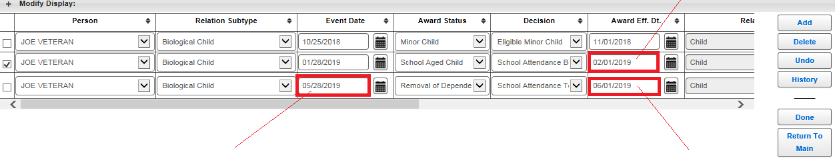

(graduation date) (1st of the month after

the graduation date)

1. Change the ***Award Status*** to “**School Aged Child**” and change the ***Decision*** to “**School Attendance Begins.**” This will populate a third line.
2. Under the ***Event date***, enter in the date of graduation
3. Under the ***Decision***, select “**School Attendance Terminates.**” This will populate the 1st of the month following the graduation date in the ***Award Eff. Dt.*** block
4. On the line that reflects “**School Attendance Begins,**” make sure to change the ***Award Eff. Dt*.** to the first of the month following the child’s 18th birthday. This is **NOT** automatic and must be manually changed. This step is extremely important as we cannot pay the increased rate for the school child prior to the first of the month following his or her 18th birthday *(38 CFR 3.31* and *M21-1, Part III, Subpart, iii, 6.B.1.a*). ***Note:*** This is the number one error when establishing a school child on a Veteran’s award.
5. Add or update the status of any other dependents. Click **Done** to save changes and return to the ***Record Decisions*** screen.

**Adding a School Child from Date Attendance Began**

When establishing a school child from the date attendance began, a new line will be added regardless of whether the child was on the Veteran’s award as a minor child, or not.

1. Click **Add** on the right side of the Dependency screen

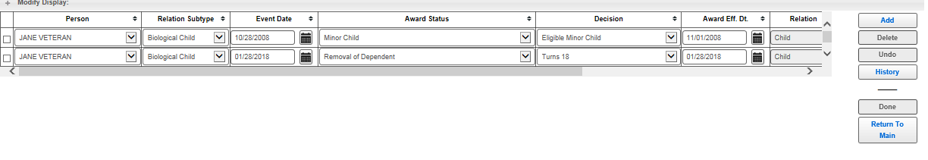

1. Enter the ***Person***, ***Relation Subtype***, ***Event Date (date attendance began)***, ***Award Status*** of **“School Child,”** and ***Decision*** of**“School Attendance Begins.”** (After the next step, you will need to go back to this line and ensure the ***Award Eff. Dt*.** is correct.)

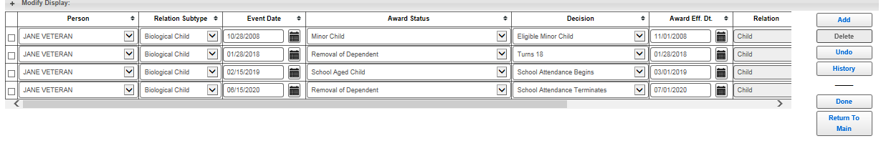

1. Once the ***Decision*** is entered, a new line will automatically appear for the removal of the school child. Enter the expected graduation date under ***Event Date***. The ***Award Status*** will automatically populate with ***“Removal of Dependent.”*** Click on ***Award Eff. Dt.*** and enter the first of the month following that date, if it does not populate automatically. ***Note:*** If the child turns 23 before the expected graduation date, enter “Turns 23” under the Decision.
2. Add or update the status of any other dependents. Click **Done** to save changes and return to the ***Record Decisions*** screen.

**Denying Entitlement to Additional Compensation for a School Child**

If VA denies entitlement to additional benefits for a dependent, the Veteran must be provided with the reason for the denial, and the favorable findings related to the claim. This means VA must notify the Veteran of the elements, necessary to grant the claim, which were met by the evidence of record.

Favorable findings are necessary ***only*** when denying entitlement to additional benefits for a dependent.

If a Veteran claims additional benefits for a dependent for which VA cannot pay, an award must still be generated in VBMS-A. Doing so provides an official record that the claim has been addressed. It also allows the VSR to generate a Redesigned Automated Decision Letter (RADL) for notification.

To deny entitlement to additional benefits for a school child in VBMS-A:

1. Select the dependent’s name from the ***Person*** drop-down menu
2. ***Relation Subtype*** – Select “**adopted child,” “biological child,”** or “**stepchild”**
3. ***Event Date*** – Actual date of the event affecting the dependency
4. Select the ***Award Status*** of **“Not an Award Dependent – School Aged Child”**
5. Under ***Decision***, select **“Edit”**, which will list the favorable findings, select the ***Decision Elements*** as **“Met”** or **“Not Met.”** Once you have selected the decision elements, hit save and the green check mark will appear in the decision box
6. Enter or update the ***Award Effective Date*** or leave blank
7. Select ***“Done”*** to save the decision and close the screen

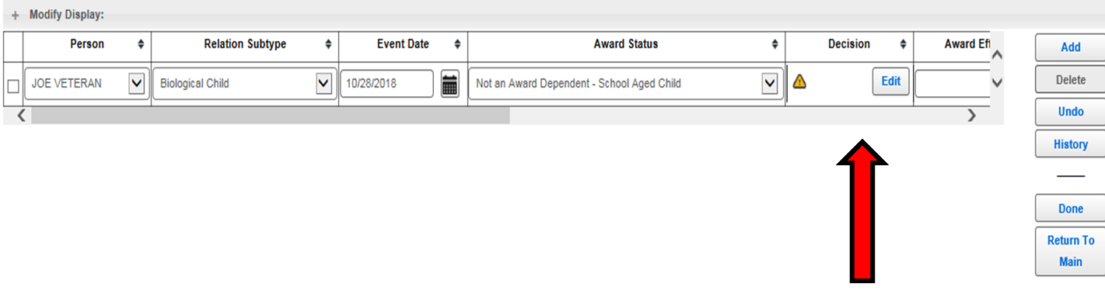

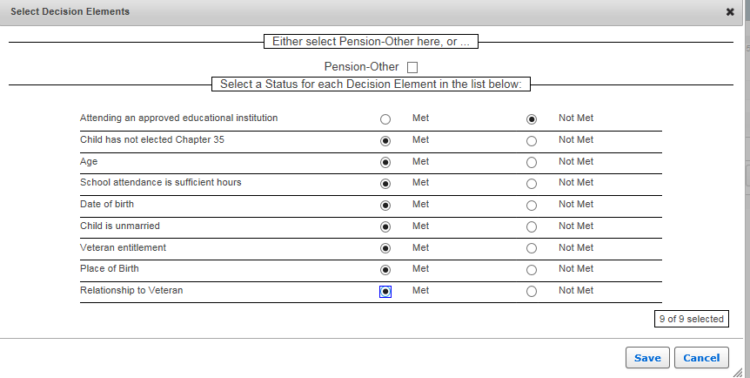

**Removing a School Child**

There may be certain situations in which a school child would need to be removed from a Veteran’s award. If the school child needs to be removed from a date other than originally scheduled, do not create a new line for removal, but edit the existing removal line.

Situations in which this may be required include, but are not limited to:

* A school child terminating school prior to graduation (or graduating early)
* A school child terminating and resuming school (multiple lines for the same child)
* A school child elects DEA or the Fry Scholarship (remove from the effective date of the education benefit)

To remove the child from the award:

1. Select the current removal line for the person in question
2. Update the ***Event Date***
3. Change the Award Status to ***“Removal of Dependent”***
4. Update the decision
5. The ***Award Eff. Dt.*** will auto populate to the 1st of the following month, update if necessary (election of DEA or Fry Scholarship)
6. Click ***“Done”*** to save and return to the ***Record decision*s** screen.

**Generate the Award & Notify**

Once all decisions have been entered, click ***Generate Award***.

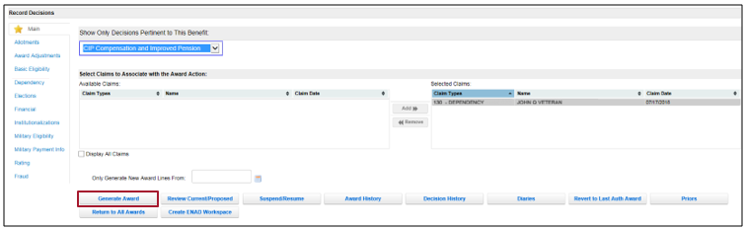

As discussed in the *Dependency Effective Dates and Awards* course, a decision notice must be provided to the Veteran for each dependent claimed. The process of notification for the establishment of school children is the same as other dependents. In addition to the information below, see the aforementioned lesson for a refresher.

The VSR must create the decision notice using the RADL functionality in VBMS-A or use PCGL if the RADL fails, is incorrect, or is insufficient beyond the addition of minor free text. See *M21-1, Part III, Subpart v, 2.B*, or the *Reviewing Ratings and Notification Requirements* or *Introduction to Personal Computer Generated Letter (PCGL)* courses, for the requirements of a decision notice. ***Reminder:***You will always need to add evidence used in making the decision to the decision notice, whether using RADL or PCGL.

Examples of decision notice language to use in a PCGL, when establishing a school child:

Example 1: Granting entitlement to additional benefits for a school age child:

**<Insert Dependent’s Name>** has been added to your award effective **<Insert Event Date>**, because you submitted all the required information and meet the eligibility requirements for dependency allowance. (38 CFR 3.4, 38 CFR 3.57, 38 CFR 3.204, 38 CFR 3.209, 38 CFR 3.210, 38 CFR 3.216, 38 CFR 3.667, 38 CFR 3.707, 38 CFR 21.4200)

**<Insert Dependent’s Name>** has been removed from your award on **<Insert Event Date>** the first of the month following the expected graduation dated. The regulations used to make our decision for **<Insert Dependent’s Name>** are 38 CFR 3.213 and 38 CFR 3.667.

Example 2: Denying entitlement to additional benefits for a school age child (this example involves a case in which VA did not receive a graduation date for the school age child. For other examples, see ***Approved Language for Favorable Findings – Dependency***, provided in the references section):

**<Insert Dependent’s Name>** is over the age of 18 and attending school but not at a VA-approved educational institution. (38 CFR 3.57, 38 CFR 3.667

Even though we aren’t able to pay additional compensation for your dependent, the following findings were favorable to your claim:

* **<Insert Dependent’s Name>** is not in receipt of Chapter 35/Dependents Educational Assistance benefits
* **<Insert Dependent’s Name>** is between the ages of 18 and 23
* Your child is attending a sufficient number of hours of school
* You provided **<Insert Dependent’s name>** date of birth
* **<Insert Dependent’s name>** is unmarried
* You are rated 30% or greater service connected
* You provided **<Insert Dependent’s Name>** place of birth
* Your relationship with **<Insert Dependent’s Name>** has been established

Practical Exercise

Directions: Read the scenarios and answer the associated questions.

1. VA received a complete *VA Form 21-674* on April 15, 2020, showing that the Veteran’s child is still in high school. The child was previously on the Veteran’s award until they turned 18 on February 18, 2020. The child has an expected graduation date from high school of June 15, 2020. Answer the following questions:
2. Did we receive the claim within one year of the child’s 18th birthday?
3. Can we continue the child on the Veteran’s award?
4. What is the ***payment date*** for additional compensation for the school child?
5. When will the school child come off the Veteran’s award?

1. VA received a *VA Form 21-674* on May 30, 2020, showing the Veteran’s child graduated from high school on June 20, 2019. The child was previously on the Veteran’s award until they turned 18. The child was born on September 23, 1999. The child will start college on September 26, 2019, with an anticipated graduation date of May 20, 2023.

Based on the above information, answer the following questions:

1. When did the minor child turn 18?
2. Did we receive the claim within one year of the minor child’s 18th birthday?
3. Can we continue the child on the Veteran’s award from their 18th birthday?
4. What is the ***payment date*** for additional compensation for the school child?
5. When will additional compensation for the school child end?
6. A school child was previously established on the Veteran’s award with an effective date of May 15, 2019, the date the child turned 18. The child is removed from the award on July 1, 2019, the first of the month following the child’s graduation from high school. The Veteran submits a new *VA Form 21-674*, showing the child began attending college starting on August 14, 2019. The expected graduation date is May 19, 2023. What are the steps to take to re-establish the school child on the Veteran’s award?

1. VA received a *VA Form 21-674* on October 12, 2019, showing that the Veteran’s child is now attending college. The child was previously on the Veteran’s award until they turned 18 on July 13, 2018. The child attended school from September 6, 2018 to December 22, 2018; January 3, 2019 to May 21, 2019; Setember 7, 2019 to   
   December 20, 2019; and January 4, 2020 to May 22, 2020.

Based on the above information, answer the following questions:

1. Did the Veteran file a claim within one year of their child starting school?
2. What is the ***effective date*** for additional benefits for the school child?
3. VA received a *VA Form 21-674* on October 2, 2019, showing that the Veteran’s child is attending college. The child has never been on the Veteran’s award. In the file there is a rating decision, dated September 28, 2018, that increased the Veteran’s disability evaluation from 20% to 50% effective April 5, 2015. VA notified the Veteran of the rating decision on October 5, 2018. The *VA Form 21-674* shows that child turned 18 on November 15, 2014, attended high school until graduation on June 1, 2014, and attended college continuously from August 31, 2014 to May 25, 2018. What is the ***payment date*** to establish the school child?