(VSR VIP Pre-D) Introduction to

Compensation and Pension Record Interchange (CAPRI)

Trainee Handout

**Table of Contents**

Objectives 2

References 3

Topic 1: CAPRI Login 4

Topic 2: CAPRI Exams and Functionality 8

Topic 3: Selecting and Storing Records from CAPRI 12

Practical Exercise 14

Objectives

* Explain how to login to CAPRI
* Recognize how to select the appropriate VAMC in CAPRI
* Recall how to identify patient treatment records in CAPRI
* Identify how to add a new patient into CAPRI
* Recognize functionality available within the CAPRI Tabs
* Explain how to add a new exam request in CAPRI
* Identify the steps required to select and store records from CAPRI

References

All M21-1 references are found in the [Compensation Pension Knowledge Management Portal](https://vaww.vrm.km.va.gov/system/templates/selfservice/va_kanew/help/agent/locale/en-US/portal/554400000001034)

* [M21-1, Part III, Subpart iv, 3.A Examination Request](https://vaww.vrm.km.va.gov/system/templates/selfservice/va_kanew/help/agent/locale/en-US/portal/554400000001034/content/554400000015809/M21-1-Part-III-Subpart-iv-Chapter-3-Section-A-Examination-Requests-Overview)
* [M21-1, Part III, Subpart iv, 3.D Examination Reports](https://vaww.vrm.km.va.gov/system/templates/selfservice/va_kanew/help/agent/locale/en-US/portal/554400000001034/content/554400000015812/M21-1-Part-III-Subpart-iv-Chapter-3-Section-D-Examination-Reports)
* [M21-1, Part III, Subpart iii, 1.C Requesting Evidence From Federal Records Custodians](https://vaww.vrm.km.va.gov/system/templates/selfservice/va_kanew/help/agent/locale/en-US/portal/554400000001034/content/554400000014156/M21-1-Part-III-Subpart-iii-Chapter-1-Section-C-Requesting-Evidence-From-Federal-Record-Custodians)
* [CAPRI User Guide](https://vbaw.vba.va.gov/bl/21/DEMO/capri.htm)

Topic 1: CAPRI Login

Before you can use CAPRI to order exams or obtain VA Medical Center treatment records you will need to gain access to the program. The Regional Office (RO)/ISO will provide the Access Code and Verify Code. Once login credentials including Access and Verify codes have been obtained you would login as noted in the screenshot

**Login Screen**

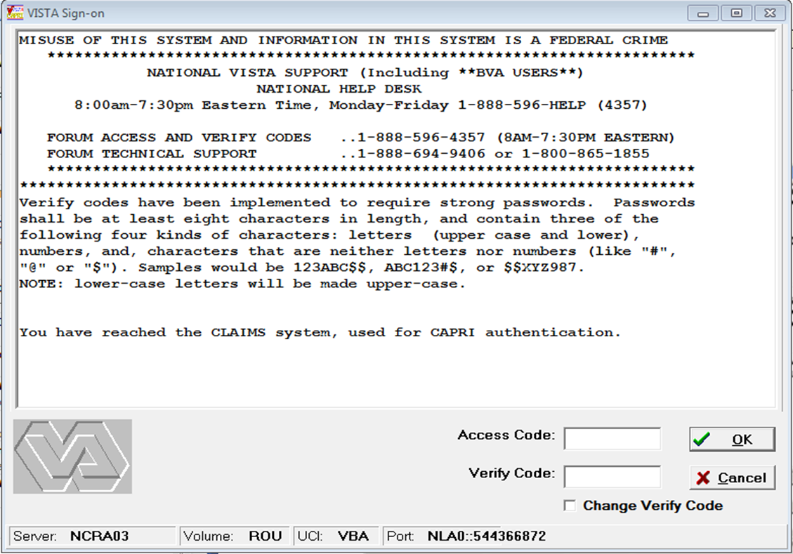

Select VAMC

Next you must select a VA Medical Center to continue the login process. The list will display all VA Medical Centers.

Select the appropriate facility after reviewing all documents submitted by the claimant to determine if specific VAMC treatment records have been noted. If no VAMC records have been identified by the claimant select any VAMC and use the enterprise search feature. Please note the Sort by State feature as it will help you locate the records quicker.

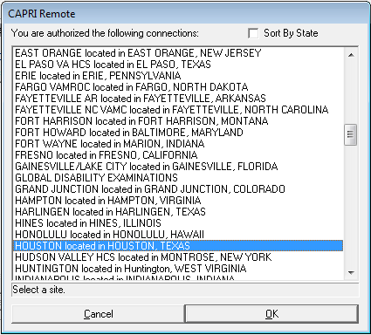

Select the approproate VAMC location and then select “OK.”

Identify Patient Treatment Records

Enter the Social Security for Patient ID to proceed to the enterprise search to find all potentially relevant treatment records.

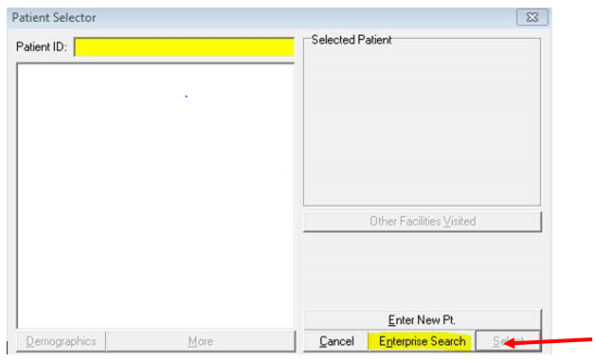

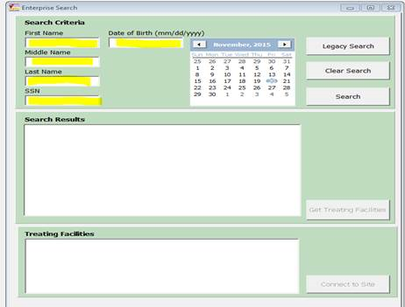

The search results will display the VAMCs the veteran has been had treatment.

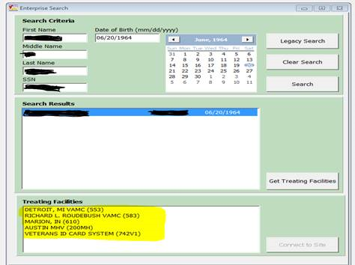

Proceed to obtain the relevant medical records listed under “Treating Facilities.” If VAMC Treatment records are not available and no records have been previously identified by the claimant update VBMS with a permanent note stating, no CAPRI records are available for the

individual. If a CAPRI exam is required and no record exists select “Enter New Patient.” This would be at the VAMC of jurisdiction for the Veterans home of record.

**Enter New Patient**

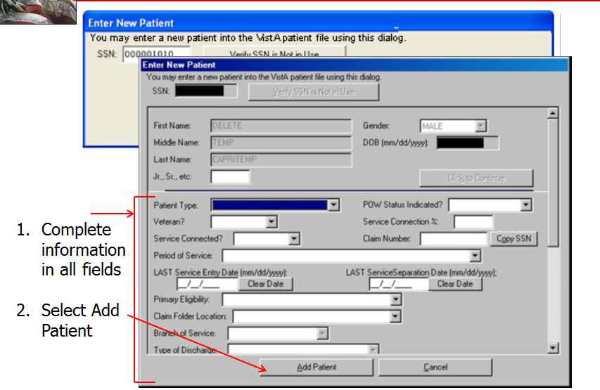

Topic 2: CAPRI Exams and Functionality

The Compensation and Pension Record Interchange (CAPRI) is an automated information system that provides authorized users read-only access to Veterans’ medical records created and maintained by Veterans Health Administration (VHA) facilities.

Through CAPRI, users may electronically request and/or retrieve

* Department of Veterans Affairs (VA) examinations or medical opinions
* Specific medical information about a Veteran who has received treatment at a VHA facility, including information users would otherwise request through submission of VA Form 10-7131, *Exchange of Beneficiary Information and Request for Administrative Action, and*
* General medical records referring to treatment of a Veteran at a VHA facility.

Please note the “Other Facilities Visited” tab noted below- this will allow users to quickly locate and obtain treatment records at every VA Medical Center that has relevant treatment records.

**CAPRI Program Tabs**

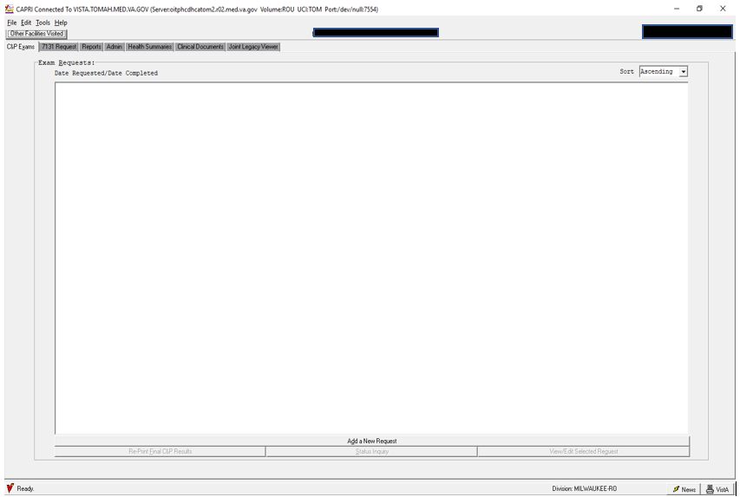

**C&P Exams**

Selection of this tab provides users with an electronic means of

* Requesting, modifying, canceling, and inquiring about the status of VA compensation and pension (C&P) examinations, and
* Obtaining exam reports for upload into VBMS.

ROs use CAPRI to electronically transmit examination requests to a VA medical center (VAMC) in lieu of using a paper *VA Form 21-2507, Request for VA Examination*.

 By selecting the C&P EXAM tab in CAPRI, ROs may also

* View/edit a pending request
* Cancel a request
* Add a new examination request
* Create status inquiry reports
* View a completed request
* Track the progress of a pending request
* Notify the VAMC of an inadequate/insufficient examination, and
* Print examination reports.

***Important***:  A pending examination request may *not* be edited in CAPRI for the purposes of adding additional medical conditions and/or examination types that were not specified at the time of the initial request’s submission. If the need for such modification arises, RO personnel must submit a new request for any additional examinations needed to adjudicate the underlying claim.

Please see the **CAPRI Exam Request Job Aid** for visual instructions regarding how to input an examination request.

VAMC Actions upon receipt of an exam request:

* + Schedule the exam(s)
  + Generate Disability Benefits Questionnaire (DBQ) unique to each exam
  + Transmit final exam findings back (through CAPRI)

**7131 Request**

The 7131 Request functionality allows users to obtain VA records that may be archived or unavailable electronically using CAPRI. Claims processors should always consider submitting a VA Form 10-7131 request for archived records when treatment is alleged at a VAMC prior to 2005.

These include:

* Older/retired records that do not exist in an electronic format
* Hospital summaries
* Notices of discharge
* 21-day certificates (confirming hospitalization for a period of at least 21 days)
* Competency reports
* Admission reports
* Asset information, and
* VA Form 21-2680, *Examination for Housebound Status or Permanent Need for Regular Aid and Attendance*

**Reports**

This selection allows the users to:

* Inquire about a specific Veteran’s
  + Demographics
  + Eligibility for treatment, and
  + Inpatient admissions
* Determine whether a Veteran has been treated at another VHA facility
* Review registration and profile data, and
* Obtain surgery reports

**Admin**

Selection of this tab allows users to view

* Permanent and temporary addresses VHA records show for a specific Veteran
* Veteran’s past and future appointments, and
* Dates of a Veteran’s inpatient admissions.

**Health Summaries**

Selection of this tab provides users with various customized health summaries, including

* *Inpatient Health Summary*
* *Outpatient Health Summary*
* *Medication Profile*, and
* *Ad Hoc Report*

**Clinical Documents**

Selection of this tab allows users to search and view a Veteran’s clinical documents. Clinical documents are organized by category and accessible from the following tabs, which appear at the bottom of the screen:

* NOTES (progress notes)
* DISCHARGE SUMMARIES
* CONSULTS
* VITALS
* MEDS
* LABS
* IMAGING (X-rays, magnetic resonance imaging (MRI), computer axial tomography (CT))
* DIET
* NUTRITIONAL ASSESSMENT
* ORDER SUMMARY
* PROCEDURES (Holter monitor, echocardiogram, stress test, etc.), and
* PROBLEM LIST

**Joint Legacy Viewer (JLV)**

JLV can be used to view Department of Defense (DoD) and Military Treatment Facilities in addition to VAMC records. For more information on JLV, please see the help section within JLV.

Topic 3: Selecting and Storing Records from CAPRI

If medical evidence relevant to a pending issue are available electronically through CAPRI, the records must be added to the claims folder.

A claims processor can create a single collection of pertinent medical records with the CAPRI Report Builder and save the selected records as a portable document format (PDF) document with Adobe PDF or MS Word and upload the records into VBMS Documents folder using the Upload Document function.

**References**:  For more information on:

* saving documents as a PDF, see [M21-1, Part III, Subpart ii, 4.G.2.b](https://vaww.vrm.km.va.gov/system/templates/selfservice/va_kanew/help/agent/locale/en-US/portal/554400000001034/content/554400000014132/M21-1,-Part-III,-Subpart-ii,-Chapter-4,-Section-G---Folder-Maintenance).

ROs can reasonably conclude VA records do not exist when a Veteran indicates treatment at a VA facility

* for a period earlier than his/her
  + registration date (if one is present), or
  + enrollment date (if one is present), when the indicated treatment began or after 1996
* for a specific condition during a timeframe when other electronic records exist for the Veteran (and the records cannot be found electronically), or
* if the attempts outlined in [M21-1, Part III, Subpart iii, 1.C.2.d](https://vaww.vrm.km.va.gov/system/templates/selfservice/va_kanew/help/agent/locale/en-US/portal/554400000001034/content/554400000014156/M21-1-Part-III-Subpart-iii-Chapter-1-Section-C-Requesting-Evidence-From-Federal-Record-Custodians#2d)-[f](https://vaww.vrm.km.va.gov/system/templates/selfservice/va_kanew/help/agent/locale/en-US/portal/554400000001034/content/554400000014156/M21-1-Part-III-Subpart-iii-Chapter-1-Section-C-Requesting-Evidence-From-Federal-Record-Custodians#2f) for records not electronically accessible in CAPRI is unsuccessful.

***Exception***:  Do not conclude records are nonexistent without first attempting to obtain the records using VA Form 10-7131, when evidence in the claims folder contradicts the registration or enrollment information displayed in CAPRI.

**Important**:  Claims processors must consider the circumstances of the individual claim when making conclusions on whether records exist.  These may include, but are not limited to, the following considerations:

* Electronic claim submission services require specific calendar start and end date when entering a date range for treatment. The claimant may not have the ability to list a more general start and end period (month/year) for the treatment period.
* Treatment for a disability does not always require continued evaluation and review on a weekly or monthly basis. Gaps in treatment during a date range provided by the claimant should be expected and do not always necessitate the documentation of unavailability or non-existence.
* Obtaining relevant reports of treatment that occur prior to, but approximately close to, the starting date(s) of treatment provided by the claimant, may be considered sufficient for purposes of obtaining records from the starting date(s).

**References**:  For more information on

* registration and enrollment dates, see [M21-1, Part III, Subpart iii, 1.C.2.c](https://vaww.vrm.km.va.gov/system/templates/selfservice/va_kanew/help/agent/locale/en-US/portal/554400000001034/content/554400000014156/M21-1-Part-III-Subpart-iii-Chapter-1-Section-C-Requesting-Evidence-From-Federal-Record-Custodians#2c)
* determining whether a VA Form 10-7131 should be submitted, see [M21-1, Part III, Subpart iii, 1.C.2.e](https://vaww.vrm.km.va.gov/system/templates/selfservice/va_kanew/help/agent/locale/en-US/portal/554400000001034/content/554400000014156/M21-1-Part-III-Subpart-iii-Chapter-1-Section-C-Requesting-Evidence-From-Federal-Record-Custodians#2e), and

Practical Exercise

1. What two login credentials are required in order to gain access to CAPRI?

1. ERRA instructs you to order the examination at the nearest VA Medical Center. After logging into CAPRI and performing an Enterprise Search, no Veteran record is found. What is the next action you should take?

1. List the two main reasons for which CAPRI is used.

1. You are reviewing a claim in your queue. There is a pending EP 020 with two contentions. The first contention, for a lower back strain, was already reviewed and an exam was ordered for the back. After reviewing the second contention for a neck strain, you decide an examination is needed. After reviewing CAPRI, you notice the first exam has not been completed. Can you modify the pending exam request to add the neck condition?

1. What tab allows users to request VA records that may be archived or unavailable electronically?

You are reviewing a claim in your queue. The Veteran is claiming he is convalescing from a recent total knee replacement on his service-connected left knee. The Veteran states the surgery was completed last month at his local VA Medical Center. Where could you find these records in CAPRI?

1. You are reviewing a claim in your queue. The Veteran is claiming an increase for bilateral hearing loss and a left knee strain. The Veteran identifies records at her local VA Medical Center. Which of the following medical records would be relevant to the Veteran’s claim? (select all that apply)

A – An audiogram from three months ago.

B – A visit from last month for a prescription refill.

C – A visit from last month during which the Veteran was diagnosed with an upper respiratory infection.

D – An emergency room visit from eight months ago due to a fall resulting from the Veteran’s left knee giving out.

E – A recent visit for new orthotics.

F – A visit from two months ago during which the Veteran discussed right knee pain after working on their feet all-day.

1. Which tool in CAPRI is used to prepare records for upload into CAPRI?
2. When inputting an examination into CAPRI and the claims folder has been uploaded into VBMS, which should be chosen for the following two selections:
   * Claim Folder Required? (Yes/No)
   * Electronic claim Folder Available? (Yes/No)

