Identifying Contentions and Classifications

Trainee Handout

**Table of Contents**

Objectives 2

References 3

Topic 1: Contentions 4

Topic 2: Classifications 6

Practical Exercise 13

Attachment A: Contention Classification Job Aid 14

Objectives

Given the handout and all available references, the Claims Assistant (CA) will:

* Determine and identify contention(s) made by the claimant.
* Recognize how to enter a contention appropriately.
* Determine the most appropriate contention classification.
* Recognize how to enter the classification appropriately.

References

* [M21-1, Part III, Subpart iii, 1.F, Record Maintenance During the Development Process](https://vaww.vrm.km.va.gov/system/templates/selfservice/va_kanew/help/agent/locale/en-US/portal/554400000001034/content/554400000071983/M21-1-Part-III-Subpart-iii-Chapter-1-Section-F-Record-Maintenance-During-the-Development-Process)
* [M21-1, Part III, Subpart iii, 1.F, Utilizing Contentions and Special Issues Indicators associated with the claimed issues](https://vaww.vrm.km.va.gov/system/templates/selfservice/va_kanew/help/agent/locale/en-US/portal/554400000001034/content/554400000071983/M21-1-Part-III-Subpart-iii-Chapter-1-Section-F-Record-Maintenance-During-the-Development-Process#2)
* [M21-1, Part III, Subpart iii, 1.F, Identifying Contentions](https://vaww.vrm.km.va.gov/system/templates/selfservice/va_kanew/help/agent/locale/en-US/portal/554400000001034/content/554400000071983/M21-1-Part-III-Subpart-iii-Chapter-1-Section-F-Record-Maintenance-During-the-Development-Process#2)
* [M21-1, Part III, Subpart iii, 1.F, Verifying Contentions](https://vaww.vrm.km.va.gov/system/templates/selfservice/va_kanew/help/agent/locale/en-US/portal/554400000001034/content/554400000071983/M21-1-Part-III-Subpart-iii-Chapter-1-Section-F-Record-Maintenance-During-the-Development-Process#2)
* [M21-1, Part III, Subpart iii, 1.F, Contention Classification and Exam Management](https://vaww.vrm.km.va.gov/system/templates/selfservice/va_kanew/help/agent/locale/en-US/portal/554400000001034/content/554400000071983/M21-1-Part-III-Subpart-iii-Chapter-1-Section-F-Record-Maintenance-During-the-Development-Process#2)
* [M21-1 Part III, Subpart iii, 5.L, EP Control When Requesting Evidence/Information Required to Add a Dependent in a Decision Notice](https://vaww.vrm.km.va.gov/system/templates/selfservice/va_kanew/help/agent/locale/en-US/portal/554400000001034/content/554400000032212/M21-1-Part-III-Subpart-iii-Chapter-5-Section-L-Adjusting-Awards-for-Dependents)
* [M21-1, Part III, Subpart v, 10.A, Claim Labels](https://vaww.vrm.km.va.gov/system/templates/selfservice/va_kanew/help/agent/locale/en-US/portal/554400000001034/content/554400000032244/M21-1,%20Part%20III,%20Subpart%20v,%20Chapter%2010,%20Section%20A%20-%20800%20Series%20Work%20Items%20and%20Cost-of-Living%20Allowance%20(COLA)%20Adjustments)
* [Medical EPSS](http://cptraining.vba.va.gov/C&P_Training/Job_Aids/Medical_EPSS.htm)
* [DBQ Switchboard](http://vbacoweb03.dva.va.gov/bl/21/DBQ/default.asp)
* [Index of DBQ/Exams by Disability](http://vbacodmoint1.vba.va.gov/bl/21/DBQ/DBQByDisab.asp)

**Topic 1: Contentions**

**Contentions**

The claims processor should enter issues as contentions when they are:

* Expressly claimed by the claimant/Veteran/authorized representative and/or
* Put at issue and requires development.

Contentions should be entered as soon as they are identified and should be easy to understand and in “the claimant’s own words’, as appropriate. All employees reviewing a claim are responsible for ensuring all contentions are correct and verified.

Important:

* This information will be made available via eBenefits.
* Non-rating contentions should relate to the specific benefit being sought.
* Dependency claims request a mandatory language and format.
* Claims derived from Work Items must have a contention.
* Sometimes the claim requires two separate contentions like a claim for total disability due to individual unemployability is treated as a claim for increase in the service-connected (SC) disabilities *the Veteran identifies* as causing unemployability. Therefore, the identified SC disabilities should be entered *as individual* contentions.

Example 1:

VA receives a claim for "increase in diabetes mellitus to include heart, depression, and numbness in hands." The contentions should be entered as

* diabetes mellitus
* heart condition
* depression, and
* numbness in hands.

A Veteran submits a claim for “ringing in the ears”. The contention should be entered as “ringing in the ears”.

Example 2:

A Veteran submits a claim to add a spouse and a child to a running award. Create separate contentions for the spouse and child as follows:

* Dependency claim for [name of spouse], and
* Dependency claim for [name of child].

Example 3:

VA receives a Work Item 840: Combat-Related Special Compensation (CRSC)/Concurrent Retirement and Disability Payments (CRDP) Audit Error Worksheet.

VA would establish an End Product (290) and ensure contention is listed.

* The contention at a minimum should list the type of Work Item.
  + Minimum: “Audit Error Worksheet”
* Best Practice to use specific information when categorizing Work Items.
  + From this example contention should read:

“Audit Error Worksheet – CRSC/CRDP”

[M21-1, Part III.v.10.A](https://vaww.vrm.km.va.gov/system/templates/selfservice/va_kanew/help/agent/locale/en-US/portal/554400000001034/content/554400000032244/M21-1,%20Part%20III,%20Subpart%20v,%20Chapter%2010,%20Section%20A%20-%20800%20Series%20Work%20Items%20and%20Cost-of-Living%20Allowance%20(COLA)%20Adjustments) hyperlinks are provided directing specific actions when establishing End Products from Work Items.

When establishing claims, a review of any prior rating decision should be reviewed through SHARE corporate record, the last rating decision within the eFolder, or the Rated Issues + icon within the VBMS contention page.



Example 4:

A Veteran submits a claim for "bilateral knee condition". A review of the corporate record indicates the Veteran is service connected for right knee patellofemoral pain syndrome and was previously denied for a left knee strain.

The contentions should be entered as follows:

* right knee patellofemoral pain syndrome (claimed as bilateral knees), and
* left knee strain (claimed as bilateral knees).

When an **original claim** for benefits (EP 110 or EP 010) is received with a VA Form 21-686c, Declaration of Status of Dependents, we must add the dependents noted as contentions.

When a VA Form 21-686c, Declaration of Status of Dependents, is received and it is a **non-original claim**, then a separate EP 130 will need to be established.

*Explain:* Reason for establishing a separate claim for dependency on a non-original claim is VA is entitled to additional credit for processing the claim and length of time for processing EP 130s may be significantly shorter than compensation claims.

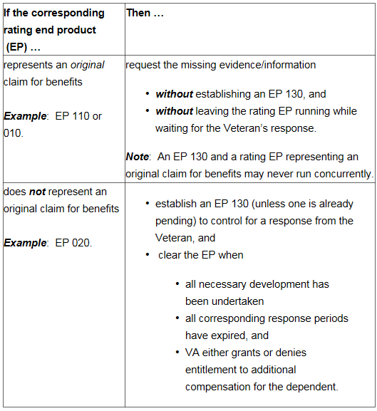

**Verifying the Contention**

Contentions automatically entered by the system that are missing critical information, such as the contention classification, will be marked unverified. The claims processor must update the missing/incorrect information and select SAVE. The contention will then be marked as verified and viewable in eBenefits.

**Topic 2: Classifications**

**Classification and Medical Field**

The CLASSIFICATION and MEDICAL fields are required components when entering a contention. The classification is associated with the contention being entered, you are associating the medical condition. This information is used in the exam management functionality and it is imperative the classification is correct.

* When selecting a classification, use
  + appropriate medical verbiage that corresponds to the claimed medical condition, instead of the claimant’s original language, and
  + the *Administrative* classification only for non-rating issues, such as dependency.
* Select *Yes* in the MEDICAL field if the contention may require an examination or medical opinion to make a determination. Otherwise, select *No*.

***Exception***:  Individual unemployability as a contention must be identified by

* selecting *Unemployability* as a classification in order to complete necessary specific development actions in VBMS, and
* Selecting *Yes* in the MEDICAL field.

**How do I choose the Classification?**

The user selects the appropriate medical verbiage that corresponds to the claimed medical condition. This is different than the plan language contention entered previously.

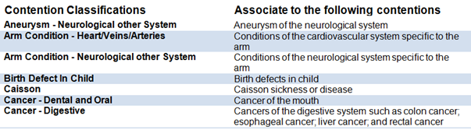

Non-Rating issues, to include dependency, should be updated to “administrative”.

Whenever in doubt about which contention classification to select for a condition, you may use one of the following sources.

[Index of DBQ/Exams by Disability](http://vbacodmoint1.vba.va.gov/bl/21/DBQ/DBQByDisab.asp) [Medical EPSS](http://cptraining.vba.va.gov/C&P_Training/Job_Aids/Medical_EPSS.htm)

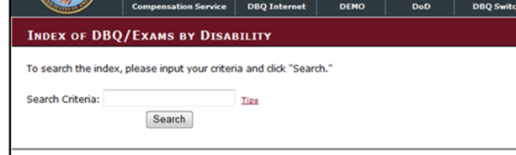 

[DBQ Switchboard](http://vbacoweb03.dva.va.gov/bl/21/DBQ/default.asp)



Index of DBQ/Exams by Disability

Example 5: Veteran submits a claim for service connection for diabetes mellitus. The claimed condition of “diabetes” can be typed into the search criteria.

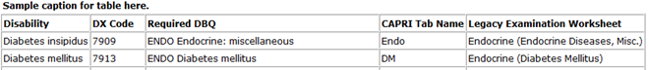

Reviewing the results provided, you know to choose “Endocrine” as the classification for the claimed condition.

Medical EPSS

Example 5: Veteran submits a claim for service connection for diabetes mellitus. The claimed condition of “diabetes” can be typed into the search criteria.

v

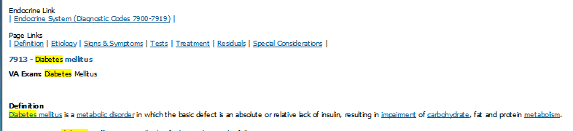

Reviewing the results provided, you know to choose “Endocrine” as the classification for the claimed condition.

DBQ Switchboard

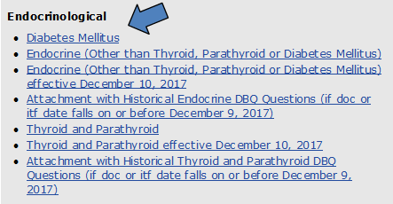

Reviewing the results provided, you know to choose “Endocrine” as the classification for the claimed condition.

Index of DBQ/Exams by Disability

Example 6: The Veteran claimed “erectile disfunction” on the VA Form 21-526EZ. A search of “erectile disfunction” produced no results within the Index of DBQ/Exams by Disability page. A new search of “erec” produced a result of “erectile dysfunction” and “hysterectomy”.

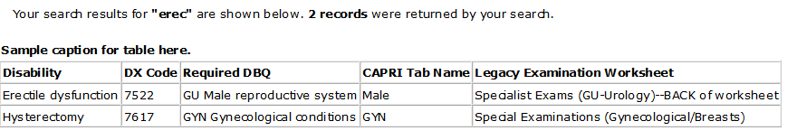

Example 6: The Veteran claimed “erectile disfunction” on the VA Form 21-526EZ. A search of “erectile disfunction” produced no results within the Index of DBQ/Exams by Disability page. A new search of “erec” produced a result of “erectile dysfunction” and “hysterectomy”.

DBQ Switchboard

By looking at the results from the initial search table it produced two results. If uncertain arose, then utilizing the DBQ Switchboard would produce the following:

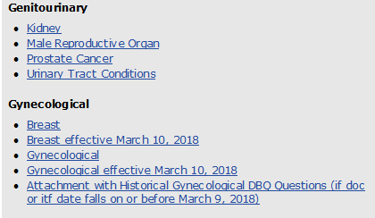

Further investigation within “Male Reproductive Organ” worksheet by using the Control + F (for find key word “erectile”) would yield erectile dysfunction located on page 2. Male Reproductive Organ was listed under the “Genitourinary” header.

Medical EPSS

Example 6: The Veteran claimed “erectile disfunction” on the VA Form 21-526EZ. A search of “erectile disfunction” produced no results. A new search of “erectile” produced a result of “erectile dysfunction”.

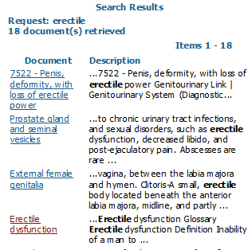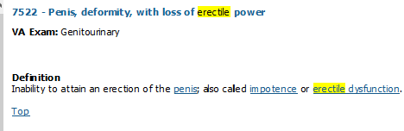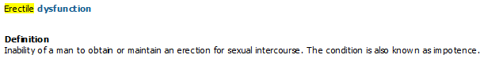

Reviewing the results provided, you know to choose “Genitourinary” as the classification for the claimed condition.

VBMS Input and Putting It All Together

Example 5: You received a claim from a Veteran claiming service connection for diabetes mellitus.

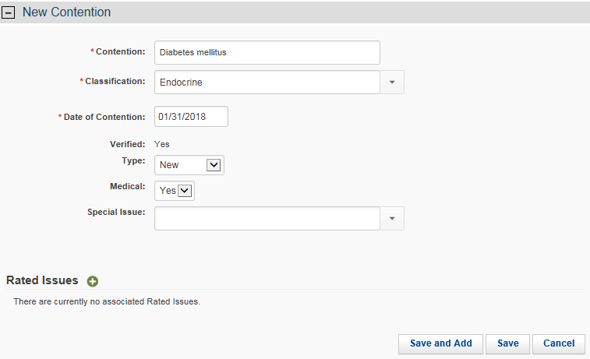

Example 6: The Veteran claimed “erectile disfunction” on the VA Form 21-526EZ.

By typing “ge” the list started to populate and here is where the user would select “Genitourinary” as the classification.

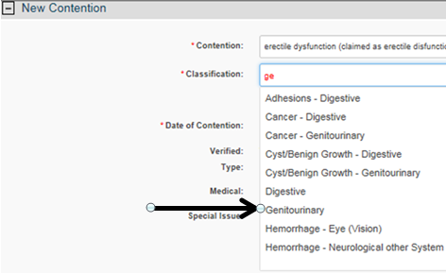

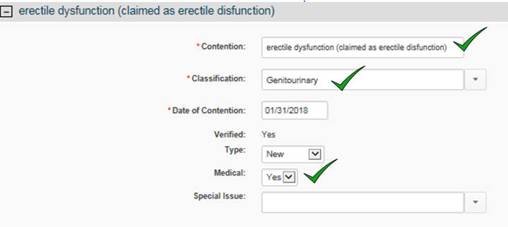

Practical Exercise

v

**Directions:** Use the either of the following tools along with the CONTENTION CLASSIFICATION JOB AID found in attachment A above to determine the proper contention classification.

[Index of DBQ/Exams by Disability](http://vbacodmoint1.vba.va.gov/bl/21/DBQ/DBQByDisab.asp) [Medical EPSS](http://cptraining.vba.va.gov/C&P_Training/Job_Aids/Medical_EPSS.htm)

 

[DBQ Switchboard](http://vbacoweb03.dva.va.gov/bl/21/DBQ/default.asp)



1. ringing in ears
2. diabetes mellitus
3. heart condition
4. dependency claim for Salley
5. depression
6. individual unemployablity

Attachment A: Contention Classification Job Aid

Use the table below as a guide for determining what contention classification to associate.

|  |  |
| --- | --- |
| Contention Classifications | Associate to the following contentions |
| Adhesions - Digestive | Adhesions of the digestive system |
| Adhesions - Gynecological | Adhesions of the gynecological system |
| Adhesions - Heart/Veins/Arteries | Adhesions of the cardiovascular system |
| Adhesions - Neurological other System | Adhesions of the neurological system |
| Adhesions - Respiratory | Adhesions of the respiratory system |
| Administrative Issue | Only non-rating issues such as dependency or drill pay |
| Aneurysm - Heart/Veins/Arteries | Aneurysm of the cardiovascular system |
| Aneurysm - Neurological other System | Aneurysm of the neurological system |
| Arm Condition - Heart/Veins/Arteries | Conditions of the cardiovascular system specific to the arm |
| Arm Condition - Neurological other System | Conditions of the neurological system specific to the arm |
| Birth Defect In Child | Birth defects in child |
| Caisson | Caisson sickness or disease |
| Cancer - Dental and Oral | Cancer of the mouth |
| Cancer - Digestive | Cancers of the digestive system such as colon cancer; esophageal cancer; liver cancer; and rectal cancer |
| Cancer - Endocrine | Cancers of the endocrine system such as pancreatic cancer |
| Cancer - Eye (Vision) | Cancers of the eye |
| Cancer - Genitourinary | Cancers of the genitourinary system such as kidney cancer and bladder cancer |
| Cancer - Gynecological | Cancers of the gynecological system such as ovarian cancer |
| Cancer - Heart/Veins/Arteries | Cancers of the cardiovascular system |
| Cancer - Hemic and Lymphatic | Cancers of the hemic and lymphatic system such as leukemia |
| Cancer - Musculoskeletal - Ankle | Cancers relating to the ankle |
| Cancer - Musculoskeletal - Elbow | Cancers relating to the elbow |
| Cancer - Musculoskeletal - Foot | Cancers relating to the foot |
| Cancer - Musculoskeletal - Hand | Cancers relating to the hand |
| Cancer - Musculoskeletal - Hip | Cancers relating to the hip |
| Cancer - Musculoskeletal - Knee | Cancers relating to the knee |
| Cancer - Musculoskeletal - Mid/Lower Back (Thoracolumbar Spine) | Cancers relating to the mid and lower back |
| Cancer - Musculoskeletal - Neck/Upper Back (Cervical Spine) | Cancers relating to the neck and upper back |
| Cancer - Musculoskeletal - Shoulder | Cancers relating to the shoulder |
| Cancer - Musculoskeletal - Wrist | Cancers relating to the wrist |
| Cancer - Musculoskeletal - Other | Avoid the use of this classification unless no other possible classification is appropriate |
| Cancer - Musculoskeletal and Muscle Injuries | Cancers of the musculoskeletal system such rhabdomyosarcoma |
| Cancer - Neurological other System | Cancers of the neurological system such as brain cancer |
| Cancer - Respiratory | Cancers of the respiratory system such as lung cancer |
| Cancer - Skin | Cancers of the skin such as skin cancer |
| Contention Classifications | **Associate to the following contentions** |
| Cold Injury Residuals | Cold injury residuals |
| Competency | Competency and incompetency |
| Cyst/Benign Growth - Dental and Oral | Cysts or growths of the mouth |
| Cyst/Benign Growth - Digestive | Cysts or growths on the digestive system |
| Cyst/Benign Growth - Ear Disease and Other Sense Organs | Cysts or benign growths on the ear or other sense organs |
| Cyst/Benign Growth - Endocrine | Cysts or benign growths on the endocrine system |
| Cyst/Benign Growth - Eye (Vision) | Cysts or benign growths on the eyes |
| Cyst/Benign Growth - Genitourinary | Cysts or benign growths on the genitourinary system such as kidneys or bladder |
| Cyst/Benign Growth - Gynecological | Cysts or benign growths on the gynecological system such as ovaries |
| Cyst/Benign Growth - Heart/Veins/Arteries | Cysts or benign growths on the cardiovascular system |
| Cyst/Benign Growth - Hemic and Lymphatic | Cysts or benign growths on the hemic and lymphatic system |
| Cyst/Benign Growth - Musculoskeletal - Ankle | Cysts or benign growths on ankle |
| Cyst/Benign Growth - Musculoskeletal - Elbow | Cysts or benign growths on elbow |
| Cyst/Benign Growth - Musculoskeletal - Foot | Cysts or benign growths on foot |
| Cyst/Benign Growth - Musculoskeletal - Hand | Cysts or benign growths on hand |
| Cyst/Benign Growth - Musculoskeletal - Hip | Cysts or benign growths on hip |
| Cyst/Benign Growth - Musculoskeletal - Knee | Cysts or benign growths on knee |
| Cyst/Benign Growth - Musculoskeletal - Mid/Lower Back (Thoracolumbar Spine) | Cysts or benign growths on mid/lower back |
| Cyst/Benign Growth - Musculoskeletal - Neck/Upper Back (Cervical Spine) | Cysts or benign growths on neck/upper back |
| Cyst/Benign Growth - Musculoskeletal - Other | Avoid the use of this classification unless no other possible classification is appropriate |
| Cyst/Benign Growth - Musculoskeletal - Shoulder | Cysts or benign growths on shoulder |
| Cyst/Benign Growth - Musculoskeletal - Wrist | Cysts or benign growths on wrist |
| Cyst/Benign Growth - Musculoskeletal and Muscle Injuries | Cysts or benign growths on muscles |
| Cyst/Benign Growth - Neurological other System | Cysts or benign growths on neurological system |
| Cyst/Benign Growth - Respiratory | Cysts or benign growths on respiratory system such as lungs |
| Cyst/Benign Growth - Skin | Cysts or benign growths on skin |
| Dental and Oral | Any dental or oral conditions not related to the temporomandibular joint (TMJ) |
| Dental and Oral - Musculoskeletal | Any condition related to TMJ; Fracture of jaw |
| Digestive | Conditions of the digestive system such as esophagus; stomach; intestines; gastroesophageal reflux disorder (GERD); irritable bowel syndrome (IBS); hemorrhoids |
| Ear Disease and Other Sense Organs | Ear infections; vertigo; Meniere’s disease; dizziness |
| Eating Disorders | Anorexia; bulimia; binge eating |
| Embolism/Infarction - Heart/Veins/Arteries | Embolism of the cardiovascular system such as pulmonary embolism |
| Embolism/Infarction - Neurological other System | Embolism of the neurological system |
| Endocrine | Conditions of the endocrine system such as thyroid; parathyroid; pancreas; pituitary gland; and Cushing’s syndrome |
| Eye (Vision) | Macular degeneration; glaucoma; herpes on eye(s); other vision related conditions |
| Genitourinary | Conditions of the genitourinary system such as kidney (nephropathy) and bladder |
| Contention Classifications | **Associate to the following contentions** |
| Gulf War Unexplained Chronic Multi-Symptom Illness | Gulf War unexplained chronic multi system illnesses such as fibromyalgia and chronic fatigue |
| Gulf War Undiagnosed Illness | Undiagnosed illness Gulf war |
| Gynecological | Any gynecological conditions such as menstrual disorders and hysterectomy |
| Hearing Loss | Hearing loss; tinnitus |
| Heart/Veins/Arteries | Conditions of the cardiovascular system such as heart and hypertension |
| Helpless Child | Helpless child |
| Hemic and Lymphatic | Conditions of the hemic and lymphatic system such as spleen; bone marrow; lymph nodes |
| Hemorrhage - Eye (Vision) | Hemorrhage of eye |
| Hemorrhage - Neurological other System | Hemorrhage of neurological system such as a cerebral hemorrhage and stroke |
| Infectious Diseases, Immune Disorders & Nutritional Deficiencies | Malaria; leprosy; HIV/AIDS; pellagra; beriberi; lupus |
| Leg Condition - Heart/Veins/Arteries | Conditions of the cardiovascular system specific to the leg such as varicose veins |
| Leg Condition - Neurological other System | Conditions of the neurological system specific to the leg |
| Mental Disorders | Depression; anxiety; insomnia; and other mental health conditions |
| Musculoskeletal - Amputations | Amputations other than toe amputations |
| Musculoskeletal - Ankle | Ankle conditions such as Ankle sprain and ankle strain |
| Musculoskeletal - Arthritis | Arthritis |
| Musculoskeletal - Elbow | Elbow conditions; Tendonitis of elbow; Tennis elbow |
| Musculoskeletal - Foot | Pes planus (flatfoot); plantar fasciitis; heel spur; other foot related conditions |
| Musculoskeletal - Hand | Any finger conditions; any hand conditions |
| Musculoskeletal - Hip | Hip bursitis; hip strain; thigh strain; other hip and thigh conditions |
| Musculoskeletal - Knee | Patellofemoral syndrome (PFS); anterior cruciate ligament (ACL); meniscus tear; other knee related conditions |
| Musculoskeletal - Mid/Lower Back (Thoracolumbar Spine) | Mid/low back conditions such as lumbosacral pain; degenerative disc disease; low or mid back pain |
| Musculoskeletal - Neck/Upper Back (Cervical Spine) | Upper back pain; cervical spine; degenerative disc disease |
| Musculoskeletal - Osteomyelitis | Bone conditions such as osteomyelitis; bone infection; and inflammation of bone |
| Musculoskeletal - Other | Avoid the use of this classification unless no other possible classification is appropriate |
| Musculoskeletal - Shoulder | Shoulder bursitis; shoulder tendonitis; Rotator cuff; other shoulder conditions |
| Musculoskeletal - Toe Amputations | Amputations of toes |
| Musculoskeletal - Wrist | Sprained wrist; strained wrist; tendonitis of wrist; other wrist conditions |
| Musculoskeletal and Muscle Injuries | Weakness of muscles; bruising or contusion of muscle |
| Neurological - Cranial/Peripheral Nerves | Facial nerve disorders; carpal tunnel; peripheral neuropathy |
| Neurological other System | Amyotrophic lateral sclerosis (ALS); multiple sclerosis (MS) |
| Pension | Live pension and death pension |
|  |  |
| Contention Classifications | **Associate to the following contentions** |
| Pension - Aid and Attendance/Housebound | Special monthly pension (SMP); pension aid and attendance; pension housebound |
| Post Traumatic Stress Disorder (PTSD) Combat - Mental Disorders | Combat related PTSD |
| Post Traumatic Stress Disorder (PTSD) Personal Trauma - Mental Disorders | Personal trauma related PTSD; military sexual trauma (MST) |
| Respiratory | Asthma, bronchitis, asbestosis; sinusitis; rhinitis; and other respiratory conditions |
| Scars (Extremities and Trunk) | Scars on extremities and trunk |
| Scars (Head, Face, Or Neck) | Scars on head, face, or neck |
| Service Connected Death | Service connected death |
| Skin | Dermatitis; rosecea; pseudofolliculitis barbae (PFB); herpes; acne; and other skin related conditions |
| Special Monthly Compensation - Aid and Attendance/Housebound | Aid and attendance; housebound; special monthly compensation (SMC) |
| Special Monthly Compensation - Anatomical Loss/Loss Of Use | Erectile dysfunction |
| Spina Bifida | Spina Bifida |
| Traumatic Brain Injury | Traumatic brain injury (TBI) |
| Tuberculosis | Tuberculosis (TB) |
| Unemployability | Individual unemployability (IU) |
| Wound, Bullet/Shell Fragment | Gunshot wound (GSW); shrapnel wound; bullet wound |