Appeals Process Overview and Speical Handling of Claims Folders

Trainee Handout

**Table of Contents**

Objectives 2

References 3

Topic 1: Understand the major stages of the Appeals Process 4

Topic 2: Define Special Handling of Claims Folders 9

Practical Exercise 11

Objectives

* Understand the major stages of the Appeals process
* Understand Special Handling of Claims Folders

References

All M21-1 references are found in the [Compensation.Pension (CPKM) Portal](https://vaww.compensation.pension.km.va.gov/).

* M21-1, Part I, Chapter 5, Section A
* M21-1, Part III, Subpart ii, Chapter 4, Section I
* 38 CFR 20.201
* 38 CFR 20.301(a)
* 38 CFR 20.501(a)

Topic 1: Understand the Major Stages of the Appeals Process

|  |
| --- |
| **Definitions:**  Appellant – a claimant who has initiated an appeal to the Board of Veterans’ Appeals (BVA) by filing a timely notice of disagreement (NOD) with the agency of original jurisdiction (AOJ) that completed the decision.  Claimant – a person who has filed a claim under 38, U.S.C., for entitlement to Department of Veterans Affairs (VA) benefits.  Decision Review Officer (DRO) – a senior technical expert who is responsible for holding post-decisional hearings and processing appeals.  De Novo Review – a new and complete review of the appealed issue with no deference given to the decision being appealed.  This review leads to a new decision, which may be a full grant, partial grant, clear and unmistakable error (CUE), or no change.  Notice of Disagreement (NOD) – Effective March 24, 2015 every case in which the agency of original jurisdiction (AOJ) provides, in connection with its decision, a form for the purpose of initiating an appeal, a notice of disagreement consists of a completed and timely submitted copy of that form.    *Prior to March 24, 2015 no standardized form was required.  Statement of a Case (SOC) – is an explanation of the decision made on the appellant’s case.  Supplemental Statement of the Case (SSOC) – presents the appellant with changes or additions to the SOC.  Remanded appeal – is an appeal that has been returned by BVA to the RO or Appeals Resource Center (ARC) for   * development of additional evidence * due process, or * Reconsideration of issues. |

**Appeals Process:**

In order to file an appeal, the claimant must have previously filed a claim for benefits and received a decision from VA.

VA is unable to accept a Notice of Disagreement (NOD) from a claimant if a final decision has not been rendered.

*Note: A proposal to reduce benefits is not a final decision.

The appellant must file a NOD in response to a VA decision regarding his/her benefit claim, and

may elect either a DRO review process or the traditional appellate review process.

The appellant has **One Year** from the date of the notification letter to submit a timely NOD.

VA Form 21-0958, Notice of Disagreement, is the current standardized form.

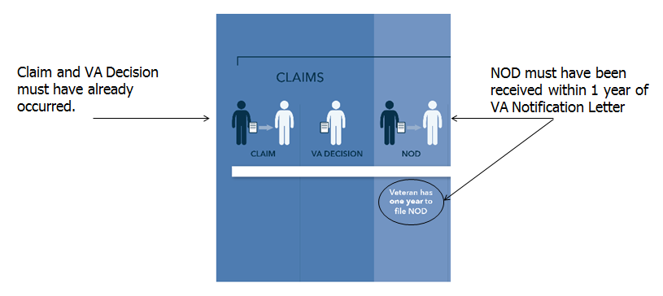

**Notice of Disagreement:**

If a valid, complete, and timely NOD is received, then IPC will place the NOD under control.

End Product will be routed to proper employee through National Work Queue (NWQ) through VBMS based on appellant’s choice of Decision Review Officer (DRO) Review Process or Traditional Appellate Review Process.

**Statement of the Case (SOC):**

*Assuming appellant chose Decision Review Officer:*   
A review of the previous claim occurs and a Decision Review Officer (DRO) may complete one of the following:  
 - Full Grant on Appeal   
 - Partial Grant on Appeal  
 - Statement of the Case

Statement of the Case is required when the evidence does not warrant a full grant on appeal.

An SOC provides the appellant with a complete understanding of the decision so the appellant can prepare an effective substantive appeal with specific allegations N errors of fact or law.  
  
Note: *The appellant has a choice to elect a Decision Review Officer(DRO) or a De Nova review but may also choose the traditional appeal route. Most appellants do elect a DRO review.*

The purpose of an SOC is to provide the appellant a decision and explanation of the continued denial on the issue(s) listed on an NOD. As stated in [38 CFR 19.29](http://www.ecfr.gov/cgi-bin/text-idx?SID=14f65ac18c8c007aa7603a9589552383&mc=true&node=se38.2.19_129&rgn=div8), the SOC must contain enough information to allow the appellant to present written and/or oral arguments before BVA.

The SOC must provide the appellant

* a summary of the relevant evidence
* a summary of the applicable laws and regulations
* a discussion of how such laws and regulations affect the determination
* the determination on each issue, and
* the reasons for each such determination

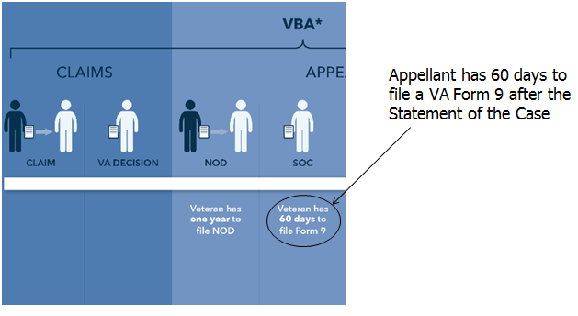

**Substantive Appeal:**

The substantive appeal time limit is calculated by determining the time period between the

* filing of a substantive appeal, and  
  **later** of the
  + response period from the date a decision on the appeal was mailed to the appellant (statement of the case (SOC) or supplemental statement of the case (SSOC)), **(60 days)** or
  + remaining appeal period, if any, from the date the decision notice being appealed was mailed to the appellant. **(one year from the decision notice)**

A substantive appeal is one of the following documents containing the necessary information as provided in [38 CFR 20.202](http://www.ecfr.gov/cgi-bin/text-idx?SID=2fb1f6831d7779d0e4f3c8e7dbafa73a&node=se38.2.20_1202&rgn=div8):

* [VA Form 9, Appeal to Board of Veterans’ Appeals](http://www.va.gov/vaforms/va/pdf/VA9.pdf)
* a statement at a formal hearing or informal conference reduced to writing, or
* written correspondence indicating a desire to continue the appeal.

**Note**:  The submission of a substantive appeal is also known as perfecting the appeal.

Once a Statement of the Case is issued to the appellant, then the appellant has 60 days to file a VA Form 9, Appeal to Board of Veterans’ Appeals.

An appellant may request an extension of the time limit for filing a substantive appeal. In this situation, the time limit may be extended if an appellant shows good cause.

[38 CFR 20.303](http://www.ecfr.gov/cgi-bin/retrieveECFR?gp=&SID=2fb1f6831d7779d0e4f3c8e7dbafa73a&n=pt38.2.20&r=PART&ty=HTML#se38.2.20_1303) provides that a request to extend the 60-day time limit to file a substantive appeal, or to respond to an SOC/SSOC when such a request is required, must be made in writing before the time limit has elapsed.

[38 CFR 3.109(b)](http://www.ecfr.gov/cgi-bin/text-idx?SID=c1cf3fbde951a5a84646c69b2552d220&node=se38.1.3_1109&rgn=div8) provides that a request to extend the one-year time limit to file a substantive appeal may be submitted after the time limit has elapsed, but only if the appellant has completed, or is in the process of completing, the action for which the extension is requested.

VA Form 9, Appeal to Board of Veterans’ Appeals, requires the Veteran to clearly identify which disability(s) he/she is going to appeal to the Board of Veteran Affairs (BVA). This form also provides an opportunity for appellant to request a Board Hearing.

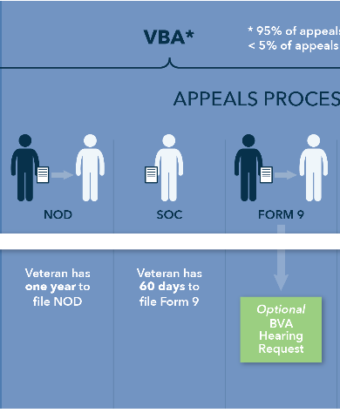

*The three different types of Board Hearings (sometimes refered to as “hearing board”):  
1. By Live Videoconference at a Local VA Office  
2. In Washington, DC  
3. At a Local VA Office (sometimes referred to as (travel board))*

Each time the appellant submits additional evidence, then a SSOC must be provided to the appellant. Thus adding additional time onto the appeals process.

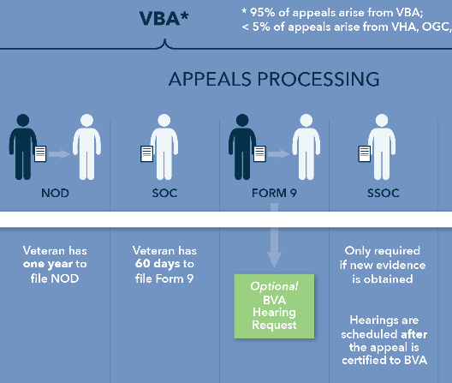

**VA Form 646:**

The Department of Veterans Affairs (VA) must provide an appellant’s accredited representative the opportunity to review the appeal and submit[*VA Form 646*](http://www.va.gov/vaforms/va/pdf/VA646.pdf) once all development for the pending appeal is complete, and prior to certification to BVA.

VA allows the representative10 business days to respond to VA’s request for a completed VA Form 646.

**Certification Process:**

The Decision Review Officer (DRO), ARCM, VSCM, PMC, or his/her designee is responsible for  
 - reviewing all appeals, and  
 - certifying the appeal is ready for review by BVA.

Proper review of the case includes verification that all  
 - issues on appeal have been decided and discussed, and   
 - appropriate development has been initiated and properly conducted.

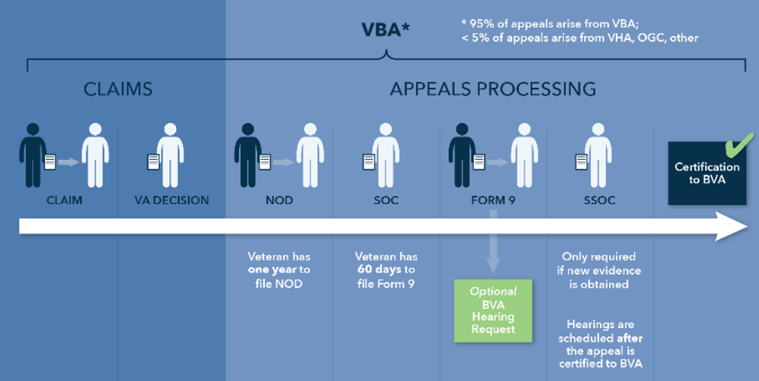

Topic 2: Define Special Handling of Claims Folders

**Special Handling:**

The Department of Veterans Affairs (VA) requires special procedures for the handling of *paper* claims folders containing decisions by the Board of Veterans’ Appeals (BVA) that meet the criteria for review by the Court of Appeals for Veteran Claims (CAVC).

**Judicial Review Act:**

The Veterans Judicial Review Act, [*Public Law 100-687*](http://www.gpo.gov/fdsys/granule/USCODE-2011-title38/USCODE-2011-title38-partV-chap71-sec7104/mods.xml), enacted into law on November 18, 1988,

* created CAVC (originally the Court of Veterans Appeals (COVA)), and
* granted CAVC exclusive jurisdiction to review BVA decisions.

BVA decisions resulting from a Notice of Disagreement (NOD) filed on or after November 18, 1988, are subject to review by CAVC.

**Special Handling Period After BVA Decisions:**

In accordance with [38 U.S.C. 7266](https://www.law.cornell.edu/uscode/text/38/7266), appeals of BVA decisions must be filed directly with CAVC within 120 days of an adverse BVA decision.

Prior to the expiration of this appeal period, VA requires special handling of the paper claims folder in order to

* preserve the record that served as the basis for the BVA decision, and
* ensure that the paper claims folder is available for immediate transfer to the Office of General Counsel’s (OGC’s) Professional Staff Group VII (PSG VII) if the claimant files an appeal.

***Important***:  Although the statute allows only 120 days for an appeal to be filed, VA policy is to maintain special handling of paper claims folder for a period of 150 days to allow for mail processing.

**Converting Paper Folders with a BVA Decision to an eFolder:**

When applicable, regional offices (ROs) and Appeals Management Center (AMC) should route the paper claims folders received after a BVA decision to the scanning vendor for conversion to an electronic claims folder (eFolder).

***Exception***:  Do not ship claims folders to the scanning vendors if the claims are currently *excluded* from the Veterans Claims Intake Program (VCIP).

After paper claims folders are converted to an eFolder

* BVA decisions that meet the criteria for review by the CAVC *do not* require special handling.
* The scanning vendors will use *BVA decision* as the document type when scanning in the pink BVA file inserts used to identify cases requiring special handling.
* PSG VII will have access to the eFolder if the appellant files an appeal with CAVC.

**General Policy for Maintaining a Temporary File:**

During the special-handling period *do* *not* add or delete material contained in the permanent paper claims folder.

During the special-handling period, the RO should maintain the temporary file it previously created when the appeal associated with a paper claims folder was transferred to BVA for appellate review.

During the special-handling period, the RO must limit the reviews of the paper claims folder to the fewest number of VA employees.

**Definition: Temporary File:**

A ***temporary file***

* is a paper folder that contains
  + copies of documents from the paper permanent claims folder, and
  + original documents received while the paper permanent claims folder was transferred out of the RO and during the special-handling period
* is *not* subject to the same stringent restrictions as the permanent claims folder, and
* Should have a charge card.

**Action Taken After Expiration of the Special Handling Period:**

Follow the steps in the table below when the local control matures 150 days after the date of the BVA decision and the RO has not received a request from PSG VII to transfer the paper claims folders.

| **Step** | **Action** |
| --- | --- |
| 1 | Remove the paper claims folder from the secured area. |
| 2 | Remove the   * outside label * file inserts, and * BVA evidence tabs inside the folder. |
| 3 | Transfer the material from the temporary file to the permanent claims folder. |
| 4 | * Route the permanent paper claims folder to the main file bank, or * Send the paper claims folder to the scanning vendor to convert into an eFolder, when applicable. |
| 5 | Destroy the temporary file according to current procedures. |

Practical Exercise

Directions: Students will have 30 minutes to complete the following questions.

1. What is the standardized VA form a claimant must submit to initiate an appeal?

Answer:

1. What is a Statement of a Case (SOC)?

Answer:

1. What is a Decision Review Officer (DRO)?

Answer:

1. How long after VA notifies the claimant of a decision does the claim have submit a NOD?

Answer:

1. Intake Processing Center will place the NOD under control if it is ______________, ________________, and _____________________.
2. ______________________ is required when the evidence does not warrant a full grant on appeal.
3. Statement of the Case (SOC) is required when the evidence does not warrant a _________________ on appeal.
4. Appellant has ________ days to file a VA Form 9 after the SOC.
5. Each time the appellant submits additional evidence then a _______________ must be provided to the appellant.
6. BVA is an acronym for ___________________________________.
7. VA must provide an appellant’s credited representative the opportunity to review the appeal and submit a __________ once all development for the pending appeal is complete, prior to certification to BVA.
8. A ______________________, ARCM, VSCM, PMC, or his/her designee can certify an appeal to BVA.
9. Public Law 100-687, enacted on November 18, 1988 created ____________________________ which allows BVA decisions to be reviewed.
10. Claimants have ________ days to file a claim directly with Court of Appeals for Veterans Claims (CAVC).
11. Permanent claims folders which a BVA decision has been rendered should not have any additional materials added or deleted from the claims file for ____________ days.
12. During the ___________________ period, the RO should maintain the temporary file it previously created when the appeal associated with the paper claims folder was transferred to BA for appellate review.
13. When applicable, RO and AMC should route the paper claims folders received after a _____________________________ decision to the scanning vendor for conversion to an electronic claims folder (eFolder).
14. _____________________ is destroyed after additional materials are transferred into the permanent claims folder.