Drill Pay Waivers Overview

Trainee Handout

**Table of Contents**

Objectives 2

References 3

Topic 1: Define and Explain 4

Topic 2: Drill Pay vs. Active Duty 6

Topic 3: Drill Pay Waiver Forms 8

Topic 4: Automated Systems and Centralized Processing 9

Topic 5: Procedures and Subsequent Claims Processing 11

Job Aid 1: Sample VA Form 21-8951-2 13

Job Aid 2: VBMS-A Screenshots & Instructions 15

Review Exercise: 18

Objectives

Upon completion of this lesson, you will be able to:

* Define drill pay and explain why VA must process drill pay adjustments
* Discuss the difference between drill pay and active duty adjustments
* Summarize the actions under the automated processing of drill pay adjustments
* Identify the drill pay adjustment tasks assigned to centralized processing offices vs. drill pay adjustment tasks assigned to all regional offices
* Explain the impact of drill pay adjustments on subsequent claims worked by all regional offices

References

* [10 U.S.C § 12316](https://www.law.cornell.edu/uscode/text/10/12316), Payment of certain Reserves while on duty
* [38 U.S.C. § 5304 (c)](https://www.law.cornell.edu/uscode/text/38/5304), Prohibition against duplication of benefits
* [38 CFR 3.654(c)](http://www.ecfr.gov/cgi-bin/text-idx?SID=75794814451aa554401c0867c0aeda13&mc=true&node=se38.1.3_1654&rgn=div8), Active service pay: Training duty
* [38 CFR 3.700 (a)(1)(iii)](http://www.ecfr.gov/cgi-bin/text-idx?SID=75794814451aa554401c0867c0aeda13&mc=true&node=se38.1.3_1700&rgn=div8), General: Veterans: Active service pay: Reservists
* [M21-1, Part I, Subpart 2](https://vaww.compensation.pension.km.va.gov/system/templates/selfservice/va_ka/portal.html?encodedHash=%23!agent%2Fportal%2F554400000001034%2Ftopic%2F554400000003064%2FChapter-2-Due-Process), Due Process
* [M21-1, Part III, Subpart v, 4.C](https://vaww.compensation.pension.km.va.gov/system/templates/selfservice/va_ka/portal.html?encodedHash=%23!agent%2Fportal%2F554400000001034%2Farticle%2F554400000014246%2FM21-1-Part-III-Subpart-v-Chapter-4-Section-C-Adjusting-Department-of-Veterans-Affairs-VA-Benefits-Based-on-a-Veterans-Receipt-of-Active-Service-Pay), Adjusting Department of Veterans Affairs (VA) Benefits Based on a Veteran’s Receipt of Active Service Pay
* [VA Compensation Rate Tables](http://vbaw.vba.va.gov/bl/21/publicat/Manuals/Rates/rates_home.htm)
* [Date to Date Calculator](http://www.timeanddate.com/date/duration.html)

Topic 1: Define and Explain

**What is Drill Pay?**

Drill pay refers to monetary benefits a reservist or member of the National Guard receives for performing active or inactive duty training.

* Active duty training (ADT) generally consists of a 2 week period of training, usually during the summer.
* Inactive duty training (IDT) generally consists of a weekend (Saturday and Sunday) Multi-Unit Training Assembly (MUTA). This duty is paid for four periods (each a half day) during a weekend, or 4 drill days.

Although many different categories of drill pay exist, we are provided with one number that represents a combined total of all drill pay days received by the Veteran in one fiscal year (FY).

**Prohibition against Duplication of Benefits**

10 U.S.C. 12316 and 38 U.S.C. 5304(c) prohibits the concurrent receipt of drill pay and Department of Veterans Affairs (VA) disability compensation or pension. Veterans who perform active or inactive duty training must choose the benefit they prefer and waive the other.

Most Veterans choose to receive drill pay instead of disability compensation or pension because drill pay is typically the greater benefit. These Veterans must waive their VA benefits for the same number of days they received drill pay.

**How Drill Pay Waivers are Generated**

At the end of each fiscal year (FY) the Defense Manpower Data Center (DMDC) sends an electronic file to the Hines Information Technology Center (ITC) that identifies Veterans who received both military pay and VA benefits during that fiscal year.

***Note:*** If there has been an interruption in getting this data from DMDC, the file may include drill pay data for one or more prior years as well. Before processing the file, the Hines ITC updates the corporate record of each Veteran to reflect the number of days for which he or she received drill pay during the prior fiscal year. This update is visible in the DRILL PAY PROFILE field of the DRILL PAY tab under the Award Adjustments screen in VBMS-A

Hines ITC simultaneously uploads into the Veteran’s Virtual VA (VVA) eFolder, and sends to the Veteran, VA Form 21-8951, Notice of Waiver of VA Compensation or Pension to Receive Military Pay and Allowances, to inform them that DMDC has identified them as having received active or inactive duty training pay. The form further advises the Veteran that training pay cannot legally be paid concurrently with VA compensation or pension benefits.

**Fiscal Year (FY)**

The fiscal year (FY) goes from October 1st of the previous year to September 30th of the named FY.

* FY 2014: October 1, 2013 – September 30, 2014
* FY 2015: October 1, 2014 – September 30, 2015
* FY 2016: October 1, 2015 – September 30, 2016

It is very important that you understand what a Fiscal Year (FY) is because:

* VA is notified of the number of drill pay days in a particular FY, NOT calendar year. Sometimes this confuses Veteran’s because they think we mean the calendar year and we have to explain the difference.
* We withhold at the monthly rate the Veteran was entitled to on the last day of the FY. For example, FY 2015 ended on September 30, 2015, and the rate to withhold would be the rate paid to the Veteran on September 30, 2015 for FY 2015.
* If subtracting for active duty (AD) days in the same FY, you must be careful to calculate only the AD days in the same FY.

Topic 2: Drill Pay vs. Active Duty

**Drill Pay vs. Active Duty (AD) Adjustments**

* When a Veteran receives drill pay and elects to waive VA compensation we withhold at the rate of their monthly entitlement amount on the last day of the FY in question.
* If a Veteran returns to AD we stop their compensation entirely for the period they are on AD.
* When adjusting for drill pay days every month is counted as having 30 day months, regardless of the actual number of days in the calendar month, for consistency and prorate purposes. Even the month of February is considered to have 30 days when counting drill pay days.
* If adjusting for AD each month is counted as having its normal number of calendar days.

**Check for AD in the Same FY**

The number of drill pay days reported includes AD days. Therefore, if the Veteran was on AD in the same FY, we must subtract the number of AD days in that FY from the number of drill pay days reported. You can calculate AD days at <http://www.timeanddate.com/date/duration.html> (make sure to check box to include end date in calculation).

If an amount equal to or more than 179 training days is reported, further development will be needed to determine if any of the days listed are due to AD.

*Examples:*

Veteran was on AD January 20, 2015 – August 21, 2015

Number of AD days in FY 2015: 214 days

Veteran was on AD December 5, 2014 – August 4, 2015

Number of AD days in FY 2015: 243 days

Veteran was on AD July 4, 2014 – December 5, 2015

Number of AD days in:

* FY 2014: 89 days (July 4, 2014 – September 30, 2014)
* FY 2015: 365 days (October 1, 2014 – September 30, 2015)
* FY 2016: 66 days (October 1, 2015 – December 5, 2015)

**Monthly Rate of Withholding for Drill Pay**

The withholding rate is the same as the Veteran’s gross monthly compensation entitlement amount on the last day of the FY in question. This includes increases effective in September that we pay on October 1st.

This can change if, on the last day of the FY, the Veteran had:

* a temporary grant of 100%
* no entitlement to compensation
* reduced entitlement because they were incarcerated
* an apportionment on their award

Topic 3: Drill Pay Waiver Forms

**Drill Pay Waiver Forms**

* VA Form 21-8951, Notice of Waiver of VA Compensation or Pension to Receive Military Pay and Allowances
  + This form is automatically generated and sent to the Veteran by the VA information technology center (ITC) in Hines, IL, which we call “Hines.”
* VA Form 21-8951-2, Notice of Waiver of VA Compensation or Pension to Receive Military Pay and Allowances
  + This form is manually filled out by the Veteran, or us (if we have information in the Corporate Record indicating drill pay but do not have a copy of the original VA Form 21-8951).

**Previous Version of VA Form 21-8951/8951-2**

* VA Form 21-8951 dated earlier than December 2014/8951-2 dated earlier than February 2015
* Due process must be provided prior to withholding (regardless of whether or not the form is signed by the Veteran) as these forms notified the Veteran that withholding would be made prospectively (in the future),

**New Version of VA Form 21-8951/8951-2**

* VA Form 21-8951 dated December 2014/8951-2 dated February 2015
* Eliminates the need to provide due process, when submitted by the Veteran
* Provides Veteran notice that an overpayment will occur when the drill pay withholding is processed retroactively

This allows the Veteran to select repayment options or request waivers due to hardship. The Debt Management Center (DMC) will contact the Veteran in regards to the debt and repayment/waiver options. The Veteran will be notified in the award decision letter that he or she will be contacted by DMC. Under the old procedure an overpayment was not created resulting in a lesser benefit paid to the Veteran during future months which often created months of financial hardship.

Topic 4: Automated Systems and Centralized Processing

**Drill Pay Automated Procedures**

Compensation Service has revised the system for processing drill pay adjustments. The new procedures are as follows:

If the system is able to generate and send the notice of adverse action (formerly called due process letter) and VA Form 21-8951 to the Veteran, then there is no predetermination action required from the RO.

* An EP 600 – Drill Pay Adjustment and EP 693 – Potential Over/Underpayment will be automatically established (unless an EP 693 already exists for the Veteran).
* The system will also:
  + Set the suspense date for 65 days and reason, “Awaiting Response for VA Form 21-8951”
  + Create tracked item titled “Drill Pay Proposal” and apply to the pending EP 600
  + Create a contention titled “Drill Pay Adjustment for FY 2016 – XX days, and establish the contention date as the Date of Claim
    - Ex. Drill Pay Adjustment for FY 2016 – 81 days
  + Create a special issue label titled “Automated Drill Pay Adjustment”

If no response is received from the Veteran during due process, the system will automatically close the pending tracked item and make the necessary adjustments for the number of drill pay days listed on the form and recorded in the system.

All responses received from the Veteran will be addressed by the regional office of jurisdiction as determined and distributed by the National Work Queue.

If the Veteran responds within the due process period, additional action will be needed. If the Veteran agrees with the proposed withholding, action will be taken to finalize the proposal through the automated system.

However, if the Veteran disagrees with the number of days listed, wishes to waive the drill pay and maintain compensation benefits, or submits an incomplete form, the claim will be processed manually outside of the automated system.

All drill pay adjustments that need to be processed outside of the automated system will be processed according to rules provided in the manual. ([M21-1, III.v.4.C](https://vaww.compensation.pension.km.va.gov/system/templates/selfservice/va_ka/portal.html?encodedHash=%23!agent%2Fportal%2F554400000001034%2Farticle%2F554400000014246%2FM21-1-Part-III-Subpart-v-Chapter-4-Section-C-Adjusting-Department-of-Veterans-Affairs-VA-Benefits-Based-on-a-Veterans-Receipt-of-Active-Service-Pay) - Adjusting Department of Veterans Affairs (VA) Benefits Based on a Veteran’s Receipt of Active Service Pay)

Additional post-Challenge training for drill pay processing will be provided to VSRs at the discretion of each RO.

**Centralized Processing of Drill Pay Adjustments**

Processing of drill pay adjustments for FY 2014 and earlier has been centralized to a select number of regional offices. These offices include: Milwaukee, Nashville, San Diego, Detroit, Ft. Harrison, St. Paul, Salt Lake City, Providence, Winston-Salem, Muskogee, Columbia, and Little Rock.

All drill pay adjustments that are rejected from automated processing must be processed manually by the regional office to which the claim is assigned by National Work Queue (NWQ).

Topic 5: Procedures and Subsequent Claims Processing

**Drill Pay Adjustments based on Subsequent Claims**

All regional offices will work claims that could potentially impact a previous drill pay adjustment. The subsequent adjustments are not to be sent to one of the centralized offices in charge of drill pay adjustments. Rather, the appropriate adjustment to drill pay should be made at the same time the award is processed.

Increased Rating

If the drill pay adjustment has been completed and a subsequent rating decision is completed, increasing the Veteran’s overall combined evaluation at the end of that same fiscal year (in which the drill pay was already adjusted), the drill pay withholding amount must also be adjusted. If the new net amount that the Veteran will receive is still greater than or equal to the current net amount he or she is receiving, due process will not be needed. If the new net amount to the Veteran will be less than the current net amount he or she is receiving, we must send due process prior to making the adjustment to the drill pay withholding amount. We cannot reduce or terminate the Veteran’s payment without giving the Veteran 60 day’s due process.

***Example:***

End of FY 14 – Veteran has 20% combined evaluation at a rate of $258.83

8/15/15 – drill pay withholding processed ($263.23 - $258.83 = $4.40 (net paid))

4/24/16 – Veteran granted an increased evaluation of 40% effective 5/10/14 (no dependents). The new rate at the end of FY 14 (9/30/14) is $577.54.

4/27/16 – The new rating is processed. Since the rate at the end of FY 14 has increased, the withholding must be adjusted. ($587.36 - $577.54 = $9.82 (net paid))

Since the new net is more than the old net, due process is not necessary.

If the an increase is granted in September of the FY, for example September 14, we will withhold at the rate effective on September 14, even if the Veteran does not actually receive payment until the first of the following month (October 1).

Decreased Rating

Occasionally, VA is unable to adjust a Veteran’s benefits from the standard effective date of October 1st because the rate of payment on October 1st is *less* than the rate of payment at the end of the prior fiscal year.  This occurs most often when there has been sustained improvement in a service-connected condition, causing a decrease in the overall combined evaluation.

In these cases, identify the most recent award line that shows a monthly rate of payment equal to or exceeding the Veteran’s rate of payment at the end of the FY during which he or she earned drill pay. Retroactively reduce the Veteran’s benefits effective the date of the award line mentioned above.

\***Note:** If the Veteran is not in receipt of compensation on the last day of the FY, see M21-1, III.v.4.C.4.g..

**Drill Pay Withholding in VBMS-A**

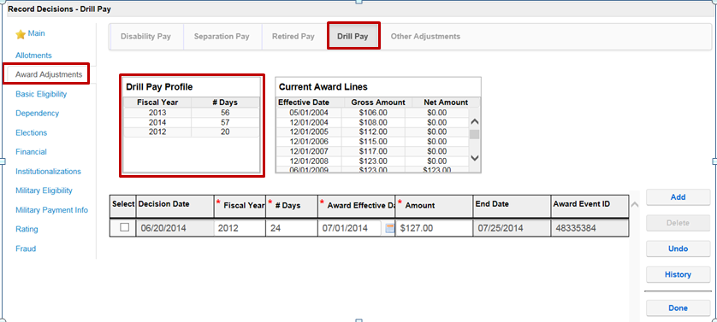

All drill pay adjustments are made using this screen in VBMS-A.

Job Aid 1: Sample VA Form 21-8951-2

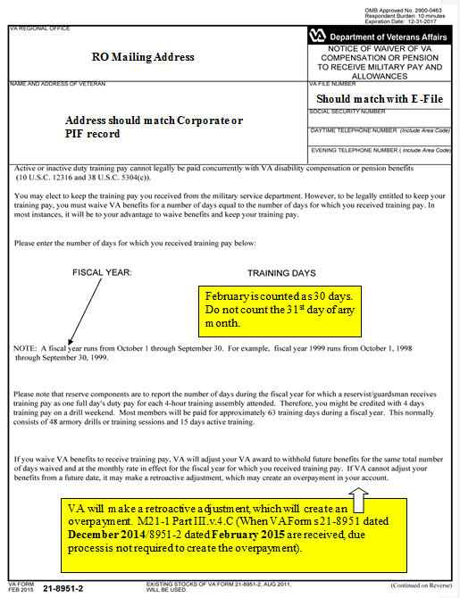

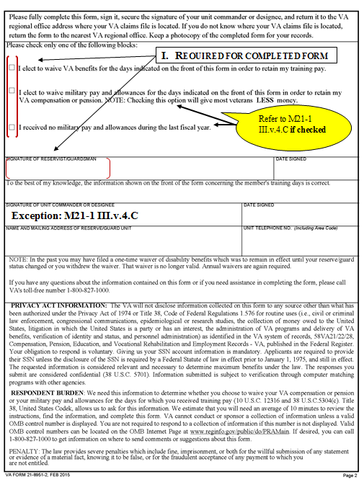

Job Aid 2: VBMS-A Screenshots & Instructions

To process the award to adjust benefits, you must first access the Award Adjustment screen in VBMS-A.



1. Note the **Drill Pay Profile** grid above the **Decision** grid. This grid will be updated when information is received electronically (via Hines) regarding the Veteran’s drill days.

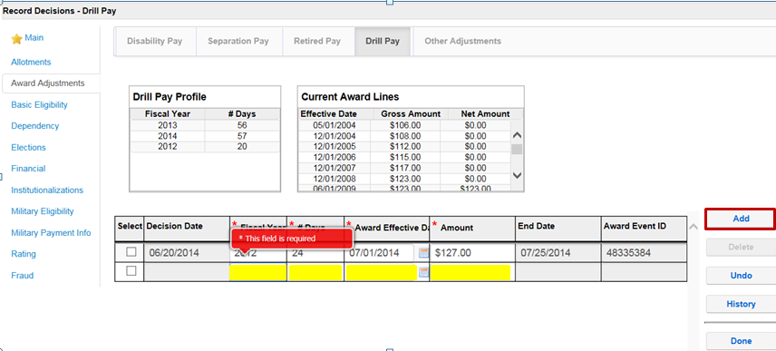

1. Click **Add**;enter the **Fiscal Year** that the drill pay was received; record the number of **Days** of drill pay; enter the **Award Effective Date (**the date that is entered to start the withholding).
2. The **Award End Date** will be system generated from the **Award Effective Date** and number of days that were entered.
3. Calculate the benefit amount to be withheld and enter into the **Amount** field (Rate on September 30, FY = withheld amount).
4. Select **Done** to update the grid.
5. If drill pay for another fiscal year needs to be added, select the **Add** button and record the information for that year. Manually enter the next fiscal year’s **Award Effective Dat**e as the ***same date*** as the prior fiscal year’s **End Date**.
6. Select **Done** to save the decision(s) and close the screen.
7. **Generate** the award.
8. **Notify** the Veteran of our decision using **ADL** if available (making sure to add the evidence), or **PCGL** if ADL is not available (GP 14 letter – making sure to add the evidence). See [M21-1, Part III, Subpart v, 2.B.1 & 4](https://vaww.compensation.pension.km.va.gov/system/templates/selfservice/va_ka/portal.html?encodedHash=%23!agent%2Fportal%2F554400000001034%2Farticle%2F554400000014231%2FM21-1-Part-III-Subpart-v-Chapter-2-Section-B-Decision-Notices), for information on notification.

Review Exercise:

1. Give a definition for Drill Pay and explain why VA compensation benefits must be adjusted based on receipt of Drill Pay.
2. How is a Drill Pay Day (DPD) calculated by the military?
   1. One day equals one DPD during the 2-week annual training
   2. One 4-hour training assembly on a drill weekend equals one DPD
   3. One day always equals one DPD
   4. A & B
3. An adjustment for _______________ requires that the Veteran’s compensation benefits are stopped completely for the set period of duty. An adjustment for _____________ requires a withholding of benefits equal to the amount of compensation paid on the last day of the Fiscal Year (FY).
4. How many days do we withhold for drill pay for FY 2011, if a Veteran, who was on active duty from January 15, 2009 – October 31, 2010 and August 1, 2011 – July 31, 2012, agrees with and signs VA Form 21-8951 for FY 2011 that indicates 120 days of drill pay?
   1. 28
   2. 30
   3. 92
   4. 120
5. Along with establishing an EP 600/693 for processing the drill pay adjustment, what other tasks are completed by the automated system when the notice of adverse action (formerly called due process letter) and VA Form 21-8951 are created and sent to the Veteran?
   1. _____________________________________________________________
   2. _____________________________________________________________
   3. _____________________________________________________________
   4. _____________________________________________________________
6. Which of the following responses from the Veteran during the period of due process for a drill pay adjustment will require the development/completion of a claim manually rather than using the automated system? (Choose all that apply)
   1. Veteran does not respond with VA Form 21-8951
   2. Veteran disagrees with the number of days listed on VA Form 21-8951
   3. Veteran wishes to keep VA compensation and waive drill pay
   4. Veteran agrees with the number of days listed on VA Form 21-8951
   5. Veteran submits an incomplete VA Form 21-8951
7. Explain why completing a drill pay adjustment retroactively and creating an overpayment (as opposed to the previous procedure of withholding from future compensation benefits) is of benefit to the Veteran?
8. We previously withheld for FY 2016 drill pay for 30 days. Based on a rating decision you are working today, VA is retroactively increasing compensation benefits effective September 1, 2015, and the new amount will be more than what was previously paid. What is the next step needed?
   1. Pay the full retroactive amount without adjusting FY drill pay withholdings
   2. Adjust the previous drill pay withholding for FY 2016 based on the new increase
   3. Give due process for the increased amount to be withheld for FY 2016 drill pay
   4. Remove the previous FY 2016 drill pay adjustment entirely
9. A Veteran is currently rated at 50% disabled, and being paid as a Veteran with a spouse and two minor children. If VA grants an increase for the Veteran’s service connected back condition effective July 20, 2016, raising the combined evaluation from 50% to 60% disabled, how much would VA withhold for FY 2016 drill pay?
   1. $1,227.09
   2. $1,230.27
   3. $1,275.09
   4. $1,278.27
10. A Veteran is currently rated at 30% disabled, and being paid as a single Veteran with no dependents. If VA receives a claim and takes action to add a spouse to the Veteran’s award effective September 15, 2016, paying for the spouse beginning October 1, 2016, how much would we withhold for FY 2016 drill pay?
    1. $407.75
    2. $408.97
    3. $455.75
    4. $456.97