CAPRI

Trainee Handout

**Table of Contents**

Objectives 2

References 3

Topic 1: CAPRI Demo 4

Practical Exercise…………………………………………………………………………..…….11

Objectives

* Identify how to successfully login to CAPRI
* Recognize how to select the correct VAMC in CAPRI
* Know how to identify the Veteran in CAPRI
* Understand the process to add a new patient into CAPRI
* Distinguish how to go through each CAPRI tab and describe their purpose
* Understand how to add a new exam request in CAPRI

References

* [M21-1, Part III, Subpart iv, 3.A Examination Request](https://vaww.compensation.pension.km.va.gov/system/templates/selfservice/va_ka/portal.html?encodedHash=%23!agent%2Fportal%2F554400000001034%2Farticle%2F554400000015809%2FM21-1-Part-III-Subpart-iv-Chapter-3-Section-A-Examination-Requests-Overview)
* [M21-1, Part III, Subpart v, 6.G Compensation and Pension Record Interchange (CAPRI)](https://vaww.compensation.pension.km.va.gov/system/templates/selfservice/va_ka/portal.html?encodedHash=%23!agent%2Fportal%2F554400000001034%2Farticle%2F554400000014267%2FM21-1-Part-III-Subpart-v-Chapter-6-Section-G-Compensation-and-Pension-Record-Interchange-CAPRI)
* [CAPRI User Guide](http://vbaw.vba.va.gov/bl/21/DEMO/capri.htm)

**Topic 1: CAPRI Demo**

**This is a basic introduction and overview to the CAPRI program.**

**Overview**

Compensation and Pension Records Interchange (CAPRI)

Acts as a bridge between the VBA and VHA information systems

Allows VBA employees access to Veteran’s VA electronic records and ability to schedule Veterans for C&P Exams

**Successfully Login**

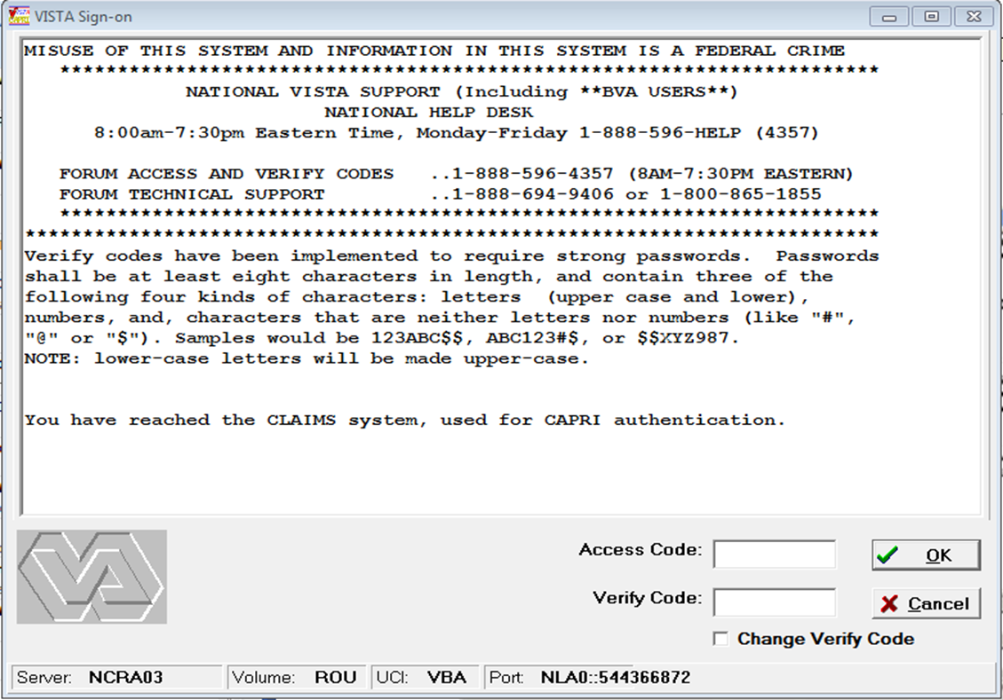

1. Your local RO/ISO will give you the Access Code and Verify Code. Please follow local procedures on gaining access to this program.

Select VAMC

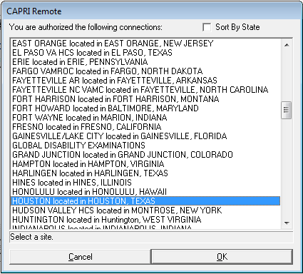

1. Select the VAMC facility. Usually, the Veteran will provide the VAMC(s) they are receiving (or have received) treatment at. Review all documents submitted by the claimant to determine if development to a VAMC is needed.

Identify the Veteran

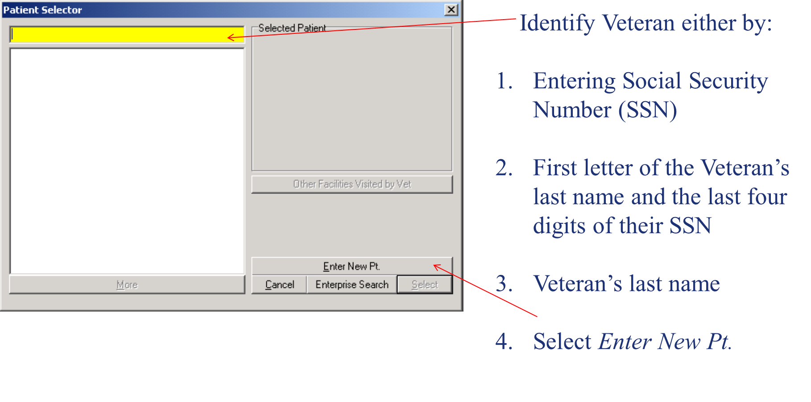

1. A brief profile of the patient’s data will appear on the right hand side of the screen to help aid in selection of the correct Veteran’s records.
2. Once you verify that this is the correct Veteran’s records. Hit “Select”. This will open up the Veteran’s individual patient records
3. If there are “No Records Found”, double check that you have entered the correct social security number. If after a second attempt there are still no records found that means that the veteran has not been seen by that VA Medical Center or records are not available electronically at that facility. If you need to request a VA Exam through that facility, you will have to “Enter a New Patient”.

**New Patient**

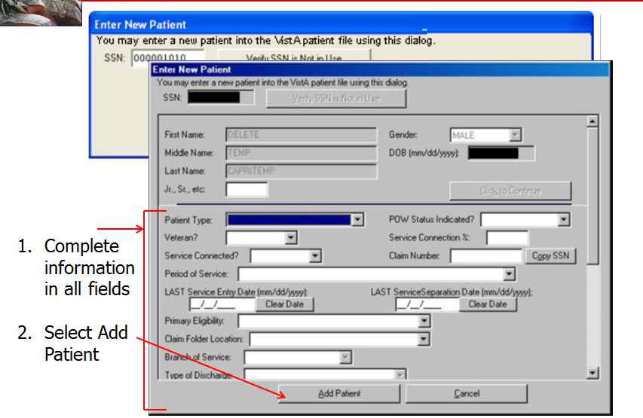

1. This is how the VA is able to request an exam through a VAMC facility even if the Veteran has not been seen at that VA Medical Center before.

**CAPRI Tabs**

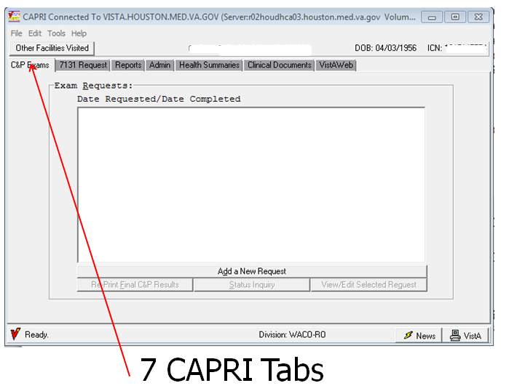

**CP Exams**

Provides the user the ability to add new C&P Exam Requests and edit/view existing requests and print completed examination reports.

**7131 Request**

Allows users to request VA records that may be archived or unavailable electronically

These include:

* older/retired records that do not exist in an electronic format
* hospital summaries
* notices of discharge
* 21-day certificates (confirming hospitalization for a period of at least 21 days)
* coompetency reports
* admission reports
* asset information, and
* VA Form 21-2680, *Examination for Housebound Status or Permanent Need for Regular Aid and Attendance*

**Reports**

Selection of this tab allows the user to make various patient inquiries, review registration and profile data, and request surgery reports for the Veteran.

**Admin**

The user can view information about the patient’s address and appointments, including admissions.

**Health Summaries**

The user can view customized reports comprising of CAPRI components developed by VHA facilities or specified end users

**Clinical Documents**

After selecting this tab another complete set of tabs opens along the bottom of the screen allowing further navigation. This is where the patient’s outpatient treatment records are found.

These tabs are as follows:

* Notes (progress notes)
* Discharge Summaries
* Consults
* Vitals
* Meds
* Labs
* Imaging
* Diet
* Nutritional Assessment
* Order Summary
* Procedures
* Problem List

**DoD Records**

Selection of this tab allows users access to a limited number of the Veteran’s service treatment records if they were saved electronically.

* Federal Health Information Exchange (FHIE)
* Bilateral Health Information Exchange (BHIE)

**VistAWeb -Veterans Health Information Systems and Technology Architecture (VistA)**

In addition to Department of Defense (DoD) and VA medical records available by selecting the other tabs discussed in this block, selection of this tab allows users to view records that are available only as images through the Advanced Web Image Viewer (AWIV).

**Adding New Exam Request**

Brief description of what is to be included in a request for a VA Exam specifically the Exam Request Builder (ERB). This is not an all-inclusive list:

* DOC/Days Pending
* What exams are being requested
* Whether exams are for claims for direct service connection, direct service conection or increase
* Point of Contact name and phone number/email
* Potentially relevant evidence
  + Veteran’s MOS
  + Confirmed Agent Orange Exposure
  + Conceded service in a combat location

**VAMC Actions**

The role of the VAMC upon receipt of an exam request from the RO is the following:

* Schedule the exams that the RO has requested
* Generate a DBQ while examining the Veteran
* Transmit the exam findings back to the RO through CAPRI or directly into VBMS

Practical Exercise

Read each scenario and determine the next step in the development proess, specifically, if an exam is warranted and, if so, which DBQ would be ordered.

1. A Veteran files a claim for bilateral hearing loss on a VA Form 21-526EZ that is received on July 20, 2015. A review of the Veteran’s file shows that he is currently service connected for bilateral hearing loss at 0%. The Veteran also indicated that he has been receiving treatment at the Hines and Jesse Brown VA Medical Center since August 1, 2009.

A review of the file also shows that the Veteran served in the Air Force from June 1, 1960 to June 1, 1968. Complete STRs and service documents are in file. The Veteran currently resides in Oak Park, Illinois 60301.

What type of claim is this/is an exam needed?

What additional steps should you as the VSR take?

1. Veteran files an original claim for a low back condition, and a left knee condition. The claim is received on a VA Form 21-526EZ, Veteran’s Application for Compensation and/or Pension, on April 22, 2015. The Veteran submits a copy of his DD Form 214, showing Army service for the period dated April 1, 2000 to April 2, 2009. A review of SHARE indicates that the period of service is VADS verified. The Veteran submitted 3 pages of copies of his STRs, including a document showing a complaint of the claimed conditions in August 2007.

The Veteran indicates he has not received treatment at a VA Medical Facility; but he has seen private providers, and submits a VA Form 21-4142/a, *Authorization to Disclose Information to the Department of Veterans Affairs (VA),* for Mayo Health System for dated of treatment dated August 1, 2009 to December 1, 2014.

What are our next steps? Is an exam warranted?

1. Veteran files an original claim for benefits on VA Form 21-526EZ, Veteran’s Application for Compensation and/or Pension that is received on June 1, 2015. A review of the Veteran’s VBMS file shows that the complete STRs were previously sent by the Records Management Center and scanned into VBMS. The Veteran has submitted a copy of a certified DD Form 214 showing service in the Marines for the period dated February 1, 2010 to February 2, 2015.

The Veteran’s application shows that he has received treatment at the Houston VAMC since February 3, 2015 to the present.

The Veteran is filing service connection for:

* Left foot condition
* Back condition
* Bilateral hearing loss
* Tinnitus
* Acquired psychiatric condition, claimed as depression

The Veteran’s STRs show ongoing complaints of a left foot fracture, ongoing back pain, audio exams conducted upon enlistment/discharge and additional audio exams conducted periodically; and mental health treatment prior to discharge.

What are our next steps? Is an exam warranted?

1. Veteran files a claim for service connection for a right knee condition and a left shoulder condition. A review of the Veteran’s file shows that he is service connected for a back condition at 10%. He was previously denied service connection for a left shoulder condition, the denial reason was due to no evidence of the claimed condition occurred in service; or manifesting to a compensable degree within one year of discharge. The Veteran was denied for service connection for left shoulder on May 1, 2005.

The Veteran served in the Navy from September 1, 1999 to October 1, 2004. Complete STRs are in file, and service has been verified. The Veteran states that he receives all his treatment at the North Chicago VA Medical Center and has since June 1, 2008. No additional STRs are received, and no medical evidence prior to June 1, 2008 has been identified/provided. The Veteran submitted his claim on a VA Form 21-526EZ, and the claim was received on July 17, 2015.

A review of the Veteran’s STRs shows that he received treatment for a right knee pain in April 2003 and continuously until his discharge examination. In-service diagnosis was right knee patellofemoral syndrome. His current VAMC treatment records show treatment for the service-connected back condition and right knee pain.

What type of claim is this? What are our next steps?