Records Management for RVSRs

Trainee Handout

**Table of Contents**

Objectives 2

References 2

Attachment A: Service Records Locations Quick Reference Charts 3

Attachment B: Sample NA Form 13055 4

Attachment C: Sample SSA Disability Request Form 5

Practical Exercise 6

# Objectives

In order to accomplish the purpose of this lesson, the RVSR will be required to accomplish the following lesson objectives:

Given the trainee handout and all available references, trainees will, upon completion of the lesson, be able, with 98% accuracy, to identify and differentiate types of federal and non-federal records, methods for retrieving them, and follow-up procedures.

# References

All M21-1 references are found in the [Live Manual Website](https://vaww.compensation.pension.km.va.gov/).

* [38 CFR 3.159(c), VA's duty to assist claimants in obtaining evidence](http://www.ecfr.gov/cgi-bin/text-idx?SID=ad275643432556b9dda942343fb89296&mc=true&node=pt38.1.3&rgn=div58#se38.1.3_1159)
* [M21-1, Part I, Chapter 1, Section C - Requesting Records](https://vaww.compensation.pension.km.va.gov/system/templates/selfservice/va_ka/portal.html?encodedHash=%23!agent%2Fportal%2F554400000001034%2Farticle%2F554400000014066%2FM21-1-Part-I-Chapter-1-Section-C-Requesting-Records)
* [M21-1, Part III, Subpart iii, Chapter 1, Rules and Process](https://vaww.compensation.pension.km.va.gov/system/templates/selfservice/va_ka/portal.html?encodedHash=%23!agent%2Fportal%2F554400000001034%2Ftopic%2F554400000003085%2FChapter-01-Rules-and-Process)
* [M21-1, Part III, Subpart iii, Chapter 2, Developing for Service Records](https://vaww.compensation.pension.km.va.gov/system/templates/selfservice/va_ka/portal.html?encodedHash=%23!agent%2Fportal%2F554400000001034%2Ftopic%2F554400000003086%2FChapter-02-Developing-for-Service-Records)
* [M21-1, Part III, Subpart iii, Chapter 3, Information Requests to and from the Social Security Administration (SSA)](https://vaww.compensation.pension.km.va.gov/system/templates/selfservice/va_ka/portal.html?encodedHash=%23!agent%2Fportal%2F554400000001034%2Ftopic%2F554400000003087%2FChapter-03-Information-Requests-to-and-from-the-Social-Security-Administration-SSA)
* [M21-1, Part III, Subpart iii, Chapter 4, Information Requests to or From Other Federal and State Agencies](https://vaww.compensation.pension.km.va.gov/system/templates/selfservice/va_ka/portal.html?encodedHash=%23!agent%2Fportal%2F554400000001034%2Farticle%2F554400000015794%2FM21-1-Part-III-Subpart-iii-Chapter-4-Information-Requests-to-or-From-Other-Federal-and-State-Agencies)
* [M21-1, Part III, Subpart iv, Chapter 6, Section C, Evidence](https://vaww.compensation.pension.km.va.gov/system/templates/selfservice/va_ka/portal.html?encodedHash=%23!agent%2Fportal%2F554400000001034%2Farticle%2F554400000014206%2FM21-1-Part-III-Subpart-iv-Chapter-6-Section-C-Completing-the-Rating-Decision-Narrative)

# Attachment A: Service Records Locations Quick Reference Charts

**personnel records location based on date of separation (RAD)**

|  |  |  |  |
| --- | --- | --- | --- |
| **BRANCH** | **At NPRC (PIES)** | **RMC** | **Thru DPRIS Web** |
| **ARMY** | RAD before 10/01/1994 | N/A | RAD on or after 10/01/1994 |
| **NAVY** | RAD before 01/01/1995 | N/A | RAD on or after 01/01/1995 |
| **AIR FORCE** | RAD before 10/01/2004 | N/A | RAD on or after 10/01/2004 |
| **MARINE CORP** | RAD before 01/01/1999 | N/A | RAD on or after 01/01/1999 |
| **COAST GUARD** | All records | N/A | No records at this time |

**strs locations based on date of seperation (RAD)**

|  |  |  |  |
| --- | --- | --- | --- |
| **BRANCH** | **At NPRC (PIES)** | **RMC** | **Thru DPRIS Web** |
| **ARMY** | RAD before 10/16/1992 | RAD on or after 10/16/1992 | N/A |
| **NAVY** | RAD before 01/31/1994 | RAD on or after 01/31/1994 | N/A |
| **AIR FORCE** | RAD before 05/01/1994 | RAD on or after 05/01/1994 | N/A |
| **MARINE CORP** | RAD before 05/01/1994 | RAD on or after 05/01/1994 | N/A |
| **COAST GUARD** | RAD before 05/01/1998 | RAD on or after 05/01/1998 | N/A |

For Merchant Marines, see M21-1MR III.iii.2.F.

For individuals with National Guard service, see M21-1MR III.iii.2.K.79.a for a list of State Adjutants Generals.

For active Reservists, send the request to the unit.

A resource for Reservists and National Guard records is the [**Reserve/National Guard Quick Reference Guide**](http://vbaw.vba.va.gov/bl/21/publicat/docs/RNG.doc) located on the C&P Intranet User Guides Page.

# Attachment B: Sample NA Form 13055

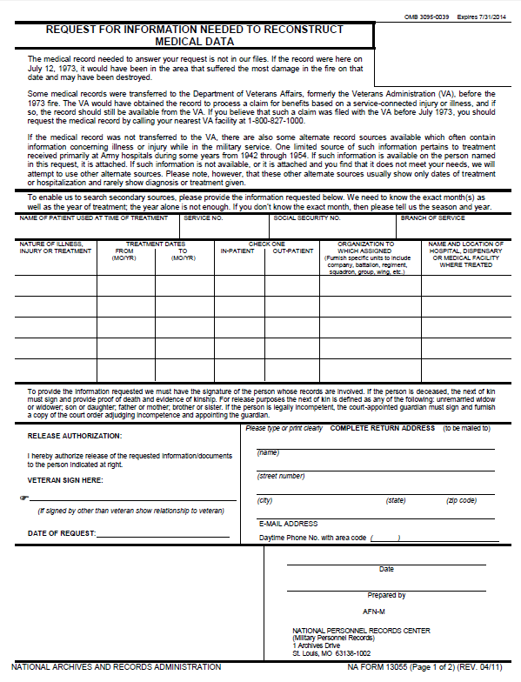

# Attachment C: Sample SSA Disability Request Form

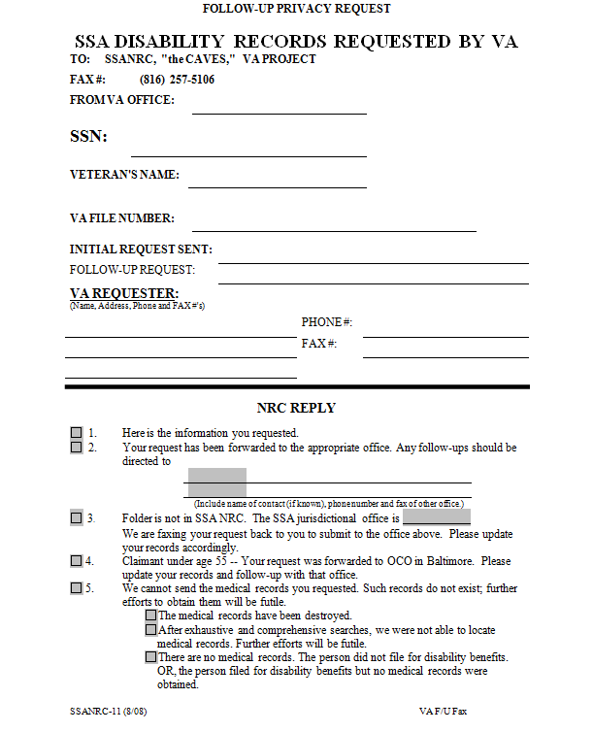

# Practical Exercise

1. When reviewing a file, what questions should you ask yourself ask about STRs:
2. Who is ultimately responsibility for furnishing evidence needed to perfect the claim?
3. Why can we not send a VA Form 21-4142 printed prior to September 2003 when requesting non-Federal records?
4. What do you check for when discovering that Federal records are unavailable?
5. What information should be provided in the final-attempt letter?
6. What information should be provided in the subsequent rating decision?