COMPENSATION OFFSETS:

Recoupment of Separation Benefits

Trainee Handout

**Table of Contents**

Objectives 2

References 3

Topic 1: Separation Benefits 4

Topic 2: Steps to Verify And Withhold Separation Benefits 6

Topic 3: Disability Severance Pay (DSP) 8

Topic 4: Calculating Withholding for Disability Severance Pay (DSP) 11

Topic 5: Entering/Reviewing Separation Benefits Balances in VBMS-A 12

Topic 6: Example of a PCGL Notification Letter 17

Attachment A: Separation Benefits 22

Practical Exercise 23

Objectives

* Understand the different types of common Separation Benefits
* Identify if withholding for recoupment of Separation Benefits is needed
* Learn how to confirm/verify receipt of Separation Benefits
* Promulgate an award that includes recoupment of Separation Benefits
* Create a letter to notify the veteran using PCGL (Personal Computer Generated Letter) and/or ADL (Automated Decision Letter)

References

* [38 U.S.C. 5304, Prohibition against duplication of benefits](https://www.law.cornell.edu/uscode/text/38/5304)
* [10 U.S.C. 1174, Separation pay upon involuntary discharge or release for active duty](https://www.law.cornell.edu/uscode/text/10/1174)
* [10 U.S.C. 1174a, Special Separation Benefit (SSB)](https://www.law.cornell.edu/uscode/text/10/1174a)
* [10 U.S.C. 1175, Voluntary Separation Incentive (VSI)](https://www.law.cornell.edu/uscode/text/10/1175)
* [10 U.S.C. 1212, Disability severance pay](https://www.law.cornell.edu/uscode/text/10/1212)
* [38 CFR 3.700, Concurrent benefits and Elections (General)](http://www.ecfr.gov/cgi-bin/text-idx?SID=ad275643432556b9dda942343fb89296&mc=true&node=pt38.1.3&rgn=div58#se38.1.3_1700)
* [M21-1, Part III, Subpart iii.2.D, Requesting Information and Records Through the Personnel Information Exchange System (PIES)](https://vaww.compensation.pension.km.va.gov/system/templates/selfservice/va_ka/portal.html?encodedHash=%23!agent%2Fportal%2F554400000001034%2Ftopic%2F554400000003075%2FSubpart-ii-Initial-Screening-and-Determining-Veteran-Status)
* [M21-1, Part III, Subpart iii, 2.K, Other Contact and Reference Information](https://vaww.compensation.pension.km.va.gov/system/templates/selfservice/va_ka/portal.html?encodedHash=%23!agent%2Fportal%2F554400000001034%2Farticle%2F554400000014165%2FM21-1-Part-III-Subpart-iii-Chapter-2-Section-K-Other-Contact-and-Reference-Information)
* [M21-1, Part III, Subpart v, 4.B, Recoupment of Readjustment, Separation and Severance Pay](https://vaww.vashare.vba.va.gov/sites/SPTNCIO/focusedveterans/training/VSRvirtualtraining/Curriculum%20Library/(VSR%20Challenge)%20CompOffsets%20Recoupment%20of%20Separation%20Benefits%20-%204183766/M21-1-Part-III-Subpart-v-Chapter-4-Section-B-Recoupment-of-Separation-Benefits)
* [Compensation Service Intranet Homepage/Publications/Rate Tables](http://vbaw.vba.va.gov/bl/21/publicat/Manuals/Rates/rates_home.htm)
* [Compensation Service Intranet Homepage/Training Home Page/Quick References/Miscellaneous References/Disability Rating Calculator](http://cptraining.vba.va.gov/C&P_Training/Job_Aids/Quick_Ref.htm#MCR)
* [Compensation Service Intranet Homepage/Training Home Page/Quick References/Dependency & Promulgation References/Severance, Separation, SSB Calculator](http://cptraining.vba.va.gov/C&P_Training/Job_Aids/Quick_Ref.htm)

Topic 1: Separation Benefits

38 CFR 3.700 prohibits the Department of Veterans Affairs (VA) from paying compensation to a Veteran who also received certain separation benefits from the Department of Defense (DoD). These benefits include:

* Readjustment pay under former 10 U.S.C 687 and 3814a
* Non-disability severance pay under 10 USC.1174(h)(2)
* Separation pay under 10 U.S.C 1174
* Reservists’ Involuntary Separation Pay (RISP)
* Special Separation Benefit (SSB) under 10 U.S.C 1174a
* Voluntary Separation Pay (VSP) under 10.U.S.C.1175a, and
* Disability severance pay under 10 U.S.C 1212 (c)

Readjustment pay under former 10 U.S.C 3814a – was paid to regular officers below the rank of major who were discharge during a reduction in force. The authority for making these payments expired at the end of 1977.

Readjustment pay under former 10 U.S.C. 687 was paid to reserve officers who were involuntarily released after completing at least five years of active service but did not qualify for retirement. The authority for making these payments was repealed effective September 15, 1981.

Non-disability severance pay under 10 USC.1174(h)(2) - DoD awarded non-disability severance pay to certain individuals, under former 10 U.S.C 359, 360, 859, and 860, who involuntarily separated from service, usually due to their failure to meet standards of performance. This benefit is subject to recoupment *unless* the Veteran established entitlement to VA compensation *before* September 15, 1981.

Separation pay under 10 U.S.C 1174 – replaced readjustment pay effective September 15, 1981. Is paid to regular and reserve officers who involuntarily separate from service after completing at least five years of active duty but do not qualify for retirement. Is also paid to regular enlisted members under PL 101-510, Section 501, (enacted November 5, 1990) who involuntarily separate from service after completing six years of active duty and do not qualify for retirement.

Reservists’ Involuntary Separation Pay (RISP) - *PL 102-484, Section 4418*, provided for the payment of RISP to certain reservists who are involuntarily released from the Selected Reserve. The VA is required to withhold for RISP, provided the compensation is for a disability incurred in or aggravated by service prior to the date of receipt of RISP

Reservists Special Separation Pay (RSSP) - *PL 102-484, Section 4416*, provided for the payment of RSSP to reservists with at least 20 years of service who are not yet old enough to retire. Payments are made annually for up to five years or until the reservist turns sixty. The VA is not required to withhold RSSP.

Special Separation Benefit (SSB) under 10 U.S.C 1174a and Voluntary Separation Incentive (VSI) under 10 U.S.C, 1175 - *PL 102-190, Sections 661 and 662*, enacted December 5, 1991, added SSB under [10 U.S.C. 1174a](http://law.cornell.edu/uscode/html/uscode10/usc_sec_10_00001174---a000-.html) and VSI under [10 U.S.C. 1175](http://law.cornell.edu/uscode/html/uscode10/usc_sec_10_00001175----000-.html) as separation benefits to facilitate the downsizing of the armed forces. Service departments use these two exit-bonus incentive programs to encourage service members, who might otherwise face involuntary separation or denial of reenlistment, to separate voluntarily.

To qualify for SSB or VSI, a service member must have:

* separated on or before September 30, 1995
* served
* on active duty for more than six years but fewer than 20 years as of December 5, 1991, and
* at least five years of continuous active duty immediately prior to separation, and
* agreed to serve in the Ready Reserve

One of the primary differences between VSI and SSB is the manner in which DoD pays each benefit.  **The most important difference, however, is that VA is *not* responsible for recouping VSI from a Veteran’s disability compensation.**

Voluntary Separation Pay (VSP) under 10.U.S.C.1175a, - provides for the payment of VSP to service members voluntarily separated from active duty due to restructuring or a reduction in force.

VA must recoup VSP from a Veteran’s disability compensation ***unless*** he/she

* was eligible to retire (20 or more years of active service), to include transfer to the Fleet Reserve or Fleet Marine Corps Reserve, at the time DoD awarded VSP
* is eligible to receive combat-related special compensation, or
* receives a waiver from the Secretary of his/her service department.

Disability severance pay under 10 U.S.C 1212 (c) - This is paid to members with less than 20 years of service and disabilities rated less than 30 percent. The minimum severance pay is now 12 months of basic pay for troops separated for a disability incurred in a combat zone and six months of basic pay for all other members. The maximum severance pay has been increased from 24 months of basic pay to 38 months.

**Separation Benefits and Determining Veteran’s Separation Pay**

Separation Benefits generally are a lump-sum payment for voluntary or involuntary separation to facilitate downsizing of the armed forces. The VA may withhold all, part or nothing from Compensation benefits depending on the type of separation benefit. The amount the VA withholds, total (gross) or after tax (net) amount depends on when the Veteran was discharged and what kind of benefit they received.

**Common Separation Benefits**

Although there are many different types of separation benefits, the most common types include:

* “regular” separation pay
* SSB
* Disability Severance Pay

Topic 2: Steps to Verify And Withhold Separation Benefits

A review of one or more of the following will typically reveal whether or not a Veteran received separation benefits:

* application for VA compensation or pension
* *DD Form 214, Certificate of Release or Discharge From Active Duty*
* the MISCELLANEOUS INFO tab on the VETERANS IDENTIFICATION screen in the Beneficiary Identification and Records Locator Subsystem (BIRLS)
* the DISCHARGE PAY tab on the MILITARY PAYMENT INFORMATION screen in
* Veterans Service Network (VETSNET) Awards, and
* Veterans Benefits Management System (VBMS) - Awards (VBMS-A), or
* the MILITARY PAYMENTS tab on the Corporate MILITARY INFORMATION screen in Share.

***Important***: The presence of an amount in the SEPARATION PAY field is ***only*** an indicator the Veteran received *some type* of separation benefit.  It is ***not*** a reliable indicator of whether this benefit is the same “separation pay” described in [10 U.S.C. 1174](http://law.cornell.edu/uscode/html/uscode10/usc_sec_10_00001174----000-.html).[*M21-1*](http://www.benefits.va.gov/WARMS/M21_1MR3.asp)[*III.v.4.B*](http://www.benefits.va.gov/WARMS/M21_1MR3.asp) directs ROs to verify the severance or separation amount received by the Veteran. The VSR should ensure the separation benefit has been verified by

* VIS,
* PIES, or
* Compensation Service’s Military Pay Staff.

The information for contacting the Compensation Service’s Military Pay Staff can be found within the M21-1.

To access VIS, refer to the VBA Intranet [C&P Website](http://vbaw.vba.va.gov/bl/21/index.htm) and go to the [Business Management (215) section](http://vbaw.vba.va.gov/bl/21/systems/ap_home.htm).

* Click the [Veterans Information Solution (VIS)](http://vbaw.vba.va.gov/bl/21/Systems/VIS.htm) link and log in.
* Go to the Veteran’s electronic file and click the DFAS Payments tab, which will provide you with the Disability Severance Pay amount.

**Determine Whether to Recoup and How Much to Recoup**

The following factors determine whether and how much of a Veteran’s separation benefits VA must recoup from his/her disability compensation:

* type of separation benefit
* date of entitlement of VA compensation, and
* date of receipt of the separation benefit.
  + Not needed for SSB – **we always withhold the after-tax amount**

*(Review Attachment A for the types of separation benefits and the amounts to withhold)*

Once VA determines recoupment of separation benefits is necessary and the amount that is subject to recoupment, it must withhold some or all of the Veteran’s monthly compensation until recoupment is complete. The amount VA withholds each month includes any of the following to which the Veteran is entitled:

* additional compensation for dependents, and
* special monthly compensation.

***Important***:  VA may ***not***

* recoup separation benefits from a Veteran’s compensation if the disability on which the compensation is based was incurred or aggravated during a period of service that ***follows*** the period of service for which the Veteran received separation benefits
* apportion any disability compensation it is withholding for the recoupment of separation benefits, or
* withhold Medal of Honor pension to recoup separation benefits.

Although the records may show the amount of separation benefits a Veteran received, these amounts are not always accurate,  therefore, Regional Offices (ROs) ***must*** confirm them

* through the Veterans Information Solution (VIS)
* by submitting a request through the Personnel Information Exchange System (PIES), or
* request assistance from Compensation Service’s Military Pay Staff

**Calculating the After-Tax Separation Benefit**

The table below can be used to determine which flat-tax rate was in effect on the date the Veteran received their benefit

* Multiply the gross amount of the separation benefit bu the appropriate flat-tax rate, and
* Subtract the product from the gross amount of the separation benefit

|  |  |
| --- | --- |
| Effective Date | Flat-Tax Rate |
| December 31, 1993, and earlier | 20 percent |
| January 1, 1994 | 28 percent |
| August 7, 2001 | 27.5 percent |
| January 1, 2002 | 27 percent |
| May 28, 2003 | 25 percent |

Note: there is no need to made these calculations when VIS is used to verify the amount of Federal income tax withhold from a Veteran’s separation benefit

Topic 3: Disability Severance Pay (DSP)

Service Members who are separated from military service for medical reasons may be eligible for either military disability retirement benefits or a one-time severance payment. DSP is paid to members with:

* Less than 20 years of service
* Disabilities rated less than 30 percent
* One-time lump sum payment

**Identifying DSP**

Before recouping disability severance pay, it is necessary to identify the disability(ies) for which the Veteran received this benefit. The best source for this information is the Veteran’s Physical Evaluation Board (PEB) report, which is normally included in his/her STRs.

If the PEB report is not included in the Veteran’s STRs, it might be located in his/her service personnel records.  Use the table below to determine how to submit a request for the PEB report.

|  |  |
| --- | --- |
| **If the Veteran separated from the...** | **Then submit a request through...** |
| * Coast Guard * Army prior to October 1, 1994 * Navy prior to January 1, 1995 * Air Force prior to October 1, 2004, or * Marine Corp prior to January 1, 1999 | PIES, using request code O50.  ***Exception***: For claims not being processed in VBMS, request the records from PIES using the request code O11. |
| * Army on or after October 1, 1994 * Navy on or after January 1, 1995 * Air Force on or after October 1, 2004, or * Marine Corp on or after January 1, 1999 | the Defense Personnel Records Image Retrieval System (DPRIS), using request code AG5 |

**General Policies Regarding Withholding to Recoup DSP**

Generally, if a Veteran received disability severance pay, VA must withhold from his/her monthly compensation an amount equal to the monthly compensation payable for the disability(ies) for which the Veteran received disability severance pay. VA continues to withhold this amount until it has recouped the amount specified.

The rate of recoupment of severance pay shall not be in excess of the initial rating decision grant of compensation payable for the same severance disabilities. This rate excludes periods of hospitalization and convalescence. The initial rate of compensation payable is defined as the first compensable rating decision for that condition.

If all of the Veteran’s disabilities are severance pay conditions, then a total withholding is appropriate.

If only some of the disabilities are severance pay disabilities, the VSR must follow certain rules to ensure the correct withholding.

* The VSR will withhold the amount of monthly compensation payable for the severance disabilities and pay the balance to the Veteran.
* However, the balance paid to the Veteran must be *no less than the amount* the Veteran would be entitled to for the non-severance pay disabilities.

**No withholding for DSP if:**

Do not withhold if the severance condition does not affect the combined percentage. For example, if the severance condition is rated at 0% or the combined evaluation of the ***non-severance conditions***, is equal to the total combined evaluation of both the non-severance ***and*** severance conditions

*Example: Vet is service connected for the following:*

*Non-severance conditions: Diabetes Mellitus Type II – 20%*

*Right knee condition – 10%*

*Right shoulder condition – 10% 40%*

*Hypertension – 0% 40%*

*Severance condition: Left knee condition – 10%*

Do not withhold amounts if the Veteran separated from service on or after January 28, 2008 and incurred the disability for which he/she received disability severance pay in the line of duty in a combat zone or during combat-related operations. This information can be found:

* Block 28 on *DD 214*
* PED report

Do not withhold VA compensation for severance pay if the Veteran’s only entitlement is a ten percent evaluation based on multiple zero percent disabilities.

Do not withhold amounts paid for Special Monthly Compensation (SMC) to severance withholdings.

Prestabilization ratings (Paragraph 28) – Input a total evaluation to withhold for severance pay. When the rating board designates a percentage for the disability, the severance pay withholding will then be based on that percentage.

**Important Information:** Disability severance pay will be recouped at a rate not to exceed the rate payable for the severance pay disabilities, based on the initial compensable rating. Therefore, VSRs must know the amount of disability severance pay received, the exact disabilities for which it was received, and the effective date assigned on the initial rating decision award document.

Topic 4: Calculating Withholding for Disability Severance Pay (DSP)

When calculating the monthly amount of VA Compensation to withhold from the Veteran with both severance and non-severance pay disability, always use the withholding that pays the Veteran the higher rate of compensation.

**Other tools:**

Combinator – Calculates separate combined percentages for severance and non-severance conditions This is located: Compensation Service Intranet Homepage/Training Home Page/Quick References/Miscellaneous References/Disability Rating Calculator

Recoupment Calculator – Calculates the after-tax amount – this is located: [Compensation Service Intranet Homepage/Training Home Page/Quick References/Dependency & Promulgation References/Severance, Separation, SSB Calculator](http://cptraining.vba.va.gov/C&P_Training/Job_Aids/Quick_Ref.htm)

The following shows the mathematical equation for withholding (called Methods 1&2), however VBMS-A and Vetsnet Awards will do this automatically.

#### METHOD 1 METHOD 2

Combined % Combined %

**-** Severance % (withhold**) - Non Severance % (pay)**

**= Pay difference** = Withhold difference

Note: The greater amount determines the method used for the amount paid and the amount withheld.

## Here’s an example:

Combined % is 70%

Severance % is 30%

Non-Severance % is 50% Effective date is 07-5-13

**Method 1** **Method 2**

$1293 (combined 70%) $1293 (combined 70%)

-$395 (w/h severance 30%) -$**810** (Pay non severance 50%)

$**898** (Pay difference) $ 423 (w/h difference)

Based on this example we would use Method 1, because the difference is greater than paying the non-severance 50% amount.

Topic 5: Entering/Reviewing Separation Benefits Balances in VBMS-A

Please note: The first part of award processing was previously covered during “Intro to Ratings” lesson.

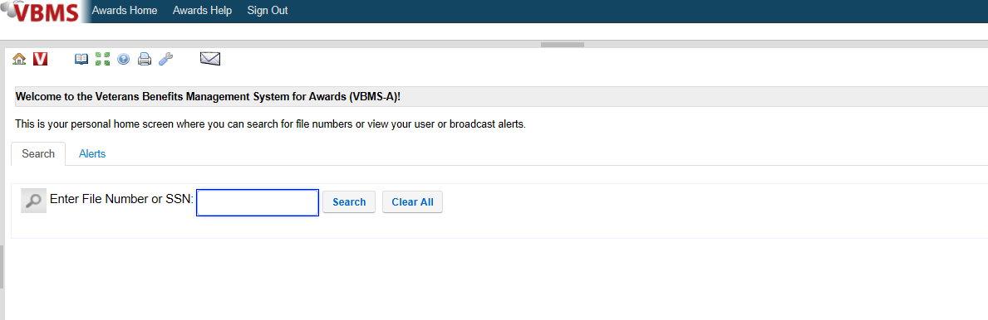

Through VBMS-A, search the Veteran by entering the file number or Social Security Number, then select search

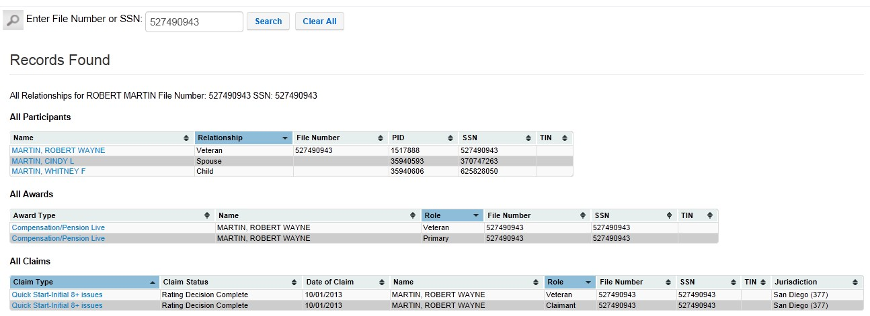

#### Important:

If working a rating issue, the claim status should be “Rating Decision Complete.”

In the grid under the **All Claims** section, select Claimant by double clicking with the mouse or using the tab key followed by the enter key.

After you select your claim, you will come to the next screen.

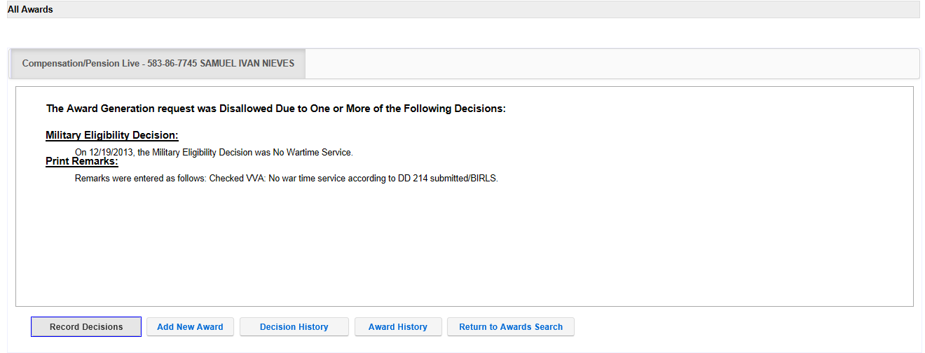

Select Record Decisions. By selecting Record Decisions you will come to the screen below. Here is where you want to enter the separation or severance pay amounts. First select Military Payment Information. Once you are finished entering your information there, you will then select Award Adjustment.

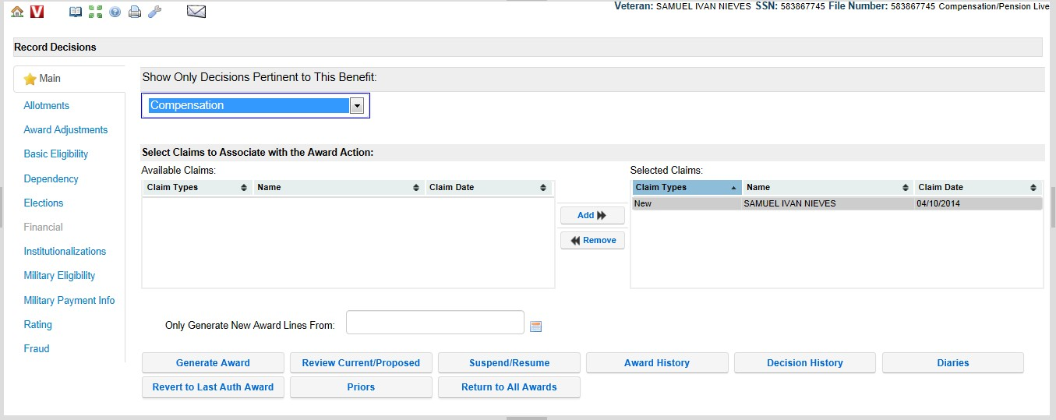

After you have selected the Military Payment Information screen, you will select Discharge Pay.

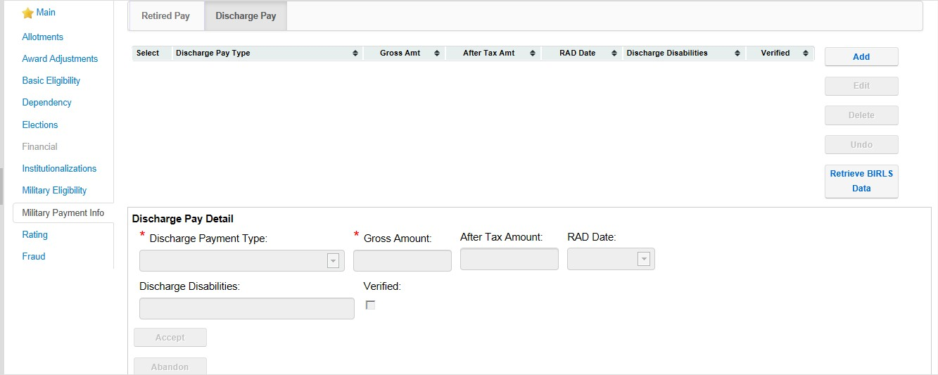

On the Discharge Pay tab

1. Select **Add**.
2. Select the **Discharge Pay Type** “Separation”.
3. Record the **Gross Amount Received** and the **After Tax Amount Received**.
4. Select the **RAD Date** to identify the period of service for which the Separation Pay was received.
5. Select **Accept** to update the screen.

6. Select **Done** to save the decision and close the screen.

On the Award adjustments screen, select the Separation Pay or Disability Pay (if Severance) tab.

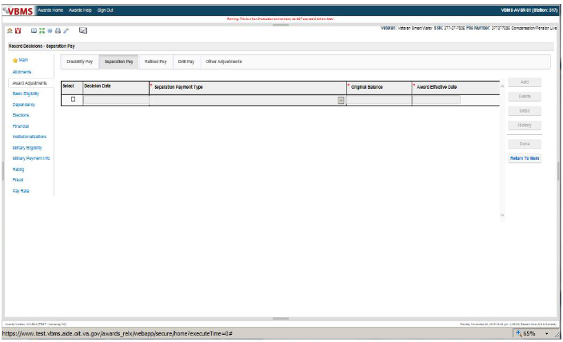

If Separation Pay:

1. Select **Add**.
2. Select the **Separation Pay Type** of “Separation.”
3. Note the balance to be recouped has been populated into the **Original Balance** field based on the prior entries on the Military Payment Information screen.
4. Enter the **Award Effective Date** to identify when the withholding is to begin.
5. Select **Accept** to update the screen.
6. Select **Done** to save the decision and close the screen.

## If Disability Severance Pay:

## 1. Click the Add button to create a blank entry row.

2. In the **Payment Type** field, click the drop-down list and select the type of payment.

3. In the **Original Balance** field, enter the amount of the original award balance.

4. In the **Award Effective Date** field, enter the date the adjustment affects the award in the **MM/DD/YYYY** format.

5. When finished, click the **Done** button.

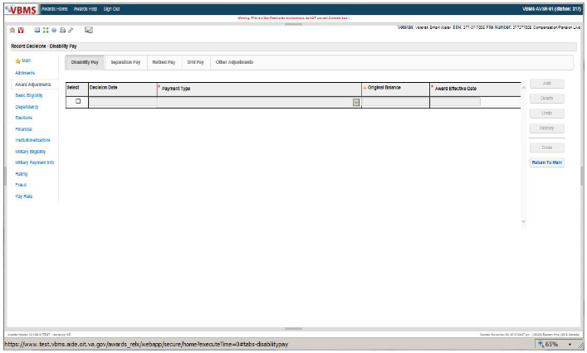

After you have entered all of your information, it is now time to generate the award. Simply select the Generate Award tab.

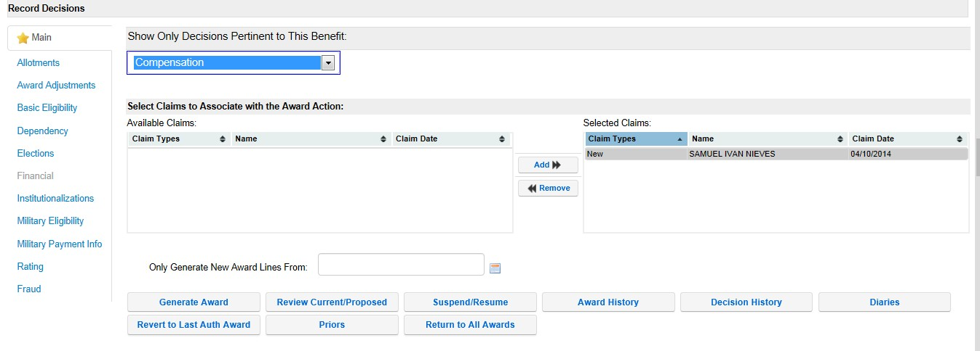

If VBMS-A cannot be used, use VETSNET Awards. The same procedures apply.

Refer to the [VETSNET Awards Handbook](http://vbaw.vba.va.gov/VetsNet/Awards_Docs/Awards%20User%20Guide.pdf) for more information.

Topic 6: Example of a PCGL Notification Letter

**DEPARTMENT OF VETERANS AFFAIRS**

JOE VETERAN In reply refer to: 384/PNP/Challenge

1234 MAIN ST CSS XXX XX XXXX

ANYTOWN, USA 10001 Veteran, Joe

Dear Mr. Veteran:

We made a decision on your claim for service connected compensation received on May 8, 2013.

This letter tells you about your entitlement amount and payment start date and what we decided. It includes a copy of our rating decision that gives the evidence used and reasons for our decision. We have also included information about additional benefits, what to do if you disagree with our decision, and who to contact if you have questions or need assistance.

#### Your Award Amount and Payment Start Date

Your monthly entitlement amount is shown below:

|  |  |  |  |  |
| --- | --- | --- | --- | --- |
| **Total VA Benefit** | **Amount Withheld** | **Amount Paid** | **Effective Date** | **Reason For Change** |
| $133.57 | $133.57 | $0.00 | Jun 1, 2017 | Original Award |
| $136.24 | $136.24 | $0.00 | Dec 1, 2017 | Cost of Living Adjustment, Severance Pay Adjustment |
| $136.24 | $44.14 | $92.10 | Oct 1, 2025 | Severance Pay Adjustment |
| $136.24 | $0.00 | $136.24 | Nov 1, 2025 | Severance Pay Adjustment |

**When You Can Expect Payment**

**Normally, your payment would begin the first day of the month following your effective date; however, no payments will be released to you until the Separation/Disability Severance Pay amount has been recouped. You must provide VA with a current address at all times. Failure to report for a scheduled examination or furnish required evidence may result in a discontinuation of your compensation and future monetary benefits provided by VA could be delayed or not delivered. (Per M21-1 III.v.4.B.5.c)**

#### We Have Withheld Benefits

You received a severance and/or separation pay allowance of $15,287.00 [total/gross amount] from the military for your *Lumbosacral Strain* condition. We must hold back all of your VA compensation until this severance amount is paid back. *VA shall withhold (after federal income tax) the severance amount received.* After an amount equal to your severance pay allowance is paid back, you'll start receiving your full VA compensation.

#### What We Decided

We determined that the following conditions were related to your military service, so service connection has been granted:

|  |  |  |
| --- | --- | --- |
| **Medical Description** | **Percent (%) Assigned** | **Effective Date** |
| Lumbosacral Strain | 10% | May 1, 2017 |
| Atrioventricular block (2nd degree) | 0% | May 1, 2017 |
| Hypertension | 0% | May 1, 2017 |

We determined that the following conditions were not related to your military service, so service connection couldn't be granted:

|  |
| --- |
| **Medical Description** |
| Lower back pain |
| Chronic left knee pain |
| Toenail fungus |

Your overall or combined rating is 10%. We do not add the individual percentages of each condition to determine your combined rating. We use a combined rating table that considers the effect from the most serious to the least serious conditions.

We have enclosed a copy of your Rating Decision for your review. It provides a detailed explanation of our decision, the evidence considered, and the reasons for our decision Your Rating Decision and this letter constitute our decision based on your claim received on

May 8, 2017. It represents all claims we understood to be specifically made, implied, or inferred in that claim.This page will be deleted

We enclosed a VA Form 21-8764, "Disability Compensation Award Attachment-Important Information," which explains certain factors concerning your benefits.

#### Are You Entitled to Additional Benefits?

You may be eligible for government life insurance if you

* + were released from active duty after April 25, 1951,
  + are in good health (except for any service connected conditions), and
  + apply within two years of this notification of your disability rating.

If you are totally disabled, you may be eligible to have your government life insurance premiums waived. The Insurance is called Service-Disabled Veterans Insurance (S-DVI), and you should receive a package within two weeks. This package will contain information about the insurance and an application. If you do not receive an S-DVI package, please contact the Insurance Center to request additional information. Call the Insurance toll free number, 1-800-669-8477, or visit the Insurance website, [**http://www.insurance.va.gov**,](http://www.insurance.va.gov/) for further information about Service-Disabled Veterans Insurance.

You may be eligible for medical care by the VA health care system for any service connected disability. You may apply for medical care or treatment at the nearest medical facility. If you apply in person, present a copy of this letter to the Patient Registration/Eligibility Section. If you apply by writing a letter, include your VA file number and a copy of this letter.

REDUCE OR ELIMINATE YOUR MEDICAL CO-PAYMENTS

If you receive care at a VA medical facility, **please call our Health Benefits Call Center at 1-877-222-VETS (8387) or notify your local VA medical center** of this change in your compensation benefits. This rating decision may reduce or eliminate your co- payments for your VA-provided medical care. You may also be eligible for a refund based on this rating decision. Information regarding VA health care eligibility and co-payments is available at our website [**www.va.gov/healtheligibility**.](http://www.va.gov/healtheligibility)

You should contact your State office of Veteran's affairs for information on any tax, license, or fee-related benefits for which you may be eligible as a Veteran (or surviving dependent of a Veteran). State offices of Veteran's affairs are available a[t http://www.va.gov/statedva.htm.](http://www.va.gov/statedva.htm)

You may be able to receive vocational rehabilitation employment services. The enclosed VA Form 28-8890, "Important Information about Vocational Rehabilitation Benefits," explains this benefit completely. To apply for this benefit, complete and return the enclosed VA Form 28-1900, "Disabled Veterans Application for Vocational Rehabilitation."

#### What You Should Do If You Disagree With Our Decision

If you do not agree with our decision, you must complete and return to us the enclosed VA Form 21-0958, “*Notice of Disagreement,”* in order to initiate your appeal. You have *one year from the date of this letter to appeal the decision.* The enclosed *VA Form 4107, “Your Rights to Appeal Our Decision,”* explains your right to appeal.

#### What Is eBenefits?

eBenefits provides electronic resources in a self-service environment to Service members, Veterans, and their families. Use of these resources often helps us serve you faster! Through the eBenefits website you can:

* + - Submit claims for benefits and/or upload documents directly to the VA
    - Request to add or change your dependents
    - Update your contract and direct deposit information and view payment history
    - Request a Veterans Service Officer to represent you
    - Track the status of your claim or appeal
    - Obtain verification of your military service, civil service preference, or VA benefits
    - And much more!

Enrolling in eBenefits is easy. J[ust visit www.eBenefits.va.gov](http://www.eBenefits.va.gov/) for more information. If you submit a claim in the future, consider filing through eBenefits. Filing electronically, especially if you participate in our fully developed claim program, may result in faster decision than if you submit your claim through the mail.

#### If You Have Questions or Need Assistance

If you have any questions, you may contact us by telephone, e-mail, or letter.

|  |  |
| --- | --- |
| **If you** | **Here is what to do.** |
| Telephone | Call us at 1-800-827-1000. If you use a Telecommunications Device for the Deaf (TDD), the Federal number is 711. |
| Use the Internet | Send electronic inquiries through the Internet at https://iris.va.gov. |
| Write | VA now uses a centralized mail system. For all written communications, put your full name and VA file number on the letter. Please mail or fax all written correspondence to the appropriate address listed on the attached *Where to Send Your Written Correspondence*. |

In all cases, be sure to refer to your VA file number XXX XX XXXX.

If you are looking for general information about benefits and eligibility, you should visit our website a[t https://www.va.gov,](http://www.va.gov/) or search the Frequently Asked Questions (FAQs) at https://iris.va.gov.

We sent a copy of this letter to your representative, **[POA]**, whom you can also contact if you have questions or need assistance.

Sincerely yours,

RO Director

VA Regional Office

Enclosure(s): Rating Decision

VA Form 21-0958

VA Form 21-8764

VA Form 28-1900

VA Form 28-8890

VA Form 4107

Where to Send Your Written Correspondence

cc: [POA]

Attachment A: Separation Benefits

The following factors determine whether and how much of a Veteran’s separation benefits VA must recoup from his/her disability compensation:

* type of separation benefit
* date of entitlement to VA compensation, and
* date of receipt of the separation benefit.

The table below shows how these factors affect recoupment of the various types of separation benefits.

|  |  |  |  |
| --- | --- | --- | --- |
| **Type of Separation Benefit** | **Date of Entitlement to VA Compensation** | **Date of Receipt of the Separation Benefit** | **Amount of Pay VA Recoups** |
| * readjustment pay under former 10 U.S.C. 3814a, or * non-disability severance pay | prior to September 15, 1981 | N/A | None |
| on or after September 15, 1981 | on or before September 30, 1996 | pre-tax amount |
| after September 30, 1996 | after-tax amount |
| readjustment pay under former 10 U.S.C. 687 | prior to September 15, 1981 | N/A | 75 percent of pre-tax amount |
| on or after September 15, 1981 | on or before September 30, 1996 | pre-tax amount |
| after September 30, 1996 | after-tax amount |
| SSB | N/A | PL 105-178 provides for recoupment of the after-tax amount of SSB a Veteran receives, regardless of the date of receipt. | after-tax amount |
| * separation pay under [10 U.S.C. 1174](http://law.cornell.edu/uscode/html/uscode10/usc_sec_10_00001174----000-.html) * VSP * RISP | N/A | on or before September 30, 1996 | pre-tax amount |
| after September 30, 1996 | after-tax amount |
| disability severance pay for a disability VA initially rated at least 10 percent disabling | N/A | on or before September 30, 1996 | pre-tax amount |
| after September 30, 1996 | after-tax amount |

**Exceptions**: For exceptions to the policies described in the table above, see [M21-1, Part III, Subpart v, 4.B.2.e](https://vaww.compensation.pension.km.va.gov/system/templates/selfservice/va_ka/#2e).

**References**: For more information about

* calculating the after-tax amount of separation benefits, see [M21-1, Part III, Subpart v, 4.B.2.g](https://vaww.compensation.pension.km.va.gov/system/templates/selfservice/va_ka/#2g) , and
* the recoupment of
  + separation benefits, in general, see [38 CFR 3.700(a)](http://www.ecfr.gov/cgi-bin/text-idx?SID=551958c4c12b9d27d79484f158b3f4bb&mc=true&node=se38.1.3_1700&rgn=div8), and
  + disability severance pay, see [M21-1, Part III, Subpart v, 4.B.3](https://vaww.compensation.pension.km.va.gov/system/templates/selfservice/va_ka/#3).

Practical Exercise

1. What regulation covers concurrent payments?
2. Name three types of separation benefits.
3. Which separation benefit does VA not recoup?
4. What information is needed to determine whether and how much of a Veteran’s separation benefits VA must recoup from his/her disability compensation?
5. On what two decision tabs in VBMS-A do you enter the separation benefit amount?
6. Under what conditions do we not withhold for disability severance pay?