Entitlement to Individual Unemployability Benefit
Trainee Handout

Table of Contents

Objectives 2
References 3
Topic 1: Eligibility Criteria for Individual Unemployability 4
Topic 2: Evidence Requirements for Individual Unemployability 7
Topic 3: Claim Processing for Individual Unemployability 11
Attachment A: Exercise - Evidence Requirements 14
Attachment B: Exercise - Claim Processing for Individual Unemployability 15
Attachment C: Veteran’s Application for Increased Compensation Based on Unemployability 16
Attachment D: Request for Employment Information in Connection with Claim for Disability Benefits 18
Attachment E: Employment Questionnaire 19
Attachment F: Letter to Employer 20
Attachment G: Letter to Veteran Requesting Employment Records 21
Practical Exercise 23

Objectives
- Define the term Individual Unemployability
- Determine the requirements for eligibility to Individual Unemployability
- Identify the schedular requirements to assign total disability ratings
- Select the evidence required to process an Individual Unemployability claim
- Determine the medical evidence required to process an Individual Unemployability claim
- Identify the resources to obtain additional evidence of record
- Identify the steps for processing an Individual Unemployability benefits claim
- Identify ancillary benefits available to the Veteran’s dependents
- Identify the requirements for gainful employment
References
- 38 CFR 3.321(b)(1) General rating considerations for compensation
- 38 CFR 3.340 Total and permanent total ratings and unemployability
- 38 CFR 3.341 Total disability ratings for compensation purposes
- 38 CFR 3.707 Dependents Educational Assistance
- 38 CFR 3.807 Dependents Educational Assistance; certification
- 38 CFR 4.16 Total disability ratings for compensation based on unemployability of the individual
- 38 CFR 4.18 Unemployability
- M21-1 IV.II.2.F (Individual Unemployability)
- M21-1 I.1.C (Requesting Records)
- M21-1 III.II.2.C (Intent to File)

Topic 1: Eligibility Criteria for Individual Unemployability

Definition of Individual Unemployability
The Individual Unemployability (IU) benefit is payable at the 100 percent rate when a Veteran cannot secure or follow a substantially gainful occupation as a result of one or more service-connected disabilities.
Establishing Entitlement to Increased Compensation Based on Individual Unemployability
The Veteran must be unable to secure or retain employment by reason of service-connected (SC) disability(ies) and either:
- Meet the schedular requirements of 38 C.F.R. 4.16, or
- Having an extra-schedular evaluation approved by the Compensation Service.
- A claim for a total disability evaluation on the basis of IU is not a separate claim for benefits, but involves an attempt to obtain an appropriate rating for a disability or disabilities, either as part of the initial claim or as part of a claim for increased compensation.
If a VA Form 21-8940, Veteran’s Application for Increased Compensation based on Unemployability, or other submission expressly requests Total Disability Based on Individual Unemployability (TDIU), this will be considered a claim for increased compensation TDIU.
A request for a total disability evaluation for IU, whether expressly raised by the Veteran or reasonably raised by the record, is not a separate claim for benefits.
If the medical evidence is incomplete or inconsistent, a general medical examination will be scheduled. A request for special tests should only occur when required for proper evaluation of the degree of severity of relevant disabilities.
Unemployability

The term unemployability is not synonymous with the terms unemployed and unemployable for the purpose of determining entitlement to increased compensation. A Veteran may be unemployed or unemployable for a variety of reasons.
A determination as to entitlement to a total evaluation based on unemployability is appropriate only when a Veteran’s unemployability is a result of service-connected disabilities.

Total Disability
38 CFR 3.340 defines a total disability in the following manner:
A total disability exists when there is any impairment of mind or body which is sufficient to render it impossible for the average person to follow a substantially gainful occupation.
Total disability may or may not be permanent. Total ratings will not be assigned, generally, for temporary exacerbations or acute infectious diseases except where specifically prescribed by the schedule.

Schedular Requirements
The schedular requirements for entitlement to Individual Unemployability benefits are as follows:
- A single service-connected disability rated as a minimum 60% or more evaluation.
Example: Veteran is service-connected for asbestosis at 60% disabling.
- Multiple service-connected disabilities with at least one disability rated at 40% or more and sufficient additional disabilities to bring the combined rating to 70% or more.
Example: Service-connection for posttraumatic stress disorder (PTSD) rated at 50% disabling; diabetes mellitus rated at 20% disabling; tinnitus rated at 10% disabling; and scars rated at 10% disabling.
- Service-connected disabilities with a common etiology rated as a combined minimum evaluation of 60% disabling.
Example: Service-connection for diabetes mellitus rated at 20%; peripheral neuropathy of the bilateral lower extremities secondary to the diabetes mellitus, rated at 20% each; and peripheral neuropathy of the bilateral upper extremities secondary to the diabetes mellitus, rated at 10% each. Common etiology due to the diabetes mellitus.
For the above purpose of one 60% disability, or one 40% disability in combination, the following will be considered as one disability:
- Disabilities of one or both upper extremities, or of one or both lower extremities, including the bilateral factor, if applicable
- Disabilities resulting from common etiology or a single accident
- Disabilities affecting a single body system, e.g. orthopedic, digestive, respiratory, cardiovascular-renal, neuropsychiatric
- Multiple injuries incurred in action, or
- Multiple disabilities incurred as a prisoner of war (POW)
- If the Veteran does not meet the minimum schedular requirements, but provides evidence that his or her service-connected disabilities prevent gainful employment, the claim will be forwarded to Central Office for their review and consideration of an extra-schedular evaluation.
NOTE 1: The claim must first be reviewed by a supervisor prior to being sent to the Central Office.
NOTE 2: Inquiries will only be accepted from an RO’s VSCM, AVSCM, or FAQ Coordinator. (See FAQ website for the complete list of FAQ Coordinators)
- The final eligibility requirement is that the Veteran must be unemployable on the basis of one or more of his or her service-connected disabilities.

Total Disability Rating
Total disability ratings for compensation may be assigned when:
- The schedular rating is less than total;
- The disabled person is unable to obtain or follow a substantially gainful occupation due to the service-connected disabilities; and
- The Veteran has a single service-connected disability rated at 60% or more, provided,
- If there is only one disability it shall be ratable at 60% or more.
If there are two or more disabilities, at least one disability is ratable at 40% or more and additional disability(ies) to bring the combined rating to 70% or more.
Claim Considerations
Reasonably raised claims for IU may arise during an original claim or in a claim for an increased rating. VA must consider a claim for IU if:
- The Veteran’s service-connected rating meets minimum schedular criteria for IU, and;
- Evidence in the claimant’s file or under Department of Veterans Affairs (VA) control shows that the Veteran might be unemployable as a result of one or more service connected disabilities.
Inferred IU Claim that Requires a Deferred Rating Decisions
An inferred IU claim has two distinct requirements:
- The schedular requirements of 38 CFR 4.16(a) – are met, and
- There is evidence in the claimant’s file or under VA control of unemployability due to service-connected condition(s)
Procedures where IU is inferred and additional evidence is needed:
- Develop the inferred IU issue under the existing end product (EP), which will remain pending
- Send Section 5103 Notice (formerly VCAA Notice)
- Send the Veteran a VA Form 21-8940 for completion.
Topic 2: Evidence Requirements for Individual Unemployability

Employment Evidence

The following employment evidence is required to develop a Veteran’s Individual Unemployability claim:
- A completed VA Form 21-8940 (Attachment C) that contains the Veteran’s employment history
- A completed VA Form 21-4192 from the Veteran’s employers or VA Form 21-4140-1 for self-employment, VA employment or other
- Sufficient medical evidence to support the claim
- Social Security Administration records (if indicated)
- Vocational Rehabilitation & Employment records (if indicated)

Employment History Required Evidence -VA Form 21- 8940
To complete VA Form 21-8940, the following employment history evidence is required:
- The 5-year period preceding the date on which the Veteran claims to have become too disabled to work, and
- The entire time after the date on which the Veteran claims to have become too disabled to work
Important: VA Form 21-8940 must contain the Veteran’s work history.
Employer Information - VA Form 21-4192 (Attachment D)
We also need information from each employer for whom the Veteran worked during the 12-month period prior to the date the Veteran last worked, unless it has been more than five (5) years since the Veteran last worked.
Send VA form 21-4192 to the former employer(s). Be sure to fill out Section 1 of the form before sending it out. Additionally, VA Form 21-4192 should be sent to the Veteran when the request(s) to former employers are sent.
Overview of Development
The following development items must be completed by the VSR for an IU claim:
- Send Duty to Assist/Section 5103 Notice letters used for original disability compensation claims or claims for increased evaluations to Veteran. Attach VAF 21-8940 if not of record.

- Send VA Form 21-4192 to the former employer(s) listed on VA Form 21-8940.

- Send VA Form 21-4192 to the Veteran when the requests are sent to the former employers.
If VA Form 21-4192 is not received from the Veteran’s employer(s) within 15 days
- Send a follow-up request to the employer(s) for VA Form 21-4192, allowing an additional 15 days for response, and
- Notify the Veteran that:
  - The employer has failed to respond to VA’s request, and
  - It is ultimately his/her responsibility to obtain this information
Medical Evidence
A claim for IU must contain sufficient medical evidence to support a current evaluation of the extent of all of the Veteran’s disabilities.
The evidence should reflect the Veteran’s condition within the past 12 months and include, but need not be limited to:
- Results of VA examination(s)
- Hospital reports and/or
- Outpatient treatment records
Medical and Specialist Exams
VA examinations are generally done in conjunction with original and/or increased compensation claims. In addition, any specialist examinations (Eyes, Audio, Dental, Mental, TBI) should be requested for applicable service connected disabilities.

Claim for Increase
If a Veteran does not meet schedular requirements, a claim for IU is considered a claim for increase. Set up a general medical examination (DBQ), or specialist examinations (Eyes, Audio, Dental, Mental, TBI) if needed, for all service-connected conditions for which we do not have medical evidence within the last year. If we do have medical evidence for a condition within the last year, an exam may or may not be needed for that condition. Consult a RVSR to see if an exam is needed for these issues.
The schedular requirements for IU are that the Veteran has one disability at 60% or a combined evaluation of 70%, with one disability at 40%. Special circumstances apply. See 38 CFR 4.16.
NOTE: Consider the following when requesting medical examinations:
- For any condition(s) for which we do have medical evidence within the last year, an examination may not be needed, just statement regarding functional limitations. Consult with a RVSR.
- If all service connected condition(s) have been examined within the last year, consult a RVSR to see if exams are still needed.
Other Sources of Evidence
Additional methods for obtaining other sources of evidence are the Social Security Administration (SSA) and Vocational Rehabilitation and Employment Service (VR&E).
Social Security Administration (SSA)
If the evidence of record is insufficient to award IU and the Veteran has been awarded disability benefits by SSA, we must request a copy of the decision and any supporting evidence. 38 U.S.C. 5105 requires that evidence filed with either the SSA or the VA must be made available to the other agency

Vocational Rehabilitation and Employment Service (VR&E)
When the record indicates that the Veteran was seen by VR&E, obtain and evaluate the Veteran’s Vocational Rehabilitation and Employment Service (VR&E) record. The VR&E records may document participation in a training program, or show the training was not feasible or was unsuccessful.
Topic 3: Claim Processing for Individual Unemployability

Claim Processing
Claims for entitlement to IU are normally worked under the end product 020, Claim for Increase, or 110/010 original claims. You should establish the end product as normal procedure, unless an EP is already pending.
The following steps are used when processing IU claims:
- Step 1 - Review VA Form 21-8940
- Step 2 - Send Section 5103 Notice with VA Form 21-8940, if a complete version is not of record
- Step 3 - Send out VA Form 21-4192 to employer(s), with a copy to the Veteran
- Step 4 - Review for Examination and Schedule

Step 1- Review VA Form 21-8940
- Double check that the information is complete and includes information pertaining to the employment history for 5 years prior to the date the Veteran became too disabled to work and that the work history for the entire time after that date is complete.
- If VA Form 21-8940 is not included in the claim, then you should develop accordingly and request that the Veteran complete VA Form 21-8940 in your Section 5103 Notice.

Step 2- Send Section 5103 Notice
- If a completed VA Form 21-8940 was not included then you should also send VA Form 21-8940 and request completion in your Section 5103 Notice.
- You must request additional information from the Veteran in your Section 5103 Notice in cases of self-employment.

NOTE: Request the Veteran complete VA Form 21-4140-1 or a statement regarding the following:
- Type of work performed
- Number of hours worked per week
- Amount of time lost in the previous 12 months due to service-connected disability(ies).
Step 3- Send out VA Form 21-4192
- You should request each employer for whom the Veteran worked during the 12-month period prior to the date the Veteran last worked complete and return VA Form 21-4192.
- VA Form 21-4192 should also be sent to the Veteran when requesting information from former employers.
- VA Form 21-4192 requests employer provide information about the Veteran’s:
  - Job duties
  - On-the-job concessions
  - Date of and reason for job termination
NOTE: An IU evaluation should not be denied solely because an employer failed to return a completed VA Form 21-4192.
- If the employer completes the VA Form 21-4192, and the information on the completed form only states that the Veteran retired, then you must request additional information from the employer as to whether the Veteran’s retirement was because of disability(ies). If so, ask the employer to identify the nature of the disability for which the Veteran was retired.

Step 4 - Review for Examination and Schedule
- If the Veteran meets schedular requirements but requires an exam
  - Request a medical examination (DBQ) and any applicable specialist (Eyes, Audio, Dental, Mental, TBI) examinations for the Veteran’s service-connected disability(ies) that the Veteran specified render him/her unemployable.
Ancillary Benefits
Once a Veteran is granted permanent entitlement to Individual Unemployability benefits the following ancillary benefits may also be granted:
- Dependents Educational Assistance, or Chapter 35, is a benefit granted to the spouse and/or children of a Veteran.
- 38 CFR 3.707 covers Dependents Educational Assistance.
- CHAMPVA
Continuing Requirements for the IU Award
On a yearly basis, HINES will automatically send out a VA Form 21-4140, Employment Questionnaire, to Veterans receiving IU benefits unless the Veteran is 70 years of age or older, or has been in receipt for 20 years or more, or 100% schedular has been assigned. The Veteran is required to report any employment for the past 12 months or certify that no employment has occurred during this period. The form must be returned with the Veteran’s signature certifying employment status within 60 days or the Veteran’s benefits may be reduced.
If the form is returned in a timely manner and show no employment, IU will continue uninterrupted.
Attachment A: Exercise - Evidence Requirements
Review the below scenarios, and determine what examination action is required.
- A Veteran who has a 70% overall combined evaluation, with 50% for post-traumatic stress disorder, 40% for lumbosacral spine, and 10% for tinnitus, applies for IU benefits with a completed VA Form 21-8940. There is no current medical evidence in file.

What exam actions do you take, and what do you input in the exam request if it is determined one is needed?

- A Veteran, who has a 40% overall combined evaluation, with 30% for post-traumatic stress disorder and 20% for lumbosacral strain, applies for IU benefits with a completed VA Form 21-8940. There is no current medical evidence on file.

What exam actions do you take, and what do you input in the exam request if it is determined one is needed?

Attachment B: Exercise - Claim Processing for Individual Unemployability

Match Column A to the statement in Colum B. Write the correct number in the “Response” column.
Response | Column A | Column B
 | VA Form 21-8940 | - Statement in support of claim
 | VA Form 21-4192 | - Total disability(ies) determined to be static with no future examinations required
 | Ancillary benefit | - Application for increased compensation based on unemployability
 | Permanent | - Chapter 35, Dependents Education Assistance
 | VA Form 21-4138 | - Request to employer

Attachment C: Veteran’s Application for Increased Compensation Based on Unemployability
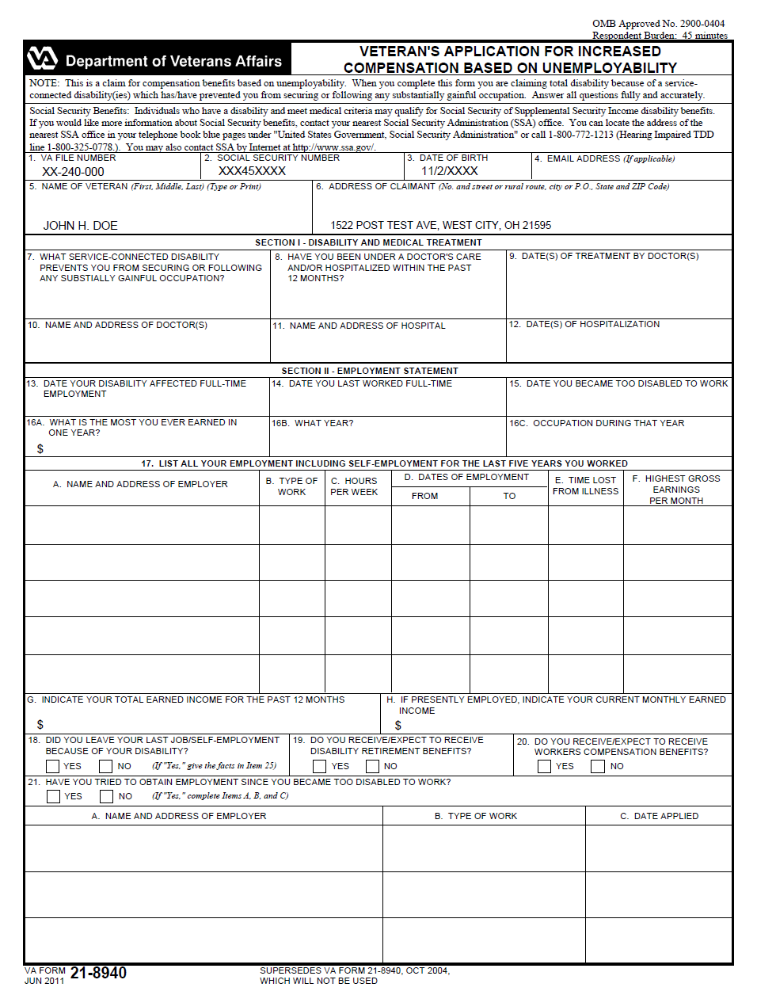
Attachment D: Request for Employment Information in Connection with Claim for Disability Benefits
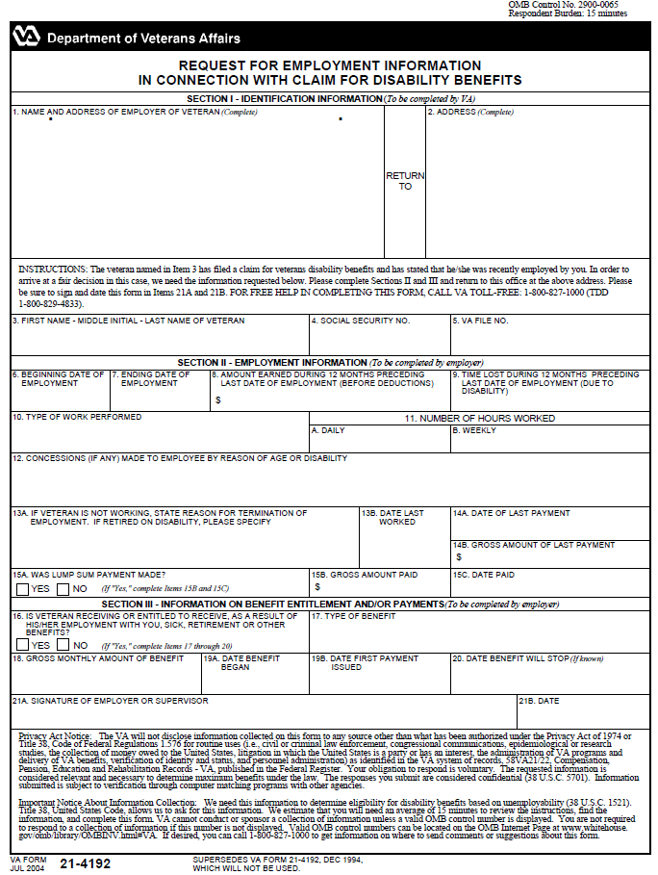
Attachment E: Employment Questionnaire
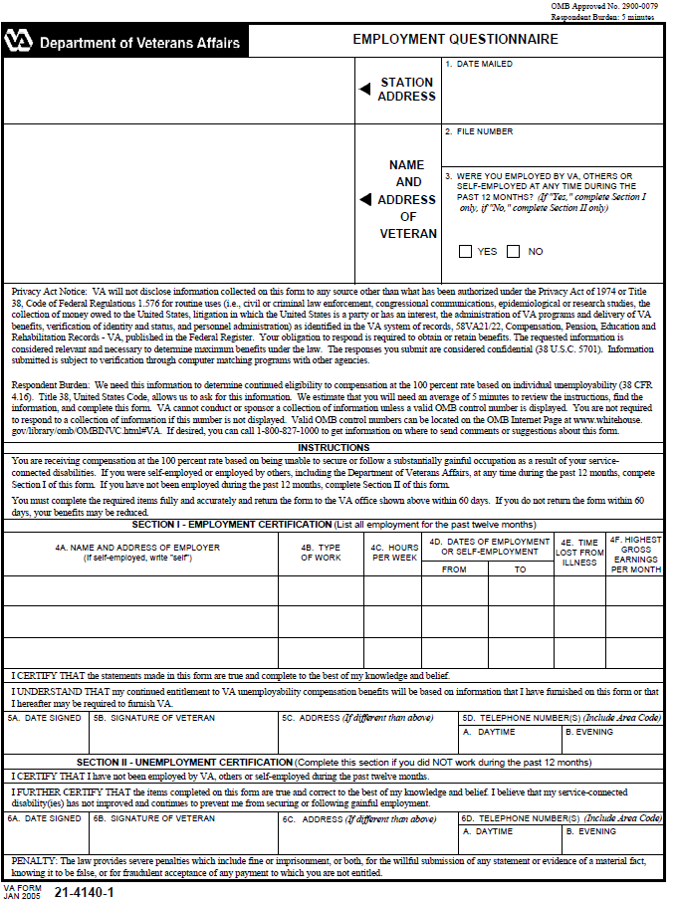
Attachment F: Letter to Employer

Department Of Veterans Affairs

Date
ANY CORPORATION In reply/refer to: 313/PRE/wbt
ATTN: PERSONNEL DEPT File #: XXX 54 YY98
1234 S 5TH STREET IM A Veteran
ANYTOWN USA 12345

IMPORTANT – reply requested
We are reviewing a claim for VA benefits from the Veteran, IM A VETERAN, social security number XXX 54 YY98, who has stated that he was employed with your company until January 2006.
What Do We Need From You?
We need more information about this Veteran’s employment. Please complete and return the enclosed VA Form 21-4192, “Request for Employment Information in Connection with Claim for Disability Benefits.” A self-addressed label is enclosed for your convenience. We would appreciate a response within 15 days. If no records of employment are available, we would appreciate a negative response.
Do You Have Questions or Need Assistance?
If you need additional information or have any questions regarding this request, please contact us at 1-800-827-1000 weekdays between the hours of 8:00 a.m. and 4:00 p.m.
Your assistance with this matter is greatly appreciated.
Sincerely yours,

VSC Manager
Veterans Service Center Manager
Contact us at: https://iris.va.gov
Enclosures: VA Form 21-4192
Self-addressed envelope
Cc: DAV
Attachment G: Letter to Veteran Requesting Employment Records

Department Of Veterans Affairs

{DATE}
JOE J VETERAN  4501 ANYWHERE AVENUE  ANYWHERE MD 21411 | In reply, refer to:  313/211/MM  File Number: XXX 54 YY98  Joe J. Veteran

IMPORTANT -- reply needed
Dear Mr. Veteran:
We are writing in connection with the claim that you filed on (date of claim); however we need additional information or evidence.
We wrote (Employer) to get more information about your employment on (date previous letter sent to employer). We haven't received a reply. We need the information to assist us in making a decision on your claim for benefits. We have sent a follow-up request for this information to them. If we do not receive this information, we may decide your claim within 15 days from the date of this letter.
A VA Form 21-4192, Request for Employment Information, is enclosed. Please ask (Employer) to complete the form and return it to us.
Even though we have asked for this information, it is your responsibility to see that VA receives it (except for any evidence kept by the VA, military or any other federal government agency)
Where Should You Send What We Need?

Please send what we need to this address:
Department of Veterans Affairs
Claims Intake Center
PO Box 5235
Newnan, GA 30271-0020
Attachment G: continued

How Soon Should You Send It?
We sent you a letter on {date of Section 5103 Notice} telling you what we need in support of your claim. You can take up to a year from the date of that letter to make sure we receive the information and evidence we have requested. VA may decide your claim within 15 days if we have completed our attempts to get all the relevant evidence about which we know. If VA decides your claim before {one year from the date of the Section 5103 Notice}, you continue to have until that date to submit additional evidence.

How Can You Contact Us?
If you are looking for general information about benefits and eligibility, you should visit our web site at http://www.va.gov. Otherwise, you can contact us in several ways. Please give us your VA file number, {XXXXXX}, when you do contact us.

- Call us at 1-800-827-1000. If you use a Telecommunications Device for the Deaf (TDD), the number is 1-800-829-4833.
- On the Internet at https://iris.va.gov.
- Write to us at the address at the top of this letter.

Sincerely yours,

VSC Manager

Veterans Service Center Manager

Enclosures: | VA Form 21-4192

cc: AMERICAN LEGION

Practical Exercise

Review the scenario. Use a blank piece of paper to describe the development needed for the Veteran’s claim.
A service-connected Veteran submits a claim for individual unemployability benefits. A review of the VA Form 21-8940 noted it is complete, including the addresses of his former employers. A review of the claims folder revealed he is service-connected for following: post-traumatic stress disorder @ 30%; diabetes mellitus with erectile dysfunction @ 20%; peripheral neuropathy of the lower extremities @ 20% each; peripheral neuropathy of the upper extremities @ 10% each, and several noncompensable evaluations for a combined overall evaluation of 70%. The last VA examinations for the diabetes and related conditions were conducted within the prior 11 months.

What would be your next action as the VSR managing this case?

