Rating References

Trainee Handout

**Table of Contents**

Objectives 2

References 2

Topic 1: Reference materials (including VA laws, regulations, manuals, and directives) 3

Topic 2: Compensation Service Website 4

To set the Compensation Service Intranet Page as your home page: 4

CPKM link: 4

http://vaww.compensation.pension.km.va.gov 4

KNOWVA link: 4

Topic 3: Tools for understanding references 5

Objectives

Introduce trainees to the:

* Reference materials (including VA laws, regulations, manuals, and directives)
* Compensation Service Website
* Tools for accessing references

References

* [Compensation Service Homepage](http://vbaw.vba.va.gov/bl/21/index.htm)
* [Title 38 U.S. Code](http://vbaw.vba.va.gov/bl/21/publicat/pub_home.htm)
* [38 Code of Federal Regulations Part 3](http://www.ecfr.gov/cgi-bin/text-idx?SID=ad275643432556b9dda942343fb89296&mc=true&node=pt38.1.3&rgn=div58)
* [38 Code of Federal Regulations Part 4](http://www.ecfr.gov/cgi-bin/text-idx?SID=ad275643432556b9dda942343fb89296&mc=true&node=pt38.1.4&rgn=div5)
* [M21-1 Adjudication Procedures Manual](https://vaww.compensation.pension.km.va.gov/system/templates/selfservice/va_ka/portal.html?encodedHash=%23!agent%2Fportal%2F554400000001034%2Ftopic%2F554400000003061%2FM21-1-Adjudication-Procedures-Manual)
* [KnowVA](http://www.knowva.ebenefits.va.gov/system/templates/selfservice/va_ss/" \l "!portal/554400000001018?LANGUAGE=en&COUNTRY=us)
* [Compensation & Pension Knowledge Management (CPKM)](https://vaww.compensation.pension.km.va.gov/system/templates/selfservice/va_ka/portal.html?portalid=554400000001034)
* [Compensation Service Fast Letters (historical)](http://vbacodmoint1.vba.va.gov/bl/21/FastLetters/FLList.asp)
* [Compensation Service Training Letters (historical)](http://vbaw.vba.va.gov/bl/21/publicat/Letters/TrngLtrs.htm)
* [Compensation Service Training Site](http://cptraining.vba.va.gov/C&P_Training/)
* [Rating Job Aids](http://vbaw.vba.va.gov/bl/21/rating/rat00.htm)
* [Court & DAD Cases (historical)](http://vbaw.vba.va.gov/bl/21/advisory/CAVCDAD.htm)
* [FAQ – Q&A Committee (historical)](http://vbaw.vba.va.gov/bl/21/FAQ/faq.htm)
* [Intranet Advanced Search](http://vaww.index.va.gov/search/va/va_adv_search.jsp?SQ=vbaw.vba.va.gov/bl/21)

Topic 1: Reference materials (including VA laws, regulations, manuals, and directives)

**Precedence Chart of VBA References**

**The CONSTITUTION of**

**The UNITED STATES of AMERICA**

Established

**The CONGRESS**

which passes bills about Veterans which when signed into law by

**The PRESIDENT**

are codified as

**Title 38 United States Code (U.S.C.)**

which is interpreted by VA in

**38 Code of Federal Regulations (C.F.R.)**

from which policy & procedural instructions are given in

**DIRECTIVES (M21)**

and currently found in manuals through CPKM

NOTE: The Court of Appeals for Veterans Claims (in CAVC case decisions) and VA General Counsel (in GC Opinions) will refine the interpretation of Title 38 U.S.

Topic 2: Compensation Service Website

<http://vbaw.vba.va.gov/bl/21/index.htm>

To set the Compensation Service Intranet Page as your home page:

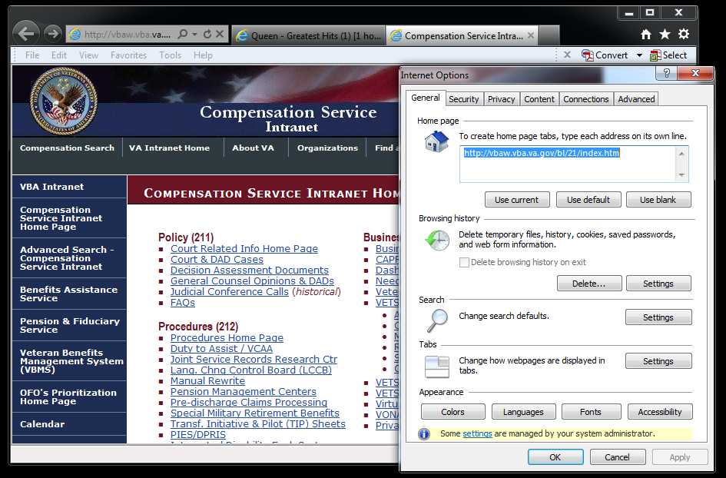

Tools>Internet Options>Home page>Use current> OK

CPKM link:

<http://vaww.compensation.pension.km.va.gov>

KNOWVA link:

[http://www.knowva.ebenefits.va.gov](http://www.knowva.ebenefits.va.gov/system/templates/selfservice/va_ss/#!portal/554400000001018?LANGUAGE=en&COUNTRY=us)

Topic 3: Tools for understanding references

**How Do I Read These References?**

**Reading M21-1 Manual References**

Start with M21-1 III.iv.6.C.10.a:

* + **M21-1** (The Manual)
    - Part **III** (Which Part of the Manual)
      * Subpart **iv** (The Subpart of Part III)
        + Chapter **6** (The Chapter of the Subpart)

Section **C** (The Section of the Chapter)

Topic **10** (The Specific Topic of the Section)

Block **a** (The Specific Block of Information for the Topic)

***See the*** [***M21-1 Website Quick Reference User Guide***](https://vaww.compensation.pension.km.va.gov/system/templates/selfservice/va_ka/portal.html?encodedHash=%23!agent%2Fportal%2F554400000001034%2Ftopic%2F554400000003061%2FM21-1-Adjudication-Procedures-Manual) ***for additional information.***

**Reading CFR References**

Start with 38 CFR §3.309(a):

* + Title **38** (What Part of the CFR)
    - **CFR** (Code of Federal Regulations)
      * **§3.309** (What Regulation in CFR)
        + **(a)** (Specific Paragraph in Regulation)