COVERS Mail, Folder and Report Control

Trainee Handout

**Table of Contents**

Objectives 2

References 3

Paper vs Electronic Files 4

COVERS Folder Inquiries and Requests 5

COVERS Mail Searches 8

Introduction to COVERS Reports 11

Practical Exercise 12

Objectives

After completing this training you should be able to:

1. Determine when to convert paper files to electronic folders
2. Demonstrate proper procedure to request folders through COVERS
3. Understand how to set/delete mail searches in COVERS
4. Discuss how to use the report functionality in COVERS

References

* [M21-1, Part III, Subpart ii, 3.B, Paper and Electronic Claims Folders](https://vaww.compensation.pension.km.va.gov/system/templates/selfservice/va_ka/#!agent/portal/554400000001034/article/554400000014123/M21-1-Part-III-Subpart-ii-Chapter-3)
* [M21-1, Part III, Subpart ii, 4.A, Paper Claims Folders Storage and Control](https://vaww.compensation.pension.km.va.gov/system/templates/selfservice/va_ka/#!agent/portal/554400000001034/article/554400000014126/M21-1-Part-III-Subpart-ii-Chapter-4)
* [COVERS online users guide](http://css.vba.va.gov/COVERS/)

Paper vs Electronic Files

Types of Claims Folders:

Although the majority of claims folders are currently stored in electronic systems, including VBMS and Virtual VA, there are still many claims folders in paper format. Most paper claims folders will be converted into electronic format; however there are a few exceptions. The following claims files will be established and/or retained in paper format:

* all sensitive level 8 claims including
  + witness protection, and
  + classified claims, and
* Integrated Disability Evaluation System (IDES) claims requiring Military Services Coordinators (MSC) to build a physical claims folder for original disability compensation claims. Original IDES claims require creation of a paper claims folder only when service treatment records (STRs) provided to the MSC are
  + hard copies, or
  + a combination of hard copies and electronic.

***Important:*** *Do not* convert documents to an electronic format for claims with a sensitive level 8 or above. If scanned into centralized mail (CM), print the documents for the paper claims folder and remove from the portal

Use the table below to determine if/when to request conversion of a paper claims folder to electronic format.

|  |  |  |
| --- | --- | --- |
| **If the newly established EP …** | **And the station number listed in the current folder location field is …** | **Then …** |
| requires conversion of the claims folder | the same as the regional office (RO) processing the documents | * obtain the volumes remaining in paper through local procedures, and * route to scanning for conversion. |
| requires conversion of the claims folder | a facility   * related to another jurisdiction, and * not the Records Management Center (RMC) (station 376) | send an e-mail to the RO’s Intake Processing Center (IPC) point of contact (POC) requesting conversion of paper claims folders. |
| requires conversion of the claims folder | RMC | follow the guidance in [M21-1, Part III, Subpart ii, 3.B.1.g](https://vaww.compensation.pension.km.va.gov/system/templates/selfservice/va_ka/#1g). |
| does not require conversion of the claims folder | either the same or different from the RO processing the documents | * either   + manage evidence, or   + create a VBMS note regarding the mail received, and * upload the documents to the eFolder. |

COVERS Folder Inquiries and Requests

COVERS (Control of Veterans Records System) is a Microsoft Windows-based Client/Server application using barcode technology to support RO (Regional Office) and RMC (Record Management Center) folder activities, including requests, mail, search, and external transfers.

**Folder inquiries:** To conduct an inquiry to determine the current location of a claims folder use the “Single Inquiry” button, enter the file number and folder type and press “OK.” If a folder type is not selected – the single inquiry function defaults to “claims” folder type.

Claims processors use the COVERS locations listed in the table below when a paper claims folder is sent for scanning conversion or when establishing a claims folder where no paper claims folder previously existed.

|  |  |
| --- | --- |
| **COVERS Location** | **Description** |
| DCSC1 | Converted and stored at CACI Newnan, GA |
| DCSC2 | Converted and stored at CACI Mt Vernon, KY |
| DCSS1 | Converted and stored at SMS Janesville, WI |
| DCSS2 | Converted by Records Management Center (RMC) and stored at SMS Janesville, WI |
| PALL01- PALL22 | Converted and stored at RMC |
| VBMSRT | Location for claim folders that exist only in VBMS |
| INVBMS | Location for claim folders that exist only in VBMS |
| EFILE | Location for claim folders that exist only in VBMS |
| INVVA | Location for claim folders that exists in Virtual VA |
| NEWXFF | Location for claim folders that exists in Virtual VA |

**Folder requests**

If an inquiry reveals that a paper file exists for a claims folder you can request the folder by utilizing the “Request” function from the COVERS main menu. Each RO will have its own procedures for responding to folder and mail searches. In most cases, there will be clerks who will use a Search List report to physically locate folders with associated searches.

Use the “Request” function to request a folder be sent to the user's location. When a folder with a folder search is received, the user will be notified that a request has been made.

This process establishes a search request for a folder, indicating that the user requires the physical folder for reasons other than for attaching mail. The Enter Folder Identification screen is displayed and the user enters a folder number and an option priority. Data entered on the screen is validated, and if no errors are found, a folder search request is issued for the folder. Various messages might be displayed about the status of the folder, as it relates to search request establishment.

All users have access to this process, however, a VSO user may not issue a search request for a folder for which they do not have POA authority.

**To request that a folder be sent to your location**

1. Select the “Request” button the COVERS Main Menu. The Enter Folder Identification (Request Folder) window will appear.
2. Enter the file number for the folder.
3. Select the folder type. This will default to ‘CLAIM’ if left blank
4. Select the volume number. This will default to ‘1’ if left blank.
5. Select a priority code if desired. If your RO has not assigned any priority codes, this filed will not be available.
6. Select the “OK” button to continue the process, “Clear” button to clear the current entry, or “Main Menu” button to cancel the process and return to the Main Menu.
7. COVERS will initiate the folder search. If the search request was rejected, one of the following problems may have occurred:

* The folder may already be at the users’ location.
* The user may have already issued a search request for this folder.
* You do not have POA for the folder.
* The folded contains restricted material.
* The folder has multiple POA’s.
* The folder may be PTO; folder searches are not allowed.

***Note: Do not “Receive” a claims folder until it is in your possession.***

***Important: Never use the “Request” or “Receive” functions in COVERS for eFolders; receiving an eFolder in COVERS will update the system to indicate the file is in your possession and can cause confusion for anyone searching for the file at a later time.***

**To delete a request for a single folder**

1. Select “Delete” for a single folder on the “Change/Delete” menu. The “Enter Folder Identification” (Delete Search for a Single Folder) window will appear.
2. Enter the file number for the folder, or scan the label on the folder. If scanning, remember that the cursor must be in the file number field. If scanning, skip to step 6.
3. Select the folder type. This will default to 'claim' if left blank.
4. Select the volume number. This will default to '1' if left blank.
5. Select “OK” to continue the process, “Clear” to clear the current entry, or “Main Menu” to return to the main menu.
6. If COVERS were unable to locate the file, there are no searches for the file, or there are no searches the user is authorized to delete, COVERS will display a brief error message. Otherwise, the user will be presented with a list of all active searches for which delete authority is available.
7. Select the search or searches to be deleted. Use CONTROL+CLICK or SHIFT+CLICK to select a collection of searches. Select the Clear button to clear the selections. Select the Delete All Searches button to delete all listed searches.
8. Select the OK button to continue the process, Clear button to clear the current entry, or Main Menu button to return to the Main Menu.
9. The user may also delete a request for a single folder from the Single Inquiry Screen.
10. Select the Single Inquiry button. Type or scan in the file number. A search message will be displayed if there is a search for the file. The Folder Data screen will display.
11. Select the Search tab.
12. Select the Delete Search button.

Folder access restrictions

COVERS enforces a type of access restriction that may prevent the user from retrieving information on a folder.

* Veterans Service Organization (VSO) users must have a power of attorney (POA) recorded in COVERS for in order to retrieve information through a folder inquiry. If a VSO user does not have POA for a claimant, or if the claimant has multiple POAs or contains restricted data, the inquiry will be denied. These will be logged in the unauthorized messages.

This function is also available from the Folder Data screen of the Single Inquiry function. See [Request A Folder](http://css.vba.va.gov/COVERS/Request_A_Folder.htm).

COVERS Mail Searches

[Mark for Mail](http://css.vba.va.gov/COVERS/Mark_For_Mail.htm#Mark For Mail): Use this function to inform COVERS that there is loose mail to associate with a claims folder. When the folder is received at any location, the recipient will be notified that there is associated action mail via Info/Error Messages on the Main Menu.

The Mark Folder for Mail screen is used to inform COVERS that there is action mail to attach to a folder.

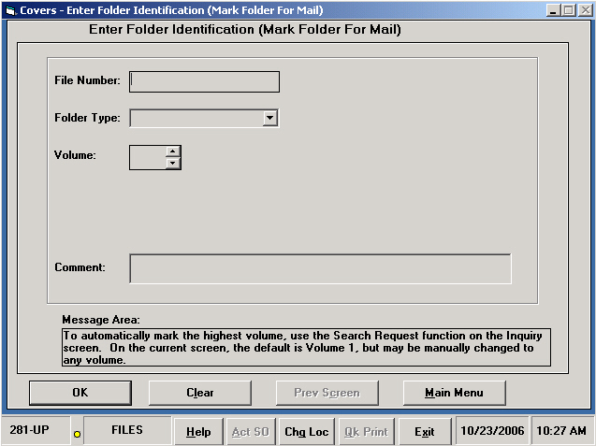

To mark a folder for mail

1. Select “Mark for Mail” button on the COVERS Main Menu. The *Enter Folder Identification* (Mark Folder for Mail) window will appear.
2. Enter the file number for the folder, or scan the label on the folder. If scanning, remember that the cursor must be in the file number field. If scanning, skip to step 6.
3. Select the folder type. This will default to 'CLAIM' if left blank.
4. Select the volume number, if applicable. This will default to '1' if left blank.
5. Select the **OK** button to continue the process, **Clear** button to clear the current entry, or **Main Menu** button to cancel the process and return to the Main Menu.
6. COVERS will initiate the mail search (search type "M"). If the mail search cannot be established, one of the following problems may have occurred:

* The folder may already be at the location.
* The folder may be PTO; mail searches are not allowed.
* There may already be a search from this location.
* If the user is a SO, access to this function is not allowed.
* The folder may already be at the location.
* The folder may be PTO; mail searches are not allowed.
* There may already be a search from this location.
* If the user is a SO, access to this function is not allowed.

*Note: Because COVERS does not actually associate mail with a folder, the user who attaches the mail must delete the corresponding mail search from COVERS using the Search Change/Delete function. COVERS allow folders to be marked as needing mail to be attached.*

Delete Mail Search in Bulk

The “Delete Mail Search in Bulk” function allows the user to cancel a number of mail searches issued by a location in a single batch. Non-VSO users are granted access to this function by the 'Delete Mail Search in Bulk' indicator in CSS under Application Operations.

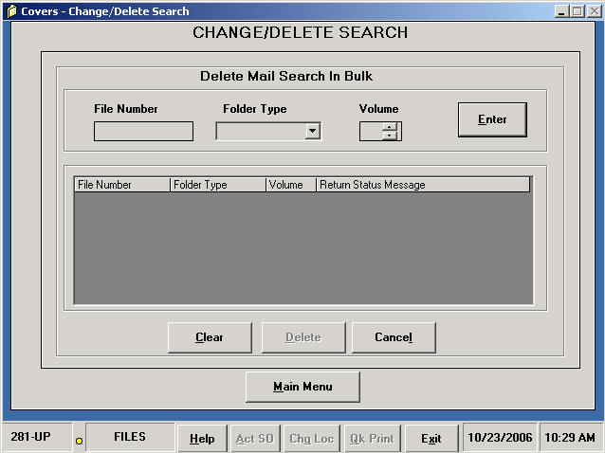

1. Select the **Delete Mail Search in Bulk** button on the Change/Delete Search menu. The *Delete Main Search in Bulk* window will appear.
2. Enter or scan the file number for the folder.
3. Select the folder type. This will default to 'CLAIM' if left blank.
4. Select the volume number. This will default to '1' if left blank.
5. Select the **Enter** button to add this folder to the deletion list.
6. Repeat steps 2-4 until the list is complete. Up to forty folders may be selected. Select the **Clear** button to clear all entries from the deletion list or clear a single entry by double-clicking the entry. This does not delete the mail search; it simply clears the entry or entries.
7. Select the **Delete** button to delete mail searches for all folders on the list, **Cancel** button to return to the previous screen, or **Main Menu** to cancel and return to the Main Menu.
8. A completion message will be received for each folder.

# Introduction to COVERS Reports

COVERS provides reports to help authorized users track various aspects of system usage. Reports are available from the Utilities menu.

The following COVERS reports are available from the Reports selection screen:

Search List by Search Location

Search List by Priority Code

Search List by Folder Location

Search List by Terminal Digit

Folder Statistics Report

Temporary Transfers Report

Permanent Transfer Report

Folder Aging for a Location Report

Special Codes Statistics Report

Multi-Volume Folders - Terminal Digit Sequence

Multi-Volume Folders - Folder Number Sequence

Unauthorized SO Holdings Report

Folder Search Review

Validation Tables Report

**To generate a COVERS Report**

1. Select the Reports button or the Utilities button from the COVERS Main Menu.
2. If utilizing the Utilities Menu, select the Reports button. The *Reports Selection* menu will appear.
3. Request a report by clicking on the name of the report and selecting the OK button, or by double-clicking on the name of the report.

***Note: For some reports, COVERS immediately issue the report request. For others, the user will be asked to enter more information before the request for the report is issued. The Folder Search Review report is a screen display rather than a printed report; it displays as soon as the data is available.***

For all printed reports, except the Validation Tables Reports, once the report is requested, a message will be received stating the report has been requested and will be emailed after 6:00PM Central Time, or that no searched satisfied the screen criteria.

The Validation Tables Report will print as soon as it is requested.

Practical Exercise

1. Identify whether the locations below are used for paper or electronic claims files. If electronic identify VBMS or Virtual VA.
   1. EFILE
   2. FILES
   3. NEWXFF
   4. DCSC2
2. You have requested a paper claims folder to be brought to your desk. Which of the following functions should you avoid until you are in receipt of the claims folder?
   1. Request
   2. Receive
   3. Delete
   4. Mark for Mail
3. When a claims file is “Marked for Mail” and you have associated the mail to the file, which function is used to remove this annotation?
   1. Mark for Mail
   2. Request
   3. Single Inquiry
   4. Change/Delete
4. The COVERS program is used to track claims folders. Which types of claims folders should you never “Receive” in COVERS?
   1. Sensitive claims files
   2. Files at other people’s desks
   3. Electronic folders
   4. Files located in IPC