Appeals DRO Review Process

Trainee Handout

**Table of Contents**

Objectives 2

References 2

Topic 1: DRO Duties, Jurisdiction, and Authority 2

Topic 2: Review of the NOD 4

Topic 3: *De novo* Review 8

Topic 4: Informal Conference 9

Topic 5: Making a Decision 9

Attachment A: VA Form 21-0958, Notice of Disagreement 11

Attachment B: Telephone Script 13

Attachment C: DRO Process Explanation Letter 14

Attachment D: Traditional Process Explanation Letter 15

Attachment E: Appeal Process Request Letter 16

Attachment F: Request for Application for NOD Letter 17

Attachment G: Clarification of NOD Letter 19

Attachment H: NOD Not Timely Letter 20

Attachment I: Extension of Appeal Letter 21

Attachment J: Informal Conference Report 22

Attachment K: Appeals Satisfaction Notice 23

Practical Exercise 24

Objectives

|  |
| --- |
| This lesson is intended to provide students with an overview of the initial review process of an appeal by the DRO. Additional appeals courses specific to SOC/SSOCs and certifiying appeals to BVA can be found in the VBA Learning Catalog.  This lesson will contain discussions and exercises that will allow you to gain a better understanding of:   * the duties of the DRO * jurisdication and authority of the DRO * the DROs review of the NOD * the *de novo* review * the informal conference * decisions made by the DRO |
| References  All M21-1 references are found in the [Live Manual Website](https://vaww.compensation.pension.km.va.gov/).   * [38 U.S.C. Chapter 71, Board of Veteran’s Appeals](https://www.law.cornell.edu/uscode/text/38/part-V/chapter-71) * [38 U.S.C. Chapter 72, U.S. Court of Appeals for Veterans’ Claims](https://www.law.cornell.edu/uscode/text/38/part-V/chapter-72) * [38 CFR 19, Board of Veterans’ Appeals: Appeals Regulations](http://www.ecfr.gov/cgi-bin/text-idx?SID=01034526ca21dfa4b5e2032354fc65d6&mc=true&node=pt38.2.19&rgn=div5) * [38 CFR 20, Board of Veterans’ Appeals: Rules of Practice](http://www.ecfr.gov/cgi-bin/text-idx?SID=ad275643432556b9dda942343fb89296&mc=true&node=pt38.2.20&rgn=div5) * [38 CFR 3.2600, Review of Benefit Claims Decisions](http://www.ecfr.gov/cgi-bin/text-idx?SID=ad275643432556b9dda942343fb89296&mc=true&node=pt38.1.3&rgn=div58) * [38 CFR 3.109(b), Extension of Time Limit](http://www.ecfr.gov/cgi-bin/text-idx?SID=ad275643432556b9dda942343fb89296&mc=true&node=pt38.1.3&rgn=div58) * [M21-1 Part I, Chapter 5, Appeals](https://vaww.compensation.pension.km.va.gov/system/templates/selfservice/va_ka/portal.html?encodedHash=%23!agent%2Fportal%2F554400000001034%2Ftopic%2F554400000003067%2FChapter-5-Appeals) |
| Topic 1: DRO Duties, Jurisdiction, and Authority | | |
| **Topic Objectives:**   * define the duties of the DRO * understand the DROs jurisdiction over appellate and downstream issues * identify issues not under the jurisidiction of the DRO * understand the DROs decisional authority and limits of authority | | |
| DRO Duties  The DRO is a senior technical expert who is responsible for holding post-decisional hearings and processing appeals. The primary function of a DRO is appeal resolution. DRO duties include:   * Making direct contact with appellants and their representatives to include holding informal conferences and formal hearings. * Evaluating the evidence of record, including the need for additional evidence as a result of information obtained during the conference or hearing. * Making a decision based on the entire evidentiary record. * Issuing SOC/SSOCs, certifiying, and coordinating the transfer of appeals to BVA.   In addition to processing appeals, the DRO plays a central role in employee development. | | |
| **DRO Jurisdiction over Appellate Issues**  The DRO has:   * *de novo* review jurisdiction over only appeals governed by 38 CFR Part 3 and 38 CFR Part 4 * limited jurisdiction over a rating issue raised during an informal conference or formal hearing, provided the issue was part of the rating decision that is subject of the hearing, and * no jurisdiction over an appeal on a rating decision made by the DRO him/herself. | | |
| **DRO Jurisdiction over Downstream Issues**  When a DRO issues a favorable decision on an appealed issue, the DRO assumes jurisdiction over and decides any downstream issues, including:   * disability evaluation * effective date, and * any inferred or ancillary issues that are encompassed by that favorable decision.   The decisions on downstream issues may confer new appeal rights and requires the appellant to submit a new, timely NOD. | | |
| **Issues Not Under the Jurisdiction of the DRO**  The DRO does not have jurisdiction over:   * Committee on Waivers and Compromises (COWC) issues * loan guaranty * insurance, and * hearing requests concerning the denial of benefits from a medical determination rendered by a VAMC. | | |
| **DRO Decisional Authority**  The DRO may:   * amend, reverse, or modify a decision based on de novo review, new evidence, or CUE. * exercise single signature CUE authority on decisions that do not involve reduction of evaluation or severance of service connection. | | |
| **DRO Authority Limits**  The DRO has no authority to participate in a formal hearing if he/she participated in the decision now under appeal.  The DRO has a prohibition against bargaining with an appellant in exchange for withdrawal of an appeal. A DRO is not prohibited, however, from discussing the lack of merit in any particular case or encouring the claimaint or his/her representative to withdraw a meritless appeal.  BVA decisions are final and binding on the regional office. The DRO cannot recommend a change on a binding BVA decision unless new and material evidence is received which would result in a different decision. | | |

Topic 2: Review of the NOD

|  |
| --- |
| **Topic Objectives**:   * demonstrate the ability to recognize a complete and timely NOD * identify the required development for incomplete/untimely NODs, NOD extension requests, and withdrawing/reinstating NODs |
| Review of the NOD  Although the NOD is initially reviewed and the appeal established prior to a DROs contact with the claim, the the DRO should perform a detailed review the NOD to ensure timeliness of the appeal and to ascertain if there is a need for further clarification.  As part of reviewing the NOD, the DRO should ensure the VACOLS record is properly established and an EP 170 is pending.  When reviewing the NOD itself, the DRO should determine if the appellant requested a DRO review or traditional appellate review; identify if the appellant requested telephone contact; and, determine if the appellant requested a hearing.  Once the NOD review is complete, the DRO should perform an initial review of the appeal to determine if the prior decision was correct and any development or other action is needed. | |
| Identifying an Incomplete NOD  An NOD is incomplete if it lacks any of the following information:   * information necessary to identify the claimant * the claim to which the NOD pertains * information necessary to identify the category of disagreement * the signature of the claimant or his/her accredited representative.   NODs should not be considered incomplete if it fails to identify the category of disagreement, but the category can be reasonable ascertained based on the decision for which the NOD applies. | |
| **NODs prior to March 24, 2015**  Prior to March 24, 2015, no specific VA form or wording is required; however, it must be written in terms that can be reasonably interpreted as a disagreement with a decision and a desire for appellate review.  VA employees should liberally evaluate all evidence and statements from appellants to ensure all appealed issues are addressed. This does not require reading into the record an argument that has not been made. | |
| **VA Form 21-0958, Notice of Disagreement**  Effective March 24, 2015, a timely VA Form 21-0958, Notice of Disagreement, is required in every case in which the AOJ provides the form for the purpose of initiating an appeal.  Any additional evidence or statements suggesting appealed issues will be considered a request for notice of disagreement.  Review the following table to determine when a VA Form 21-0958 is required: | |
| NOD Time Limits  A valid NOD for contested claims, including an apportionment claim, must be filed within 60 days from the date VA mailed the decision notice to the unsuccessful claimant.  For all other claims, a valid NOD must be filed within one year from the date VA mailed the decision notice to the claimant. | |
| Computing Time Limits  When computing the NOD time limit:   * exclude the first day of the specified period * include the last day of the specified period, and * if the time limit expires on a Saturday, Sunday, or legal holiday, include the next workday in the computation.   If the postmark date on a paper NOD is:   * prior to the expiration of the NOD time limit, consider the NOD timely filed and retain the postmarked envelope * absent, presume the postmark date to be five business days prior to the date VA received the NOD. | |
| NOD Considerations  There is no standard form requirement for an NOD contesting entitlement to NSC pension, DIC, or accrued benefits.  Do not accept an NOD in response to a notice of proposed adverse action as the proposal of an adverse action is not a final decision.  Do not accept an NOD in response to a provisional rating when VA Form 4107, Your Rights to Appeal Our Decision, was provided in the notification letter.  An NOD in response to exclusion from the FDC Program may be accepted, depending on when the NOD was filed and the type of claim. If the NOD was premature or exclusion from the FDC program did not result in a substantive loss of benefits, ensure the claimant was advised the NOD is not valid. | |
| NOD Time Limit Extension Requests  A claimant may request an extension of the time limit before or after expiration of the NOD period.  Decisions to grant NOD time limit extensions is based on whether or not good cause is demonstrated.  The denial of a request for a time limit extension to file an NOD is appealable to BVA. | |
| Untimely NODs  If a claimant submits an NOD past the time limit, ensure:   * the claimant was informed via letter, and * VA Form 4107, *Your Rights to Appeal Our Decision*, was sent with the letter.   The decision that an NOD was not timely filed is appealable to BVA. If the claimant disagrees with a determination that an NOD was not timely filed, the DRO will issue an SOC. | |
| New Issues Raised on NODs  If new issue(s) are raised on an NOD received prior to March 24, 2015, ensure the new issue(s) are developed and decided by the VSC.  Do not accept non-appeal issues raised on an NOD received on or after March 24, 2015 as a new claim unless the new issue(s) is/are within the scope of the issue on appeal. Non appeal issues raised on an NOD after March 24, 2015, that are not within the scope of the appeal are considered a request for application.  Do not delay sending an SOC covering the issue(s) previously decided unless there is outstanding evidence related to an appealed issue. | |
| Multiple Issue NODs  An NOD may express disagreement with a decision that contains multiple issues, but may not be clear as to which issue(s) is being appealed. In these circumstances, the DRO should ensure development is completed to identify the one or more issues that are being appealed.  As part of this development, the DRO should confirm the claimant was notified that a response for clarification must be received within the remainder of the appeal period. | |
| Withdraw/Reinstating NODs  A request for withdraw of an NOD or appeal must be in writing *unless* the appellant withdraws the appeal on the record at a hearing.  A duly appointed representative, including an attorney, can withdraw an NOD or substantive appeal without the written consent of the appellant.  The appellant or his/her authorized representative can reinstate an NOD or appeal after it has been withdrawn. The request to reinstate must be in writing, and received by VA within the remaining appeal period. | |

Topic 3: *De novo* Review

|  |
| --- |
| **Topic Objectives**:   * define a *de novo* review * understand what is reviewed by the DRO during a *de novo* review * identify the appellants’ right to a *de novo* review * understand what actions the DRO may take after the de novo review is complete |
| *De novo* Review  The *de novo* review is a new and complete review of the appealed issue with no deference given to the decision being appealed. The review may lead to a new decision which may be a full grant, partial grant, CUE, or no change.  This special review authority of the DRO allows for a *de novo* review only when a timely NOD has been submitted and the appellant has timely elected the post decision review process.  The review encompasses only the decision with which the appellant has expressed disagreement with the NOD. The DRO should only review decisions that have not become final by appellate decision or failure to timely appeal. | |
| **Appellants’ Right to *De novo* Review**  An appellant has a right to *de novo* review of his/her claim if he/she files a timely NOD with the decision on a benefit claim, and either   * requests *de novo* review at the time of submission of the NOD, or * requests *de novo* review within 60 days of the date VA sends the notice of the right to *de novo* review.   The 60-day time limit cannot be extended and the appellant cannot have more than one *de novo* review of the issue on appeal. | |
| ***De novo* Review Actions**  Based on a review of the evidence, the DRO   * makes a new decision, or * pursues additional evidence considered necessary to resolve the claim which may consist of conducting an informal conference. | |

Topic 4: Informal Conference

|  |
| --- |
| **Topic Objectives**:   * understand the purpose of the informal conference * identify the Informal Conference Report * understand what EP is cleared following an informal conference |
| **Informal Conference**  Informal conferences are scheduled and conducted at the discretion of the DRO. The informal conference differs from a formal hearing in that the informal conference is completed without an oath or affirmation from the appellant.  The purpose of the informal conference is to:   * clarify the issues the appellant wishes to appeal * provide explanations regarding the appealed decision, and * identify additional sources of pertinent information. | |
| Informal Conference Report  Use the informal conference report to:   * document the informal conference * describe all the issues in detail * document specific additional evidence required, and * document the course of action agreed upon by the parties.   Once the informal conference is compelted, the report should be retained in the claims folder or electronic file.  When the informal conference is completed or cancelled, and no further action is required, EP 173 will be cleared. | |

Topic 5: Making a Decision

|  |
| --- |
| **Topic Objectives**:   * understand the concept of making a “new” decision after *de novo* review regardless whether the decision is a full grant, partial grant, or an uphold of the previous decision * understand when EP 174 is cleared after DRO takes action on the NOD |
| **Making a Decision**  Based on the evidence gathered, the DRO   * upholds or overturns the original decision, and * begins to prepare the appeal for BVA review by sending a SOC, unless there is a full grant of the benefit(s) sought.   The “new” decision must be prepared by the DRO, and for SOCs, should not simply be a copy of the prior rating which led to the disagreement.  EP 174 will be cleared when a formal hearing is conducted by a DRO or a formal decision is rendered by the DRO (including issuance of a SOC). |
| **Awarding Full Benefits**  If all benefits sought are awarded for the entire period covered by the appeal:   * consider the appeal resolved * advise the appellant, and * update VACOLS.   The decision notice must include a statement that the decision   * is an award of all benefits sought on appeal, and * the appeal is considered satisfied in full. |
| **Awarding Partial Benefits**  The DRO may make a partial grant of an issue on appeal when the maximum schedular benefit allowed by law and regulation for the issue(s) under appeal is not granted for the entire period under appeal.  In this case the DRO sends the appellant   * the new rating decision * an SOC/SSOC * the appeals satisfaction notice, and * notice of appeal rights. |
| **Upholding the Previous Decision**  If the DRO confirms the previous decision, he/she sends an SOC   * confirming the decision on appeal, and * explaining the reasons and bases for the VA decision, and * provides VA Form 9, Appeal to Board of Veterans’ Appeals, to the appellant.   A DRO’s decision is final and binding on all ROs and is not subject to revision on the same factual basis, except by BVA or as provided under [38 CFR 3.105(a)](http://www.ecfr.gov/cgi-bin/text-idx?SID=e8eba06ba7975b6de61800cc3dcd5768&node=pt38.1.3&rgn=div5#se38.1.3_1105). |

Attachment A: VA Form 21-0958, Notice of Disagreement

|  |
| --- |
|  |
|  |

Attachment B: Telephone Script

|  |
| --- |
|  |

Attachment C: DRO Process Explanation Letter

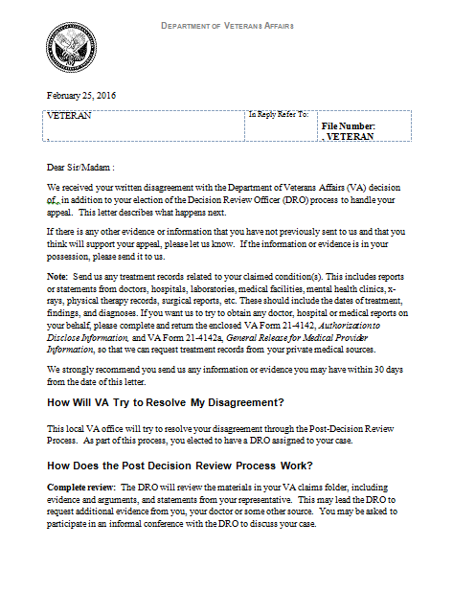

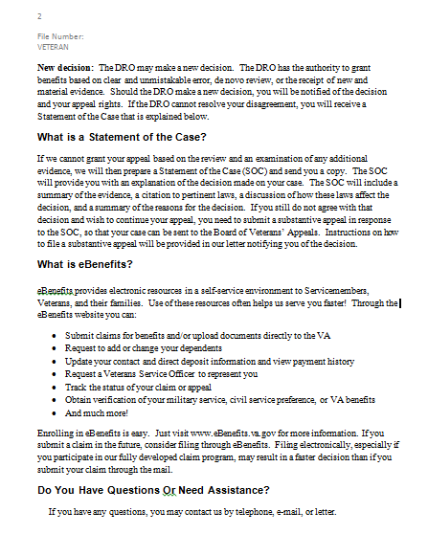

Attachment D: Traditional Process Explanation Letter

|  |
| --- |
|  |

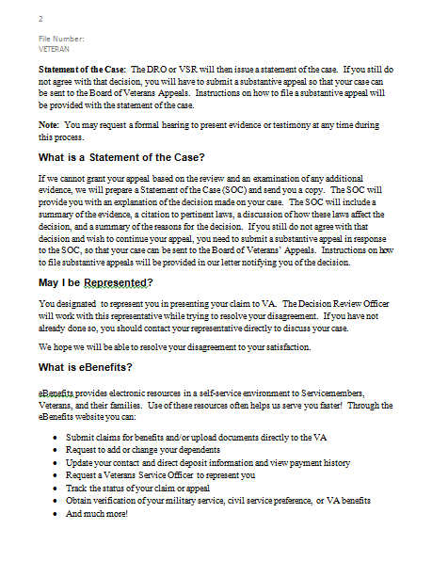

Attachment E: Appeal Process Request Letter

|  |
| --- |
|  |

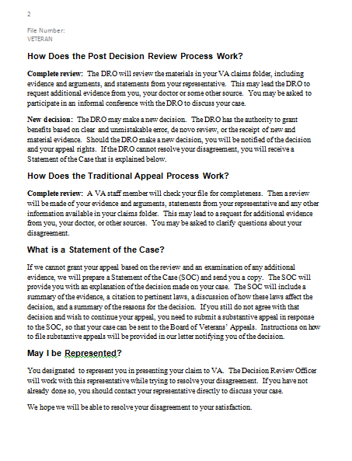

Attachment F: Request for Application for NOD Letter

|  |
| --- |
|  |
|  |

Attachment G: Clarification of NOD Letter

|  |
| --- |
|  |

Attachment H: NOD Not Timely Letter

|  |
| --- |
|  |

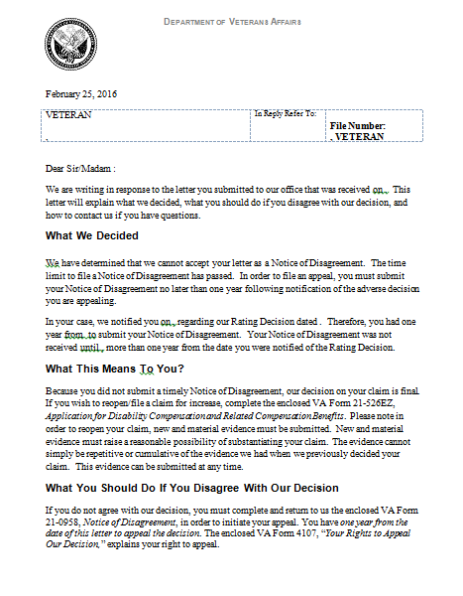

Attachment I: Extension of Appeal Letter

|  |
| --- |
|  |

Attachment J: Informal Conference Report

|  |
| --- |
| http://vaww.vrm.km.va.gov/img/M21-1MRI_5_SecC_1_Informal_Conference_Report.png |

Attachment K: Appeals Satisfaction Notice

|  |
| --- |
| http://vaww.vrm.km.va.gov/img/M21-1MRI_5_SecC_2_Appeals_Satisfaction_Notice.png |

Practical Exercise

Directions: Answer the following questions.

|  |  |
| --- | --- |
| **scenario 1:** | A Veteran files NODs with a denial of service connection for arthritis of the left knee and the evaluation of hiatal hernia at 10%. After *de novo* review, the DRO grants service connection for arthritis of the left knee and increases the evaluation of hiatal hernia to 30%.   * 1. Is the decision considered a full grant or partial grant of all issues on appeal?   2. Explain what action the DRO must take to implement his/her decision. |
| **scenario 2:** | On June 12, 2015, a Veteran filed a one-issue original claim for service connection of costochondritis. On August 4, 2015, the Veteran was notified by decision letter that his claim for service connection was denied. The notification letter included VA Form 4107 and VA Form 21-0958. On February 23, 2016, the Veteran submitted a statement in support of claim disagreeing with a denial of service connection for costochondritis and service connection for prostate cancer. The Veteran indicated he would like a DRO to review the previous decision. EP 170 was established by an appeals VSR for both issues and forwarded to the DRO for *de novo* review.   * 1. Were the issues of costochondritis and prostate cancer correctly accepted as appeal issues? Why or Why not?   2. Explain what development action the DRO will direct for the issues of costochondritis and prostate cancer. |
| **true or false:** | 5. The *de novo* review of a downstream issue must be conducted by a DRO who did not render the initial decision on the downstream issue.  6. A DRO can exercise single signature authority on decisions involving severance of service connection.  7. Failure of the appellant to complete Part III-Appeal Process Election, of VA Form 21-0958, renders the NOD incomplete.  8. The decision that an NOD was not timely filed is appealable to BVA.  9. Failure of the appellant to report for an examination in connection with the issue under appeal constitutes a withdrawal of the appeal.  10. An appellant cannot have more than one *de novo* review of the issue on appeal. |