Claims That Require Priority Processing

Trainee Handout

**Table of Contents**

Objectives 2

References 3

Topic 1: Identify Categories of Claims That Require VA Priority Processing 4

Topic 2: Flag and Direct Claims For Priority Processing 6

Practical Exercise 8

Objectives

In order to accomplish the purpose of this lesson, the student will be required to accomplish the following lesson objectives.

*The**student**will be able to:*

1. Identify categories of claims that require VA priority processing
2. Flag and direct claims for priority processing

References

[M21-1, Part III, Subpart ii, Chapter 1, Section D – Claims That Require Priority Processing](https://vaww.compensation.pension.km.va.gov/system/templates/selfservice/va_ka/)

[M21-1, Part III, Subpart ii, Chapter 1, Section B - Mail Management](https://vaww.compensation.pension.km.va.gov/system/templates/selfservice/va_ka/)

[M27-1, Part II, 2.2](http://www.benefits.va.gov/WARMS/docs/admin21/M27_1/Part_II/M27_1_II_2.doc)

Topic 1: Identify Categories of Claims That Require VA Priority Processing

|  |  |
| --- | --- |
| **OBJECTIVES** | Topic objectives:  *The**student**will be able to:*   * Identify VA claims which require priority processing |
| **Emergent Claims Requiring VA Priority Processing**  *Slide 4* | The following list identifies VA claimants that require priority processing:   * Diagnosed with Amytotrophic Lateral Sclerosis (ALS) or Lou Gehrig’s Disease * FDC program participant * Extreme Financial Hardship cases * Survivor of a former Prisoner of War (FPOW) |
| **Emergent Claims Requiring VA Priority Processing**  *Slide 5* | Any current or former member of the Armed Forces, or survivor who:   * was very seriously injured/seriously injured (VSI/SI) in service and is not already receiving Department of Veterans Affairs (VA) disability benefits * is an FPOW * is homeless * is terminally ill * is more than 85 years old, or * received the Medal of Honor. |
| **Emergent Claims Requiring VA Priority Processing**  *Slide 6* | Upon receipt of a claim from individuals identified in M21-1, Part III, Subpart ii, 1.D.1.a regional offices (ROs) must take any action on the claim that is necessary to move it to the next stage in the claims process ***before*** taking action on any other non-priority claim. |
| **Managing Claims Requiring Priority Processing**  *Slide 7* | ROs are required to case manage these cases by:   * frequently following up on pending actions * utilizing issue specific coordinators, where applicable * using the telephone to contact homeless Veterans and to conduct development activities, whenever possible, and * collaborating with the Veterans Health Administration (VHA) and other involved counterparts. |
| **Priority Processing Claims in a Paperless Environment**  *Slide 8*  **Cross Reference:**  [**M21-1, Part III, Subpart ii, Chapter 1, Section B - Mail Management**](https://vaww.compensation.pension.km.va.gov/system/templates/selfservice/va_ka/) | Adjudicate a claim that requires priority processing before sending any associated paper documentation to a Veterans Claims Intake Program (VCIP) vendor for scanning if:   * the claim is in paper form, or * the claimant still has a traditional claims folder |

Topic 2: Flag and Direct Claims For Priority Processing

|  |  |
| --- | --- |
| **OBJECTIVES** | Topic objectives:  *The**student**will be able to:*   * Prioritize Homeless Veterans Claims, Extreme Financial Hardship Claims, Very Seriously Injured and Seriously Injured Veterans Claims, and Terminal Illness Claims |
| **Homeless Veterans’ Claims**  *Slide 9* | The following steps should be taken to flag and direct Homeless Veterans’ claims:   * Upon receipt of an application for benefits that contains a telephone number but no mailing address, attempt to contact the claimant by telephone to obtain a current mailing address. * If neither a mailing address nor a telephone number are provided on the application, follow the instructions in M21-1, Part III, Subpart iii, 1.B.9.i. * Advise the Homeless Veterans Claims Coordinator (HVCC) |
| **Extreme Financial Hardship Claims**  *Slide 10* | The following steps should be taken to flag and direct extreme financial hardship claims:   * Accept claimant’s statement of extreme financial needs as factual * Review potential documentation to support include: eviction notice, past due notices, collection notices * Append the Hardship corporate flash to a claimant’s record when extreme financial hardship has been adequately demonstrated |
| **Defining VSI and SI**  *Slide 11* | For the purposes of the VSI/SI program, a “serious disability” is defined as a disability that:   * occurred as a result of participation in a military operation, and * will likely result in discharge from military service. |
| **VSI and SI Claims**  *Slide 12* | The DoD classifies these injuries and illnesses into the following categories:   * Very Seriously Ill or Injured (VSI) * Seriously Ill or Injured (SI), and * Not Seriously Ill or Injured (NSI).   All service members categorized as VSI or SI are considered seriously disabled for VA purposes. |
| **Terminal Illness**  *Slide 13* | If a claim is submitted with medical evidence of an illness that is likely to be terminal, the first line supervisor will determine prioritization.  When determining if prioritization is warranted, consider   * the likelihood the claimant will pass away before the completion of the claims process, and * the probable need for access to ancillary benefits, such as Aid and Attendance, due to end of life care. |
| **Terminal Illness Flash**  *Slide 14* | If the determination is made to prioritize the case due to Terminal Illness, the following steps are taken:   * Paper format - add a flash to the front of the paper claims folder indicating a claim for a terminal illness, and append the contention with the Terminally Ill special issue flash. * Electronic format - append the contention with the Terminally Ill special issue flash, and change the claim priority to high in the Veterans Benefits Management System (VBMS). |

Practical Exercise

Directions: The student should review the examples to determine if the claim requires priority processing. A determination should be made with consideration that the VA Form 21-526 or 21-526EZ were completed and given the information provides in the examples.

**Example #1**

Making a decision based only on the information shown in the screen shots below, and assuming completion of the entire VA Form 21-526 or 21-526EZ, does the submission meet the criteria for VA priority processing? Why or why not?

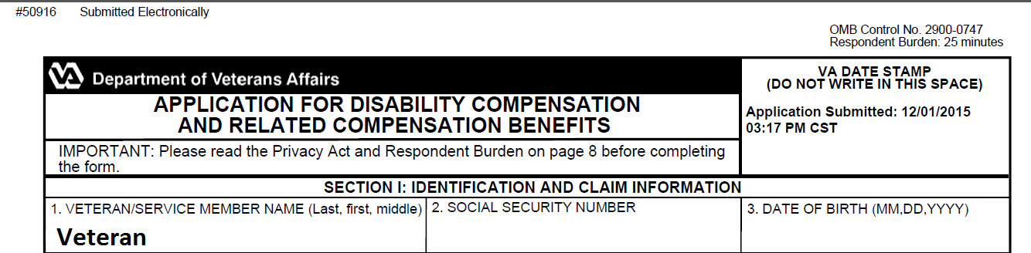



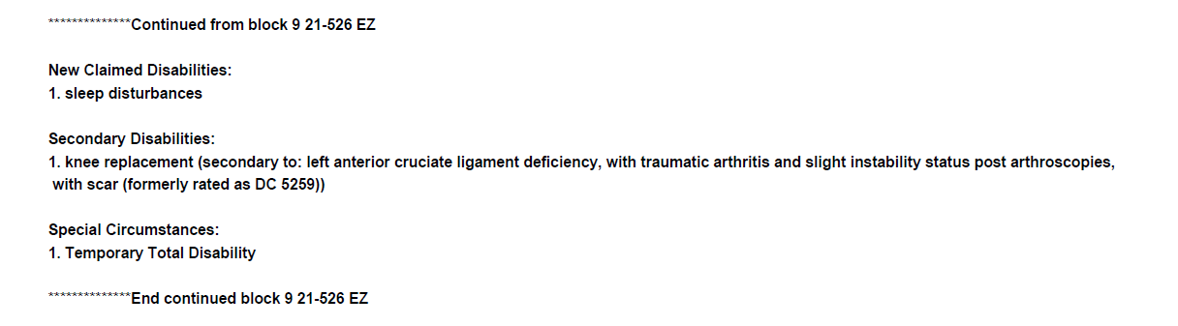

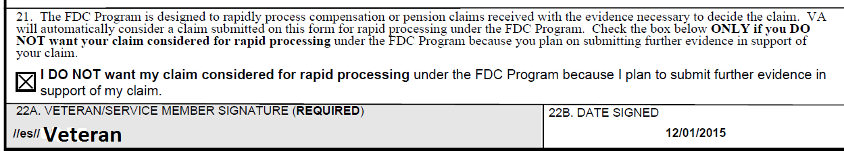

**Example #2**

Making a decision based only on the information shown in the screen shots below, and assuming completion of the entire VA Form 21-526 or 526EZ, does the submission meet the criteria for VA priority processing? Why or why not?

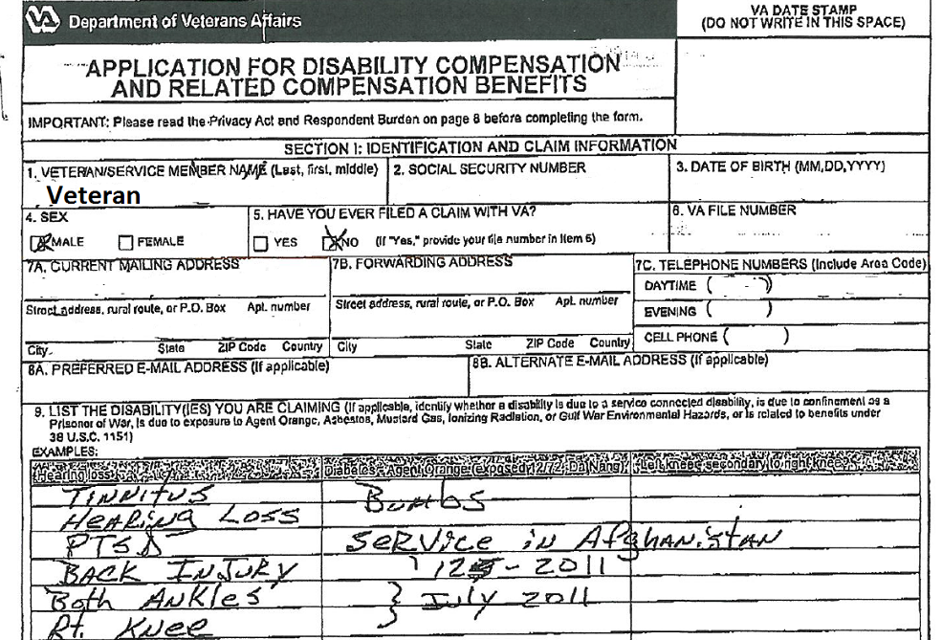

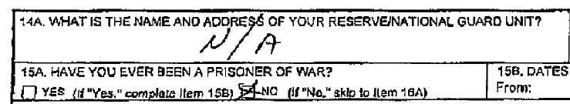

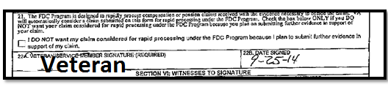

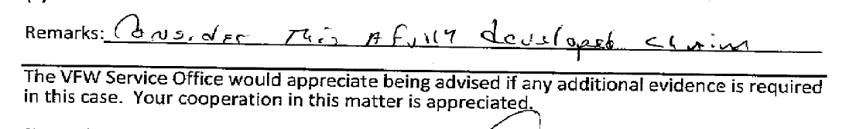

**Example #3**

Making a decision based only on the information shown in the screen shots below, and assuming completion of the entire VA Form 21-526 or 526EZ, does the submission meet the criteria for VA priority processing? Why or why not?

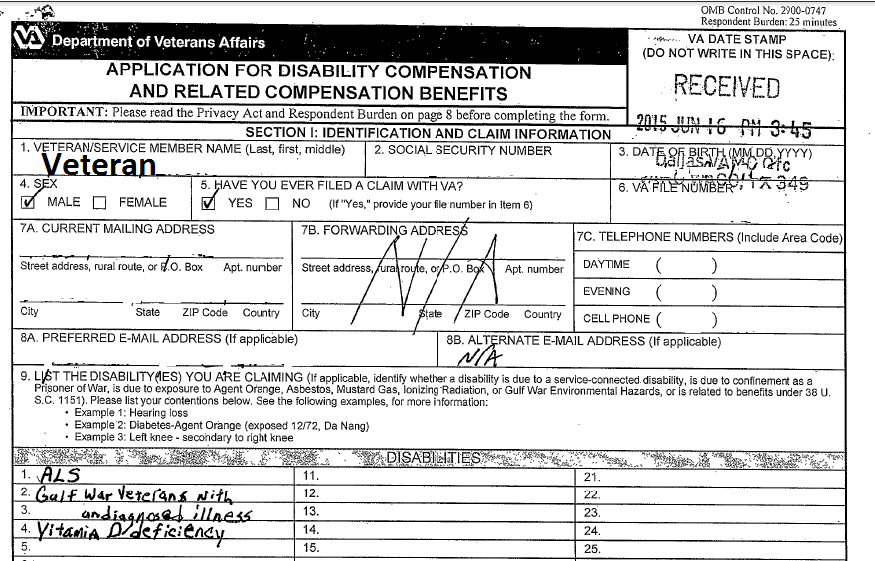

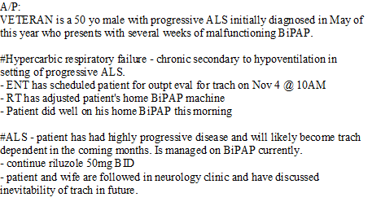

**(CAPRI notes submitted with claim)**

**Example #4**

Making a decision based only on the information shown in the screen shots below, and assuming completion of the entire VA Form 21-526 or 526EZ, does the submission meet the criteria for VA priority processing? Why or why not?

