Appeals Orientation
Trainee Handout

Table of Contents

Objectives 2
References 2
Topic 1: What is an Appeal? 2
Topic 2: Jurisdiction, objecitve, and composition of the appeals team 3
Topic 3: Common Appeals Terminology/Definitions/Forms 4
Topic 4: Stages in the Appeal Process 9
Topic 5: Appeals after Death 13
Topic 6: Correspondence with Representatives 13
Topic 7: Appeal End Products (EPs) 14
Attachment A: VA Form 21-0958, Notice of Disagreement 15
Attachment B: VA Form 9, Appeal to Board of Veterans’ Appeals 17
Attachment C: VA Form 8, Certification of Appeal 18
Attachment D: VA Form 646, Statement of Accredited Representative in Appealed Case 19
Attachment E: Request for Application for NOD Letter 20
Attachment F: Clarification of NOD Letter 22
Practical Exercise 23

Objectives
This lesson is intended to provide students with a basic overview of the appeals process. Additional appeals courses specific to topics covered in this lesson can be found in the VBA Learning Catalog. This lesson will contain discussions and exercises that will allow you to accomplish the following lesson objectives.

- identify and define an appeal
- define common appeals terminology and acronyms
- recognize common VA forms required during the appellate process
- understand appeal time limits
- identify a valid Notice of Disagreement (NOD)
- distinguish between the DRO review and the traditional review process
- identify the stages in the appeal process
- understand how an appellant’s death affects a pending appeal
- recognize deficiencies pertaining to communication with accredited representatives
- become familiar with EP credit taken for appeal actions

References
All M21-1 references are found in the Live Manual Website.

- 38 U.S.C. Chapter 71
- 38 U.S.C. Chapter 72
- 38 CFR 19
- 38 CFR 20
- M21-1, Part I, 5, Appeals
- M21-1, Part III, Subpart I, 1.5, Appeals Team
- M21-1 Part I, 5, D.2.a, Guide to SOC/SSOC, Laws & Regulation Citations
- M21-1 Part I, 3, General Information on Power of Attorny (POA)

Topic 1: What is an Appeal?
Topic objectives:
- Define an appeal, what an appeal consists of, and how an appeal preserves the date of claim.
- Identify the two most common types of disagreement.
Claimants not satisfied with decision(s) made by the local VA regional office on their claims for benefits may elect to have the decision(s) reviewed on appeal.
An appeal consists of a timely filed NOD in writing, and after a Statement of the Case (SOC) has been furnished, a timely filed substantive appeal.
An appeal preserves the date of claim.
The two most common types of disagreement are:
- Denial of service connection.
- Disagreement with an assigned evaluation.

Topic 2: Jurisdiction, objecitve, and composition of the appeals team
Topic objectives:
- Be able to discuss the overall objective of the appeal team and its role in the appeal process.
- Identify the composition of the appeals team.
- Understand who has jurisdiction of appeals at the regional office level and understand that remands from Board of Veterans’ Appeals (BVA) may also fall under the jurisdiction of the Appeals Management Center (AMC).

At the regional office level, the responsibility for appeals belongs to the appeals team. An issue on appeal should not be rated by the rating board.
If BVA determines a remand is in order, they will send the remanded appeal either directly to the AMC or the regional office for processing.
The appeals team’s primary objective is the expeditious processing of appeals and remands that do not fall under the jurisdiction of the AMC.
Responsibilities of the appeals team includes:
- establishing, monitoring, and updating appeals-tracking records
- developing and deciding issues on appeal and on remanded appeals
- certifying claims to BVA if the appeal cannot be resolved at the regional office level
- promulgating, authorizing, preparing, and mailing decisions to appellants
- communicating with BVA
The appeals team is a self-contained unit that is composed of essentially the same type of employees as a cross-functional team.
The appeals team is staffed with a coach and one or more:
- VSRs that have been cross-trained in both claim development and award promulgation
- SVRs and/or certified GS-11 VSRs
- Decision Review Officers (DROs)

Topic 3: Common Appeals Terminology/Definitions/Forms
Topic objectives:
- Define common appeals terminology.
- Recognize common appeals abbreviations.
- Differentiate between full grants and partial grants.
- Differentiate between a de novo review and traditional review.
- Understand the time limits for filing an NOD and a substantive appeal.
- Recognzie an SOC/SSOC and understand the required language for liberally construing evidence.
- Identify the roles of BVA, AMC, and CAVC.

Appellant | An appellant is a claimant who has initiated an appeal to the BVA by filing a timely notice of disagreement (NOD) with the agency of original jurisdiction (AOJ).
Decision Review Officer (DRO) | A senior technical expert whose duties include reviewing and deciding appeal cases; holding informal conferences and personal hearings with claimants/appellants; and, conducting de novo review or traditional review of claims on appeal.
De novo review | A new and complete review of the appealed issue with no deference given to the decision being appealed. It leads to a new decision which may be a full grant, partial grant, clear and unmistakable error (CUE), or no change.  An appellant has a right to de novo review of his/her claim if he/she files a timely NOD with the decision on a benefit claim, and either  - requests a de novo review at the time of submission of the NOD, or  - requests a de novo review within 60 days of the date VA sends the notice of the right to de novo review.
Full Grant | If the issue under appeal is initial service connection (SC), a full grant occurs when SC for the disability is granted.  If the issue under appeal is the evaluation of an already SC disability, a full grant occurs when the maximum benefit allowed by law and regulation is granted for the entire period under appeal.
Partial Grant | A partial grant of an issue on appeal occurs when the maximum schedular benefit allowed by law and regulation for the issue(s) under appeal is not granted for the entire period under appeal.  If the issue under appeal is initial SC, a partial grant cannot occur. The decision rendered must either involve a full grant or denial of the appealed issue.
Clear and Unmistakable Error | Errors that are undebatable, so that it can be said that reasonable minds could only conclude the original decision was fatally flawed at the time it was made.  A reversal of a prior decision on the grounds of CUE has the same effect as if the corrected decision had been made on the date of the reversed decision.
Downstream Issue(s) | Issue(s) which arises as a direct result of a favorable decision on an appealed issue and must be addressed by the decision maker.  A decision on a downstream issue may or may not confer a new appeal rights.
Inextricably Intertwined Issue(s) | An issue is inextricably intertwined with a matter(s) on appeal when a decision on that issue by the RO could have a significant impact on the matter(s) under appeal.  All matters that are inextricably intertwined must be adjudicated before any determination by BVA may be made.
Notice of Disagreement (NOD) | Prior to March 24, 2015, an NOD is written communication from a claimant or his/her representative expressing dissatisfaction or disagreement with a decision, and a desire to contest the result.  For compensation claims decided on or after March 24, 2015, VA Form 21-0958, Notice of Disagreement, must be used to file an NOD when the form is provided with the decision letter.  An NOD must be received within one year of the date of notification on a rating decision; 60 days on a contested claim.  Must be both valid and timely (postmarked or received by VA within the specified time limits)  If the NOD is not timely filed, appeal rights are required.
Contested Claims | Claims where two parties have an interest in the outcome. A grant of one claim requires the denial of the other claim and once claimant contest the award to the other claimant.  Typically involves apportionment, attorney fees, claims based on relationship, or two people claiming entitlement to the same benefit.
Formal Hearings | A recorded proceeding wherein a party presents sworn or affirmed testimony, other evidence, and/or argument relevant to an issue pending adjudication before a decision maker.  The appellant may elect to have a formal hearing at any time during the appeal process.  The DRO has no authority to participate in a formal hearing if he/she participated in the decision now under appeal.
Informal Conference | The purpose of an informal conference is to  - clarify the issue(s) the appellant wishes to appeal  - provide explanations regarding the rating decision  - identify additional resources of pertinent evidence.  A DRO cannot make or bargain with an appellant by requesting or requiring him/her to withdraw a claim or take any action in exchange for the granting of any benefit.  A claimant may request, cancel, or reschedule an informal conference in writing, by e-mail, by fax, by telephone, or in person.  The informal conference is scheduled and conducted at the discretion of the DRO.
Statement of the Case (SOC)  Additional Handout: Guide to SOC/SSOC Laws & Regulations Citations | Explanation of the decision made on an appellant’s case.  Provides an appellant with a complete understanding of the decision so the appellant can prepare an effective substantive appeal with specific allegations of errors of fact or law.  The following language is required in all SOCs:  “VA, in determining all claims for benefits that have been reasonably raised by the filings and evidence, has applied the benefit-of-the-doubt and liberally and sympathetically reviewed all submissions in writing from the (Veteran/claimant) as well as all evidence of record.”
Supplemental Statement of the Case (SSOC) | Presents the appellant with changes or additions to the SOC.  The changes and additions are usually based on additional evidence received:  - after the issuance of the SOC  - before or after receipt of a substantive appeal, or  - after a remand.
Substantive Appeal | Must be filed in response to the SOC in order to “perfect” or complete the appeal.  May be one of the following documents containing the necessary information as provided in 38 CFR 20.202  - VA Form 9, Appeal to the Board of Veterans' Appeals  - a statement at a formal hearing or informal conference reduced to writing, or  - written correspondence containing the necessary information.  The time limit for contested claims is 30 days. For all other claims, the substantive appeal must be received before the later of the following dates:  - the last day of the one-year period from the date VA mailed the decision notice of the issue being appealed, or  - 60 days from the date VA mailed the SOC or SSOC.
Remanded Appeal | An appeal that has been returned by BVA to the RO or AMC for  - development of additional evidence  - due process, or  - reconsideration of issues.  Remanded appeals are among the oldest cases and must be worked on a priority basis.
Veterans Appeals Control and Locator System (VACOLS) | VA’s computer application used to manage and locate appeals.  Effective tracking of appeals requires accurate and timely updates of VACOLS each time the end user takes action on a pending appeal.  Reference: For more information on VACOLS, see the VACOLS User’s Guide.
Board of Veterans Appeals (BVA) | BVA is part of VA and is located in Washington D.C.  Members of the Board review benefit claims determinations made by the local VA offices and issue decisions on appeals. These law judges are the only ones who can issue Board decisions.
U.S. Court of Appeals for Veterans Claims (CAVC) | CAVC is part of the U.S. judiciary and not part of the VA.  The court has exclusive jurisdiction over decisions made by BVA.  The court reviews Board decisions appealed by claimants who believe the Board erred in its decision.
VA Form 9, Appeal to Board of Veterans’ Appeals | The form used to file a substantive appeal to BVA.  Should be reviewed for new issues, not formally on appeal, that may be considered a request for application or a request for notice of disagreement.
VA Form 8, Certification of Appeal | The form used to certify an appeal to BVA.  Only the issues on appeal should be cited on the form.  If the appeal is enlarged to include additional issues, certify all inextricably intertwined issues on appeal to BVA.
VA Form 646, Statement of Accredited Representative in Appealed Case | Provided to the appellant’s accredited representative once all development for the pending appeal is complete, and prior to certification to BVA.  Gives an appellant’s accredited representative an opportunity to review the appeal and submit a statement regarding the appeal.

Topic 4: Stages in the Appeal Process
Topic objectives:
- Understand how the appeals process flows beginning the moment an original application for benefits is received and concluding with an appeal to the U.S. Supreme Court.
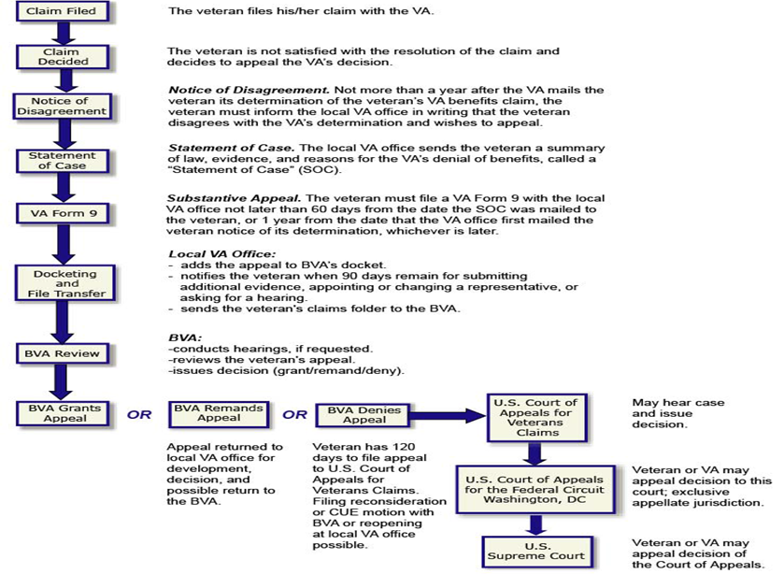
Appeals Flow Chart: Stage One | Appellant files a timely NOD in response to a VA decision regarding claimed benefits, and may elect either a DRO review process or the traditional review process.  If the NOD is not complete or submitted on the appropriate form, the claimant is notified and must provide the completed form within:  - 60 days from the date of request, or  - the remainder of the 1 year period from the mailing of the notice of decision from AOJ, whichever is later.
Appeals Flow Chart: Stage Two | NOD is accepted if no further clarification is needed. If multiple issues are on the rating decision, the claimant must specify which issue or issues are being appealed, or state that all issues are being appealed.  VACOLS record must be established within 7 days to control and track the appeal.  If the appellant does not elect an appeals review option with their NOD, a letter is sent giving them the option to elect either the DRO de novo review process or the traditional review process.
Appeals Flow Chart: Stage Three | Appellant elects either the DRO de novo review process, or traditional appellate review process.  If the appellant does not elect the DRO de novo review process on the NOD or within 60 days of VA notification of the right to this process, the appeal proceeds in accordance with the traditional appellate review.
Appeals Flow Chart: Stage Four | Based on the appellant’s choice, one of the following review process is conducted:  - traditional appellate review (which may be conducted by a VSR, RVSR, or DRO)  - de novo review (which may only be conducted by a DRO or VSCM/PMCM)
Appeals Flow Chart: Stage Five | After reviewing the claims file, the appeals rating activity determines if a change is warranted in the decision.  If a change is warranted on all issues, the appeals rating activity  - issues a new rating decision and includes a complete statement of facts in the new decision with any discussion needed to clearly show the basis for changes made.  If a change is warranted on only some issues, the appeals rating activity  - issues a new rating decision  - issues an SOC confirming the decision on appeal and explaining the reasons for the VA decision, and  - sends a VA Form 9 to the appellant
Appeals Flow Chart: Stage Six | The appellant returns VA Form 9 or a substantive appeal in lieu of VA Form 9 within the applicable time frame (perfecting the appeal).  May elect a local hearing, before a DRO at the RO or jurisdiction, or one of the following types of BVA hearings.  - travel board  - videoconference, or  - in person in Washington D.C.
Appeals Flow Chart: Stage Seven | Appeals rating activity sends an SSOC to the appellant if  - VA received additional evidence, and  - the appellant requests, in writing, that VA performs an initial review of the evidence, and  - gives the appellant 30 days to reply before the appeal is sent to BVA.  No reply is necessary from the appellant once a substantive appeal is received.  Without a written request from the appellant, VA’s initial review of additional evidence is waived.
Appeals Flow Chart: Stage Eight | The DRO, VSCM or PMCM, or his/her designee certifies the case to BVA by  - reviewing the claims file  - verifying that  - all issues on appeal have been decided  - all non-appeal issues that are inextricably intertwined with appeal issues have been properly addressed  - all necessary development is complete  - the accredited representative was given the opportunity to execute and return VA Form 646  - completing the Appeal Certification to BVA worksheet, and  - completing and signing VA Form 8, Certification of Appeal.
Appeals Flow Chart: Stage Nine | Once certification of the appeal is complete, the appeals development activity  - transfers the paper claim folder to BVA (if applicable), and/or  - utilizes the appeals Caseflow tool.  The Caseflow tool is a simple, web-based tool primarily intended to ensure that paperless appeals which are transferred from an RO to the Board have all the required documents (NOD, SOC, SSOC, Form 9) in their respective VBMS e-folder and have consistent correct certification.
Appeals Flow Chart: Stage Ten | BVA either:  - issues a decision granting or denying the benefit for all issues on appeal, or  - issues a decision granting or denying some of the issues on appeal and remands other issues, or  - remands all of the issues on appeal to the RO or the AMC for additional action.
Appeals Flow Chart: Stage Eleven | If BVA issues a decision, then the following actions occur  - RVSR or DRO issues a rating decision, if necessary, implementing BVA’s decision  - VSR processes the RVSR/DRO decision, and  - VSR closes out any pending VACOLS records.  If BVA remands the case to the RO or AMC, then VSR, RVSR, or DRO  - performs additional development, and  - issues a new decision.  If the new decision does not fully grant the benefit on appeal, the appeals rating activity  - prepares an SSOC, and  - returns the case to BVA.
Appeals Flow Chart: Stage Twelve | BVA issues a final decision in a remanded case.  Case is returned to the RO for review/processing.
Appeals Flow Chart: Stage Thirteen | The appellant may appeal the final BVA decision to the U.S. Court of Appeals for Veterans Claims (CAVC) within 120 days of the date of decision if he/she is not satisfied with BVA’s decision.

Topic 5: Appeals after Death
Topic objectives:
- Understand how an the death of an appellant who has an appeal pending before BVA is handled.
- Understand what happens to an appeal when death occurs during the one year appeal period.

Appeals pending before BVA at the time of the appellant’s death do not survive the appellant’s death; unless a person who is eligible for accrued benefits requests to proceed with the decedent’s claim or appeal.
If the Veteran’s death occurs within the one-year period in which any NOD may be filed, the RO’s decision subject to that potential appeal becomes final. An accrued decision is based on the evidence of record that existed in the claim folder at the time of death.

Topic 6: Correspondence with Representatives
Topic objectives:
- Understand that it is required to provide notice of communications and/or access to the eFolder for the accredited representative.

Ex-parte communications, or communication with the appellant without providing correspondence to the representative is prohibited and may result in litigation against the VA.
Unless representation is limited by the claimaint, representatives are entitled to notice of any VA decisions affecting the payment of benefits or relief sought by claimants whom they represent. Representatives also must receive other forms of correspondence sent to claimants, to include, but not limited to:
- decision notices
- SOC/SSOCs
- notification of certification of transfer of appeals to BVA
- incomplete application notices, and
- request for information and evidence needed to substantiate a claim.

Ensure:
- Attorneys are sent copies of ALL correspondence on the claim/appeal for which they represent the Veteran.
- Telework employees are having correspondence mailed in a tiemly fashion.
- All correspondence is addressed to the private attorney’s physical address.
- The POA code at the bottom of letters is changed from 099/066 to the attorney’s name.
Once an NOD is filed, direct contact with a represented claimant on matters that are not simply ministerial may improperly interefere with the appellant’s statutory right to retain counsel.

Accordingly, contact with the claimant’s representative on any non-ministerial matters after an NOD is filed should be completed and documented on VA Form 27-0820. In addition, any contact with a represented appellant should be documented on VA Form 27-0820, made a part of the evidence of record, and copied to the representative.
Since most private attorneys and claims agents do not have access to the full eFolder, the RO must send all accredited private attorneys or claims agents a copy of any correspondence regarding the claim they represent.

All VA personnel handling special correspondence from an accredited representative requesting the status of the appeal should expedite processing the request and maintain appropriate controls to ensure prompt reply or acknowledgement.

Topic 7: Appeal End Products (EPs)
Topic objectives:
- Identify the EPs to use during adjudication of an appeal to determine appropriate work credit.

EP 170: Appeal Control – established within 7 days of receipt of an NOD and substantive appeal to control the appeal. EP 170 is is not for credit purposes.
Please refer to the “Guide to Appeals End Products” Job Aid for further information regarding the following appeals EPs:
EP 070: Appeals Processing
EP 172: Statement of the Case / Grant of Benefits
EP 173: Hearings Conducted by an Employee other than a DRO / Informal DRO Hearings
EP 174: Hearings Conducted by DRO / Decisions

Attachment A: VA Form 21-0958, Notice of Disagreement
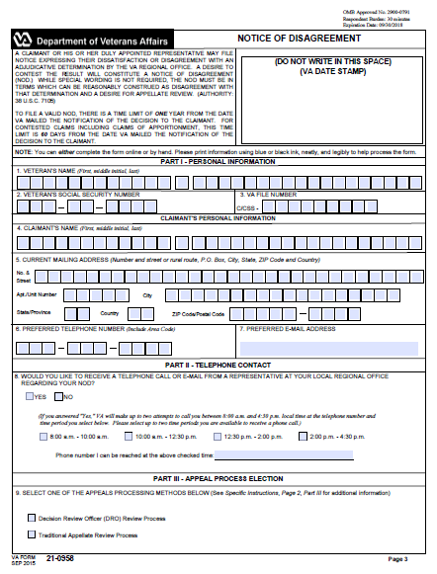
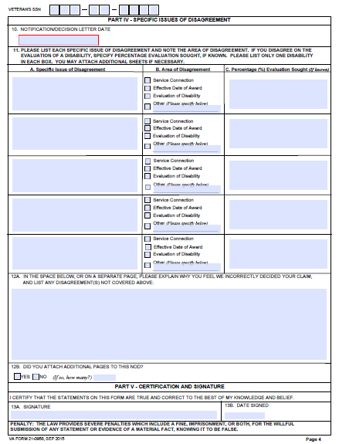

Attachment B: VA Form 9, Appeal to Board of Veterans’ Appeals
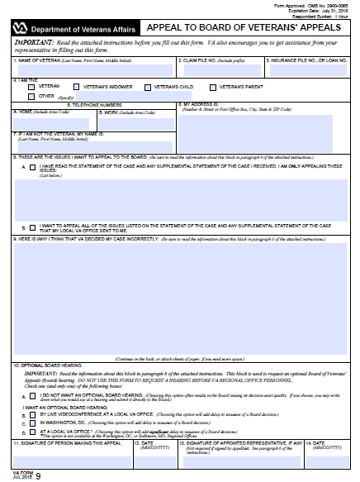

Attachment C: VA Form 8, Certification of Appeal
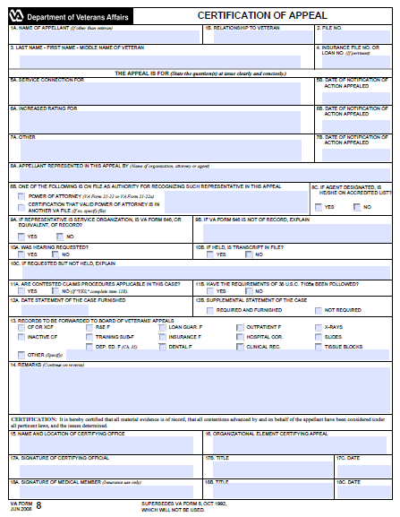

Attachment D: VA Form 646, Statement of Accredited Representative in Appealed Case
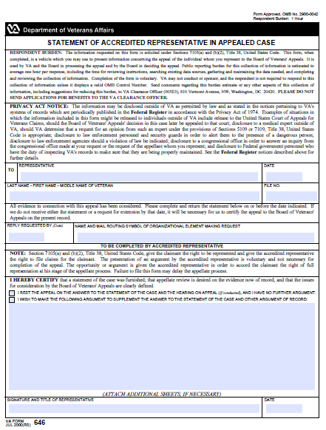

Attachment E: Request for Application for NOD Letter
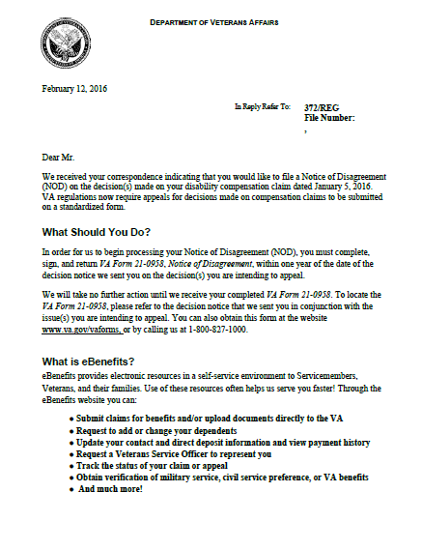

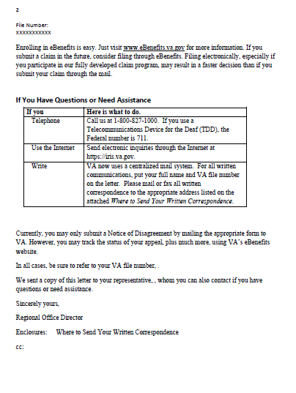

Attachment F: Clarification of NOD Letter
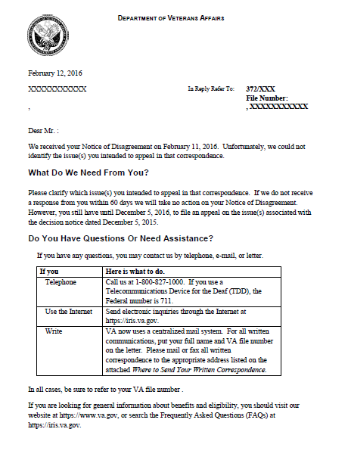

Practical Exercise
Directions: Answer the following questions.

scenario 1: | Rating decision dated April 15, 2015 granted service connection for bilateral hearing loss at 0 percent disabling. The Veteran was notified by decision letter dated April 22, 2015, provided VA Form 4107, and VA Form 21-0958.  On August 4, 2015, the Veteran submitted a VA Form 21-4138, Statement in Support of Claim, indicating notice of disagreement with the evaluation by stating his hearing impairment is of such severity that a compensable evaluation should be warranted.  - Is the NOD valid and timely filed? Why or why not?  - Describe what action appeals activity must take in response to the NOD.  - Would the VA Form 21-4138 be considered a valid and timely filed NOD if the notification letter dated April 22, 2015, did not provide a VA Form 21-0958?
scenario 2: | Rating decision dated January 15, 2015 granted service connection for bilateral hearing loss at 0 percent disabling and bilateral tinnitus at 10 percent disabling. The Veteran was notified by decision letter dated January 22, 2015.  On January 5, 2016, the Veteran submitted a VA Form 21-0958, Notice of Disagreement, but did not identify the disability(ies) that he/she wished to appeal.  A “clarification of NOD” letter was sent to the Veteran on January 10, 2016. The Veteran returned a completed VA Form 21-0958 on March 3, 2016, identifying disagreement with the evaluation of bilateral hearing loss.  - Is the NOD valid and timely filed? Why or why not?
scenario 3: | Rating decision dated March 15, 2015 granted service connection for bilateral hearing loss at 0 percent disabling. The Veteran was notified by decision letter dated March 17, 2015.  VA Form 21-0958, Notice of Disagreement, received on August 23, 2015. The Veteran identified the evaluation of bilateral hearing loss as the contention of disagreement.  A SOC was issued on November 22, 2015, and the Veteran was furnished a VA Form 9, Appeal to the Board of Veterans’ Appeals.  The Veteran returned VA Form 9 on January 20, 2016.  5. Did the Veteran timely perfect the appeal? Why or why not?
true or false: | 6. The appeal process can only begin after a decision has been made and we have notified the claimant of that decision.  7. An NOD must be received on VA Form 21-0958 for a decision rendered on or after March 24, 2015, if the form was provided with the notification letter.  8. Due to the overwhelming appeals backlog, appellants do not have a choice between a de novo review or the traditional appellate process, but must accept whichever is most expeditious.  9. The traditional appellate review means that the issues under disagreement and only the evidence relating to them will be reviewed and can be conducted by either an RVSR or DRO.  10. If the appellant received an SOC and continues to disagree with the decision, they must file a VA Form 9 or equivalent, to continue the appeal.  11. EP 172 must be established upon receipt of an NOD and substantive appeal.  12. If the Veteran’s death occurs within one year of receiving notification of a VA decision, and no NOD had been received from the Veteran prior to his/her death, the RO’s decision becomes final.

