Quality reviews development
Trainee Handout

Table of Contents

Objectives 2
References 3
Topic 1: Quality reviews development 4
Topic 2: National quality review 5
Topic 3: Local quality review 6
Topic 4: Star checklist 8
Topic 5: Systems compliance 12
Topic 6: Appeals process 13
Job Aid: Rating EP Aspen Screenshot 14
Attachment A: Star Authorization Quality Review Checklist 16
Practical Exercise 20

Objectives
- Understand the purpose of a Quality Review
- Differentiate between national and local quality review
- Recognize the duties of the Quality Review team
- Identify the elements of a quality review checklist
References
- M21-4 Chapter 3: National Quality Reviews
- FL 13-18: Overview of Quality Review Teams
- October 2014 Compensation Service Bulletin

Topic 1: Quality reviews development

Purpose
Effective quality reviews and positive action to improve quality levels are required for all compensation claims. Methods used to determine quality levels and improve quality on an organized technical basis vary and are described in the following subchapter. The methods may consist of
- regular supervision and training
- mandatory or optional reviews and spot checks
- controls of various kinds including cost controls or formal control procedures such as the Systematic Technical Accuracy Review (STAR) program, and
- special focused quality improvement reviews.

Topic 2: National quality review

National Quality Review

STAR is the Veterans Benefits Administration’s (VBA) national program for measuring compensation claims processing accuracy. STAR includes review of work in two areas
- claims that usually require a rating decision, and
- claims that generally do not require a rating decision.
Note: STAR results are generated for all of VBA’s regional offices (ROs) and are included in both the station’s and the RO Director’s Performance Dashboards.

The quality review system is intended to assist managers in monitoring the level of service to claimants. This system requires that quality observations and reviews be performed on a continuing basis in all areas of Veterans Service Center (VSC) operations.
Note: The quality review system does not require that evaluations encompass every work team within the VSC.

Topic 3: Local quality review
Local Quality Review

The QRT is comprised of dedicated Quality Review Specialists (QRS) whose sole purpose is to improve the quality of claims processing by evaluating station quality, identifying error trends, and ensuring individual employee reviews are performed monthly. To reach the strategic goal of 98% accuracy by 2015 and to implement non-punitive “in-process reviews,” each regional office (RO) implemented QRTs.

In addition to improved quality, the QRT is expected to decrease the amount of rework performed on cases and improve timeliness of claims processing. RO production will improve as benefit entitlement accuracy improves, as expected.

Types of Reviews

There are two main quality reviews:

Individual Quality Reviews (IQRs) – the review of five randomly-selected cases per month (on average) for those Veterans Service Representatives (VSRs), Rating Veterans Service Representatives (RVSRs), and Decision Review Officers (DROs) who have a quality element in their performance standards. This review determines the employee’s individual quality level as part of his or her overall performance evaluation.
In-Process Reviews (IPRs) – a review designed to correct deficiencies throughout the claims process prior to promulgation and identifies training opportunities. Immediate feedback will be provided to employees so that prompt corrective action can be taken to resolve deficiencies. This feedback should be in the form of a face-to-face discussion to explain the deficiency in detail, and provide citations and training to reinforce the correct action. These reviews are non-punitive and will not be used for individual performance management purposes.

Additional Duties of the QRT

Other areas in which QRT may be involved are:

- Implement results of feedback provided from Compensation Service such as STAR, or from training provided from inter-rater reliability studies (IRRS) and consistency questionnaires
- Provide specific training recommendations, at the employee level and station level, to improve quality based on the results of reviews
- Work in coordination with the RO Training Manager and/or VSC Training Coordinator to plan, direct, and identify who should conduct the training. This training may be recorded as station-determined training utilizing topics identified in the National Training Curriculum. If there is not an already established TMS number, the station’s Training Manager may contact the Compensation Service Training Staff to request the addition of the selected item to the curriculum.
- Conduct monthly meetings with station leadership and Training Manager to identify trends and specific recommendations
- Work with Training Managers at VSCs to create and provide specific training identified by error trends and analysis
- Work with Training Managers at ROs to ensure training was recorded in TMS
- Track improvements after corrective actions are taken and follow-up with continuous monitoring. Increased emphasis placed on quality reviews and training will encourage the importance of quality and continuous improvement.
- Provide positive feedback to employees if quality is improved
- Share all national STAR errors called on the station, as well as all local errors with Training Manager and Veterans Service Center Manager (VSCM).
- Use national and local results to identify recurring issues at the individual or team level that require additional training
- It may be advantageous to allow QRT personnel to maintain their technical skill set by working production work on overtime. Any production work completed by a QRS on overtime is subject to quality review from the team supervisor or designee.
- Attend QRT Challenge training. Additionally, it is strongly recommended that QRS employees complete the Instructor Development Course (IDC).

Topic 4: Star checklist
Checklist for Quality Reviews

The STAR process requires a comprehensive review and analysis of all elements of processing associated with a specific claim or issue. STAR checklists are designed to facilitate consistent structured reviews.
The Rating and Authorization checklists classify errors into three categories
- Benefit Entitlement
- Decision Documentation/Notification, and
- Administrative.

General Guidelines
The general guideline is to record an error when an action taken violates current regulations or other directives and affects outcome, or has the potential to affect outcome.
Examples of outcome-related deficiencies include, but are not limited to
- errors that result in an overpayment or underpayment to a claimant
- procedural deficiencies that violate the claimant’s due process rights, and
- deficiencies which would result in a remand from the Board of Veterans Appeals (BVA) if not corrected.
Note: The deficiencies include all items listed under Benefit Entitlement on the STAR Checklist for rating and authorization.

STAR Checklist Categories
STAR reports reflect claims processing accuracy in two separate review categories for rating and authorization reviews. These categories are Benefit Entitlement and Decision Documentation/Notification.

A-Address All Issues I-Due Process Issues
B- Proper Development J- Denials
C-Income Issues K-Notifications
D-Dependency Issues L- Appropriate Signature
F-Accrued Benefits Issues
G-Adjustments
H-Payments & Effective Dates
Applicable to Pre-Determination Quality Review

BENEFIT ENTITLEMENT
ADDRESS ALL ISSUES | The reviewer must insure that all issues associated with the claim under review have been considered.
A1) Were all claimed issues addressed? | A “claimed issue” is any benefit specifically mentioned by the applicant or his/her representative. Since a claim may be received through any means of communication, each document in the hard copy file and/or electronic file must be checked to ensure that all issues have been addressed.
A2) Were all inferred issues addressed? | An “inferred issue” is not defined by regulation. An “inferred issue” is often derived from the consideration or outcome of a “claimed issue.” The Veterans Court has stated that “An issue may not be ignored or rejected merely because the Veteran did not expressly raise the appropriate legal provision for the benefit sought.”

PROPER DEVELOPMENT
B1) Was a development letter sent, addressing duty to notify (if applicable), and evidence requirements, for the claimed issues? | 38 CFR 3.159 states that upon receipt of a substantially complete application, VA is required to notify the claimant and the claimant's representative, if any, of any information, and any medical or lay evidence, not previously provided that is necessary to substantiate the claim. As part of that notice, VA is required to indicate which portion of that information and evidence, if any, is to be provided by the claimant and which portion, if any, VA will attempt to obtain on behalf of the claimant.
B2) Does the record show development, properly documented prior to final action on the claim (i.e., complete letters, VA Form 27-0820, Report of Contact, etc.)? | Have reasonable efforts been made to obtain the necessary evidence after the claim was established in order to complete the claim.
B3) Was the proper procedural process accomplished? | Procedural errors are considered errors with regard to manual direction but not specified by regulations and rising to the level of benefit entitlement error.

ADMINISTRATIVE DECISIONS
DENIALS
J1) Admin – Grant or Denial – Was all applicable evidence discussed? | Question J1 is self-explanatory.
J2) Admin – Grant or Denial – Was the basis of each decision explained? | Question J2 is self-explanatory.
J3) Were required formal admin decisions completed and correct (apportionment, deemed valid marriage, character of discharge, etc.)? | 38 CFR 3.450 through 3.461 contains the basic rules for apportionment decisions. The specific requirement for a formal apportionment decision, for both favorable and unfavorable decisions, is found in M21-1, Part III, Subpart v, 3 and M21-1, Part III, Subpart v, 8.B.

NOTIFICATION | 38 CFR 3.103 contains the basic rule. Claimants and their representatives are entitled to timely notice of any decision made by VA. This rule applies to both awards and disallowances.
K1) Was notification sent and documented in the file? | Notification may be placed in claims folder or in the electronic record(s). The appeal period does not begin until the claimant and representative are notified of the decision.
K2) Was the notification correct? | Correspondence is VA’s primary communication medium. Information must be complete and accurate.
K3) Were appeal rights included? | Notice of procedural and appellate rights is required following every decision.
K4) Was Power of Attorney indicated, correct, and notification properly documented? | The Corporate record should be updated to include designation of the claimant’s representative so computer-generated notices are furnished to both.

ADMINISTRATIVE
APPROPRIATE SIGNATURE (INTERNAL CONTROL) | The appropriate signature has been added for internal control purposes only. It is a means of checks and balances to eliminate potential fraud situations.
L1) Was the appropriate second signature documented? | This question typically relates to an administrative decision.
L2) Were three signatures appropriately documented when required? | This question typically relates to an administrative decision

Topic 5: Systems compliance
Systems Compliance Guidance
With the multiple transitions between VSR standards, there continues to be confusion in the field in regard to the S1 – Systems Compliance error included in Individual Quality Reviews (IQRs) for VSRs. To ensure consistency between all QRT members utilizing the current VSR standard, we have made some changes to how S1 errors will be called. QRSs will use the following, updated list to call S1 errors:
- Is the date of claim and end product correct?
- Are all the payees' addresses (including direct deposit information) correct?
- Are all periods of service for the Veteran verified and updated in all systems?
- Was the Power of Attorney (POA) information/access updated in all systems and correspondence?
- Were special issues and flashes entered and correct?
- Were contentions and classifications entered correctly?
- Were tracked items entered and updated as necessary?
- Was the claim status (Ready for Decision (RFD), Rating Decision Complete (RDC), OPEN) updated appropriately?
- Were the suspense dates (tracked item or claim level) updated and correct?
- Regional Offices are required to utilize this list when calling S1 errors. Local guidance will not be used to call S1 – System Compliance errors. This guidance does amend the previous directive issued in February of 2014.

Topic 6: Appeals process
Request for Reconsideration-National
It is anticipated that occasionally ROs may receive a review result with which they disagree or believe the explanation offered is unclear or inadequate. Any basic disagreement over the correctness of a call must be formally addressed.
If an RO believes an erroneous error call has been made, the case may be returned for a formal reconsideration by the QA Staff under the direction of the Quality Assurance Officer (QAO). To request reconsideration of an error, prepare a memorandum to the QA Office stating the basis for the request for reconsideration.
Requests for reconsiderations must be submitted within 10 business days. The 10-day period for rating and authorization will begin with the date the RO receives the file or is notified that an electronic review has been completed. QA Staff maintains an official grace period of 10 days for paper cases after the prescribed 10-day period, which begins when the station receives the paper folder from the QA Office.

Appeal Process-Local
Some stations have worked with their local union to devise an appeal process for disagreements on error calls that impact an individual’s performance. For stations where this is the case, the error’s verification will be resolved based on the locally determined procedures. If there is no locally bargained agreement in place, the following procedures apply if an employee disagrees with an error call involving his/her IQR:
- The employee has 5 business days after being notified of an error to express disagreement in writing. Employee must provide manual and/or regulation citation or other appropriate reference to support rebuttal of error call, in his/her written disagreement.
- Disagreements with error calls more than 5 business days after notification will not be entertained except in rare circumstances as determined by the QRT coach or designee.
- Employee and QRS will discuss the error in an attempt to resolve differences of opinion.
- Employee must provide manual and/or regulation citation or other appropriate reference to support rebuttal of error call, in writing
- If QRS and employee do not reach agreement on the error, the error will be resolved by locally determined procedures.
- The employee will be notified of the final decision in writing; the only basis for overturning an error is because the QRT’s manual and/or regulation citation or other reference used to support the error call was incorrect.

Job Aid: Rating EP Aspen Screenshot

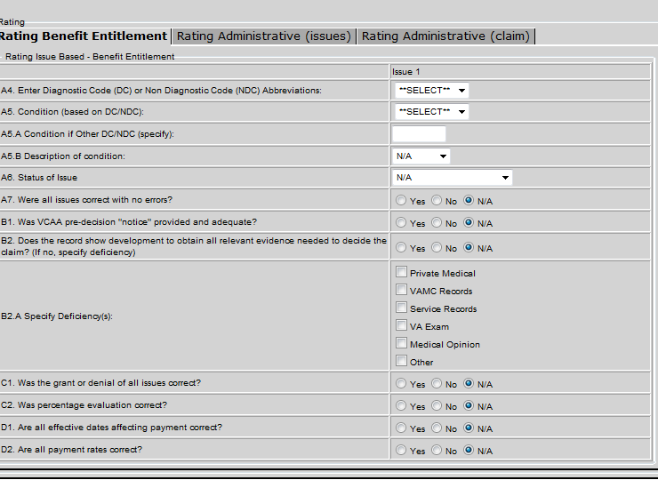
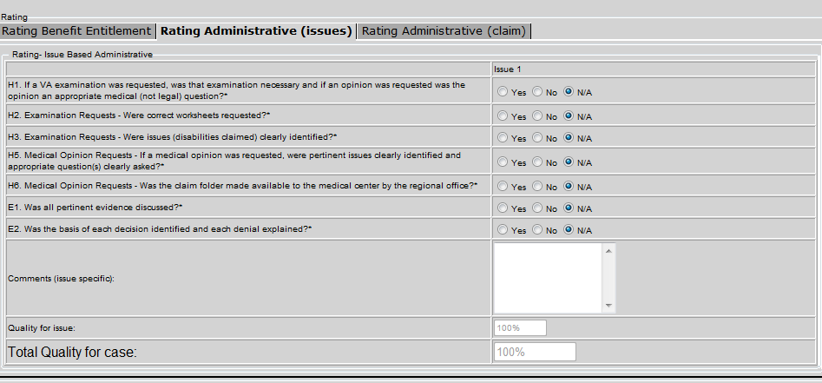
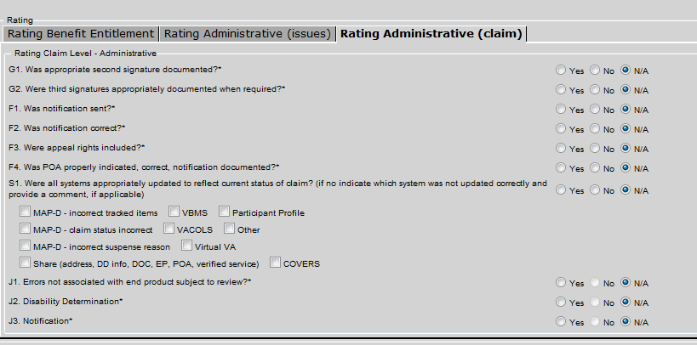

Attachment A: Star Authorization Quality Review Checklist
The following is a sample of the authorization checklist.
Regional Office Number ____________ | Claim Number______________
End Product _________________________ | Veteran’s Name _______________

Authorization Checklist

 |  |  |  |  | YES |  | NO |  | N/A
 | BENEFIT ENTITLEMENT
 | Address All Issues
 | A1) Were all claimed issues addressed?
 | A2) Were all inferred issues addressed?
 | Proper Development or Procedural Issues
 | B1) Was a development letter sent, addressing duty to notify (if applicable) and evidence requirements, for the claimed issues?
 | B2) Does the record show complete development, properly documented prior to final action on the claim (i.e., complete letters, VA Form 27-0820, Report of Contact, etc.)?
 | B3) Was the proper procedural process accomplished?
 | Income Issues
 | C1) Was Net Worth determination correct?
 | C2) Was total family income counted properly and/or in the correct reporting period?
 | C3) Were all deductions, including unreimbursed medical expenses, calculated correctly?
 | Dependency Issues
 | D1) Was a dependent spouse correctly established or removed? (38 CFR 3.50)
 | D2) Were dependent children correctly established or removed? (38 CFR 3.57 and 3.667)
 | D3) Were dependent parents correctly established or removed? (38 CFR 3.59)
 | D4) Was a surviving spouse correctly established or removed? (38 CFR 3.50(b))
 | D5) Were surviving children correctly established or removed? (38 CFR 3.57)
 | Accrued Benefits Issues
 | F1) Was the proper claimant paid?
 | F2) Was the correct amount paid?
Adjustments (Hospital, Incarceration, Active Duty, or Drill Pay)
G1) Were required adjustments accomplished and correct?
G2) Was restoration of benefits correct?
Payment & Effective Dates
H) Are all payment dates and rates correct?
DUE PROCESS/ADMIN DECISIONS/NOTIFICATION
Due Process Issues
I1) Was a predetermination notice sent?
I2) Was the predetermination notice fully informative?
I3) Was claimant given 60 days before the due process period expired?
Administrative Decisions
J1) Admin – Grant or Denial – Was all applicable evidence discussed?
J2) Admin Grant or Denial – Was the basis of each decision explained?
J3) Were required formal apportionment decisions completed and correct (apportionment, deemed valid marriage, character of discharge, etc.)?
Notification
K1) Was notification sent and documented in the file?
K2) Was the notification correct?
K3) Were appeal rights included?
K4) Was Power of Attorney indicated, correct and notification properly documented?
ADMINISTRATIVE
Appropriate Signature (Internal Control)
L1) Was the appropriate second signature documented?
L2) Were third signatures appropriately documented when required?
 | Comments | YES
 | M1a) Errors not associated with end product under review
 | M1b) Development Errors not associated with end product under review
 | M1c) Decision Errors not associated with end product under review
 | M1d) Payment Errors not associated with end product under review
 | M1e) Comment for all other actions not associated with end product under review
 | M1f) Notification Errors not associated with end product under review
 | M2) Notification Errors - end product under review
 | Special Case Identification
 | N1) Brokered Case |  | Regional Office: | Resource  Office:
 | N1) Brokered Case |  | None selected | None selected
 | N2) Pension Management Center Case
 | N3) PLCP
FOR EACH “NO” ANSWER RECORDED, PROVIDE A BRIEF NARRATIVE SUMMARY OF THE ERROR AND STATUTORY, REGULATORY, JUDICIAL OR MANUAL REFERENCES ON THE REVERSE OF ATTACHED NARRATIVE SUMMARY SHEET. NOTE: DATE OF CLAIM ERRORS DO NOT REQUIRE CITATIONS ON THE STAR CHECKLIST.

Practical Exercise

Please complete the following review questions. You may use your reference material.
- What is the purpose of the Quality Review System and what does the system require?

- What is the Quality Review Team (QRT) is responsible for determining?

- Individual employee reviews are performed on a ____ basis:

- Daily
- Annual
- Weekly
- Monthly

- Define the two types of main quality reviews?

- Match the STAR Checklist categories to their correct letter identifier:

  - Benefit Entitlement
  - Proper Development of Procedural Issues
  - Administrative Decisions
  - Notification
  - Systems Compliance

- A Systems compliance error cannot be called if a special issue or flash is not entered and correct? (True/False)

- Provide the types of Notification errors that are part of the Pre-Determination Quality Review?

