Processing Ratings Decisions
Trainee Handout

Table of Contents

Objectives 2
References 3
Topic 1: Denial Ratings 4
Topic 2: Service Connected Grant Rating Decision 5
Topic 3: Confirmed and Continued Rating Decision 9
Job Aid 1: Additional Benefits and Required Forms 10
Job Aid 2: Post-D Check List 12
Attachment: Sample Rating Decision 13
Processing Rating Decision Example 16
Practical Exercise 21

Objectives
PREREQUISITE TRAINING: |  |  | This is an entry level VSR Course.
 | TMS # | 4175973
OBJECTIVES: |  |  | The purpose of this lesson is:  - To introduce the process involved with promulgating rating decisions  - To define Denial Rating Decisions  - To define and identify 0-20% and 30% or higher Rating Decisions  - To define Confirmed and Continued rating decisions  - To accurately identify what type of action is needed to process each type of Rating Decision.  - To demonstrate how to create a notification letter to the Veteran using VBMS-A/ADL or PCGL
Time Required: |  |  | 4 hours: by lecture, class participation, and demos

References

- Rate Tables
- M21-1. Part III, Subpart iv, Chapter 6 Section D – Codesheet Section
- M21-1, Part III, Subpart v.2.A, Decision Authorization
- M21-1, Part III, Subpart v.2.B, Decision Notices
- M21-1, Part III, Subpart v.2.B, Notification Requirements

Topic 1: Denial Ratings

The characteristics of a generated award and notification letter for Denial Rating Decisions.
Denial Rating Decisions
- Entitlement to service connection is not granted
- If there is a previous denial rating for a condition (This will be indicated as a “previously denied condition, and remains denied.”)
- Award will result in a zero net effect (no monetary compensation)
- Example of Denial decision text:
  - Service connection for (condition)… ” “… is denied.”
Important note when a rating is complete:
* Once a rating on service connection is completed, dependency information submitted on a VA Form 21-526, VA Form 21-686c, and/or VA Form 21-674, requires a decision from the VSR even when the Veteran is less than 30% service-connected

Topic 2: Service Connected Grant Rating Decision

The characteristics of a service connected award and notification letter for combined evaluation of 0% to 20% rating decisions.

What initiates a 0-20% service connected rating? Any claimed disability that is granted service connection.

- Compensable evaluations of 10% to 20% or
- Non compensable evaluations of 0% or
- 10% based on multiple 0% under (38 CFR 3.324)

Characteristics of a 0-20% rating decision

- Claim Types:
  - Original,
  - Non-Original
  - New condition, Increase, Secondary, Reopen grant

What to look for when processing a 0-20% rating decision

- Check rating decision for the following:
    - Date of claim
    - Effective Dates
    - Payment dates
    - Reason for decision
    - Consistency with issues claimed (i.e. § 5103 notice)

What to look for in the system for processing a 0-20% rating decision

- Check SHARE/VBMS for the following:
- Correct Veteran and C-Number
- Name and Address of Veteran
- Correct Date of claim
- Changes in dates
- Consistency with last rating, if applicable
- Military Payment Information to include Retired Pay, Severance or Separation Pay
- Rating decision conditions matches VBMS-A/VETSNET data

Notification Letter Requirements

- Notification Letter: ADL/PCGL format for Grant, Increase and 0% combined. If a notification letter cannot be completed in ADL, the notification letter must be done in PCGL

(Please see VBMS-A Tip sheet of September 6, 2013 -Uploading VETSNET Awards and PCGL Decision Notification letters into VBMS to upload VETSNET Awards and PCGL decision notification letters into VBMS)

- The decision made
- A summary of the evidence considered
- Reason for the decision
- Include payment information
- Any benefits being withheld and the reason for the withholding
- A notice of procedural due process and appellate rights of the claimant
- Include additional benefits, if applicable

- Once a rating on service connection is completed, dependency information submitted on a VA Form 21-526, VA Form 21-686c, and/or VA Form 21-674, requires a decision from the VSR even when the Veteran is less than 30% service-connected.

This is accomplished by adding the dependents in SHARE/VBMS and adding on the award as “not an award dependent” in VBMS-A.

The characteristics of a service connected award and notification letter for combined evaluation of 30% Rating Decisions or Higher

What initiates a 30%or higher service connected rating? Any claimed disability that is granted service connection.

- Compensable evaluations of 30% and higher or
- Can be Individual Unemployability or
- Can be Permanent and Total and entitled Ancillary Benefits

Characteristics of a 30% or higher rating decision

- Claim Types:
  - Original,
  - Non-Original
    - New condition, Increase, Secondary, Reopen grant

What to look for when processing a 30% or high rating decision

- Check rating decision for the following:
    - Date of claim
    - Effective Dates
    - Payment dates
    - Reason for decision
    - Consistency with issues claimed (i.e. § 5103 notice)

What to look for in the system for processing a 30% or higher rating decision

- Check SHARE/VBMS for the following:
    - Correct Veteran and C-Number
    - Name and Address of Veteran
    - Correct Date of claim
    - Changes in dates
    - Consistency with last rating, if applicable
    - Military Payment Information to include Retried Pay, Severance or Separation Pay
    - Rating decision condition matches VBMS-A/VETSNET data
    - Dependency information

Notification Letter Requirements

- Notification Letter: ADL/PCGL format for Grant, Increase and 0% combined. If a notification letter cannot be completed in ADL, the notification letter must be done in PCGL

(Please see VBMS-A Tip sheet of September 6, 2013 -Uploading VETSNET Awards and PCGL Decision Notification letters into VBMS to upload VETSNET Awards and PCGL decision notification letters into VBMS)

    - The decision made
    - A summary of the evidence considered
    - Reason for the decision
    - Include payment information
    - Any benefits being withheld and the reason for the withholding
    - A notice of procedural due process and appellate rights of the claimant
    - Dependency Information
    - Include additional benefits, if applicable

Topic 3: Confirmed and Continued Rating Decision

The characteristics of a generated award and notification letter for Confirmed and Continued (C&C) and Denial Rating Decisions.
Confirmed and Continued Rating Decisions
- Rating decision that does not change the current evaluation of the Veteran.
- If the Veteran is receipt of payment, it will continue unchanged
- A prior rating decision has to exist for the Veteran regarding the conditions being sought. (Veteran asking an increase on a service connected condition)
- Award will result in a zero net effect (no monetary compensation)
- Actually a denial as the decision is to continue the current decision
- Examples of Confirmed and Continued decision text:
  - The evaluation of (condition) , which is currently ___% disabling is confirmed and continued.”
  - The previous denial of service connection for (condition) is confirmed and continued.”

SOMETHING TO REMEMBER – Your job as a VSR is to review the Rating Decision to ensure that all requirements of promulgation have been met.

Your job is not to question the opinion/evaluation of the Rating Decision or the RVSR.

Job Aid 1: Additional Benefits and Required Forms
These attachments are required for PCGL Notification letters. Additional benefits paragraphs are included in ADL notification letters.

Combined Evaluation | Additional Benefits | Enclosures
0% | - Service Disabled Veterans Insurance  - Veterans Health Administration (VHA): No charge for medical treatment to a rated service connected disability | VA Form 4107
10%-20% | - Service Disabled Veterans Insurance  - Veterans Health Administration (VHA): No charge for medical treatment to a rated service connected disability  - Vocational Rehab: Financial assistance for Post Education | - VA Form 28-1900  - VA Form 28-8890  - VA Form 21-8764  - VA Form 4107
30%-90%; No IU | - Service Disabled Veterans Insurance  - Veterans Health Administration (VHA): No charge for medical treatment to a rated service connected disability  - Vocational Rehab: Financial assistance for Post Education  - Dependency Solicitation | - VA Form 28-1900  - VA Form 28-8890  - VA Form 21-8764  - VA Form 21-686(c)  - VA Form 4107
100% or IU; NOT P&T | - Service Disabled Veterans Insurance  - Veterans Health Administration (VHA): No charge for medical treatment to a rated service connected disability  - Vocational Rehab: Financial assistance for Post Education  - Dependency Solicitation  - Department of Education Disability Discharge Loan Program | - VA Form 28-1900  - VA Form 28-8890  - VA Form 21-8764  - VA Form 21-686(c)  - VA Form 4107
100% P&T or IU P&T | - Service Disabled Veterans Insurance  - Veterans Health Administration (VHA): No charge for medical treatment to a rated service connected disability  - Vocational Rehab: Financial assistance for Post Education  - Dependency Solicitation  - Department of Education Disability Discharge Loan Program  - Commissary  - Insurance Waiver  - Champ VA  - DEA | - VA Form 21-8764  - VA Form 21-8760  - VA Form 28-1900  - VA Form 28-8890  - VA Form 21-686(c)  - VA Form 22-5490  - VA Pamphlet 22-73-3  - VA Form 4107

Job Aid 2: Post-D Check List

- Confirm and Verify correct Veteran and C-file/E-Folder

- Confirm and Verify correct Date of Claim established

- Check SHARE (Corporate record, if no Master record or processing initial award)

- Name and Address
- POA
- VID screen (Service Information)
- Svc is verified either VADS/Verified Note: If service is not verified the VSR must verify service via Participant Profile to process award.

- Check Military Payment Information

  - Severance
  - Separation
  - Retired Pay

- Review Rating Decision for correct C-file and Signature (electronic)

- Confirm and Verify claim type and all issues have been addressed and properly developed

- Confirm and Verify all conditions on rating decision

- Input Award via VBMS-A/VETSNET C&P Awards

- Notify claimant via ADL or PCGL Letter

    - Date of Claim correct
    - Rates, Dates and Reasons
    - Is there any withholdings
    - Additional dependency benefits
    - All claimed disability information: condition, rating % and effective date
    - If multiple conditions don’t add up = combined para
    - Additional development (if applicable)
    - Additional Benefits included (if applicable)
    - Notice of appeal rights
    - Required Attachments and Forms included
Attachment: Sample Rating Decision

DEPARTMENT OF VETERANS AFFAIRS
Anywhere Regional Office
PO Box 1111
Anywhere, USA 33333
Should match with the C-file Name and number
Joe Q. Veteran

VA File Number
C/CSS #
Verify 21-22 in VBMS documents
Represented by:
AMERICAN LEGION

Rating Decision
August 4, 2014

INTRODUCTION

The records reflect that you are a veteran of the Vietnam Era. You served in the Navy from May 12, 1965 to April 4, 1967. You filed a new claim for hearing loss and tinnitus that was received on May 27, 2014. Based on a review of the evidence listed below, we have made the following decision(s) on your claim.
All claimed disabilities should be addressed in rating decision

DECISION

1. Service connected for tinnitus is granted with an evaluation of 10 percent effective May 27, 2014.

2. Service connection for bilateral hearing loss is granted with an evaluation of 10 percent effective May 27, 2014.
All received evidence should be stated in rating decision

EVIDENCE

- VA Form 21-526EZ, Fully Developed Claim received May 27, 2014
- VA Audio examination dated June 20, 2014
- VA 21-22 Appointment of Veterans Service Organization as Claimant’s Representative received on May 27, 2014
- Medical Clinic outpatient treatment records from February 24, 2011 through June 16, 2012
- Service Treatment Records

REASONS FOR DECISION

1. Service connection for tinnitus.

Service connection for tinnitus is granted with an evaluation of 10 percent. The VA examiner's opinion did support an increase to your service connected disability. This is the maximum evaluation granted for this condition.

2. Service connection for bilateral hearing loss.

Service connection for bilateral hearing loss is service connected. Evidence found in the Service Treatment Records did show evidence of hearing loss. The VA examiner's opinion that your current hearing loss is related to noise exposure during your military service, therefore service connection for hearing loss is granted.

Note: The rating decision will include a statement providing what is required for an increased rating. (if applicable)

REFERENCES:

Title 38 of the Code of Federal Regulations, Pensions, Bonuses and Veterans' Relief contains the regulations of the Department of Veterans Affairs that govern entitlement to all Veteran benefits. For additional information regarding applicable laws and regulations, please consult your local library, or visit us at our web site, www.va.gov.
Military data should match introduction and VID data.
ACTIVE DUTY
EOD | RAD | BRANCH | CHARACTER OF DISCHARGE
05/12/1965 | 04/04/1967 | Navy | Honorable
LEGACY CODES
ADD’L SVC  CODE | COMBAT  CODE | SPECIAL  PROV CDE | FUTURE EXAM  DATE
 | 1 |  | None
Same as Date of Claim (DOC)

JURISDICTION: Original Disability Claim Received 05/27/2014
EP should be 110 based on Original Disability

ASSOCIATED CLAIMS(s): 110; Initial Live Comp <8 issues: 05/27/2014

SUBJECT TO COMPENSATION (1. SC)
All conditions should match with disabilities in Decision with Original Claim
6260 | TINNITUS  Service Connected, Vietnam Era, Incurred  10% from 05/27/2014
6100 | BILATERAL HEARING LOSS  Service Connected, Vietnam Era, Incurred  10% from 05/27/2014

COMBINED EVALUATION FOR COMPENSATION:
Effective Date
20% from 05/27/2014

___________________________________________
I certify that I have reviewed and electronically signed
This decision

Processing Rating Decision Example
The first step in promulgating a rating decision is to generate an award. The steps below describe how to generate an award in VBMS A. (Vetsnet can be used as well to generate an award.)

Log into VBMS-A

Step #1
Enter the claim number

Step #2
Highlight the claim you intend to process
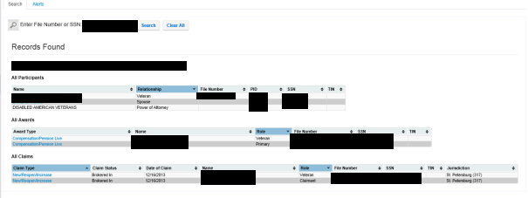

Step #3
Select Record Decisions
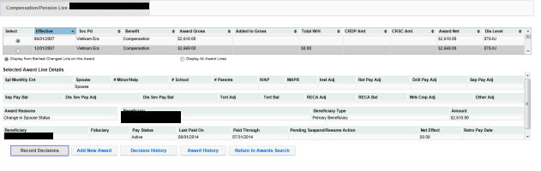
Note: If this is an original claim (110/010) you may be required to add an award record

Step #4
Generate Award (Note: You need to make sure that there is a claim in the box below)
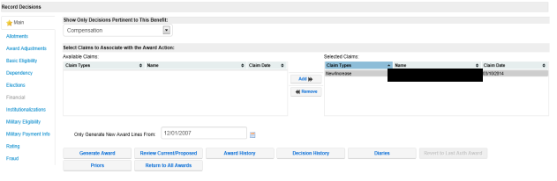

Step #5
This screen is to verify the payment address, via direct deposit or mailing address for a paper check. Click continue generation.
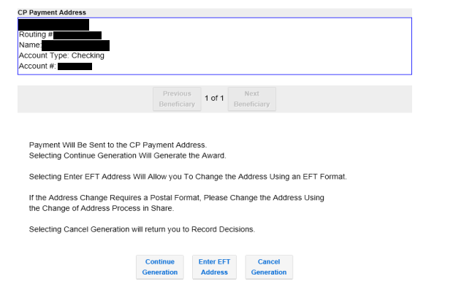Step #6
On this screen, preview the letter to make sure it is complete. Then, generate eDoc.
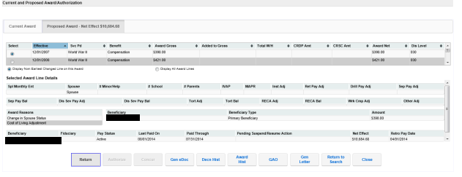

Step #7
This is the remarks screen. By clicking “Submit”, the eDoc will appear in a separate window.

Important: Input a brief remark to indicate the purpose of this award generation.
Award Print Sample

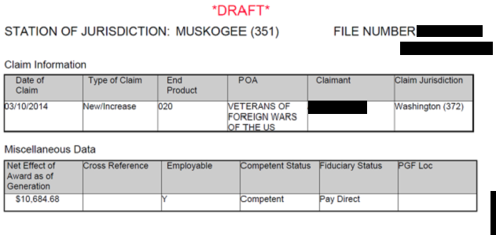
0.00 (If a rating decision renders a Denial or Confirmed and Continued decision, the net effect will always be zero.

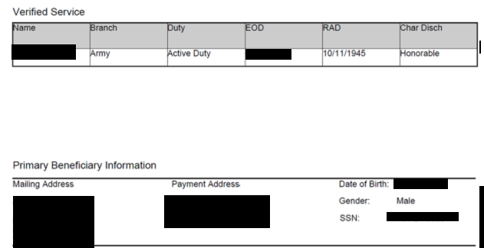

Practical Exercise

1. Which two programs can be used to generate an award letter to the Veteran?

_____________________________

_____________________________

2. Where can you find the combined evaluation for a Veteran on a Rating Decision?

_____________________________

3. What is the main difference between a rating decision of 20% or less and 30% or higher

____________________________

4. A VSR should do all of the following except

- Become familiar with the current Rating Decision
- Check accuracy of name, address, POA etc.
- Question the evaluation of the Rating Decision
- Generate the notification letter using ADL or PCGL

5. If the Veteran submits all relevant dependency information on a VA Form 21-686c along with his original claim, but is only granted 10% service connection, should dependency be addressed in the notification letter? (True/False) _______________

6. What are the two (2) systems can be used to generate Compensation awards?

_________________________ and ___________________________

7. When generating a PCGL notification letter, what is the minimum combined disability evaluation percentage required before the Veteran receives information about Vocational Rehabilitation? ______________________

