Dependency Awards (VSR)

Trainee Handout

### Table of Contents

Objectives 2

References 3

Topic 1: Adding Dependents to the Corporate Record 4

Topic 2: Adding Dependents in VBMS-A 9

Topic 3: Removing Dependents from VBMS-A 16

Practical Exercise 18

Objectives

* Understand how to add dependents to a Veteran’s Corporate Record using VBMS or SHARE
* Recognize when to add dependents to a Veteran’s award and process an award using VBMS-A
* Know how to remove dependents from a Veterans award

### 

References

* 38 CFR §3.1, Definitions
* 38 CFR §3.4, Compensation
* 38 CFR §3.31, Commencement of the period of payment
* 38 CFR §3.50, Spouse and surviving spouse
* 38 CFR §3.57, Child
* 38 CFR §3.204, Evidence of dependents and age
* 38 CFR §3.210, Child's relationship
* 38 CFR §3.315, Basic eligibility determinations; dependents, loans, education
* 38 CFR §3.401, Veterans
* 38 CFR §3.403, Children
* 38 CFR §3.660, Dependency, income and estate
* 38 CFR §3.667, School Children
* M21-1, Part III, Subpart iii, 5.A, General Information on Relationship andDependency
* [M21-1, Part III, Subpart iii, 5.F, Establishing a Child’s Age and Relationship](https://vaww.compensation.pension.km.va.gov/system/templates/selfservice/va_ka/portal.html?encodedHash=%23!agent%2Fportal%2F554400000001034%2Farticle%2F554400000015796%2FM21-1-Part-III-Subpart-iii-Chapter-5-Section-F-Establishing-a-Childs-Age-and-Relationship)
* M21-1, Part III, Subpart iii, 5.L, Adjusting Awards for Dependents
* M21-1, Part I, Chapter 2, A, General Information on Due Process
* [M21-1, Part III, Subpart v, 2, Decision Authorization and Notification](https://vaww.compensation.pension.km.va.gov/system/templates/selfservice/va_ka/portal.html?encodedHash=%23!agent%2Fportal%2F554400000001034%2Ftopic%2F554400000003103%2FChapter-02-Decision-Authorization-and-Notification)
* VBMS-A Web help (Accessed through the program)
* VBMS-A User guide (Accessed through the program)

Topic 1: Adding Dependents to the Corporate Record

* Add dependents through VBMS
* If you can’t add dependents through VBMS you must use SHARE.

### 

### Adding dependents in VBMS

Under the “**Veteran**” drop down menu select “**Dependents**”.

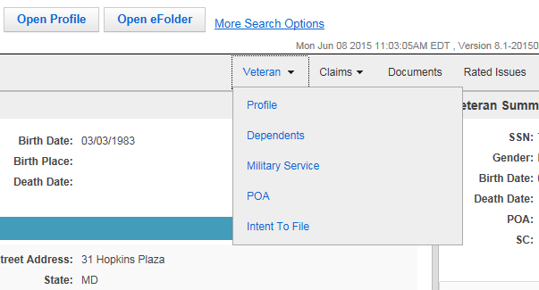

Select “**Add**” on the type of dependent you are trying to input.

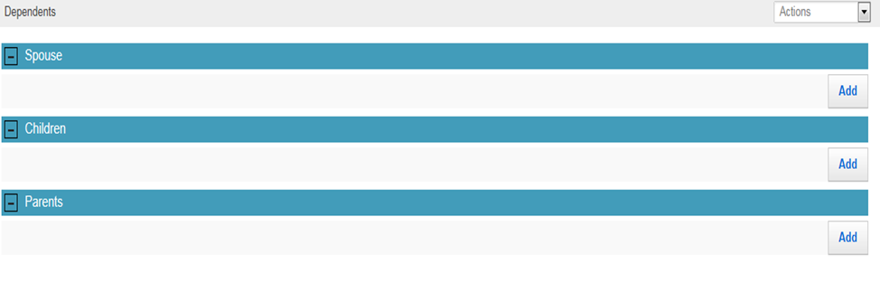

Once you have entered all the information, select the disk icon “**Save**” to add the dependent.

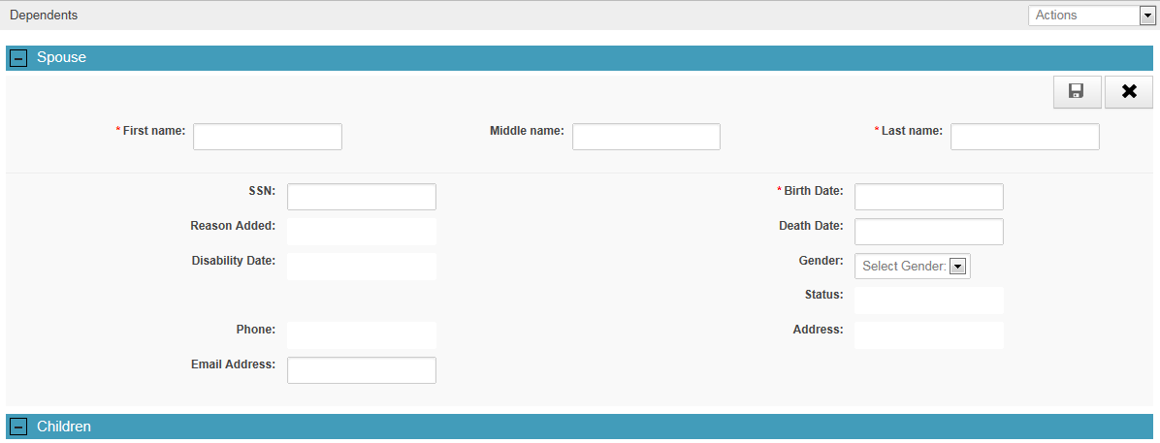

### Adding Dependents to the Corporate Record using SHARE

We can add dependents to the Corporate Record by selecting the “**Dependents**” option from the Available Processes menu that is found on the left side of the Share VBA Ready Screen.

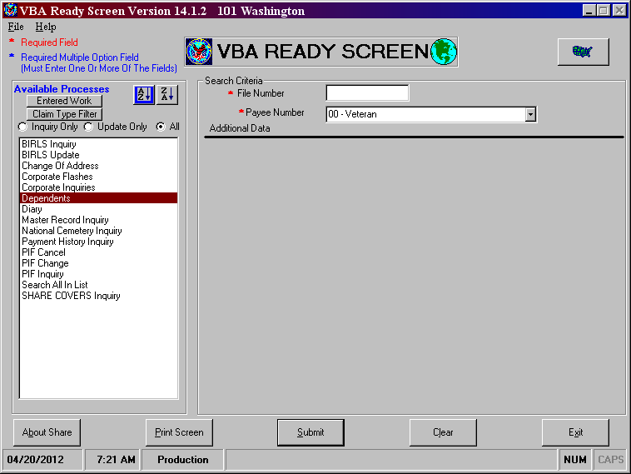

Select “Dependents” from Available Processes menu then enter File/Claim Number and select “Submit

After clicking submit on the previous VBA Ready Screen you will see the screen below. Select “**Add**” to continue.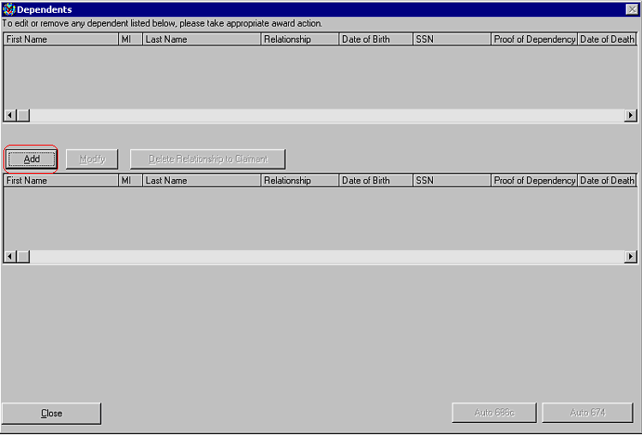

After selecting dependent from the dropdown, input details – then select “**Update**”

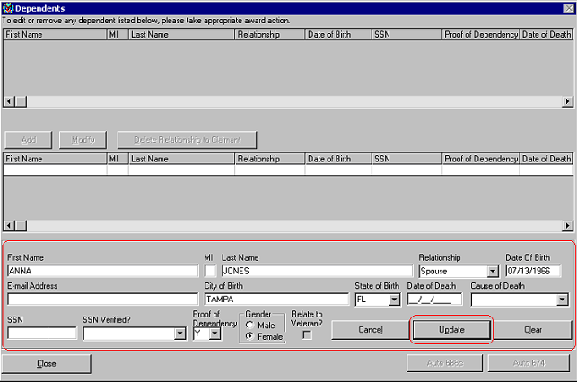

Select “**OK**” and then select “**Close**” if all dependents are added. Select “**Add**” for additional dependents and follow previous two steps above until all are added.

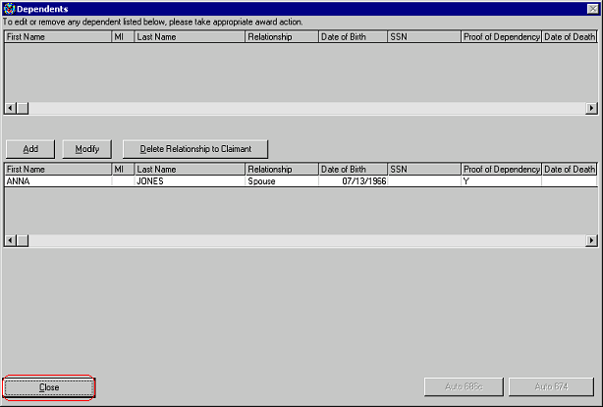

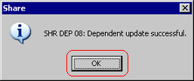

This process is only to add the dependents into the Corporate Record. If an award was to be generated without any further action the dependent(s) would not be added to the award. That action will be done once we go into the VBMS-A system and add the dependent(s) on to the actual award.

To ensure the dependents have been added to the Corporate Record, from the VBA Ready Screen, input the claim number - select “**Search All in List**” and “**Submit**”. From the screen shown below you will double click on the Corporate Record:

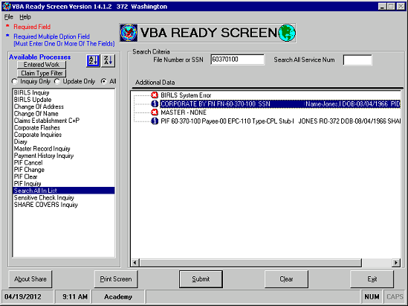

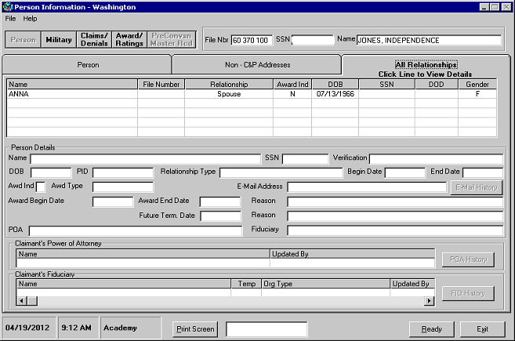

Select the “All Relationships” tab and ensure that the dependents have been added to the Corporate Record

### 

Topic 2: Adding Dependents in VBMS-A

**Dependency Effective Dates**

### Dependency effective dates can be affected by several factors for example:

* + Date of Claim
  + Date of Marriage
  + Date of Birth
  + Date of Adoption
  + Date of Divorce
  + Date of School attendance
  + Rating decision effective date

### 

### Dependency: Add Spouse

As with every dependency action, you will need to add the reported family member to the Corporate Record before attempting to pay for the dependent in VBMS-A.

Select “**Dependency**” in the column of decision screens to open the Dependency decision screen.

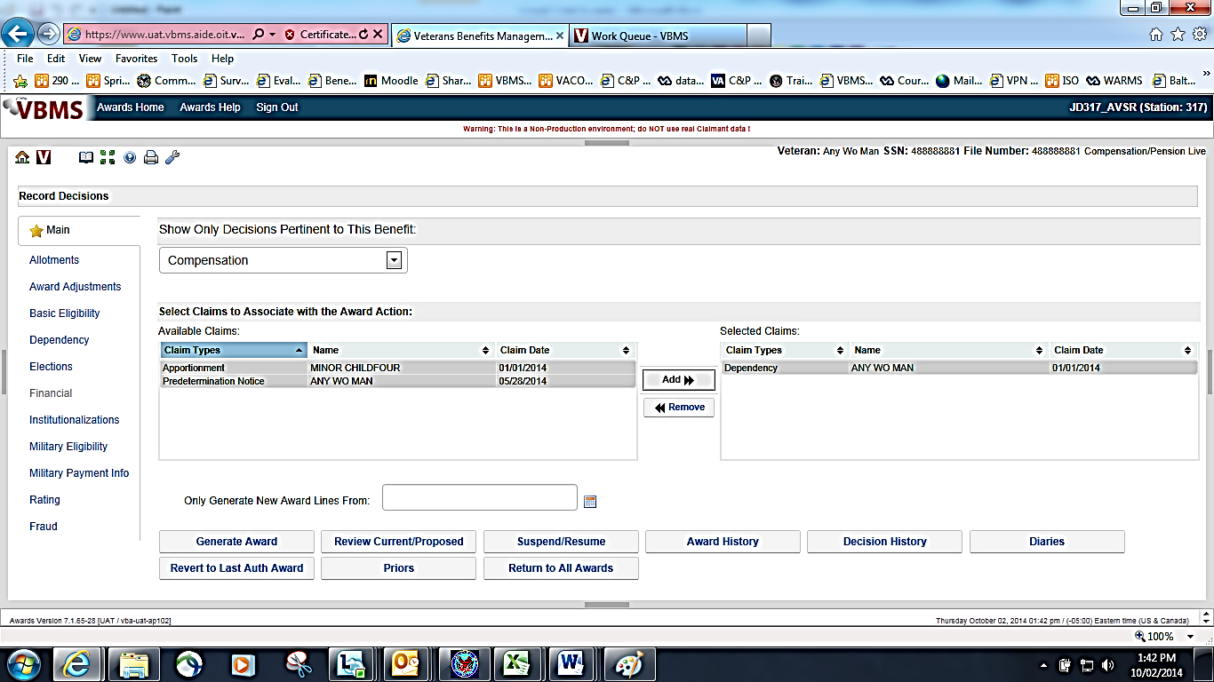

1. Select the “**Add**” button and then select the “**Person”** for whom a dependency decision will be made. The system will list all dependents that have been previously established as family members through the Corporate Record.

The personal information will be automatically populated based on the information entered into the Corporate Record.

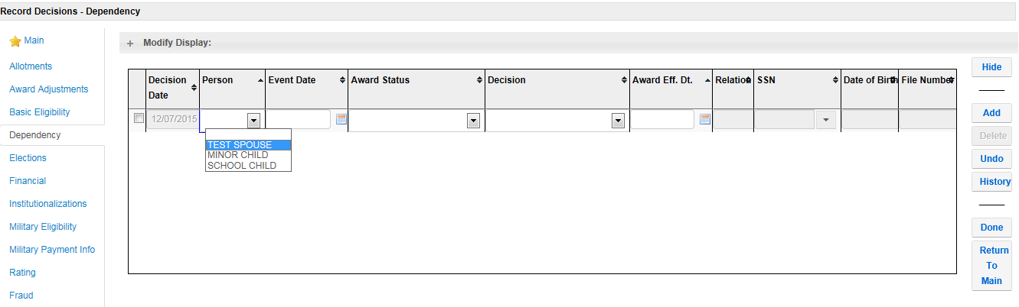

1. Enter the “**Event Date”**.

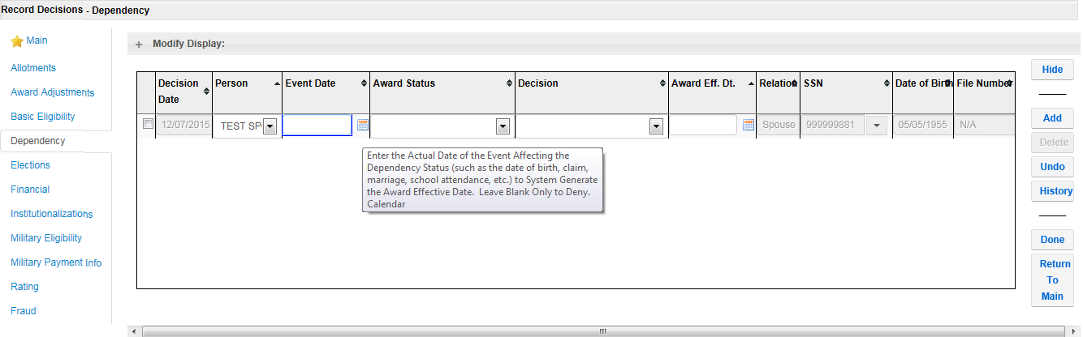

1. Select the “**Award Status”** of Spouse.

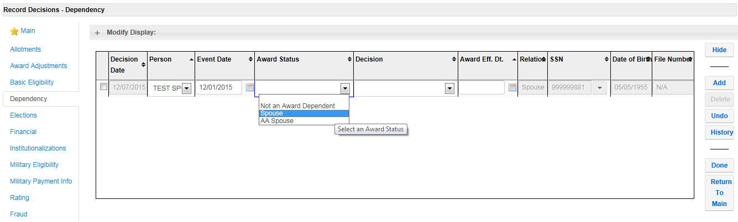

1. Select the “**Decision”** of Dependency Established

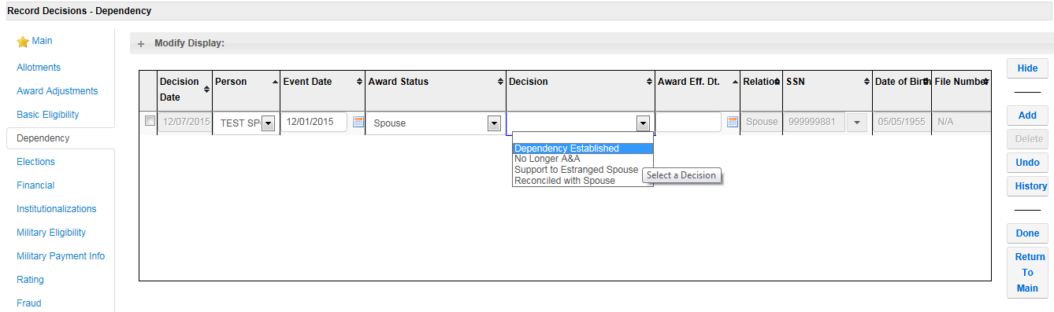

1. Once the decision has been entered, the “**Award Effective Date”** will automatically populate. Click “**Done”** to save the decision.

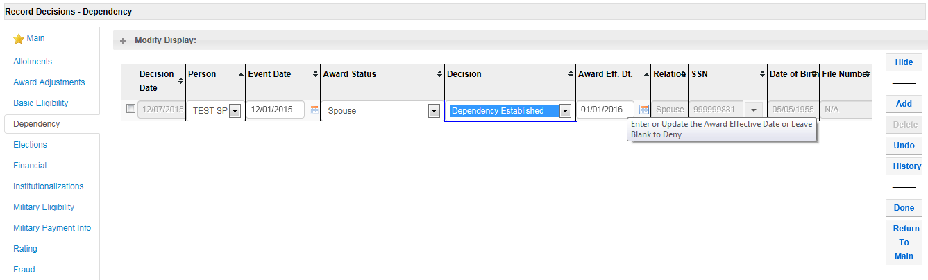

### 

### Dependency - Add a Minor Child

Select “**Dependency”** in the column of decision screens to open the Dependency decision screen.



1. Select the “**Add”** button and then select the “**Person”** for whom a dependency decision will be made.

The Relationship Type, Date of Birth, and SSN information will be automatically populated based on the information entered into the Corporate Record.



1. Enter the “**Event Date”** and the “**Award Status”.**

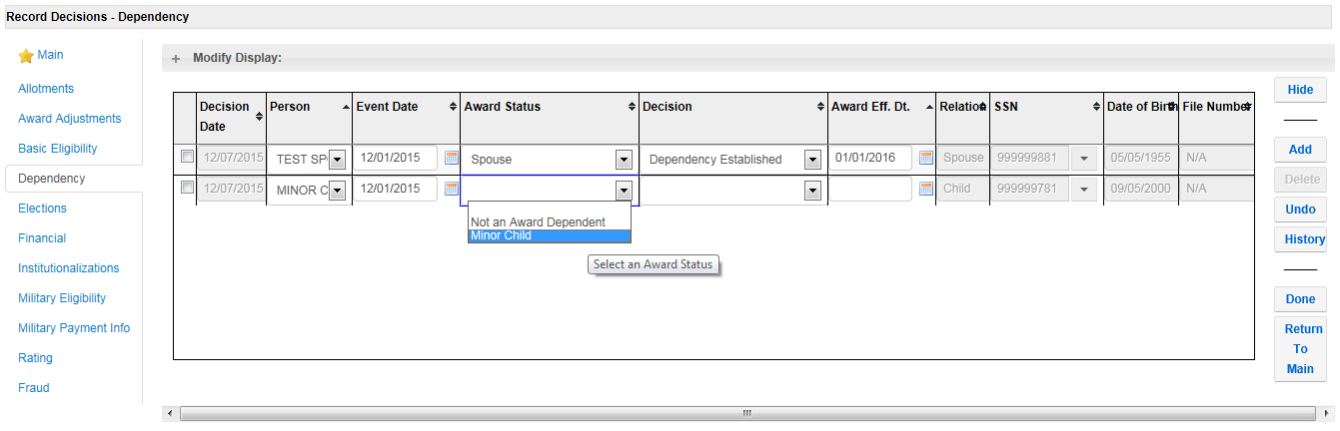

1. Enter the Decision and the Award Effective Date will auto populate. Click “**Done**” to save your decision.

### Dependency – Change Minor Child to School Child

For a situation where a minor child was already on an award as a dependent through the 18th birthday and is now still in school or attending college, it may be necessary to pay the additional minor child benefit through the end of the month in which the child turned 18.

Select the “**Dependency”** button in the column of decision screen buttons to open the Dependency decision screen.

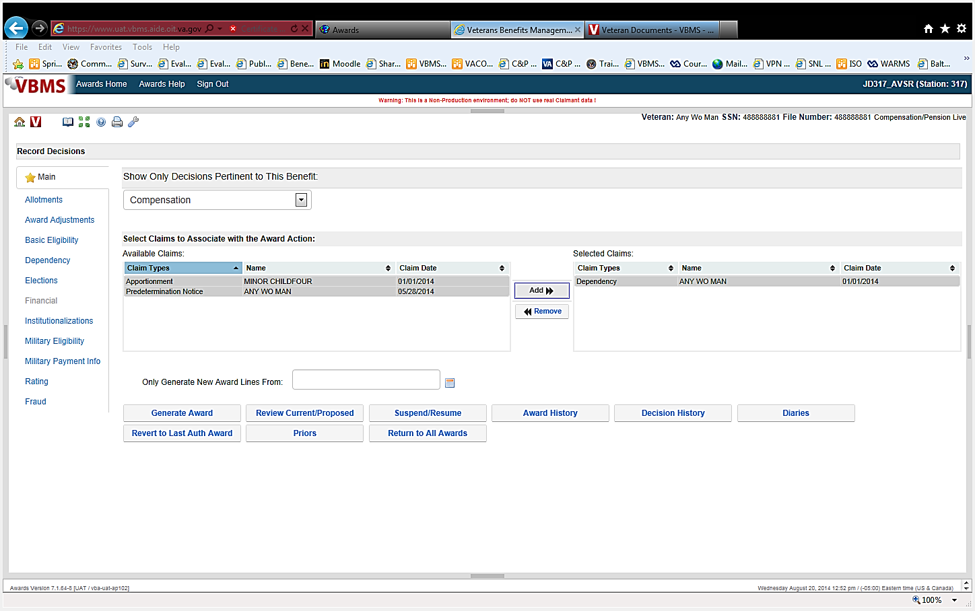

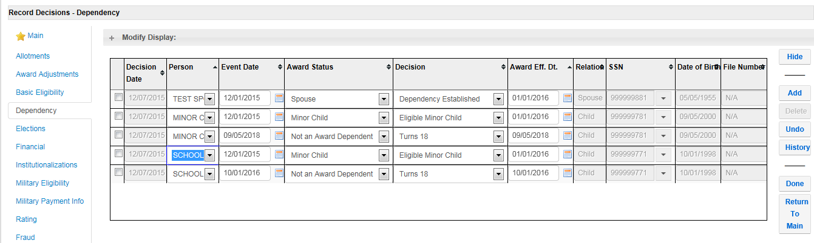

Identify the row indicating that the child was removed for turning 18

1. Update the “**Award Statu**s” field of the 18th birthday line to read School Child.

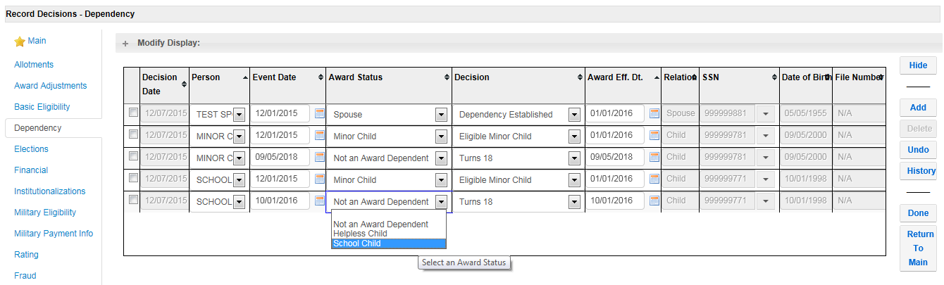

1. Update the “**Decision”** field to read “**School Attendance Begins**”, and modify the “**Award Effective Date”** to be first of the month following the 18th birthday month.

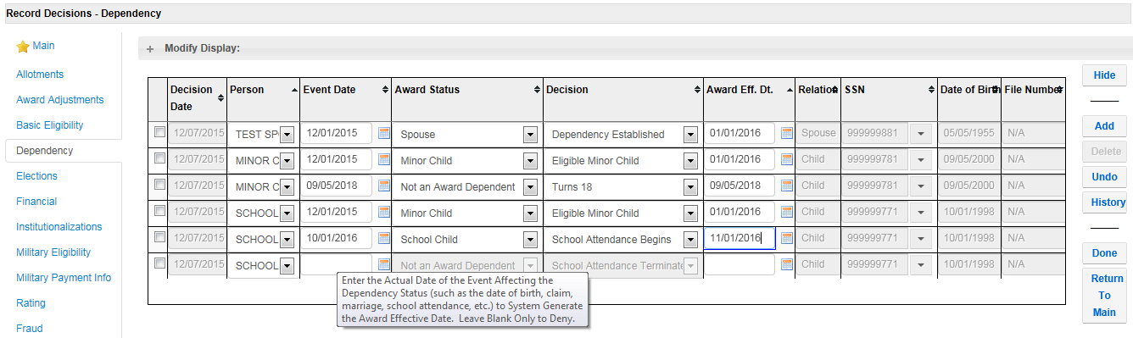

1. Once the 18th birthday line has been modified, a new award will appear automatically asking for the graduation date of the school child. The “**Event Date”** will be the actual date of graduation. Once the event date is entered, you will need to add a decision. In the “**Decision Tab”** you will need to enter, “School Attendance Terminates”. The “**Award Effective Date”** will automatically default to first of the month following the graduation date. Click “**Done”** to save decision
   * + 1. **Special Note:** The system will know if the graduation date is passed the 23rd birthday, it will automatically default to that date.

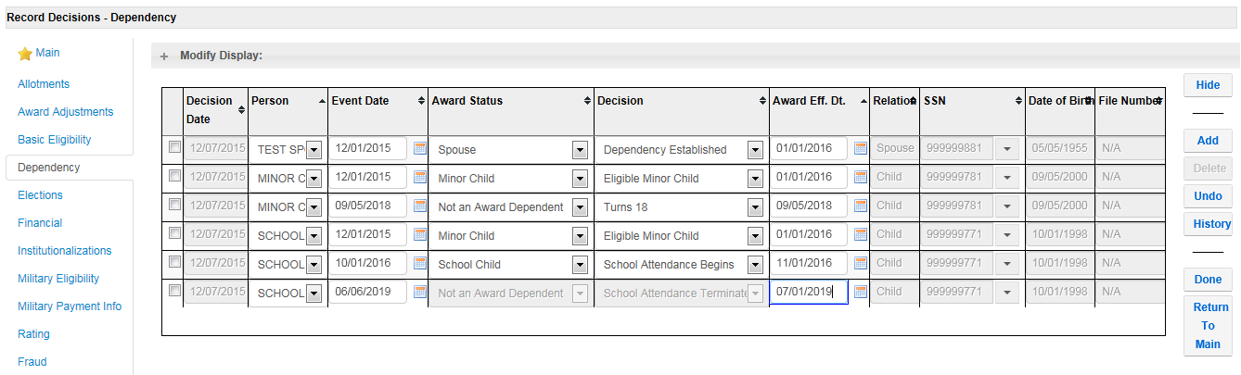

There will now be three lines for the dependent in the grid. One for the original add date, one for the change of status from a minor child to a school child, and one for the removal from the award for either school ending or turning 23.

**Dependency – Adding School Child**

Adding a school child is basically the same as changing a minor child to a school child:

1. Select Add button and select “**Person”** to add as a school child.
2. Fill in Dependency Decisions section (**Event Date** is date school attendance begins; **Award Status** is school child, etc…then select Accept)
3. Select Ok on pop-up message; then input the date school attendance terminates and select Accept button)
4. Screen will look the same as above “except” it will not have the *Minor Child* line

Topic 3: Removing Dependents from VBMS-A

**Effective dates for removing dependents**

* End of month rule-divorce, death, annulment or school child graduates
* “Date of” rule-18th or 23rd birthday

**Note:** Notice of proposed adverse action (due process) is not required if the information is provided by the beneficiary or his/her custodian. Otherwise, due process is required.

##### **Removing Dependents from VBMS-A**

To remove a dependent effective the date they were initially added to the award, use the following steps on the Dependency screen:

1. Select the line in the grid that initially established the dependent
2. Select the “**Delete”** button.
3. Select the “**Accept”** button.
4. Select “**Yes”** to the prompt displayed to confirm the decision to delete the decision.
5. Select “**Done”** to save the decision and close the screen.

##### **Dependency – Remove spouse or helpless child dependent after the initial eligibility date**

To remove a dependent spouse after the initial eligibility date for the dependency:

1. Select the “**Add”** button.
2. Select the spouse or helpless child from the “**Person”** drop-down menu.
3. Select the “**Award Status”** of Not an Award Dependent.
4. Select the “**Decision”** that supports removing the dependent.
5. Enter the “**Award Effective Date”** that the dependent is to be removed from the award.
6. Select “**Done”** to save the decision and close the screen.

##### **Dependency – Remove minor child or school child dependent after the initial eligibility date**

To change the established end date (age 18, end of school attendance) to an earlier end date for a dependent child:

1. Select the line in the grid that removes the award dependent.
2. Record the “**Event Date”**.
3. Update the “**Award Status”**.
4. Select the “**Decision”** that supports removing the dependent.
5. Record the “**Award Effective Date”**.
6. Select “**Done”** to save the decision and close the screen.

Practical Exercise

1. What VA systems are used to add dependents into the Corporate System?
2. What decision screen in VBMS-A is used to enter Dependency information?
3. Can an ADL letter be generated using VBMS-A for an EP 130?
4. Give an example of a First Party Notification.
5. Give an example of a Third Party Notification.
6. Can a Veteran call to report a divorce, or do we need a prescribed form?