Introduction to VBMS-A/VETSNET Awards
Trainee Handout

Table of Contents

Objectives 2
Topic 1: VBMS-A/VETSNET Awards 4
Topic 2: VBMS-A 5
Topic 3: VETSNET Awards 10
Practical Exercise 11

Objectives
- Understand the purpose of VBMS-A/VETSNET Awards
- Know how to access Web Help for VBMS-A/VETSNET Awards
- Understand how to use basic VBMS-A/VETSNET Awards decision screens to promulgate awards
- Become acquainted with the Automated Decision Letter (ADL) function in VBMS-A
References
- M21-1, Part III, Subpart v, 2.A, Decision Authorization
- M21-1, Part III, Subpart v, 2.B, Decision Notices
- VBMS-A Web Help (accessed through the program)
- VBMS-A User Guide (accessed through the program)
- VBMS-A Context Sensitive Help (accessed through the program)
- VETSNET Awards Web Help (accessed through the program)
- VETSNET Awards Handbook (August 2008)

Topic 1: VBMS-A/VETSNET Awards

Purpose of these programs

These applications are used to commence, modify, or terminate payments and/or update the Corporate Record. An award should be generated even if payment amounts are not changing, to update the Corporate Record and support automatic letter generation.

Web Help

VBMS-A Web Help:

- VBMS-A Web Help (accessed through the program)

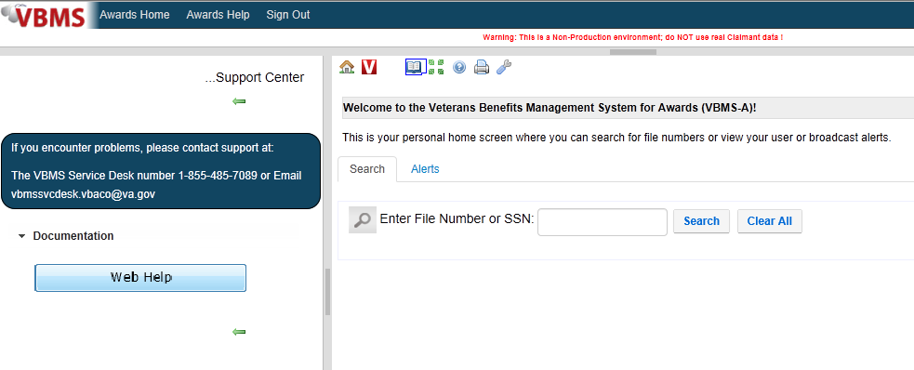

VETSNET Awards Web Help:

- VETSNET Awards Handbook (August 2008)
- VETSNET Awards Web Help (accessed through the program)

Topic 2: VBMS-A

VBMS-A is the new processing system that allows for automatic generation of the Notification Letter using the “Gen Letter” function imbedded in VBMS-A. Implementation of this system will reduce the overall time that claims await Award Generation and Authorization. Not only does this system facilitate the standardization of the Notification Letter, but it also supports more rapid language changes than legacy products.

If a rating decision is being promulgated, and the letter is created using the Automated Decision Letter (ADL) function in VBMS-A, the Veteran will no longer receive a separate copy of the Rating Narrative (like they do if we have to use PCGL) because the Reason for Decision is included in the body of the ADL.

VBMS-A Navigation:

Home Page:

The Home Page is the landing screen upon logging into VBMS Awards. Users can access a particular Award by entering the File Number or Social Security Number of a Veteran and selecting Search. Users can also utilize the search functionality by entering the Social Security Number of a beneficiary, dependent, or participant previously established in VBMS through a relationship with a Veteran.

Records Found screen:

Upon searching for a particular Claim, the search results will display on the screen. To access Award Data or add a new Award, select the appropriate link from the All Participants, All Awards, or All Claims list.

All Awards screen:

- Displays existing Award data about the Veteran or another Beneficiary.
- Users can select from the following operations: Record Decisions, Add New Award, Decision History, Award History, or Return to Awards Search.

Record Decisions screen:

- The Record Decisions screen contains all functions necessary for Award Generation.
- Users can select from the list of decision tabs on the left-side panel if any additional decisions are warranted.

Dependency screen:

- Indicates which dependents have been entered into VBMS-A, NOT necessarily which dependents have been added to the Veteran’s Award. An award must be authorized after the dependents have been entered for them to be added to the Award.
- Displays dependency information.
- Users can add, edit, or delete dependents from this screen.

Military Payment Info screen:

- Allows users to enter or modify Military Retired Pay and Discharge Pay.
- Use the Retrieve BIRLS Data button to import the most recent information.

Award Adjustments screen:

- Allows users to enter withholding amounts for Military Retired Pay, Disability Severance Pay, Separation Pay, Drill Pay, or other miscellaneous withholdings.

Combined Rating screen:

- Allows users to view rating information that has been imported from VBMS-R.
- Disability Decision screen contains information about all individual contentions claimed
- SMC Decision screen contains all decision regarding SMC grants and denials

Award Generation

Select Generate Award to create an award that can be authorized by an SVSR. Enter EFT (Electronic Funds Transfer – aka Direct Deposit) information if available and select Continue Generation to complete award generation. Or select Review Current/Proposed to continue to the Current and Proposed Award/Authorization screen.

Current and Proposed Award/Authorization screen

- The Return Award button allows users to remove an award from pending authorization status. Use this button if you need to make changes to the award. Do not return the award if you are submitting for review/authorization.
- Only SVSRs will have access to the Authorize button.
- Select Gen eDoc to generate an award document that can be printed.
- Select Gen Letter to view and edit the ADL.

Notification Letters

An award must be generated in order for both ADL and PCGL letters to properly populate.

Automated Decision Letter (ADL)

- VBMS-A allows users to automatically generate the Notification Letter for approved EPs (M21-1, III.v.2.B.4.b).
- The Veteran will NOT receive a separate Rating Decision Narrative if ADL is used, because the reason for the decision is included in the body of the letter.
- If ADL does not work, a PCGL letter must be created.
Current and Proposed Awards/Authorization Screen:

Select Gen Letter to access the Award Letter Interview Screen to perform additional development and preview the Notification Letter.

Award Letter Interview process:
- Dependency Development
- Soliciting Claims
- Evidence List
- Free text

Dependency Development:

In order to complete Dependency Development from the Award Letter Interview screen, navigate to the Dependency tab and select Add. This action will activate the Dependency Development boxes shown above. Input the Dependent’s name into the field, and select any of the provided issues to trigger the appropriate development language. To ensure your development is saved, select Accept and Save before continuing.

Soliciting Claims:

If the Rating Specialist indicated on the Rating Decision that an additional Claim must be solicited, users can create the Development paragraph from the Soliciting Claims tab. Select the Add button and enter the name or title of the Claim being solicited.

For Example: If the Rating Specialist indicated that the Veteran may be entitled to Individual Unemployability and wants a Claim solicited, the user would enter “Individual Unemployability” in the text field and select both Accept and Save.

Evidence List:

To assist claimants in understanding what evidence was considered in reaching a decision, ROs must summarize the evidence it considered in reaching a decision in the corresponding decision notice.
Important: Automated Decision Letters (ADLs) include all evidence listed in the rating decision. However, award decision evidence may need to be entered by the user through the Veterans Benefits Management System-Awards (VBMS-A).
For guidelines on specifying and formatting evidence in the notification letter refer to M21-1, Part III, Subpart v, 2.B.4.d.

Free Text:

To add Free Text to the Notification Letter, users can select the Free Text button from the Award Letter Interview screen. Upon selecting the Free Text button, a list of hyperlinked sections within the Notification Letter is displayed on the left-side panel. In the space provided, type the information pertaining to the selected section. When finished entering the information in each section, click the Save button to the right of the text area.

Preview Letter:
Select Preview Letter to view the ADL. To ensure all of the entered information is correct, select the Preview Letter button from the Award Letter Interview screen.

Sample ADL Language:

Select Gen Letter to access the Award Letter Interview Screen to perform additional development and preview the Notification Letter.
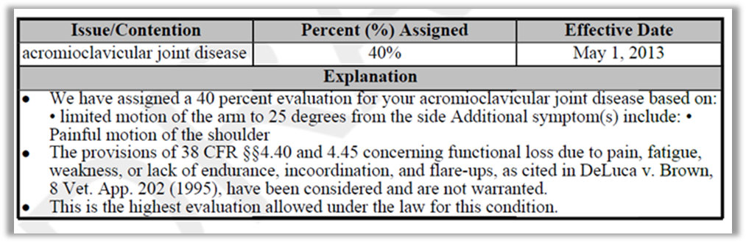

Topic 3: VETSNET Awards

VETSNET Awards:

- Mirrors VBMS-A functionality
- Tabs are the same but arranged differently
- Each tab contains the same decisions

Accessing VETSNET Awards

The Awards application is opened by searching for C&P Awards, or by selecting:

- Start button,
- then VBAPPS,
- then VETSNET,
- and finally by selecting C&P AWARDS.

VETSNET Awards Search screen:

To search the veteran, the VSR will input the veteran’s file number or SSN and click the Search button.

VETSNET Awards screens:

The award decisions screens are identical to those of VBMS-A. The functionality and purpose also mirror VBMS-A. The big difference is the location of the decision tabs.

Notification Letters:
VETSNET Awards does not have the ability to generate an automated letter. If an award is generated using VETSNET Awards, VBMS-A will reflect a pending award and ADL can be used.

Practical Exercise

- What types of payments does the Military Payment Information screen store information regarding? (name at least three)

- What are the five tabs located on the Award Adjustments screen?

- If the Veteran is potentially entitled to an additional benefit, such as service connection for a broken right ankle, which Development tab in the Award Letter Interview screen would you go to?

- Once a VSR has generated an award, what button must they select if they need to correct a mistake made on one of the decision screens?

- Are all EPs compatible with the ADL function in VBMS-A?

- In order to ensure your work is saved in VBMS-A, which button do you select?

