Claims Development: Hepatitis C
Trainee Handout

Table of Contents

Objectives 2
References 3
Topic 1: Hepatitis - Introduction 4
Topic 2: Hepatitis C – Background and Overview 5
Topic 3: Service-Connection Requirements 7
Topic 4: Hepatitis C Claims Development 9
Topic 5: Hepatitis C and Examinations 10
Attachment A: Hepatitis C Questionnaire 12
Attachment B: Hepatitis C WTEMS 13
Attachment C: Flow Chart from TL 01-02 14
Practical Exercise 16

Objectives

At the conclusion of this lesson, participants will be to complete the following tasks:
- Define hepatitis

- List the main types of hepatitis

- Explain the history of hepatitis

- Restate the legal requirements for granting service-connection of hepatitis C

- Identify several risk factors for hepatitis C

- Recognize the appropriate development requirements for hepatitis C claims

- Assess the sufficiency of hepatitis C examination results

References

- VBN Broadcast, “Hepatitis C Rating issues” dated April 25, 2001

- Compensation Service VSCM Conference Call, “Hepatitis C Development” June 2012

- Training Letter 01-02, Hepatitis C Review

- Center for Disease Control, Hepatitis C General Information Fact Sheet

- Training Letter 00-01, Hepatitis C Infection Treatment and its side effects

- FL 04-13, Relationship Between Immunization with Jet Injectors and Hepatitis C Infection as it Relates to Service Connection

- FL 98-110, Infectious Hepatitis

Topic 1: Hepatitis - Introduction

Definition

Hepatitis, a word of Greek origin, literally translates: ___________ of the _____________.

*****

The liver is a vital organ that processes nutrients, filters the blood, and fights infections. Inflammation in the liver compromises the liver’s ability to properly perform these functions.

*****

How many common types of the hepatitis virus exist? ______________

Identify the most common types of hepatitis: ______________________________________ ___________________________________________________________________________________________________________________________________________________________.

*****
Currently, the only types of the virus that can be prevented by vaccination are ________________ and __________________.

- There are other types strands of the virus (for example hepatitis G and hepatitis X), but they are not as common.
- The plural of hepatitis is hepatitides or hepatitises.
- It is possible for a person to contract different strands of hepatitis at different times.

Topic 2: Hepatitis C – Background and Overview

History

Scientists developed tests to identify hepatitis A and hepatitis B in 1963 and 1973, respectively. During this time, if a person had inflammation of the liver that did not meet hepatitis A or hepatitis B criteria, the diagnosis given was often written as “hepatitis non-A, non-B”.

A blood test to detect hepatitis C was note perfected until 1992. Shortly thereafter (same year), hepatitis C received recognition as its own medical diagnosis.

- Hepatitis is the most common cause of chronic liver disease and cirrhosis.
- Hepatitis is the most common indication for liver transplantation in the US Australia, and Europe.
- Each year 17,000 Americans become infected with hepatitis C.
- Currently, an estimated total of 3.2 million persons in the US have the virus.

Facts

The medical shorthand for hepatitis C is _________________.

- Hepatitis C is the most common chronic blood-borne infection in the United States.
- The Hepatitis C can survive outside the body at room temperature, on environmental surfaces, for at least 16 hours but no longer than four days.

Symptoms

Many people with hepatitis C fail to display symptoms. However, known symptoms include:

- Fever | - Fatigue
- Loss of appetite | - Nausea
- Vomiting | - Jaundice
- Dark urine | - Sore muscles

Progression

Acute infection refers to people who have been infected for less than ____________ months.

Chronic infection refers to people who have been infected for more than ___________ months.

With proper treatment:

- An adult with acute hepatitis C has a 20 percent chance of spontaneous recovery.
- Infants are estimated to have a high rate of 75 percent chance (and greater) of recovery.

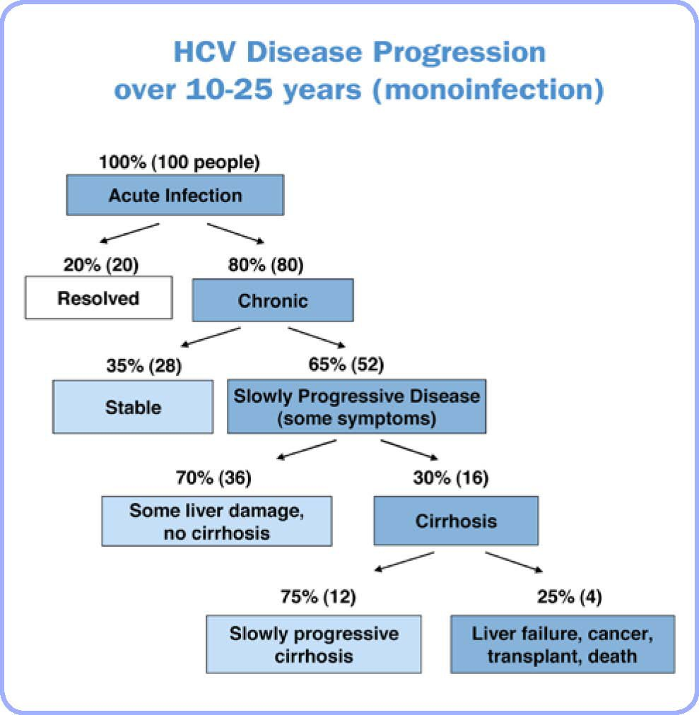
Topic 3: Service-Connection Requirements

Service-connection

With most claims, there is a three prong requirement for service-connection: in-service injury or event, a nexus, and a diagnosis.

 | Most Claims | HCV Claims
Then | In-service event, or  In-service injury
Between | Nexus
Now | Confirmed Diagnosis

Risk Factors

A risk factor is something that increases a person's chances of developing a disease.

Risk factors for hepatitis C include:

- Organ transplant before 1992
- Transfusion of blood/blood products* before 1992
- Hemodialysis
- Exposure to blood by health care workers
- Intravenous drug use
- Intranasal cocaine use
- High risk sexual activity
- Other direct percutaneous exposure to include instances where a person might be exposed to blood by the direct piercing of the skin, such as tattooing, body piercing, acupuncture with non-sterile needles, and shared shaving razors or even shared toothbrushes.
*A blood product is any component of the blood used for transfusion – like red blood cells, blood plasma, or platelets – as the whole blood is not always needed during a transfusion.

Name three less common, but recognized risk factors for hepatitis C:

- __________________________________________
- __________________________________________
- __________________________________________

Confirmed Diagnosis

A diagnosis of hepatitis C is considered confirmed when medical evidence establishes that the Veteran has received either:
- A positive EIA (enzyme immunoassay),
- A positive a ELISA ( enzyme-linked immunosorbent assay) along with a positive RIBA (recombinant immunoblot assay, also known as the “western blot” test”), or
- A positive HCV RNA (hepatitis C viral ribonucleic acid)

Topic 4: Hepatitis C Claims Development

There are special development requirements for Hepatitis C Compensation Service created both a “Hepatitis C Risk Factors Questionnaire” and a “Hepatitis What the Evidence Must Show” (WTEMS) that must be included in the Section 5103 notice sent to the Veteran.

MAP-D

In MAP-D you will find these items under ______________________ Development. Therefore, there is no need to copy and paste additional information in the Section 5103 Notice when it is completed in MAP-D.

VBMS

VBMS, however, does not contain the special paragraph or WTEMS. You will need to create a custom development item to satisfy the required development.

A copy of the questionnaire and WTEMS are included at the end of this handout.

EZ Forms

Per FL 13-06, if a hepatitis C claim is received on an EZ form, then VA is obligated to send the claimant the special questionnaire and WTEMS to assist in substantiating the claim.

Topic 5: Hepatitis C and Examinations
New Claims

An examination for hepatitis C is warranted when:

- The medical evidence of record presents a confirmed _____________ or medical evidence of treatment for known symptoms of hepatitis C, and
- The evidence for a confirmed in-service _________ __________ or an in-service diagnosis of hepatitis C.

* Note that the phrase “hepatitis non-a, non-b” (as used before 1992) satisfies the requirement for in-service diagnosis for the purpose of warranting a medical examination.

**Confirmed risk factor exposure and medical evidence of symptoms alone does not entitle the Veteran to service-connection, but it does qualify the Veteran for a medical examination and opinion.

*** If the only risk factors are intranasal cocaine or intravenous drug use, an examination is not needed and the claim can be referred to the RVSR for consideration.

Claims for Increase

If the Veteran is already service-connected, then an examination is warranted. Otherwise, no special actions are required.

Reopened Claims

Did the Veteran provide new and material information?
Did the Veteran give us something that is not already of record and is that information relevant to the reason that the Veteran was initially denied?

Second, if the claim was previously denied due to “no diagnosis”, review the date of the denial. Remember, hepatitis C was not recognized until 1992. If the denial or exposure occurred before this date look for other evidence such as risk factor exposures, treatment of known HCV symptoms, or a diagnosis of “hepatitis non-A, non-B”.

Requesting the Exam

The correct DBQ for hepatitis C is ________________________DBQ for hepatitis, cirrhosis, and other liver conditions.

When ordering an examination:
- List the all confirmed risk factors found in the evidence. Be specific
- Ask the physician to focus on and discuss all confirmed risk factors.
- If positive HCV test results are not of record, be sure to ask the physician to provide confirmation testing of the HCV infection.
- Be sure to ask the examiner if the Veteran’s current Hepatitis C diagnosis is “as least as likely as not” related to the specific risk factors identified by the Veteran.
- If the Veteran’s STRs show a “Hepatitis non-A, non-B” then the medical examiner should be asked to review the medical records to assess if the illness diagnosed before 1992 correlates with current laboratory and clinical findings of HCV.
- If the Veteran has confirmed exposure to more than one risk factor, ask the examiner to provide an opinion about the relationship between the current HCV infection and each confirmed or supported risk factor(s).

Adequate Examination

An adequate exam notes:
- That the examiner reviewed the claims folder,
- Complete laboratory results (to include liver function tests),
- Clinical findings to include symptoms,
- The requested medical opinion, (except for increase), and
- A discussion of all known risk factors for that veteran and the likelihood of HCV infection due to each risk factor.

To view a blank DBQ used for hepatitis C, click here.

Attachment A: Hepatitis C Questionnaire

Hepatitis: Which Risk Factors Apply To You?

The medical community recognizes several risk factors for hepatitis C infections. These risk factors include the following:

- organ transplant before 1992
- transfusions of blood or blood products before 1992
- hemodialysis
- accidental exposure to blood by health care workers (to include combat medic or corpsman)
- intravenous drug use or intranasal cocaine use
- high risk sexual activity
- other direct percutaneous (through the skin) exposure to blood such as by tattooing, body piercing, acupuncture with non-sterile needles, and shared toothbrushes or shaving razors

We need to know which risk factor(s) applies to you. You should give us any information, statements, or evidence you have about your risk factor(s). Include dates and describe the circumstances of any incident involving your exposure to any of these risk factors. You may provide this information on the enclosed VA Form 21-4138, Statement in Support of Claim.
Attachment B: Hepatitis C WTEMS

What The Evidence Must Show
To establish entitlement for service-connected compensation benefits for hepatitis C, the evidence must show three things:
- You were diagnosed with hepatitis C in service, OR, you had symptoms of hepatitis C in service, OR you were exposed to certain hepatitis C risk factors in service. If we do not yet have them, we will get your service treatment records and will review them to see if they contain this evidence. We will also get other military service records, if necessary.
- A current diagnosis of hepatitis C. This can be shown by medical evidence indicating a confirmed diagnosis of hepatitis C. We will get any VA medical records or other medical treatment records you tell us about. You can also give us other evidence showing you have persistent or recurrent symptoms of hepatitis C. This evidence could be your own statement or statements from other people describing your physical or mental symptoms. The confirmed diagnosis means a positive EIA (enzyme immunoassay) or ELISA (enzyme-linked immunosorbent assay) along with a positive RIBA (recombinant immunoblot assay, also called "Western blot" test); or a positive test for HCV RNA (hepatitis C viral ribonucleic acid).
- A relationship between your current hepatitis C and the infection, symptoms, or risk factor exposure you had in service. This evidence is usually contained in medical records or medical opinions. We will request this medical evidence for you if you tell us about it. You can give us a medical opinion regarding this relationship from your own doctor.

Attachment C: Flow Chart from TL 01-02

Practical Exercise
Read the following scenarios and determine whether or not an examination is warranted and provide a rationale.

Read and answer the “b” questions in light of the information provided in the “a” questions to determine if the following examination results are adequate and explain why. (For example 1b is a continuation of 1a)

1a. Mr. Jenkins, a combat Veteran, files a new claim for service-connection for hepatitis C. The Veteran does not have a confirmed diagnosis, but submits medical evidence showing that he has received recurrent treatment for nausea, vomiting, sore muscles, fever, and loss of appetite. His latest treatment record notes yellowish tint to the eyes and skin. The Veteran’s STRs note that he received a series of air gun injections before his deployment and received a blood transfusion immediately after returning from Vietnam.

Is an examination warranted? Why or why not? _________________________________ ________________________________________________________________________________________________________________________________________________

1b. On the DBQ, the examiner provides Mr. Jenkins’ liver function test (LFT) results and clinical findings. Also, the physician notes that he reviewed the c-file. The examiner remarks on the exam “Based on the Veteran’s LFT performance and the symptoms that the Veteran presents, I opine that the Veteran has hepatitis C and that the Veteran’s hepatitis C is at least as likely as not related to the series of air gun injections Mr. Jenkins received prior to his deployment.”

Is this examination sufficient for rating purposes? Why or why not? _________________ ________________________________________________________________________________________________________________________________________________________________________________________________________________________

2a. Ms. Thomas is filing a reopened claim for hepatitis C. She was previously denied in January of 1991 for having for diagnosis of a compensable disability. Her military personnel records show that she served as a nurse at hospital and constantly handled blood and blood products from 1984 to December of 1989, when she was diagnosed with “hepatitis non-A, non-B”. Ms. Thomas provides two positive HCV RNA result – one from 1992 and the other from last year.

Is an examination warranted? Why or why not? _________________________________ ________________________________________________________________________________________________________________________________________________

2b. On the DBQ, the examiner provides Ms. Thomas’ liver function test (LFT) results and clinical findings (symptoms). The physician also notes that he reviewed the c-file. The examiner opines that Ms. Thomas’ current hepatitis C diagnosis is at least as likely as not related to the handling of blood and blood products. The doctor also states that Ms. Thomas’ in-service diagnosis of hepatitis non-A, non-B is more likely than not the same as her current HCV. The doctor provides a thorough rationale for each of his opinions.

Is this examination sufficient for rating purposes? Why or why not? _________________ ________________________________________________________________________________________________________________________________________________________________________________________________________________________

3a. Mr. Shaw files a new claim for hepatitis C due to hugging a friend that is now infected. Mr. Shaw provided medical evidence of a positive ELISA along with a positive RIBA. Mr. Shaw received the “Hepatitis C Questionnaire” and failed to provide any other risk factors.

Is an examination warranted? Why or why not? _________________________________ ________________________________________________________________________________________________________________________________________________

3a (2) Within-in two months of receiving his notification letter (denial), Mr. Shaw submits a statement that while he was active duty, he received an organ transplant in 1991 at a private medical facility with the medical evidence of his surgery.

Is an examination warranted? Why or why not? _________________________________ ________________________________________________________________________________________________________________________________________________

3b. The examiner indicates that she has reviewed Mr. Shaw’s c-file. The examiner provides the requested medical opinions with complete rationales.

Is this examination sufficient for rating purposes? Why or why not? _________________ ________________________________________________________________________________________________________________________________________________________________________________________________________________________

