Compensation offsets:
Readjustment, separation and severance pay
Trainee Handouts

PREREQUISITE TRAINING: | Prior to this training you must have completed the following:  - Is this case ready to promulgate? To include  - VA Form 21-526  - VCAA Duty to Assist  - Claims Recognition  - Establishing Veteran Status  - Effective Date vs. Payment Date  - Dependency for Compensation  - Introduction to Ratings
OBJECTIVES: | The purpose of this lesson is to teach you the different types of compensation offsets and to provide instruction for the establishment of withholdings.  At the end of this lesson, you will:  - Understand some of the basic different compensation offset types  - Understand the rules for withholding benefits, depending on the types of military separation pay received  - Process awards and notification letters
Time Required: | 2 hours: 1 hour class presentation; 1 hour practical exercise: Separation and Severance
Materials/ Training Aids: | Classroom or private area where a discussion may be held. Chairs and writing surfaces are required.  Large writing surface such as—easel pad, chalkboard, dry erase board with appropriate markers, overhead projector, etc., or computer with projection equipment and PowerPoint software.  - Compensation Offsets Trainee Handouts for Readjustment, Separation, and Severance Pay  - Compensation Offsets PowerPoint presentation for Readjustment, Separation and Severance Pay

Table of Contents

References………………………………………………………………………………… ……3 CFR 3.700…………………………………………………………………………………..… 4

Disability Severance Pay…………………………………………………………………………7

STEPS to Disability Severance Pay………………………………………………………………8
Formula for Severance Pay ………………………………………………………………………9

Reviewing Severance or Separation Pay Balances In VETSNET……………………………….10
Example Separation Pay Award..………………………………………………………………..14
Example PCGL Notification letter……...……………………………………………………….20
Review Exercise 1……………………………………………………………………………….23
Review Exercise 2……………………………………………………………………………….24

References

- 38 U.S.C. 5304 Prohibition against duplication of benefits
- 10 U.S.C. 1174 Separation pay
- 10 U.S.C. 1174a Special Separation Benefit (SSB)
- 10 U.S.C. 1175 Voluntary Separation Incentive (VSI)
- 10 U.S.C. 1212 Severance pay
- 38 CFR 3.700 Concurrent benefits
- M21-1MR III.iii.2.D.23 PIES Programmed Request Codes
- M21-1MR III.iii.2.K.76 PIES Finance Address Codes
- M21-1MR III.v.4.B Recoupment of Readjustment, Separation and Severance Pay
- M21-1, Part I, Appendix B, Rate Tables, or link: http://vbaw.vba.va.gov/bl/21/publicat/Manuals/Rates/rates_home.htm
- Fast Letter 08-15, Overview of Changes Made By Public Law 110-181, the National Defense Authorization Act for Fiscal Year 2008

38 CFR 3.700

Not more than one award of pension, compensation, or emergency officers', regular or reserve retirement pay will be made concurrently, to any person based on his or her own service, except as provided in §3.803 relating to naval pension and §3.750(c) relating to waiver of military retirement pay. Not more than one award of pension, compensation, or dependency and indemnity compensation may be made concurrently, to a dependent, on account of more than one period of service of a Veteran. (Authority: 38 U.S.C. 5304(a))
(a) Veterans:
(1) Active service pay.
(i) Pension, compensation, or retirement pay, on account of his or her own service will not be paid to any person , for any period for which he or she receives active service pay. (Authority: 38 U.S.C. 5304(c))
(ii) Time spent by members of the ROTC in drills as part of their activities as members of the Corps is not considered active duty service.
(iii) Reservists may waive their, compensation, pay for periods of field training, instruction or other duty or drills. A waiver may include prospective periods and contain a right of recoupment, for the days for which the reservists did not receive payment for duty by reason of failure to report for duty.
(2) Lump-sum readjustment pay.
(i) Where entitlement to disability compensation was established prior to September 15, 1981, a Veteran who has received a lump-sum readjustment payment under the former 10 U.S.C. 687 (as in effect on September 14, 1981), may receive disability compensation for a disability incurred, in or aggravated by service, prior to the date of receipt of lump-sum readjustment payment, subject to deduction of an amount equal to 75 percent of the amount received as readjustment payment. (Authority: 38 U.S.C. 1501(a))
(ii) Readjustment pay authorized under the former 10 U.S.C. 3814(a) is not subject to recoupment through withholding of disability compensation entitlement to which was established prior to September 15, 1981. (Authority: 38 U.S.C. 1501(a))
(iii) Where entitlement to disability compensation was established on or after September 15, 1981, a Veteran who has received a lump-sum readjustment payment, may receive disability compensation for a disability incurred in or aggravated by service, prior to the date of receipt of the lump-sum readjustment payment, subject to recoupment of the readjustment payment. Where payment of readjustment pay was made on or before September 30, 1996, the VA will recoup from disability compensation an amount equal to the total amount of readjustment pay. Where payment of readjustment pay was made after September 30, 1996, the VA will recoup from disability compensation an amount equal to the total amount of readjustment pay, less the amount of Federal income tax withheld from such pay. (Authority: 10 U.S.C 1174(h)(2) and 1212(c))
(iv) The receipt of readjustment pay does not affect the payment of disability compensation based on a subsequent period of service. VA Compensation payable for a service-connected disability, incurred or aggravated in a subsequent period of service, will not be reduced for the purpose of offsetting readjustment pay based on a prior period of service. (Authority: 10 U.S.C. 1174(h)(2))
(3) Severance pay. Where the disability or disabilities found to be service-connected are the same as those upon which disability severance pay is granted, or where entitlement to disability compensation was established on or after September 15, 1981, an award of compensation will be made subject to recoupment of the disability severance pay. Prior to the initial determination of the degree of disability, recoupment will be at the full monthly compensation rate payable for the disability or disabilities for which severance pay was granted. Following initial determination of the degree of disability, recoupment shall not be at a monthly rate in excess of the monthly compensation payable for that degree of disability. For this purpose the term "initial determination of the degree of disability" means the first regular schedular compensable rating in accordance with the provisions of Subpart B, Part 4 of this chapter and does not mean a rating based in whole or in part on a need for hospitalization or a period of convalescence. Where entitlement to disability compensation was established prior to September 15, 1981, compensation payable for service-connected disability other than the disability for which disability severance pay was granted, will not be reduced for the purpose of recouping disability severance pay. Where entitlement to disability compensation was established on or after September 15, 1981, a Veteran may receive disability compensation for a disability incurred or aggravated by service , prior to the date of receipt of the severance pay, but the VA must recoup from that disability compensation, an amount equal to the severance pay. Where payment of severance pay was made on or before September 30, 1996, the VA will recoup from disability compensation, an amount equal to the total amount of the severance pay. Where payment of severance pay was made after September 30, 1996, the VA will recoup from disability compensation, an amount equal to the total amount of the severance pay, less the amount of Federal income tax withheld from such pay. (Authority: 10 U.S.C. 1174(h)(2) and 1212(c))
(4) Improved pension. If a Veteran is entitled to improved pension on the basis of the Veteran's own service, and is also entitled to pension under any pension program currently or previously in effect, on the basis of any other person's service, the Department of Veterans Affairs shall pay the Veteran only the greater benefit. (Authority: 38 U.S.C. 1521(i))
(5) Separation pay
(i) Where entitlement to disability compensation was established on or after September 15, 1981, a Veteran, who has received separation pay, may receive disability compensation for a disability incurred in or aggravated by service, prior to the date of receipt of separation pay, subject to recoupment of the separation pay. Where payment of separation pay or special separation benefits under section 1174a was made on or before September 30, 1996, the VA will recoup from disability compensation, an amount equal to the total amount of separation pay or special separation benefits. Where payment of separation pay or Special Separation Benefits (SSB) under section 1174a was made after September 30, 1996, the VA will recoup from disability compensation, an amount equal to the total amount of separation pay or special separation benefits, less the amount of Federal income tax withheld from such pay.
(ii) The receipt of separation pay does not affect the payment of disability compensation based on a subsequent period of service. Compensation payable for a service-connected disability, incurred or aggravated in a subsequent period of service, will not be reduced for the purpose of offsetting separation pay based on a prior period of service. (Authority: 10 U.S.C. 1174)
Additional Notes:

DISABILITY SEVERANCE PAY

The rate of recoupment of severance pay shall not be in excess of the initial rating decision grant of compensation payable for the same severance disabilities. This rate excludes periods of hospitalization and convalescence. The initial rate of compensation payable is defined as the first compensable rating decision for that condition.
If all of the Veteran’s disabilities are severance pay conditions, then a total withholding is appropriate.
If only some of the disabilities are severance pay disabilities, the VSR must follow certain rules to ensure the correct withholding.
- The VSR will withhold the amount of monthly compensation payable for the severance disabilities and pay the balance to the Veteran.
- However, the balance paid to the Veteran must be no less than the amount the Veteran would be entitled to for the non-severance pay disabilities.
Do not withhold VA compensation for severance pay if the Veteran’s only entitlement is a ten percent evaluation based on multiple zero percent disabilities. Also, if the Veteran is rated zero percent for a severance pay disability, do not withhold any non-severance pay compensation entitlements.
Do not withhold amounts paid for Special Monthly Compensation (SMC) to severance withholdings.
Prestabilization ratings (Paragraph 28) – Input a total evaluation to withhold for severance pay. When the rating board designates a percentage for the disability, the severance pay withholding will then be based on that percentage.
Importation: Disability severance pay will be recouped at a rate not to exceed the rate payable for the severance pay disabilities, based on the initial compensable rating. Therefore, VSRs must know the amount of disability severance pay received, the exact disabilities for which it was received and the effective date assigned on the initial rating decision award document.

Medical Evaluation Board and Physical Evaluation Board
Service members may become physically unfit for duty due to illness or injury. A service member is unfit for duty when they are unable to perform the duties of their rate, considering their rank and duty position. If it is determined that a service member is unfit for duty then a PEB will determine whether the injury or illness occurred on or was aggravated by service. This means that a determination must be made whether the illness or injury that caused the member to be found unfit was the result of the member’s military service. This is similar to a civilian “workman’s compensation” determination.

Steps To Verify Disability Severance Pay

STEPS to Verify the Disability Severance Pay (If the Severance Pay Information is not furnished with the Veteran’s basic service treatment records).
- Carefully review the claim’s folder before initiating development to ensure severance pay information is not already of record. The service departments routinely furnish this information to VA.
Remember: Physical Evaluation Board (PEB) proceedings will indicate the disability or disabilities for which severance pay was received. If a copy of the PEB report is not included with the Veteran's service treatment records, refer to M21-1MR III.iii.2.D.23.c.for the codes to use when requesting a copy of the PEB report.
PIES REASON CODES
Reason Code O02: To request military benefit information from a finance center, when the Veteran alleges receipt of a benefit but the benefit is not verified in type and/or amount. The finance center will provide the type, gross and net amount of the benefit.
Reason Code O03: To request severance pay information from a finance center when the Veteran alleges receipt of severance pay but the type and/or amounts are not verified. The finance center will provide the type, gross and net amounts of severance pay. Requests for financial records are an exception and must be manually addressed. The user must insert the address code for the appropriate finance center from M21-1MR, Part III.iii.2.K.76.
Reason Code O04: To request separation pay information from a finance center when the Veteran alleges receipt of a separation pay, but the type and amount is not verified. The finance center will provide the type, gross and net amounts of separation pay.
2. If the Veteran was a member of the National Guard, develop for the PEB report and the amount of disability severance pay as you would for a member discharged from active duty. However, if you are unable to secure the required information from these sources, contact the Veteran's National Guard unit and the State Adjutant General. Addresses and telephone numbers of State Adjutants General appear in M21-1MR III.iii.2.K.79.

Formulas for Severance Pay

Method 1 Method 2
 
Combined % Combined %
- Severance % (withhold) - Non Severance % (pay)
= Pay difference = Withhold difference

Note: The greater amount determines the method used for the amount paid and the amount withheld.

Here’s an example:

Combined % is 70%
Severance % is 30%
Non Severance % is 50%
Effective date is 10-5-07

Method 1 Method 2

$1135 (combined 70%) $1135 (combined 70%)
-$348 (w/h severance 30%) -$ 712 (Pay non severance 50%)
$787 (Pay difference) $ 423 (w/h difference)

Based on this example we would use Method 1, because the difference is greater than paying the non-severance 50% amount.

Reviewing Severance or Separation Pay Balances
In VETSNET

Be advised: The first part of award processing was previously covered during “Intro to Ratings” lesson.

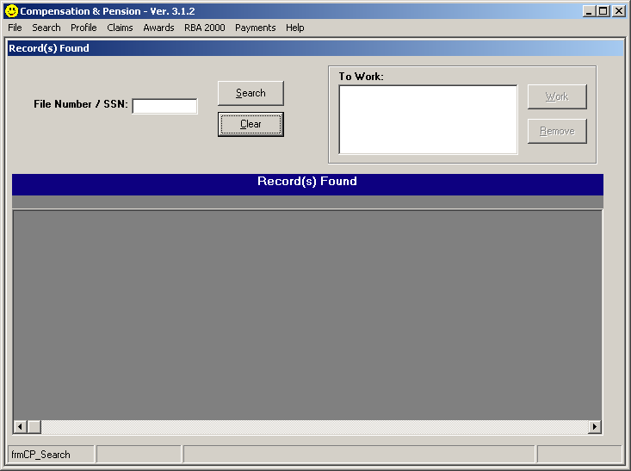

Through C&P Awards, search the Veteran by entering the file number or social security number then select “Search”

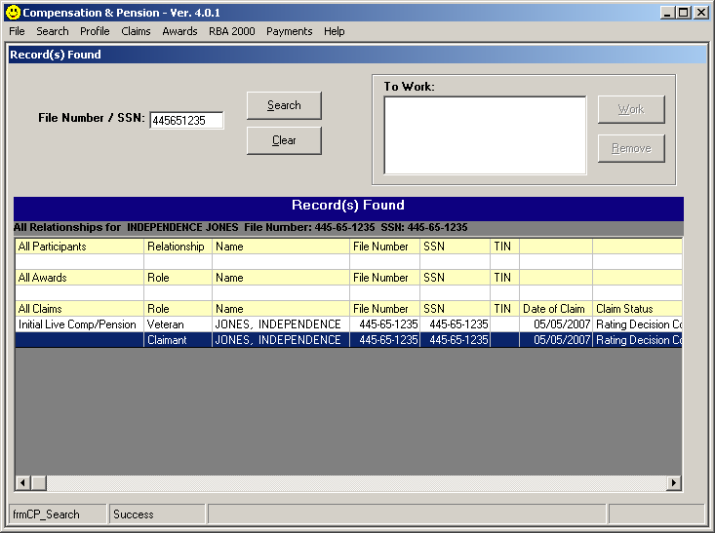
1.
Important:
If working a rating issue, the claim status must be “Rating Decision Complete.”

- In the grid under the All Claims section, select Claimant by double clicking with the mouse or
using the tab key followed by the enter key.

Separation Pay – Two Periods of Service
When a Veteran has disabilities associated with two separate tours and separation pay was received for one tour, the Other Adjustments tab will be used to allow for payment for the tour where separation pay was not received.

For this scenario, assume the following:

- The Veteran has two periods of service.

- PTSD with a 50% evaluation from 05/15/2007 is associated with the first tour.

- The right knee condition with a 30% evaluation from 05/15/2007 is associated with the second tour.

- The Veteran’s separation pay was received for the second tour.

We want to ensure that we pay the Veteran at the 50% rate for the PTSD condition.

Access the Military Payment Information screen by selecting the Military Payment Information button.

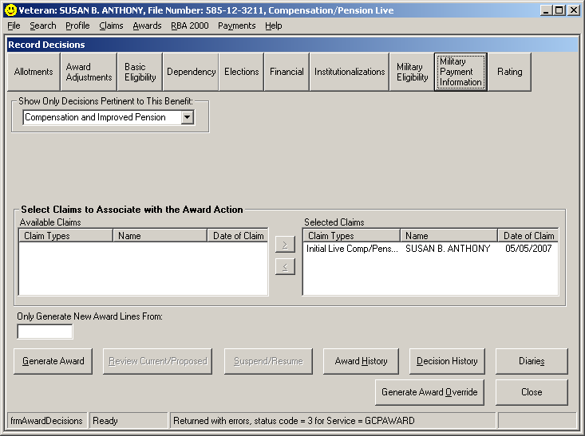

On the Military Payment Information Screen select the Discharge Pay tab

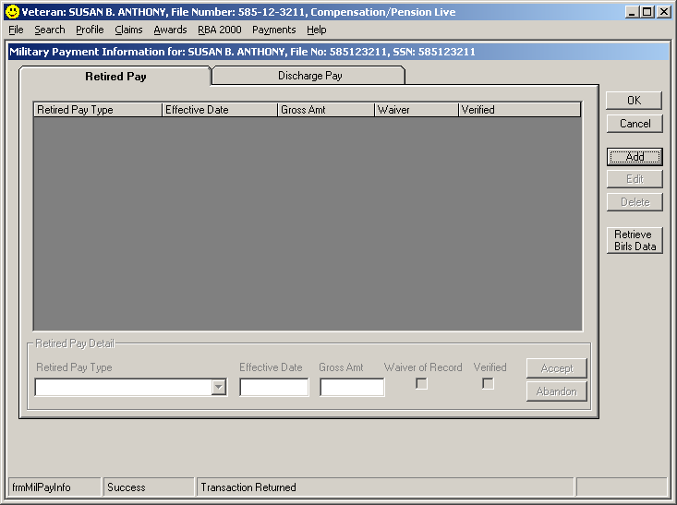

On the Discharge Pay tab (shown on the next page)

- Select Add.
- Select the Discharge Pay Type “Separation”.
- Record the Gross Amount Received and the After Tax Amount Received.
- Select the RAD Date to identify the period of service for which the Separation Pay was received.
- Select Accept to update the screen.
- Select OK to save the decision and close the screen.
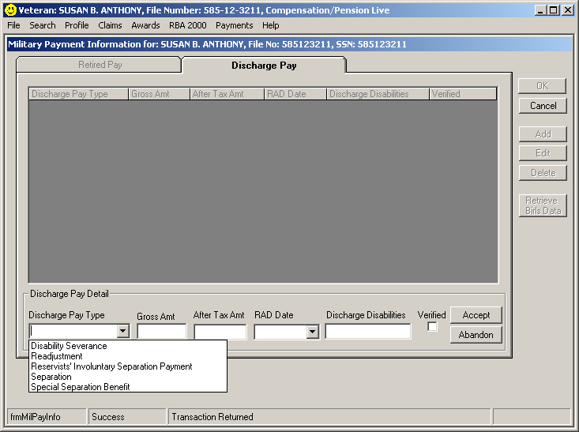
1
2
3
4
5
6

Select the Award Adjustments button to open the set of Adjustment Decision screens.

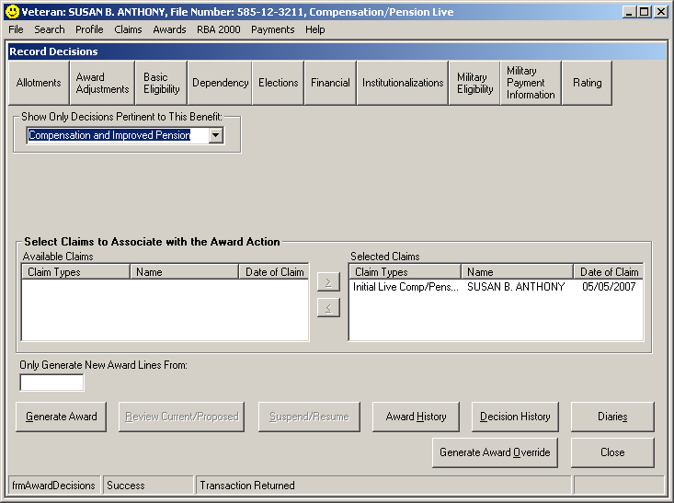

On the Award adjustments screen, select the Separation Pay or Disability Pay (if Severance) tab.

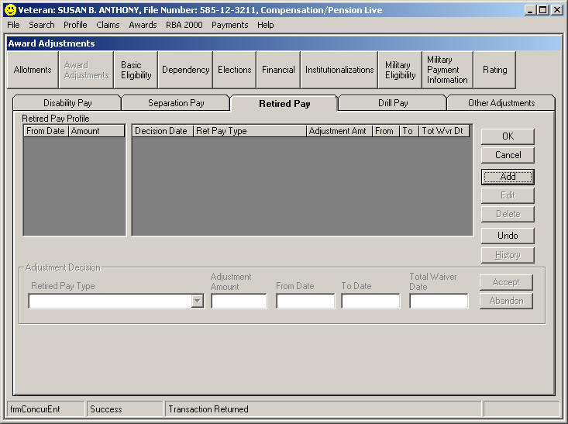

If Separation Pay:

- Select Add.
- Select the Separation Pay Type of “Separation.”
- Note the balance to be recouped has been populated into the Original Balance field based on the prior entries on the Military Payment Information screen.
- Enter the Award Effective Date to identify when the withholding is to begin.
- Select Accept to update the screen.

Note – If you were to close the screen here and generate the award, the system would apply all benefits due to the separation balance until fully recouped.

Select “Other Adjustments” tab on the Award Adjustments screen.

On the Other Adjustments tab:

- Select the Add button.
- Select the Adjustment Reason “Preserve Net Rate.”
- Enter the Adjustment Amount – this is the amount you want to pay for the conditions
associated with the tour for which no separation pay was received. In this case, the
amount will be $712.00 – the 50% rate for a single Veteran.
- Enter the From Date.
- Enter the To Date if applicable.
- Select Accept to update the screen.
- Select OK to save the decision and close the screen.

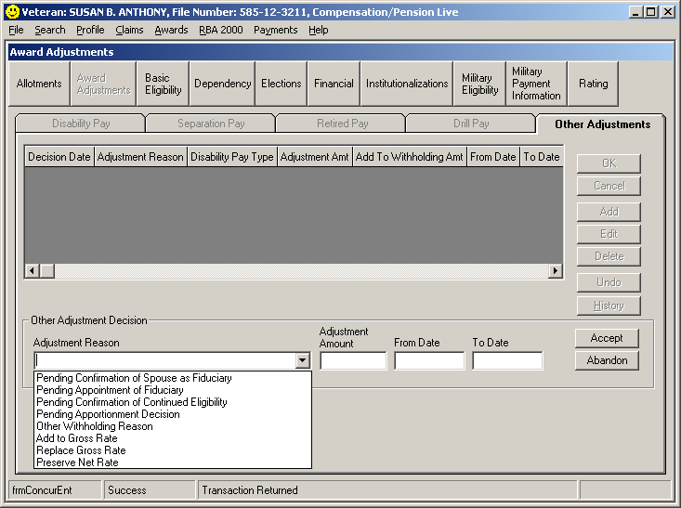
1
2
3
4
5
6

After recording all of the decisions identified above, generate the award and review the proposed award.

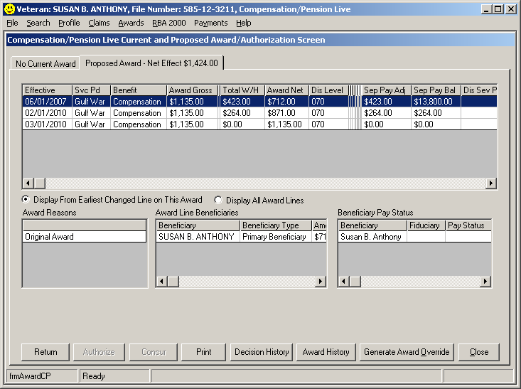

The computer will calculate to the date when all separation pay will have been recouped based on the
current service connected and non service connected rating. The example above is based on the
current date being prior to 12-1-07 COLA adjustment and shows withholding is terminated 3-1-10.
This is the date all separation pay has been recouped.

***Keep in mind that as the COLA adjustments are made, the projected date when separation/severance pay will change also.

EXAMPLE OF PCGL
NOTIFICATION LETTER

DEPARTMENT OF VETERANS AFRAIRS

VA Regional Office
123 West Side Ave
Anywhere, USA 00000-0000

In Reply Refer to: 111/300/Triage
CSS 000 00 0000
VETERAN, J.P

J. P VETERAN
123 GALAXY DRIVE
ANYWHERE, USA 00000-0000

Dear Mr. Veteran:

We made a decision on your claim for service connected compensation received on November 15, 2008.

This letter tells you about your entitlement amount and payment start date and what we decided. It includes a copy of our rating decision that gives the evidence used and reasons for our decision. We have also included information about additional benefits, what to do if you disagree with our decision, and who to contact if you have questions or need assistance.

Your Award Amount and Payment Start Date
Your monthly entitlement amount is shown below:

Total VA Benefit | Amount Withheld | Amount Paid | Effective Date | Reason For Change
$230.00 | $117.00 | $113.00 | Dec 1, 2008 | Effective date of your award

We are paying you as a single Veteran with no dependents.

You Can Expect Payment
Your payment begins the first day of the month following your effective date. You will receive a payment covering the initial amount due under this award, minus any withholdings, in approximately 15 days. Payment will then be made at the beginning of each month for the prior month. For example, benefits due for May are paid on or about June 1.

We Have Withheld Benefits
You received severance pay of $15,208.80 from the military for your Herniated disc L4-L5 and L5-S1, chronic lower lumbar spine.
We must hold back part of your VA compensation until the severance amount is paid back. VA shall withhold (after federal income tax) the severance amount received after September 30, 1996. Severance amount received prior to October 1, 1996, will include the amount before taxes are taken out. After an amount equal to your severance pay allowance is paid back, you'll start receiving your full monthly VA compensation.

What We Decided
We determined that the following condition(s) was/were related to your military service, so service connection has been granted:

Medical Description | Percent (%) Assigned | Effective Date
chronic lower lumbar spine | 20% | Nov 15, 2008

We have enclosed a copy of your Rating Decision for your review. It provides a detailed explanation of our decision, the evidence considered, and the reasons for our decision. Your Rating Decision and this letter constitute our decision based on your claim received on . It represents all claims we understood to be specifically made, implied, or inferred in that claim.

We enclosed a VA Form 21-8764, "Disability Compensation Award Attachment-Important Information," which explains certain factors concerning your benefits.

Are You Entitled to Additional Benefits?
You may be eligible for government life insurance if you
- were released from active duty after April 25, 1951,
- are in good health (except for any service connected conditions), and
- apply within two years of this notification of your disability rating.

If you are totally disabled, you may be eligible to have your government life insurance premiums waived. The Insurance is called Service-Disabled Veterans Insurance (S-DVI), and you should receive a package within two weeks. This package will contain information about the insurance and an application. If you do not receive an S-DVI package, please contact the Insurance Center to request additional information. Call the Insurance toll free number, 1-800-669-8477, or visit the Insurance web site, http://www.insurance.va.gov, for further information about Service-Disabled Veterans Insurance.

You may be eligible for medical care by the VA health care system for any service connected disability. You may apply for medical care or treatment at the nearest medical facility. If you apply in person, present a copy of this letter to the Patient Registration/Eligibility Section. If you apply by writing a letter, include your VA file number and a copy of this letter.

REDUCE OR ELIMINATE
YOUR MEDICAL CO-PAYMENTS

If you receive care at a VA medical facility, please call our Health
Benefits Call Center at 1-877-222-VETS (8387) or notify your
local VA medical center of this change in your compensation
benefits. This rating decision may reduce or eliminate your co-
payments for your VA-provided medical care. You may also be
eligible for a refund based on this rating decision. Information
regarding VA health care eligibility and co-payments is available at
our website www.va.gov/healtheligibility.

You should contact your State office of Veteran's affairs for information on any tax, license, or fee-related benefits for which you may be eligible as a Veteran (or surviving dependent of a Veteran). State offices of Veteran's affairs are available at http://www.va.gov/statedva.htm.

You may be able to receive vocational rehabilitation employment services. The enclosed VA Form 28-8890, "Important Information About Vocational Rehabilitation Benefits," explains this benefit completely. To apply for this benefit, complete and return the enclosed VA Form 28-1900, "Disabled Veterans Application for Vocational Rehabilitation."

What You Should Do If You Disagree With Our Decision
If you do not agree with our decision, you should write and tell us why. You have one year from the date of this letter to appeal the decision. The enclosed VA Form 4107, "Your Rights to Appeal Our Decision," explains your right to appeal.

If You Have Questions or Need Assistance
If you have any questions, you may contact us by telephone, e-mail, or letter.

If you | Here is what to do.
Telephone | Call us at 1-800-827-1000. If you use a Telecommunications Device for the Deaf (TDD), the number is 1-800-829-4833.
Use the Internet | Send electronic inquiries through the Internet at https://iris.va.gov.
Write | Put your full name and VA file number on the letter. Please send all correspondence to the address at the top of this letter.

In all cases, be sure to refer to your VA file number .

If you are looking for general information about benefits and eligibility, you should visit our website at https://www.va.gov, or search the Frequently Asked Questions (FAQs) at https://iris.va.gov.

We have no record of you appointing a service organization or representative to assist you with your claim. You can contact us for a listing of the recognized Veterans' service organizations and/or representatives. Veterans' service organizations, which are recognized or approved to provide services to the Veteran community, can also help you with any questions.

Sincerely yours,

A. Veterans Service Center Manager

A. Veterans Service Center Manager

Veterans Service Center Manager
Email us at: https://iris.va.gov

Enclosure(s): Rating Decision
VA Form 21-8764
VA Form 28-1900
VA Form 28-8890
VA Form 4107

