Virtual VA
TRAINEE HANDOUT

Prerequisite | Prior to this lesson, you must complete the VA terminology lesson.
Purpose of Lesson | The purpose of this lesson is to introduce you to Virtual VA and demonstrate the types of documents that can be accessed through this application.
Time Required | One hour lecture, 45 minutes practical application utilizing demonstration and Virtual VA computer based training (CBT)
Instructional Methods | Lecture to be supplemented by practical demonstration and practice.
Materials/ Training Aids | Virtual VA Trainee Handout / PowerPoint / Virtual VA computer based training (CBT)
Training Objectives | After completing this lesson, you will be able to state or demonstrate the following:  - What is Virtual VA  - What types of records are available in Virtual VA  - How to log into Virtual VA  - How to search for a veteran’s eFolder  - How to access a record within a veteran’s eFolder  - How to access various resources and training materials about Virtual VA
References | Virtual VA User Guide: http://vbaphiweb.vba.va.gov/training/guides/virtualvauser.pdf  This document can be located under the C&P Services Intranet site, under Business Management - Virtual VA.

Table of Contents

What is Virtual VA.…………………………………………………………………….. 3
What Types of Records are Available in Virtual VA. …………………………………. 4
How to Log into Virtual VA. …………………………………………….……………. 5
How to Search for a Veteran’s eFolder. ………………………………………………. 6
How to Access a Record within a Veteran’s eFolder. …………………………………. 8
Virtual VA’s Learning Tools…………………………………………………………….10

What is Virtual VA

Virtual VA moves the Department of Veterans Affairs towards a paperless Agency by maintaining veterans' claim folders electronically rather than on paper. The Virtual VA system centers on the concept of a veteran's electronic claims folder, or eFolder.
Virtual VA provides:
- Electronic storage for applications and evidence coming into the Department of Veterans Affairs
- Electronic storage for all correspondence and ratings sent out from the Department of Veterans Affairs
- The ability for a user to categorize, search, and sort the contents of the eFolder to assist in evaluating the claim
Using imaging technology, documents are electronically inserted in the veteran’s eFolder by means of fax, scanning/indexing, electronic insertion, and/or data feeds from external sources. Virtual VA can accept claims from several sources: mail, fax, email, or via the VONAPP automated system which will provide submission of a claim application through the Internet.
Virtual VA allows documents to be shared among the entire VA organization and even other government agencies such as Defense Finance and Accounting Service (DFAS) without the constraint of moving a physical folder. In addition, other automated systems, such as RBA2000, and VETSNET, are able to use Virtual VA as a storage repository for released correspondence and other documents.
We receive RBA2K documents (rating decision documents) electronically through data feed, and some VETSNET batch letters & write outs. We do not receive MAP-D letters through data feed. If MAP-D letters are in Virtual VA, they are scanned in by the Pension Maintenance Centers (PMCs) and rating activity sites (RAS). We are working with VETSNET to get MAP-D letters automatically imported once we move to a central server.
As we move closer to becoming a paperless claims processing agency, more documents will be stored in Virtual VA for claims evaluation.

What types of records are available in Virtual VA

Currently, the following types of documents can be obtained from Virtual VA:
- Many documents relating to a veteran’s pension award (scanned in by Pension Management Centers)
- Benefits Delivery at Discharge (BDD) and Disability Evaluation System (DES) claims processing documents
- Documents generated by Debt Management Center
- Recent rating decisions and code sheets
- Recent decision notification letters
- BDN generated letters
- QTC and MES examination results
- CRSC/CRDP Notification Letters & Worksheets
- Compensation cost of living adjustment (COLA) – End of Year Letters
- Write-outs
- Marine Corp Records (Korea/Vietnam Wartime)

How to log into Virtual VA

To login to Virtual VA:

1. Go to the Virtual VA website at http://virtualva.vba.va.gov.
2. Enter your Station Number, Username, and Password.
3. Click the Login button.

Your username and password are your LAN username and password.

Note: If you enter an invalid user ID, RO number, or password at any time during this process, a message box will display prompting a valid input combination. Check your information and try again.

Note 2: The first time you access Virtual VA, you may be prompted to accept a security certificate. Accept the certificate and continue. If you do not accept the certificate, Virtual VA will not run properly.
How to search for a veteran’s eFolder
When a user is logged in, the ready screen or what is known as the “Manage Work Items” page is present.
To locate a veteran’s eFolder, enter the VA file number into the field marked “Find eFolder” or select the “Find eFolder” tab.
NOTE: If a claim number exists for the veteran, entering his/her SSN in the ‘Find eFolder’ field will not yield a return. However, if you only have the veteran’s SSN available, you should use the ‘Find eFolder’ tab as it performs a cross check for SSN and claim number.
Once you are logged in, this is the screen you will see:
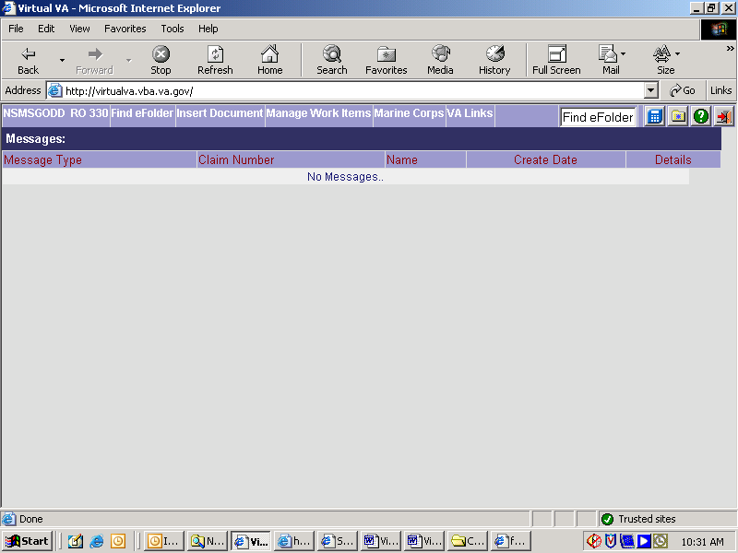
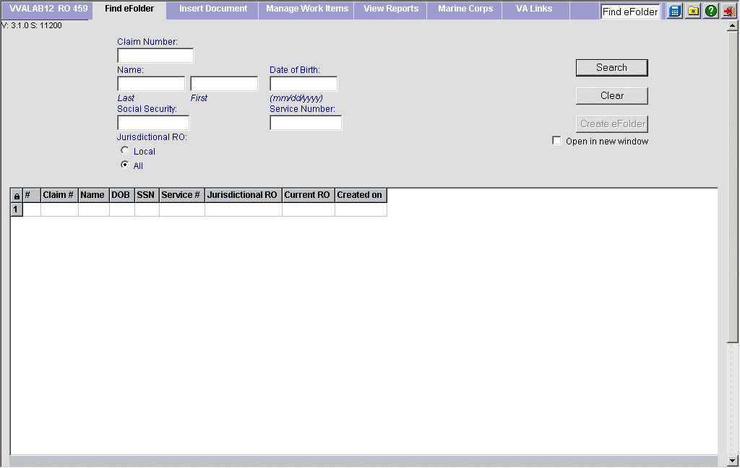

To locate a veteran’s eFolder, enter the VA file number into the field marked “Find eFolder.” Hit the enter key. NOTE: If a file number exists, a record will not be found using the veteran’s social security number.
Another way to search for a veteran’s record is to use the “Find eFolder” tab, which will bring you to a screen which will allow you to search by entering one or more of the following fields: claim number, first name, last name and DOB, SSN, or service number.
How to access a record within a veteran’s eFolder

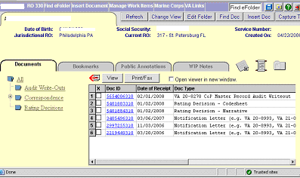
Once the veteran’s eFolder is located, a list of available documents is displayed. The document ID number, document date and document type are displayed for each record available.
To choose a record, click on the hyperlinked (blue) document ID number. This will pull up the document for review.
To close the document, click “Close” in the upper, right corner of the screen.
To print the document, click on the printer icon on the tool bar.

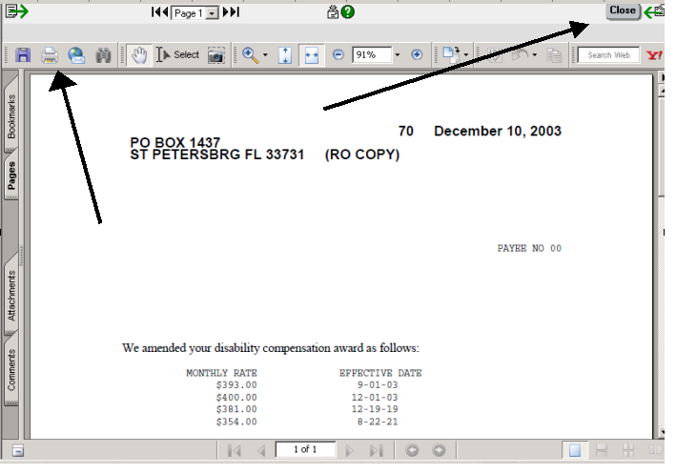
VIRTUAL VA’S LEARNING TOOLS
The Virtual VA login screen contains several resources and links that provide useful information. You should familiarize yourself with the resources available.
One resource that provides guidance and instruction on various topics related to Virtual VA is the Virtual VA Training webpage. This webpage provides user guides and computer based training (CBT) on a variety of topics.
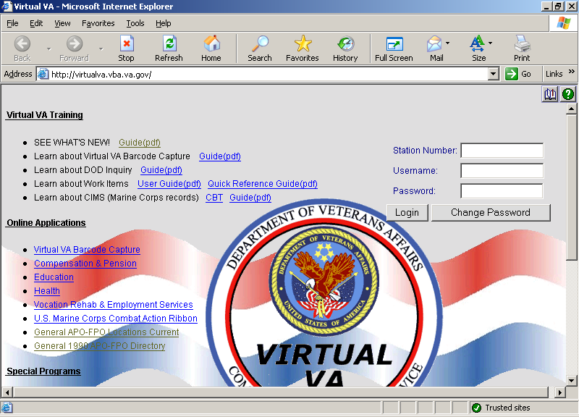
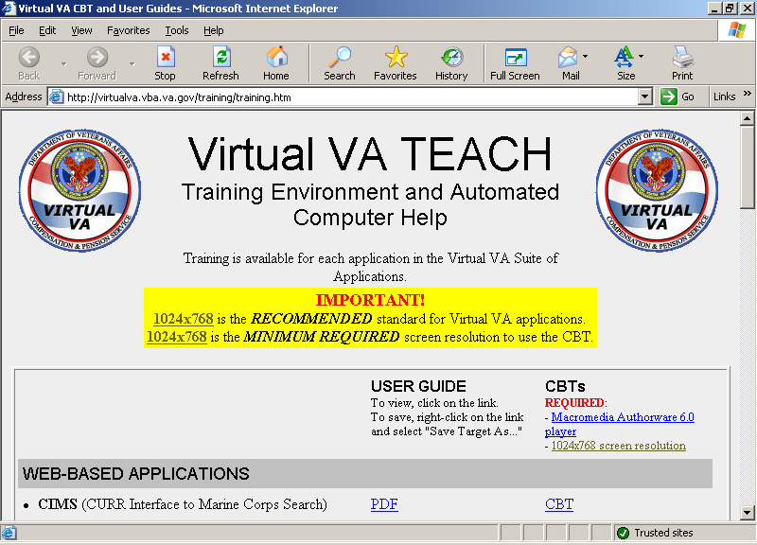
Click here, and you are taken to the screen below

