CEST and EP Controls in SHARE
Trainee Handout

Table of Contents

Objectives 2
References 3
Topic 1: Claims Establishment (CEST) in SHARE 4
Topic 2: End Products 8
Attachment A: End Product Codes 10
Attachment B: CEST and EP Control Review Exercise 11
Practical Exercise 13

Objectives
- Given the trainee handout packet, identify procedures to establish a claim using SHARE, with 85% accuracy.
- Given the trainee handout packet, identify how end product (EP) controls affect claim management, productivity, and staffing, with 85% accuracy.
- Given the trainee handout packet, establish a claim in SHARE, to instructor satisfaction.
- Given the trainee handout packet and SHARE, establish end product (EP) controls, to instructor satisfaction.

References

- 38 CFR 3.1 (r), Date of Receipt
- M21-1MR III.ii.1.B.5, Establishing Mail Control
- M21-1MR III.ii.1.C.10, Recording the Date of Receipt
- M21-1MR III.ii.1.C.12, Claims from Foreign Residents
- M21-1MR III.i.2.A.2, End Products and Dates of Claim for Pre-Discharge Claims
- M21-1, Part II, Chapter 1, Claims Establishment and Mail Management
- M21-1, Part V, Chapter 16, Claims Establishment and Control Procedures
- M21-4, Chapter 4 and Appendix C, Claims and Appeals Processing Timeliness, End Product Classification Codes and Work Rate Standards for Quantitative Measurement
- Self Help and Resource Exchange (SHARE)User’s Guide
- Fast Letter 10-23
- Compensation and Pension Service Bulletin February 2009

Topic 1: Claims Establishment (CEST) in SHARE

BDN Commands
Benefits Delivery Network (BDN) system control is established in the initial processing period. When establishing control, consider identification of the proper EP, the type of control necessary, and the applicable control period.
BDN commands used to authorize, establish, clear, cancel, or change a claim include:

Command | Meaning | Used to
CAUT | Claims Authorization | Authorize and generate an award or disallowance transaction
CEST | Claims Establishment | Establish and maintain control on all pending claims expected to result in award or disallowance actions
PCLR | Pending Issue Clear | Clear an existing pending issue
PCAN | Pending Issue Cancel | Cancel a pending issue
PCHG | Pending Issue Change | Change limited pending issue control data
CEST Command
The CEST command establishes a pending issue file (PIF) control for a pending claim or appeal. CEST accesses the Beneficiary Identification Records Locator Subsystem (BIRLS) record, which is used to obtain the Veteran’s service data for all original or reopened transactions.
Note: For VA purposes, an original signed application or statement of the Veteran and a claim file number or Social Security number of the claimant is needed to establish a claim.
CEST Procedures
CEST procedures include:
- Completing entries on the SHARE Ready screen
- Verifying Veterans Identification Data (VID)
- Completing entries on the 101 screen
SHARE Ready Screen
The CEST process begins on the SHARE Ready screen. Required entries on the Ready screen include:
- CEST command
- Operator’s password
- Payee Number
  - For live compensation and pension (CPL) issues valid entries are 00, 10-19, 31-39, 50, 60, or 99
  - For death cases (CPD), valid entries are 00, 10-19, 31-39, 50,60, or 70-78
- Claim Type
- Benefit Type (CPL or CPD)
- File Number or Veteran’s Social Security Number
- Veteran’s First and Last Name
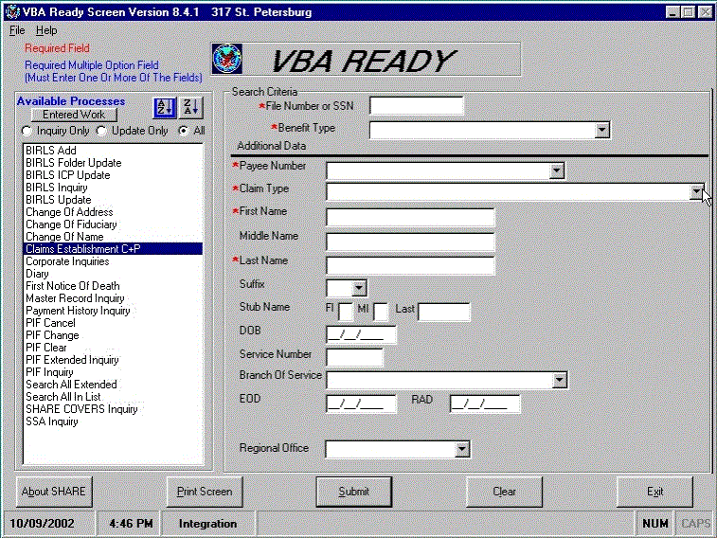
Veterans Identification Data (VID)
After the Ready screen is complete, the Veteran’s identification data (VID) is displayed, when appropriate. The following tasks need to be completed:
- Compare the information displayed with the current claim or issue to ensure the record displayed is that of the Veteran whose service provides the basis for the claim.
- If the record is the correct one, review the data for accuracy and completeness.
- Correct any erroneous data and enter any missing data.
- Select “Continue Establishment.”
- The 101 screen will then appear.
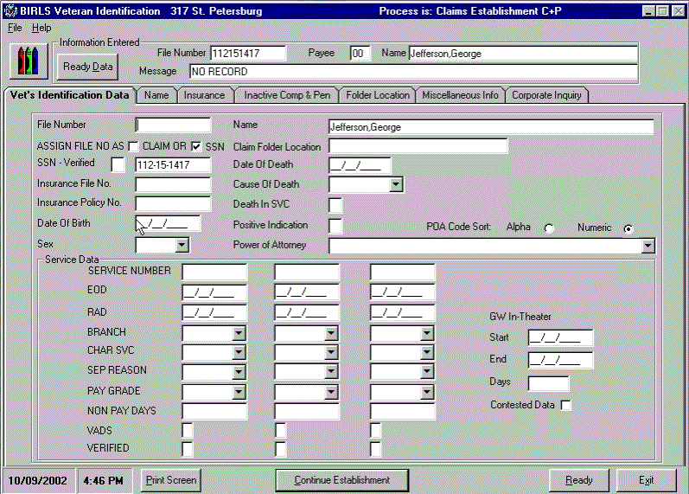
101 Screen
The last step in CEST procedures is to complete the 101 screen, also known as the
Pending Issue/Corporate Control Establishment screen:
- Complete all the entries required on the 101 screen.
- As provided by M21-1, Part V, Chapter 16, the VSR is required to manually enter the following fields: Address (if blank), Power of Attorney, Section/Unit Number, Date of Claim.
- Select “Create Establishment.”
The CEST process is now complete.
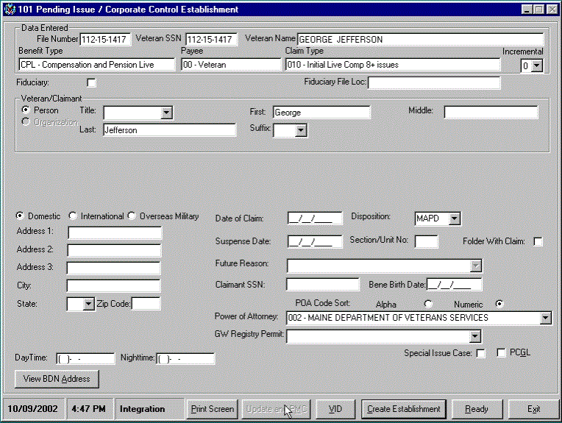
Note: Additional guidance on completion of the 101 screen can be found in the SHARE User Guide.
Date of Claim
The Date of Claim is a required entry on the 101 screen and serves as the basis for determining processing timeliness. For CEST purposes, it is the earliest date the claim was actually received by any VA facility. The term “VA facility” includes, but is not limited to:
- Your RO or pension maintenance center (PMC)
- Another VA RO or PMC if the claim was first received there before being forwarded to your office
- A VA medical center (VAMC) if the claim was first received there before being forwarded to your office
VA requires this date stamp on all information received by the RO mailroom, including claims, applications, and associated evidence.

Topic 2: End Products

End Products
The end product (EP) system is the primary Service Center workload monitoring and management tool. Correct use of the EP system facilitates proper control of pending workloads and appropriate work measurement credit. Correct work measurement is essential to substantiate proper staffing requirements and determine productive capacity. Received and completed EPs are also used to formulate the annual budget submission to the Secretary, OMB, the President, and Congress.

Productivity and Staffing
EPs are an important factor in staffing and budgetary decisions, so it’s important that an office claim the proper EP for each issue it works and remembers to clear every legitimate EP when the work is completed.
When the standard man-hour credit (M21-4, Appendix C, Section III) is multiplied with each EP taken during a given month, the result reflects how many hours of work credit were earned during that month. If the result is compared with the total number of hours actually worked by personnel, productivity of an office can be determined high or low.

EP Controls
Within 7 days of receipt, a claim should be placed under EP control. Except for the few exceptions specifically identified in MR21-4, Appendix C, the EP should remain pending until all required actions on that claim have been completed.
EP codes 010 and 110 are used for original claims, based on the number of disabilities claimed:
- EP 010 is limited to initial disability compensation or concurrent initial disability compensation and pension claims containing eight issues or more.
- EP 110 is limited to initial disability compensation or concurrent initial disability compensation and pension claims containing seven issues or less.
Generally, only one EP is proper even though the casework may involve multiple actions that could have resulted in separate EPs had they been received and/or worked at different times. The EP should not be cleared until all issues have been adjudicated.
Third Digit Modifiers
Third digit modifiers provide more precise information to the statistical picture provided by the EP system.
EPs may be modified with a third digit to identify specific issues, type of claim, or incremental multiple claims of the same EP category. For EPs 010, 020, 110, 120, 130, 140, 150, 160, 170, 180, 190, 310, 320, 330, 400, 500, 510, 600, 680, 690, 930, and 960, the following modifiers should be used when applicable:
Third Digit Modifiers
BDD Claims | 011, 111, 021 | “1”
Radiation Claims | 012, 112, 022 | “2”
Foreign Claims | 016, 116, 026, 136 | “6”
Quick Start and Pension Claims | 017, 117, 027 | “7”
Dual and Reopened Service Connected Death Claims | 019, 119, 029 | “9”

Attachment A: End Product Codes
010 Original comp or C&P, 8 issues or more  020 Supplemental compensation  050 EVR without further referral  070 SSOC, Appeal certification  095 Vocational-rehab eligibility, memo rating  110 Original comp or C&P, 7 issues or less  120 Reopened pension  130 Dependency issues  135 Hospital/NH/Medicaid adjustments  140 Original DIC  150 Income, Estate, Election issues  154 IVM  155 EVR with further referral  160 Burial claim  165 Accrued claim  170 Appeals control – No work credit  172 Statement of the Case  173 Hearing – Other than Hearing Officer  174 Hearing Officer hearing  180 Original pension | 190 Original death pension  290 Miscellaneous eligibility determinations  293 COWC decisions  295 Vocational-rehab eligibility, no rating  310 Review exams, unemployability, no rating  314 IVM-Comp employability issue  320 Hospital reviews, Para 29 and 30  400 Miscellaneous actions-no work credit  410 Original spina bifida claim  420 Reopended claims for spina bifida  450 Claim for increase – spina bifida  470 Notices of Disagreement – spina bifida  500 Controlled correspondence  - FOIA/PA release of information  - Due Process  - Special projects without rating action (e.g., PGW, tobacco)  690 Special projects without rating action  - Reviews, referrals  960 Administrative error
Reference M21-4, Appendix C

