Power Of Attorneys (POAs)/Service Organizations
Trainee Handout

Table of Contents

Objectives 2
References 3
Topic 1: Types of Power of Attorneys (POAs) and Their Authority 4
Topic 2: VA Form 21-22 or VA Form 21-22a Processing 6
Topic 3: Exclusive Contact/Revocation or Termination of a Power of Attorney 8
Job Aid: Claimant Representative Roles 9
Attachment A: National Organizations Power of Attorney Codes 11
Attachment B: State Organizations Power of Attorney Codes 12
Attachment C: Private Attorney Codes 14
Attachment D: Sample VA Form 21-22 15
Attachment E: Sample VA Form 21-22a 16
Attachment F: Topic 2 Exercise 18
Practical Exercise 19

Objectives

- Using the trainee handout packet, identify the types of POAs that may be appointed by claimants for VA purposes and their authority, with 85% accuracy.
- Using the trainee handout packet, differentiate the requirements when processing VA Form 21-22 and VA Form 21-22a, with 85% accuracy.
- Using the trainee handout packet, differentiate the requirements for exclusive contact, revocation, or termination of a POA, with 85% accuracy.
References

- 38 CFR 3.155
- 38 CFR 20.204
- 38 CFR 20.301
- 38 CFR 14.628(a)(2)
- 38 CFR 14.630 – 631
- M21-1MR, Part I, Chapter 3

Topic 1: Types of Power of Attorneys (POAs) and Their Authority
Types of POAs
There are three types of POAs:
- Accredited representative of a service organization or agent. Service organizations must obtain recognition from the VA in order to represent claimants through the VA’s Office of General Counsel.
- Non-licensed individual. A non-licensed individual can represent a claimant on a one-time, one-claim basis per the provisions of 38 CFR 14.630. A non-licensed individual may only represent one VA claimant (unless a request is made to the VA’s General Counsel).
- Attorney. An attorney needs to be a member in good standing of a state bar.
Attorney Fee Coordinators
Claimants may enter into a fee agreement with an attorney POA representative who represents them in preparation, presentation, and prosecution of their claim with the VA. These types of POA are handled by an attorney fee coordinator in each specific office.
POA Authority and Limitations
A POA is authorized to prepare, present, and prosecute a claimant’s claim. A POA has the authority to:
- Review the claimant’s records
- Present evidence on behalf of the claimant
- Sign an informal claim, a notice of disagreement (NOD), or a substantive appeal on behalf of the claimant
- Withdraw an appeal
While POAs can submit, request, and present certain information on behalf of the claimant, there are also limitations that govern the POAs ability to sign documentation. Here are the limitations of what a recognized POA can and cannot do.
A POA can:
- Submit an informal claim
- Submit a Notice of Disagreement
- Present evidence on behalf of a claimant
- Submit a VCAA Notice Response
- Request, on behalf of the claimant, additional time to submit evidence
- Submit a claim which does not require claimant certification
- Change a claimant’s address or direct deposit information by phone
A POA cannot:
- Sign an original, formal claim for benefits
- Sign any forms requested in a development letter
- Sign a claim or other form which does require claimant certification
- Sign a VA Form 21-572 or VA Form 24-0296 or other document
Note 1: A POA may not sign formal (or original) applications for Veteran’s benefits or other forms requiring claimant certification, such as eligibility verification reports. However, a POA may sign informal claims on behalf of the claimant, because, under 38 CFR 3.155, an informal claim may be accepted without the claimant’s signature. Informal claims, which are often filed on VA Form 21-4138, Statement in Support of Claim, include, but are not limited to, claims for increase or to reopen.
Note 2: The representative is furnished copies of all correspondence sent to the claimant.

Topic 2: VA Form 21-22 or VA Form 21-22a Processing
POA Requests
Process POA requests as soon as they are received from the claimant and/or representative.
Forms to Establish POAs
The following forms can be used to establish a POA for VA purposes:
- VA Form 21-22, Appointment of Veterans Service Organization as Claimant’s Representative. VA Form 21-22 identifies the service organization the claimant has chosen to represent him/her. VA Form 21-22 needs only to be signed by the claimant.
- VA Form 21-22 a, Appointment of Individual as Claimant’s Representative. VA Form 21-22a identifies the agent or attorney the claimant has chosen to represent him/her. VA Form 21-22a needs to be signed by both the claimant and the agent or attorney.
- A declaration of representation that complies with the provision outlined in 38 CFR 14.640. A non-licensed individual can be appointed as POA through a declaration of representation. An attorney can also be appointed POA through a declaration of representation written on the attorney’s letterhead and signed by the attorney.
Notes:
- An Agent may only establish representation by using a VA Form 21-22a.
- Attorneys and non-licensed individuals may establish representation by using the VA Form 21-22a or an appointment letter.
Processing VA Form 21-22
The following actions are taken to process VA Form 21-22, Appointment of Veterans Service Organization as Claimant’s Representative:
Copy | Action
Copy 1 | - Enter the current date and your initials in the ACKNOWLEDGED block.  - Indicate any action taken with copy 3 in the appropriate block.  - Reverse file on the right flap of the claims folder.
Copy 2 | Send copy 2 to the accredited representative of the service organization to acknowledge the Department of Veteran Affairs (VA’s) receipt of VA Form 21-22.
Copy 3 | EITHER  - File copy 3 in any other relevant folders, such as insurance, Counseling, Evaluation and Rehabilitation (CER), Chapter 30 or loan guaranty folders.  - Forward copy 3 to any relevant third parties to note the existence of the accredited representative of a service organization as a representative  OR  - Dispose of copy 3, if not needed, in accordance with the Records Control Schedule VBA, Part I, 13-052.300.
References: For more information on the relevant folders and third parties that should receive copy 3 of VA Form 21-22, see M21-1MR, Part I, 3.B.9.e.

Processing VA Form 21-22a
The following actions are taken to process VA Form 21-22a, Appointment of Individual as Claimant’s Representative:
Copy | Action
Original | - Annotate with the current date and “Acknowledged.”  - Reverse file on the right flap of the claims folder.
Photocopy 1 | Send a photocopy to the agent or non-licensed individual representative to acknowledge the VA’s receipt of VA Form 22a or appointment letter.
Additional Photocopies | File any additional photocopies needed in any relevant folders or send to any relevant third parties to note the existence of the agent or non-licensed individual as a representative.

Topic 3: Exclusive Contact/Revocation or Termination of a Power of Attorney
Request for Exclusive Contact
VA does not honor requests by an attorney for exclusive contact to restrict the communication between VA and the claimant.
Processing a Request for Exclusive Contact
In any case where an attorney requests exclusive contact in writing, send the attorney a letter incorporating the following notice:
We are unable to comply with your request that we correspond exclusively with you and not with the VA claimant you represent.

We have discontinued the policy of "exclusive contact" with a claimant’s representative. While VA has attempted in the past to accommodate exclusive contact requests the agency has found that our attempts to comply with these requests adversely impacted the timely completion of essential ministerial functions, such as responding to phone inquiries from claimants and the issuance of standard benefit information letters. Rather, as required by regulatory and statutory provisions, we have determined that corresponding directly with the VA claimant with a copy of each and every communication to the representative is the best means for keeping all interested persons up-to-date about VA’s actions regarding a particular claimant. This course of action is consistent with the non-adversarial nature of the VA benefits adjudication system and with VA statutes and regulations.
Restricted Information
In certain cases, access to information is restricted. VA must obtain consent from the claimant prior to disclosing any restricted information that is protected under 38 U.S.C. 7332.
Revoking and Terminating Representation
Claimants or their representatives may revoke or terminate the relationship between the claimant and the representative OR the representation can be revoked automatically.
Type of Revocation or Termination | Description
Claimant revocation or termination | A claimant, claimant’s guardian, or VA fiduciary may terminate his or her relationship with a representative at ANY time by informing the VA.
Representative revocation or termination | A representative may terminate the representation of a VA claimant in the presence of an RO employee.
Automatic revocation or termination | Representation is automatically terminated if an unlimited declaration of representation is received. The new declaration revokes the old declaration of representation.  If a limited declaration is received, any prior unlimited declaration remains in effect for all other claims or issues not named in the limited declaration of representation.
Note: ROs have a designated individual who handles cases that involve private attorneys.

Job Aid: Claimant Representative Roles

The Job Aid Claimant Representative Roles details what a recognized POA can and cannot do.

What a Recognized POA Can Do |  | What a Recognized POA Cannot Do
Submit an informal claim. For example: A claimant's service organization of record files a document stating the veteran wishes to apply for VA Pension. |  | Sign an original, formal claim for benefits, such as that which is filed on a 21-526 or 21-534.
Submit a Notice of Disagreement or an appeal
Present evidence on behalf of a claimant. For example: We send a veteran a letter requesting a marriage certificate. The service organization of record submits and signs a cover sheet indicating that it is attached and attaches the certificate. This is acceptable.
Submit a VCAA Notice Response advising whether or not the claimant has additional evidence to submit. |  | Sign the form(s) requested in a development letter, such as if we ask a surviving spouse to complete a VA Form 21-8049 in order to make a net worth determination.
Request, on behalf of the claimant, additional time to submit evidence.
Submit a claim which does not require claimant certification, such as a claim for Special Monthly Pension once an original claim is of record. |  | Sign a claim or other form which does require claimant certification, such as an Eligibility Verification Report or Medical Expense Report or a Declaration of Status of Dependents (21-686c).
Change a claimant's address or direct deposit information by phone, as long as the verification requirements have been met. |  | Sign a VA Form 21-572 or VA Form 24-0296 or other document to change claimant's address or direct deposit information.
Claimant Certification Requirement explanation. Claims that require claimant certification are generally claims where the evidence that will be used to decide the claim is the form submitted. A Medical Expense Report is enough to adjust a claimant's benefit, as the form itself is the evidence. Therefore, it must be signed by the veteran or surviving spouse. On the other hand, in a claim for special monthly pension, we will not use the document that is asking for SMP to decide the claim. We will use medical evidence obtained or a VA exam. As a result, it can be signed by the claimant's recognized POA. A 21-4138 is a good example of a form that may or may not require a claimant signature. If the 21-4138 is a claim for additional benefits or if it is acting as a cover, it can be signed by the claimant's representative. However, if the 21-4138 includes information that will affect benefits (a report of the death of a veteran's spouse, a report that the veteran left an assisted living facility) it must be signed by the claimant. Treat information received from a service organization that requires a claimant signature, as third party information. Submissions noted in the left column do not require a claimant signature.
Remember, for purposes of this handout, the term "POA" refers to a claimant's duly appointed service organization, agent, individual or attorney. A private power-of-attorney appointment has no effect on a claim, as a private power of attorney is not recognized for VA purposes.
M21-1 MR Part 1, Chapter 3, Section A

Attachment A: National Organizations Power of Attorney Codes
National Organization Name | Code
African American PTSD Association | 091
AMVETS | 077
American Defenders of Bataan and Corregidor, Inc. | 061
American Ex-Prisoners of War, Inc. | 065
American GI Forum, National Veterans Outreach Program | 068
American Legion | 074
American Red Cross | 075
Armed Forces Services Corporation | 078
Army and Navy Union, USA | 079
Blinded Veterans Association | 080
Catholic War Veterans of the U.S.A. | 081
Disabled American Veterans | 083
Fleet Reserve Association | 085
Gold Star Wives of America, Inc. | 012
Italian American War Veterans of the United States, Inc. | 095
Jewish War Veterans of the United States | 086
Legion of Valor of the United States of America, Inc. | 087
Marine Corps League | 088
Military Order of the Purple Heart | 089
National Amputation Foundation, Inc. | 024
National Association for Black Veterans, Inc. | 084
National Association of County Veterans Service Officers | 064
National Veterans Legal Services Program | 082
National Veterans Organization of America | 094
Navy Mutual Aid Association | 093
Non Commissioned Officers Association of the U.S.A. | 062
Paralyzed Veterans of America, Inc. | 071
Polish Legion of American Veterans, U.S.A. | 003
Retired Enlisted Association | 007
Swords to Plowshares, Veterans Rights Organization, Inc. | 043
United Spanish War Veterans of the United States | 096
The Veterans Assistance Foundation, Inc. | 063
Veterans of Foreign Wars of the United States | 097
Veterans of World War I of the U.S.A., Inc. | 098
Veterans of the Vietnam War, Inc. and The Veterans Coalition | 092
Vietnam Era Veterans Association | 029
Vietnam Veterans of America | 070

Attachment B: State Organizations Power of Attorney Codes
State | State Organization Name | Code
Alabama | Department of Veterans Affairs | 022
American Samoa | Veterans Affairs Office | 067
Arizona | Veterans Service Commission | 045
Arkansas | Department of Veterans Affairs | 050
California | Department of Veterans Affairs | 044
Colorado | Division of Veterans Affairs | 039
Connecticut | Department of Veterans' Affairs | 008
Delaware | Commission of Veterans Affairs | 060
Florida | Department of Veterans Affairs | 017
Georgia | Department of Veterans Service | 016
Guam | Office of Veterans Affairs | 056
Hawaii | Office of Veterans Services | 059
Idaho | Division of Veterans Services | 047
Illinois | Department of Veterans Affairs | 028
Kansas | Commission on Veterans Affairs | 052
Kentucky | Center for Veterans Affairs | 027
Louisiana | Department of Veterans' Affairs | 021
Maine | Department of Veterans Services | 002
Maryland | Veterans' Service Commission | 013
Massachusetts | Department of Veterans Service | 001
Minnesota | Department of Veterans Affairs | 035
Mississippi | Veterans Affairs Board | 023
Missouri | Veterans Commission | 031
Montana | Veterans Affairs Division | 036
Nebraska | Department of Veterans' Affairs | 034
Nevada | Commission for Veterans Affairs | 054
New Hampshire | State Veterans Council | 073
New Jersey | Department of Military and Veterans' Affairs | 009
New Mexico | Veterans' Service Commission | 040
New York | Division of Veterans' Affairs | 006
Northern Mariana Islands | Veterans Affairs Office | 053
North Carolina | Division of Veterans Affairs | 018
North Dakota | Department of Veterans Affairs | 037
Ohio | Governor's Office of Veterans' Affairs | 025
Oklahoma | Department of Veterans Affairs | 051
Oregon | Department of Veterans' Affairs | 048
Pennsylvania | Department of Military Affairs Bureau for VA | 010
Puerto Rico | Public Advocate for Veterans Affairs | 055
Rhode Island | Division of Veterans Affairs | 004
South Carolina | Division of Veterans Affairs | 019
South Dakota | Division of Veterans Affairs | 038
Tennessee | Department of Veterans' Affairs | 020
Texas | Veterans Commission | 049
Utah | Office of Veterans Affairs | 041
Vermont | Veterans Affairs Section, Military Department | 005
Virgin Islands | Office of Veterans Affairs | 032
Virginia | Department of Veterans Affairs | 014
Washington | Department of Veterans Affairs | 046
West Virginia | Division of Veterans Affairs | 015
Wisconsin | Department of Veterans Affairs | 030

Attachment C: Private Attorney Codes
Attorney Name | Code
Agent or Private Attorney–Exclusive Contact Not Requested | 099
Attorney–Exclusive Contact Requested | 066
Caldwell, Mark R. | 00A
Carpenter, Kenneth | 00B
Chisholm, Chisholm & Kilpatrick LLD | 00R
Cook, Barbara J. | 00P
DeVita, Stephen | 00C
El Malik, Rashid | 00H
Jones, Betty L.G. | 00N
Kileen, Nancy – Kileen and Associates | 00J
Law Firm of Berry Kelly Hanson and Reiman | 00I
Law Office of Theodore Jarvi | 00Q
Lee, Lisa Ann | 00M
Legal Aid Society of Cincinnati | 00E
Ponton, Carol – Hill and Ponton Professional Associates | 00K
Solotoff, Irving | 00F
St. John, Leroy | 00G

Attachment D: Sample VA Form 21-22
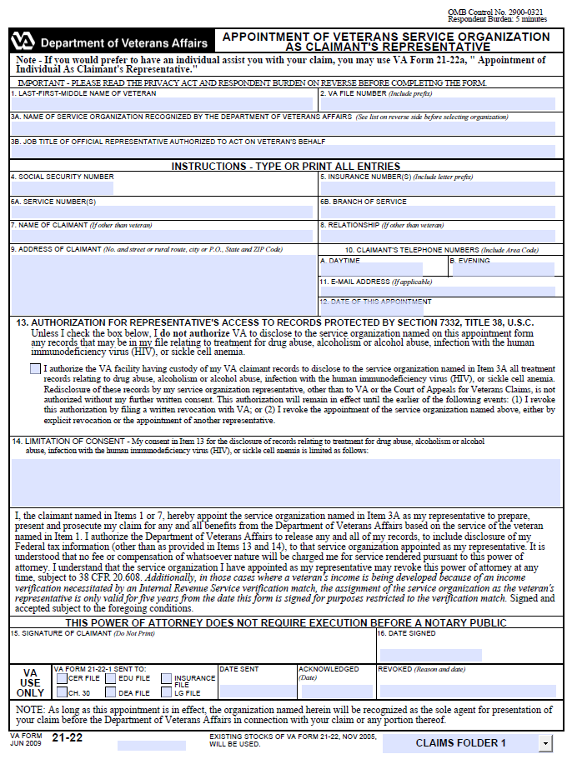
Attachment E: Sample VA Form 21-22a
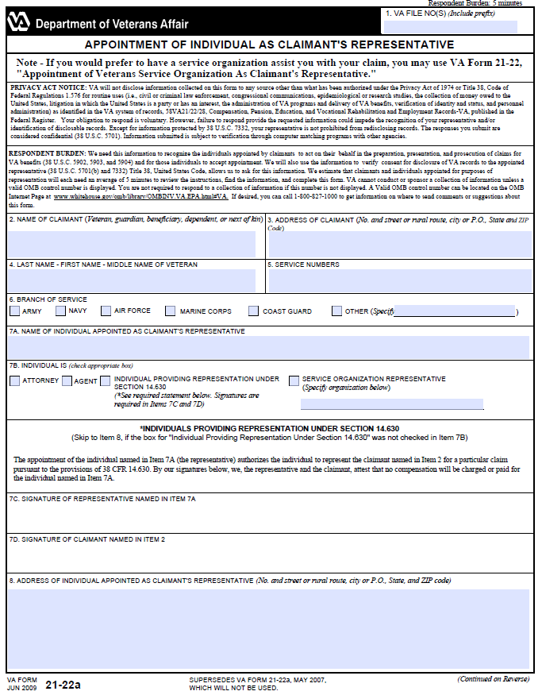
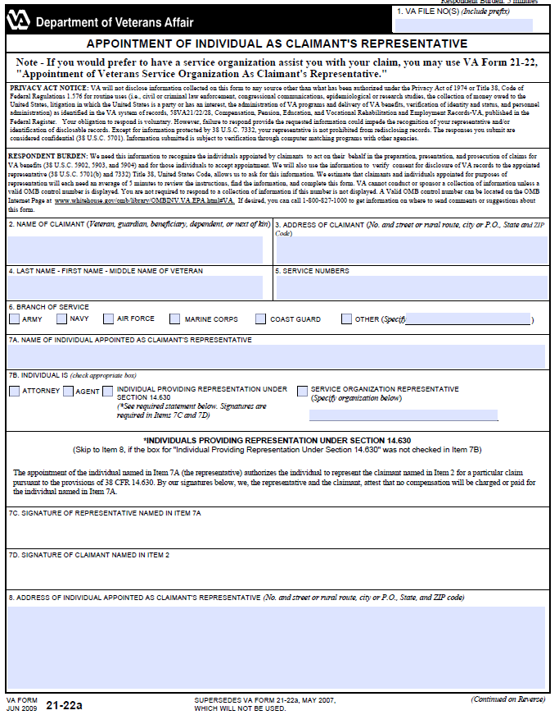

Attachment F: Topic 2 Exercise
Instructions: Circle the VA Form number that would be used to request a POA for each type of POA listed below.

Type of POA | VA Form (circle one)
Veterans Service Organization | 21-22 / 21-22a
Attorney | 21-22 / 21-22a
Agent | 21-22 / 21-22a
Non-licensed individual | 21-22 / 21-22a

