Drill Pay Waiver
Trainee Handout

Table of Contents

Objectives 2
References 3
Topic 1: Drill Pay Waiver Overview 4
Topic 2: Drill Pay Waiver Adjustment Determination 7
Topic 3: Drill Pay Waiver Award for Adjustment 11
Attachment B: Exercise – Overview Drill Pay Waiver 19
Attachment C: Exercise – Overview Drill Pay Waiver 21
Attachment D: Sample Due Process Letter 22
Attachment E: Sample VETSNET Screen 26
Attachment F: Sample Post Notification Letter when due process has been given 27
Attachment G: Exercise – Award for Adjustment 30
Practical Exercise 31

Objectives
- Identify the components and requirements for a Drill Pay Waiver
- Differentiate drill pay procedures
- Differentiate the criteria required to review and prepare a Drill Pay waiver.
- Differentiate the requirements to make a Drill Pay Waiver adjustment determination
- Distinguish the requirements to process a Drill Pay Waiver Award for Adjustment
References

- 10 U.S.C. 12316
- 5304 (C)
- 38 CFR 3.6
- 38 CFR 3.654
- 38 CFR 3.700(a)(1)
- M21-1MR, Part III, Subpart v, Ch 4, Sec C
- 38 U.S.C 5304 (c)
- Compensation Service Bulletin February 2013
- Compensation Service Bulletin May 2013

Topic 1: Drill Pay Waiver Overview
Drill Pay
The term “drill pay” refers to the monetary benefits a reservist or member of the National Guard receives for performing active or inactive duty training, and may also be referred to as “training pay” or “military pay.” Performance of prescribed duties can include:
- ADT (Active Duty Training), which normally consists of a two-week period of training duty.
- IDT (Inactive Duty Training, which normally consists of a weekend (Sat & Sun) MUTA (Multi-Unit Training Assembly).
Drill/Training Days Computation
The DOD computes the number of Drill/Training days as follows:
- Reserve and National Guard components report the number of days during the fiscal year for which members received drill pay.
- Based on actual paid attendance which normally consists of 48 drills (training sessions) and 15 days of active duty training.
- One full day's duties pay for each four-hour training assembly.
- Four-hour drill segments may be combined, as two segments per day, or may be performed separately.
- When performed on a weekend or weekday (a typical “drill weekend” [Sat. & Sun.] a Reservist is credited with attending two drill assemblies and is paid for four days).
Waiver Requirement
Drill pay cannot legally be paid concurrently with Department of Veterans Affairs (VA) Compensation and Pension (C&P) benefits, under 10 U.S.C. 12316 and 38 U.S.C. 5304(c). A Veteran must waive either VA benefits or drill pay. In most cases, it is to the Veteran’s advantage to waive VA benefits. To waive VA benefits and retain drill pay, the Veteran must:
- Complete VA Form 21-8951, Notice of Waiver of VA Compensation or Pension to Receive Military Pay and Allowances
- Submit a waiver each year in which reserve or guard pay is received
VA Form 21-8951 and VA Form 21-8951-2
In lieu of VA Form 21-8951, the Veteran may file VA Form 21-8951-2 However, because VA Form 21-8951-2 does not have training days and identifying information preprinted on the form, the Veteran or reserve unit must write in this information.
Drill Waiver Process
The Drill Waiver process encompasses the VA requirements and the VSR’s responsibilities in order for a Veteran to waive his/her VA benefits in lieu of receiving active or inactive duty training pay (drill pay) for duties performed while participating in the Reserves or National Guard.
Defense Manpower Data Center (DMDC) Notification
DMDC sends a tape to the Hines Information Technology Center (ITC) identifying reservists/guard members who received both VA benefits and drill pay during the same fiscal year. The Hines ITC generates VA Form 21-8951 and sends to each reservist/guard member receiving duplicate benefits. The Veteran is responsible for completing the form and returning it to VA Regional Office.
VA Form 21-8951 - Receipt and Review
On receipt of VA Form 21-8951 from the Veteran the VSR must, CEST 290 with a DOC as shown on the date stamp indicating date the form was received in VA.
Before processing VA Form 21-8951 the VSR reviews the form to make sure that all required entries are complete and signed as required.
Incomplete or unsigned forms are returned to the Veteran.
Waiver Process
When a Veteran elects to waive VA benefits for the number of days for which drill pay was received, benefits must be withheld for the same number of days at the rate in effect on the last day of the fiscal year (September 30th) in which the drill pay was earned.
- Determine withholding amount with regards to:
- Temporary rate increases
- Rate increases
- Rate reductions
- Increases effective in September of the fiscal year in question, but payable from October 1
- Prepare an award for a drill pay waiver
- Post notification
Due Process
If there is no reply from the Veteran after 65 days of due process, the VA will take the proposed action as if the Veteran has agreed to the proposal.
VA Form 21-8951
At the end of the fiscal year the DMDC notifies the Hines ITC of all Reservists or Guard members who received drill pay and also received VA benefits during the fiscal year just ended.
- Hines ITC generates VA Forms 21-8951 with preprinted identification and drill pay data from the interface with DMDC.
- Sends VA Form 21-8951 to each identified reservist/guardsman receiving duplicate benefits to inform them of this situation.
- Advises the Veteran that training pay cannot legally be paid concurrently with VA disability compensation or pension benefits.
- Establishes a 90-day corporate record diary
Preprinted Information VA Form 21-8951
The preprinted VA Form 21-8951 generated by the Hines ITC displays:
- Identifying information from the corporate record
- The return address of the Regional Office of record, and
- Number of days for which the Veteran received training pay, obtained from the electronic file provided by DMDC shown by fiscal year
Veteran’s Options
When VA Form 21-8951 is mailed to the Veteran, he/she is required to select only one of the following options to complete the form:
- Elect to waive VA benefits for the number of training days indicated in order to retain training pay;
- Elect to waive military pay and allowances for the number of days indicated in order to retain VA compensation and pension;
- Certify that no military pay and allowances were received during the fiscal year(s) shown on the form
Veteran’s Options – VSR Review
If the Veteran elected to waive drill pay in order to retain VA compensation and pension, the VSR will:
- option of telephoning the Veteran prior to sending 21-8951 to VACO when Veteran elects waiver of drill pay.
- {(Monthly rate of compensation/pension withheld ÷ 30) times the number of days withheld at that monthly rate}
- Example: Monthly rate to be withheld is 10% rate for fiscal year 2011, $123.00, for 63 days.
- Result: {($123.00 ÷ 30) times 63} = $258.30 withheld.
- Make a copy of submitted VA Form 21-8951
- Send original form to VACO (212) who will forward it to the appropriate service department finance center
- Annotate the file to show the action taken
If the Veteran certified that no drill pay was received during the fiscal year shown on the form, the VSR will:
- Review C-file for evidence that supports the Veteran was not in the Guard or Reserves
- Initiate development if the validity of the evidence is questioned
Veteran’s Signature Requirements Form 21-8951 must be signed by both the Veteran and the Veteran’s unit commander or designee when certifying that the number of training days is less than the preprinted number of days.
However, a waiver form signed by the Veteran but missing the unit commander or designee’s signature is acceptable for processing if the Veteran:
- Agrees with the number of training days reported on the waiver form, or
- Reports a greater number of training days.

Topic 2: Drill Pay Waiver Adjustment Determination
Benefits Waiver Criteria
VA benefits must be waived for the total number of days for which active and inactive duty training pay is received. All branches of armed forces Reserve and National Guard components base their waivers on actual paid attendance, normally consisting of:
- 48 armory drills or training sessions, and
- 15 days of active duty training.
Although a total of 63 days is normal, the total may vary due to excused absences from drills or performance of additional drills.
- VA computes payments based on a standard 30-day month:
- 31st of any month is not counted,
- February is also counted as a 30-day month; in non-leap years, the 28th of February is considered 3 days (the 28th, 29th, and 30th), and in leap years, the 29th is considered 2 days (the 29th, and 30th),
- The number of days the VA waives C&P benefits depends on the number of training days for which a Veteran receives drill or active duty training pay.
Reserve/Guard Unit Reporting
A reserve/guard unit reports the number of days during the fiscal year for which each member received drill pay as one full day’s pay for each four-hour training assembly the member attended. These four-hour drill segments may be combined, as two segments per day on a weekend, or may be performed separately. Also, they may be performed on a weekend or on a weekday or evening.
Drill Pay Waiver Processing
When processing a Drill Pay Waiver:
- The number of days of duty pay should be reported rather than the number of calendar days on which drill attendance occurred.
- For Active Duty Training Pay a reservist/guard member receives only one day's pay for each day of the two-week annual active duty training period (summer camp) which he or she attends.
- When reservist/guard members are in a No-Pay Status for all of their inactive duty training, and are paid only for active duty training at summer camp or its equivalent, only use the number of days paid for active duty training.
- Travel time. In computing the number of days VA benefits must be waived, include any authorized travel time for which service pay and allowances are paid.
Active Service Reentry
The number of training days (first page Form 21-8951) could indicate the Veteran has returned or been reactivated into active duty status. Active duty days are counted based on actual calendar days not on the 30 day month process. For example, drill days for FY 09 were 219, and the Veteran was on active duty during same Fiscal Year from Oct 1 to Dec 31. The Veteran was on active duty for 92 days of the 219 reported. The Veteran drilled for 127 days once active duty days are subtracted from the number of days reported on the 21-8951,
- If more than 179 training days are reported, this may be an indication the Veteran has returned to active duty.
- If confirmed, VA must propose to terminate the Veteran’s benefits and advise this action may create a possible overpayment.
VA Form 21-8951 Review
Before processing VA Form 21-8951, review the form to ensure all required entries are completed:
- Veteran’s acceptance (page two) of information on front page and signature in signature block. If a Veteran agrees to the front page, their Commanding Officer’s (CO’s) signature is not required to be considered “complete.”
- If no signature or if Veteran did not check blocks on page two, make a copy of the form and send the original to the Veteran. Instruct Veteran to complete and return to the VA RO once it is completed (advise the Veteran that failure to complete or sign the form may result in a reduction of benefits).
- If Veteran disagrees with waiver information, check page two for their Commanding Officer’s signature. If there is no signature, develop evidence for it.
Incomplete Form - Exception
Do not return VA Form 21-8951 to the Veteran as incomplete when the unit commander or designee’s signature is missing, and the Veteran:
- Agrees with the number of drill periods or training days reported on the waiver form, or
- Reports a greater number of drill periods or training days.
VA Form 21-8951 Processing
Once VA Form 21-8951 has been reviewed:
- The form must be processed to determine whether or not the Veteran’s award should be adjusted.
- Most drill pay adjustments are made prospectively regardless of the fiscal year in which the drills were actually conducted.
- Benefits are adjusted prospectively to avoid an overpayment of benefits to the Veteran.
Withholding Benefits - Rate Difference
Withhold the Veteran’s benefits at the rate in effect on the last day of the fiscal year in which the drill was held.
- The Veteran should receive the rate difference between the fiscal year of the drill and when the withholding took place.
- Make drill pay adjustments prospectively regardless of the fiscal year in which the drills were actually conducted.
- Prospective adjustments are usually made from the first of the month following the date the claim is worked.
Fiscal Year
It is essential that the VSR understands that the fiscal year (FY) is from October 1 – Sept 30.
- Fiscal Year = October 1 of the prior year through September 30 of the current year.
- Example: Fiscal Year 2006 time period = October 1, 2005 through September 30, 2006.
Rate Determination
The VSR must withhold at the rate in effect on the last day of the fiscal year (September 30th) in which the training pay was earned.

This rate is usually, but not always, the total amount due on that date.

The exception is for September increases which are payable from October 1. Under 38 CFR 3.31, Veterans are in receipt of increased benefits between the effective date of an increased award and the date payment commences.
The VSR should review the Corporate Record and write down the rate the Veteran was receiving on the last day of fiscal year (September 30). This is amount the VSR will propose to withhold and pay the difference. Determine correct rate:
- Access the Rate tables for each year found on the Compensation Service Intranet page under publications.
- Select the amount received at the end of fiscal year during which drill pay was received.
- Withhold at the rate in effect on the last day of the fiscal year when drill was held.
Veteran’s Payment Calculation
Pay the Veteran the difference between the rate for the fiscal year the drill occurred and the rate in effect on the date of the award for the withholding.
Paragraphs 28, 29, & 30 of the Rating Schedule
If a Veteran was receiving compensation based on a temporary 100% disability rating under paragraph 29 or 30 on the last day of the fiscal year:
- Adjust the award prospectively at the permanent rate as opposed to the temporary 100 percent rate.
- Example: Veteran had a permanent 20% combined rating, but was receiving a temporary 100% rating based on Para 30 on the last day of the fiscal year. Withhold at the 20% rate.
Rate Increase
When a Drill Pay Waiver is received for a prior period and there has been a subsequent increase in the VA rate:
- Adjust the award to provide for withholding of the permanent rate in effect on the last day of the fiscal year to which the waiver pertains.
- Exception – Do not include increases under Paragraphs 29 or 30 of the Rating Schedule.
- Example – A Veteran is receiving a 10% combined rating at the beginning of fiscal year, but on the last day of the fiscal year was receiving compensation at a 30% combined rating. Withhold at the 30% rate. If Veteran was receiving additional dependency benefits, they are included with the withheld amount.
Rate Decrease
In some situations, a Drill Pay Waiver is received for a prior period and there has been a subsequent decrease in the VA rate. The prospective monthly rate is less than the monthly rate that must be withheld for the retroactive period. In this case:
- Adjust the award retroactively as of the latest award line in the master record for which the monthly rate equals or exceeds the rate that must be withheld for the number of days of drill pay performed, creating an overpayment if necessary. Due process may need to be given.
Example
A Veteran received compensation at the 20% rate on the last day of a fiscal year in which drill pay was received. However, the Veteran was later reduced to the 10% rate, and the 10% rate is currently being paid. Identify the most recent award line date showing a monthly rate of payment equal to or exceeding the 20% rate received on the last day of the fiscal year in which drill pay was received, and which runs at least the number of days which the Veteran received drill pay. Retroactively reduce the Veteran’s award by the Veteran’s rate of compensation at the end of the fiscal year in which drill pay was received from that date, and discontinue the reduction as soon as it has been in place for the same number of days the Veteran received drill pay.
Topic 3: Drill Pay Waiver Award for Adjustment
Drill Pay Recipients – No Response Actions
The Corporate record diary expires and a work item EP 820 is established. Hines ITC then generates three copies of the VA Form 21-8951, and sends two copies to the RO and one copy to the Central Office (CO). Hines ITC is expected to begin uploading the VA Form 21-8951 sent to the Veteran beginning with the forms for FY 2012.
No Response – VSR Responsibilities
On notification of no response the VSR should:
- Review the information on the form to verify it is correct and then notify the Veteran of the VA’s proposal to withhold benefits. Send a notice of proposed adverse action based on the assumption that the preprinted information on VA Form 21-8951 is correct.
- If information is not correct, follow the procedures in the table in M21-1MR, Part III, Subpart v, 4.C.13.

- If the Veteran does not respond within 65 days, follow the procedures in M21-1MR, Part III, Subpart v, 4.C.14 to adjust the award.
Due Process
If there is no reply after 65 days of due process, the VA takes the proposed action as if the Veteran has agreed to its proposal. Adjust the Veteran’s award accordingly, by following the procedures in M21-1MR, Part III, Subpart v, 4.C.14.
Example – VA sends a due process letter on January 1st for 63 training days. The first of the month after 65 days would be April 1st. Counting April 1st as day 1 through June 3rd would be 63 days. Remove withholding and resume full benefits effective June4th.

Predetermination Notification
“Due process” to the Veteran includes notification of the VA’s proposed actions, to include withholding amounts and dates:
- The main purpose of the letter is to give the Veteran notification of the VA’s proposal to withhold benefits due to the receipt of drill pay.
- If notification is from Veteran with signature, no due process is necessary.
Predetermination Notification Steps
Follow these steps to provide notification:
1. Drill pay diary in the Corporate record should be deleted if predetermination needed prior to expiration.2. If it is a third party notification, clear EP 290 and establish EP 600 for Due Process. (Date of claim will be the date the predetermination letter is to be mailed to Veteran).
3. Calculate the number of days withholding in accordance with M21-1MR, Part III, Subpart v, 4.C.14.
4. Open MAP-D and select “Contentions” and then select “Claimant Letter”.
5. Development Type = Predetermination
6. Follow guidelines from Due Process lesson for proper pre notification.
7. Once completed, update suspense for 65 days from the date of letter. If work item 820 exists, it should be cleared upon issuance of the predetermination notice.
Note – Refer to VETSNET lesson on how to access “C&P Awards” if required. Refer trainees to the Handout for depiction of the VETSNET screen.
Input VETSNET Award
This process is similar to inputting awards for Separation and Severance Pay. To process the award to adjust benefits, you must first access the Drill Pay screen, under Award Adjustments. Follow these steps:
- Note the Drill Pay Profile grid to left of the decision grid. This grid will be updated when information is received electronically (via Hines ITC) regarding the Veteran’s drill days.
- Select the Add button.
- Enter the Fiscal Year that the drill pay was received.
- Record the number of days of drill pay.
- The Award Effective Date and End Date will be system generated, but the Award Effective Date may be edited if necessary.
- Calculate the amount to be withheld and enter into the Amount field. Current Rate – Rate at time of September 30, FY = withheld amount
- Select Accept to update the grid.
- If drill pay for another fiscal year needs to be offset, select the Add button and record the information for that year. Manually enter an award effective date to be equal to the end date of the prior adjustment line.
- Select OK to save the decision(s) and close the screen.
When no predetermination letter is issued, there is no specific PCGL letter for drill pay withholding. For notification letter requirements in general see M21-1MR III.v.2.B.9. Suggestion for opening would be something like below:

We received your VA Form 21-8951, Notice of Waiver of VA Compensation or Pension to Receive Military Pay and Allowances, from you on _____ showing you received Military Drill Pay for ____ days for fiscal year (FY) ____. We have decided to reduce your benefits accordingly.

This letter explains your new monthly payments. We have also included information about what to do if you disagree with our decision, and who to contact if you have questions or need assistance.

Note that PCGL letter GP14 does not summarize the evidence considered and a VSR edit will be needed.
When due process is issued, and final action can be taken, please see below.
Post Notification Letter
Use these steps to process the post notification letter when notifying veterans of drill pay adjustments using PCGL:
1. BDN Data Availability Mode: VETSNET Data
2. Selection of Letter Type- CENTRAL: C and P
3. General Pre & Post: GP14 Post: Drill Pay
4. Enter Date of Predetermination Letter when prompted
5. Enter the four digit fiscal year followed by Rate
6. We have withheld benefits for: enter number of days and the year
7. Continue generation of letter to keep remaining of letter intact to include source of letter generation, Domestic or Foreign indication of address, file number, POA indicator, forms

Most cases will not create an overpayment unless veteran had a decrease in rate when compared with current fiscal year

Attachment A: VA Form 21-8951-2

Previously, the first run of Drill Pay Waiver Batch Processing sent a copy of VA Form 21-8951, Notice of Waiver of VA Compensation or Pension to Receive Military Pay and Allowances, to the Veteran and established a diary (Reservist Requires Drill Pay Days) in the corporate record. No copy was sent to Virtual VA. After 60 days, a second run of the Batch Process would clear the diary, and send two hard copies of the VA Form 21-8951 to the RO for processing.

The Business Management Staff has recently streamlined the Drill Pay Waiver (Active Reservist) Batch Process as indicated below.

The first run of the Drill Pay Waiver Batch Process will send a copy of VA Form 21-8951 to the Veteran, create a diary (Reservist Requires Drill Pay Days) in the corporate record, and send
a copy of the VA Form 21-8951 into Virtual VA.

If the Veteran signs and submits the form…… |  | Then….
agreeing with the number of days on the pre-printed form (or reports a greater number of days) |  | make the adjustment under end product (EP) 290 and clear the diary.
but corrects the number of training days, and includes the signature of the commanding officer (if reporting less training days than provided on VA Form 21-8951) |  | make the adjustment under EP 290 and clear the diary.
If the Veteran signs and submits the form…… |  | Then….
agreeing with the number of days on the pre-printed form (or reports a greater number of days) |  | make the adjustment under end product (EP) 290 and clear the diary.
but corrects the number of training days, and includes the signature of the commanding officer (if reporting less training days than provided on VA Form 21-8951) |  | make the adjustment under EP 290 and clear the diary.
If the Veteran signs and submits the form…… | Then….
but disagrees with the number of days without including the signature of the commanding officer (reports less training days than provided on VA Form 21-8951) | initiate development for the signature of the commanding officer under EP 290 and clear the diary.  - If no response is received within 30 days, clear the EP 290 and send due process under EP 600.  - If the Veteran submits the form with the commanding officer’s signature verifying the change, then make the adjustment under the EP 290.

Note: If you have not cleared the diary when taking any of the above actions, the second run of the Batch Process will generate a work item. If a work item is generated, while awaiting the signature of the commanding officer, it will be necessary to clear the work item, as well.

The second run of the Batch Process (60 days after the first run) will clear the diary and create an EP 820 work item which should prompt RO personnel to go into Virtual VA and pull the VA Form 21-8951 to process.

- If the Veteran has not submitted VA Form 21-8951, clear the work item EP and initiate due process under EP 600.
- If the Veteran has submitted VA Form 21-8951, follow the above listed procedures and be sure to clear the work item.
- If action has already been taken, cancel the work item and annotate “no action necessary.”
Refer to M21-1MR III.v.4.C.13.b if checked
RO Mailing Address
Address should match Corporate or PIF record
February is counted as 30 days. Do not count 31st day of any month.
M21-1MR, Part III.v.4.C.14.a
February is counted as 30 days. Do not count 31st day of any month.
M21-1MR, Part III.v.4.C.14.a
RO Mailing Address
Address should match Corporate or PIF record
Required for completed Form
Exception: M21-1MR III.v.4.C.13.a
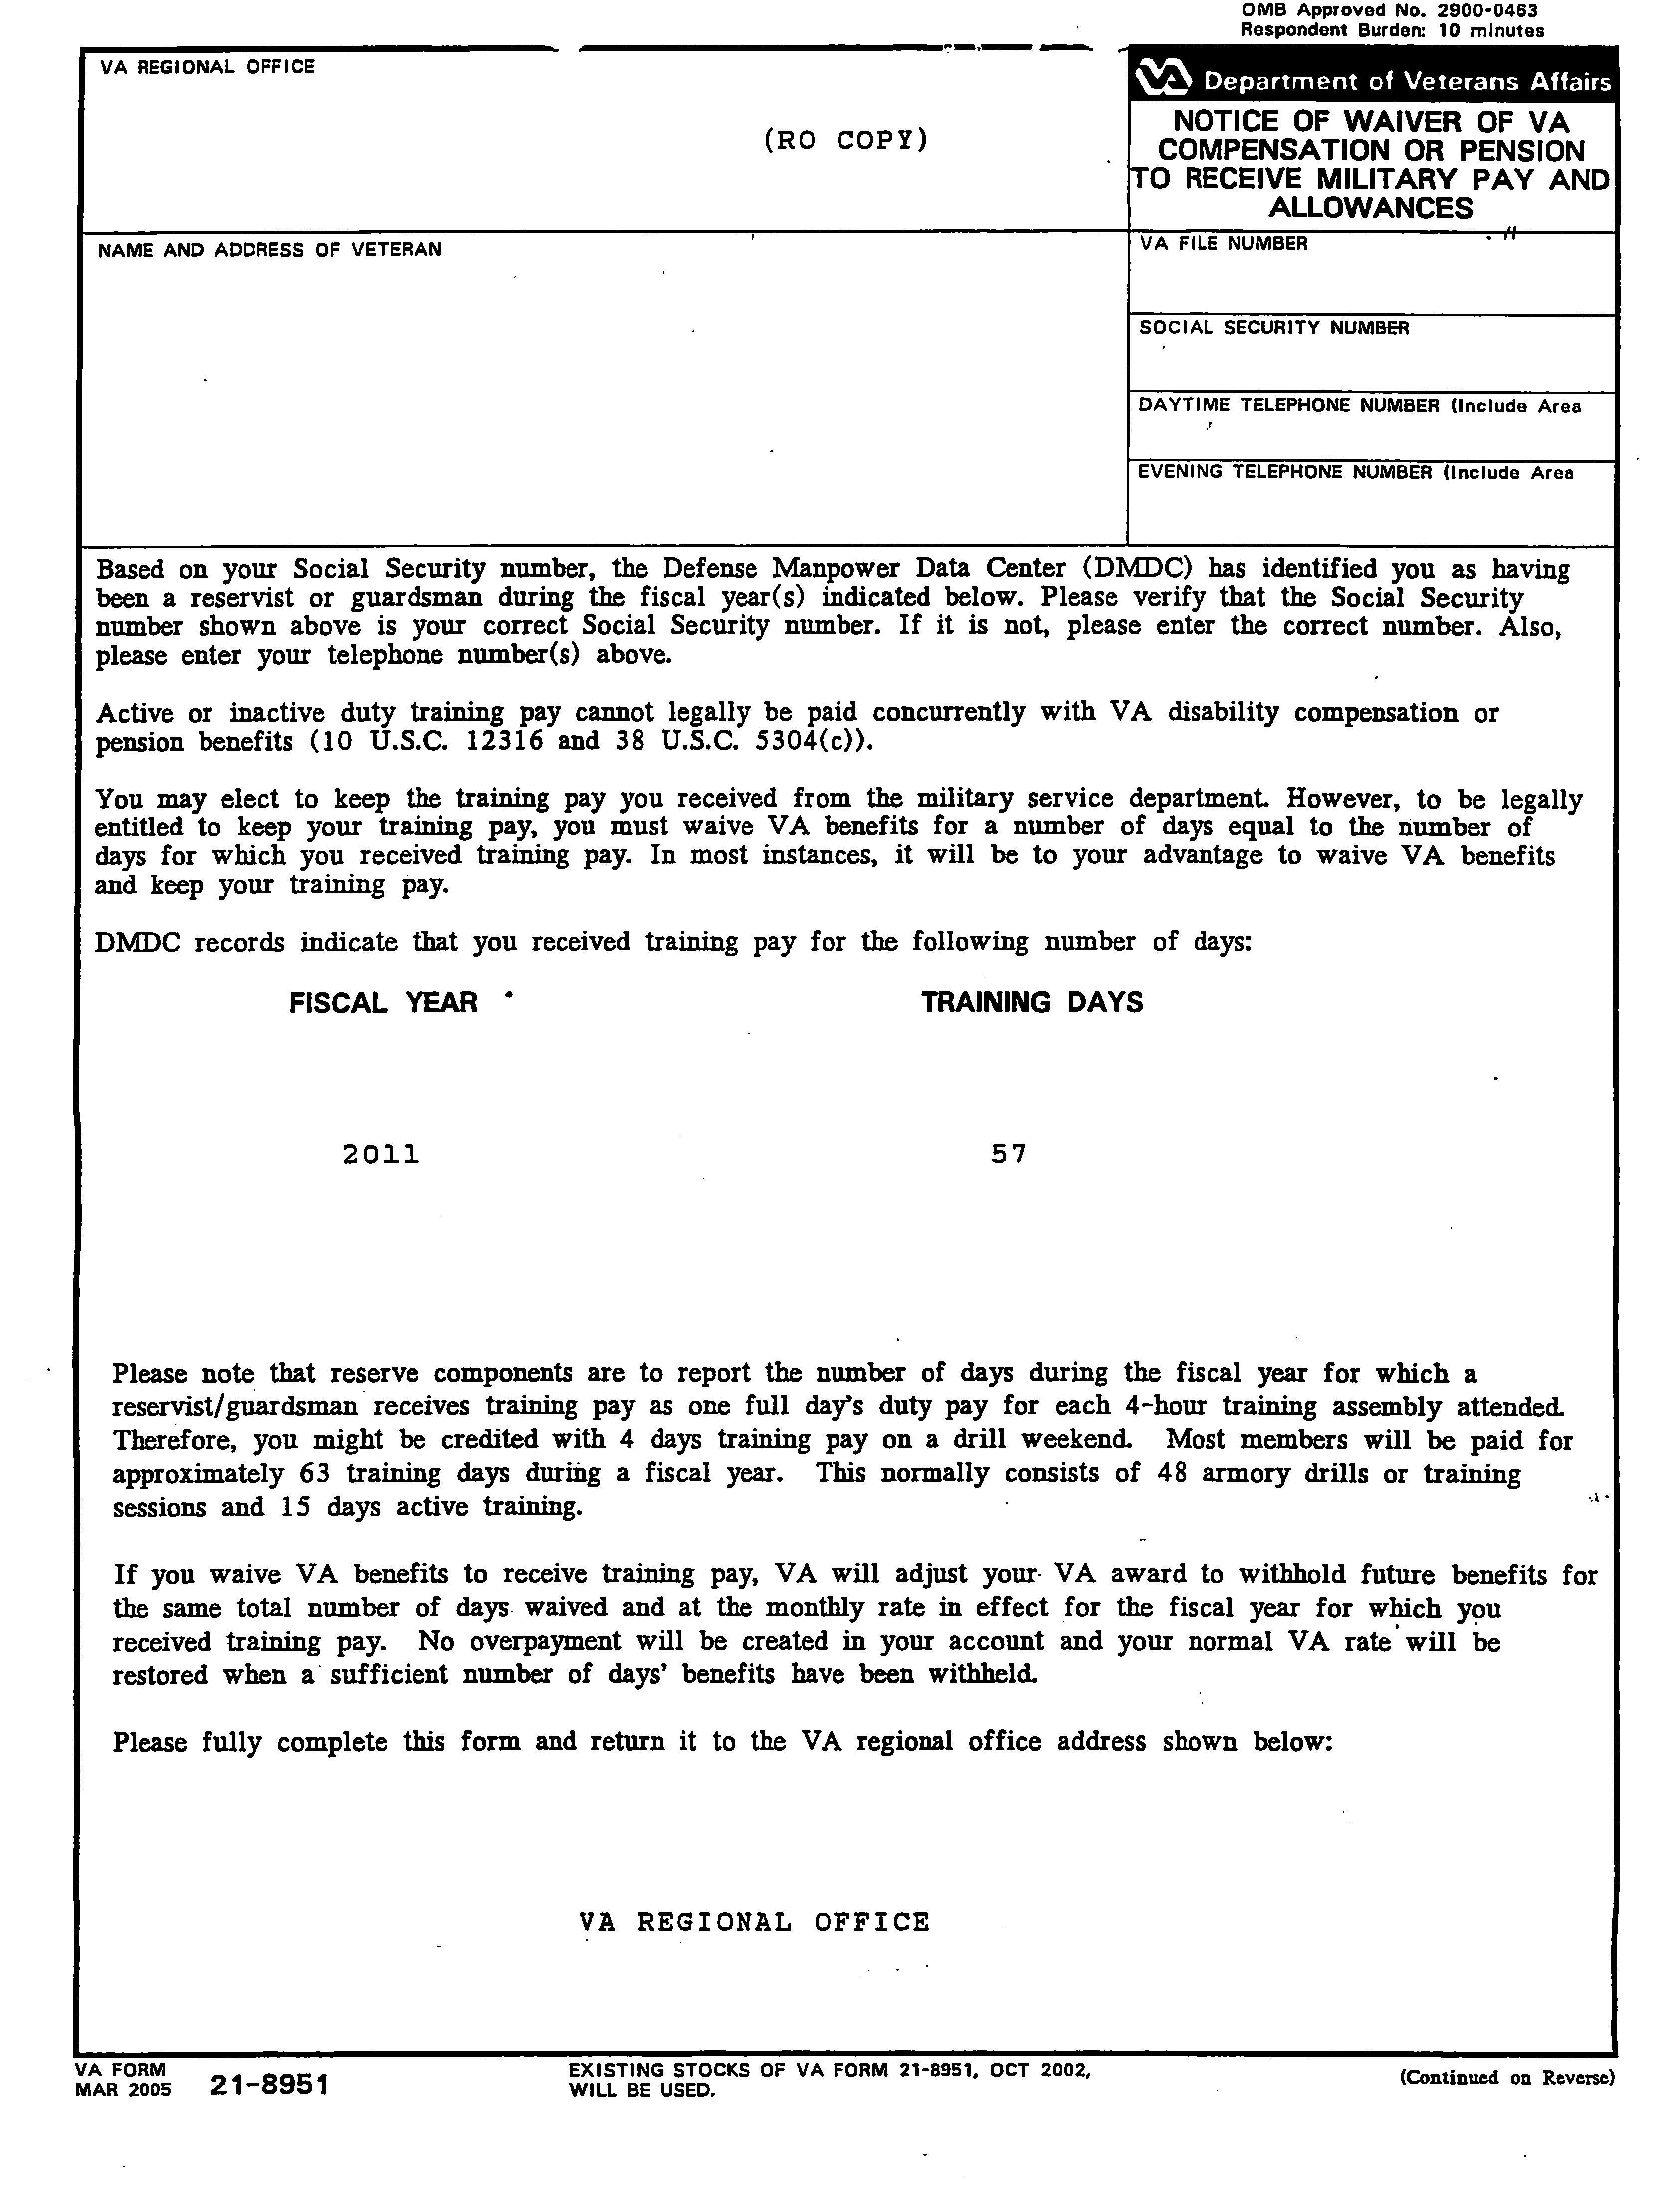
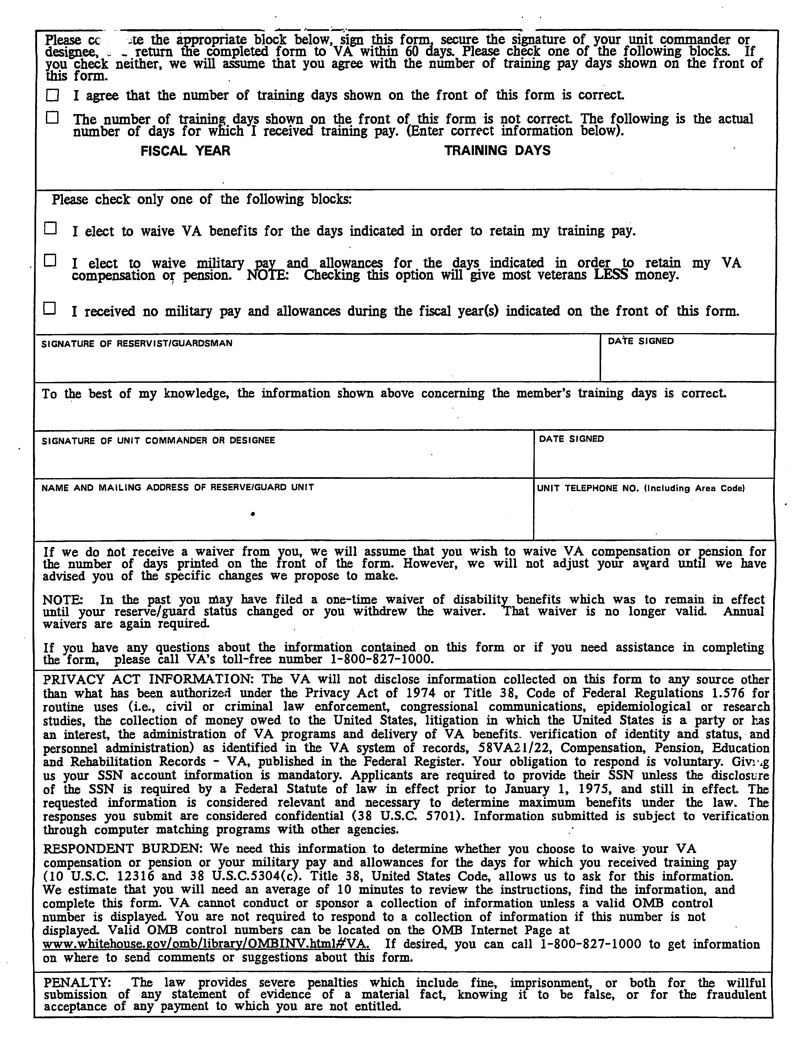
Attachment B: Exercise – Overview Drill Pay Waiver

Read the following statements and determine whether each is a true or false statement. Provide reasons for your answers.
- Active or inactive duty training pay (drill pay) cannot legally be paid concurrently with VA disability compensation or pension benefits.
______________________________________________________________________________________________________________________________________________________________________________________________________________________________________________________________________________________________________________________________________________________________________________________________________
- A Veteran may elect to waive military pay and allowances in order to retain VA benefits.
______________________________________________________________________________________________________________________________________________________________________________________________________________________________________________________________________________________________________________________________________________________________________________________________________
- A Veteran only has to waive compensation for drill pay once and future waivers are automatic.
______________________________________________________________________________________________________________________________________________________________________________________________________________________________________________________________________________________________________________________________________________________________________________________________________
- A Veteran must waive all of his basic VA benefit to receive drill pay.
______________________________________________________________________________________________________________________________________________________________________________________________________________________________________________________________________________________________________________________________________________________________________________________________________

Attachment C: Exercise – Overview Drill Pay Waiver
Based on the provided scenario determine the requested information.
A waiver of 63 days is received and adjudicated in January 2004 for active/inactive duty training completed during fiscal year 2002 for a 10 percent Veteran. The last day of FY 2002 is September 30, 2002. The 10 percent compensation rate in effect on September 30, 2002, was $103. The 10 percent compensation rate in effect on February 1, 2004, was $106.
Fiscal year = _______
Number of days = _______
Award effective date = _______
Amount = _______
End date = _______

Attachment D: Sample Due Process Letter

In reply to:
RO#/Team/Initials
C/CSS #
IMPORTANT — reply needed

Dear Mr. Veteran:

We have received notification that you are a reservist or national guardsman and have performed active or inactive duty training during fiscal year {200X}. In accordance with 10 United States Code (U.S.C.) 12316 and 38 U.S.C. 5304(c) you cannot receive active or inactive duty training pay concurrently with VA disability payments. If this information is correct, we must reduce your compensation payments.

What We Propose to Do
We plan to adjust your compensation benefits as follows:

Total Award Amount | Amount Withheld | Monthly Entitlement Amount | Payment Start Date | Reason For Change
$0.00  What the Veteran is currently receiving | $0.00  What the Veteran was receiving on the last day of FY | $0.00  The difference after subtracting “Total Award” – “Amount withheld” | {1st of the month following 65 days from date of this letter} | Adjustment due to receipt of {#} days of drill pay received during fiscal year {200X}

This action will not create an overpayment in your account.

We won't do anything to reduce your benefits until 60 days from the date of this letter – unless you ask us to reduce them now. We're giving you this time so that you can show us why we shouldn't reduce your compensation.

What Additional Information or Evidence Do We Still Need From You?
Please complete and return the enclosed Form 21-8951, “Notice of Waiver of VA Compensation or Pension to Receive Military Pay and Allowances”.

Submission of Evidence
If you disagree with the {#} days reported based on your Social Security number, please submit documentation to show the difference. Please report any active or inactive duty training we may have missed.

Your payments will continue at the present rate for 60 days following the date of this notice so that you may, if you wish, submit evidence to show that the proposed action should not be taken. You may submit evidence in person, through the mail or through your accredited representative.

If you wait more than 60 days to submit evidence, we will carefully consider whatever you submit, but the adjustment of benefits described above will already have gone into effect and your benefits will continue in that status while we review the additional evidence.

How to Obtain a Personal Hearing
If you desire a personal hearing to present evidence or argument on any point in your claim, notify this office and we will arrange a time and place for the hearing. If you want, you may bring witnesses and their testimony will be entered in the record. VA will furnish the hearing room and provide hearing officials. VA cannot pay for any other expenses of the hearing since a personal hearing is held only on your request.

If within 30 days from the date of this notice VA receives your hearing request, we will not make any adjustments to your award until we have held your hearing and reviewed the testimony.

You may request a hearing after 30 days; however, we may continue with our proposed action.

How to Obtain Representation
An accredited representative of a Veterans' organization or other service organization recognized by the Secretary of Veterans Affairs may represent you, without charge. An accredited agent or attorney may also represent you. However, under 38 U.S.C. 5904(c), an accredited agent or attorney may only charge you for services performed after the date you file a notice of disagreement. If you desire representation, let us know and we will send you the necessary forms. If you have already designated a representative, no further action is required on your part.

What Is eBenefits?
eBenefits provides electronic resources in a self-service environment to Servicemembers, Veterans, and their families. Use of these resources often helps us serve you faster! Through the eBenefits website you can:

- Submit claims for benefits and/or upload documents directly to the VA
- Request to add or change your dependents
- Update your contract and direct deposit information and view payment history
- Request a Veterans Service Officer to represent you
- Track the status of your claim or appeal
- Obtain verification of your military service, civil service preference, or VA benefits
- And much more!

Enrolling in eBenefits is easy. Just visit www.eBenefits.va.gov for more information. If you submit a claim in the future, consider filing through eBenefits. Filing electronically, especially if you participate in our fully developed claim program, may result in faster decision than if you submit your claim through the mail.

Do You Have Questions Or Need Assistance?
If you have any questions, you may contact us by telephone, e-mail, or letter.

If you | Here is what to do.
Telephone | Call us at 1-800-827-1000. If you use a Telecommunications Device for the Deaf (TDD), the number is711.
Use the Internet | Send electronic inquiries through the Internet at https://iris.va.gov.
Write | Put your full name and VA file number on the letter. Please send all correspondence to the address at the top of this letter.

In all cases, be sure to refer to your VA file number .

If you are looking for general information about benefits and eligibility, you should visit our web site at https://www.va.gov, or search the Frequently Asked Questions (FAQs) at https://iris.va.gov.

We have no record of you appointing a service organization or representative to assist you with your claim. You can contact us for a listing of the recognized Veterans' service organizations and/or representatives. Veterans' service organizations, which are recognized or approved to provide services to the Veteran community, can also help you with any questions.

Sincerely yours,
Veterans Service Center Manager
Enclosure: VA Form 21-8951
Attachment E: Sample VETSNET Screen

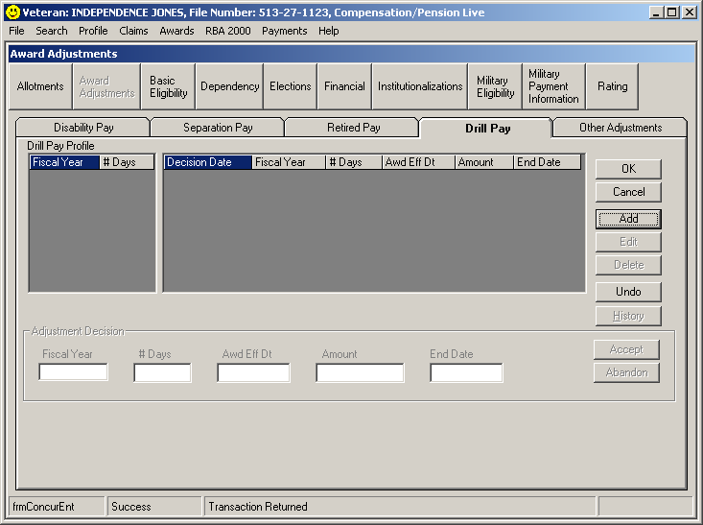
2 and 8
3
4
5
6
7
9
1

Attachment F: Sample Post Notification Letter when due process has been given

In reply to:
RO#/Team/Initials
C/CSS #

Dear Mr. Veteran:

In our letter of {Month, Day, Year (Due process letter)}, we informed you we would reduce your benefits because you received Military Drill Pay for fiscal year (FY) {Year}. We have adjusted your benefits accordingly.
This letter tells you about your entitlement amount and payment start date and what we decided. We have also included information about what to do if you disagree with our decision, and who to contact if you have questions or need assistance.
What Is Your Entitlement Amount And Payment Start Date?
Your monthly entitlement amount is shown below:

Total Award Amount | Amount Withheld | Monthly Entitlement Amount | Payment Start Date | Reason For Change
$0.00  What the Veteran is currently receiving | $0.00  What the Veteran was receiving on the last day of FY | $0.00  The difference after subtracting “Total Award” – “Amount withheld” | {1st of the month following 65 days from date of this letter} | Adjustment due to receipt of {#} days of drill pay received during fiscal year {200X}
$0.00  {Amount entitled to of current FY} | 0.00  Remove withheld amount | 0.00  {Full benefit Amount } | {Next day after last training day} | Adjustment for drill pay received during fiscal year {200X} is terminated

Why Have We Withheld Benefits?
You received drill pay for {# of days on VAF 21-8951} days during fiscal year {Year} from the military. Beginning {effective date}, we have withheld {$0.00} for {# of days on VAF 21-8951} days, which is the amount you received effective September 30, {Year of FY we are adjusting}. Your full VA compensation of {$gross amount} will resume {Month, Day, Year}.

This action will not create an overpayment.
How Did We Make Our Decision?
We received notification that you are a reservist or national guardsman and performed active or inactive duty training during fiscal year {20XX}. In accordance with 10 United States Code (U.S.C.) 12316 and 38 U.S.C. 5304(c) you cannot receive active or inactive duty training pay concurrently with VA disability payments.
What Evidence Did We Use TO Decide Your Claim?
In making our decision, we used the following evidence:
- VA Form 21-8951 “Notice of Waiver of VA Compensation of Pension to Receive Military Pay and Allowances.”

What You Should Do If You Disagree With Our Decision
If you do not agree with our decision, please download and complete VA Form 21-0958, Notice of Disagreement. You can download the form at http://www.va.gov/vaforms or you can call us at 1-800-827-1000. You have one year from the date of the letter to appeal the decision. The enclosed VA Form 4017, Your Rights to Appeal Our Decision, explains your right to appeal.

What Is eBenefits?
eBenefits provides electronic resources in a self-service environment to Servicemembers, Veterans, and their families. Use of these resources often helps us serve you faster! Through the eBenefits website you can:

- Submit claims for benefits and/or upload documents directly to the VA
- Request to add or change your dependents
- Update your contract and direct deposit information and view payment history
- Request a Veterans Service Officer to represent you
- Track the status of your claim or appeal
- Obtain verification of your military service, civil service preference, or VA benefits
- And much more!

Enrolling in eBenefits is easy. Just visit www.eBenefits.va.gov for more information. If you submit a claim in the future, consider filing through eBenefits. Filing electronically, especially if you participate in our fully developed claim program, may result in faster decision than if you submit your claim through the mail.

Do You Have Questions Or Need Assistance?
If you have any questions, you may contact us by telephone, e-mail, or letter.

If you | Here is what to do.
Telephone | Call us at 1-800-827-1000. If you use a Telecommunications Device for the Deaf (TDD), the number is711.
Use the Internet | Send electronic inquiries through the Internet at https://iris.va.gov.
Write | Put your full name and VA file number on the letter. Please send all correspondence to the address at the top of this letter.

In all cases, be sure to refer to your VA file number XXXXX .

If you are looking for general information about benefits and eligibility, you should visit our web site at https://www.va.gov, or search the Frequently Asked Questions (FAQs) at https://iris.va.gov.

We sent a copy of this letter to your representative, DAV, whom you can also contact if you have questions or need assistance.

Sincerely yours,

Service Center Manager’s name
Veterans Service Center Manager

Enclosure: VA Form 4107

cc: DISABLED AMERICAN VETERANS
Drill Pay Scenario Questions and Answers

Question 1: If a retroactive increase is granted, covering a period in which a drill pay adjustment was done, is due process required prior to taking action, since we must increase the amount of withholding for drill pay? Or can an immediate adjustment be made to pay the increase and adjust the withholding to reflect the increased amount received at the end of the FY in question?

If due process is required, should the rating decision be promulgated or remain open, pending expiration of due process?

Answer 1: No due process is necessary. Take the two actions (retroactive increase and withholding) simultaneously under the provisions of M21-1MR III.vi.2.A.2.a.

Question 2: It is discovered that an incorrect amount was withheld for drill pay, due to an increase in the Veteran’s rate. Due process is required to the Veteran to allow us to withhold the correct higher amount. The question is what is the correct procedure for this scenario? 1) withhold the increased rate from the past date and create an overpayment, 2) remove past withholding and withhold prospectively, or 3) withhold the difference prospectively and leave the past withholding the same?

What if the number of drill days counted previously was incorrect, and should have been more? The same three choices could apply to this scenario, as well.

Answer 2: Increase the amount of the withholding or extend the period of the withholding (whichever is appropriate) retroactive to the initial period of withholding, not from a future date. Taking this approach leaves intact (for historical purposes) a record of the initial withholding for receipt of drill pay. Furthermore, it avails the Veteran of his/her right to request a waiver of the debt.

Note: We will add another exception to the policy described in M21-1MR III.v.4.C.14.a, which requires ROs to “make all award adjustments that are based on a Veteran’s receipt of drill pay from a future date. . . .”

Question 3: The maximum number of days shown on the VA Form 21-8951 seems to be 360 days, which goes along with the MR’s guidance on figuring drill days based on 30-day months. However, we have been advised to consider actual calendar days for active duty time. Can this discrepancy be further explained?

Answer 3: The process for calculating drill days for a Veteran who received both drill pay and active duty pay during the same fiscal year is described in M21-1MR III.v.4.C.16.j. For the purpose of this block, active duty days are not calculated in the same manner as drill days are calculated in M21-1MR III.v.4.C.14.b (using 30-day months). Compensation Service is taking this approach because it is more beneficial to the Veteran.

Attachment G: Exercise – Award for Adjustment
Answer the following question:
- What should a VSR do on notification of no response (receiving two copies of VA Form 21-8951) from Hines ITC?
________________________________________________________________________________________________________________________________________________________________________________________________________________________________________________________________________________________________________________________________________________________________________________________________________________________________________________________________________________________________________________________________________________________________________________________________________________________________________________________________________________________________________________________________________________________________________________________________________________________________________________________________________________________________________________________________________________________________________
- Arrange the following Predetermination Notification Steps in the correct order.
- Open MAP-D and select “Contentions” and then select “Claimant Letter”.
- At the time VA Form 21-8951 is mailed to the Veteran, a master record diary is set for 90 days. Access Share and select “Diary” command. Delete Diary code “27” for drill pay.
- Follow guidelines from Due Process lesson for proper pre notification.
- Calculate the number of days withholding beginning from the 1st of month following the 65 day suspension.
- Once completed, update suspense for 65 days from the date of letter.
- Development Type = Predetermination
- If it is a third party notification; establish EP 600 for Due Process. (Date of claim will be the date the predetermination letter is to be mailed to Veteran).

Step 1 ____
Step 2 ____
Step 3 ____
Step 4 ____
Step 5 ____
Step 6 ____
Step 7 ____

Practical Exercise
Based on the provided scenarios determine the requested information.
- A waiver of 63 days is received and adjudicated in June 2004 for fiscal year 2000. A Veteran with no dependents was entitled to receive the 10 percent rate on September 30, 2000, which is the last day of fiscal year 2000. The evaluation was increased to 30 percent effective December 1, 2000. The 10 percent compensation rate in effect on September 30, 2000, was $98. The 30 percent rate in effect on July 1, 2004, was $316.
Fiscal year = _______
Number of days = _______
Award effective date = _______
Amount = _______
End date = _______
- A waiver of 63 days is received and adjudicated in January 2004 for fiscal year 2000. A Veteran with no dependents was evaluated as 10 percent disabled during fiscal year 2000. However, in December of 2003 the Veteran was granted 30 percent retroactively to April 1, 1999. The last day of FY 2000 is September 30, 2000. The 30 percent compensation rate in effect on September 30, 2000, was $288. The 30 percent compensation rate in effect on February 1, 2004, was $316.
Fiscal year = _______
Number of days = _______
Award effective date = _______
Amount = _______
End date = _______
- A waiver of 55 days is received and adjudicated in January 2004 for active/inactive duty training completed during fiscal year 2002. The Veteran received compensation at the 10 percent rate on September 30, 2002, which was the last day of fiscal year 2002. However, the Veteran was reduced to 0 percent and the compensation award was stopped effective April 1, 2003. The last award line in the system prior to the April 1, 2003 no rate line is a 37 line for $104 on December 1, 2002. The 10 percent compensation rate in effect on September 30, 2002, was $103.
Fiscal year = _______
Number of days = _______
Award effective date = _______
Amount = _______
End date = _______

- A waiver is received and adjudicated in April 2004 for 55 days in fiscal year 03. The Veteran’s evaluation has been a combined service connection of 20 percent, at all times, but the 10 percent is severance pay. The last day of FY 2003 was September 30, 2003, when the 10 percent rate was $104. The 20 percent rate in effect on April 1, 2004, was $205. Include how much would you withhold for severance pay and how much would the Veteran receive.
Fiscal year = _______
Number of days = _______
Award effective date = _______
Amount = _______
End date = _______
Severance Pay withholding = _______
Veteran would receive = _______

