VETSNET AWARDS: BASIC COMPENSATION
Trainee Handout

Table of Contents

Objectives and References 2
VETSNET Award Input Limitations and Access 3
Basic Eligibility Screen 4
Dependency Screen 5
School Children 6
Diary 7
Financial Decision 8
Practical Exercise 13

Objectives
The purpose of this lesson is to teach the trainees how to input data into the VETSNET Awards system for basic grants & denials.

At the end of this lesson, the trainee will be able to:
• Understand the three ways to access a veteran’s record in VETSNET
• Understand how to use VETSNET Awards screens to input data and TO GENERATE awards

REFERENCES
VETSNET AWARDS GUIDE LOCATED AT
HTTP://VBAW.VBA.VA.GOV/BL/SYSTEMS/AWARDS.HTM
VETSNET AWARD INPUT LIMITATIONS AND ACCESS

Types of actions that can be input into VETSNET Awards
- Original Service-Connected grants
- Non service-connected determinations
- SMC K or higher
- Electronic or paper checks
- Dependents
- Retired Pay, Separation & Drill Pay
- Severance pay (without bilateral factor)
- Adjustments to running awards in VETSNET
- Severance pay with bilateral factor
- Pension cases
- Incompetent veterans
- Incarcerated or hospitalized veterans
- Cases with debts
- Foreign cases
- Tort cases
- Dual Entitlement
- RECA benefits
- Death benefits (DIC, Death Pension, & accrued, exception burial)

Types of actions that cannot be input into VETSNET Awards
- Education
- Vocational Rehabilitation
- Death benefits (burials)

BASIC ELIGIBILITY SCREEN

The Basic Eligibility Decisions that can be recorded for Disability Compensation are:

Administrative Error
Beneficiary Error
Claim Withdrawn
Death of Beneficiary
Eligible Beneficiary*
Failed to Furnish Requested Evidence
Forfeiture
Fraud
Fugitive Felon
Not Properly Signed
Not the Proper Claimant
Renouncement
Treason
Elected FECA
Election Required Due to FECA Eligibility
No Waiver of Retired Pay
Re-Elected Retired Pay
On Active Duty
Return to Active Duty

*This reason is used to pay/reinstate benefits when the veteran’s award has been denied/terminated for one of the other reasons. It has other uses in death claims.
DEPENDENCY SCREEN: AWARD STATUS & DECISION OPTIONS

Relationship type | Award Status | Decision
Spouse | Spouse | Dependency established
 |  | No longer A&A
 | A&A spouse | Rated A&A
 |  | Dependency established
 | Not an award dependent | Death
 |  | Failed to confirm dependency
 |  | Incarcerated
 |  | Not an award dependent
 |  | Marriage terminated
 |  | Relationship not established
 |  | Failed to furnish requested evidence
Parent | Parent | Dependency established
 | Not an award dependent | Death
 |  | Failed to confirm dependency
 |  | Incarcerated
 |  | Not an award dependent
 |  | Relationship not established
 |  | Failed to furnish requested evidence
Child | Minor child | Eligible minor child
 | Helpless child | Rated helpless
 | School child | School Attendance begins
 |  | Marriage terminated
 | Not an award dependent | Death
 |  | Failed to confirm dependency
 |  | Incarcerated
 |  | Insufficient school hours
 |  | School Attendance terminates
 |  | Stepchild not in household
 |  | Stepchild relationship terminates
 |  | Turns 18

Financial Decision Screen
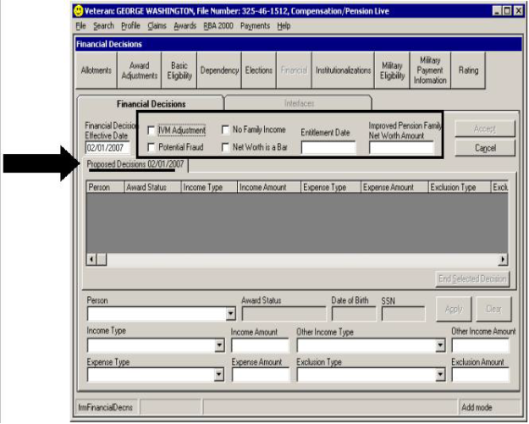

DIARY ACTIONS AVAILABLE IN AWARDS

Diary Name | Diary Code
10 Month Clothing Allowance Review | CL1
100% Unemployable Review | 02
Disappearance – 7 Year Review | 13
EVR Extended Suspense Control | 43
EVR Selection Control | 41
EVR Suspense Control | 42
Expiration of Employability Control | 32
Follow-Up on Paragraph 28 Review | 94
Future Physical Examination | 01
Helpless Child Reaches Majority | 20
Helpless Child Review | 03
IU LTR Not Sent – 2nd Notice | 34
Issue Dependency Verification Form | 24
Local Regional Office Special Use | 30
Paragraph 28 Review | 93
Reduction Under 38 CFR 3.551(B) | 11
Reservist Requires Drill Pay Days | 27
Restore Under 38 CFR 3.556(D) | 12
Return of Dependency Verification Form | 25
Review Hardship Expense | 26
Review Hospital Status Every 6 Months for 2 Years | 95
Review Need for Reevaluation | 39
VR&C Motivational Contact | 14
Verify Income or Dependency | 22
Verify School Attendance | 21
Veteran Hospitalized 100% Greater Than 3 Months | 92

Practical Exercise

Review Exercise 1

- What screen is used to access the individual decision screens (Dependency, Basic Eligibility, etc.)?

- What does the Award History screen display?

- The rating screen is in what type of mode, and who has jurisdiction to update section?

- What types of decisions can be found on the Other Decisions tab of the Rating screen? (name three)

- Name 5 examples of decisions that an award can be made within the Basic Eligibility screen?
Review Exercise 2

- What is the Basic Eligibility screen used for in Awards?

- What is the first action a VSR should take to input a decision using the Basic Eligibility screen?

- In order to add a dependent for payment purposes using the Awards program, where must information about the dependent first be logged? What commands can the VSR use to input this information?

- When a VSR enters a child (not helpless) for the first time in Awards for payment purposes, what function does the system automatically perform for the VSR?

- In order to remove a spouse or parent after the date of initial entitlement, what action must the VSR perform?
Review Exercise 3

- What types of payments does the Military Payment Information screen store information regarding? (name three)

- What are the five tabs located on the Award Adjustments screen?

- What Award Effective Date should the VSR input on the Severance pay and Separation pay tabs of the Award Adjustments screen, in general?

- When processing an award action involving a Severance Pay withholding, what must the VSR check for on the Rating Screen?

- Once a VSR has generated an award action, what button must then select if they need to correct a mistake made on one of the decision screens?

- Financial decision screen is used to record what type of cases? What type of information is required?

