Veterans Service Representative (VSR) Simplified Notification Letter (SNL)
Trainee Handout
Time Required: 8.0 Hours

Table of Contents
Table of Contents 1
Table of Figures 3
Introduction to VSR SNL Lesson 4
Instructor Introduction 4
Purpose of Lesson 4
Lesson Objective 4
Motivation 5
References 5
Topic 1: SNL Changes 6
Introduction 6
Background For The SNL 6
Overview of Changes 7
Revised Rating Decision Document 7
Special Notation Box 8
Evaluation Builder 9
Issues Traditionally Rated (SNL Exclusions) 10
Questions and Check Comprehension 11
Topic 2: Changes to Veteran’s Decision Notice 12
Changes to Notification Enclosures 12
Questions and Comments 16
Questions and Check Comprehension 16
Topic 3: Using the Personal Computer Generated Letter (PCGL) Application 17
Introduction 17
Building the PCGL Notice 17
Deferred Issue Box 17
Revised Paragraph on Direct Deposit 18
Revised Paragraph on Withholding Compensation 18
Text for Denials 19
NSC Medical Description 21
Contention Selection Box 22
N&M Selection Box 23
Presumptive Selection Box 23
Radiation Selection Box 24
Add Rationale Selection Box 24
Lay Evidence Selection Box 25
V Selection Box 25
PTSD Selection Box 26
PV Selection Box 26
ACK Selection Box 27
Other Issues to Deny 28
Deny Pension Box 30
Developing for Dependents 30
Evidence Missing 31
Forget to Check a Box? 31
Paying NSC Pension As the Greater Benefit 32
Questions and Check Comprehension 32
Practical Exercise 33
Practical Exercise Instructions 33
Lesson Review, Assessment, and Wrap-up 35
Summary 35
Questions 35
Final Evaluation 35
Attachment A: Sample Rating Decision Document 1
Attachment B: Sample Decision Notice 1
Attachment C: Forgot to Check a Denial Reason? 1
Attachment D: Denial Reasons 1
Attachment E: Denial Rationales 1
Attachment F: Process Checklist 1
Attachment G: Hybrid Rating Decision 1

Table of Figures
Figure 1: Special Notation Box 8
Figure 2: Deferred Issue Box 18
Figure 3: Direct Deposit 18
Figure 4: CRSC/CRDP Eligible 19
Figure 5: Decision Box 20
Figure 6: NSC Medical Description 21
Figure 7: Contention Selection Box 22
Figure 8: N&M Selection Box 23
Figure 9: Presumptive [P] Selection Box 23
Figure 10: Radiation [R] Selection Box 24
Figure 11: Add Rationale Selection Box 24
Figure 12: Lay Evidence Selection Box 25
Figure 13: V Selection Box 25
Figure 14: PTSD Selection Box 26
Figure 15: PV Selection Box 26
Figure 16: ACK Selection Box 27
Figure 17: Rationale for Contention #2 Box 27
Figure 18: Other Issues to Deny 28
Figure 19: IU Rationale Box 29
Figure 20: SMC Box 29
Figure 21: Deny Pension Box 30
Figure 22: Developing for Dependents Selection Box 30
Figure 23: Evidence Missing Box 31

Introduction to VSR SNL Lesson
TITLE SLIDE  Slide 1 |  | Welcome to Veteran’s Service Representative (VSR) SNL Training
Instructor Introduction  Slide 2 |  | Your Instructor(s) will complete the following:  - Introductions  - Orient trainees to the facilities  - Ensure that all trainees have the required handouts  - Explain logistics, such as location of:  - Restrooms  - Fire exits  - Vending machines  - Cafeteria  - Map all students to classroom printer
time required |  | 0.5 hours
Purpose of Lesson  Slide 3 |  | This lesson is intended to familiarize VSRs with SNL and teach VSRs to complete a rating decision notification using the redesigned rating process. This lesson will contain discussions and exercises that will allow VSRs to gain a better understanding of:  - SNL Changes  - Changes to Veteran’s Decision Notice  - Issues Traditionally Rated  - Using the Personal Computer Generated Letter (PCGL) Application
Lesson Objective  Slide 4 | In order to accomplish the purpose of this lesson, the VSR will be required to accomplish the following lesson objective:  Given the VSR SNL Trainee Handout, and Veterans’ Claims Files, the trainee must complete 4 out of 5 rating notifications with a minimum of 80% accuracy.  The learning objective is covered in the associated topics. At the conclusion of the lesson, the learning objective will be reviewed.  - Terminal Learning Objective  - Complete a Rating Decision Notification using the redesigned rating process.  - Enabling Learning Objectives(s)  - Explain the changes to the rating decision document resulting from the SNL.  - Explain the changes to the decision notice resulting from the SNL.  - Select the appropriate denial reason in the Personal Computer Generated Letter (PCGL) application.
Motivation  Slide 5 | The new SNL with Evaluation Builder gives Veterans decisions on their claims that are more consistent in results, format, and substance. The decisions and reasons for them are shorter and easier to understand, using less medical terminology and legal jargon.  VSRs will find that the new SNL with Evaluation Builder allows them to serve more Veterans. RVSRs using the Evaluation Builder and replacing narratives with simplified and standardized reasons for decisions will provide more consistent decisions for VSRs to promulgate. VSRs will use a new decision notice that automatically captures much of the necessary information from the corporate database, reducing the need for manual input. New decision boxes will guide VSRs as they choose reasons for decisions for each issue specified by RVSRs.
STAR Error code(s) | Decision Documentation/Notification
References  Slide 6 | - 38 USC, particularly §5104  - 38 CFR, particularly §§3.103(b)&(f)

Topic 1: SNL Changes
Introduction  Slide 7 |  |  | This topic will allow the trainee to complete a rating decision notification using the redesigned rating process.
Time Required |  |  | 0.5 hours
Topic OBJECTIVES |  |  | Given the VSR SNL Trainee Handout, and the Evaluation Builder Video, the trainee must explain the changes to the traditional rating process resulting from SNL, by correctly answering 3 out of 4 questions.
Teaching Points |  |  | The following topic teaching points support the topic objectives:  - Overview of Changes  - Revised SNL Decision Document  - Evaluation Builder  - Issues Traditionally Rated
 | Background For The SNL  Slide 8 | While developing this new notice process, VBA regularly consulted with the Office of General Counsel (OGC) and the Board of Veterans’ Appeals (BVA). Both organizations offered valuable advice to ensure that the process complied with the law.  VBA also vetted SNL with STAR, which has reviewed hundreds of cases created using this process. STAR is aware that the new process requires changes to its current accuracy checklist, particularly for Decision Documentation/Notification. Likewise, SNL requires significant changes to the M21-1 Manual Rewrite (MR) discussion on creating rating decisions and decision notice.  SNL is a departure from the traditional way of claims decision notice that still complies with the requirements of 38 USC §5104 and 38 CFR §3.103. Neither the law nor the regulation requires a traditional, separate rating decision. However, both the law and the regulation require that the notice of decision include information about how to appeal the determination, and SNL does not alter that aspect of the decision notification process. SNL leaves intact the current and more stringent procedures in handling appeals. The fundamental audience for the claims decision notice is not BVA or the Court of Appeals for Veterans Claims (CAVC), but the claimant and representative (if any). We solicited input from Veterans’ Service Organizations at both the national and local levels. In numerous informal queries, virtually every Veteran preferred the SNL notice over the traditional notice.  The duty of every decision-maker using SNL remains the same: to grant every benefit to which a claimant is entitled under the law according to the facts in each case while protecting the interests of the Government (38 CFR §3.103).
 | Overview of Changes  Slide 9 |  | 38 U.S.C. §5104 requires the Secretary to provide the following:  - Decision notice to all claimants that includes an explanation of the procedure for obtaining review of the decision  - Statement of the reasons for the decision in a denial  - Summary of the evidence considered in a denial  Currently, both the rating decision and the decision notice provide the following:  - Pertinent information regarding the payment of benefits  - Decision  - Effective date  SNL simplifies the notification, reducing redundancy with a single notice sent to the claimant.  This process modification does not change the way VBA considers and decides claims for compensation. Rather, it simply changes how VBA communicates the compensation decision to the claimant.
 | Revised Rating Decision Document  Slide 10 |  | The format of the rating decision has changed. The rating decision will no longer contain the following elements:  - Introduction  - Decision  - Reasons for Decision  - References  Although 38 U.S.C. §5104 and 38 C.F.R. §§3.103(b) & (f) only require an evidence summary for denials, the SNL decision will include an “Evidence Summary” section for all decisions. Although SNL does not contain the “Reasons for Decision,” it does include standardized denial reasons and, if applicable, simplified denial rationales.  The RVSR’s decision will now display on the code sheet, rather than the cover sheet. Attachment A contains a sample of the new rating decision document.
 | Special Notation Box  Slides 11 & 12 |  | The RVSR will use the Special Notation box to identify the decision(s) made and the reason(s) for it using special abbreviations.  The RVSR will use the Special Notation box to:  - Identify the decision(s) made  - Document the reason(s) for the decision using the appropriate abbreviations for denials of service connection or confirmed and continued decisions, and denial rationales (see Attachments D and E for the reasons and rationales).
The Special Notation box may look similar to the one below:
1. Service connection for Diabetes Mellitus Type II associated with herbicide exposure is granted with a 20 percent evaluation effective May 11, 2011.
2. Evaluation of Right Ankle Tendonitis, which is currently 0 percent disabling, is continued. C&C Eval, ACK:SX (Pittsburgh VA Medical Center), FTR (Orthopedic Exam)
3. Service connection for Seborrheic Dermatitis (claimed as dermatophytosis) is denied. NIS, NONEX, V:NONEX (Pittsburgh VAMC), PV:V>P (Dr. Smith)
VSR: Tell the Veteran “While you report current symptoms of a skin disorder, you have not submitted or identified any other medical evidence specifically addressing a connection between your skin disorder and military service.”
4. Service connection for Degenerative Disc Disease of the Cervical Spine (claimed as cervical spine condition) is denied. NIS, STRs, NOCRED (Mark Veteran)
5. Service connection for Sleep Apnea is denied. NIS, NONEX, NO CONT, L:NONEX (Mary Veteran), ACK:NODX (Dr. Smith)
VSR: Tell the Veteran “You have not submitted any other sources of competent medical evidence regarding a connection or link between your symptoms of sleep apnea and military service.”
Figure 1: Special Notation Box
The RVSR will provide a brief explanation of the effective date in the Special Notation box if the date is other than the date of claim, or the day following discharge. You must advise the Veteran in the notification letter if the effective date is other than the day following discharge or the date of claim. This information should be provided under the table that addresses the effective date for the specific contention.

When denying service connection, the RVSR must annotate an abbreviated denial reason and, if applicable, a denial rationale next to the decision in the Special Notation box. The RVSR must also include, in parenthesis, any evidence to be specified in the notice letter, as well as provide in quotation marks any free text.

The RVSR must select one or more of the approved denial reasons listed in Attachment D of this training guide. The RVSR may select one or more denial rationales listed in Attachment E of this guide. While the RVSR can never select a denial rationale without an accompanying reason, it is possible to select a denial reason without a rationale. It is the responsibility of the RVSR to select all applicable denial reasons and rationales, to specify in parentheses any evidence for the VSR to include in the notice when necessary, and to provide free text, word for word, for use in the notification letter. The specified evidence and free text will be added to the Explanation portion of the table that addresses the issue to which it is attached.
 | Evaluation Builder  Slide 13 |  | Under the SNL approach, RVSRs must use the Evaluation Builder for all grants, increases, and confirmed-&-continued (C&C) evaluations. The Evaluation Builder tool is located at http://vbaw.vba.va.gov/bl/21/rating/rat00.htm.
 |  |  | In cases where the Evaluation Builder is utilized, the RVSR copy and paste the Evaluation Builder results into the RBA-generated document. A copy of calculator results (hearing loss, SMC, etc.) must be put in the folder and provided to the Representative. The Veteran will not receive a copy of the SMC calculator, but will receive a copy of the narrative generated by the hearing loss calculator.
 | Issues Traditionally Rated (SNL Exclusions)  Slides 14, 15 & 16 |  | The simplified and standardized text used in SNL will not adequately explain every decision. There are instances when these simplified and standardized reasons will not adequately explain the decision and a traditional rating decision is the best medium to address it. Examples of procedural exceptions include, but are not necessarily limited to:  - Nehmer claims  - Denials associated with Military Sexual Trauma  - Denials of PTSD under the “Fear-Based” standard  - Appeals  - Live pension  - Discontinuances  - Proposals (including IDES)  - Reductions  - Severances  - Survivor Claims  - Assertions of clear and unmistakable error  - 38 USC 1151 claims  - Special monthly compensation (SMC) (except loss, or loss of use, of a creative organ or Aid & Attendance/Housebound)  - Claims for an earlier effective date  - Incompetency proposals  - Incompetency findings  - Issues involving potential fraud  - Traumatic brain injury  - Ancillary benefits (except for DEA grants)  - Claims for dental treatment only
The above list is not exhaustive. When the RVSR encounters an issue(s) that is not an exclusion, and believes the issue would be best resolved through use of the traditional rating process, the RVSR should consult with either a Coach or Decision Review Officer, as determined by local station policy, for guidance.
In claims involving multiple issues, of which at least one is an exception to SNL, the RVSR will create a hybrid rating decision.
 | Slide 17 |  | A hybrid rating decision occurs when some issues are processed utilizing SNL, while other issues require a traditional rating format. In a hybrid rating decision, the RVSR will use the traditional rating format for the exclusion, while the remaining issues are processed in the SNL format. An example of a hybrid rating decision is provided in Attachment G.  In cases of a hybrid rating, you must edit the PCGL notice (including an edit to the list of enclosures), advising the Veteran that greater explanation for a particular issue can be found in the attached documents.
Medical Description | Denial Reason
Contention | - The evidence does not show an event, disease, or injury in service.  - The evidence does not show that your condition, which existed prior to service, permanently worsened as a result of service
Explanation
Please see the enclosure for a greater explanation.

If the only excluded issue involves due process, the Veteran will receive the traditional rating decision with the applicable due process notification letter.
If the excluded issue does not involve due process, the Veteran will receive the SNL PCGL notice and the traditional rating decision as an attachment. The Post Determination Team will edit the PCGL notice to include the rating decision as an attachment.
Questions and Check Comprehension
Slide 18

Topic 2: Changes to Veteran’s Decision Notice
Introduction | This topic will allow the trainee to explain the changes to the decision notice resulting from SNL.
Time Required | 0.5 hours
Topic OBJECTIVES | Given the VSR SNL Trainee Handout, the trainee must explain the changes to the decision notice resulting from SNL, by correctly answering 3 out of 4 questions.
Teaching Points  Slide 19 | The following topic teaching points support the topic objectives:  - Notification Enclosures
Changes to Notification Enclosures  Slides 20, 21 & 22 | Changes in the format of the rating decision have required significant changes in the PCGL decision notice. In the traditional format, the Rating Decision provides the reasons and basis for the decision (for example, the claimed condition was not shown in service). The PCGL letter now provides narratives with simplified and standardized reasons for decisions based upon codes provided by the RVSR in the Special Notation box of the rating code sheet.  When you select the codes in PCGL, the letter is automatically populated with language associated with each code:
  Medical Description | Denial Reason
  Contention | - The evidence does not show an event, disease or injury in service.  - We did not find a link between your medical condition and military service.
  Explanation
  You submitted medical evidence of symptoms of, and treatment for, your headaches. The VA medical opinion found no link between your diagnosed medical condition and military service. The medical opinion we received from the VA Medical Center was more persuasive than your private physician's opinion since it was based on a thorough review of your relevant military and/or personal history and contained a more convincing rationale.
The RVSR may also specify a piece of evidence following an abbreviated code. In this case, the Special Notation box may look similar to the following.

Service Connection for XXXX is denied. NONEX, STRs, L:NONEX (Rick Downs), L:NODX (Joe Anderson), V:NONEX (Ann Arbor VA Medical Center).

VSR: Tell the Veteran “The evidence shows you have symptoms, but there is no competent medical evidence of a diagnosis or of a link between these symptoms and military service.”

If the RVSR specifies a piece of evidence, you must input the name of this evidence into the notification letter. This will require typing into the Word document after the letter is completed.

Medical Description | Denial Reason
Contention | - We did not find a link between your medical condition and military service.
Explanation
You submitted a lay statement to support your claim. A credible lay statement may establish what was seen, heard, and directly experienced. The lay evidence from Joe Anderson was found not to be competent and sufficient in this case to establish a diagnosis of your condition or to show that a diagnosis had been made by a medical professional. The lay evidence from Rick Downs was found not to be competent and sufficient in this case to establish a link or nexus between your medical condition and military service or to establish that such a link has been found by a medical professional. The VA medical opinion from the Ann Arbor VA Medical Center found no link between your diagnosed medical condition and military service.

The standard denial reasons and supporting rationales may be sufficient to provide the reasons for the decision in many situations. With some issues, however, an RVSR may consider using free text to provide critical information. On the other hand, free text is required for the denial reasons identified in Attachment D by the phrase “free text” in the fourth column.

When a denial reason requires free text, or when the RVSR chooses to use free text, the RVSR will provide the free text, word for word, in the Special Notation box. Free text will be used in situations where it is:
- Supplementing denial reasons that are largely but not completely adequate.
- Addressing case-specific facts essential to the decision.
- Identifying evidence the claimant should submit to change the decision.
- Providing a response to specific arguments raised by the Veteran.
You must cut and paste or manually input any free text provided by the RVSR into the Explanation section of the decision notice. Therefore, the RVSR should ensure that free text is:
- Clear
- Succinct
- In lay terms
Local management will give VSRs that promulgate decisions access to the “Q” drive, so they can copy and paste the language from the Special Notation box into the PCGL notice.
For example, VA previously denied a claim for service connection because there was no nexus to service. The appeal period has expired and the decision is now final. The Veteran submits evidence which confirms the diagnosis of the condition but fails to address the nexus. The RVSR denies the claim for failure to furnish new and material evidence. In this instance, the RVSR will insert the following into the Special Notation box:
“The statement you submitted from your spouse addressed the symptoms you currently experience, and that information is not material to the question of whether there is a connection between your current disability and service. While the evidence from Dr. Anderson provided a diagnosis, he reported that your disability is due to an automobile accident that occurred after your discharge from the military. You must submit evidence that establishes a connection between your current disability and service.”
In the notice to the Veteran, the reasons for decision would read:
Medical Description | Denial Reason
Contention | - We did not find a link between your medical condition and military service.  - The evidence you submitted is not new and material. Therefore, your claim is not reopened. It is not material because it does not relate to an unestablished fact necessary to substantiate the claim and/or does not raise a reasonable possibility of substantiating the claim.
Explanation
The statement you submitted from your spouse addressed the symptoms you currently experience, and that information is not material to the question of whether there is a connection between your current disability and service. While the evidence from Dr. Anderson provided a diagnosis, he reported that your disability is due to an automobile accident that occurred after your discharge from the military. You must submit evidence that establishes a connection between your current disability and service.

 | While the primary purpose of the Special Notation box is to record the decision, the Special Notation box may still fulfill its traditional purpose to communicate an instruction or administrative message. The RVSR must clarify if the message is solely administrative (for example, Veteran is competent) or to be shared with the Veteran (for example, tell Veteran we will schedule a future exam for his back condition since it revealed noticeable improvement on the recent VA exam).
In the aforementioned scenario, the Special Notation box should be completed as follows:
1 . Service connection for Post Traumatic Stress Disorder (PTSD) is granted with a 100 percent evaluation effective May 11, 2011.

Reviewer: Veteran is competent.

2 . We have confirmed and continued your evaluation for your back condition. C&C EVAL

VSR: Tell the Veteran, “We have scheduled a future exam for your back condition as the most recent exam showed improvement.”

Note:
VSR: Consider denying Veteran’s pension claim because of excessive income.

Questions and Comments | Questions and comments should be referred to local management. VSC management may submit additional inquiries to the following:  For questions or comments regarding the Evaluation Builder, please email the following mailbox:  DENTT.VBAPHO@va.gov or VAVBAPHO/RO/DENTT  For questions or comments regarding the SNL, please contact:  VAVBAWAS/CO/SNL
Questions and Check Comprehension
Slide 23

Topic 3: Using the Personal Computer Generated Letter (PCGL) Application
Introduction  Slide 24 | This topic will allow the trainee to enter the appropriate decision and reasons in the Personal Computer Generated Letter (PCGL) application.
Time Required | 1.5 hours
Topic OBJECTIVE | Given the VSR SNL Trainee Handout Packet, the Rating Decision Document (Special Notation box), the PCGL, 38 U.S.C. §5104 and 38 CFR §3.103, and Veterans’ Claims folders, the trainee must enter the appropriate decision and reasons in the PCGL application in 4 out of 5 cases at 100% accuracy.
Teaching Points | The following topic teaching points support the topic objectives:  - Building the PCGL Notice  - Revised Paragraph on Direct Deposit  - Revised Paragraph on Withholding Compensation  - Text for Denials and Rationales  - Paying Nonservice-connected (NSC) Pension as the Greater Benefit
Building the PCGL Notice  Slide 25 | The PCGL notice was modified to include information that was traditionally included in the rating decision.  Titles and the location of this letter will vary by RO if released in the local letter library.  As your instructor provides the information, please fill in the blanks below.  The PCGL notice is titled _____________________________ and is available in the _________________________________ library under the ___________________________________________ section.  Other significant modifications to the PCGL notice are discussed next.
Deferred Issue Box  Slide 26 | A deferred issue box has been added to the beginning of the letter (after date-of-claim box and before you select which letter to compose).  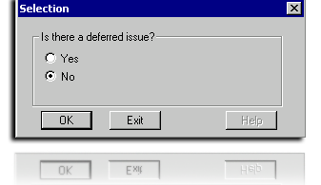  Figure 2: Deferred Issue Box
Revised Paragraph on Direct Deposit  Slide 27 | If the Claimant did not provide his/her banking information (for example, “No” is selected as in figure below), the “How Do You Start Direct Deposit?” section will include the Treasury Mandate information required by FL 11-25.  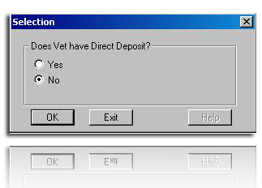  Figure 3: Direct Deposit
Revised Paragraph on Withholding Compensation  Slide 28 | If we are withholding compensation, a box will appear asking if the Veteran is also eligible for CRSC/CRDP.  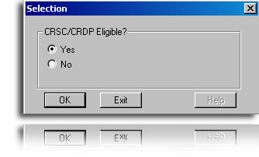  Figure 4: CRSC/CRDP Eligible  If “Yes” is selected, the CRSC/CRDP information will populate the letter.
Text for Denials  Slide 29 | The “What We Decided” section of the decision notice was modified to include additional language for conditions that were denied, as shown below.  When prompted with the Decision Box, you must select all decisions that apply. For example, if the RVSR is granting service connection for contention #1, confirming and continuing contention #2, and denying service connection for contentions #3 and #4, you would select S/C Granted, All Denials including Pension, and C&C Eval-No Chg.  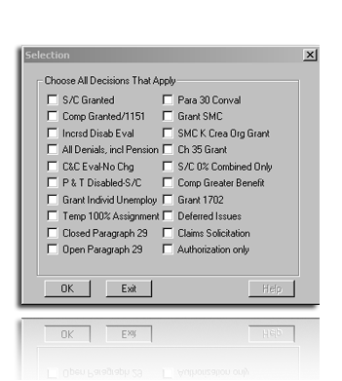  Figure 5: Decision Box  You must select all decisions that apply. The option to select deferred issues will remain in the decision box and you can select that box as well (if he/she forgot to do so at the beginning of the letter). The duplication of the deferred issue is a programming limitation.
NSC Medical Description  Slide 30 | If the “All Denials, incl Pension” box is selected, the following menu will appear.  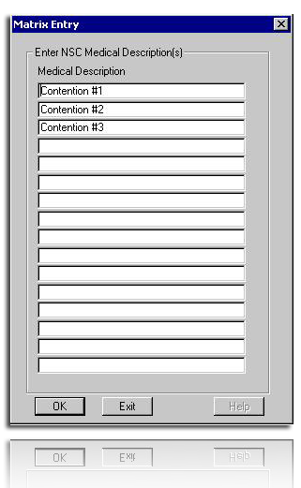  Figure 6: NSC Medical Description
Contention Selection Box  Slide 31 | When you select “OK,” an additional box will appear for each contention.  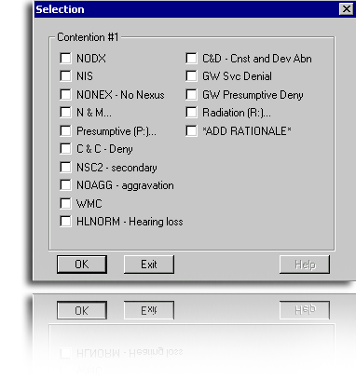  Figure 7: Contention Selection Box  PCGL will require you to input the denial reason(s) for each condition. Multiple reasons can be selected. The abbreviations in this box correspond with the abbreviations the RVSR is required to annotate in the Special Notation box (See Attachments D and E). If there are additional abbreviations that are not listed in this box, also select “ADD RATIONALE.”  It is important to note that while “GW Svc Denial” and “GW Presumptive Deny” are available as options, they should not be used and are removed from the list of the denial reasons in the attachments.
N&M Selection Box  Slide 32 | If “N&M…,” “Presumptive P:…,” “Radiation (R:),” or “Add Rationale” are selected, additional boxes will appear, as shown in the following figures.  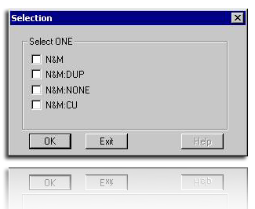  Figure 8: N&M Selection Box
Presumptive Selection Box  Slide 33 | 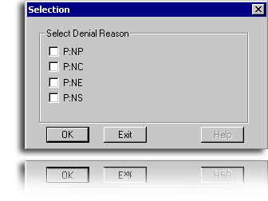  Figure 9: Presumptive [P] Selection Box
Radiation Selection Box  Slide 34 | 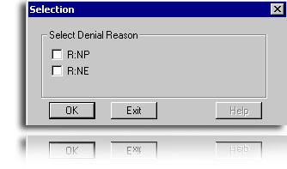  Figure 10: Radiation [R] Selection Box
Add Rationale Selection Box  Slide 35 | 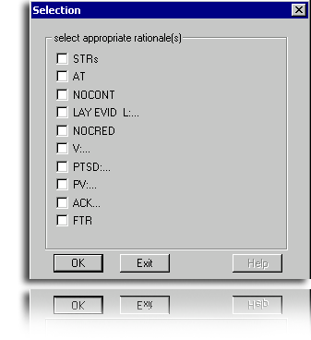  Figure 11: Add Rationale Selection Box
 | You must select “Add Rationale” when the RVSR provides free text to further support their denial. If the RVSR only provides free text and does not provide a standard rationale code, select “OK”. If the RVSR provides a denial rationale code and free text, select the code and then select “OK”. After the PCGL notice is completed, you will have to type the free text provided by the RVSR (or retrieve it from the Q drive) in the “Explanation” section of the text box applicable to the contention.
Lay Evidence Selection Box  Slide 36 | Similarly, additional boxes will appear if Lay Evid L…, V:…., PTSD:…, PV:…, or ACK…are selected.  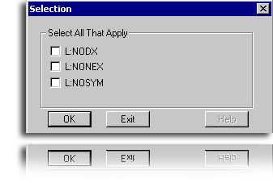  Figure 12: Lay Evidence Selection Box
V Selection Box  Slide 37 | 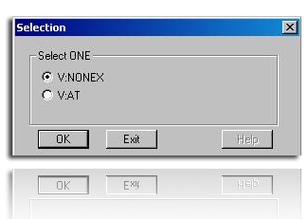  Figure 13: V Selection Box
PTSD Selection Box  Slide 38 | 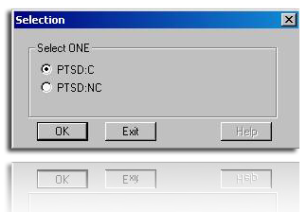  Figure 14: PTSD Selection Box
PV Selection Box  Slide 39 | 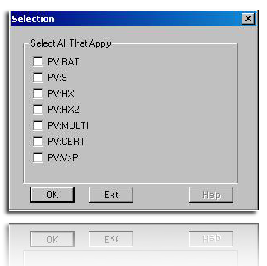  Figure 15: PV Selection Box
ACK Selection Box  Slide 40 | 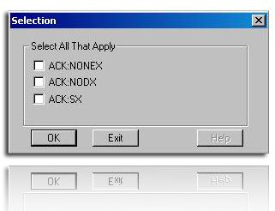  Figure 16: ACK Selection Box  If you select “C&C Evaluation,” PCGL will ask if there is rationale to include in the letter (that is, did the RVSR provide additional rationale codes on the code sheet?).  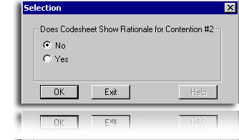  Figure 17: Rationale for Contention #2 Box
Other Issues to Deny  Slide 41 | You will also be asked if there are any other issues that are denied, if there are no other issues to deny, select “OK.”  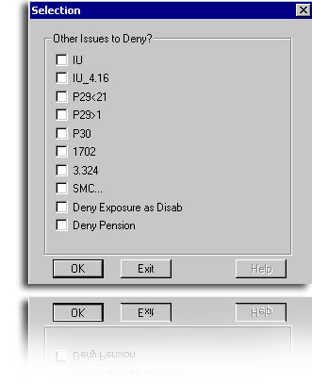  Figure 18: Other Issues to Deny
If IU is selected, PCGL will ask if there is rationale to include in the letter (that is, did the RVSR provide additional rationale codes on the code sheet?). If no rationale, select “OK.”
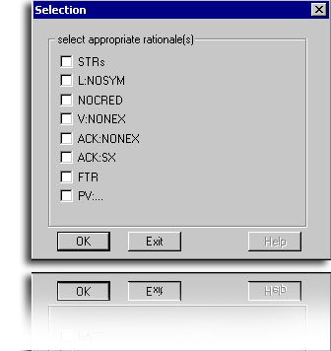
Figure 19: IU Rationale Box
If “SMC…” is selected, the following box will appear:
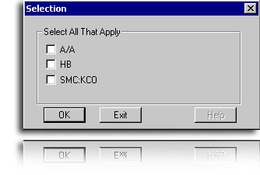
Figure 20: SMC Box
Deny Pension Box  Slide 42 | If “Deny Pension” is selected, the following box will appear.  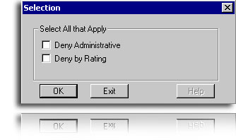  Figure 21: Deny Pension Box
Developing for Dependents  Slide 43 | The letter is programmed to ask you if we are developing for dependents.  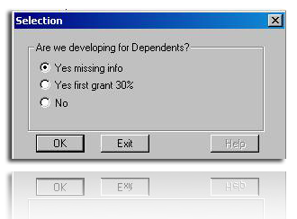  Figure 22: Developing for Dependents Selection Box
Evidence Missing  Slide 44 | If, “Yes missing info” is selected, then the following box will appear asking you to input the type of evidence we are requesting:  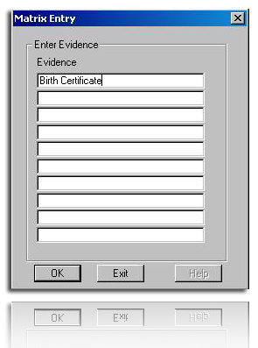  Figure 23: Evidence Missing Box
Forget to Check a Box? | If you forgot to check a box (for example, a denial reason or “ADD RATIONALE”) and completed the letter, you can follow the instructions in Attachment C to avoid having to redo the entire letter.
Paying NSC Pension As the Greater Benefit  Slide 45 | Finally, there is a separate letter available if you are paying NSC pension as the greater benefit and the RVSR completed a hybrid rating decision.  Titles and the location of this letter will vary by RO if released in the local letter library.  As your instructor provides the information, please fill in the blanks below.  The PCGL notice is titled _____________________________ and is available in the _________________________________ library under the ___________________________________________ section.
Questions and Check Comprehension
Slide 46

Regional Office Specific Topics | At this time add any information pertaining to:  - Station quality issues with this lesson  - Additional State specific programs/guidance on this lesson

Practical Exercise
Time Required | 4.0 hours
Practical Exercise Instructions  Slide 47 | - The Practical Exercise will allow the trainees to demonstrate their understanding of the information presented in this lesson.  - Trainees will receive 5 rating decisions to each trainee.  - Trainee directions:  - Your Instructor will provide you with five (5) rating decisions.  - For each rating decision, you must generate an award (if applicable) and complete a decision notification using PCGL. Your decision notifications will be evaluated according to the process checklist in Attachment F of the VSR Trainee Handout.  - During the exercise, you may refer to your Trainee Handout, User Guides, and any other notes and references you may have received during your training.  - The cases completed during the Practical Exercise will be reviewed based on the following checklist:  Claimant’s name and address are correct.  PCGL decision notice must address all issues, claimed or inferred, in the Special Notation box on the code sheet.  PCGL decision notice includes all messages in the Special Notation box that the RVSR wanted relayed to the claimant.  PCGL decision notice must contain all the reasons for the denial of each condition.  PCGL decision notice must address all ancillary benefits according to current procedures.  PCGL decision notice must have the correct evaluation and effective date for grants.  Summary of Evidence (with Veteran’s name, POA, and date) must be attached to Veteran and POA copies of letter.  Any other applicable enclosures must be attached to Veteran and POA copies of letter.  VSR performed any additional action as directed by the RVSR.

IMPORTANT: The VSR SNL Practical Exercise MUST take place after the RVSR SNL Training is complete. VSRs will use the decision documents resulting from the RVSR SNL Practical Exercise to complete this task. Cases are selected for the RVSR Practical Exercise based on the following criteria: Minimum of 5 cases per trainee, at least 150 total:
- Number of issues per case: 1-3
- Types of issues: Any issues except:
  - Nehmer cases
  - Denials associated with Military Sexual Trauma
  - Denials of PTSD under the “Fear-Based” standard
  - Appeals
  - Live pension
  - Discontinuances
  - Proposals (including IDES)
  - Reductions
  - Severances
  - Survivor Claims
  - Assertions of clear and unmistakable error
  - Claims under 38 USC 1151
  - SMC (except loss or loss of use of a creative organ or Aid & Attendance/Housebound)
  - Claims for an earlier effective date
  - Incompetency proposals or findings
  - Issues potentially involving fraud
  - Traumatic brain injury
  - Ancillary benefits (except for DEA grants)
  - Claims for dental treatment only

Lesson Review, Assessment, and Wrap-up
Introduction | The VSR SNL lesson is complete.  Your Instructor will review each lesson objective and give you the opportunity to any questions or comments.
Time Required | 0.5 hours
Lesson Objective | You have completed the VSR SNL lesson. By now, you should be able to complete a rating decision notification using the redesigned rating process.
Summary  Slide 48 | - Terminal Learning Objective  - Complete a rating decision notification using the redesigned rating process.  - Enabling Learning Objectives(s)  - Explain the changes to the rating decision document resulting from SNL.  - Explain the changes to the decision notice resulting from SNL.  - Select the appropriate denial reason in the Personal Computer Generated Letter (PCGL) application.
Questions  Slide 49 | Any final questions about the entire course?
Final Evaluation  Slide 50 | Before you go we have one last task for you to complete – the final evaluation. The evaluation form is one way we measure our success. We also ask you for input to solicit a range of opinions on how we can improve the lesson for future training efforts.

Attachment A: Sample Rating Decision Document


DEPARTMENT OF VETERANS AFFAIRS
VARO Anystate
123 Main Street
Small Town, USA 12345

JOE VETERAN

VA File Number
XXX XX XXXX

Represented by:
DISABLED AMERICAN VETERANS

Rating Decision
MM/DD/YYYY
EVIDENCE
- VA Form 21-526b, Veteran's Supplemental Claim received May 11, 2011
- DD Form 214 from August 18, 1965 through July 31, 1975
- Service treatment records from June 18, 1965 through July 31, 1975
- VCAA/Duty to Assist Letter dated May 18, 2011
- VA Form 21-4138, Statement in Support of Claim, from Mary Veteran, received May 11, 2011
- VA Form 21-4138, Statement in Support of Claim, from Mark Veteran, received May 11, 2011
- Private medical records, Dr. John Smith, from September 1, 2004 through January 31, 2010
- Private medical records, Jones Spine and Neurology, dated August 8, 2009
- Private medical records, University of Pittsburgh Medical Center, dated April 18, 2009
- Treatment reports, Pittsburgh VA Medical Center, from February 6, 1999 through April 4, 2011
- Diabetes Mellitus VA examination, Pittsburgh VA Medical Center, dated July 1, 2011
- Skin Diseases VA examination, Pittsburgh VA Medical Center, dated July 1, 2011
- Failure to report to an Orthopedic VA Exam at the Pittsburgh VA Medical Center on July 8, 2011
1. Service connection for Diabetes Mellitus Type II associated with herbicide exposure.

We have assigned a 20 percent evaluation for your diabetes mellitus based on:

• Requirement for oral hypoglycemic agent
• Restricted diet required

A higher evaluation of 40 percent is not warranted unless there is diabetes requiring insulin, restricted diet, and regulation of activities.

2. Evaluation of Right Ankle Tendonitis, currently 0 percent disabling.

We have assigned a noncompensable evaluation for your ankle condition based on:

• Slight limitation of motion of the ankle

Note: In every instance where the schedule does not provide a zero percent evaluation for a diagnostic code, a zero percent evaluation shall be assigned when the requirements for a compensable evaluation are not met. {38 CFR §4.31}

The provisions of 38 CFR §§4.40 and 4.45 concerning functional loss due to pain, fatigue, weakness, or lack of endurance, incoordination, and flare-ups, as cited in DeLuca v. Brown, 8 Vet. App. 202 (1995), have been considered and are not warranted.

A higher evaluation of 10 percent is not warranted unless there is:

• Moderate limitation of motion of the ankle; or,
• Ankylosis of the subastragalar or tarsal joint in good weight-bearing position; or,
• Malunion of os calcis or astragalus with moderate deformity; or,
• Painful motion of the ankle; or,

Additionally, a higher evaluation of 20 percent is not warranted unless there is:

• Astragalectomy; or,
• Ankylosis of the ankle in plantar flexion less than 30 degrees

ACTIVE DUTY
EOD | RAD | BRANCH | CHARACTER OF DISCHARGE
06/18/1965 | 07/31/1975 | Army | Honorable

LEGACY CODES
ADD’L SVC  CODE | COMBAT  CODE | SPECIAL  PROV CDE | FUTURE EXAM  DATE
 | 1 |  | None

JURISDICTION: Reopened Claim Received 05/11/2011

ASSOCIATED CLAIM(s): 020; Reopened Claim; 05/11/2011

SUBJECT TO COMPENSATION (1. SC)

5271 | RIGHT ANKLE TENDONITIS  Service Connected, Vietnam Era  Static Disability  0% from 03/28/2006
7913 | DIABETES MELLITUS TYPE II [Agent Orange-Vietnam Diabetes]  Service Connected, Vietnam Era, Presumptive  Static Disability  20% from 05/11/2011

COMBINED EVALUATION FOR COMPENSATION:

0% from 03/28/2006
20% from 05/11/2011

NOT SERVICE CONNECTED/NOT SUBJECT TO COMPENSATION (8.NSC Gulf War)

5237 | DEGENERATIVE DISC DISEASE OF THE CERVICAL SPINE (CLAIMED AS CERVICAL SPINE CONDITION)  Not Service Connected, Not Incurred/Caused by Service

6847 | SLEEP APNEA  Not Service Connected, Not Incurred/Caused by Service

7800-7806 | SEBORRHEIC DERMATITIS (CLAIMED AS DERMATOPHYTOSIS)  Not Service Connected, Not Incurred/Caused by Service

1. Service connection for Diabetes Mellitus Type II associated with herbicide exposure is granted with a 20 percent evaluation effective May 11, 2011.

2. Evaluation of Right Ankle Tendonitis, which is currently 0 percent disabling, is continued. C&C Eval, ACK:SX, (Pittsburgh VA Medical Center), FTR (Orthopedic Exam)

3. Service connection for Seborrheic Dermatitis (claimed as dermatophytosis) is denied. NIS, NONEX, V:NONEX, (Pittsburgh VAMC), PV:V>P (Dr. Smith)

VSR: Tell the Veteran “While you report current symptoms of a skin disorder, you have not submitted or identified any other medical evidence specifically addressing a connection between your skin disorder and military service.”

4. Service connection for Degenerative Disc Disease of the Cervical Spine (claimed as cervical spine condition) is denied. NIS, STRs, NOCRED (Mark Veteran)

5. Service connection for Sleep Apnea is denied. NIS, NONEX, NO CONT, L:NONEX, (Mary Veteran), ACK: NODX (Dr. Smith)

VSR: Tell the Veteran “You have not submitted any other sources of competent medical evidence regarding a connection or link between your symptoms of sleep apnea and military service.”

RVSR

Attachment B: Sample Decision Notice

In Reply Refer To:
xxx/21
CSS XXX XX XXXX

JOE VETERAN
604 KNIGHT STREET
ANYTOWN, USA 12345

Dear Mr. Veteran:

We made a decision on your claim for service connected compensation received on May 11, 2011. This letter constitutes our decision based on all issues we understood to be specifically made, implied, or inferred in that claim.

This letter tells you about your entitlement amount and payment start date and what we decided. It includes the evidence used and reasons for our decision. We have also included information about additional benefits, what to do if you disagree with our decision, and who to contact if you have questions or need assistance.

Your Award Amount and Payment Start Date
Your monthly entitlement amount is shown below:

Monthly Entitlement Amount | Payment Start Date | Reason For Change
$243.00 | Jun 1, 2011 | Compensation Granted

You Can Expect Payment
Your payment begins the first day of the month following your effective date. You will receive a payment covering the initial amount due under this award, minus any withholdings, in approximately 15 days. Payment will then be made at the beginning of each month for the prior month. For example, benefits due for May are paid on or about June 1.

What We Decided

Please see the enclosures for more information regarding the evidence considered and the evaluation assigned.

We determined that the following condition(s) was/were related to your military service, so service connection has been granted:

Medical Description | Percent (%) Assigned | Effective Date
Diabetes Mellitus Type II | 20% | May 11, 2011

We determined that the following service connected condition hasn't changed:

Medical Description | Percent (%) Assigned
Right Ankle Tendonitis | 0%
Explanation
We reviewed the evidence received and determined your service-connected condition hasn't increased in severity sufficiently to warrant a higher evaluation. We acknowledge receipt of your medical evidence from the Pittsburgh VA Medical Center, which discusses the symptoms of your medical condition. You did not attend the VA examination at the Pittsburgh VA Medical Center we scheduled in connection with your claim, and did not show good cause for your failure to do so. Therefore, medical evidence that could have been useful to support your claim was not available to us.

We determined that the following conditions were not related to your military service, so service connection couldn't be granted:

Medical Description | Denial Reason
Seborrheic Dermatitis (claimed as dermatophytosis) | - The evidence does not show an event, disease or injury in service.  - We did not find a link between your medical condition and military service.
Explanation
The VA medical opinion found no link between your diagnosed medical condition and military service. The medical opinion we received from the Pittsburgh VA Medical Center was more persuasive than your private physician's opinion, Dr. Smith, since it was based on a thorough review of your relevant military and/or personal history and contained a more convincing rationale. While you report current symptoms of a skin disorder, you have not submitted or identified any other medical evidence specifically addressing a connection between your skin disorder and military service.

Medical Description | Denial Reason
Degenerative Disc Disease of the Cervical Spine (claimed as cervical spine condition) | - The evidence does not show an event, disease or injury in service
Explanation
Your service treatment records do not contain complaints, treatment, or diagnosis for this condition. You submitted lay evidence from Mark Veteran that your claimed disability is related to events or treatment in service. We have determined that the service treatment records and post service evidence contradict your statement(s) of a connection between your service and your claimed condition, and find the other evidence is more credible when considered in light of all the evidence.

Medical Description | Denial Reason
Sleep Apnea | - The evidence does not show an event, disease or injury in service.  - We did not find a link between your medical condition and military service
Explanation
You submitted a lay statement from Mary Veteran to support your claim. A credible lay statement may establish what was seen, heard, and directly experienced. The lay evidence was found not to be competent and sufficient in this case to establish a link or nexus between your medical condition and military service or to establish that such a link has been found by a medical professional. We acknowledge receipt of your private medical opinion from Dr. Smith intending to link your current disability to a disease, event, or injury from your military service. There was no continuity of symptoms from service to the present. You have not submitted any other sources of competent medical evidence regarding a connection or link between your symptoms of sleep apnea and military service.

Your overall or combined rating is 20%. We do not add the individual percentages of each condition to determine your combined rating. We use a combined rating table that considers the effect from the most serious to the least serious conditions.

We enclosed a VA Form 21-8764, "Disability Compensation Award Attachment-Important Information," which explains certain factors concerning your benefits.

Department of Treasury Mandate - Award
We noticed that you did not provide us with your banking information to allow your federal benefits to be sent directly to your bank. The Department of Treasury has mandated that all recurring federal benefits be administered through either Electronic Funds Transfer (EFT) or Direct Express® Debit MasterCard®. VA encourages you to select the method in which you would like to receive your VA benefits before March 1, 2013. If you do not change your payment method before March 1, 2013, the Treasury will contact you directly.

- To have your federal benefits electronically transferred to your designated financial institution (e.g. bank) please call VA at 1-800-827-1000 with your banking information.
- To have your federal benefits issued through Direct Express® Debit MasterCard® issued by Comerica Bank, please call 1-800-333-1795 to enroll in the program.

Are You Entitled to Additional Benefits?
You may be eligible for government life insurance if you
- were released from active duty after April 25, 1951,
- are in good health (except for any service connected conditions), and
- apply within two years of this notification of your disability rating.

If you are totally disabled, you may be eligible to have your government life insurance premiums waived. The Insurance is called Service-Disabled Veterans Insurance (S-DVI), and you should receive a package within two weeks. This package will contain information about the insurance and an application. If you do not receive an S-DVI package, please contact the Insurance Center to request additional information. Call the Insurance toll free number, 1-800-669-8477, or visit the Insurance web site, http://www.insurance.va.gov, for further information about Service-Disabled Veterans Insurance.

You may be eligible for medical care by the VA health care system for any service-connected disability. You may apply for medical care or treatment at the nearest medical facility. If you apply in person, present a copy of this letter to the Patient Registration/Eligibility Section. If you apply by writing a letter, include your VA file number and a copy of this letter.

REDUCE OR ELIMINATE
YOUR MEDICAL CO-PAYMENTS

If you receive care at a VA medical facility, please call our Health Benefits Call Center at 1-877-222-VETS (8387) or notify your local VA medical center of this change in your compensation benefits. This rating decision may reduce or eliminate your co-payments for your VA-provided medical care. You may also be eligible for a refund based on this rating decision. Information regarding VA health care eligibility and co-payments is available at our website www.va.gov/healtheligibility.

You should contact your State office of veteran’s affairs for information on any tax, license, or fee-related benefits for which you may be eligible as a veteran (or surviving dependent of a veteran). State offices of veteran's affairs are available at http://www.va.gov/statedva.htm.

You may be able to receive vocational rehabilitation employment services. The enclosed VA Form 28-8890, "Important Information About Vocational Rehabilitation Benefits," explains this benefit completely. To apply for this benefit, complete and return the enclosed VA Form 28-1900, "Disabled Veterans Application for Vocational Rehabilitation."

What You Should Do If You Disagree With Our Decision
If you do not agree with our decision, you should write and tell us why. You have one year from the date of this letter to appeal the decision. The enclosed VA Form 4107, "Your Rights to Appeal Our Decision," explains your right to appeal.

If You Have Questions or Need Assistance
If you have any questions, you may contact us by telephone, e-mail, or letter.

If you | Here is what to do.
Telephone | Call us at 1-800-827-1000. If you use a Telecommunications Device for the Deaf (TDD), the number is 1-800-829-4833.
Use the Internet | Send electronic inquiries through the Internet at https://iris.va.gov.
Write | Put your full name and VA file number on the letter. Please send all correspondence to the address at the top of this letter.

In all cases, be sure to refer to your VA file number XXX XX XXXX.

If you are looking for general information about benefits and eligibility, you should visit our website at https://www.va.gov, or search the Frequently Asked Questions (FAQs) at https://iris.va.gov.

We sent a copy of this letter to your representative, Disabled American Veterans, whom you can also contact if you have questions or need assistance.

Sincerely yours,

Veterans Service Center Manager

Veterans Service Center Manager

Contact us at: https://iris.va.gov

Enclosure(s): Summary of Evidence and Evaluation Criteria
VA Form 21-8764
VA Form 28-1900
VA Form 28-8890
VA Form 4107

cc: DAV

Attachment C: Forgot to Check a Denial Reason?

If you forgot to check a box (that is, a denial reason or “Check if Rationale”) and completed the letter, you can correct the error.
- Highlight the boxes containing the denied conditions that you want to change (or add rationale too) and DELETE them to remove them from the letter. You must delete the entire table, not just the language within it.

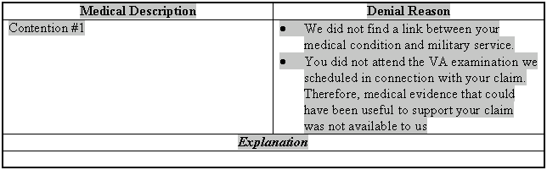
- Place your cursor at the point in the letter where you want to add the conditions back in (presumably where you deleted the prior box).

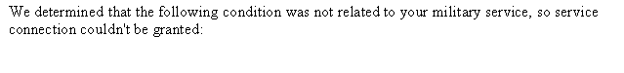
- Select the F button  from the PCGL toolbar.
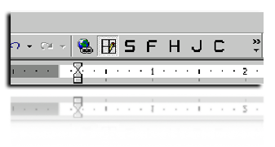

- The PCGL Environment and Configuration Screen will appear. Ensure that VETSNET Data and LOCAL – Adjudication-CP are selected.
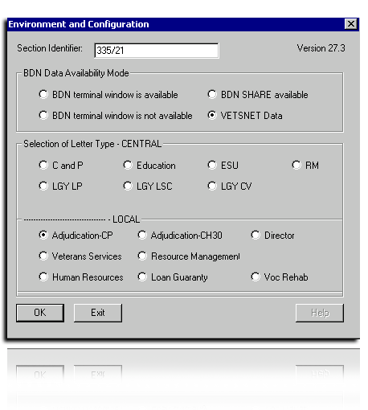

- Select the correct choice from the menu that is applicable to your RO (the location of this paragraph may vary among ROs—this example is from the St. Paul RO). Ensure the name appears in the “Order of Insertion” box at the bottom of the screen.
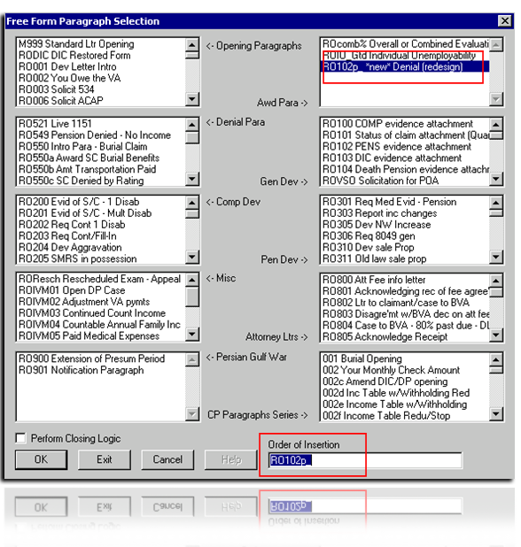
Follow the prompts the same as you would in the letter. Note that PCGL will populate ALL denied conditions, not just the ones you want to replace. Delete the contentions you are not correcting and PCGL will ignore the blank lines.
When a correction is made, PCGL will re-input the following leading sentence:
We determined that the following conditions were not related to your military service, so service connection couldn't be granted:
If this sentence was automatically populated earlier in the letter, it should be deleted here.

Attachment D: Denial Reasons

Denial Reasons
Abbreviation | Definition | PCGL Language | Reasons That Require Additional Free Text
NODX | No Diagnosed Condition | The evidence does not show a current diagnosed disability. | None
NIS | No Event, Disease or Injury in Service (Not-in-service) | The evidence does not show an event, disease or injury in service. | None
NONEX | No Nexus or Link | We did not find a link between your medical condition and military service. | Free Text
N&M | Not Material | The evidence you submitted is not new and material. Therefore, your claim is not reopened. It is not material because it does not relate to an unestablished fact necessary to substantiate the claim and/or does not raise a reasonable possibility of substantiating the claim. | Free Text
N&M:DUP | Not New 1 (Duplicate evidence) | The evidence you submitted is not new and material. Therefore, your claim is not reopened. It is not new because it had already been submitted and considered. | Free Text
N&M:NONE | Not New 2 (No medical evidence submitted) | The evidence you submitted is not new and material. Therefore, your claim is not reopened. Although you raised the possibility that more evidence exists, you did not submit it. | Free Text
N&M:CU | Not New and Material (Cumulative) | The evidence you submitted is not new and material. Therefore, your claim is not reopened. It is not new because it is cumulative or redundant of evidence we already considered. | Free Text
P:NP | Not a presumptive condition – Chronic (Not Presumptive) | Your condition is not one of the chronic diseases that VA presumes is related to your military service. | None
P:NC | Did not develop to compensable degree (Not Compensable) | The evidence does not show that your disease developed to a compensable degree within the specified time period after release from service to qualify for the presumption of service connection. | Free Text
P:NE | No qualifying exposure (No Exposure) | The evidence does not show the location(s) of your military service, or the events you experienced therein, qualify for the presumption of service connection for your disease. | Free Text
P:NS | No service qualifying for presumption (No Service) | We did not find that you had active, continuous service for 90 days or more to qualify for the presumption of service connection. | None
C&C DENY | Confirm and Continue previous denial | The evidence does not support a change in our prior decision. Therefore, we are confirming the previous denial of this claim. | None
NSC2 | Not a secondary condition | The evidence does not show that your condition resulted from, or was aggravated by, a service-connected disability. | Free Text
NO AGG | No evidence of aggravation | The evidence does not show that your condition, which existed prior to service, permanently worsened as a result of service. | Free Text
WMC | Willful misconduct | The evidence shows that this condition resulted from willful misconduct. | Free Text
HL NORM | Hearing within normal limits for VA | The evidence does not show audiometric findings that meet the criteria for a grant of service connection for defective hearing by VA standards. | None (As long as HL calculator is used.)
C&D | Constitutional and Developmental Condition | Your condition is considered a congenital or developmental defect, which is unrelated to military service and not aggravated by it. | None
R:NP | Radiation (Not a presumptive condition) | Your condition is not one of the diseases that VA presumes is related to radiation exposure. | None
R:NE | Radiation (No exposure) | We did not find that you participated in a radiation risk activity while in service. | None
C&C EVAL | Confirm and Continue current evaluation | We reviewed the evidence received and determined your service-connected condition(s) hasn’t/haven’t increased in severity sufficiently to warrant a higher evaluation. | None
IU | Individual Unemployability | Your claim for individual unemployability was denied because the evidence does not show you are unable to secure or follow a substantially gainful occupation as a result of service-connected disabilities. | Free Text
IU4.16 | Individual Unemployability - Does not meet the schedular requirements | We denied your claim for individual unemployability because you do not have one disability rated at 60%, or a combined rating of at least 70% with one disability rated at 40%, and the evidence does not demonstrate that you are unable to secure or follow substantially gainful occupation solely due to service-connected conditions. | None
P29<21 | Hospitalized less than 21 days | We denied your claim for a temporary total evaluation (100%). The evidence does not show that your service-connected condition required hospitalization for a period of more than 21 days. | None
P29>1 | Private hospital summary received more than one year following discharge | We denied your claim for a temporary total evaluation (100%). The evidence shows VA received the summary of hospitalization more than one year following discharge from the hospital. | Free Text
P30 | Temp 100% for surgery | We denied your claim for a temporary total evaluation (100%). The evidence does not show that a service-connected disability required surgery necessitating at least one month of convalescence, surgery with severe postoperative residuals, or treatment with immobilization by cast of one major joint or more. | Free Text
1702 | 1702 Denied | Entitlement to medical treatment is not established because a psychosis or mental illness was not developed during, or within two years, from the date of separation. | None
3.324 | 3.324 Denied | We denied a 10% combined evaluation based on your multiple 0% service-connected disabilities. The evidence does not show that your service-connected disabilities clearly interfere with normal employment. | None
CC3.324 | Confirmed & continued 3.324 entitlement | We have continued your 10% combined evaluation for multiple 0% S/C disabilities. The evidence shows that your service connected disabilities clearly interfere with normal employment. | None
SMC:KCO | Loss of, or loss of use of Creative Organ | We have denied entitlement to special monthly compensation because the evidence shows you have not suffered the loss or loss of use of one or more creative organs due to your service-connected disability(ies). | None
SMC:A/A | Denial of SMC A/A | We have denied entitlement to special monthly compensation because the evidence shows you do not need the regular aid and attendance of another person to perform routine activities of daily living, OR you are not permanently bedridden. | None
SMC:HB | Denial of SMC HB | We have denied entitlement to special monthly compensation because the evidence shows you are not substantially confined to your home or immediate premises due to your service-connected disability OR that you have a single service-connected disability rated 100 percent and a separate service-connected disability or disabilities independently rated 60 percent or more. | None
TRAD | Issue rated in the traditional format | None | Free text: “Please see the attachment for our decision on your claim for (insert claimed condition(s) here)”

Attachment E: Denial Rationales

Denial Rationales
Abbreviation | Definition | PCGL Language
*STRs | Not shown in STRs | Your service treatment records do not contain complaints, treatment, or diagnosis for this condition.
AT | Shown in STRs, but not persistent (Acute-&-Transitory) | While your service treatment records reflect complaints, treatment, or a diagnosis similar to that claimed, the medical evidence supports the conclusion that a persistent disability was not present in service.
NOCONT | No Continuity of Symptoms | There was no continuity of symptoms from service to the present.
L:NODX | Lay Evidence–No Diagnosis | You submitted a lay statement to support your claim. A credible lay statement may establish what was seen, heard, and directly experienced. The lay evidence was found not to be competent and sufficient in this case to establish a diagnosis of your condition or to show that a diagnosis had been made by a medical professional.

* Rationale codes with an asterisk (*) can be used when the evaluation of a service-connected condition is confirmed and continued and/or if IU is denied, because the Veteran is not unemployable due to service-connected conditions. In these instances, we have slightly modified the PCGL language for NOCRED, V:NONEX, ACK:NONEX and ACK:SX to reflect denials of conditions that are already service connected.

Denial Rationales
Abbreviation | Definition | PCGL Language
L:NONEX | Lay Evidence– No Nexus | You submitted a lay statement to support your claim. A credible lay statement may establish what was seen, heard, and directly experienced. The lay evidence was found not to be competent and sufficient in this case to establish a link or nexus between your medical condition and military service or to establish that such a link has been found by a medical professional.
*L:NOSYM | Lay Evidence – Current symptoms | You submitted a lay statement to support your claim. A credible lay statement may establish what was seen, heard, and directly experienced. The lay evidence was found not to be competent or credible evidence of the symptoms of your claimed condition.
*NOCRED | No Credible event | You submitted lay evidence that your claimed disability is related to events or treatment in service. We have determined that the service treatment records and post service evidence contradict your statement(s) of a connection between your service and your claimed condition, and find the other evidence is more credible when considered in light of all the evidence.
*V:NONEX | Negative VAMC opinion (No nexus) | The VA medical opinion found no link between your diagnosed medical condition and military service.
V:AT | Negative VAMC Opinion (Acute-&-Transitory) | The VA medical opinion found no persistent disability.
PTSD:C | Concede PTSD Stressor | We concede you experienced a stressful event in service or fear of hostile military or terrorist activity.
PTSD:NC | No PTSD stressor concession | We have not found that you experienced a stressful event in service, including fear of hostile military or terrorist activity.
*PV:RAT | Rationale better supported (Probative Value Rationale) | While you submitted positive medical evidence to support your claim, we found other medical evidence more persuasive because it is better supported in its rationale and conclusions.
*PV:S | Authored by specialist (Probative Value Specialist) | Some evidence supports your claim; however, we found other medical evidence more persuasive because a medical specialist in the appropriate field provided it.
*PV:HX | Accurate account of medical history (Probative Value Medical History) | Although some evidence supports your claim, we found other medical evidence more persuasive because it is supported by an accurate account of the medical history and/or it is the most detailed and reliable depiction of your medical condition.
*PV:HX2 | Includes relevant personal and/or military history (Probative Value Medical History2) | While some evidence supports your claim, we found other medical evidence more persuasive because it is supported by your relevant military and/or personal history.
*PV:MULTI | Multiple medical professionals (Probative Value supported by multiple medical professionals) | Even though some evidence supports your claim, we found other medical evidence more persuasive because it is supported by a consensus of medical expertise.
*PV:CERT | Greater certainty (Probative Value supported by a greater medical certainty) | Some evidence supports your claim; however, we found other medical evidence more persuasive because it is supported by a greater degree of medical confidence.
*PV:V>P | Private vs. VAMC medical opinion (Probative Value-VAX more convincing than private opinion) | The medical opinion we received from the VA Medical Center was more persuasive than your private physician’s opinion because it was based on a thorough review of your relevant military and/or personal history and contained a more convincing rationale.
*ACK:NONEX | Acknowledge receipt of Private Medical Opinion (PMO) Link (Acknowledgment of private medical evidence but insufficient to establish a nexus) | We acknowledge receipt of your private medical opinion intending to link your current disability to a disease, event, or injury from your military service.
ACK:NODX | Acknowledge receipt of PMO diagnosis. | We acknowledge receipt of your private medical opinion, which diagnosed your current disability.
*ACK:SX | Acknowledge receipt of symptom evidence | We received your medical evidence which discusses the symptoms of your medical condition.
*FTR | Failed to Report to VA Exam (Failure-to-report) | You did not attend the VA examination we scheduled in connection with your claim, and did not show good cause for your failure to do so. Therefore, medical evidence that could have been useful to support your claim was not available to us.
SUST | No sustained improvement | Although current evidence demonstrates some improvement in your condition, the record as a whole does not show that sustained improvement has been demonstrated, or that the improvement will be maintained under the ordinary conditions of life.

Attachment F: Process Checklist
Name of Veteran: _______________________________________________________
Claim Number: _________________ Date of Rating: _________________________

Criteria for SNL ONLY | YES | NO | N/A | Comments:
- Claimant’s name and address are correct.
- PCGL decision notice must address all issues, claimed or inferred, in the special notation box on the code sheet.
- PCGL decision notice includes all messages in the special notation box that the RVSR wanted relayed to the claimant.
- PCGL decision notice must contain all the reasons for the denial of each condition.
- PCGL decision notice must address all ancillary benefits according to current procedures.
- PCGL decision notice must have the correct evaluation and effective date for grants.
- Summary of Evidence (with veteran’s name, POA, and date) must be attached to Veteran and POA copies of letter.
- Evaluation Builder print in file, if necessary.
- Any other applicable enclosures must be attached to Veteran and POA copies of letter.
- VSR performed any additional action as directed by the RVSR.

Traditional Rating - If traditional rating was exclusively used, such as a claim involving discontinuances, due process, clear and unmistakable error, claims for compensation under 38 U.S.C. 1151, reduction, fraud, Nehmer, see established guidance.
Criteria for Traditional Rating | YES | NO | N/A | Comments:
- Contains the standard PCGL notice that states the decision but refers the reader to the rating decision for more details.
- The rating decision contains the introduction coversheet, issues, evidence considered, reasons for decision, and references.
- Remember that any proposed notice of adverse action in the traditional rating does not get appeal rights.

Hybrid Rating - If the rating is a hybrid, done according to SNL and the traditional rating process, then perform the checks for each type of decision separately. Keep the two different types of notice separate by stapling the enclosures to their respective document
Criteria for Hybrid Rating | YES | NO | N/A | Comments:
- Contains the PCGL notice with the denial reasons, cover sheet with summary of evidence, and Evaluation Builder print (when necessary)

_________________ __________________ ____________
REVIEWER CLAIM NUMBER DATE

Attachment G: Hybrid Rating Decision

DEPARTMENT OF VETERANS AFFAIRS
VA Regional Office
1234 Main Street
Anytown, USA 45678

JOE VETERAN

VA File Number
XXX XX XXXX

Represented by:
AMERICAN LEGION

Rating Decision
XXXXXXX

DECISION
Service connection for slight obstructive pulmonary disease (claimed as respiratory disorder) associated with asbestos exposure is denied.

EVIDENCE
- Service treatment records for your period of service from July 31, 1981 through July 31, 2001
- Medical opinion, VA Medical Center, Pittsburgh, dated June 15, 2010
- General medical examination dated March 3, 2010
REASONS FOR DECISION
1. Service connection for slight obstructive pulmonary disease (claimed as respiratory disorder) associated with asbestos exposure.
Service connection may be granted for a disability which began in military service or was caused by some event or experience in service.
Your records indicate a history of childhood asthma prior to service, and you have slight obstructive pulmonary disease. Your service treatment records show that you were diagnosed with exertional asthma.
A medical opinion from the Pittsburgh VA Medical Center confirmed that there is no evidence of an asbestos-related disease. Additionally, it was opined symptoms experienced in service were likely an extension of your childhood asthma. The examiner also stated that your time in service did not aggravate your pre-existing asthma condition.
Service connection for slight obstructive pulmonary disease (claimed as respiratory disorder) associated with asbestos exposure is denied since this condition neither occurred in nor was caused by service.

2. Evaluation of Degenerative Arthritis, left knee, currently 10 percent disabling.
We have assigned a 20 percent evaluation for your knee based on:

  - Extension is limited to 15-19 degrees

The provisions of 38 CFR §§4.40 and 4.45 concerning functional loss due to pain, fatigue, weakness, or lack of endurance, incoordination, and flare-ups, as cited in DeLuca v. Brown, 8 Vet. App. 202 (1995), have been considered and are not warranted.

A higher evaluation of 30 percent is not warranted unless there is:

  - Ankylosis of the knee, in full extension; or,
  - Ankylosis of the knee, in slight flexion between 0 degrees and 10 degrees; or,
  - Malunion of the tibia and fibula with marked knee or ankle disability; or,
  - Severe recurrent subluxation or lateral instability; or,
  - Flexion is limited to 15 degrees or less; or,
  - Extension is limited to 20-29 degrees.

ACTIVE DUTY
EOD | RAD | BRANCH | CHARACTER OF DISCHARGE
07/31/1981 | 07/31/2001 | Air Force | Honorable

LEGACY CODES
ADD’L SVC  CODE | COMBAT  CODE | SPECIAL  PROV CDE | FUTURE EXAM  DATE
 | 1 |  | None

JURISDICTION: Reopened Claim Received 09/11/2008
ASSOCIATED CLAIM(s): 020; Reopened Claim; 09/11/08

SUBJECT TO COMPENSATION (1. SC)
5003-5261 | DEGENERATIVE ARTHRITIS, LEFT KNEE  Service Connected, Peacetime, Aggravated  Static Disability  10% from 08/01/2001  20% from 09/11/2008

COMBINED EVALUATION FOR COMPENSATION:
10% from 08/01/2001
20% from 09/11/2008

NOT SERVICE CONNECTED/NOT SUBJECT TO COMPENSATION (8.NSC Gulf War, Peacetime)
5010 | DEGENERATIVE JOINT DISEASE, RIGHT KNEE  Not Service Connected, Not Incurred/Caused by Service
6699-6602 | SLIGHT OBSTRUCTIVE PULMONARY DISEASE (CLAIMED AS RESPIRATORY DISORDER) ASSOCIATED WITH ASBESTOS EXPOSURE  Not Service Connected, Not Incurred/Caused by Service

1. Degenerative Arthritis, left knee, which is currently 10 percent disabling, is increased to 20 percent effective September 11, 2008.
2. Service connection for degenerative joint disease, right knee is denied. NONEX, NSC2, P:NC, AT, NOCONT, V:NONEX
VSR: Tell the Veteran “Despite the fact that we asked you to furnish or identify medical evidence regarding a medical connection between your knee disability and service, we did not receive such information or evidence from you.”
3. Service connection for slight obstructive pulmonary disease (claimed as respiratory disorder) associated with asbestos exposure is denied. TRAD
VSR: Tell the Veteran “Please see the enclosure for a greater explanation.”

__________________________________
RVSR

These instructions are specific to the St. Paul Regional Office. This Attachment will need to be revised depending on how the PCGL letter is released nationwide.

