Rating Veteran’s Service Representative (RVSR)
Simplified Notification Letter (SNL)
Trainee Handout
Time Required: 16.0 Hours
Table of Contents
Table of Contents 1
Introduction to RVSR SNL Lesson 4
Instructor Introduction 4
Purpose of Lesson 4
Lesson Objective 4
Motivation 5
References 5
Topic 1: SNL Changes 6
Introduction 6
Background For The SNL 6
Overview of Changes 7
Revised Rating Decision Document 7
Revised Decision Notice 7
Questions and Check Comprehension 8
Topic 2: Claims Decision Documentation 9
Introduction 9
Decision Establishment 10
Step 1: Update Profile Screen 10
Step 2: Update Intro/Evidence Laws Screen 10
Step 3: Establish the Issue on the Issue Management Tab 11
Step 4: Enter the Decision 11
Step 5: Review Data and Select Accept 12
Step 6: Select OK on Issue Summary Screen 12
Step 7: Generate Code Sheet and Narrative 13
Step 8: Cut and Paste the Decision into the Special Notation Box 13
Step 9: For Denials, Annotate Abbreviated Code in Special Notation Box 15
Step 10: Finalize the Rating Decision Document 18
Additional Rating Considerations 19
Failure to Report for a VA Exam 19
Denial When the Evidence is not New and Material 19
Denial When There is No Nexus 19
Grant of Individual Unemployability 20
C&C Evaluations—Medical Improvement 20
C&C Evaluations— Failure to Report 20
C&C Evaluations— Denial Rationales 20
C&C Evaluations— Claims Received Within One Year of the Initial Denial 20
C&C Denial After New and Material Evidence is Submitted 21
Deferred Decisions 21
Effective Dates 21
Pension Claims 22
Extra-schedular Entitlement 22
Special Inferences 22
Denial Abbreviations and PCGL 23
Process Review Checklist 23
Questions and Check Comprehension 23
Topic 3: Evaluation Builder 24
Introduction 24
Introduction to the Evaluation Builder 24
What Evaluation Builder is Not 25
Difference between Evaluation Builder and DENTT 25
Evaluation Builder Providing Higher Evaluations 26
Evaluation Builder Video 26
Evaluation Builder Launch Screen 26
Evaluation Builder Opening Screen 28
Evaluation Builder Selection Screen 28
Evaluation Builder 29
Evaluation Builder Closing and Restarting 29
Evaluation Builder Navigating the Body Systems 29
Musculoskeletal System 30
Joint Replacements 32
Muscles 35
Organs of Special Sense—Vision 36
Other Body Systems 38
Cardiology Portion of Evaluation Builder 40
Dental – Missing Teeth 40
Skin 40
Skin—Scars 41
Cranial and Peripheral Nerves 43
Traumatic Brain Injury 45
Questions and Check Comprehension 45
Topic 4: Procedural Exceptions 46
Procedural Exceptions 46
Hybrid Rating Decisions 47
Questions and Check Comprehension 47
Practical Exercise 48
Practical Exercise Instructions 48
Lesson Review, Assessment, and Wrap-up 50
Summary 50
Questions 50
Final Evaluation 50
Attachment A: Sample Rating Decision Document 1
Attachment B: Sample Decision Notice 1
Attachment C: Denial Reasons 1
Attachment D: Denial Rationales 1
Attachment E: Process Checklist 1
Attachment F: Hybrid Rating Decision 1

Table of Figures
Figure 1: Decision Establishment 10
Figure 2: Update Evidence Information 10
Figure 3: Establish the Issue 11
Figure 4: Enter the Decision 11
Figure 5: Accept the Decision 12
Figure 6: Issue Summary Screen 12
Figure 7: Launching Evaluation Builder 26
Figure 8: Opening Screen 27
Figure 9: Opening with Veteran's Information 27
Figure 10: Restarting Evaluation Builder 28
Figure 11: Musculoskeletal Body System 29
Figure 12: Hip Page 30
Figure 13: Knee Page 31
Figure 14: Date of Claim (Operative Report) 31
Figure 15: Operative Report Consideration 32
Figure 16: Knee Page 32
Figure 17: Muscles Page 33
Figure 18: Muscle entry 34
Figure 19: Eyes Body System 34
Figure 20: Eyes Page 35
Figure 21: Eyes Input 35
Figure 22: Body Systems 36
Figure 23: Coronary Artery Disease 37
Figure 24: Missing Teeth 38
Figure 25: Skin Conditions 38
Figure 26: Scars Page 39
Figure 27: Add Scar Input 39
Figure 28: Scars (Input) 40
Figure 29: Cranial Nerve Body System 40
Figure 30: Nerve Criteria 41
Figure 31: TBI Symptoms 42

Introduction to RVSR SNL Lesson
Title Slide  Slide 1 |  | Welcome to RVSR SNL Training
Instructor Introduction  Slide 2 |  | Your Instructor(s) will complete the following:  - Introductions (Name, RO, experience)  - Orient trainees to the facilities  - Ensure that all trainees have the required handouts  - Explain logistics, such as location of:  - Restrooms  - Fire exits  - Vending machines  - Cafeteria  - Map to classroom printer
time required |  | 0.5 hours
Purpose of Lesson  Slide 3 |  | This lesson is intended to familiarize the RVSR with SNL and teach RVSRs to complete rating decisions using the revised process. This lesson will contain discussions and exercises that will allow you to gain a better understanding of:  - SNL Changes  - Claims Decision Documentation  - Evaluation Builder  - Procedural Exceptions
Lesson Objective  Slide 4 | In order to accomplish the purpose of this lesson, the RVSR will be required to accomplish the following lesson objective:  Using the RVSR SNL Trainee Handout Packet, Evaluation Builder Video, RBA2000, Evaluation Builder, Evaluation Builder User Guide, 38 CFR Part 4, and Veteran’s Claims Folders, complete a rating decision using the redesigned rating process for 4 out of 5 rating decisions with a minimum of 80% accuracy.  The learning objective is covered in the topics. At the conclusion of the lesson, the learning objective will be reviewed.
- Terminal Learning Objective
  - Complete a rating decision using the redesigned rating process.
- Enabling Learning Objective(s)
  - Explain the changes to the traditional rating process.
  - Document the reason a claim was denied.
  - Determine the service-connected evaluation.
  - Determine when to use the traditional rating process.
Motivation  Slide 5 | The new SNL with Evaluation Builder gives Veterans decisions on their claims that are more consistent in results, format, and substance. The decisions and reasons for them are shorter and easier to understand, using less medical terminology and legal jargon.  RVSRs will find that the new SNL allows them more time to serve Veterans. Choosing the simplified reasons for decision from a list of standardized text virtually eliminates the need to personally generate narratives. Using the Evaluation Builder helps ensure greater consistency in assigning disability percentages.
STAR Error code(s) | Decision Documentation/Notification
References  Slide 6 | - 38 CFR Part 3, particularly §§3.103(b)&(f)  - 38 USC, particularly §5104  - Evaluation Builder User Guide

Topic 1: SNL Changes
Introduction  Slide 7 | This topic will allow the trainees to explain the changes to the traditional rating process resulting from SNL.
Time Required | 0.5 hours
Topic OBJECTIVE | Using the RVSR SNL Trainee Handout Packet, explain the changes to the traditional rating process resulting from SNL, by correctly answering 3 out of 4 questions.
Teaching Points | The following topic teaching points support the topic objectives:  - Overview of Changes  - Revised Rating Decision Document  - Revised Decision Notice
Background For The SNL  Slide 8 | While developing this new notice process, VBA regularly consulted with the Office of General Counsel (OGC) and the Board of Veterans’ Appeals (BVA). Both organizations offered valuable advice to ensure that the process complied with the law.  VBA also vetted SNL with STAR, which has reviewed hundreds of cases created using this process. STAR is aware that the new process requires changes to its current accuracy checklist, particularly for Decision Documentation/Notification. Likewise, SNL requires significant changes to the M21-1 Manual Rewrite (MR) discussion on creating rating decisions and decision notice.  SNL is a departure from the traditional notice that still complies with the requirements of 38 USC §5104 and 38 CFR §3.103. Neither the law nor the regulation requires a traditional, separate rating decision. However, both the law and the regulation require that the notice of decision include information about how to appeal the determination, and SNL does not alter that aspect of the decision notification process. SNL leaves intact the current and more stringent procedures in handling appeals. The fundamental audience for the claims decision notice is not BVA or the Court of Appeals for Veterans Claims (CAVC) but the claimant and representative (if any). We solicited input from Veterans’ Service Organizations at both the national and local levels. In numerous informal queries, virtually every Veteran preferred the SNL notice over the traditional notice.  The duty of every decision-maker using SNL remains the same: to grant every benefit to which a claimant is entitled under the law according to the facts in each case while protecting the interests of the Government (38 CFR §3.103).
Overview of Changes  Slide 9 | 38 U.S.C. §5104 requires the Secretary to provide the following:  - Decision notice to all claimants that includes an explanation of the procedure for obtaining review of the decision  - Statement of the reasons for the decision in a denial  - Summary of the evidence considered in a denial  Currently, both the rating decision and the decision notice provide the following:  - Pertinent information regarding the payment of benefits  - Decision  - Effective date  SNL simplifies the notification, reducing redundancy with a single notice sent to the claimant.  This process modification does not change the way VBA considers and decides claims for compensation. Rather, it simply changes how VBA communicates the compensation decision to the claimant.
Revised Rating Decision Document  Slide 10 | The format of the rating decision has changed. The rating decision will no longer contain the following elements:  - Introduction  - Decision  - Reasons for Decision  - References  Although 38 U.S.C. §5104 and 38 C.F.R. §3.103(b) & (f) only require an evidence summary for denials, the SNL decision will include an “Evidence Summary” section for all decisions. Although SNL does not contain the “Reasons for Decision”, it does include standardized denial reasons and, if applicable, simplified denial rationales.  Attachment A contains a sample of the new rating decision document.
Revised Decision Notice  Slide 11 | SNL is also changing the format of the decision notice sent to Veterans. The decision notice will now contain the reason(s) for the decision, which was formally found only in the rating decision.  An example of a revised decision notice appears in Attachment B.
Questions and Check Comprehension
Slide 12

Topic 2: Claims Decision Documentation
Introduction  Slide 13 | This topic will allow the trainee to use the new SNL process to document a decision on a claim.
Time Required | 2.0 hours
Topic OBJECTIVE | Using the RVSR SNL Trainee Handout Packet, RBA2000, 38 CFR Part 4, and Veterans’ claims folders, document the reason a claim was denied for 4 out of 5 rating decisions with a minimum of 80% accuracy.
Teaching Points | The following topic teaching points support the topic objectives:  - Decision Establishment  - Special Notation Box  - Denials  - Final Rating Decision Document  - Additional Ratings Considerations  - Denial Abbreviations and PCGL  - Process Review Checklist
Decision Establishment  Step 1: Update Profile Screen  Slide 14 | At the beginning of the documentation process, all decisions must be established properly in RBA 2000 to effectively update the Corporate Record and PCGL. First, you, as the RVSR, will update the Profile screen with the “Jurisdiction” and “Received” date. The “Special Notation” box will also require additional updating; you will learn more about this later in the topic.  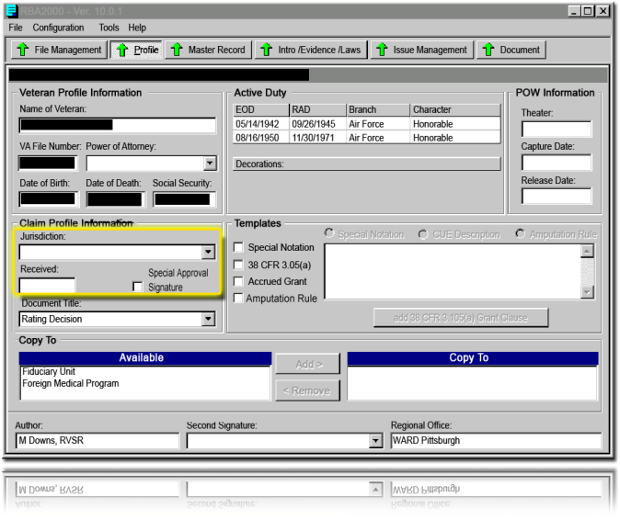  Figure 1: Decision Establishment
Step 2: Update Intro/Evidence Laws Screen  Slide 15 | Next, you will update the “Intro/Evidence Laws” screen with the pertinent evidence reviewed to support the rating decision. You do not need to generate the “Rating Introduction Text” using “Narrative Assistance.”  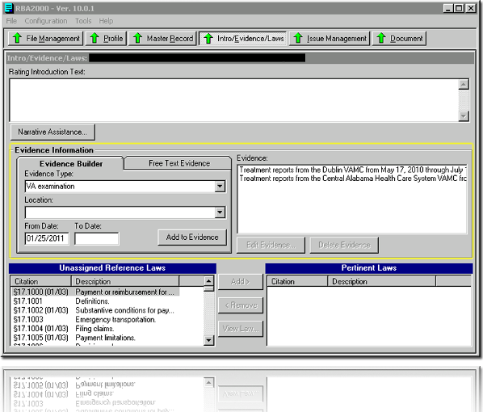  Figure 2: Update Evidence Information
Step 3: Establish the Issue on the Issue Management Tab  Slide 16 | Next, you will update the Issue Management tab for all issues claimed or inferred, as follows. First, establish the issue under “Issue Management” Tab.  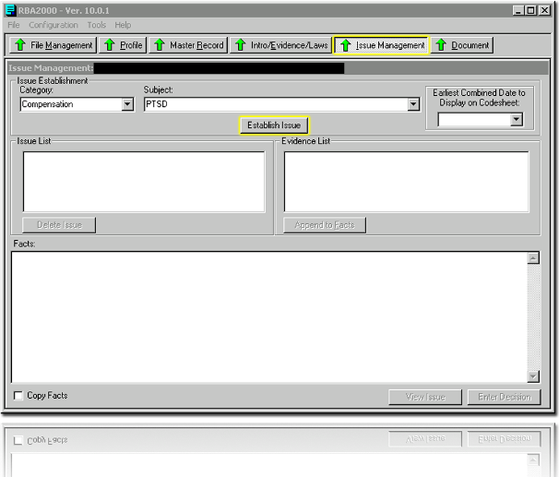  Figure 3: Establish the Issue
Step 4: Enter the Decision  Slide 17 | After establishing the issue, enter the decision by selecting the “Enter Decision” button.  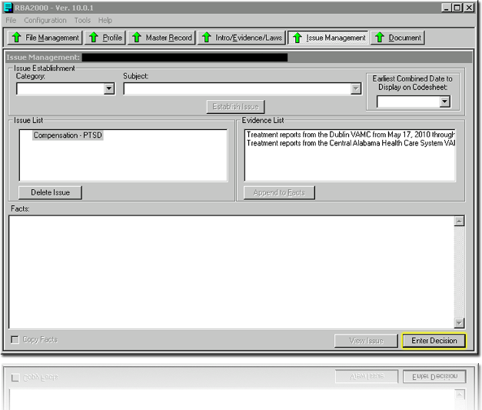  Figure 4: Enter the Decision
Step 5: Review Data and Select Accept  Slide 18 | Finally, review the data entry for accuracy and accept the decision, by selecting the “Accept” button.  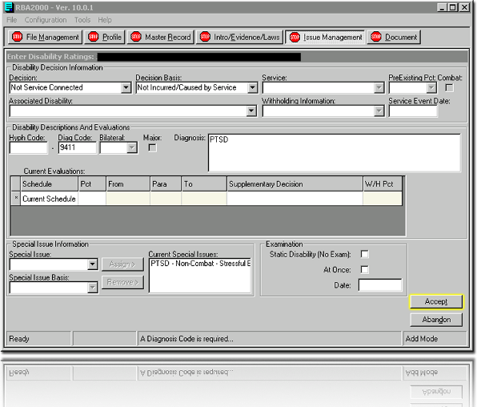  Figure 5: Accept the Decision
Step 6: Select OK on Issue Summary Screen  Slide 19 | When the Issue Management screen is generated, do not copy-and-paste the text to the bottom box.  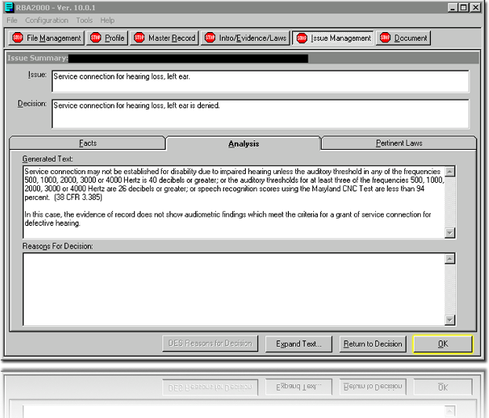  Figure 6: Issue Summary Screen  Open Evaluation Builder and generate the evaluation if service connection is granted, or if a claim for increased evaluation is either granted or denied, then copy and paste the Evaluation Builder result into this “Reasons for Decision” box. Press “OK” to continue. Do this for each disability requiring a decision involving an evaluation. For more information on Evaluation Builder, see Topic 3, Evaluation Builder.
Step 7: Generate Code Sheet and Narrative  Slide 20 | When all issues are properly established, select the  button to generate the code sheet and narrative in a Microsoft Word document.
Step 8: Cut and Paste the Decision into the Special Notation Box  Slide 21 | When the narrative is generated for a denial of service connection, cut and paste the “Decision” into the Special Notation box on the Profile Screen. The Decision will now display on the code sheet, rather than the Cover sheet.  In addition to pasting the “Decision,” for each issue you must also include the appropriate abbreviated denial reason(s), followed by the denial rationale(s). You must include the source information in parentheses after the appropriate denial reason or rationale if there is one item of evidence among several similar types of evidence that you want to mention specifically in the notice. Finally, if you are using free text, include it after the reasons and rationales. Note that free text is required if the effective date is not the date of claim or the day following discharge, or if one or more of the reasons for decision requires it (see Denial Reasons, Attachment C). If you use free text for an issue, input the free text, word for word, and in quotation marks in the numbered paragraph for each issue in the Special Notation box.
 | While the primary purpose of the Special Notation box is to record the decision, the Special Notation box may still fulfill its traditional purpose to communicate an instruction or administrative message to the VSR. You must clarify if the message is solely administrative (for example, Veteran is competent) or to be shared with the Veteran (for example, tell Veteran we will schedule a future exam for his back condition since it revealed noticeable improvement on the recent VA exam). Local management will give VSRs that promulgate decisions access to the “Q” drive, so they can copy and paste the language from the Special Notation box into the PCGL notice.
In the aforementioned scenario, the Special Notation box should be completed as follows:
1. Service connection for Post Traumatic Stress Disorder (PTSD) is granted with a 100 percent evaluation effective May 11, 2011.
Reviewer: Veteran is competent.
2. We have confirmed and continued your evaluation for your back condition. C&C EVAL
VSR: Tell the Veteran, “We have scheduled a future exam for your back condition as the most recent exam showed improvement.”
Note:
VSR: Consider denying Veteran’s pension claim because of excessive income.

Step 9: For Denials, Annotate Abbreviated Code in Special Notation Box  Slide 22 | When denying service connection, you must annotate an abbreviated denial reason and, if applicable, a denial rationale code next to the decision in the Special Notation box. A list of the abbreviated denial reasons can be found in Attachment C and a list of denial rationales can be found in Attachment D. You may only use the approved denial codes listed in the attachments.  You must select one or more of the approved denial reasons listed in this training guide, whereas you may select one or more denial rationales. While you can never select a denial rationale without an accompanying reason, it is possible to select a denial reason without a rationale. It is your responsibility to select all applicable denial reasons and rationales, to identify in parentheses any evidence for the VSR to specify in the notice, and to provide free text in quotation marks.  The standard denial reasons and supporting rationales may be sufficient to provide the reasons for the decision in many situations. With some issues, however, you may consider using free text to provide critical information. On the other hand, some denial reasons must be accompanied by free text. Those denial reasons are identified in Attachment C by the annotation of “Free Text” in the fourth column.  When a denial reason requires free text, or when the RVSR chooses to use free text, the RVSR will provide the free text, word for word, in the Special Notation box, associating the free text with the issue it addresses. An example of this is available in Attachment A. The VSR will then input the free text from the Special Notation box into the decision notification. Because each claim is unique, when free text is used, RVSRs must craft it to address the particular claim pending before them. Examples of free text included in this Handout are for illustrative purposes only. It is the RVSR’s responsibility to create free text that enhances the reasons provided by the denial reason codes and better explains his or her decision on the issue being adjudicated. Free text will be used in situations where it is:  - Supplementing denial reasons that are largely but not completely adequate.  - Addressing case-specific facts essential to the decision.  - Identifying evidence the claimant should submit to change the decision.  - Providing a response to specific arguments raised by the Veteran.
You must use free text to further explain denials due to:
- No new and material evidence (N&M, N&M:DUP, N&M:NONE, N&M:CU).
- No nexus (NONEX).
- Presumptive conditions denied because the condition did not develop a compensable degree within the specified time period after active duty (P:NC).
- Presumptive conditions denied because the Veteran did not have qualifying exposure (P:NE).
- Not a secondary condition (NSC2).
- No evidence of aggravation (NO AGG).
- Willful misconduct (WMC).
- Individual unemployability when the Veteran is not able to secure or follow substantially gainful occupation due to service-connected disability (IU).
- Private hospital summary received more than one year following discharge (P29>1).
- Temporary total evaluation for convalescence not indicated (P30).
Rationales do not require free text. RVSRs only use rationales to support denial reasons. Therefore, in determining whether to add optional free text, you must consider the denial reasons as the primary parameter.
Keep in mind that the VSR must input any free text provided by you into the Explanation section of the decision notice. Therefore, you should ensure that free text is:
- Clear
- Succinct
- In lay terms
 | You must give the VSR the exact language, in quotation marks, that will be relayed to the Veteran in the notification.
For example, VA previously denied a claim for service connection because there was no nexus to service. The appeal period has expired and the decision is now final. The Veteran submits evidence which confirms the diagnosis of the condition but fails to address the nexus. The RVSR denies the claim for failure to furnish new and material evidence. In this instance, the RVSR will insert free text into the Special Notation box. An example of free text that might be appropriate in the situation described above follows:
“The statement you submitted from your spouse addressed the symptoms you currently experience, and that information is not material to the question of whether there is a connected between your current disability and service. While the evidence from Dr. Anderson provided a diagnosis, he reported that your disability is due to an automobile accident that occurred after your discharge from the military. You must submit evidence that establishes a connection between your current disability and service.”
In the notice to the Veteran, the reasons for decision would read:
Medical Description | Denial Reason
Contention | - We did not find a link between your medical condition and military service.  - The evidence you submitted is not new and material. Therefore, your claim is not reopened. It is not material because it does not relate to an unestablished fact necessary to substantiate the claim and/or does not raise a reasonable possibility of substantiating the claim.
Explanation
The statement you submitted from your spouse addressed the symptoms you currently experience, and that information is not material to the question of whether there is a connection between your current disability and service. While the evidence from Dr. Anderson provided a diagnosis, he reported that your disability is due to an automobile accident that occurred after your discharge from the military. You must submit evidence that establishes a connection between your current disability and service.

In cases where the RVSR decides to use a standard denial rationale, and there are multiple pieces of the same type of evidence (e.g. lay evidence, medical opinions), identify the piece of evidence that your rationale references.
For example, Joe Anderson and Rick Downs submitted two pieces of lay evidence. Joe’s statement refers to his personal observations regarding the Veteran’s claimed symptoms. Rick’s statement attempts to link the Veteran’s claimed disability to military service by reporting that the symptoms didn’t exist prior to the Veteran’s military service.
The Veteran has had a VA examination for his claimed condition and the examiner reported that there was no nexus, or link, to military service and the RVSR denies the claim accordingly.
In this example, the Special Notation box shows:
Service Connection for XXXX is denied. NONEX, STRs, L:NONEX (Rick Downs), L:NODX (Joe Anderson), V:NONEX (Ann Arbor VA Medical Center).
VSR: Tell the Veteran, “The evidence shows you have symptoms, but there is no competent medical evidence of diagnosis or of a link between those symptoms and military service.”

Step 10: Finalize the Rating Decision Document  Slide 23 | After pasting the decision in the Special Notation box, re-generate the narrative and delete the headings for “Introduction,” “Decision,” “Reasons for Decision,” “References,” and any heading text pertaining to denied claims for service connection worked under SNL. Note that beneath the Evidence section, where the Reasons for Decision heading displays, you will find the Evaluation Builder results that you inserted when you were on the “Issue Summary” screen. The rating document should now only contain the “Evidence” section on the cover sheet, along with the following:  - VA seal  - Veteran identification information  - Representation, if applicable  - Rating date  You must print sufficient copies of the RBA-generated summary of evidence and evaluation information for the Veteran, the representative (if applicable), and the claims folder.  Remember, you can find an example of a SNL rating decision included in Attachment A.
Additional Rating Considerations  Slides 24, 25 & 26 | There are several additional rating considerations of which you should be aware.
Failure to Report for a VA Exam | Failure to report (FTR) for an examination does not provide a basis for denying an original compensation claim (see 38 C.F.R. § 3.655(b)). Therefore, in original compensation claims, you must also select a sufficient denial reason (e.g., lack of nexus) in addition to “FTR” in the Special Notation box on the code sheet. When you select NONEX, remember to provide free text.
Denial When the Evidence is not New and Material | When concluding that new and material evidence has not been submitted, you must utilize the applicable “N&M” reason and the previous denial reason, if it still applies, (e.g., N&M:CU, NONEX) in the Special Notation box.  You will add free text in the Special Notation box to provide information critical to the decision, such as the nature of the evidence submitted, its failure to address the reason for the previous denial, etc.
Denial When There is No Nexus | You will add free text in the Special Notation box to support a decision to deny service connection if there is no nexus, or link, to military service. This text may address the basis for the finding of no nexus or any other critical reason for the decision.
The following example shows free-text usage for a new and material and no nexus scenario.
1. Service connection for Post Traumatic Stress Disorder (PTSD) remains denied. N&M, NONEX
VSR: Tell the Veteran, “The statement you submitted from your spouse addressed the symptoms you currently experience, and that information is not material to the question of whether there is a connection between your current disability and service. The treatment records from the Cleveland VA Medical Center confirm that you have PTSD. However, the examiner reported that your PTSD is related to an automobile accident that occurred following discharge from the military, so they do not provide a connection between service and your PTSD.”
2. We have confirmed and continued your evaluation for your back condition. C&C EVAL

Grant of Individual Unemployability | If granting individual unemployability (IU) you must list all the disabilities that contributed to the establishment in the Special Notation box.  The RVSR denying entitlement to IU may also select an applicable denial rationale, as identified in the denial rationales (see Attachment D). When denying IU because the Veteran’s service-connected disabilities do not render him unemployable, free text is also required.
C&C Evaluations—Medical Improvement | While the Evaluation Builder text is included in the RBA document for most C&C evaluations, when the medical evidence shows improvement the RVSR will not copy and paste the Evaluation Builder text into the RBA-generated document because the information generated by Evaluation Builder will show a lower disability evaluation than the one currently in effect and the Veteran might misinterpret it as a proposal to reduce the evaluation. Instead, the Evaluation Builder results will be printed as an independent document, added to the claims folder, and provided to the accredited representative with their copy of the rating notification. The Veteran will not receive the criteria at this time.  If action is taken in the future to propose a reduction of the evaluation, at that time we will provide Evaluation Builder rating criteria text to support the reduction and provide notice for the next higher evaluation.
C&C Evaluations— Failure to Report | As previously mentioned, you will include Evaluation Builder rating criteria text in the RBA document in most circumstances. However, when (1) the Veteran fails to report to a VA exam without good cause for a claim for increase and, (2) there is no other ratable medical evidence, you are not required to use the Evaluation Builder.
C&C Evaluations— Denial Rationales | When you decide to C&C the evaluation of a condition, you may also select applicable denial rationales. Applicable rationales for C&C Evaluations are identified in the denial rationales in Attachment D.  For Example: Right Ankle Condition—C&C EVAL, ACK:SX, FTR
C&C Evaluations— Claims Received Within One Year of the Initial Denial | If a Veteran submits evidence within one year of a previous service connection denial and you continue the denial, you must annotate “C&C DENY,” and the previous denial reason (e.g. NODX) in the Special Notation box. Some examples are shown below.
  Example A: | The previous denial of service connection for Post Traumatic Stress Disorder (PTSD) is confirmed and continued – C&C DENY, NODX
  Example B: | Assume a Veteran’s previous PTSD denial was based on NIS, NODX, NONEX. The Veteran submits evidence within one year providing a PTSD diagnosis. Since the Veteran provided a PTSD diagnosis, NODX is omitted as a denial reason while the remaining denial reasons remain coded in the Special Notation box. The following example depicts the appropriate denial reasons:  The previous denial of service connection for Post Traumatic Stress Disorder is confirmed and continued—C&C Deny, NIS, NONEX.  You will also provide the VSR with free text addressing the NONEX denial reason.
C&C Denial After New and Material Evidence is Submitted | If the Veteran submits new and material evidence sufficient to reopen the claim but you continue the denial, the appropriate denial reason is C&C DENY and the associated denial code that explains why the denial is continued (NODX, NONEX, etc). You should annotate in the Special Notation box that N&M evidence was submitted and the claim reopened, but the condition remains denied.  For example:  Remember to include free text when the reason for the denial was no nexus. C&C Deny will never be used when the prior final decision has not been reopened by new and material evidence, so C&C Deny and N&M will never be used for the same issue.
  The previous denial of service connection for post-traumatic stress disorder is confirmed and continued. – C&C DENY; NODX
  VSR: Tell the Veteran that. “The evidence submitted was sufficient to reopen the claim, but it remains denied on the merits.”
Deferred Decisions | Deferred issues should be listed in the Special Notation box. Usually a separate document (e.g. Deferred Rating Decision, VA Form 21-6789) should be provided explaining the reason for the deferred rating and directed development.
Effective Dates | If the effective date is other than the date of claim or day after discharge, succinctly explain the date in the Special Notation box in RBA2000.  “VSR: Tell the Veteran, ’The effective date is the date of the VA examination.’”
Pension Claims | Do not process any pension claims using SNL. A hybrid rating may be used for dual claims. More information regarding hybrid ratings can be found later in this guide.
Extra-schedular Entitlement | When a Veteran claims an increased evaluation, but is already at the maximum evaluation for that condition, you may still be required to consider extra-schedular entitlement. For example, when a Veteran claims an increase on an extra-schedular basis and the evidence does not show that the Veteran meets the criteria for a higher evaluation under the applicable diagnostic code, or when the evidence suggests extra-schedular consideration is warranted, the matter must first be referred to the Under Secretary for Benefits (USB) or Director of Compensation pursuant to M21-1MRIII.iv.6.B.5.a and 38 C.F.R. §3.321.  If the direction received from the USB or Director is that a grant of an increase on an extraschedular basis is not warranted, the appropriate denial code is C&C EVAL. You should also annotate the Special Notation box in the following manner:  For Example: VSR: Tell the Veteran, “We considered a higher evaluation on an extra-schedular basis.”
Special Inferences | You must continue to consider entitlement to treatment under 38 U.S.C. §1702, when applicable. For example:  Service connection for PTSD is denied. NODX, STRs, FTR, 1702. The Veteran is not entitled to treatment under 38 U.S.C. §1702.  You are still required to infer issues such as competency with mental health evaluations of 100 percent. You should appropriately update the code sheet and annotate the Special Notation box.
  Evaluation of depression, which is currently 30 percent disabling, is increased to 100 percent effective XXXX.
  Reviewer: The Veteran is considered competent.
Denial Abbreviations and PCGL  Slide 27 | To ensure consistency amongst rating decision notices, SNL generated a list of common denial reasons and rationales with corresponding abbreviations. These abbreviations will help streamline the creation of the rating notification document and improve readability.  Attachments C and D contains the list of the denial reasons and denial rationales. Note that some denial reasons require free text.
Process Review Checklist  Slide 28 | The Process Review Checklist appears in Attachment E. The checklist will help ensure you perform the necessary steps and produce the necessary output to support the SNL. The checklist should be used to ensure RVSRs are adhering to the SNL process. All RVSRs and quality assurance personnel may use the checklist in addition to any other quality checklist.
Questions and Check Comprehension
Slide 29

Topic 3: Evaluation Builder
Introduction  Slide 30 | This topic will allow the trainee to use Evaluation Builder to determine the service-connected evaluation.
Time Required | 3.0 hours
Topic OBJECTIVE | Using the RVSR SNL Trainee Handout Packet, RBA2000, Evaluation Builder, Evaluation Builder User Guide, 38 CFR Part 4, and Veterans’ claims folders, determine the service-connected evaluation for 4 out of 5 rating decisions with a minimum of 80% accuracy.
Teaching Points | The following topic teaching points support the topic objectives:  - Introduction to the Evaluation Builder  - Evaluation Builder Location  - Using the Evaluation Builder
Introduction to the Evaluation Builder  Slide 31 | The Evaluation Builder is a standalone program to help the user assign correct evaluations and generate the text needed to explain the disability evaluation and provide the next higher criteria. The goal of the Evaluation Builder is to provide a rules-based structure for arriving at a disability evaluation for a service-connected disability, which will allow for more consistent decisions and narratives. By implementing and using a rules-based system, Veterans in Wisconsin will receive the same decision through the same process as Veterans in California. This will improve quality and consistency throughout the country.  RVSRs must use the Evaluation Builder for all grants, increases, and confirmed-&-continued (C&C) evaluations. Evaluation Builder generates text into a Word document that must then be copied and provided to the Veteran in the decision notice. The text that is generated includes the:  - Evaluation criteria  - Next higher evaluation  - Recommended diagnostic code  - Deluca criteria, when necessary  Only objective evidence should be input into the Evaluation Builder, except in the cases where some subjective evidence may be used (e.g., migraines).  The Evaluation Builder is not designed as a replacement for the rating schedule. You will continue to use the rating schedule to help ensure that the Veteran receives the most fair and accurate decision possible.
What Evaluation Builder is Not | Now that we know what the Evaluation Builder does, it is important to note what the Evaluation Builder does not do.  - The Evaluation Builder does NOT determine staged ratings. It is the rater’s responsibility to review the evidence of record to consider if a staged rating is necessary. The Evaluation Builder can still be used in a staged rating; however, the evaluation criteria will need to be input separately to generate the multiple evaluations.  - The Evaluation Builder does not consider effective dates. It is up to the rater to consider the evidence and apply the law appropriately to decide effective dates.  It is also important to note that Evaluation Builder is NOT the same as the RBA 2000 evaluation builder. The RBA2000 evaluation builder is consultative in nature. You refer to it to determine the next higher level of disability and generate text. The new Evaluation Builder is designed to actually “build” an evaluation, based upon the entries of evaluation criteria (e.g., range of motion findings, metabolic equivalents [METs], pulmonary function test [PFT] results, etc.). After entering the rating criteria, the system will provide an accurate rationale for the evaluation as well as the next higher level of disability.
Difference between Evaluation Builder and DENTT | The Evaluation Builder is a tool that is integrated into the Disability Evaluation Narrative Text Tool (DENTT) calculator. The DENTT has three components: Service Connection, Evidence Builder, and Evaluation Builder. We are currently developing a DENTT calculator for every body system which will incorporate the Evaluation Builder.
Evaluation Builder Providing Higher Evaluations | One of the most common questions about the Evaluation Builder is why the tool will sometimes provide higher evaluations when not all symptoms at that level are selected. Keep in mind the Evaluation Builder is considering 38 CFR §4.7 in all cases along with various court decisions. 38 CFR §4.7 is applied throughout the rating schedule, but is more apparent in certain diagnostic codes and body systems. In short, according to §4.7, various court decisions, and a liberal interpretation of the law, not all of the symptoms need be manifest to reach certain evaluations.  In developing the Evaluation Builder, the team has worked with STAR and Policy staff to remove as much ambiguity and subjectivity as possible from the decision process. The Compensation Service has approved all of the coding and Evaluation narratives.
Evaluation Builder Video  Slide 32 | A short video was created by the team responsible for the Evaluation Builder. This video will help further explain the changes that the Evaluation Builder has on the output for the claimant.  The Evaluation Builder tool is located at: http://vbaw.vba.va.gov/bl/21/rating/rat00.htm.
Evaluation Builder Launch Screen  Slide 33 | To Launch the Evaluation Builder, go to the Rating Job Aids screen, and select Evaluation Builder, then select Run Evaluation Builder.  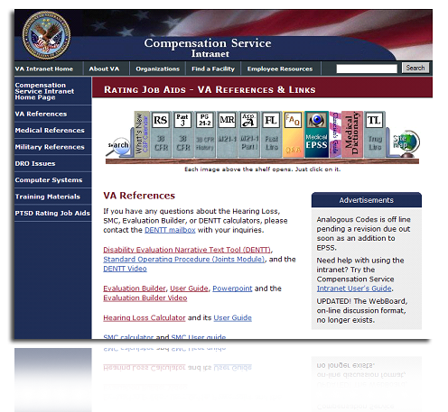  Figure 7: Launching Evaluation Builder
Evaluation Builder Opening Screen  Slide 34 | The opening screen will appear.  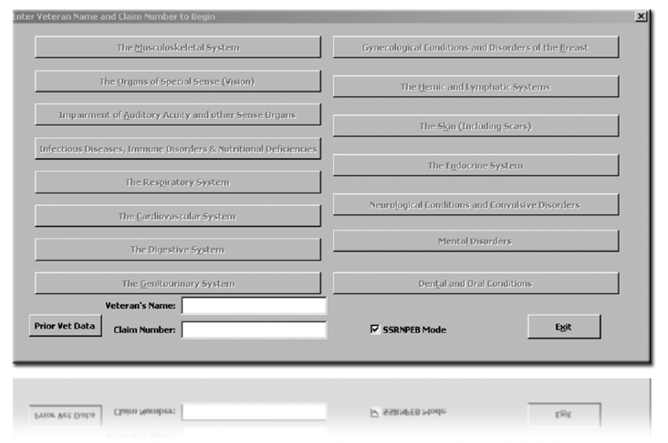  Figure 8: Opening Screen  Enter in the Veteran’s name and claim number and select the “Tab” key on your keyboard to toggle through the different fields. You can select the “Tab” key to travel through all the fields in the Evaluation Builder.
Evaluation Builder Selection Screen  Slide 35 | The Veteran's information and all the body systems will now be active. Select the appropriate body system.  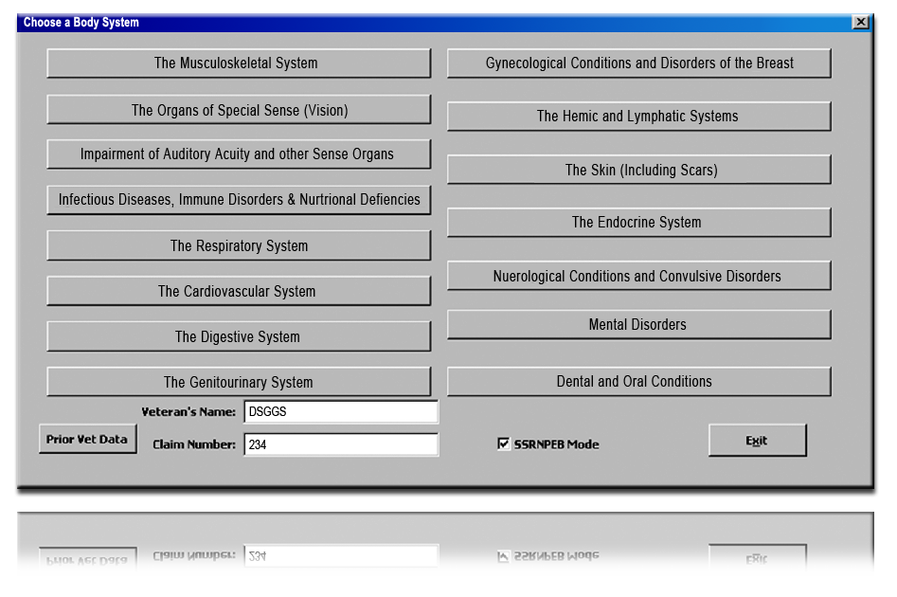  Figure 9: Opening with Veteran's Information
Evaluation Builder  Slide 36 | When using the Evaluation Builder, you must copy and paste the evaluation result into the RBA decision document, on the Issue Management screen in the box labeled “Reasons for Decision.”  An exception to that practice occurs when the medical evidence shows improvement: the RVSR will not copy and paste the Evaluation Builder text into the RBA-generated document because the information generated by Evaluation Builder will show a lower disability evaluation than the one currently in effect, and the Veteran might misinterpret it as a proposal to reduce the evaluation. Instead, the Evaluation Builder results will be printed as an independent document, added to the claims folder, and provided to the accredited representative with their copy of the rating notification. The Veteran will not receive the criteria at this time.  To print multiple evaluations onto one Microsoft Word document, select the “Add Another Disability” box while in Evaluation Builder.
Evaluation Builder (Cont’d.)  Slide 37 | This process saves you from creating separate Evaluation Builder documents for every disability. Also, printing the Evaluation Builder as a continuous Word Document can preserve the Veteran’s name, the claim number, and the information if you need to retain a hard copy of the Evaluation Builder print for the file (as when medical improvement is shown, but is not shown to be sustained).
Evaluation Builder Closing and Restarting  Slide 38 | Close Evaluation Builder by either selecting the “X” in the top right corner or the “Exit” button at the bottom of certain screens.  After exiting the Evaluation Builder, a Microsoft Word document will remain open on the screen. Select “Run Evaluation Builder” to re-launch the Evaluation Builder.    Figure 10: Restarting Evaluation Builder
Evaluation Builder Navigating the Body Systems  Slides 39 & 40 | The following instructions will guide you through the various body systems that you will use to properly evaluate disabilities.
Musculoskeletal System  Slide 41 | If selecting “Musculoskeletal,” the musculoskeletal body system screen will appear.  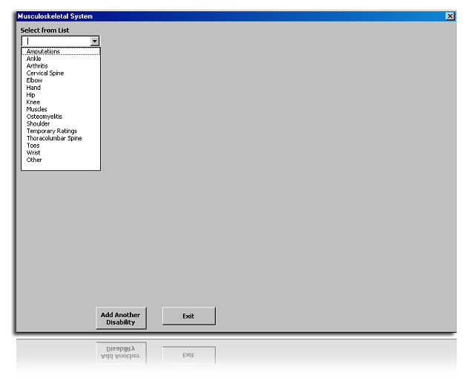  Figure 11: Musculoskeletal Body System  Select a joint or condition from the drop-down list.  On the next screen there are input areas for the evaluation criteria concerning the joint that was selected.
Musculoskeletal System (Cont’d.)  Slide 42 | 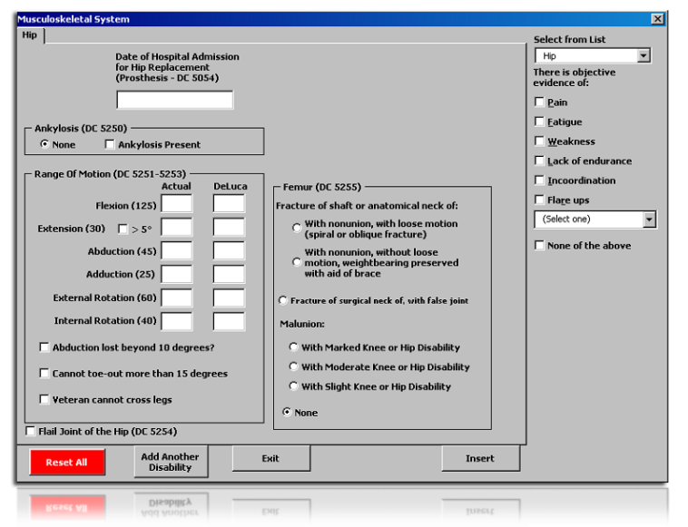  Figure 12: Hip Page  Select all criteria that represent the symptoms relevant to the case and input range of motion findings. If range of motion is not input, then the Evaluation Builder will assume that it is normal. In the range of motion boxes, input the degrees as a single number.  For Example, a hip flexion of 0-60, you would input 60.  The column labeled “Actual” is where you report the initial range of motion findings.  Input range of motion findings following repetitive motion in the column labeled “Deluca.” When there is a change in range of motion due to repetition, the additional limiting factors should be checked off in the boxes on the right side of the screen. The “Select from List” checkbox for pain is also for objective evidence of painful motion with or without further limitation due to repetitive motion.  Copy and paste the generated narrative into the RBA document.
Joint Replacements  Slide 43 | To input a joint replacement, enter the date of the replacement. Input the specific date (month, day, and year) using numbers only.  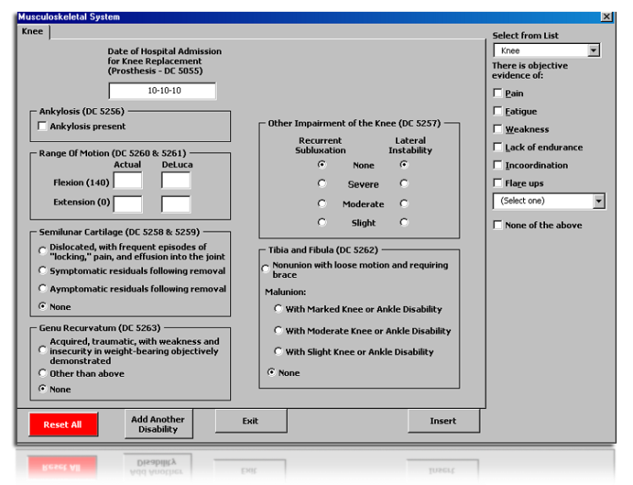  Figure 13: Knee Page
Joint Replacements (Cont’d.)  Slide 44 | If there has been a joint replacement, input the date of hospital admission.  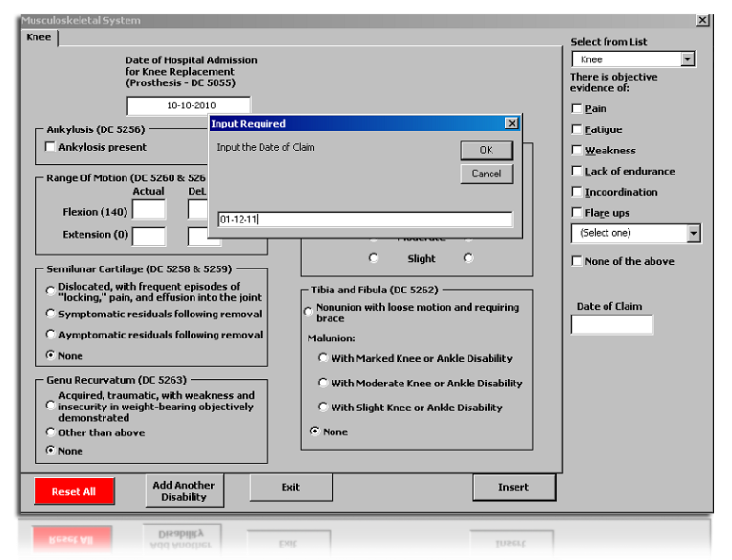  Figure 14: Date of Claim (Operative Report)
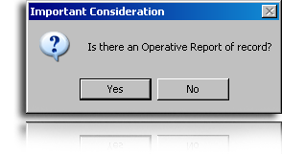
Figure 15: Operative Report Consideration
Note: An operative report or the equivalent is required to grant the temporary 100 percent for a joint replacement. If an operative report is not available, the minimum or actual evaluation may still be granted.
Joint Replacements (Cont’d.)  Slide 45 | Continue entering all other objective findings for the joint and select “Insert” to generate the evaluation narrative.  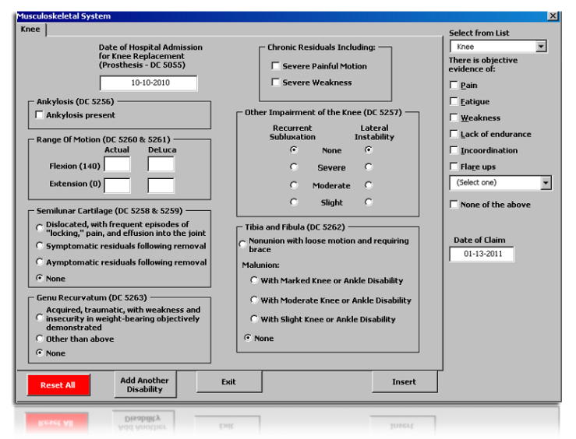  Figure 16: Knee Page  Copy and paste the generated narrative into the RBA document.
It is important to note that some Regional Offices have rated a major joint (such as an ankle), that has pain-free but limited range of motion, as 10 percent disabling. This evaluation was the result of rating a strain as analogous to 5020 or 5024 to allow a minimum compensable evaluation for “limited motion” under 5003.
This practice explains why we created the Evaluation Builder. The diagnosis does matter to the evaluation. Only conditions that CAN be rated analogous to DCs 5020-5024 should be. These conditions ARE NOT similar to strains or sprains. DCs 5020-5024 have chronic inflammation of the tissue around the joint. To evaluate a healed strain with no painful motion and slight limitation of motion analogous to synovitis is incorrect. If the evidence shows a non-compensable loss of motion with no objective evidence of a limiting factor (pain, etc.) with no diagnosis of arthritis, tendonitis, tenosynovitis, or any other compensable diagnosis, you should rate the loss of motion under 5271. A grant of “functional loss” of motion needs to be based upon an observable reason such as pain.
Muscles  Slide 46 | When “Muscles” is selected from the dropdown, you will see this:  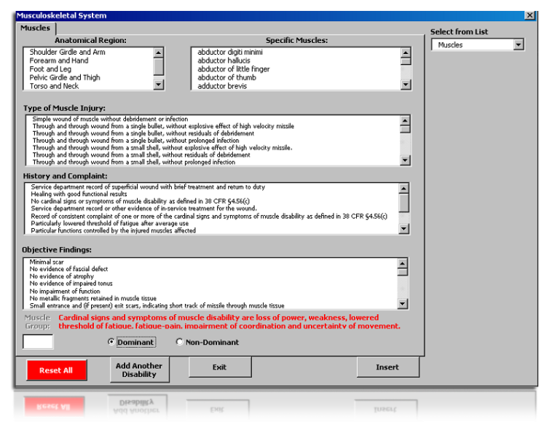  Figure 17: Muscles Page
Muscles (Cont’d.)  Slide 47 | Select either the anatomical region or specific muscles. After selecting the anatomical region this pop-up will appear:  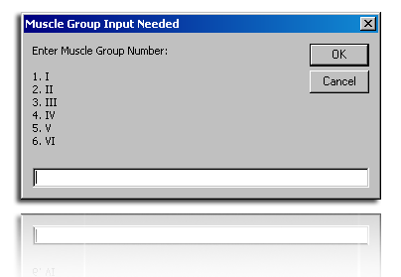  Figure 18: Muscle entry  Select the muscle group by entering in the digit in front of the muscle group. For example, to select muscle group III, input “3” into the text bar and select OK.  After selecting the muscle group or specific muscle, select and highlight all applicable symptoms pertaining to the case. Select “Insert” to generate the text. Copy and paste the generated narrative into the RBA document.
Organs of Special Sense—Vision  Slide 48 | After selecting “Vision,” the Eyes Body System Screen will appear.  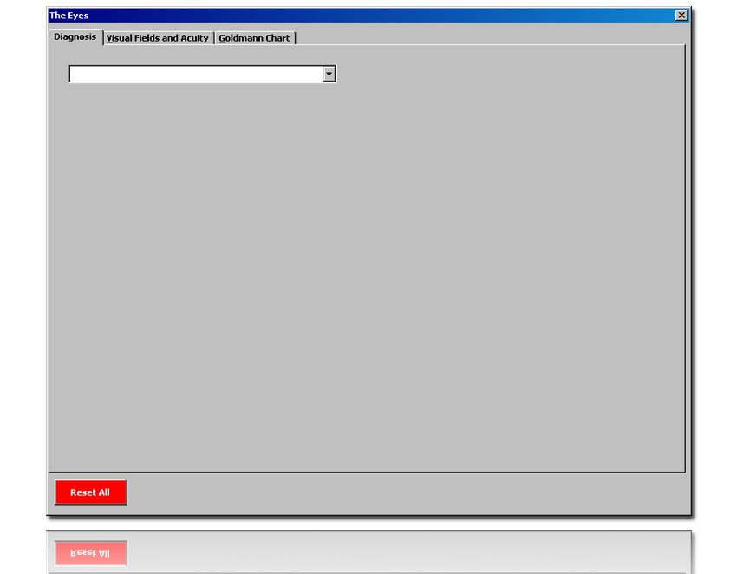  Figure 19: Eyes Body System
Organs of Special Sense—Vision (Cont’d.)  Slide 49 | Choose the specific diagnosis from the dropdown list and select any applicable criteria listed. Then, select the “Add Condition” button. If there are multiple diagnoses, continue selecting from the dropdown window, selecting symptoms, and then adding the conditions.  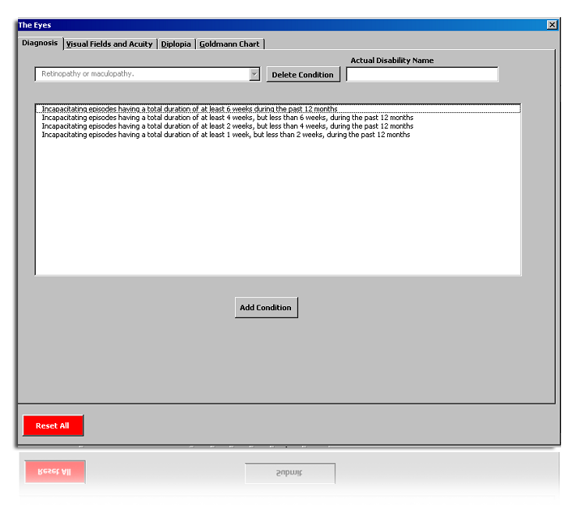  Figure 20: Eyes Page
Organs of Special Sense—Vision (Cont’d.)  Slide 50 | Next, select the tab labeled “Visual Fields and Acuity” at the top of the window. Here, you will input the Goldman chart and visual acuity findings.  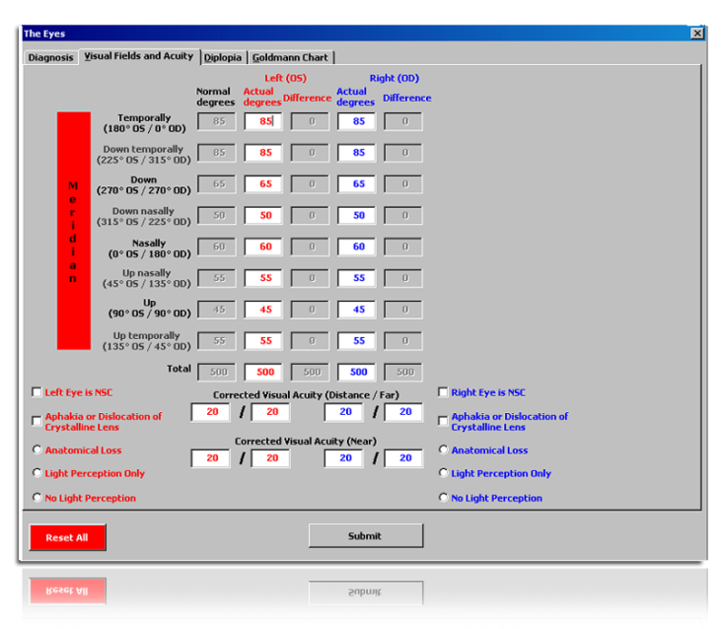  Figure 21: Eyes Input  After inputting all information, select the “Submit” button to generate a narrative, which you will copy and paste into the RBA document.
Other Body Systems  Slides 51 & 52 | For the following body systems, use the directions below:  - Auditory Acuity and Other Sense Organs  - Infectious Diseases  - Immune Disorders & Nutritional Deficiencies  - Respiratory System  - Digestive System  - Genitourinary System  - Gynecological Conditions and Disorders of the Breast  - Hemic and Lymphatic Systems  - Endocrine System  - Mental Disorders  - Cardiovascular System
Other Body Systems (Cont’d.)  Slide 53 | Generally speaking, all of these disabilities are input in the same manner as before. First, select the appropriate body system. Then select the correct diagnosis or claimed condition from the dropdown box.  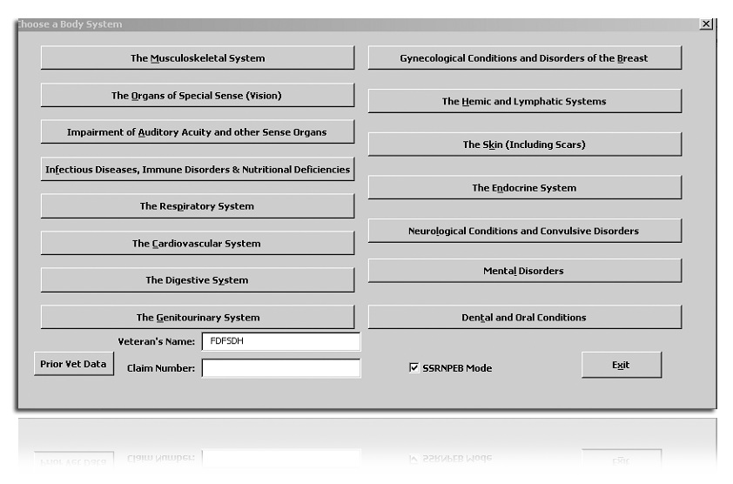  Figure 22: Body Systems
Other Body Systems (Cont’d.)  Slide 54 | Then select a list of symptoms that the Veteran is objectively experiencing. If there are multiple disabilities within the same body system, continue to select diagnoses, inputting symptoms and selecting the “Add Another Disability” button. After inputting all conditions within the body system, select the “Insert” button to generate the evaluation.  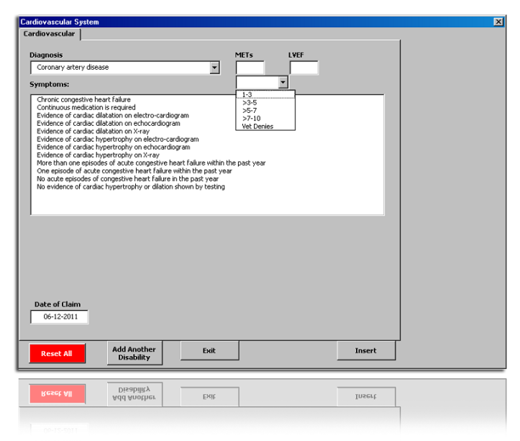  Figure 23: Coronary Artery Disease  Cut and paste the narratives into the RBA document.
Cardiology Portion of Evaluation Builder  Slide 55 | The cardiology portion of the Evaluation Builder was designed to consider Nehmer claims and effective dates, relative to surgical procedures, for staged ratings. That being stated, if the surgical procedure (e.g., coronary artery bypass graft, or CABG) was performed prior to the date of claim being used, DO NOT enter the date of procedure and use the Evaluation Builder only for assistance in determining the correct evaluation.
Dental – Missing Teeth  Slide 56 | In addition to the diagnosis dropdown box and symptom selection screen explained in the preceding section, the Dental and Oral Conditions also includes the following screen under “Missing Teeth.”  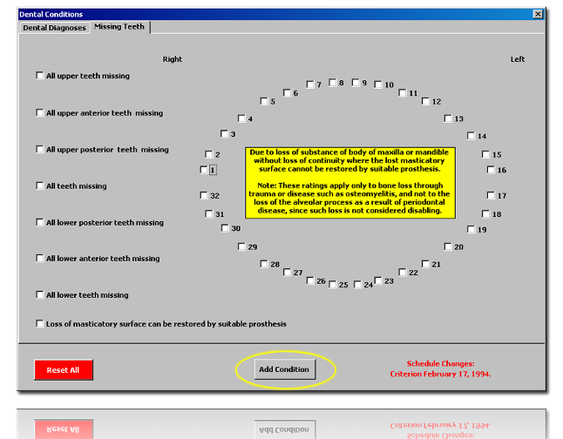  Figure 24: Missing Teeth  Here you would select the teeth that are missing, then select “Add Condition,” then “Insert into Document” to generate the evaluation.
Skin  Slide 57 | After selecting “Skin” and a diagnosis the “Skin Conditions” screen will appear.  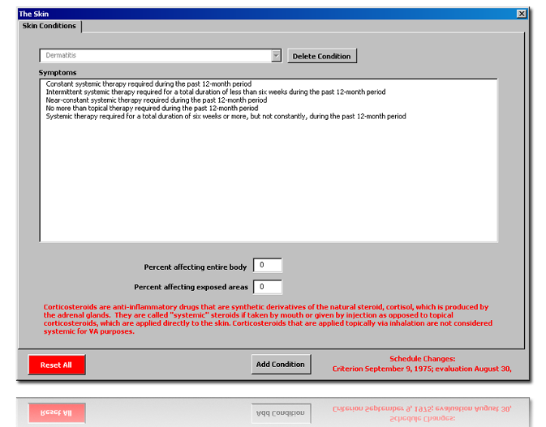  Figure 25: Skin Conditions  Choose the type of treatment used, then enter the percentage of the entire body and exposed body affected from the condition. After selecting “Add Condition,” add another diagnosis, as needed. If there is another diagnosis to enter, do so. If not, select “Submit.”
Skin—Scars  Slide 58 | For Scars (Head, Face or Neck), you will see this screen:  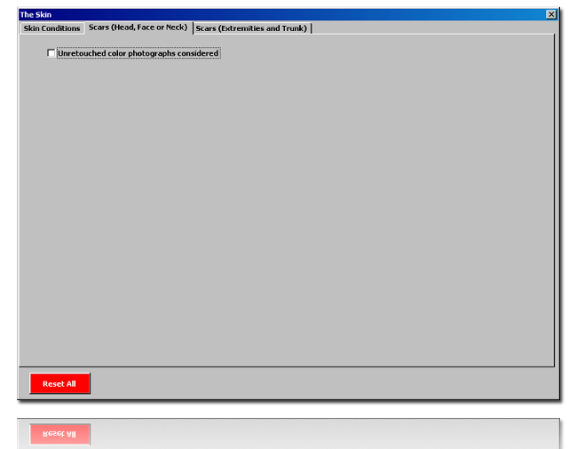  Figure 26: Scars Page
Skin—Scars (Cont’d.)  Slide 59 | In order to evaluate scars of the head, face or neck, unretouched color photographs must be included in the claims folder. Select the check box if they are present and this Scars screen will appear.  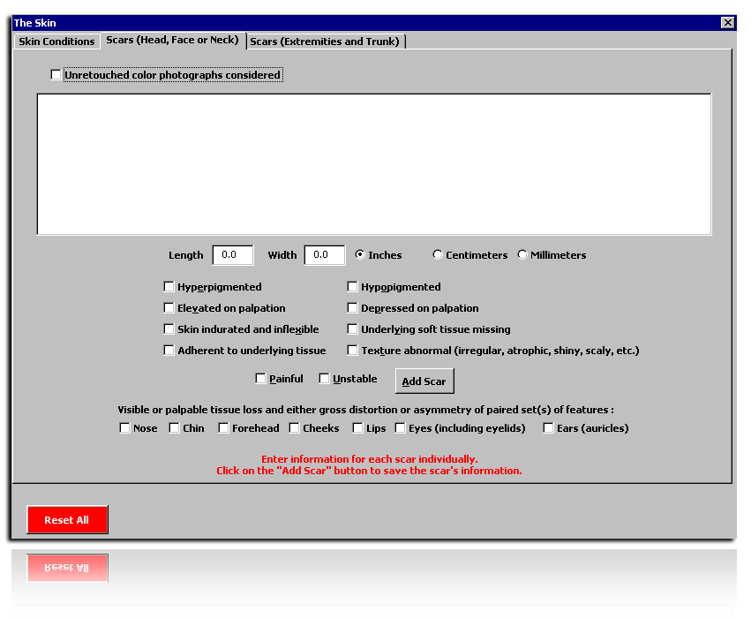  Figure 27: Add Scar Input  Make selections and input measurements, as applicable, for the scar and select the “Add Scar” button.
Skin—Scars (Cont’d.)  Slide 60 | Now you can edit the entries or delete if necessary by selecting the incorrect entry and selecting either “Edit Selected” or “Delete Scar.”  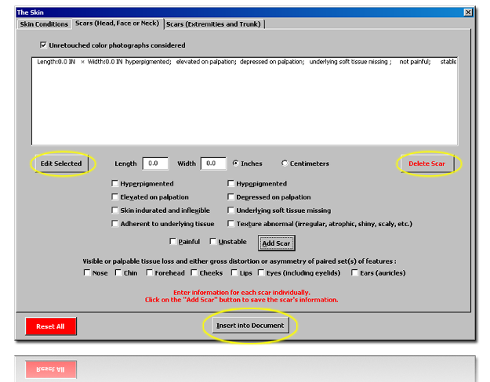  Figure 28: Scars (Input)  If there are multiple scars of the head, face and/or neck, continue inputting each scar separately and selecting “Add Scar” to add entry into the Evaluation Builder. When all scars are input, select the “Insert into Document” to generate the narrative.
Cranial and Peripheral Nerves  Slide 61 | For the Cranial and Peripheral Nerves section, there is a single tab labeled “Cranial/Peripheral Nerves.” This tab contains all the diagnoses of the nerves found in the rating schedule.  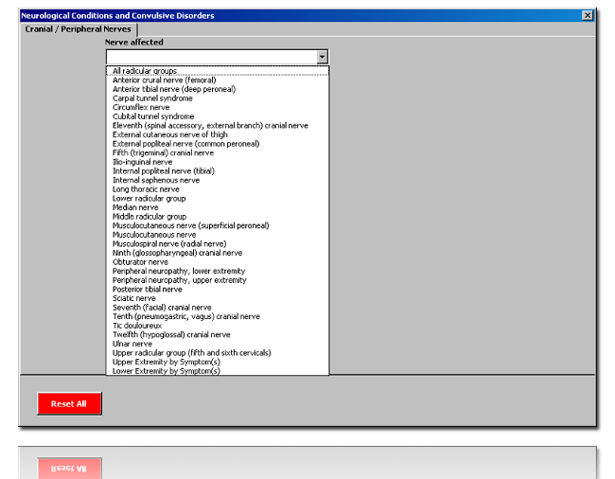  Figure 29: Cranial Nerve Body System
Cranial Peripheral Nerves (Cont’d.)  Slide 62 | When rating a peripheral neuropathy of the upper or lower extremities, follow the self-explanatory prompts to arrive at the evaluation.  At the prompt, answer some very simple questions about the type of deficit. For example, when selecting “Moderately Severe,” the Evaluation Builder will ask whether the impairment is “wholly sensory.” If a neuropathy is “wholly sensory,” then the evaluation should be mild.  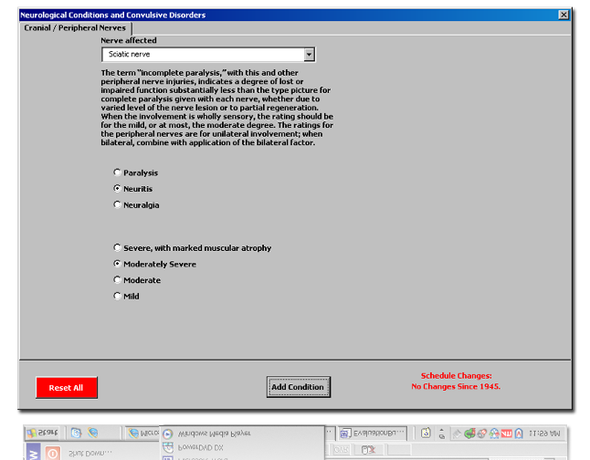  Figure 30: Nerve Criteria  After selecting “Add Condition,” add another diagnosis, as needed. If no other diagnosis is needed, select “Submit.”
Traumatic Brain Injury  Slide 63 | Select “Traumatic Brain Injury” and the TBI symptoms screen will appear.  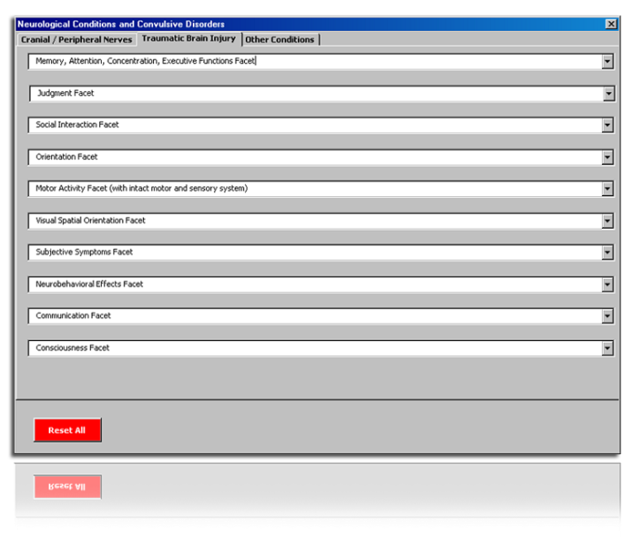  Figure 31: TBI Symptoms  This screen largely mimics the existing TBI Calculator on the Rating Job Aids page. Based on the results of the examination, select the facets that are applicable to the case and justify the evaluation. After selecting all the facts, select the “Submit” button, and copy and paste the narratives into the RBA document.
Questions and Check Comprehension
Slide 64

Topic 4: Procedural Exceptions
Introduction  Slide 65 | This topic will allow the trainee to determine when to use the traditional rating process instead of the SNL process.
Time Required | 0.5 hours
Topic OBJECTIVE | Given the RVSR SNL Trainee Handout, determine when to use the traditional rating process instead of the SNL process, for 4 out of 5 questions with 100% accuracy.
Teaching Points | The following topic teaching points support the topic objectives:  - Procedural Exceptions  - Hybrid Rating Decisions
Procedural Exceptions  Slides 66, 67 & 68 | The simplified and standardized text used in SNL will not adequately explain every decision. There are instances when these simplified and standardized reasons will not adequately explain the decision and a traditional rating decision is the best medium to address it. Examples of procedural exceptions include, but are not necessarily limited to:  - Nehmer claims  - Denials associated with Military Sexual Trauma  - Denials of PTSD under the “Fear-Based” standard (TL 10-05)  - Appeals  - Live pension  - Discontinuances  - Proposals (including IDES)  - Reductions  - Severances  - Survivor Claims  - Assertions of clear and unmistakable error  - 38 USC 1151 claims  - Special monthly compensation (SMC) (except loss or loss of use of a creative organ or Aid & Attendance/Housebound)  - Claims for an earlier effective date  - Incompetency proposals  - Incompetency findings  - Issues involving potential fraud  - Traumatic brain injury  - Ancillary benefits (except for DEA grants)  - Claims for dental treatment only
 | When you encounter an issue(s) that is not an exclusion and believe the issue would be best resolved through use of the traditional rating process, you should consult with either a Coach or Decision Review Officer, as determined by local station policy, for guidance.
Hybrid Rating Decisions  Slide 69 | A hybrid rating decision occurs when some issues are processed utilizing SNL, while other issues require a traditional rating format. In a hybrid rating decision, you will use the traditional rating format for the exclusion, while the remaining issues are processed in the SNL format. All adjudicated issues are addressed in the Special Notation box. An example of a hybrid rating decision can be found in Attachment F.  If the only excluded issue involves due process, the Veteran will receive the traditional rating decision with the applicable due process notification letter.  If the excluded issue does not involve due process, the Veteran will receive the SNL PCGL notice and the traditional rating decision as an attachment. The VSR will edit the PCGL notice to include the rating decision.
Questions and Check Comprehension
Slide 70
Regional Office Specific Topics | At this time your Instructor will add any information pertaining to:  - Station quality issues with this lesson  - Additional State-specific programs or guidance on this lesson

Practical Exercise
Time Required | 9.0 hours
Practical Exercise Instructions  Slide 71 | - The Practical Exercise will allow the trainees to demonstrate their understanding of the information presented in this lesson.  - Practical Exercise trainee directions:  - The RVSR SNL Lesson Practical Exercise consists of two parts. Part 1 of the Practical Exercise contains 10 multiple-choice questions that assess your knowledge of changes resulting from SNL.  - For each multiple-choice question in Part 1, circle the letter that you think is the best answer. For Part 2, your Instructor will provide you with five (5) rating decisions.  - For each rating decision, you must complete a decision notification using PCGL. Your decision notifications will be evaluated according to the process checklist in Attachment E of the RVSR Trainee Handout.  - During the exercise, you may refer to your Trainee Handout, User Guides, and any other notes and references you may have received during your training.  - As a reminder, here are the criteria for the live claim folders to work during the Practical Exercise—minimum of 5 claim folders per trainee, at least 150 total—selected using the following criteria:  - Number of issues per case: 1-3  - Types of issues: Any issues except:  - Nehmer claims  - Denials associated with Military Sexual Trauma  - Appeals  - Live pension  - Discontinuances  - Proposals (including IDES)  - Reductions  - Severances  - Survivor Claims  - Assertions of clear and unmistakable error  - 38 USC 1151 claims  - Special monthly compensation (SMC) (except loss or loss of use of a creative organ or Aid & Attendance/Housebound)  - Claims for an earlier effective date  - Incompetency proposals  - Incompetency findings  - Issues involving potential fraud  - Traumatic brain injury  - Ancillary benefits

Lesson Review, Assessment, and Wrap-up
Introduction | The RVSR SNL lesson is complete.  Your Instructor will review each lesson objective and give you the opportunity to raise any questions or comments.
Time Required | 0.5 hours
Lesson Objective | You have completed the RVSR SNL lesson. By now you should be able to complete a rating decision using the redesigned rating process.
Summary  Slide 72 | - Terminal Learning Objective  - Complete a rating decision using the redesigned rating process.  - Enabling Learning Objective(s)  - Explain the changes to the traditional rating process.  - Document the reason a claim was denied.  - Determine the service-connected evaluation.  - Determine when to use the traditional rating process.
Questions  Slide 73 | Any final questions about the entire course?
Final Evaluation  Slide 74 | Before you go we have one last task for you to complete – the final evaluation. The evaluation form is one way we measure our success. We also ask you for input to solicit a range of opinions on how we can improve the lesson for future training efforts.

Attachment A: Sample Rating Decision Document


DEPARTMENT OF VETERANS AFFAIRS
VARO Anystate
123 Main Street
Small Town, USA 12345

JOE VETERAN

VA File Number
XXX XX XXXX

Represented by:
DISABLED AMERICAN VETERANS

Rating Decision
MM/DD/YYYY
EVIDENCE
- VA Form 21-526b, Veteran's Supplemental Claim received May 11, 2011
- DD Form 214 from August 18, 1965 through July 31, 1975
- Service treatment records from June 18, 1965 through July 31, 1975
- VCAA/Duty to Assist Letter dated May 18, 2011
- VA Form 21-4138, Statement in Support of Claim, from Mary Veteran, received May 11, 2011
- VA Form 21-4138, Statement in Support of Claim, from Mark Veteran, received May 11, 2011
- Private medical records, Dr. John Smith, from September 1, 2004 through January 31, 2010
- Private medical records, Jones Spine and Neurology, dated August 8, 2009
- Private medical records, University of Pittsburgh Medical Center, dated April 18, 2009
- Treatment reports, Pittsburgh VA Medical Center, from February 6, 1999 through April 4, 2011
- Diabetes Mellitus VA examination, Pittsburgh VA Medical Center, dated July 1, 2011
- Skin Diseases VA examination, Pittsburgh VA Medical Center, dated July 1, 2011
- Failure to report to an Orthopedic VA Exam at the Pittsburgh VA Medical Center on July 8, 2011
1. Service connection for Diabetes Mellitus Type II associated with herbicide exposure.

We have assigned a 20 percent evaluation for your diabetes mellitus based on:

• Requirement for oral hypoglycemic agent
• Restricted diet required

A higher evaluation of 40 percent is not warranted unless there is diabetes requiring insulin, restricted diet, and regulation of activities.

2. Evaluation of Right Ankle Tendonitis, currently 0 percent disabling.

We have assigned a noncompensable evaluation for your ankle condition based on:

• Slight limitation of motion of the ankle

Note: In every instance where the schedule does not provide a zero percent evaluation for a diagnostic code, a zero percent evaluation shall be assigned when the requirements for a compensable evaluation are not met. {38 CFR §4.31}

The provisions of 38 CFR §§4.40 and 4.45 concerning functional loss due to pain, fatigue, weakness, or lack of endurance, incoordination, and flare-ups, as cited in DeLuca v. Brown, 8 Vet. App. 202 (1995), have been considered and are not warranted.

A higher evaluation of 10 percent is not warranted unless there is:

• Moderate limitation of motion of the ankle; or,
• Ankylosis of the subastragalar or tarsal joint in good weight-bearing position; or,
• Malunion of os calcis or astragalus with moderate deformity; or,
• Painful motion of the ankle; or,

Additionally, a higher evaluation of 20 percent is not warranted unless there is:

• Astragalectomy; or,
• Ankylosis of the ankle in plantar flexion less than 30 degrees

ACTIVE DUTY
EOD | RAD | BRANCH | CHARACTER OF DISCHARGE
06/18/1965 | 07/31/1975 | Army | Honorable

LEGACY CODES
ADD’L SVC  CODE | COMBAT  CODE | SPECIAL  PROV CDE | FUTURE EXAM  DATE
 | 1 |  | None

JURISDICTION: Reopened Claim Received 05/11/2011

ASSOCIATED CLAIM(s): 020; Reopened Claim; 05/11/2011

SUBJECT TO COMPENSATION (1. SC)

5271 | RIGHT ANKLE TENDONITIS  Service Connected, Vietnam Era  Static Disability  0% from 03/28/2006
7913 | DIABETES MELLITUS TYPE II [Agent Orange-Vietnam Diabetes]  Service Connected, Vietnam Era, Presumptive  Static Disability  20% from 05/11/2011

COMBINED EVALUATION FOR COMPENSATION:

0% from 03/28/2006
20% from 05/11/2011

NOT SERVICE CONNECTED/NOT SUBJECT TO COMPENSATION (8.NSC Gulf War)

5237 | DEGENERATIVE DISC DISEASE OF THE CERVICAL SPINE (CLAIMED AS CERVICAL SPINE CONDITION)  Not Service Connected, Not Incurred/Caused by Service
6847 | SLEEP APNEA  Not Service Connected, Not Incurred/Caused by Service

7800-7806 | SEBORRHEIC DERMATITIS (CLAIMED AS DERMATOPHYTOSIS)  Not Service Connected, Not Incurred/Caused by Service

1. Service connection for Diabetes Mellitus Type II associated with herbicide exposure is granted with a 20 percent evaluation effective May 11, 2011.

2. Evaluation of Right Ankle Tendonitis, which is currently 0 percent disabling, is continued. C&C Eval, ACK:SX, (Pittsburgh VA Medical Center), FTR (Orthopedic Exam)

3. Service connection for Seborrheic Dermatitis (claimed as dermatophytosis) is denied. NIS, NONEX, V:NONEX, (Pittsburgh VAMC), PV:V>P (Dr. Smith)

VSR: Tell the Veteran “While you report current symptoms of a skin disorder, you have not submitted or identified any other medical evidence specifically addressing a connection between your skin disorder and military service.”

4. Service connection for Degenerative Disc Disease of the Cervical Spine (claimed as cervical spine condition) is denied. NIS, STRs, NOCRED (Mark Veteran)

5. Service connection for Sleep Apnea is denied. NIS, NONEX, NO CONT, L:NONEX, (Mary Veteran), ACK: NODX (Dr. Smith)

VSR: Tell the Veteran “You have not submitted any other sources of competent medical evidence regarding a connection or link between your symptoms of sleep apnea and military service.”

RVSR

Attachment B: Sample Decision Notice

In Reply Refer To:
xxx/21
CSS XXX XX XXXX

JOE VETERAN
604 KNIGHT STREET
ANYTOWN, USA 12345

Dear Mr. Veteran:

We made a decision on your claim for service connected compensation received on May 11, 2011. This letter constitutes our decision based on all issues we understood to be specifically made, implied, or inferred in that claim.

This letter tells you about your entitlement amount and payment start date and what we decided. It includes the evidence used and reasons for our decision. We have also included information about additional benefits, what to do if you disagree with our decision, and who to contact if you have questions or need assistance.

Your Award Amount and Payment Start Date
Your monthly entitlement amount is shown below:

Monthly Entitlement Amount | Payment Start Date | Reason For Change
$243.00 | Jun 1, 2011 | Compensation Granted

You Can Expect Payment
Your payment begins the first day of the month following your effective date. You will receive a payment covering the initial amount due under this award, minus any withholdings, in approximately 15 days. Payment will then be made at the beginning of each month for the prior month. For example, benefits due for May are paid on or about June 1.

What We Decided

Please see the enclosures for more information regarding the evidence considered and the evaluation assigned.

We determined that the following condition(s) was/were related to your military service, so service connection has been granted:

Medical Description | Percent (%) Assigned | Effective Date
Diabetes Mellitus Type II | 20% | May 11, 2011

We determined that the following service connected condition hasn't changed:

Medical Description | Percent (%) Assigned
Right Ankle Tendonitis | 0%
Explanation
We reviewed the evidence received and determined your service-connected condition hasn't increased in severity sufficiently to warrant a higher evaluation. We acknowledge receipt of your medical evidence from the Pittsburgh VA Medical Center, which discusses the symptoms of your medical condition. You did not attend the VA examination at the Pittsburgh VA Medical Center we scheduled in connection with your claim, and did not show good cause for your failure to do so. Therefore, medical evidence that could have been useful to support your claim was not available to us.

We determined that the following conditions were not related to your military service, so service connection couldn't be granted:

Medical Description | Denial Reason
Seborrheic Dermatitis (claimed as dermatophytosis) | - The evidence does not show an event, disease or injury in service.  - We did not find a link between your medical condition and military service.
Explanation
The VA medical opinion found no link between your diagnosed medical condition and military service. The medical opinion we received from the Pittsburgh VA Medical Center was more persuasive than your private physician's opinion, Dr. Smith, since it was based on a thorough review of your relevant military and/or personal history and contained a more convincing rationale. While you report current symptoms of a skin disorder, you have not submitted or identified any other medical evidence specifically addressing a connection between your skin disorder and military service.

Medical Description | Denial Reason
Degenerative Disc Disease of the Cervical Spine (claimed as cervical spine condition) | - The evidence does not show an event, disease or injury in service
Explanation
Your service treatment records do not contain complaints, treatment, or diagnosis for this condition. You submitted lay evidence from Mark Veteran that your claimed disability is related to events or treatment in service. We have determined that the service treatment records and post service evidence contradict your statement(s) of a connection between your service and your claimed condition, and find the other evidence is more credible when considered in light of all the evidence.

Medical Description | Denial Reason
Sleep Apnea | - The evidence does not show an event, disease or injury in service.  - We did not find a link between your medical condition and military service
Explanation
You submitted a lay statement from Mary Veteran to support your claim. A credible lay statement may establish what was seen, heard, and directly experienced. The lay evidence was found not to be competent and sufficient in this case to establish a link or nexus between your medical condition and military service or to establish that such a link has been found by a medical professional. We acknowledge receipt of your private medical opinion from Dr. Smith intending to link your current disability to a disease, event, or injury from your military service. There was no continuity of symptoms from service to the present. You have not submitted any other sources of competent medical evidence regarding a connection or link between your symptoms of sleep apnea and military service.

Your overall or combined rating is 20%. We do not add the individual percentages of each condition to determine your combined rating. We use a combined rating table that considers the effect from the most serious to the least serious conditions.

We enclosed a VA Form 21-8764, "Disability Compensation Award Attachment-Important Information," which explains certain factors concerning your benefits.

Department of Treasury Mandate - Award
We noticed that you did not provide us with your banking information to allow your federal benefits to be sent directly to your bank. The Department of Treasury has mandated that all recurring federal benefits be administered through either Electronic Funds Transfer (EFT) or Direct Express® Debit MasterCard®. VA encourages you to select the method in which you would like to receive your VA benefits before March 1, 2013. If you do not change your payment method before March 1, 2013, the Treasury will contact you directly.

- To have your federal benefits electronically transferred to your designated financial institution (e.g. bank) please call VA at 1-800-827-1000 with your banking information.
- To have your federal benefits issued through Direct Express® Debit MasterCard® issued by Comerica Bank, please call 1-800-333-1795 to enroll in the program.

Are You Entitled to Additional Benefits?
You may be eligible for government life insurance if you
- were released from active duty after April 25, 1951,
- are in good health (except for any service connected conditions), and
- apply within two years of this notification of your disability rating.

If you are totally disabled, you may be eligible to have your government life insurance premiums waived. The Insurance is called Service-Disabled Veterans Insurance (S-DVI), and you should receive a package within two weeks. This package will contain information about the insurance and an application. If you do not receive an S-DVI package, please contact the Insurance Center to request additional information. Call the Insurance toll free number, 1-800-669-8477, or visit the Insurance web site, http://www.insurance.va.gov, for further information about Service-Disabled Veterans Insurance.

You may be eligible for medical care by the VA health care system for any service-connected disability. You may apply for medical care or treatment at the nearest medical facility. If you apply in person, present a copy of this letter to the Patient Registration/Eligibility Section. If you apply by writing a letter, include your VA file number and a copy of this letter.

REDUCE OR ELIMINATE
YOUR MEDICAL CO-PAYMENTS

If you receive care at a VA medical facility, please call our Health Benefits Call Center at 1-877-222-VETS (8387) or notify your local VA medical center of this change in your compensation benefits. This rating decision may reduce or eliminate your co-payments for your VA-provided medical care. You may also be eligible for a refund based on this rating decision. Information regarding VA health care eligibility and co-payments is available at our website www.va.gov/healtheligibility.

You should contact your State office of veteran’s affairs for information on any tax, license, or fee-related benefits for which you may be eligible as a veteran (or surviving dependent of a veteran). State offices of veteran's affairs are available at http://www.va.gov/statedva.htm.

You may be able to receive vocational rehabilitation employment services. The enclosed VA Form 28-8890, "Important Information About Vocational Rehabilitation Benefits," explains this benefit completely. To apply for this benefit, complete and return the enclosed VA Form 28-1900, "Disabled Veterans Application for Vocational Rehabilitation."

What You Should Do If You Disagree With Our Decision
If you do not agree with our decision, you should write and tell us why. You have one year from the date of this letter to appeal the decision. The enclosed VA Form 4107, "Your Rights to Appeal Our Decision," explains your right to appeal.

If You Have Questions or Need Assistance
If you have any questions, you may contact us by telephone, e-mail, or letter.

If you | Here is what to do.
Telephone | Call us at 1-800-827-1000. If you use a Telecommunications Device for the Deaf (TDD), the number is 1-800-829-4833.
Use the Internet | Send electronic inquiries through the Internet at https://iris.va.gov.
Write | Put your full name and VA file number on the letter. Please send all correspondence to the address at the top of this letter.

In all cases, be sure to refer to your VA file number XXX XX XXXX.

If you are looking for general information about benefits and eligibility, you should visit our website at https://www.va.gov, or search the Frequently Asked Questions (FAQs) at https://iris.va.gov.

We sent a copy of this letter to your representative, Disabled American Veterans, whom you can also contact if you have questions or need assistance.

Sincerely yours,

Veterans Service Center Manager

Veterans Service Center Manager

Contact us at: https://iris.va.gov

Enclosure(s): Summary of Evidence and Evaluation Criteria
VA Form 21-8764
VA Form 28-1900
VA Form 28-8890
VA Form 4107

cc: DAV

Attachment C: Denial Reasons

Denial Reasons
Abbreviation | Definition | PCGL Language | Reasons That Require Additional Free Text
NODX | No Diagnosed Condition | The evidence does not show a current diagnosed disability. | None
NIS | No Event, Disease or Injury in Service (Not-in-service) | The evidence does not show an event, disease or injury in service. | None
NONEX | No Nexus or Link | We did not find a link between your medical condition and military service. | Free Text
N&M | Not Material | The evidence you submitted is not new and material. Therefore, your claim is not reopened. It is not material because it does not relate to an unestablished fact necessary to substantiate the claim and/or does not raise a reasonable possibility of substantiating the claim. | Free Text
N&M:DUP | Not New 1 (Duplicate evidence) | The evidence you submitted is not new and material. Therefore, your claim is not reopened. It is not new because it had already been submitted and considered. | Free Text
N&M:NONE | Not New 2 (No medical evidence submitted) | The evidence you submitted is not new and material. Therefore, your claim is not reopened. Although you raised the possibility that more evidence exists, you did not submit it. | Free Text
N&M:CU | Not New and Material (Cumulative) | The evidence you submitted is not new and material. Therefore, your claim is not reopened. It is not new because it is cumulative or redundant of evidence we already considered. | Free Text
P:NP | Not a presumptive condition – Chronic (Not Presumptive) | Your condition is not one of the chronic diseases that VA presumes is related to your military service. | None
P:NC | Did not develop to compensable degree (Not Compensable) | The evidence does not show that your disease developed to a compensable degree within the specified time period after release from service to qualify for the presumption of service connection. | Free Text
P:NE | No qualifying exposure (No Exposure) | The evidence does not show the location(s) of your military service, or the events you experienced therein, qualify for the presumption of service connection for your disease. | Free Text
P:NS | No service qualifying for presumption (No Service) | We did not find that you had active, continuous service for 90 days or more to qualify for the presumption of service connection. | None
C&C DENY | Confirm and Continue previous denial | The evidence does not support a change in our prior decision. Therefore, we are confirming the previous denial of this claim. | None
NSC2 | Not a secondary condition | The evidence does not show that your condition resulted from, or was aggravated by, a service-connected disability. | Free Text
NO AGG | No evidence of aggravation | The evidence does not show that your condition, which existed prior to service, permanently worsened as a result of service. | Free Text
WMC | Willful misconduct | The evidence shows that this condition resulted from willful misconduct. | Free Text
HL NORM | Hearing within normal limits for VA | The evidence does not show audiometric findings that meet the criteria for a grant of service connection for defective hearing by VA standards. | None (As long as HL calculator is used.)
C&D | Constitutional and Developmental Condition | Your condition is considered a congenital or developmental defect, which is unrelated to military service and not aggravated by it. | None
R:NP | Radiation (Not a presumptive condition) | Your condition is not one of the diseases that VA presumes is related to radiation exposure. | None
R:NE | Radiation (No exposure) | We did not find that you participated in a radiation risk activity while in service. | None
C&C EVAL | Confirm and Continue current evaluation | We reviewed the evidence received and determined your service-connected condition(s) hasn’t/haven’t increased in severity sufficiently to warrant a higher evaluation. | None
IU | Individual Unemployability | Your claim for individual unemployability was denied because the evidence does not show you are unable to secure or follow a substantially gainful occupation as a result of service-connected disabilities. | Free Text
IU4.16 | Individual Unemployability - Does not meet the schedular requirements | We denied your claim for individual unemployability because you do not have one disability rated at 60%, or a combined rating of at least 70% with one disability rated at 40%, and the evidence does not demonstrate that you are unable to secure or follow substantially gainful occupation solely due to service-connected conditions. | None
P29<21 | Hospitalized less than 21 days | We denied your claim for a temporary total evaluation (100%). The evidence does not show that your service-connected condition required hospitalization for a period of more than 21 days. | None
P29>1 | Private hospital summary received more than one year following discharge | We denied your claim for a temporary total evaluation (100%). The evidence shows VA received the summary of hospitalization more than one year following discharge from the hospital. | Free Text
P30 | Temp 100% for surgery | We denied your claim for a temporary total evaluation (100%). The evidence does not show that a service-connected disability required surgery necessitating at least one month of convalescence, surgery with severe postoperative residuals, or treatment with immobilization by cast of one major joint or more. | Free Text
1702 | 1702 Denied | Entitlement to medical treatment is not established because a psychosis or mental illness was not developed during, or within two years, from the date of separation. | None
3.324 | 3.324 Denied | We denied a 10% combined evaluation based on your multiple 0% service-connected disabilities. The evidence does not show that your service-connected disabilities clearly interfere with normal employment. | None
CC3.324 | Confirmed & continued 3.324 entitlement | We have continued your 10% combined evaluation for multiple 0% S/C disabilities. The evidence shows that your service connected disabilities clearly interfere with normal employment. | None
SMC:KCO | Loss of, or loss of use of Creative Organ | We have denied entitlement to special monthly compensation because the evidence shows you have not suffered the loss or loss of use of one or more creative organs due to your service-connected disability(ies). | None
SMC:A/A | Denial of SMC A/A | We have denied entitlement to special monthly compensation because the evidence shows you do not need the regular aid and attendance of another person to perform routine activities of daily living, OR you are not permanently bedridden. | None
SMC:HB | Denial of SMC HB | We have denied entitlement to special monthly compensation because the evidence shows you are not substantially confined to your home or immediate premises due to your service-connected disability OR that you have a single service-connected disability rated 100 percent and a separate service-connected disability or disabilities independently rated 60 percent or more. | None
TRAD | Issue rated in the traditional format | None | Free text: “Please see the attachment for our decision on your claim for (insert claimed condition(s) here)”

Attachment D: Denial Rationales
Denial Rationales
Abbreviation | Definition | PCGL Language
*STRs | Not shown in STRs | Your service treatment records do not contain complaints, treatment, or diagnosis for this condition.
AT | Shown in STRs, but not persistent (Acute-&-Transitory) | While your service treatment records reflect complaints, treatment, or a diagnosis similar to that claimed, the medical evidence supports the conclusion that a persistent disability was not present in service.
NOCONT | No Continuity of Symptoms | There was no continuity of symptoms from service to the present.
L:NODX | Lay Evidence–No Diagnosis | You submitted a lay statement to support your claim. A credible lay statement may establish what was seen, heard, and directly experienced. The lay evidence was found not to be competent and sufficient in this case to establish a diagnosis of your condition or to show that a diagnosis had been made by a medical professional.

* Rationale codes with an asterisk (*) can be used when the evaluation of a service-connected condition is confirmed and continued and/or if IU is denied, because the Veteran is not unemployable due to service-connected conditions. In these instances, we have slightly modified the PCGL language for NOCRED, V:NONEX, ACK:NONEX and ACK:SX to reflect denials of conditions that are already service connected.

Denial Rationales
Abbreviation | Definition | PCGL Language
L:NONEX | Lay Evidence– No Nexus | You submitted a lay statement to support your claim. A credible lay statement may establish what was seen, heard, and directly experienced. The lay evidence was found not to be competent and sufficient in this case to establish a link or nexus between your medical condition and military service or to establish that such a link has been found by a medical professional.
*L:NOSYM | Lay Evidence – Current symptoms | You submitted a lay statement to support your claim. A credible lay statement may establish what was seen, heard, and directly experienced. The lay evidence was found not to be competent or credible evidence of the symptoms of your claimed condition.
*NOCRED | No Credible event | You submitted lay evidence that your claimed disability is related to events or treatment in service. We have determined that the service treatment records and post service evidence contradict your statement(s) of a connection between your service and your claimed condition, and find the other evidence is more credible when considered in light of all the evidence.
*V:NONEX | Negative VAMC opinion (No nexus) | The VA medical opinion found no link between your diagnosed medical condition and military service.
V:AT | Negative VAMC Opinion (Acute-&-Transitory) | The VA medical opinion found no persistent disability.
PTSD:C | Concede PTSD Stressor | We concede you experienced a stressful event in service or fear of hostile military or terrorist activity.
PTSD:NC | No PTSD stressor concession | We have not found that you experienced a stressful event in service, including fear of hostile military or terrorist activity.
*PV:RAT | Rationale better supported (Probative Value Rationale) | While you submitted positive medical evidence to support your claim, we found other medical evidence more persuasive because it is better supported in its rationale and conclusions.
*PV:S | Authored by specialist (Probative Value Specialist) | Some evidence supports your claim; however, we found other medical evidence more persuasive because a medical specialist in the appropriate field provided it.
*PV:HX | Accurate account of medical history (Probative Value Medical History) | Although some evidence supports your claim, we found other medical evidence more persuasive because it is supported by an accurate account of the medical history and/or it is the most detailed and reliable depiction of your medical condition.
*PV:HX2 | Includes relevant personal and/or military history (Probative Value Medical History2) | While some evidence supports your claim, we found other medical evidence more persuasive because it is supported by your relevant military and/or personal history.
*PV:MULTI | Multiple medical professionals (Probative Value supported by multiple medical professionals) | Even though some evidence supports your claim, we found other medical evidence more persuasive because it is supported by a consensus of medical expertise.
*PV:CERT | Greater certainty (Probative Value supported by a greater medical certainty) | Some evidence supports your claim; however, we found other medical evidence more persuasive because it is supported by a greater degree of medical confidence.
*PV:V>P | Private vs. VAMC medical opinion (Probative Value-VAX more convincing than private opinion) | The medical opinion we received from the VA Medical Center was more persuasive than your private physician’s opinion because it was based on a thorough review of your relevant military and/or personal history and contained a more convincing rationale.
*ACK:NONEX | Acknowledge receipt of Private Medical Opinion (PMO) Link (Acknowledgment of private medical evidence but insufficient to establish a nexus) | We acknowledge receipt of your private medical opinion intending to link your current disability to a disease, event, or injury from your military service.
ACK:NODX | Acknowledge receipt of PMO diagnosis. | We acknowledge receipt of your private medical opinion, which diagnosed your current disability.
*ACK:SX | Acknowledge receipt of symptom evidence | We received your medical evidence which discusses the symptoms of your medical condition.
*FTR | Failed to Report to VA Exam (Failure-to-report) | You did not attend the VA examination we scheduled in connection with your claim, and did not show good cause for your failure to do so. Therefore, medical evidence that could have been useful to support your claim was not available to us.
SUST | No sustained improvement | Although current evidence demonstrates some improvement in your condition, the record as a whole does not show that sustained improvement has been demonstrated, or that the improvement will be maintained under the ordinary conditions of life.

Attachment E: Process Checklist

This checklist is part of the SNL quality assurance process. The checklist assists reviewers in determining whether the document produced complies with the SNL process, not the local STAR review process.
Reviewers are required to minimally complete the three columns labeled as “YES”, “NO”, and “N/A”.
Area Reviewed: | YES | NO | N/A | Comments:
1 POA Copy (if needed)?
2. All Issues Listed in Special Notation box?
3. If Denied, were the proper denial reasons and rationales noted?

4. If Granted, Properly Noted?

5. If C&C, Properly Noted?

6. All Issues Properly Backfilled?
7. Code Sheet Signed By RVSR?
8. If an issue is a listed exclusion, Is a Traditional or Hybrid Rating Included?
9. Was an Evidence Summary Provided?
10. Does Cover Sheet Include—Name, POA, Date, And Evidence?
11. If multiple of pieces of the same type of evidence were submitted, did the RVSR specify where appropriate?
12. Was free text used appropriately?
13. Was the Evaluation Builder used appropriately?
14. Was the appropriate rating process used (Traditional, Rating Redesign, Hybrid)?

*An evidence list is required for all claims—regardless of outcome.

_________________ __________________ ____________
REVIEWER CLAIM NUMBER DATE

Attachment F: Hybrid Rating Decision

DEPARTMENT OF VETERANS AFFAIRS
VA Regional Office
1234 Main Street
Anytown, USA 45678

JOE VETERAN

VA File Number
XXX XX XXXX

Represented by:
AMERICAN LEGION

Rating Decision
XXXXXXX

DECISION
Service connection for slight obstructive pulmonary disease (claimed as respiratory disorder) associated with asbestos exposure is denied.

EVIDENCE
- Service treatment records for your period of service from July 31, 1981 through July 31, 2001
- Medical opinion, VA Medical Center, Pittsburgh, dated June 15, 2010
- General medical examination dated March 3, 2010
REASONS FOR DECISION
1. Service connection for slight obstructive pulmonary disease (claimed as respiratory disorder) associated with asbestos exposure.
Service connection may be granted for a disability which began in military service or was caused by some event or experience in service.
Your records indicate a history of childhood asthma prior to service, and you have slight obstructive pulmonary disease. Your service treatment records show that you were diagnosed with exertional asthma.
A medical opinion from the Pittsburgh VA Medical Center confirmed that there is no evidence of an asbestos-related disease. Additionally, it was opined symptoms experienced in service were likely an extension of your childhood asthma. The examiner also stated that your time in service did not aggravate your pre-existing asthma condition.
Service connection for slight obstructive pulmonary disease (claimed as respiratory disorder) associated with asbestos exposure is denied since this condition neither occurred in nor was caused by service.

2. Evaluation of Degenerative Arthritis, left knee, currently 10 percent disabling.
We have assigned a 20 percent evaluation for your knee based on:

  - Extension is limited to 15-19 degrees

The provisions of 38 CFR §§4.40 and 4.45 concerning functional loss due to pain, fatigue, weakness, or lack of endurance, incoordination, and flare-ups, as cited in DeLuca v. Brown, 8 Vet. App. 202 (1995), have been considered and are not warranted.

A higher evaluation of 30 percent is not warranted unless there is:

  - Ankylosis of the knee, in full extension; or,
  - Ankylosis of the knee, in slight flexion between 0 degrees and 10 degrees; or,
  - Malunion of the tibia and fibula with marked knee or ankle disability; or,
  - Severe recurrent subluxation or lateral instability; or,
  - Flexion is limited to 15 degrees or less; or,
  - Extension is limited to 20-29 degrees.

ACTIVE DUTY
EOD | RAD | BRANCH | CHARACTER OF DISCHARGE
07/31/1981 | 07/31/2001 | Air Force | Honorable

LEGACY CODES
ADD’L SVC  CODE | COMBAT  CODE | SPECIAL  PROV CDE | FUTURE EXAM  DATE
 | 1 |  | None

JURISDICTION: Reopened Claim Received 09/11/2008
ASSOCIATED CLAIM(s): 020; Reopened Claim; 09/11/08

SUBJECT TO COMPENSATION (1. SC)
5003-5261 | DEGENERATIVE ARTHRITIS, LEFT KNEE  Service Connected, Peacetime, Aggravated  Static Disability  10% from 08/01/2001  20% from 09/11/2008

COMBINED EVALUATION FOR COMPENSATION:
10% from 08/01/2001
20% from 09/11/2008

NOT SERVICE CONNECTED/NOT SUBJECT TO COMPENSATION (8.NSC Gulf War, Peacetime)
5010 | DEGENERATIVE JOINT DISEASE, RIGHT KNEE  Not Service Connected, Not Incurred/Caused by Service
6699-6602 | SLIGHT OBSTRUCTIVE PULMONARY DISEASE (CLAIMED AS RESPIRATORY DISORDER) ASSOCIATED WITH ASBESTOS EXPOSURE  Not Service Connected, Not Incurred/Caused by Service

1. Degenerative Arthritis, left knee, which is currently 10 percent disabling, is increased to 20 percent effective September 11, 2008.
2. Service connection for degenerative joint disease, right knee is denied. NONEX, NSC2, P:NC, AT, NOCONT, V:NONEX
VSR: Tell the Veteran “Despite the fact that we asked you to furnish or identify medical evidence regarding a medical connection between your knee disability and service, we did not receive such information or evidence from you.”
3. Service connection for slight obstructive pulmonary disease (claimed as respiratory disorder) associated with asbestos exposure is denied. TRAD
VSR: Tell the Veteran “Please see the enclosure for a greater explanation.”

__________________________________
RVSR

