Veterans Tracking Application (VTA) For
Seriously Injured/Very Seriously Injured (SI/VSI)
Trainee Handout

Table of Contents

Objectives 2
References 3
VTA For SI/VSI 4
VTA Print Screens 5
Level II Assessment 19

Objectives
- Using this handout, the trainee will be able to recognize data entry points in VTA with 90% accuracy.
- Using this handout, the trainee will be able to locate the OEF/OIF Manager list on line with 90% accuracy.
- Using this handout, the trainee will identify the VTA page that may contain additional medical treatment records with 90% accuracy.

References

- VBA Letter 20-07-19 Revised, April 15 ,2008, Subject: Revised, Priority Processing for Operations Iraqi Freedom and Enduring Freedom (OIF/OEF) Veterans
- VBA Letter 20-09-07, February 6, 2009, Subject: Priority Processing for Global War on Terrorism (GWOT) Veterans
- VBA Letter 20-09-01, January 12, 2009, Subject: Servicemembers’ Group Life Insurance Traumatic Injury Protection (TSGLI) Program Changes
- VBA Letter 20-07-24, June 15, 2007, Subject: Veteran Tracking Application (VTA)
- VBA Letter 20-07-04, January 30, 2007 Subject: Seamless Transition Process for Seriously Injured OEF/OIF Veterans

VBA Letter 20-05-14, March 9, 2005, Subject: Operation Enduring Freedom & Operation Iraqi Freedom

VBA OEF/OIF Intranet with conference calls posted at http://vbaw.vba.va.gov/bl/20p/faq.htm

VTA For SI/VSI

VTA can be a major source of information and communication between care givers, case managers, Federal Recovery Coordinators and VBA employees for SI/VSI active duty service members and veterans.
“There is no higher priority for any VBA employee than ensuring that we are timely meeting the needs of those seriously injured in Operation Iraqi Freedom and Operation Enduring Freedom (OIF/OEF. To assist in the tracking of these claims, VBA partnered with the Department of Defense to create the Veterans Tracking Application (VTA).”

VTA is a web-based tracking tool that allows DoD, VHA and VBA authorized personnel to input data concerning severely injured and ill Service members and veterans. VTA will replace the OIF/OEF Registry (manual input spreadsheet) VBA has been using to track case-managed claims. All data entered in the OIF/OEF Registry through April 2007 has been merged into VTA. Once the May 2007 OIF/OEF Registry has been consolidated, it will also be merged into VTA.

Effective immediately, all pertinent information for the severely injured OIF/OEF Service members and veterans within your jurisdiction must be entered into VTA. Once we have validated that VTA meets our needs, we will notify regional offices to discontinue using the OIF/OEF Registry.”
Local Regional Office Policy: Contact your local OEF-OIF Manager for your local SI/VSI local policy. The OEF-OIF Manager list is located at: http://vbaw.vba.va.gov/bl/21/staff/coordinator.htm

The Federal Recover Coordinator’s point of contact list is located on the following website: http://vbaw.vba.va.gov/bl/27/outreach/military/oef_oif/poc.htm

VTA Print Screens

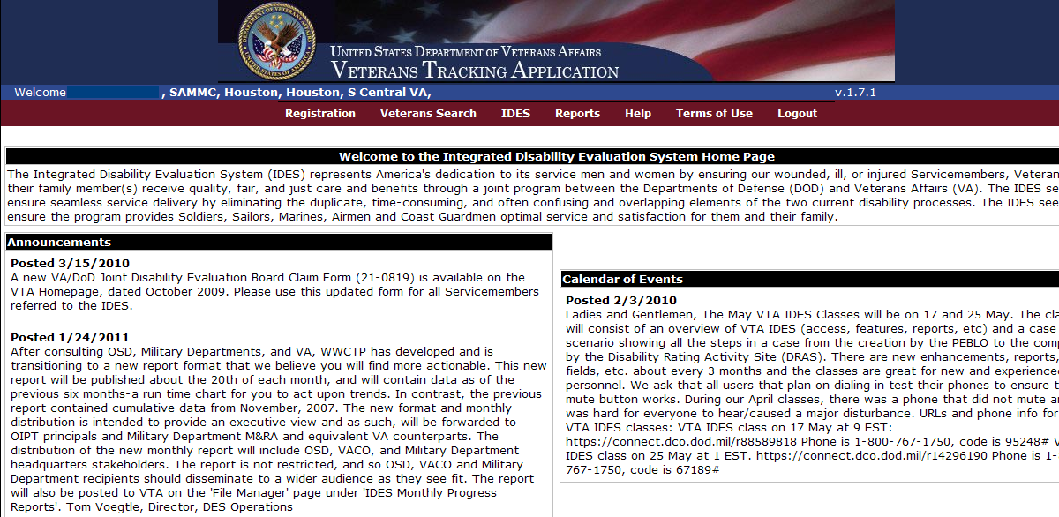

This is the initial log-on screen to Veteran Tracking Application for IDES and SI/VSI.
The arrows indicate SI/VSI tabs.

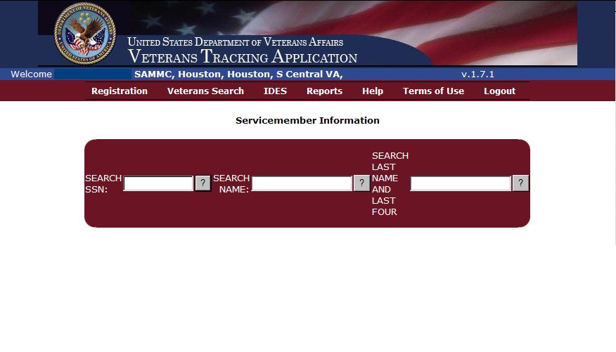
The Registration tab is for Service member Information data entries.
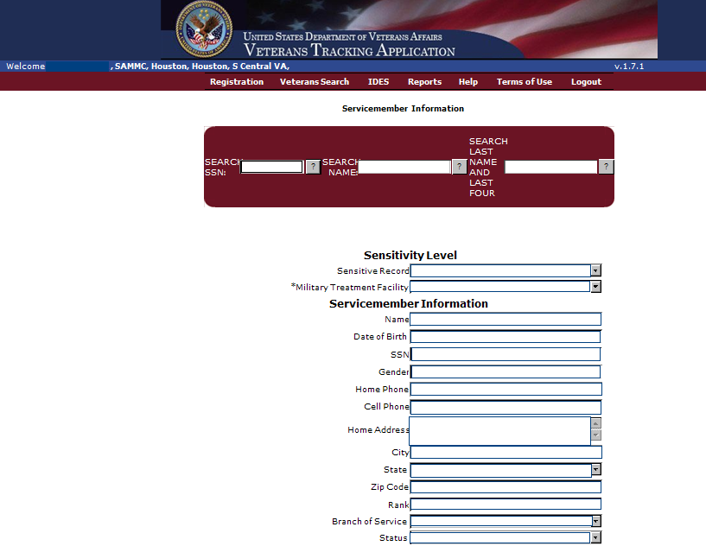

First page under the Registration tab
Ensure all information is correct and make all appropriate updates.

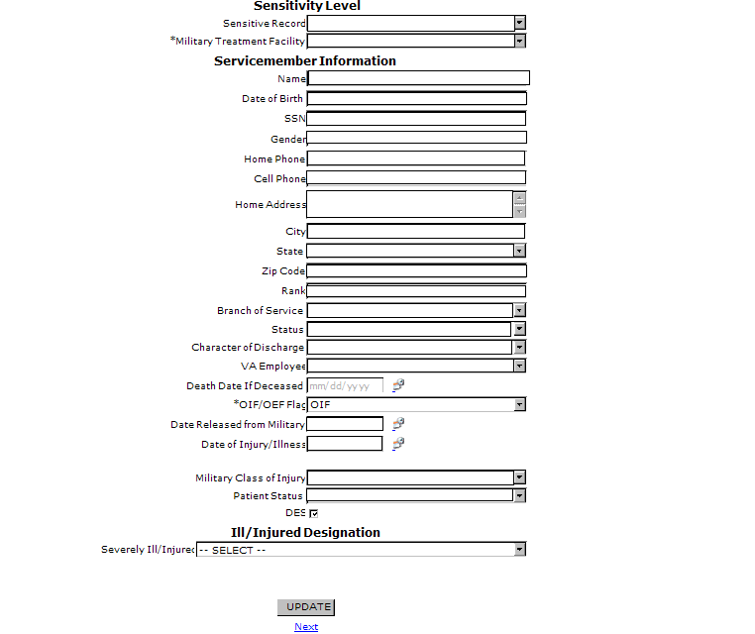

- Ensure all data on this page is correct and up to date.
- Click on the DES box to indicate the Service member is enrolled in IDES.
- Click “UPDATE”
- Click “Next”

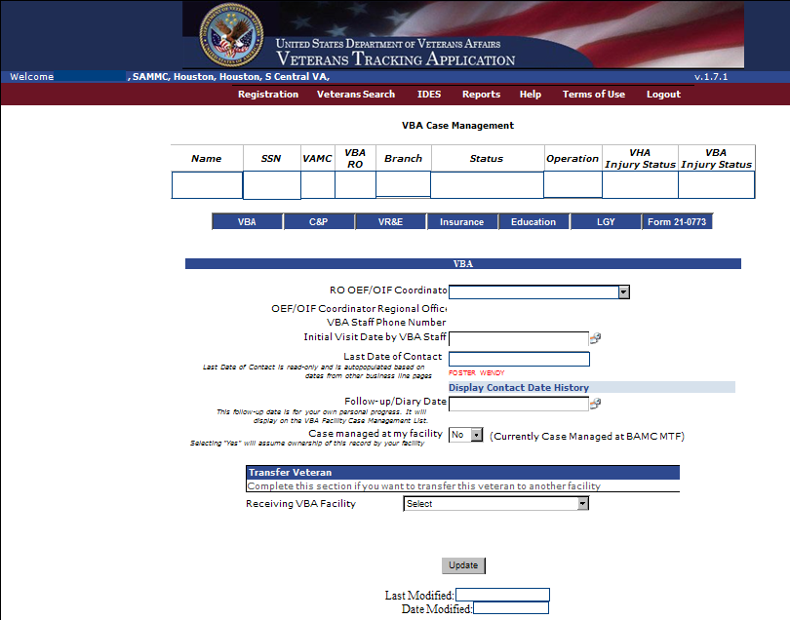

- Each tab has data entry points.
- The MSC will update the following tabbed fields:
- VBA
- C&P
- Form 21-0773
- All entries require the “UPDATE” button selection.

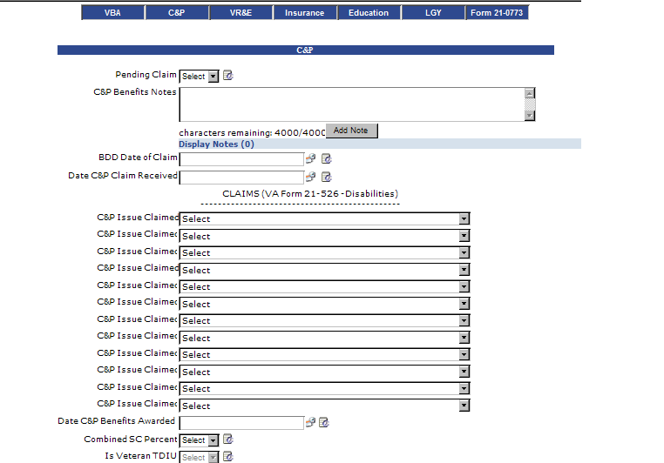

- Select the drop down box for “Pending Claim” field “Yes or No”
- Add notes and select the “Add Notes” button to save notes
- Enter the date the Claim was received
- Enter all claimed conditions
- Remaining fields will be completed upon final rating.

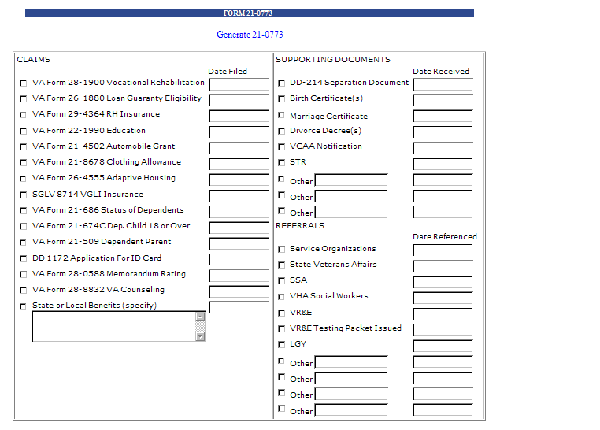

Complete all entries as appropriate.
VA Form 21-0773 must be completed every time there is contact made with the Service member or Veteran.
When all entries are completed, click on “Generate 21-0773” to print or save the 21-0773.
The 21-0773 will be back-flapped in the center of the claims folder while in the ROJ.
When the file is permanently transferred to another station, send the 21-0773 via email to the receiving station OEF/OIF Manager and Coordinator.
Check with your local OEF/OIF Manager for additional local policy concerning transfers.
Example: Some Regional Offices will want to be included in the cc line for all transfer emails.
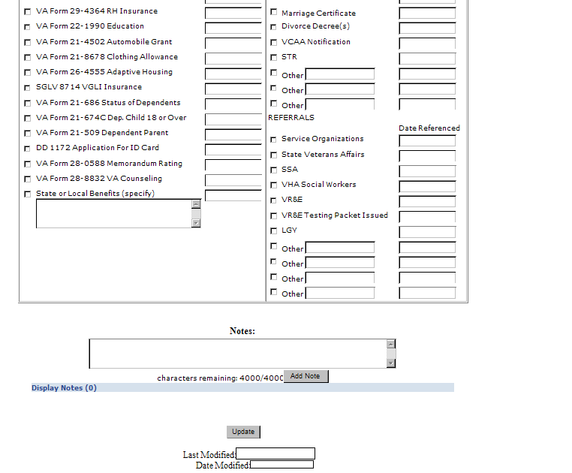

- Type in contact notes
- Click on “Add Notes”
- Click on “Update”
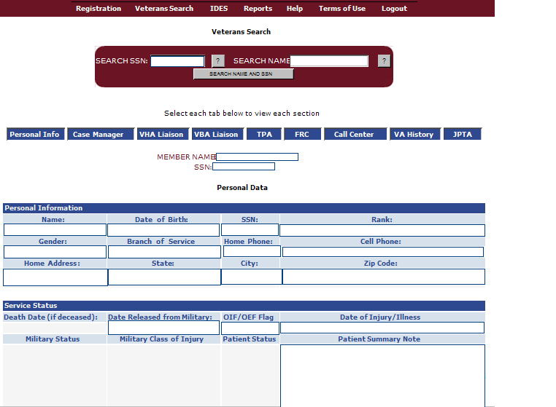

Veterans Search Tab is inquiry only information.
Data entry from all sources are combined to be seen under the blue tabs
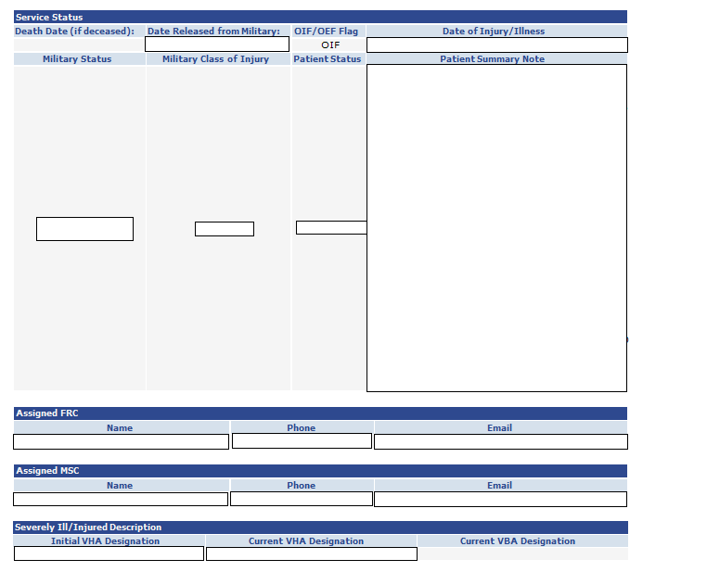

Personal Info page continued here.
The Assigned MSC is auto-populated here.
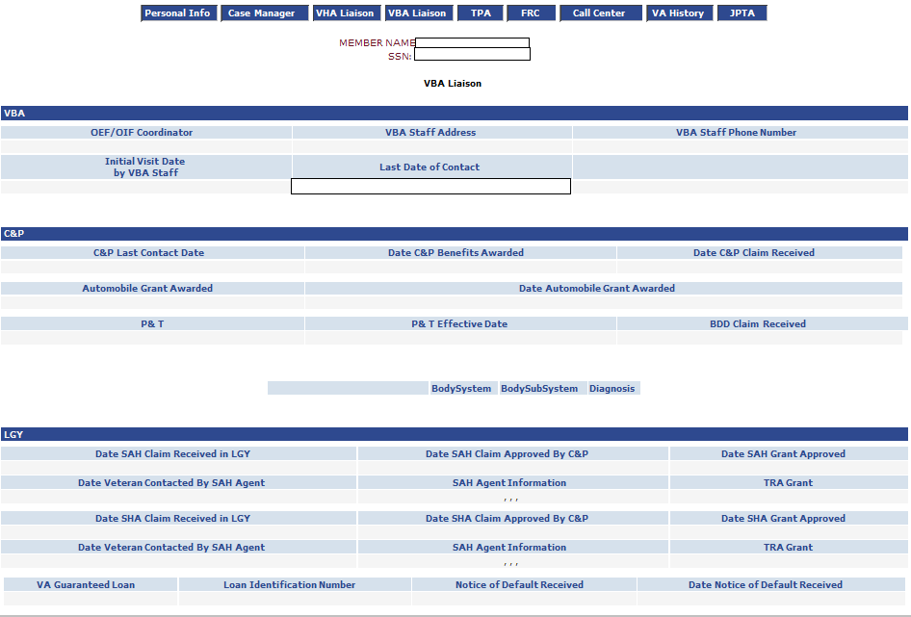
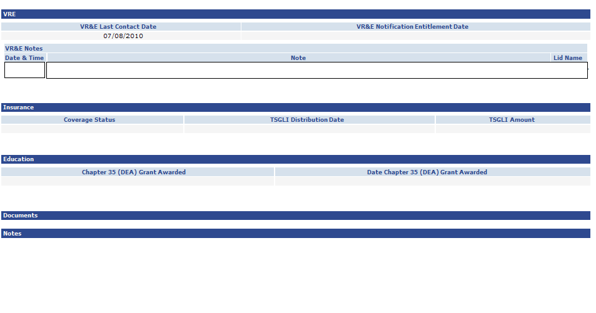
VBA Liaison page
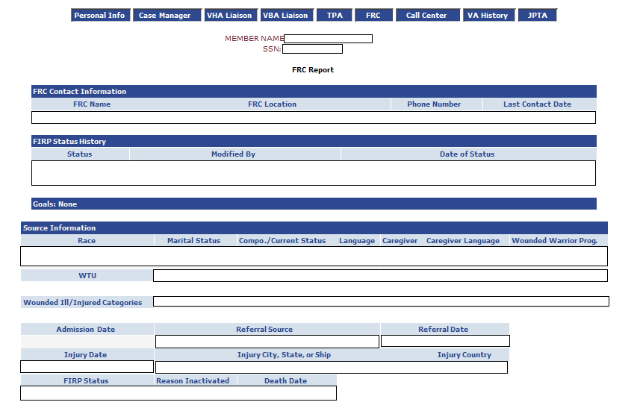

Federal Recovery Coordinator (FRC) Page

IMPORTANT:
Contact the FRC by phone or email. Inform the FRC that the Service member has entered IDES and you have updated information in VTA. Provide the FRC with your contact information.
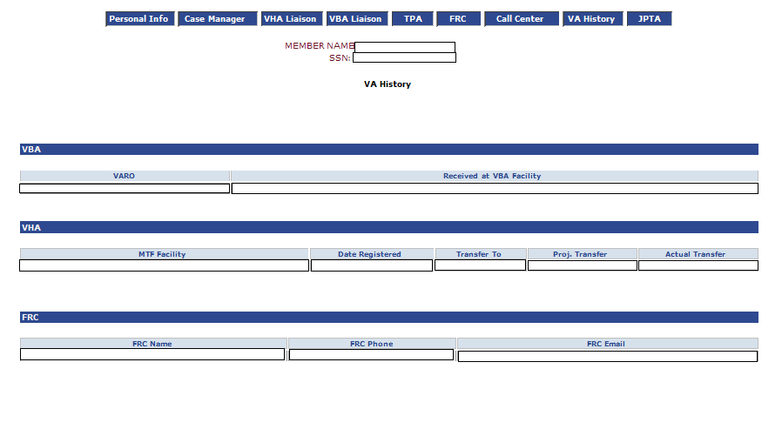
VA History page

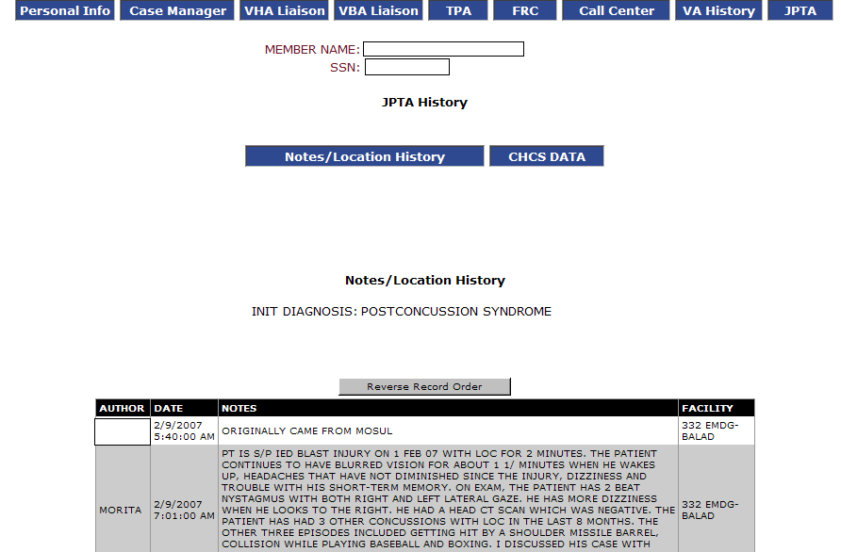
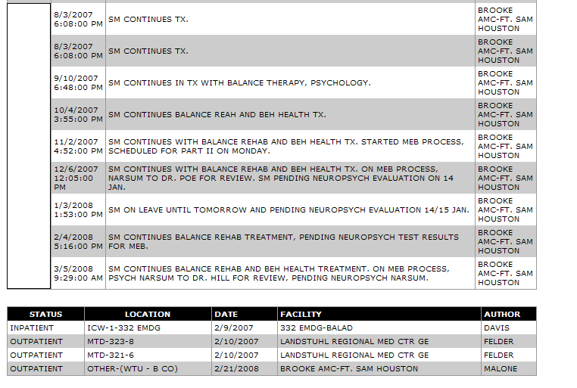
There may be additional treatment information on the JTPA page.
Level II Assessment

- VTA has many pages to enter data. What pages do VBA employees enter data?
  - VBA page
  - C&P page
  - Form 21-0773 page
  - All of the above

- Which website contains the OEF/OIF Managers point of contact list?
  - http://vbaw.vba.va.gov/bl/21/staff/coordinator.htm
  - http://cptraining.vba.va.gov/C&P_Training/
  - http://vbaw.vba.va.gov/bl/27/outreach/military/oef_oif/poc.htm
  - Both a and c

- Which page in VTA might have service treatment medical records available?
  - 21-0773 page
  - C&P page
  - JTPA page
  - FRC page

